Lesson 3
Objective: Draw and label a bar graph to represent data; relate the count scale to the number line.

Suggested Lesson Structure
 Fluency Practice (12 minutes)
 Application Problem (5 minutes)
 Concept Development (35 minutes)
 Student Debrief (8 minutes)
Total Time (60 minutes)
Fluency Practice (12 minutes)
- Sprint: Addition and Subtraction by 5 2.NBT.2 (9 minutes)
- Coin Drop 2.NBT.2, 2.OA.2 (3 minutes)
Sprint: Addition and Subtraction by 5 (9 minutes)
Materials: (S) Addition and Subtraction by 5 Sprint
Note: This Sprint gives practice adding and subtracting by 5 in preparation for counting nickels in Topic B.
Coin Drop (3 minutes)
Materials: (T) 10 dimes, 5 nickels, can
Note: In this activity, students practice adding and subtracting fives and tens.
T: (Hold up a nickel.) Name my coin.
S: A nickel.
T: How much is it worth?
S: 5 cents.
T: Listen carefully as I drop coins in my can. Count along in your minds.
Drop in some nickels, and ask how much money is in the can. Take out some of the nickels and show them. Ask how much money is still in the can. Continue adding and subtracting nickels for a minute or so. Then, repeat the activity with dimes and nickels.
Application Problem (5 minutes)
Materials: (T) Tally chart (S) 1 Number of Books Read picture graph (Template 1) per student
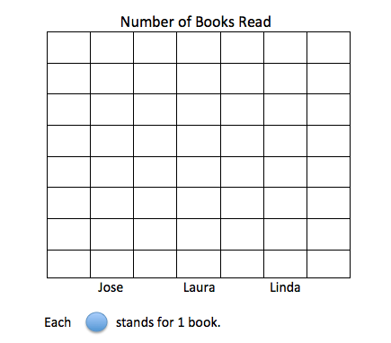
- Use the tally chart to fill in the picture graph.
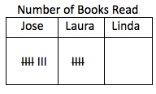

b. Draw a tape diagram to show how many more books Jose read than Laura.
c. If Jose, Laura, and Linda read 21 books altogether, how many books did Linda read?
d. Complete the tally chart and the graph.
Note: This problem reviews creating and interpreting picture graphs. It also anticipates one element of the Concept Development, in which students relate the bars of a graph to the bars of a tape diagram. Prior to the lesson, cut apart Template 1 so that each student receives one graph.
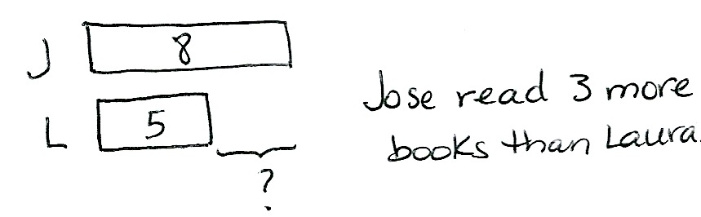
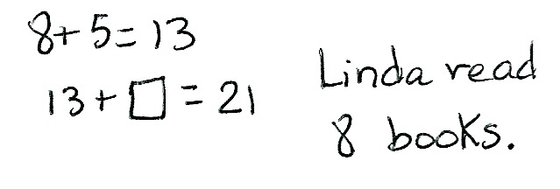
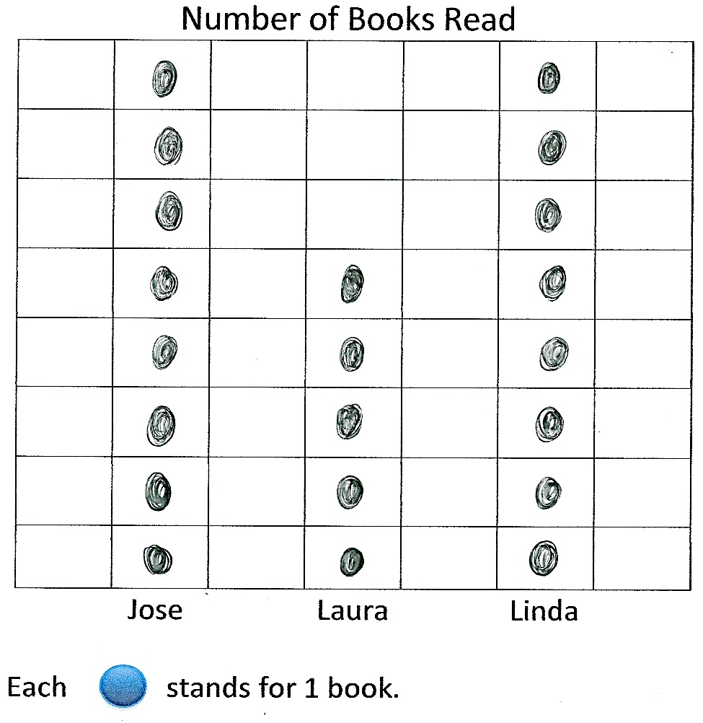
..
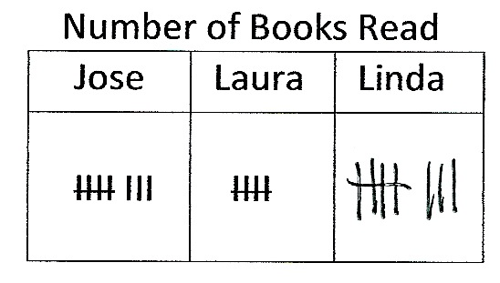

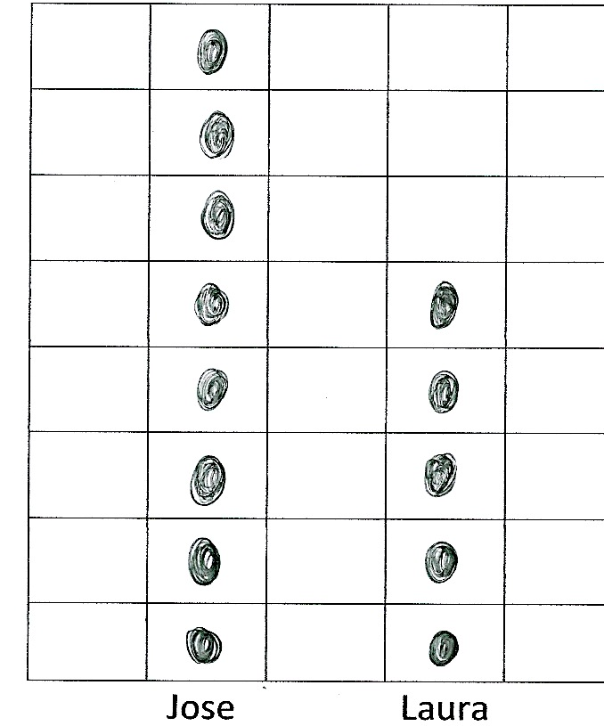
Concept Development (35 minutes)
Materials: (T) Horizontal and vertical bar graphs (Template 2), Chart 3: Animal Classification and Chart 4: Animal Habitats (from Lesson 1), completed Template 1 (from Lesson 2) (S) Tape diagrams from Application Problem, horizontal and vertical bar graphs (Template 2), personal white board, paper or math journal
T: Take your Application Problem and turn it sideways, like mine. (Model as students do the same.)
T: Talk with your partner: What do you notice about the picture graph when it’s turned this way?

NOTES ON
MULTIPLE MEANS
OF ACTION AND
EXPRESSION:
The language of comparison can be challenging for English language learners. Allow them to choose the language they prefer for discourse. Also, accompany comparative language such as more, less, taller, and shorter, with illustrative gestures.
S: Hey! It looks just like a tape diagram! The bars on the tape diagram show the same amount as the circles on the graph. They both show that 8 is longer than 5. They both show the difference between 8 and 5, but you can count the three empty spaces on the graph.
T: (Display completed vertical picture graph [Lesson 2 Template 1], pictured below at the right.)
T: Talk with your partner: How can you tell by looking at the graph which category has more and which has less?
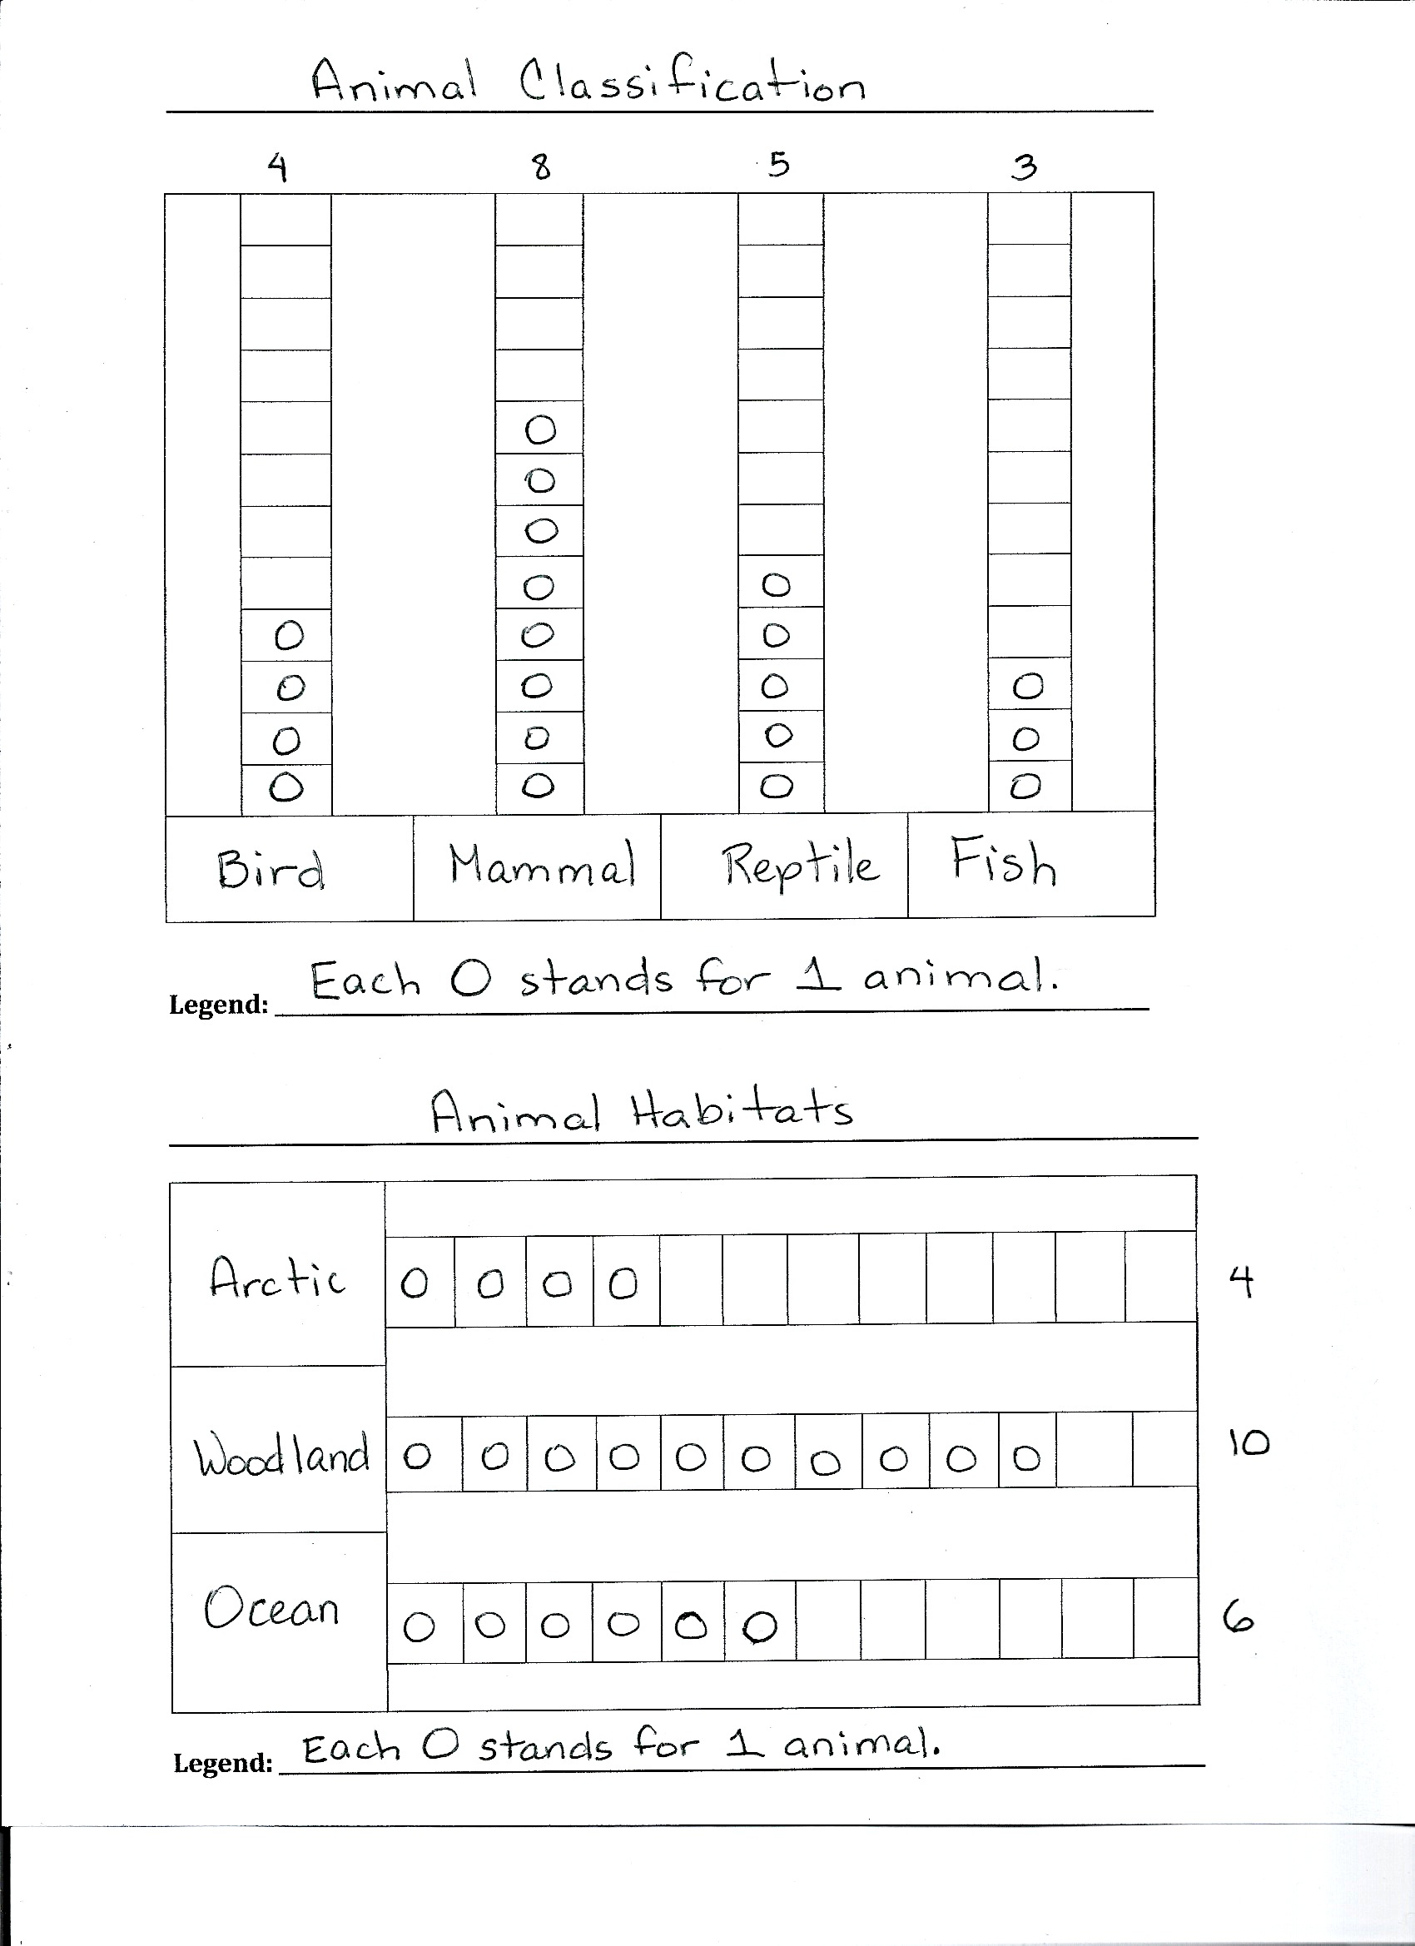
S: The category with the most is the tallest, and the category with the least is the shortest.
Template 1 from Lesson 2
T: Does the data change if I turn the graph sideways? (Rotate graph to horizontal position.)
S: No!
T: True! So, we’re learning some interesting things about graphs. We can change the position of the graph from vertical to horizontal, and the data stays the same.
T: (Display Chart 3: Animal Classification from Lesson 1.) And, we learned we can show the same data in a table and in a picture graph.
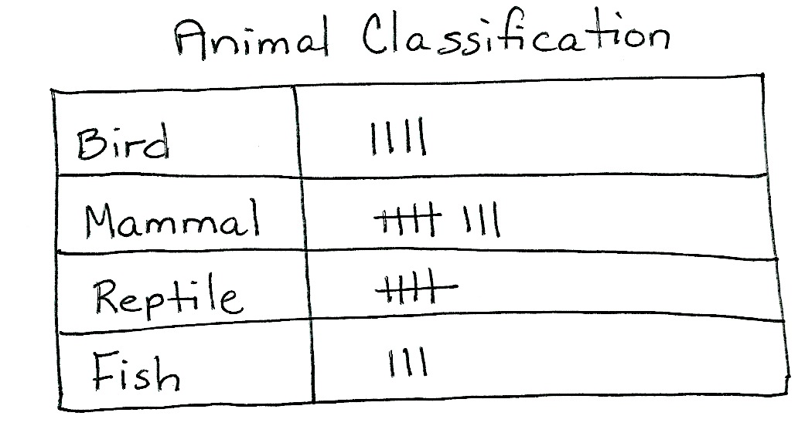
T: Well, guess what? We can also show the information another way!
Chart 3 from Lesson 1
Project or draw the horizontal bar graph from Template 2. Then, pass out student copies of the template, and have students slide the sheet into their personal white boards.
T: We’re going to create a bar graph to show the data from our Animal Classification table.
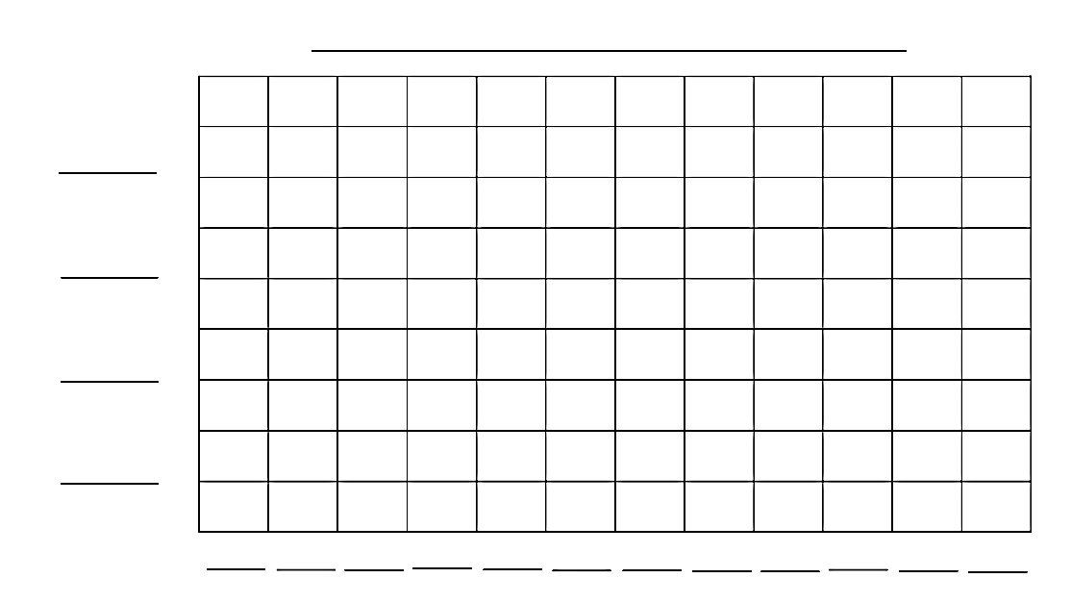
T: For our graph to make sense to someone who’s reading it, it needs to have a title. What is the title of our chart?
Template 2
S: Animal Classification!
T: We’re showing the same information, just in a different way, so the title stays the same. Fill in the title while I do the same. (Record the title as students do the same.)
T: How many categories of animals did we classify?
S: Four!

NOTES ON
MULTIPLE MEANS
OF ENGAGEMENT:
When comparing categories, have students make the hop with their fingers to show how they add and subtract on the number line. Alternatively, call students up to make live bars to compare categories. For example, to compare bird and fish, have a row of four students face a row of three students. Three students from each bar can hold hands, making it easy to see the difference.
T: Let’s label those same categories in the same order on the bar graph. (Record as students do the same.)
T: How did we record the number of animals on the table?
S: We used tally marks.
T: And how did we represent the number of each animal on the picture graph?
S: We drew a picture to represent each animal.
T: Watch how we represent data on a bar graph. (Fill in the scale.)
MP.6
T: (Point to the numbers.) First, I fill in the scale. What are we counting by?
S: Ones!
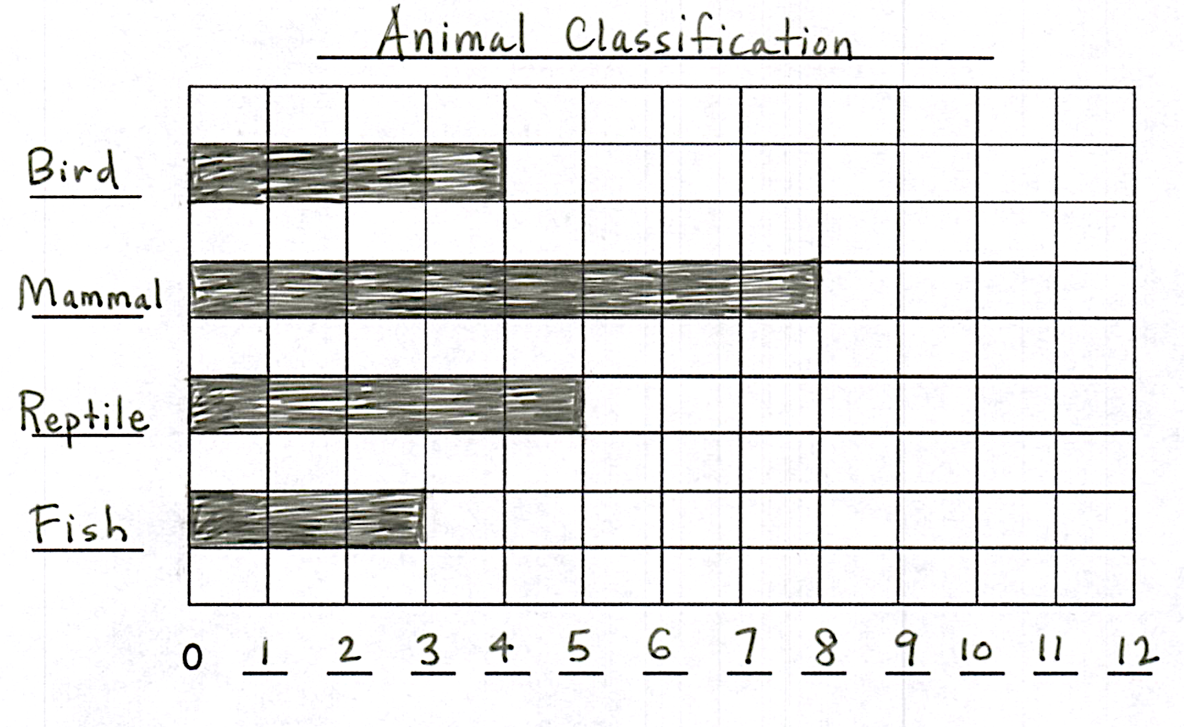
T: Yes. Whisper to your partner what the scale reminds you of.
S: It’s like a meter strip. It’s like the numbers on a ruler. It’s a number line!
T: The scale tells us that each box equals one, so how many boxes should we color in for the bird category?
S: Four boxes!
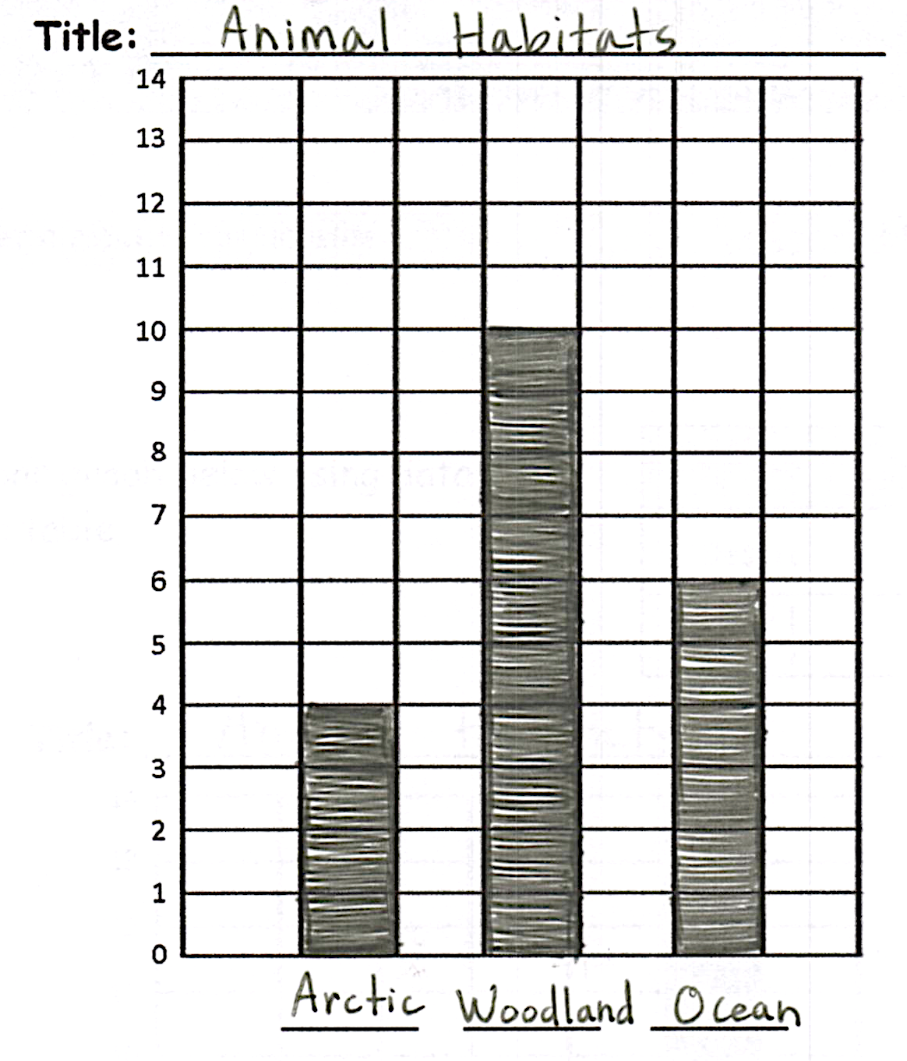
T: Color four boxes in the bird row. (Model as students do the same. Continue in this way to complete the graph.)
T: Now, just as with the picture graph, we can use the bar graph to ask and answer questions.
Pose questions such as those below, and have students write their answers on paper or in a math journal. Then, invite students to pose questions to the class based on the picture graph. Invite students to utilize the compare question sentence frames from Lesson 2 as needed.
- How many more mammals than reptiles are there?
- How many fewer birds than reptiles are there?
- How would the graph change if we added four more birds to the bird category?
Template 2
Repeat the process to create a bar graph of the data from the Animal Habitats table, using the second graph (vertical orientation) on Template 2.
After creating the graph, invite partners to ask and answer questions based on the data.
As students demonstrate proficiency creating and interpreting the graph, allow them to move on to the Problem Set. Continue working with any students who need support.
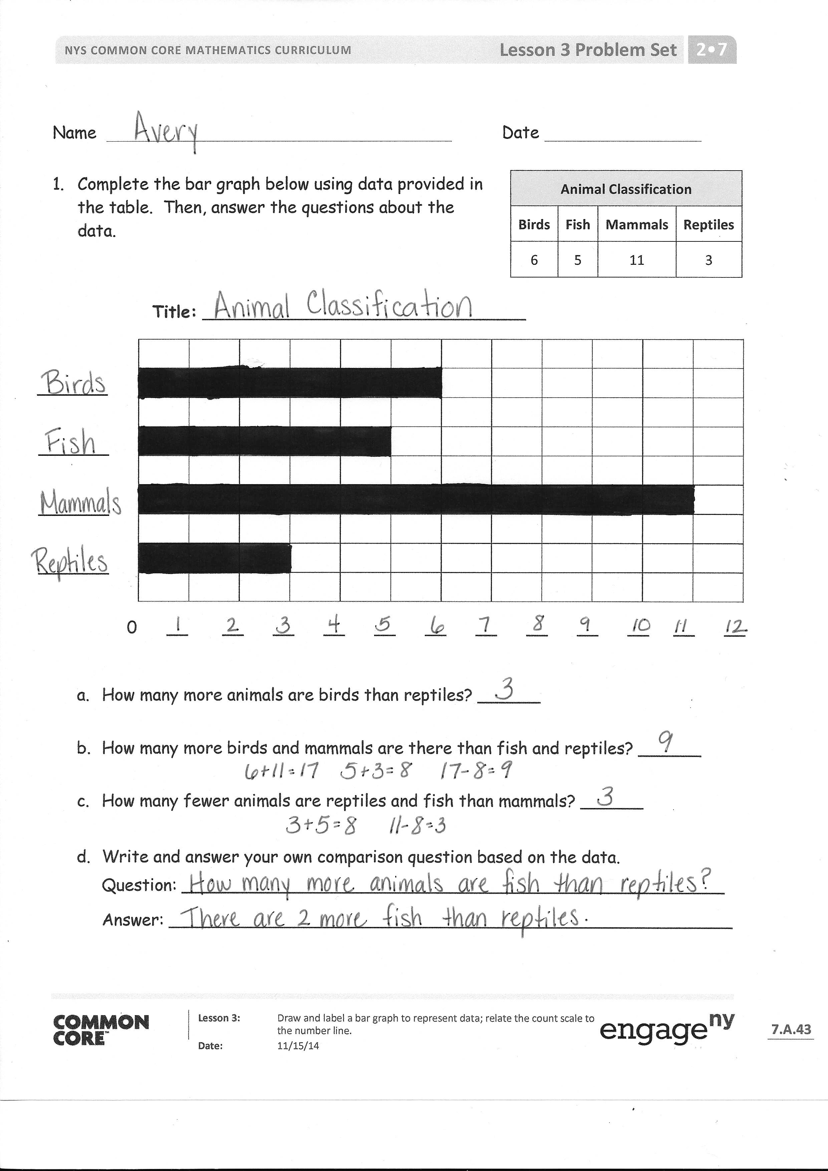
Problem Set (8 minutes)
Students should do their personal best to complete the Problem Set within the allotted 10 minutes. For some classes, it may be appropriate to modify the assignment by specifying which problems they work on first. Some problems do not specify a method for solving. Students should solve these problems using the RDW approach used for Application Problems.
Student Debrief (8 minutes)
Lesson Objective: Draw and label a bar graph to represent data; relate the count scale to the number line.
The Student Debrief is intended to invite reflection and active processing of the total lesson experience.
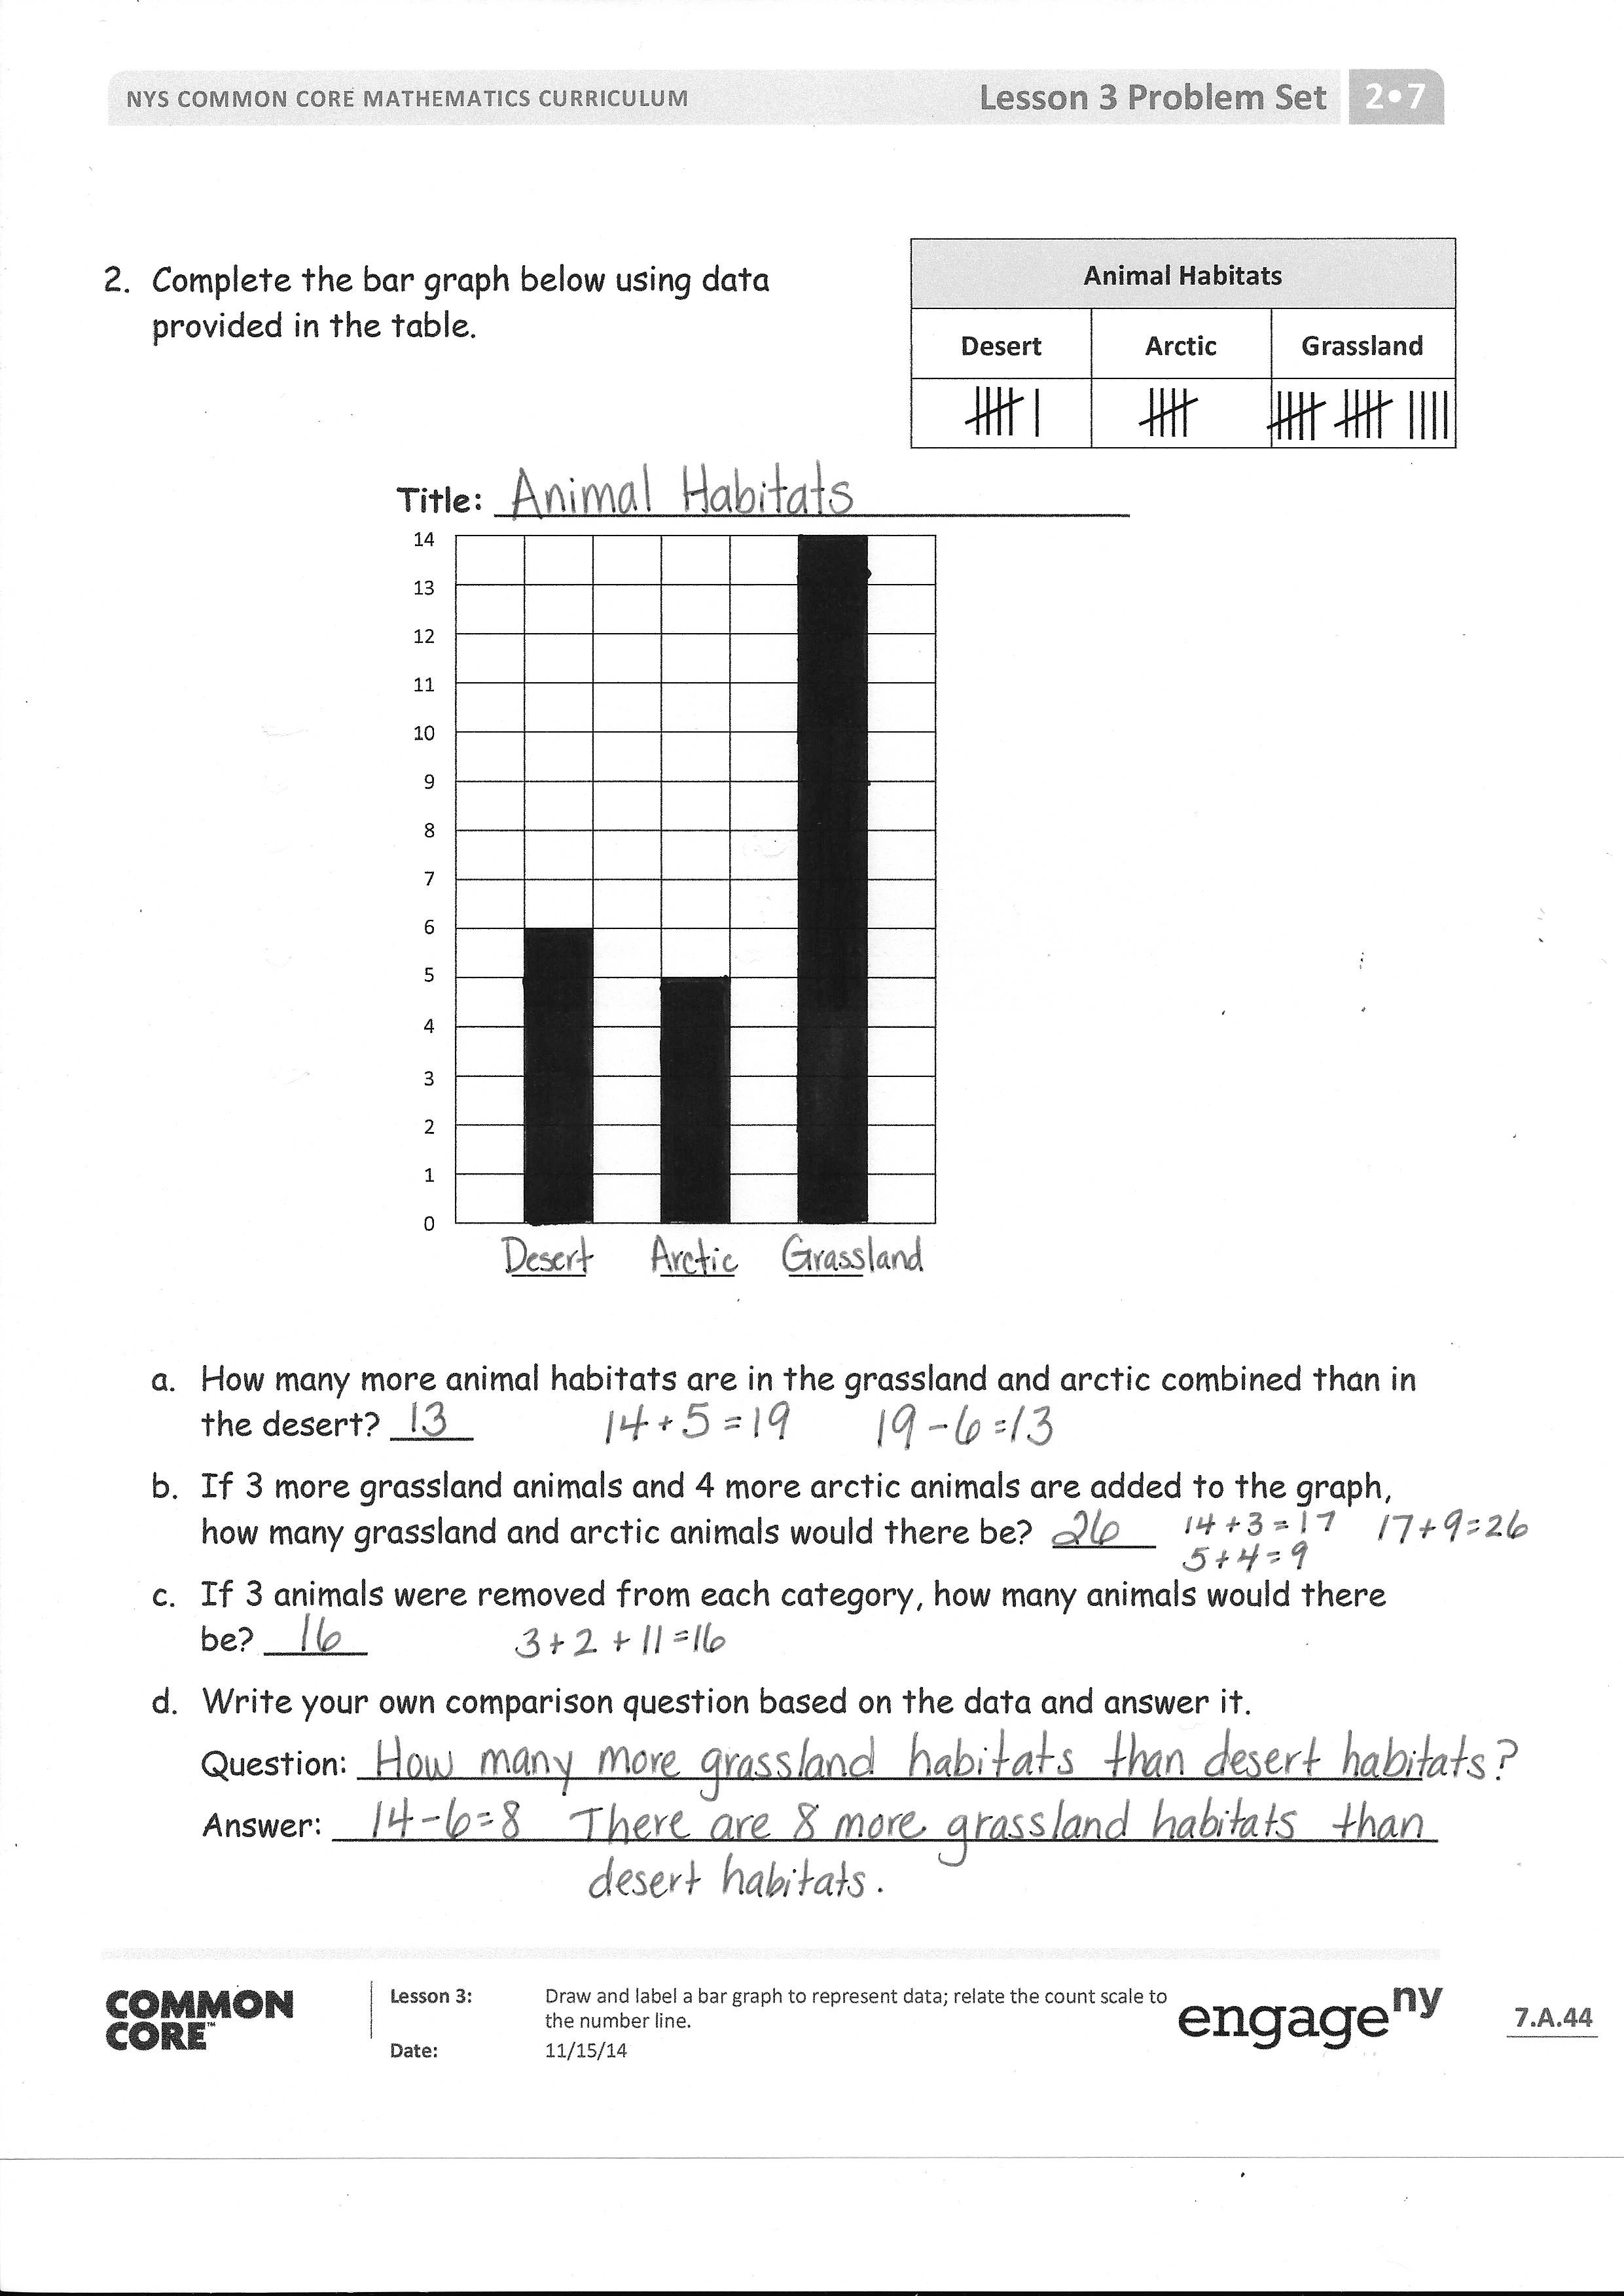
Invite students to review their solutions for the Problem Set. They should check work by comparing answers with a partner before going over answers as a class. Look for misconceptions or misunderstandings that can be addressed in the Debrief. Guide students in a conversation to debrief the Problem Set and process the lesson.
Any combination of the questions below may be used to lead the discussion.
- Look at the first graph in your Problem Set. What did you write on this graph that we didn’t put on our graph yesterday? How do the numbers on the bottom help us to record data in a bar graph?
- Show your partner which part of your graph shows how many more birds than reptiles there are.
- Look at your neighbor’s habitat graph. Are the numbers on the scale written horizontally or vertically?
- When you were coloring the boxes to record how many animal habitats are in the grasslands, did you count each box, or did you look at the numbers you wrote? Which strategy would be faster?
- Why are bar graphs good for making comparisons? Can you tell which category has more or less without using the scale? How does the scale help you make more precise comparisons?
- How does writing numbers on our graphs help us to use tape diagrams? How do bar and picture graphs help us to draw tape diagrams so that we can see the difference (more than or fewer than) between groups?
- Tell your partner the different types of graphs you know how to use. What are the differences and similarities between them? Do they all use numbers?
Exit Ticket (3 minutes)
After the Student Debrief, instruct students to complete the Exit Ticket. A review of their work will help with assessing students’ understanding of the concepts that were presented in today’s lesson and planning more effectively for future lessons. The questions may be read aloud to the students.

Number Correct: _______
A
Addition and Subtraction by 5
 | 0 + 5 = |  |  |  | 10 + 5 =
 | 5 + 5 = |  |  |  | 15 + 5 =
 | 10 + 5 = |  |  |  | 20 + 5 =
 | 15 + 5 = |  |  |  | 25 + 5 =
 | 20 + 5 = |  |  |  | 30 + 5 =
 | 25 + 5 = |  |  |  | 35 + 5 =
 | 30 + 5 = |  |  |  | 40 + 5 =
 | 35 + 5 = |  |  |  | 45 + 5 =
 | 40 + 5 = |  |  |  | 0 + 50 =
 | 45 + 5 = |  |  |  | 50 + 50 =
 | 50 – 5 = |  |  |  | 50 + 5 =
 | 45 – 5 = |  |  |  | 55 + 5 =
 | 40 – 5 = |  |  |  | 60 – 5 =
 | 35 – 5 = |  |  |  | 55 – 5 =
 | 30 – 5 = |  |  |  | 60 + 5 =
 | 25 – 5 = |  |  |  | 65 + 5 =
 | 20 – 5 = |  |  |  | 70 – 5 =
 | 15 – 5 = |  |  |  | 65 – 5 =
 | 10 – 5 = |  |  |  | 100 + 50 =
 | 5 – 5 = |  |  |  | 150 + 50 =
 | 5 + 0 = |  |  |  | 200 – 50 =
 | 5 + 5 = |  |  |  | 150 – 50 =
Number Correct: _______
Improvement: _______
B
[KEY]

Addition and Subtraction by 5
 | 5 + 0 = |  |  |  | 10 + 5 =
 | 5 + 5 = |  |  |  | 15 + 5 =
 | 5 + 10 = |  |  |  | 20 + 5 =
 | 5 + 15 = |  |  |  | 25 + 5 =
 | 5 + 20 = |  |  |  | 30 + 5 =
 | 5 + 25 = |  |  |  | 35 + 5 =
 | 5 + 30 = |  |  |  | 40 + 5 =
 | 5 + 35 = |  |  |  | 45 + 5 =
 | 5 + 40 = |  |  |  | 50 + 0 =
 | 5 + 45 = |  |  |  | 50 + 50 =
 | 50 – 5 = |  |  |  | 5 + 50 =
 | 45 – 5 = |  |  |  | 5 + 55 =
 | 40 – 5 = |  |  |  | 60 – 5 =
 | 35 – 5 = |  |  |  | 55 – 5 =
 | 30 – 5 = |  |  |  | 5 + 60 =
 | 25 – 5 = |  |  |  | 5 + 65 =
 | 20 – 5 = |  |  |  | 70 – 5 =
 | 15 – 5 = |  |  |  | 65 – 5 =
 | 10 – 5 = |  |  |  | 50 + 100 =
 | 5 – 5 = |  |  |  | 50 + 150 =
 | 0 + 5 = |  |  |  | 200 – 50 =
 | 5 + 5 = |  |  |  | 150 – 50 =

Name Date
Animal Classification
Birds | Fish | Mammals | Reptiles
6 | 5 | 11 | 3
- Complete the bar graph below using data provided in the table. Then, answer the questions about the data.

Title: _______________________________
0 __ __ __ __ __ __ __ __ __ __ __ __

- How many more animals are birds than reptiles? ______

- How many more birds and mammals are there than fish and reptiles? ______

- How many fewer animals are reptiles and fish than mammals? ______

- Write and answer your own comparison question based on the data.
Question: ____________________________________________________
Answer: _____________________________________________________
Animal Habitats
Desert | Arctic | Grassland
- Complete the bar graph below using data provided in the table.

Title: _______________________________
14
13
12
11
10
9
8
7
6
5
4
3
2
1
0
_____ _____ _____

- How many more animal habitats are in the grassland and arctic combined than in the desert? ____
- If 3 more grassland animals and 4 more arctic animals are added to the graph, how many grassland and arctic animals would there be? _____
- If 3 animals were removed from each category, how many animals would there be? _____
- Write your own comparison question based on the data and answer it.
Question: ____________________________________________________
Answer: _____________________________________________________

Name Date
Animal Classification
Birds | Fish | Mammals | Reptiles
7 | 12 | 8 | 6
Complete the bar graph below using data provided in the table. Then, answer the questions about the data.

Title: _________________________________

0 __ __ __ __ __ __ __ __ __ __ __ __ __ __

- How many more animals are fish than reptiles? ______

- How many more fish and mammals are there than birds and reptiles? ______

Name Date
Various Animal Coverings at Jake’s Pet Shop
Fur | Feathers | Shells | Scales
12 | 9 | 8 | 11
- Complete the bar graph below using data provided in the table. Then, answer the questions about the data.

Title: _________________________________

0 __ __ __ __ __ __ __ __ __ __ __ __ __ __

- How many more animals have fur than shells? ______

- Which pair of categories has more, fur and feathers or shells and scales? (Circle one.) How much more? ____

- Write and answer your own comparison question based on the data.
Question: ____________________________________________________
Answer: _____________________________________________________
City Shelter Animal Diets
Meat Only | Plants Only | Meat and Plants
- Complete the bar graph below using data provided in the table.

Title: _______________________________
14
13
12
11
10
9
8
7
6
5
4
3
2
1
0
_____ _____ _____

- How many total animals are in the city shelter? _____
- How many more meat and plant-eating animals are there than meat only? _____
- If 3 animals were removed from each category, how many animals would there be? ____
- Write your own comparison question based on the data, and answer it.
Question: ____________________________________________________
Answer: _____________________________________________________

0 __ __ __ __ __ __ __ __ __ __ __ __ __ __

Title: ______________________________
14
13
12
11
10
9
8
7
6
5
4
3
2
1
0
_____ _____ _____

number of books read picture graphs
horizontal and vertical bar graphs

