Lesson 2

Objective: Draw and label a picture graph to represent data with up to four categories.

Suggested Lesson Structure

 Fluency Practice (10 minutes)

 Application Problem (5 minutes)

 Concept Development (35 minutes)

 Student Debrief (10 minutes)

**Total Time (60 minutes)**

Fluency Practice (10 minutes)

* Grade 2 Core Fluency Differentiated Practice Sets **2.OA.2** (5 minutes)
* Coin Drop **2.OA.2, 2.NBT.2** (5 minutes)

Grade 2 Core Fluency Differentiated Practice Sets (5 minutes)

Materials: (S) Core Fluency Practice Sets (Lesson 1 Core Fluency Practice Sets)

Note: During Topic A and for the remainder of the year, each day’s Fluency Practice includes an opportunity for review and mastery of the sums and differences with totals through 20 by means of the Core Fluency Practice Sets or Sprints. The process is detailed and Practice Sets are provided in Lesson 1.

Coin Drop (5 minutes)

Materials: (T) 10 dimes, 10 nickels, 10 pennies, can

Note: In this activity, students practice adding and subtracting ones, fives, and tens with coins.

T: (Hold up a nickel.) Name my coin.

S: A nickel.

T: How much is it worth?

S: 5 cents.

T: Listen carefully as I drop coins in my can. Count along in your minds.

Drop in some nickels, and ask the value of the money in the can. Take out some of the nickels and show them. Ask how much money is still in the can. Continue adding and subtracting nickels for a minute or so. Then, repeat the activity with dimes, then with nickels and pennies, and then dimes and pennies.

Application Problem (5 minutes)

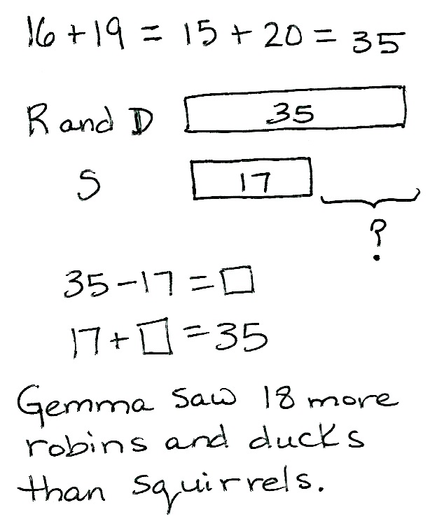

Gemma is counting animals in the park. She counts 16 robins, 19 ducks, and 17 squirrels. How many more robins and ducks did Gemma count than squirrels?

Note: This comparative problem type invites the use of a tape diagram. It leads into today’s lesson, in which students will use data involving animals to solve simple *compare* word problems. It also prepares students to notice the relationship between the tape diagram and the bars on a bar graph in Lesson 3.

Concept Development (35 minutes)

Materials: (T) Animal Classification and Animal Habitats tables (Charts 3 and 4 from Lesson 1), 1 piece of chart paper (see below) (S) Vertical and horizontal picture graphs (Template 1), vertical picture graph (Template 2), crayons or colored pencils, personal white board, paper or math journal

Note: Prior to this lesson, prepare a chart for a new table: Favorite Class of Animal*.* At the end of the lesson, save this new table and Template 1 and Template 2 graphs for work in Lesson 3.

Part 1: Use the vertical and horizontal picture graph Template.

T: (Display Animal Classification table.) Yesterday, we organized information, or data, about animals into tables using tally marks and numbers.

T: A **picture graph** is another way we can show data. What do you think we use to show data on a picture graph?

S: Pictures!

T: Yes! Let’s create a picture graph of the data in the Animal Classification table.

Pass out Template 1, and have students slide the sheet into their personal white boards. This way, the template can be used until students demonstrate proficiency in recording data.

Project or draw the first graph (vertical orientation on Template 1) on the board next to the Animal Classification table.

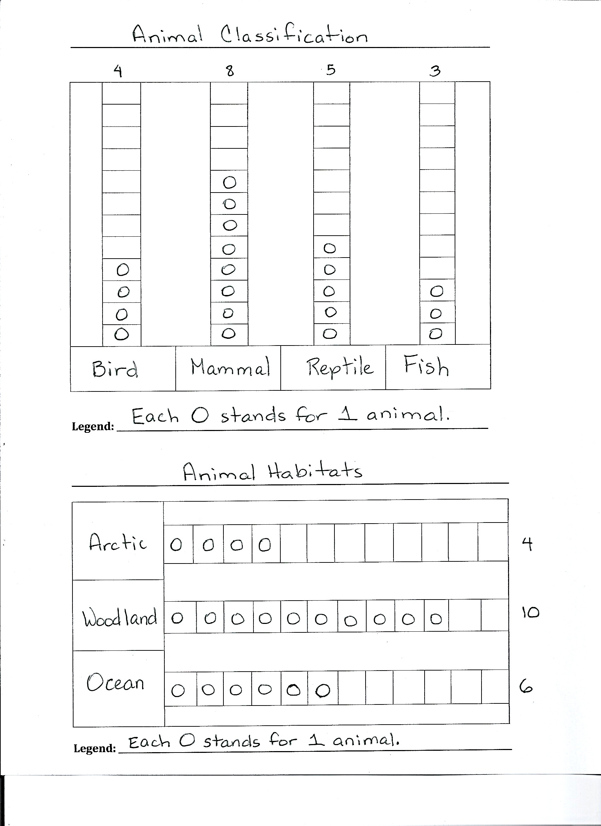

**Template 1**

T: Since graphs help us understand information, we need to know what the graph is about. What is the title of our table?

S: Animal Classification.

T: Yes. Our picture graph is going to show the same information, so write this same title on the line above the first graph. (Model as students do the same.)

T: What are the four categories of animals we classified?

S: Bird. 🡪 Mammal. 🡪 Reptile. 🡪 Fish.

T: Let’s write these labels in the same order as they appear on the table. (Model as students do the same.)

T: Why do you think it matters that we write the categories in the same order as they appear on the table?

S: So we don’t get confused. 🡪 So the information looks the same.

T: Yes, we want to be sure our data matches up.

|  |  |
| --- | --- |
|  | NOTES ON  MULTIPLE MEANS  OF ENGAGEMENT: |

Do an Internet search of images to show visuals of unusual animals such as the Komodo dragon or the chameleon, and share interesting facts. Invite students from other countries to share any information about animals that may be specific to that geographic area.

T: Now, we’re going to draw a picture in each box to represent each animal recorded by a tally mark on our table.

T: As always, it’s math, not art, so we want to be quick and efficient. We don’t have the time or enough space to draw a whale or a polar bear over and over in these little boxes, do we?

S: No!

T: What do we sometimes use in our math drawings that’s quick and efficient?

S: A circle.

T: Absolutely! A circle is a fast way to draw something, and it can stand for whatever we want it to stand for!

T: Today, our circles will be our picture, or **symbol**, for animals. Each circle will represent one animal, and we’ll draw one circle in each box.

|  |  |
| --- | --- |
|  | NOTES ON  MULTIPLE MEANS  OF ACTION AND EXPRESSION: |

Support English language learners with sentence frames to guide them in posing and answering questions based on the data. For example, “We counted _____ birds, mammals, and reptiles,” and, “The category with the fewest animals is _____.”

T: How many circles should we draw in the *bird* column?

S: Four circles!

T: Draw with me. (Model as students do the same. Continue this way to complete the picture graph.)

T: We need to add one more piece of information to our graph. We have to tell people what those circles stand for, so we need a **legend**, or key.

T: Does a circle stand for a box of crayons?

S: No!

T: What does each circle represent?

S: Each circle stands for one animal.

T: Excellent! Add the legend on your graph. (Model as students do the same.)

T: It’s also helpful to write the total for each category count right on the graph. Let’s do that. (Model as students do the same.)

T: Now, we’re ready to use our graph to ask and answer questions about the data.

Pose questions such as those below, and have students write their answers on their personal white boards.

* How many birds, mammals, and reptiles did we count?
* Which category has the fewest animals? The most?
* How many fewer reptiles are there than mammals?

T: Now, it is your turn to ask a comparison question. Use the sentence frame, “How many fewer _____ are there than ______?” to ask your partner a question about the graph.

S: How many fewer fish are there than reptiles? 🡪 How many fewer birds are there than mammals?

T: I like how you are careful with your questions. You made sure to put the class with fewer animals first in the sentence.

T: Let’s ask another type of comparison question. This time use the sentence frame, “How many more ____ are there than ____?”

S: How many more mammals are there than reptiles? 🡪 How many more birds are there than fish?

T: Which class of animals did you say first in this question?

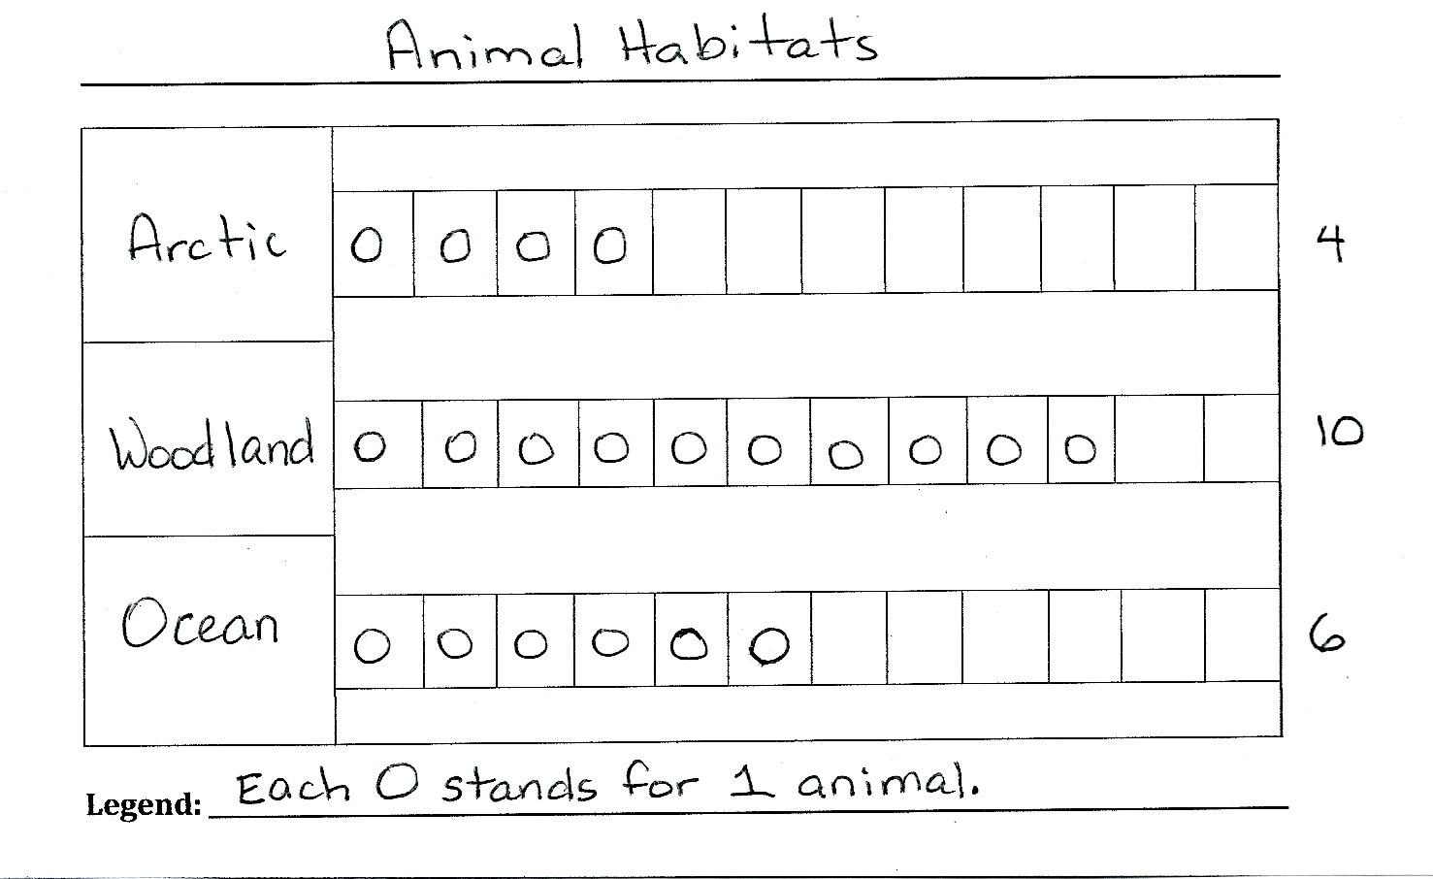

**Template 1**

S: The one with more. 🡪 The one with a greater number of animals.

Repeat the process to create a picture graph of the data from the Animal Habitats table, using the second graph (horizontal orientation) on Template 1. As students demonstrate understanding, allow them to work with a partner or independently.

After creating the graph, invite partners to ask and answer questions based on the data.

Part 2: Create picture graphs on graph paper.

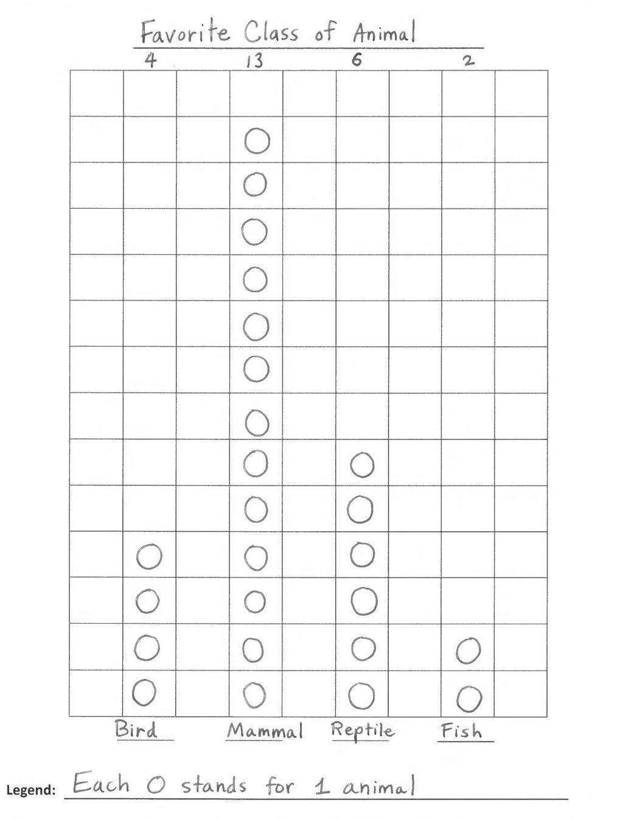

**Template 2**

Note: This next activity is designed to scaffold from the isolated columns and rows on Template 1 to the use of grid paper to create a picture graph (Template 2).

T: Now that we’ve learned how to classify certain animals, let’s gather some more data. I will **survey** the class to find out what your favorite class of animal is. (Display Favorite Class of Animal table.)

T: You each get one vote, and I will record your votes on this table. (Survey students and record votes, and then distribute Template 2.)

T: We’re going to create a picture graph of this data, this time using grid paper.

**MP.4**

Guide students through the process of filling in the title, labels, and legend. Point out that they are only filling in the squares above the labels; the boxes to either side are left blank.

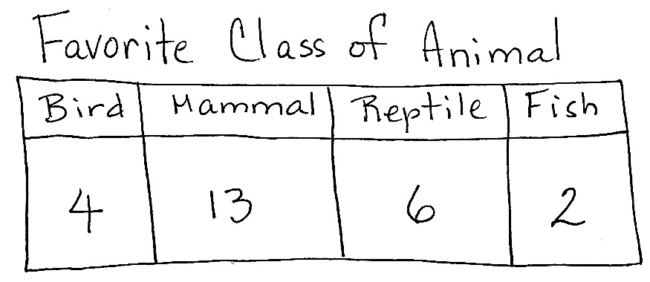After completing the graph, ask partners to ask and answer comparison questions based on the data.

As students demonstrate proficiency creating and interpreting the graph, allow them to move on to the Problem Set. Continue working with any students who need support.

Problem Set (10 minutes)

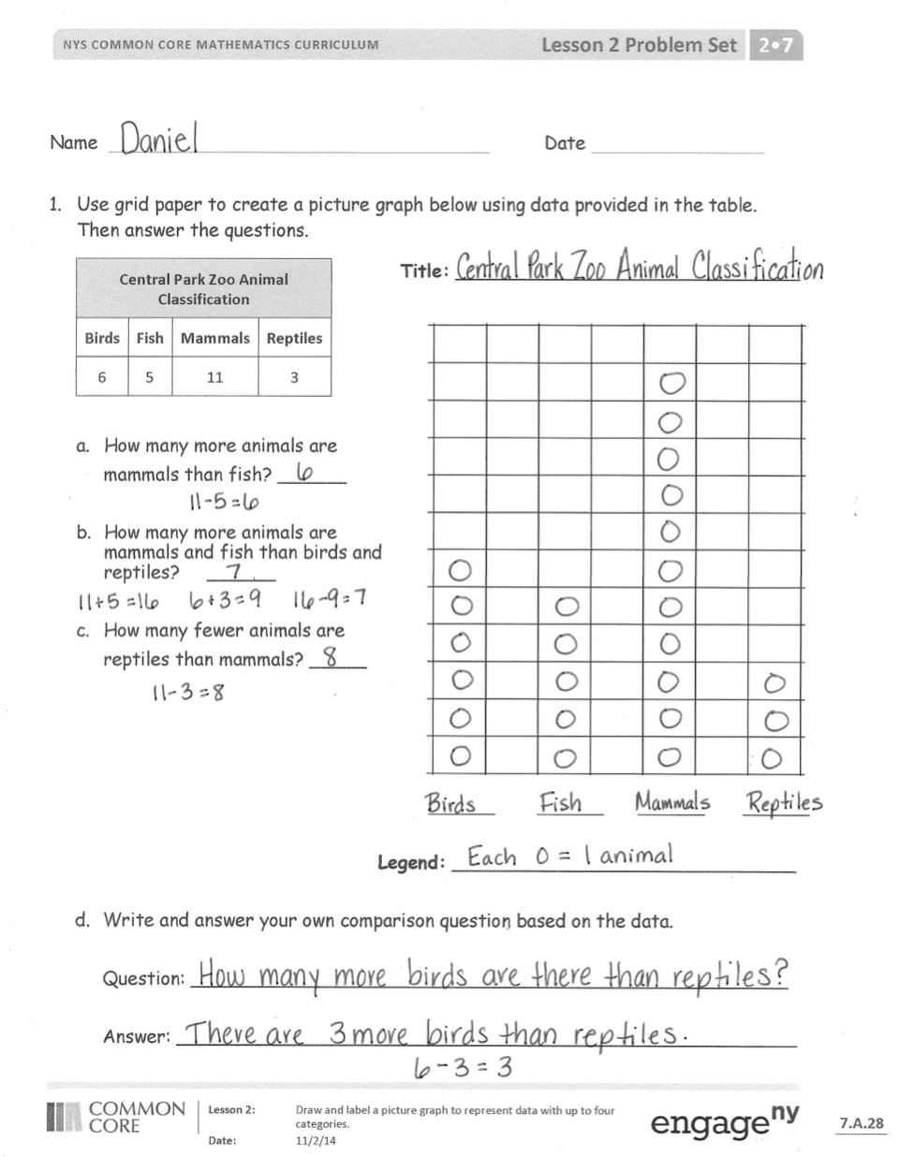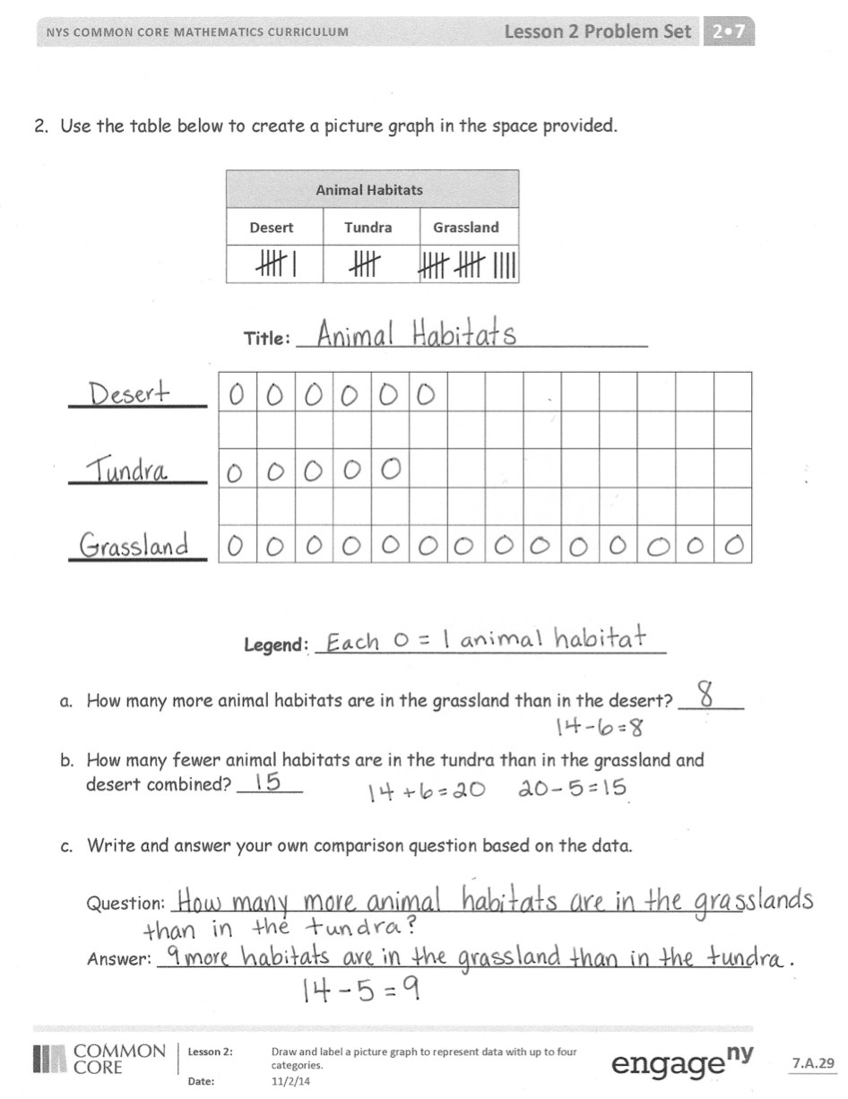

Students should do their personal best to complete the Problem Set within the allotted 10 minutes. For some classes, it may be appropriate to modify the assignment by specifying which problems they work on first. Some problems do not specify a method for solving. Students should solve these problems using the RDW approach used for Application Problems.

Student Debrief (10 minutes)

**Lesson Objective:** Draw and label a picture graph to represent data with up to four categories.

The Student Debrief is intended to invite reflection and active processing of the total lesson experience.

Invite students to review their solutions for the Problem Set. They should check work by comparing answers with a partner before going over answers as a class. Look for misconceptions or misunderstandings that can be addressed in the Debrief. Guide students in a conversation to debrief the Problem Set and process the lesson.

Any combination of the questions below may be used to lead the discussion.

* Talk to your neighbor about why we call these graphs **picture graphs**. Are there pictures in the graph?
* Look at the first page of the Problem Set. Problem 1(a) asks how many more mammals than fish are in the table. Point to the pictures on your graph that tell the answer. Show your neighbor. (Guide students to see that in comparison problems *more than* and *fewer than* refer to the extra circles of the two groups being compared.)
* Look at your Problem Set. Why does the grid paper make it easier to make a picture graph?
* Share the graph you created on the second page of the Problem Set with your neighbor. Do your graphs look the same? Can you understand your neighbor’s graph? Is the information in the graph correct? Are there labels and **symbols**? Did they include a **legend**?
* Does it matter if we record our pictures or circles in rows or columns? Does it change the information in the graph?
* How does a picture graph help us organize information from a **survey**?

Exit Ticket (3 minutes)

After the Student Debrief, instruct students to complete the Exit Ticket. A review of their work will help with assessing students’ understanding of the concepts that were presented in today’s lesson and planning more effectively for future lessons. The questions may be read aloud to the students.

Name Date

1. Use grid paper to create a picture graph below using data provided in the table. Then, answer the questions.

|  |  |  |  |
| --- | --- | --- | --- |
| **Central Park Zoo Animal Classification** | | | |
| **Birds** | **Fish** | **Mammals** | **Reptiles** |
| 6 | 5 | 11 | 3 |

**Title:** ____________________________



1. How many more animals are mammals than fish? ______
2. How many more animals are mammals and fish than birds and reptiles? ______
3. How many fewer animals are reptiles than mammals? _____

_______ _______ _______ ______

**Legend:**  __________________________

1. Write and answer your own comparison question based on the data.

Question: ____________________________________________________

Answer: _____________________________________________________

1. Use the table below to create a picture graph in the space provided.

|  |  |  |
| --- | --- | --- |
| **Animal Habitats** | | |
| **Desert** | **Tundra** | **Grassland** |
|  |  |  |

|  |  |  |  |  |  |  |  |  |  |  |  |  |  |
| --- | --- | --- | --- | --- | --- | --- | --- | --- | --- | --- | --- | --- | --- |
|  |  |  |  |  |  |  |  |  |  |  |  |  |  |
|  |  |  |  |  |  |  |  |  |  |  |  |  |  |
|  |  |  |  |  |  |  |  |  |  |  |  |  |  |
|  |  |  |  |  |  |  |  |  |  |  |  |  |  |
|  |  |  |  |  |  |  |  |  |  |  |  |  |  |

**Title:**  ________________________________

**Legend:**  ________________________________

1. How many more animal habitats are in the grassland than in the desert? ______
2. How many fewer animal habitats are in the tundra than in the grassland and desert combined? ______
3. Write and answer your own comparison question based on the data.

Question: ____________________________________________________

Answer: _____________________________________________________

Name Date

Use grid paper to create a picture graph below using data provided in the table. Then, answer the questions.

|  |  |  |  |
| --- | --- | --- | --- |
| **Fairview Park Zoo Animal Classification** | | | |
| **Birds** | **Fish** | **Mammals** | **Reptiles** |
| 8 | 4 | 12 | 5 |

**Title:** __________________________



1. How many more animals are mammals than birds? ______
2. How many more animals are mammals and reptiles than birds and fish? ______
3. How many fewer animals are fish than birds? ________

_______ _______ _______ _______

**Legend:** ________________________

Name Date

1. Use grid paper to create a picture graph below using data provided in the table. Then, answer the questions.

|  |  |  |  |
| --- | --- | --- | --- |
| **Favorite Mammals** | | | |
| **Tiger** | **Panda** | **Snow Leopard** | **Gorilla** |
| 8 | 11 | 7 | 12 |

**Title:**  _____________________________



1. How many more people chose gorilla as their favorite mammal than chose tiger? ______
2. How many more people chose tiger and gorilla as their favorite mammals than panda and snow leopard? ______
3. How many fewer people chose tiger as their favorite mammal than panda? _____

________ ________ ________ ________

**Legend:** ___________________________

1. Write and answer your own comparison question based on the data.

Question: ____________________________________________________

Answer: _____________________________________________________

1. Use the data of Mr. Clark’s class vote to create a picture graph in the space provided.

|  |  |  |
| --- | --- | --- |
| **Favorite Birds** | | |
| **Penguin** | **Flamingo** | **Peacock** |
|  |  |  |

**Title:**  ________________________

|  |  |  |  |  |  |  |  |  |  |  |  |  |  |
| --- | --- | --- | --- | --- | --- | --- | --- | --- | --- | --- | --- | --- | --- |
|  |  |  |  |  |  |  |  |  |  |  |  |  |  |
|  |  |  |  |  |  |  |  |  |  |  |  |  |  |
|  |  |  |  |  |  |  |  |  |  |  |  |  |  |
|  |  |  |  |  |  |  |  |  |  |  |  |  |  |
|  |  |  |  |  |  |  |  |  |  |  |  |  |  |

**Legend:** ___________________________

1. How many more students voted for peacocks than penguins? ______
2. How many fewer votes are for flamingos than penguins and peacocks? ______
3. Write and answer your own comparison question based on the data.

Question: ____________________________________________________

Answer: _____________________________________________________

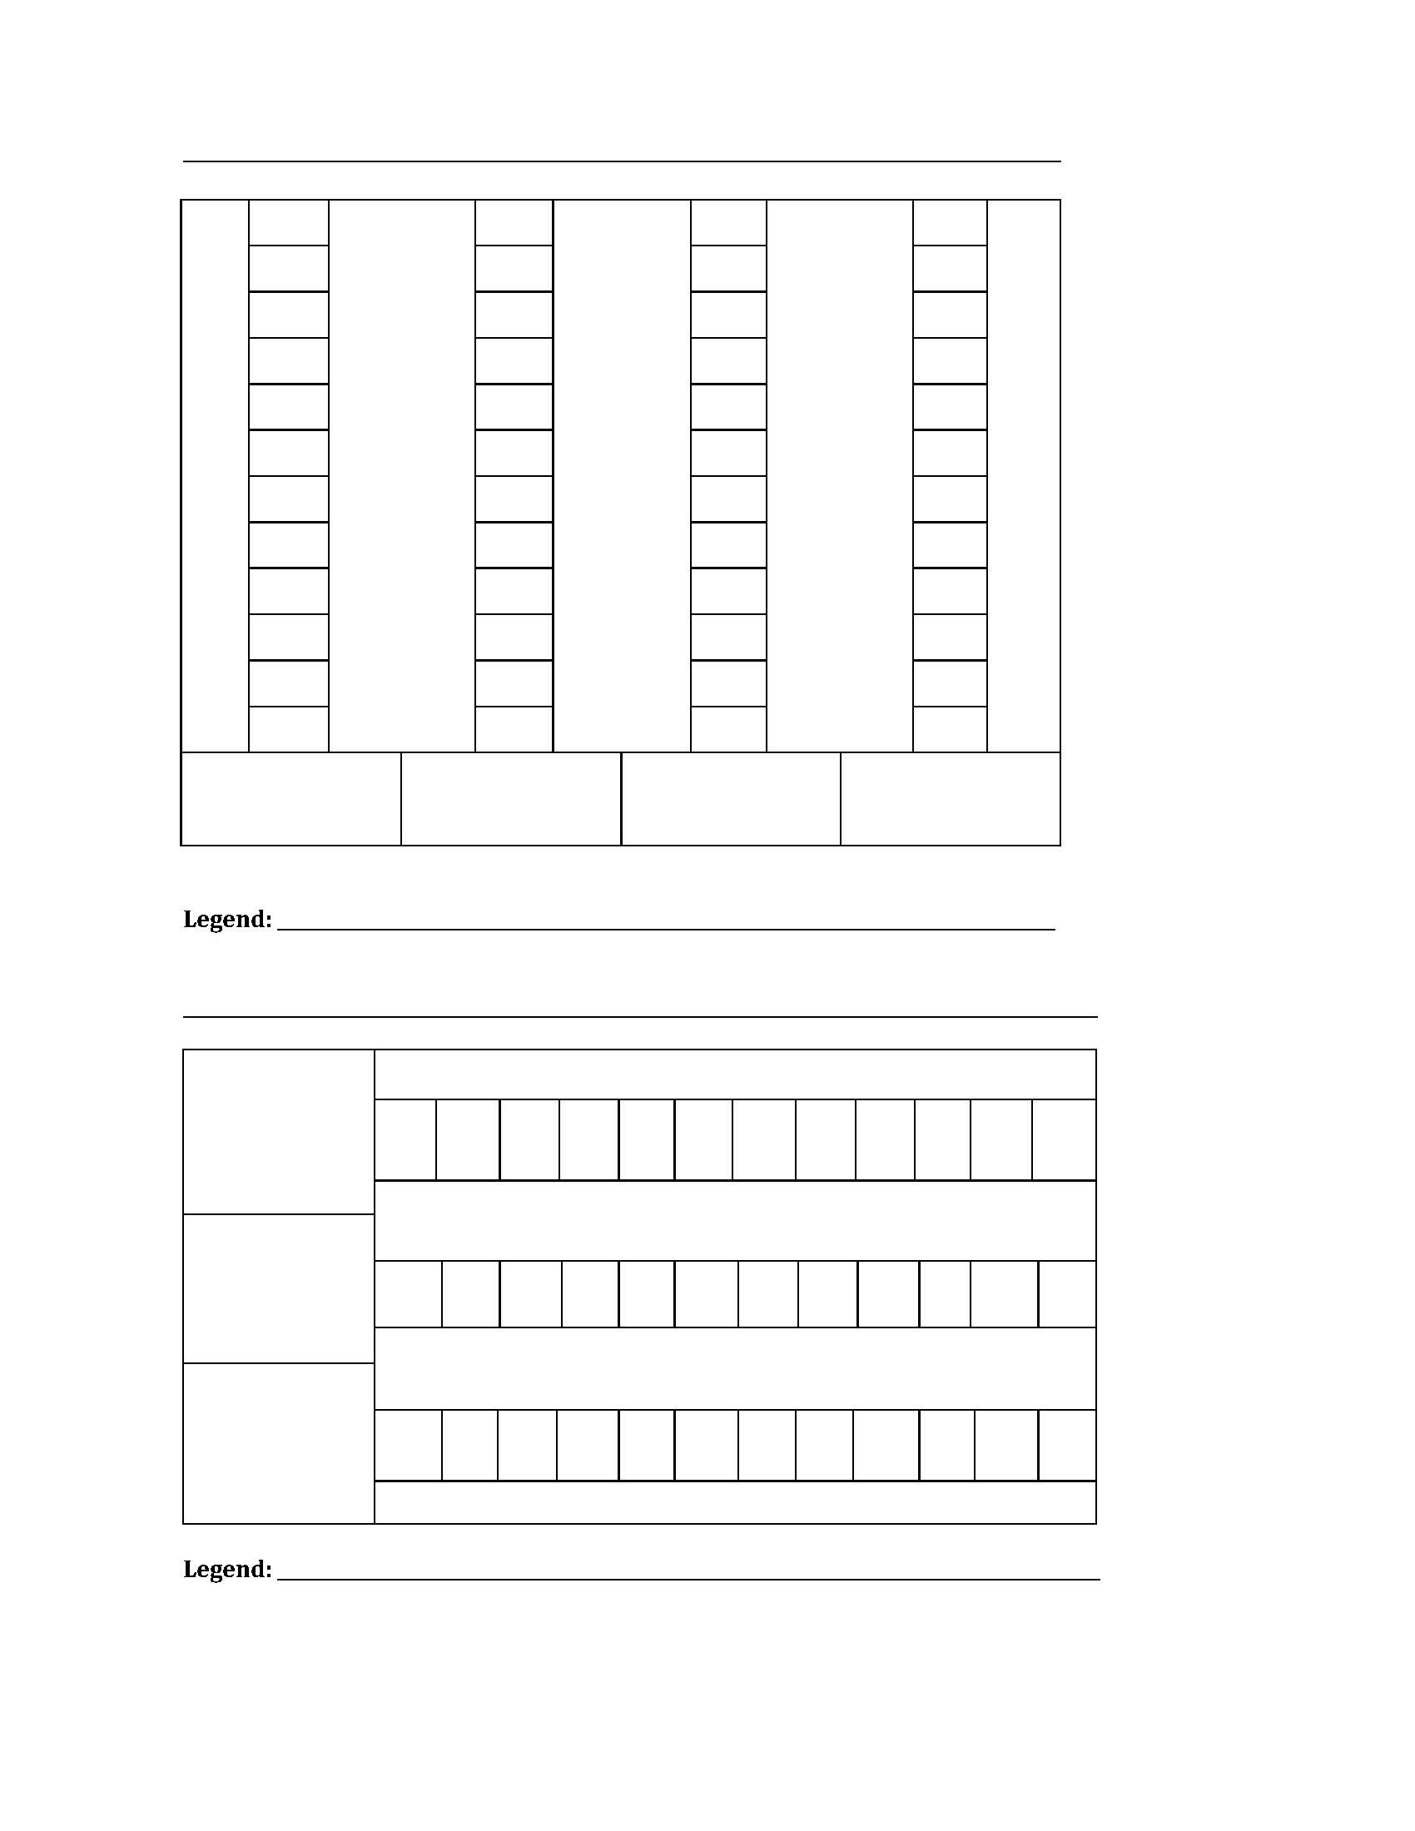

[1]



**[2]**

**Legend:**

1. vertical and horizontal picture graphs
2. vertical picture graph