Lesson 20
Objective: Use rectangular arrays to investigate odd and even numbers.

Suggested Lesson Structure
 Fluency Practice (9 minutes)
Concept Development (36 minutes)
 Application Problem (5 minutes)
 Student Debrief (10 minutes)
Total Time (60 minutes)
Fluency Practice (9 minutes)
- Skip-Counting by Twos 2.OA.3 (4 minutes)
- Grade 2 Core Fluency Practice Sets 2.OA.2 (5 minutes)
Skip-Counting by Twos (4 minutes)
Note: This fluency activity is foundational to understanding the relationship between skip-counting and multiplication and division in Grade 3.
T: On my signal, count by ones from 0 to 20 in a whisper. Ready? (Tap the desk while the students are counting the ones, and knock on the twos. For example, tap, knock, tap, knock, etc.)
T: Did anyone notice what I was doing while you were counting? I started tapping by ones, but I knocked on every other number. Let’s count again, and try knocking and tapping with me.
S: 1 (tap), 2 (knock), 3 (tap), 4 (knock), 5 (tap), 6 (knock), etc.
T: Now, let’s count only when we knock. Ready?
S: (Tap), 2 (knock), (tap), 4 (knock), (tap), 6 (knock), (tap), 8 (knock), etc.
Continue this routine up to 20 and back down again.
Grade 2 Core Fluency Practice Sets (5 minutes)
Materials: (S) Core Fluency Practice Sets (G2−M6−Lesson 12 Core Fluency Practice Sets)
Note: During Topic D and for the remainder of the year, each day’s fluency activities include an opportunity for review and mastery of the sums and differences with totals through 20 by means of the Core Fluency Practice Sets or Sprints. Practice Sets, along with details about the process, are provided in Lesson 12.

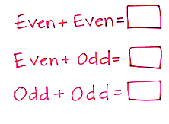
Concept Development (36 minutes)
Materials: (T) Premade Even and Odd poster (see image to the right) (S) 25 tiles, personal white board
Part 1: Even + even = even
T: Partner A, make 2 rows of 3 on your personal white board.
T: Partner B, make 2 rows of 4 on your personal white board.
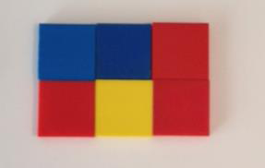
S: (Construct the arrays.)
T: How many tiles are on Partner A’s personal white board?
S: 6 tiles!
T: Is 6 even or odd?
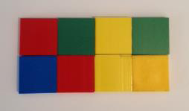
S: Even!
T: How many tiles are on Partner B’s personal white board?
S: 8 tiles!
T: Is 8 even or odd?
S: Even!
T: Now, let’s see what happens when we add two even numbers together. Partners, slide your personal white boards next to each other and combine the two arrays that you made.
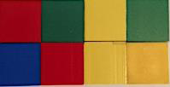
S: (Connect the tiles to show 2 rows of 7.)
T: How many tiles do you have altogether?
S: 14 tiles!
T: Is that even or odd?
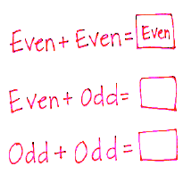
S: Even!
Repeat the above process with the following sequence:
2 rows of 5 + 2 rows of 3, and 2 rows of 4 + 2 rows of 8.
T: When we add an even number and an even number, do we get an even or an odd number?
S: Even number!
T: Let’s record that on our chart. An even number plus another even number makes an even number. (Record on the chart.)
Part 2: Even + odd = odd
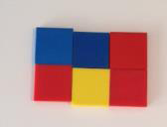
T: Now, let’s see what happens when we add an even and an odd!
T: Partner A, make an array with 2 rows of 3 on your board. Partner B, make 2 rows of 3, then add 1 tile on the top row on the right. (Pause and allow students time to complete the task.)
T: Is 6 even or odd?
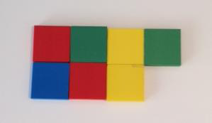
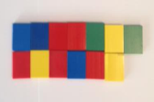
S: Even!
T: Is 7 even or odd?
S: Odd!
T: Now, slide your personal white boards together as you did before.
S: (Move boards to connect the tiles as pictured.)
T: How many tiles do you have altogether?
S: 13 tiles!
T: Is that even or odd?
S: Odd!
T: How do you know?
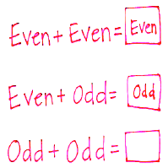
S: There is one extra. There are not 2 equal groups. You can’t count by twos to 13.
Repeat the above process using the following possible sequence:
- 2 rows of 5 + 2 rows of 2 (plus 1)
- 2 rows of 3 (plus 1) + 2 rows of 6
T: When we add an even and an odd, do we get an even or an odd?
S: Odd!
T: (Fill in the chart.)
Part 3: Odd + odd = even
T: (Record on the chart.)
T: Now, let’s see what happens when we add an odd number to another odd number!
T: Partner A, make 2 rows of 3 on your board. Then, add 1 tile to the top row on the right.
NOTES ON
MULTIPLE MEANS
OF REPRESENTATION:
At other times in the school day, you might relate the mathematical term even to the everyday term even by asking questions such as the following:
- What does it mean for kickball teams to be even?
- When you are playing cards with two people, why do we deal an even number?
- When we share our grapes with a friend, do we try to make our shares even? What does even mean then?

T: Partner B, make 2 rows of 4 on your board.
Then, add 1 tile to the bottom row on the left.
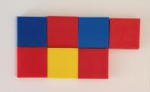
T: Is 7 even or odd?
S: Odd!
T: Is 9 even or odd?
S: Odd!
T: Partners, slide your boards together
to connect the arrays.
T: What do you have?
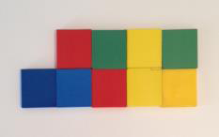
S: 2 rows of 8.
T: How many is that?
S: 16.
T: Is 16 even or odd?
S: Even!
Repeat the above process with the following possible sequence:
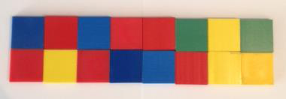
- 2 rows of 2 (plus 1) + 2 rows of 4 (plus 1)
- 2 rows of 3 (plus 1) + 2 rows of 5 (plus 1)
T: What do we get when we add an odd and an odd?
S: An even!
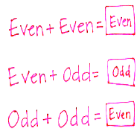
T: (Fill in the chart.)
Part 4: Extend the pattern to sums with totals within 50
T: What do we get when we add an even and an even?
S: An even!
T: What do we get when we add an even and an odd?
S: An odd!
T: Let’s see if this is still true when we are adding larger numbers.
NOTES ON
MULTIPLE MEANS
OF REPRESENTATION:
Provide an extension for students by encouraging them to build other arrays with odd numbers of tiles. Deepen their understanding that an even number can be broken into pairs or groups of 2, but that does not mean that odd numbers cannot be broken into equal groups (9 for example, can be constructed with 3 rows of 3).

T: On your board, write the problem 10 + 12 and your answer.
T: Is 10 even or odd?
S: Even!
T: Is 12 even or odd?
S: Even!
T: What is 10 + 12?
S: 22.
T: Turn and talk: Is 22 even or odd, and how do you know?
S: It is even because I can count by 2 to get to 22. 22 is even because the ones digit is a 2. It is even because 11 + 11 makes 22.
Repeat the above process for the following possible problems:
- 22 + 4, 22 + 3, 21 + 5
- 22 + 14, 22 + 13, 21 + 15
Problem Set (10 minutes)
Students should do their personal best to complete the Problem Set within the allotted 10 minutes. For some classes, it may be appropriate to modify the assignment by specifying which problems they work on first. Some problems do not specify a method for solving. Students should solve these problems using the RDW approach used for Application Problems.

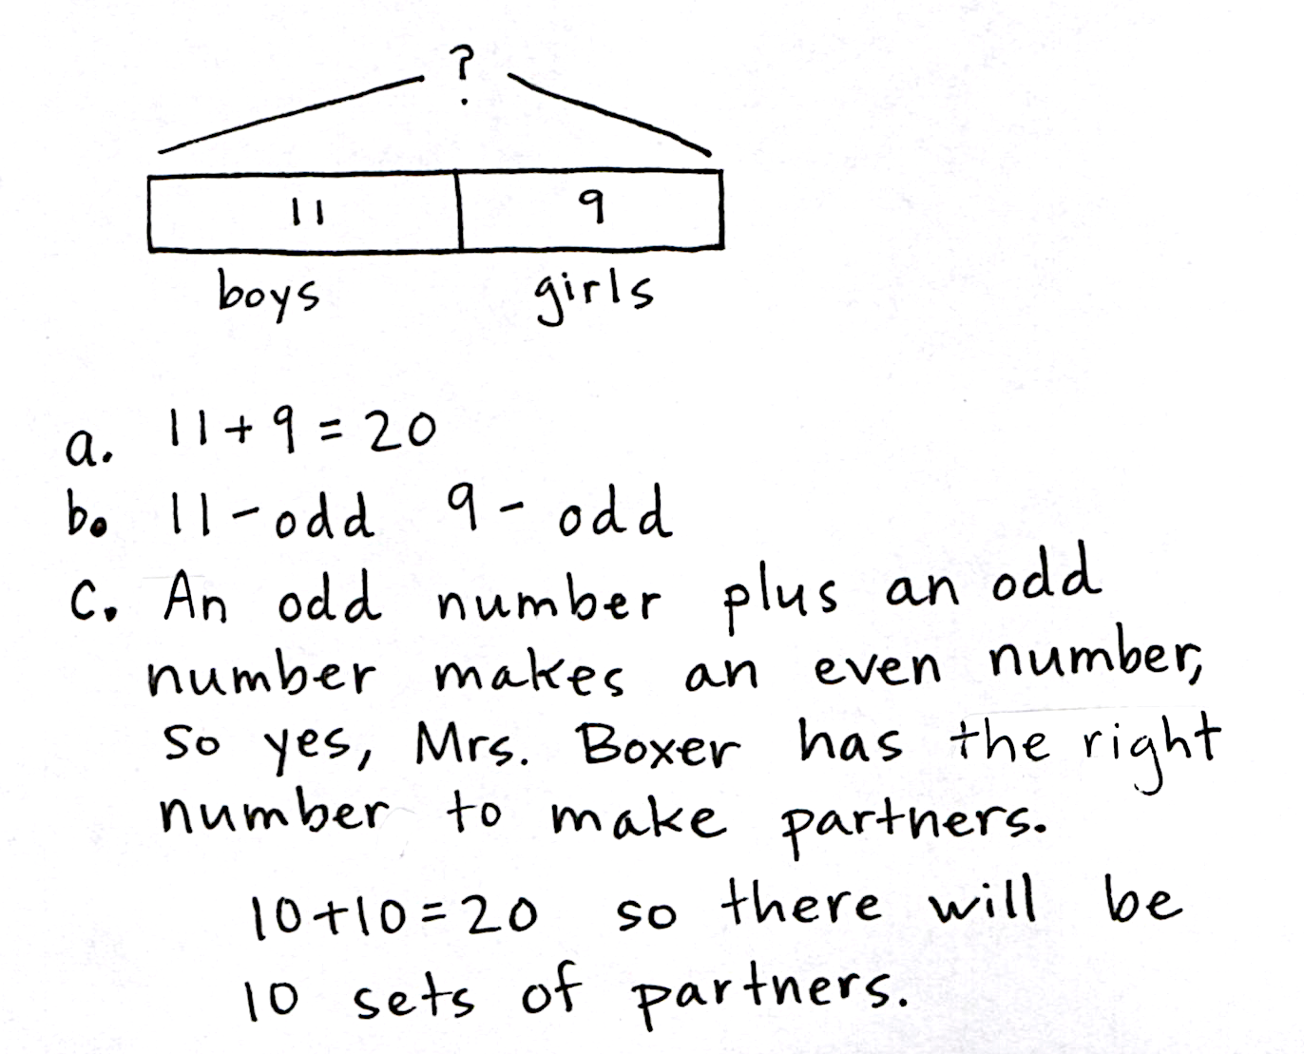
Application Problem (5 minutes)
Note: This Application Problem follows the Concept Development to provide an opportunity for students to apply their understanding from today’s lesson.
Mrs. Boxer has 11 boys and 9 girls at a Grade 2 party.
- Write the equation to show the total number of people.
- Are the addends even or odd?
- Mrs. Boxer wants to pair everyone up for a game. Does she have the right number of people for everyone to have a partner?
Student Debrief (10 minutes)
Lesson Objective: Use rectangular arrays to investigate odd and even numbers.
The Student Debrief is intended to invite reflection and active processing of the total lesson experience.
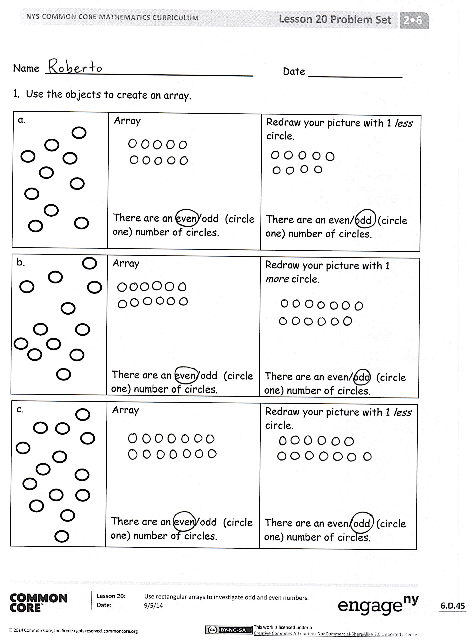
Invite students to review their solutions for the Problem Set. They should check work by comparing answers with a partner before going over answers as a class. Look for misconceptions or misunderstandings that can be addressed in the Debrief. Guide students in a conversation to debrief the Problem Set and process the lesson.
Any combination of the questions below may be used to lead the discussion.
- For Problem 1(a), what is the difference between your two drawings? Can you make an array with 2 rows or columns for an odd number of objects? Can you group the circles differently and still make an array?
- For Problem 1(b), must your array show 2 equal rows or columns for a number to be even? What about 4 rows of 3? Can you split that array into groups of 2?
- If you have rows of 3, is it true that the number must be odd? When will the number be even?
- What have you learned about the total when adding different combinations of even and odd addends? How does this connect to the 1 more/1 less circle on the first page of the Problem Set?
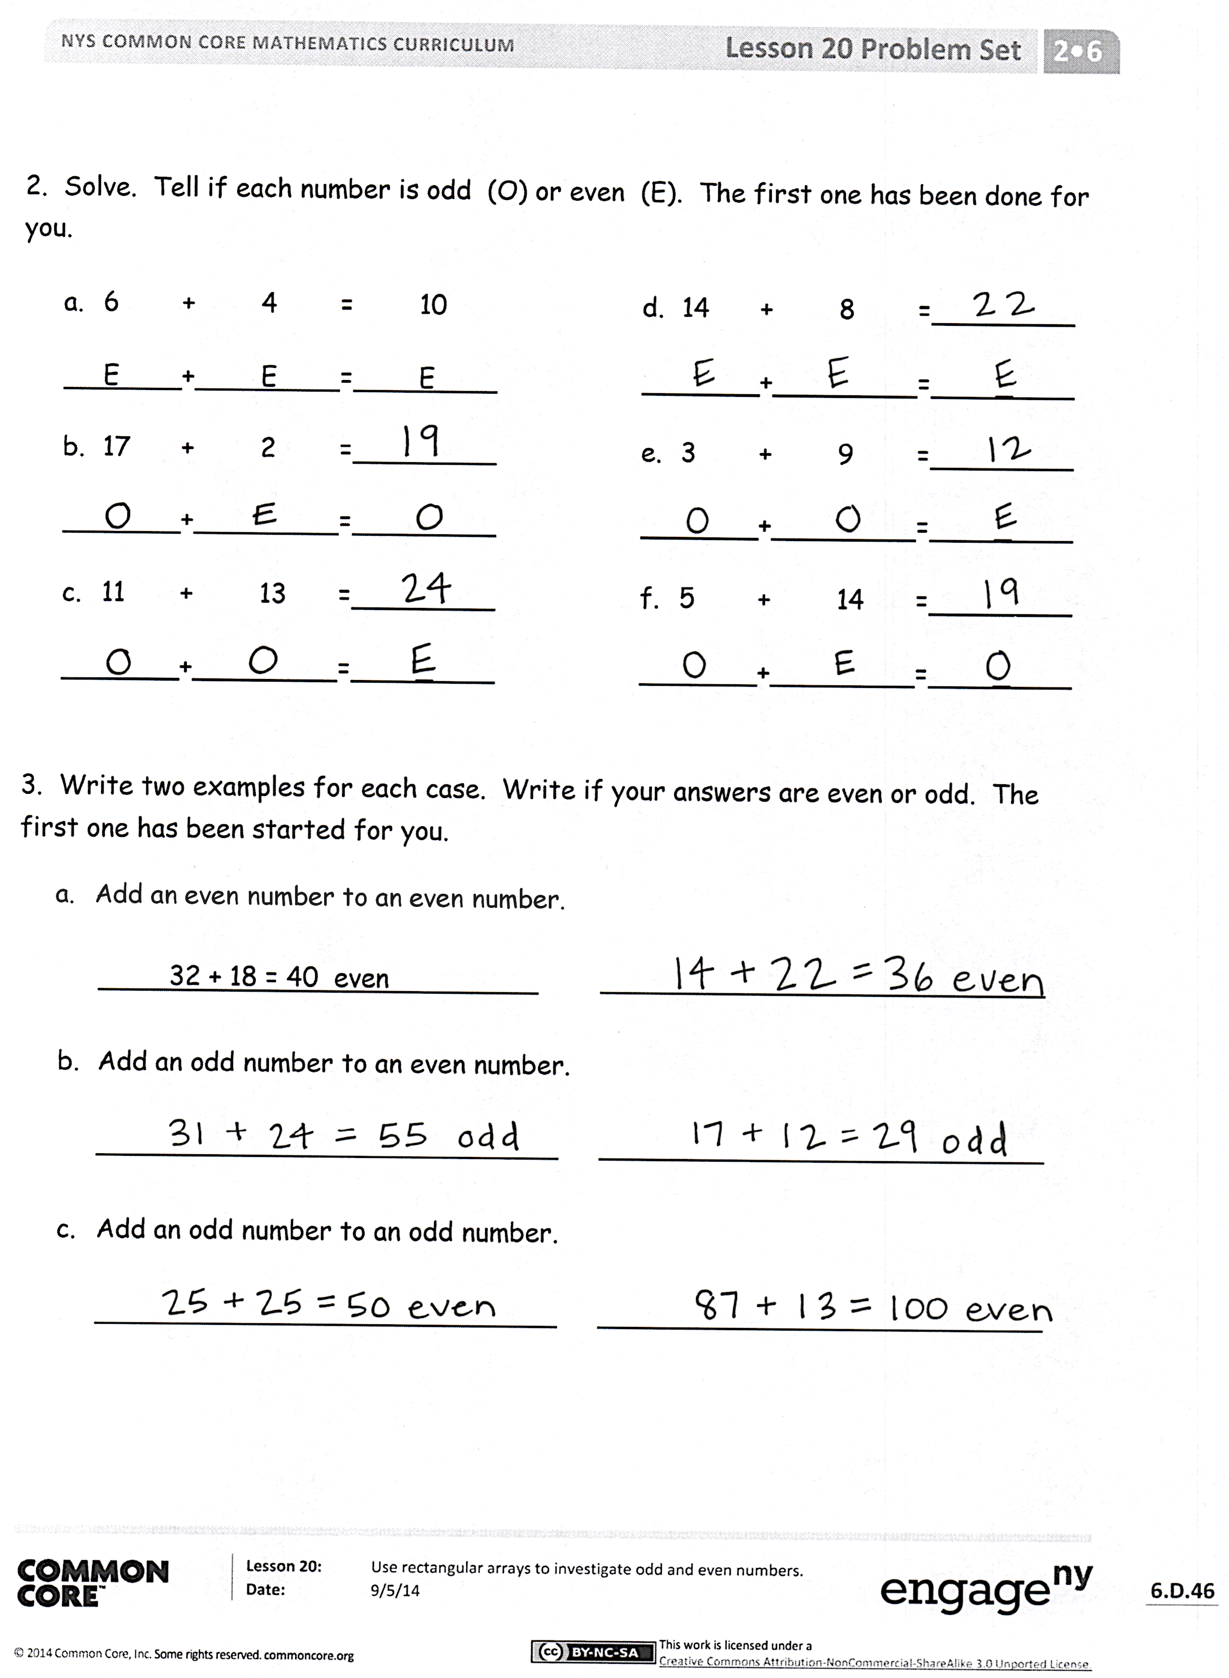
- Can you only build rectangular arrays for even numbers? (Think about 15.) How do you know?
Exit Ticket (3 minutes)
After the Student Debrief, instruct students to complete the Exit Ticket. A review of their work will help with assessing students’ understanding of the concepts that were presented in today’s lesson and planning more effectively for future lessons. The questions may be read aloud to the students.
Name Date
1. Use the objects to create an array.
a. | Array  There are an even/odd (circle one) number of circles. | Redraw your picture with 1 less circle.  There are an even/odd (circle one) number of circles.
b. | Array  There are an even/odd (circle one) number of circles. | Redraw your picture with 1 more circle.  There are an even/odd (circle one) number of circles.
c. | Array  There are an even/odd (circle one) number of circles. | Redraw your picture with 1 less circle.  There are an even/odd (circle one) number of circles.
2. Solve. Tell if each number is odd (O) or even (E). The first one has been done for
you.

a. 6 + 4 = 10
E + E = E
b. 17 + 2 =
+ =
c. 11 + 13 =
+ =
d. 14 + 8 =
+ =
e. 3 + 9 =
+ =
f. 5 + 14 =
+ =

3. Write two examples for each case. Write if your answers are even or odd. The
first one has been started for you.
- Add an even number to an even number.

32 + 18 = 40 even ___________________________
- Add an odd number to an even number.

____________________________ ___________________________
- Add an odd number to an odd number.

____________________________ ___________________________

Name Date
Use the objects to create an array.
 | Array  There are an even/odd (circle one) number of circles. | Redraw your picture with 1 less circle.  There are an even/odd (circle one) number of circles.

Name Date
1. Use the objects to create an array with 2 rows.
a. | Array with 2 rows  There are an even/odd (circle one) number of stars. | Redraw your picture with 1 less star.  There are an even/odd (circle one) number of stars.
b. | Array with 2 rows  There are an even/odd (circle one) number of stars. | Redraw your picture with 1 more star.  There are an even/odd (circle one) number of stars.
c. | Array with 2 rows  There are an even/odd (circle one) number of stars. | Redraw your picture with 1 less star.  There are an even/odd (circle one) number of stars.

2. Solve. Tell if each number is odd (O) or even (E) on the line below.

a. 6 + 6 = _______
_____ + ______ = ______
b. 8 + 13 = _______
_____ + ______ = ______
c. 9 + 15 = _______
_____ + ______ = ______
d. 17 + 8 = _______
_____ + ______ = _____
e. 7 + 8 = _______
______ + ______ = ______
f. 9 + 11 = _______
______ + ______ = ______
g. 7 + 14 = _______
______ + ______ = ______
h. 9 + 9 = _______
______ + ______ = ______

3. Write three number sentence examples to prove that each statement is correct.
Even + Even = Even | Even + Odd = Odd | Odd + Odd = Even

4. Write two examples for each case; next to your answer, write if your answers are
even or odd. The first one has been done for you.
Add an even number to an even number.
32 + 18 = 40 even
Add an odd number to an even number.

Add an odd number to an odd number.

