Lesson 19
Objective: Investigate the pattern of even numbers: 0, 2, 4, 6, and 8 in the ones place, and relate to odd numbers.

Suggested Lesson Structure
 Fluency Practice (14 minutes)
 Concept Development (31 minutes)
 Application Problem (5 minutes)
 Student Debrief (10 minutes)
Total Time (60 minutes)
Fluency Practice (14 minutes)
- Making the Next Ten to Add 2.OA.2, 2.NBT.5 (5 minutes)
- Sprint: Sums to the Teens 2.OA.2 (9 minutes)
Making the Next Ten to Add (5 minutes)
Note: Students practice this mental strategy to gain mastery of sums within 20 and to relate the strategy to larger numbers.
T: When I say 9 + 4, you say 10 + 3. Ready? 9 + 4.
S: 10 + 3.
T: Answer.
S: 13.
Continue with the following possible sequences:
9 + 6, 9 + 16, 19 + 16 8 + 7, 8 + 17, 18 + 17 7 + 6, 7 + 16, 17 + 16
9 + 8, 9 + 18, 19 + 18 8 + 5, 8 + 15, 18 + 15 7 + 4, 17 + 4, 17 + 14
Sprint: Sums to the Teens (9 minutes)
Materials: (S) Sums to the Teens Sprint
Note: Students practice crossing the ten when adding to gain mastery of sums within 20.

Concept Development (31 minutes)

NOTES ON
MULTIPLE MEANS
OF ENGAGEMENT:
Make a body and science connection by inviting students to observe structures in the human body that appear in twos: two eyes, two ears, two hands, etc. Demonstrate that even parts that appear to be singular have two halves, like the two sides of the nose and mouth.

Materials: (S) 20 tiles
T: (Write numbers to 20 in a straight line across the board.) Make a column of 2 tiles.
T: How many rows do you have?
S: 2 rows!
T: How many tiles do you have in each row?
S: 1 tile.
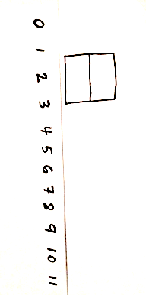
T: Say the doubles equation by adding the number in each row.
S: 1 + 1 = 2.
T: (Draw the array on the board above a number path as shown at right.)
T: Is 2 an even number?
S: Yes!
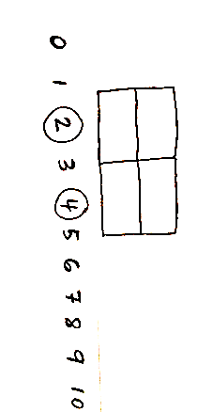
T: As we make our arrays, let’s keep track of all the even numbers we find by circling them. (Circle 2.)
T: Add another column of 2. Now, how many columns of 2 do you have?
S: 2 columns!
T: How many rows do you have?
S: 2 rows!
T: Say the doubles equation.
S: 2 + 2 = 4.
T: Turn and talk: Is 4 an even number?
S: Yes, because none are sticking out. Four is even because I can count 2, 4.
T: Let’s circle 4 because it’s an even number. (Circle 4.)
T: Add another column of 2.
S: (Add tiles to array, as teacher does the same on the board.)
T: How many columns of 2 do you have now?
S: 3 columns of 2.
Briskly continue the above sequence until all even numbers up to 20 are circled.
T: Turn and talk: What do you notice about the numbers we circled? Do you see a pattern?

NOTES ON
MULTIPLE MEANS
OF ACTION AND EXPRESSION:
For students who already understand even and odd numbers and are eager to move on, have them color a number path up to 100 with different colors for even and odd numbers.
For an even greater challenge, have them then color every 5 squares with a different color, and ask them to notice what the new blended color is when the multiple of 5 is odd and when it is even.

S: They are all even. It starts at 2 and keeps going 2, 4, 6, 8, 0 in the ones place. It is every other number that is circled.
T: It is true that all even numbers have 0, 2, 4, 6, or 8 in the ones place. This is one way we can identify even numbers. What do you notice about the numbers that are not circled?
MP.8
S: They are not even. It is every other number that is not circled. They are one more and one less than the even.
T: All the numbers that are not circled are called odd numbers.
T: Take 1 tile away from your array of 20. How many tiles do you have left?
S: 19 tiles!
T: Is 19 an even number?
S: No!
T: Why not?
S: You can’t make pairs. There is one sticking out. It has no partner. Because it’s not 10 + 10 anymore since we took 1 away. The number sentence would be 10 + 9 since there are 10 on the bottom and 9 on the top. It’s not an array with 2 rows or columns of 2.
T: That means that 19 is odd. Let’s underline the odd numbers as we take away 1 from each even number. (Underline 19.)
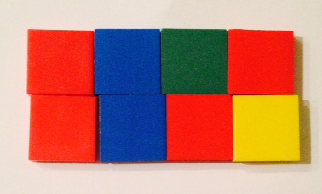
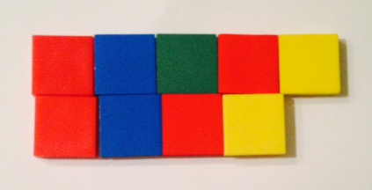
T: Take away another tile. How many tiles do you have now?
S: 18.
T: We know 18 is even. Take away a tile. How many tiles do you have now?
S: 17.
T: Turn and talk: Is 17 even or odd?
S: One tile doesn’t have a partner. 17 is odd because there is no doubles sentence. 8 + 9 is 17, so that’s odd. I can’t count by twos to 17, so it’s not even.
T: 17 is odd, so let’s underline it. (Underline 17.)
Briskly continue taking away 1 tile from each even number and underlining the odd numbers down to 1.
T: What happened when we had an even number of tiles and we took 1 away?
S: The number left over was an odd number. An even number take away 1 is odd.

NOTES ON
MULTIPLE MEANS
OF ENGAGEMENT:
Provide an extension for students by encouraging them to build other arrays with odd numbers of tiles. Deepen understanding that an even number can be broken into pairs or groups of 2, but that does not mean that odd numbers cannot be broken into equal groups. For example, 9 can be constructed with 3 rows of 3.
T: Turn and talk: What will happen when we add 1 to an even number?
S: It’s going to make one extra stick out. You won’t have a double, but a double plus 1 more. Adding 1 to an even will be odd because 8 + 1 = 9, and that is odd. Adding 1 on is just like taking 1 away. It will make an odd. I can see on the number path you can add 1 to an even to make an odd or take one away.
T: Test what we just noticed. Take two minutes to use your tiles with your partner. Partner A, build an even number. Partner B, add one and then take away one from the array of the even number. See if you get an odd number. Then, switch. Partner B, make an even number.
S: (Work.)
T: What happens when we add 1 to an even number?
S: We make an odd!
T: What happens when we take 1 away from an even number?
S: We make an odd!
T: Let’s practice using what we know on some bigger numbers.
T: (Write 40 on the board.)
T: Turn and talk: Is 40 even or odd?
S: 40 is even because it ends in 0. 40 is even because I can count by twos up to 40. I know that 40 is even because 20 + 20 = 40.
T: Is 41 even or odd?
S: 41 must be odd, because it’s an even plus 1. 41 is odd because it doesn’t end in 0, 2, 4, 6, or 8.
Continue the above process starting with numbers within 50 that are easier for students to verify with concrete materials, doubles, or counting by twos, such as 26, 30, 44, and 50.
Problem Set (10 minutes)
Students should do their personal best to complete the Problem Set within the allotted 10 minutes. For some classes, it may be appropriate to modify the assignment by specifying which problems they work on first. Some problems do not specify a method for solving. Students should solve these problems using the RDW approach used for Application Problems.
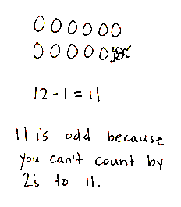
Application Problem (5 minutes)
Eggs come in cartons of 12. Joanna’s mom used 1 egg. Use pictures, numbers, or words to explain whether the amount left is even or odd.
Note: This problem is intended for independent practice and bridges the concepts of Lessons 18 and 19. It also mirrors Lesson 18’s Application Problem. Allow students to share their reasoning.
Student Debrief (10 minutes)
Lesson Objective: Investigate the pattern of even numbers: 0, 2, 4, 6, and 8 in the ones place, and relate to odd numbers.
The Student Debrief is intended to invite reflection and active processing of the total lesson experience.
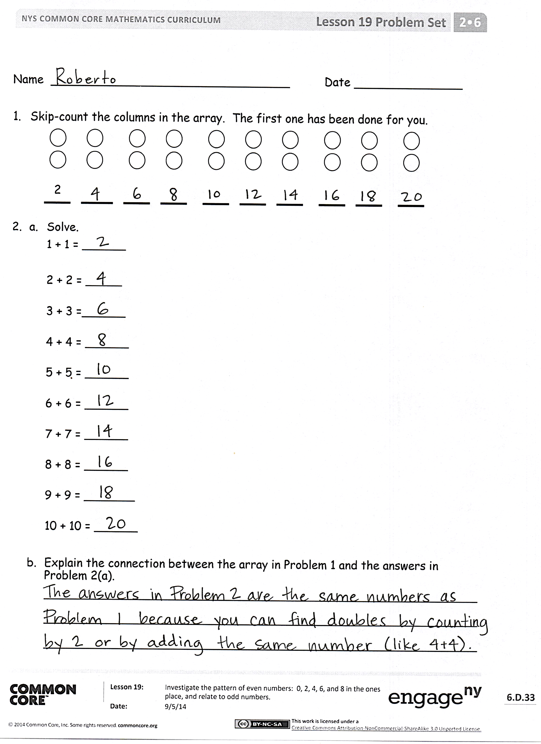
Invite students to review their solutions for the Problem Set. They should check work by comparing answers with a partner before going over answers as a class. Look for misconceptions or misunderstandings that can be addressed in the Debrief. Guide students in a conversation to debrief the Problem Set and process the lesson.
Any combination of the questions below may be used to lead the discussion.
- Now that you’ve completed Problem 1, describe another array in terms of rows and columns in which you can skip-count by twos (i.e., 2 rows of ___ or ___ columns of 2).
- In Problems 3 (a) and (b), what do you notice about all the even numbers? All the odd numbers? Can you find a similarity between these two patterns?
- For Problem 4, what happens to an even number when you add or subtract 1? What number(s) do you need to add or subtract to make another even number?
- In Problem 5(c), Sami argues that 45 is even because it starts with 4, and numbers that have 0, 2, 4, 6, or 8 are even. Is she correct? How do you know?

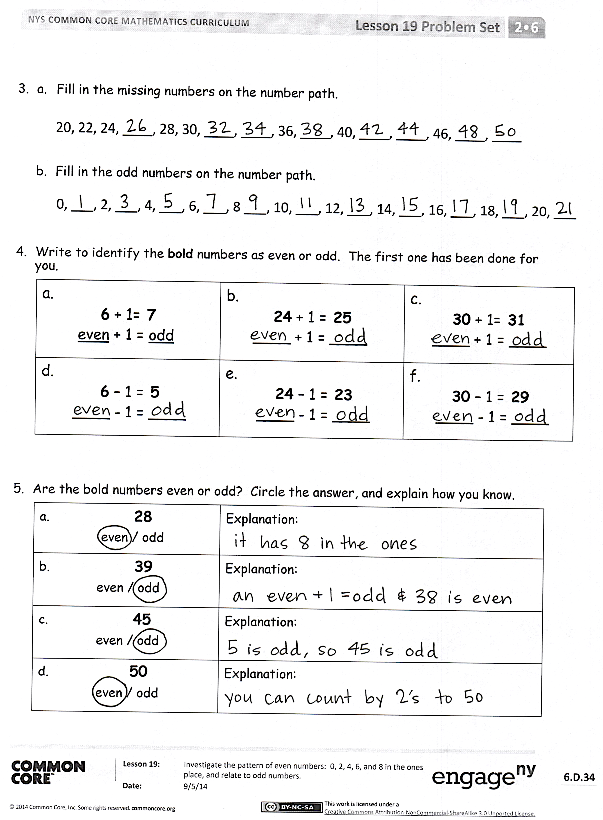
Exit Ticket (3 minutes)
After the Student Debrief, instruct students to complete the Exit Ticket. A review of their work will help with assessing students’ understanding of the concepts that were presented in today’s lesson and planning more effectively for future lessons. The questions may be read aloud to the students.
Number Correct: _______
A
Sums to Teens
 | 9 + 2 = |  |  |  | 4 + 7 =
 | 9 + 3 = |  |  |  | 4 + 8 =
 | 9 + 4 = |  |  |  | 5 + 6 =
 | 9 + 7 = |  |  |  | 5 + 7 =
 | 7 + 9 = |  |  |  | 3 + 8 =
 | 10 + 1 = |  |  |  | 3 + 9 =
 | 10 + 2 = |  |  |  | 2 + 9 =
 | 10 + 3 = |  |  |  | 5 + 10 =
 | 10 + 8 = |  |  |  | 5 + 8 =
 | 8 + 10 = |  |  |  | 9 + 6 =
 | 8 + 3 = |  |  |  | 6 + 9 =
 | 8 + 4 = |  |  |  | 7 + 6 =
 | 8 + 5 = |  |  |  | 6 + 7 =
 | 8 + 9 = |  |  |  | 8 + 6 =
 | 9 + 8 = |  |  |  | 6 + 8 =
 | 7 + 4 = |  |  |  | 8 + 7 =
 | 10 + 5 = |  |  |  | 7 + 8 =
 | 6 + 5 = |  |  |  | 6 + 6 =
 | 7 + 5 = |  |  |  | 7 + 7 =
 | 9 + 5 = |  |  |  | 8 + 8 =
 | 5 + 9 = |  |  |  | 9 + 9 =
 | 10 + 6 = |  |  |  | 4 + 9 =
Number Correct: _______
Improvement: _______
B
[KEY]

Sums to Teens
 | 10 + 1 = |  |  |  | 5 + 6 =
 | 10 + 2 = |  |  |  | 5 + 7 =
 | 10 + 3 = |  |  |  | 4 + 7 =
 | 10 + 9 = |  |  |  | 4 + 8 =
 | 9 + 10 = |  |  |  | 4 + 10 =
 | 9 + 2 = |  |  |  | 3 + 8 =
 | 9 + 3 = |  |  |  | 3 + 9 =
 | 9 + 4 = |  |  |  | 2 + 9 =
 | 9 + 8 = |  |  |  | 5 + 8 =
 | 8 + 9 = |  |  |  | 7 + 6 =
 | 8 + 3 = |  |  |  | 6 + 7 =
 | 8 + 4 = |  |  |  | 8 + 6 =
 | 8 + 5 = |  |  |  | 6 + 8 =
 | 8 + 7 = |  |  |  | 9 + 6 =
 | 7 + 8 = |  |  |  | 6 + 9 =
 | 7 + 4 = |  |  |  | 9 + 7 =
 | 10 + 4 = |  |  |  | 7 + 9 =
 | 6 + 5 = |  |  |  | 6 + 6 =
 | 7 + 5 = |  |  |  | 7 + 7 =
 | 9 + 5 = |  |  |  | 8 + 8 =
 | 5 + 9 = |  |  |  | 9 + 9 =
 | 10 + 8 = |  |  |  | 4 + 9 =

Name Date
- Skip-count the columns in the array. The first one has been done for you.

2

- a. Solve.
1 + 1 = ______

2 + 2 = _____
3 + 3 =______
4 + 4 = ______
5 + 5 = ______
6 + 6 = ______
7 + 7 = ______
8 + 8 = ______
9 + 9 = _______
10 + 10 = ______

- Explain the connection between the array in Problem 1 and the answers in Problem 2(a).
____________________________________________________________
____________________________________________________________
____________________________________________________________
- a. Fill in the missing numbers on the number path.
20, 22, 24, ____, 28, 30, ____, ____, 36, ____, 40, ____, ____, 46, ____, ____

  - Fill in the odd numbers on the number path.
0, ___, 2, ___, 4, ___, 6, ___, 8 ___, 10, ___, 12, ___, 14, ___, 16, ___, 18, ___, 20, ___

- Write to identify the bold numbers as even or odd. The first one has been done for you.
a.  6 + 1 = 7  even + 1 = odd | b.  24 + 1 = 25  ____ + 1 = ____ | c.  30 + 1= 31  ____ + 1 = ____
d.  6 – 1 = 5  ____ - 1 = ____ | e.  24 – 1 = 23  ____ - 1 = ____ | f.  30 – 1 = 29  ____ - 1 = ____

- Are the bold numbers even or odd? Circle the answer, and explain how you know.
a. 28  even/odd | Explanation:
b. 39  even/odd | Explanation:
c. 45  even/odd | Explanation:
d. 50  even/odd | Explanation:

Name Date
- Are the bold numbers even or odd? Circle the answer, and explain how you know.
a.  18  even/odd | Explanation:
b.  23  even/odd | Explanation:

Name Date
- Skip-count the columns in the array. The first one has been done for you.

2

- a. Solve.
1 + 1 = _____ 6 + 6 = _____
2 + 2 = _____ 7 + 7 = _____
3 + 3 = _____ 8 + 8 = _____
4 + 4 = _____ 9 + 9 = _____
5 + 5 = _____ 10 + 10 = _____

  - How is the array in Problem 1 related to the answers in Problem 2(a)?
____________________________________________________________
____________________________________________________________
____________________________________________________________

- Fill in the missing even numbers on the number path.

18, 20, _____, _____, 26, _____ 30, _____, 34, _____, 38, 40, _____, _____

- Fill in the missing odd numbers on the number path.

0, _____, 2, _____, 4, _____, 6, _____, 8, _____, 10, _____, 12, _____, 14

- Write to identify the bold numbers as even or odd. The first one has been done for you.
a.  4 + 1 = 5  even + 1 = odd | b.  13 + 1 = 14  _____ + 1 = _____ | c.  20 + 1= 21  _____ + 1 = _____
d.  8 – 1 = 7  _____ - 1 = _____ | e.  16 – 1 = 15  _____ - 1 = _____ | f.  30 – 1 = 29  _____- 1 = _____

- Are the bold numbers even or odd? Circle the answer, and explain how you know.
a.  21  even/odd | Explanation:
b.  34  even/odd | Explanation:

