Lesson 18
Objective: Pair objects and skip-count to relate to even numbers.

Suggested Lesson Structure
 Fluency Practice (12 minutes)
 Application Problem (5 minutes)
 Concept Development (33 minutes)
 Student Debrief (10 minutes)
Total Time (60 minutes)
Fluency Practice (12 minutes)
- Skip-Counting by Twos 2.OA.3 (4 minutes)
- Sprint: Subtraction from Teens 2.OA.2 (8 minutes)
Skip-Counting by Twos (4 minutes)
Note: This fluency activity is foundational to understanding the relationship between skip-counting and multiplication and division in Grade 3.
T: On my signal, count by ones from 0 to 20 in a whisper. Ready? (Tap the desk while the students are counting; knock on the twos. For example, tap, knock, tap, knock, etc.)
T: Did anyone notice what I was doing while you were counting? I started out tapping by ones, but I knocked on every other number. Let’s count again, and try knocking and tapping with me.
S: 1 (tap), 2 (knock), 3 (tap), 4 (knock), 5 (tap), 6 (knock), etc.
T: Now, let’s count only when we knock. Ready?
S: (Tap), 2 (knock), (tap), 4 (knock), (tap), 6 (knock), (tap), 8 (knock), etc.
Continue this routine up to 20 and back down again.
Sprint: Subtraction from Teens (8 minutes)
Materials: (S) Subtraction from Teens Sprint
Note: Students practice subtraction from teens in order to gain mastery of the sums and differences within 20.

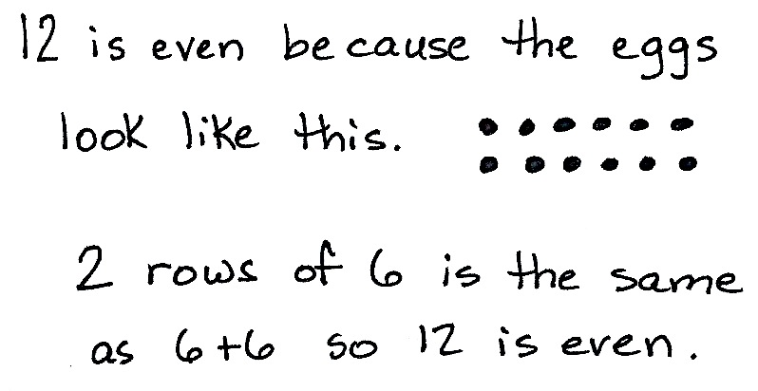
Application Problem (5 minutes)
Eggs come in cartons of 12. Use pictures, numbers, or words to explain whether 12 is even or not even.
Note: This problem is intended for independent practice and bridges the concepts of Lessons 17 and 18. Egg cartons present a familiar real-life connection to solidify the idea of even. Allow students to share their reasoning.
Concept Development (33 minutes)
Materials: (S) Personal white board, 20 counters (per pair)
T: Let’s keep exploring even numbers. (Call two students to the front of the class.)
T: Line up side by side like you’re going to lunch.
S: (Pair up.)

NOTES ON
MULTIPLE MEANS
OF ENGAGEMENT:
Challenge students who grasp the concept of even numbers quickly to extend the pattern. Can they prove whether 52 is even? How about 73?
T: (Address the whole class.) Tell your partner whether 2 is even or not even.
S: It’s even because we can say 2, 4, 6, 8, like we did yesterday. It’s even because we can say 1 + 1, so it’s a double. They each have a partner, so they’re even.
T: Interesting! You say they both have a partner. (Call another student up to continue the lineup.)
T: So what do you think? Is 3 an even number?
S: It’s not even because Samuel doesn’t have a partner. It’s not even because we don’t say 3 when we count by twos. It’s not even because 1 + 2 isn’t a double.
T: Excellent thinking! Let’s experiment with counters to see what else we can discover about even numbers.
T: Partner A, place 7 counters between you and your partner. Working together, pair up your counters to decide if 7 is even or not even.
Circulate as students work. Some may arrange the counters in arrays, while others may have them scattered in groups of two. Either is fine, so long as they are pairing the counters.
T: What did you decide?
S: 7 is not even because there’s a counter left over. 7 is not even because we don’t say 7 when counting by twos. You can’t make a doubles sentence for 7.
T: Move your counters into array form. What addition sentence, or equation, matches what you see?
S: 3 + 4 = 7.
T: That’s not a doubles fact, is it?
S: No!
T: Partner A, keep those 7 counters. Partner B, get 7 more counters. Pair your counters to decide if you’ll get an even number. (Pause.)
T: What did you find?

NOTES ON
MULTIPLE MEANS
OF ACTION AND EXPRESSION:
To make the content accessible for English language learners, model student and teacher explanations using counters, and encourage them to express their understanding by modeling. Also, pair them with students who have strong English skills, and encourage them to repeat what their partners say during pair-sharing.

S: It’s 14, and that’s even because every counter had a partner. We made 2 rows of 7. We can say
7 + 7 = 14, and if it’s doubles, it’s even. There are 7 columns of 2, so we can skip-count, 2, 4, 6, 8, 10, 12, 14.
T: So, even if one of the addends isn’t even, when we double it, we get an even number. True?
S: True!
T: Now, let’s see how many even numbers you can find! Working with your partner, continue to pair counters to see what numbers are even. Write the addition sentence for any even number on your board.
Allow enough time for students to make all of the pairings up to 20. Circulate and support any students who need it.
T: Now that you’ve had a chance to work with the counters, make an array out of all 20. (Pause to allow students time to do so.)
MP.8
T: Let’s count by twos up and back. Ready?
T: But wait! Should we start at 2 or 0? What do you think? Is 0 even? Talk about that with your partner.
S: It can’t be even because there’s nothing there.
T: Thumbs up if you agree. (If any students disagree, allow them the chance to explain their thinking.)
S: We start at 0 when we skip-count during Fluency Practice, so it’s part of counting by twos. I see a pattern in the ones place. There are 2 ones in 2, and there are 2 ones in 12. There are 4 ones in 4 and 4 ones in 14, and it keeps going like that. And, there are 0 ones in 10, and there are 0 ones in 20, so 0 is even.
T: You make very good arguments. And I have one more! What is 0 + 0?
S: 0.
T: Yes! Just like 1 + 1 = 2, 2 is a doubles fact. 0 is another doubles fact because you get 0 when you add 0 + 0.
T: So, that means 0 is an even number! When you double whole numbers, like 0, 1, 2, 3, 4, the answer is an even number.
Have students count by twos up to 20 and back down, starting at 0.
T: So, we only get a doubles fact when all of the objects have a partner. If any objects are left over without a partner, it can’t be even. True?
S: True.
When they are able to demonstrate fluency, allow students to move on to the Problem Set. Continue working with students who need extra support.
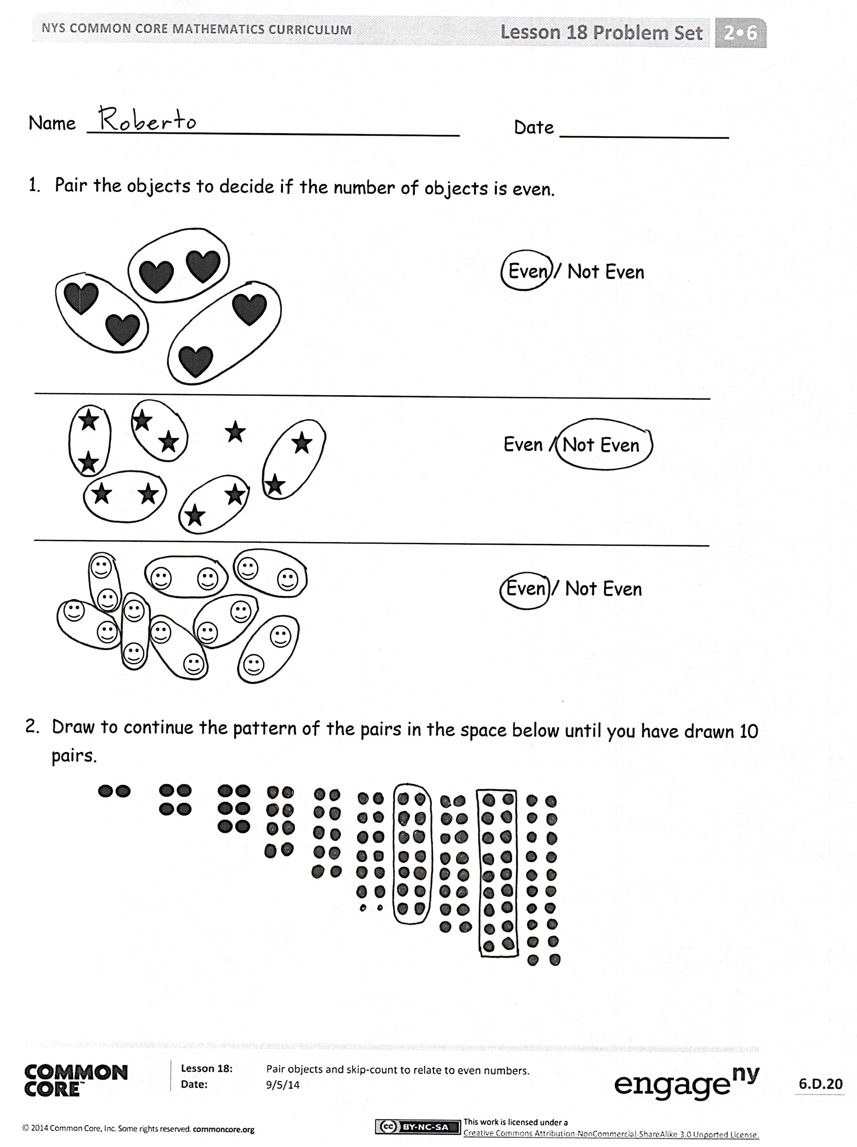
Problem Set (10 minutes)
Students should do their personal best to complete the Problem Set within the allotted 10 minutes. For some classes, it may be appropriate to modify the assignment by specifying which problems they work on first. Some problems do not specify a method for solving. Students should solve these problems using the RDW approach used for Application Problems.
Student Debrief (10 minutes)
Lesson Objective: Pair objects and skip-count to relate even numbers.
The Student Debrief is intended to invite reflection and active processing of the total lesson experience.
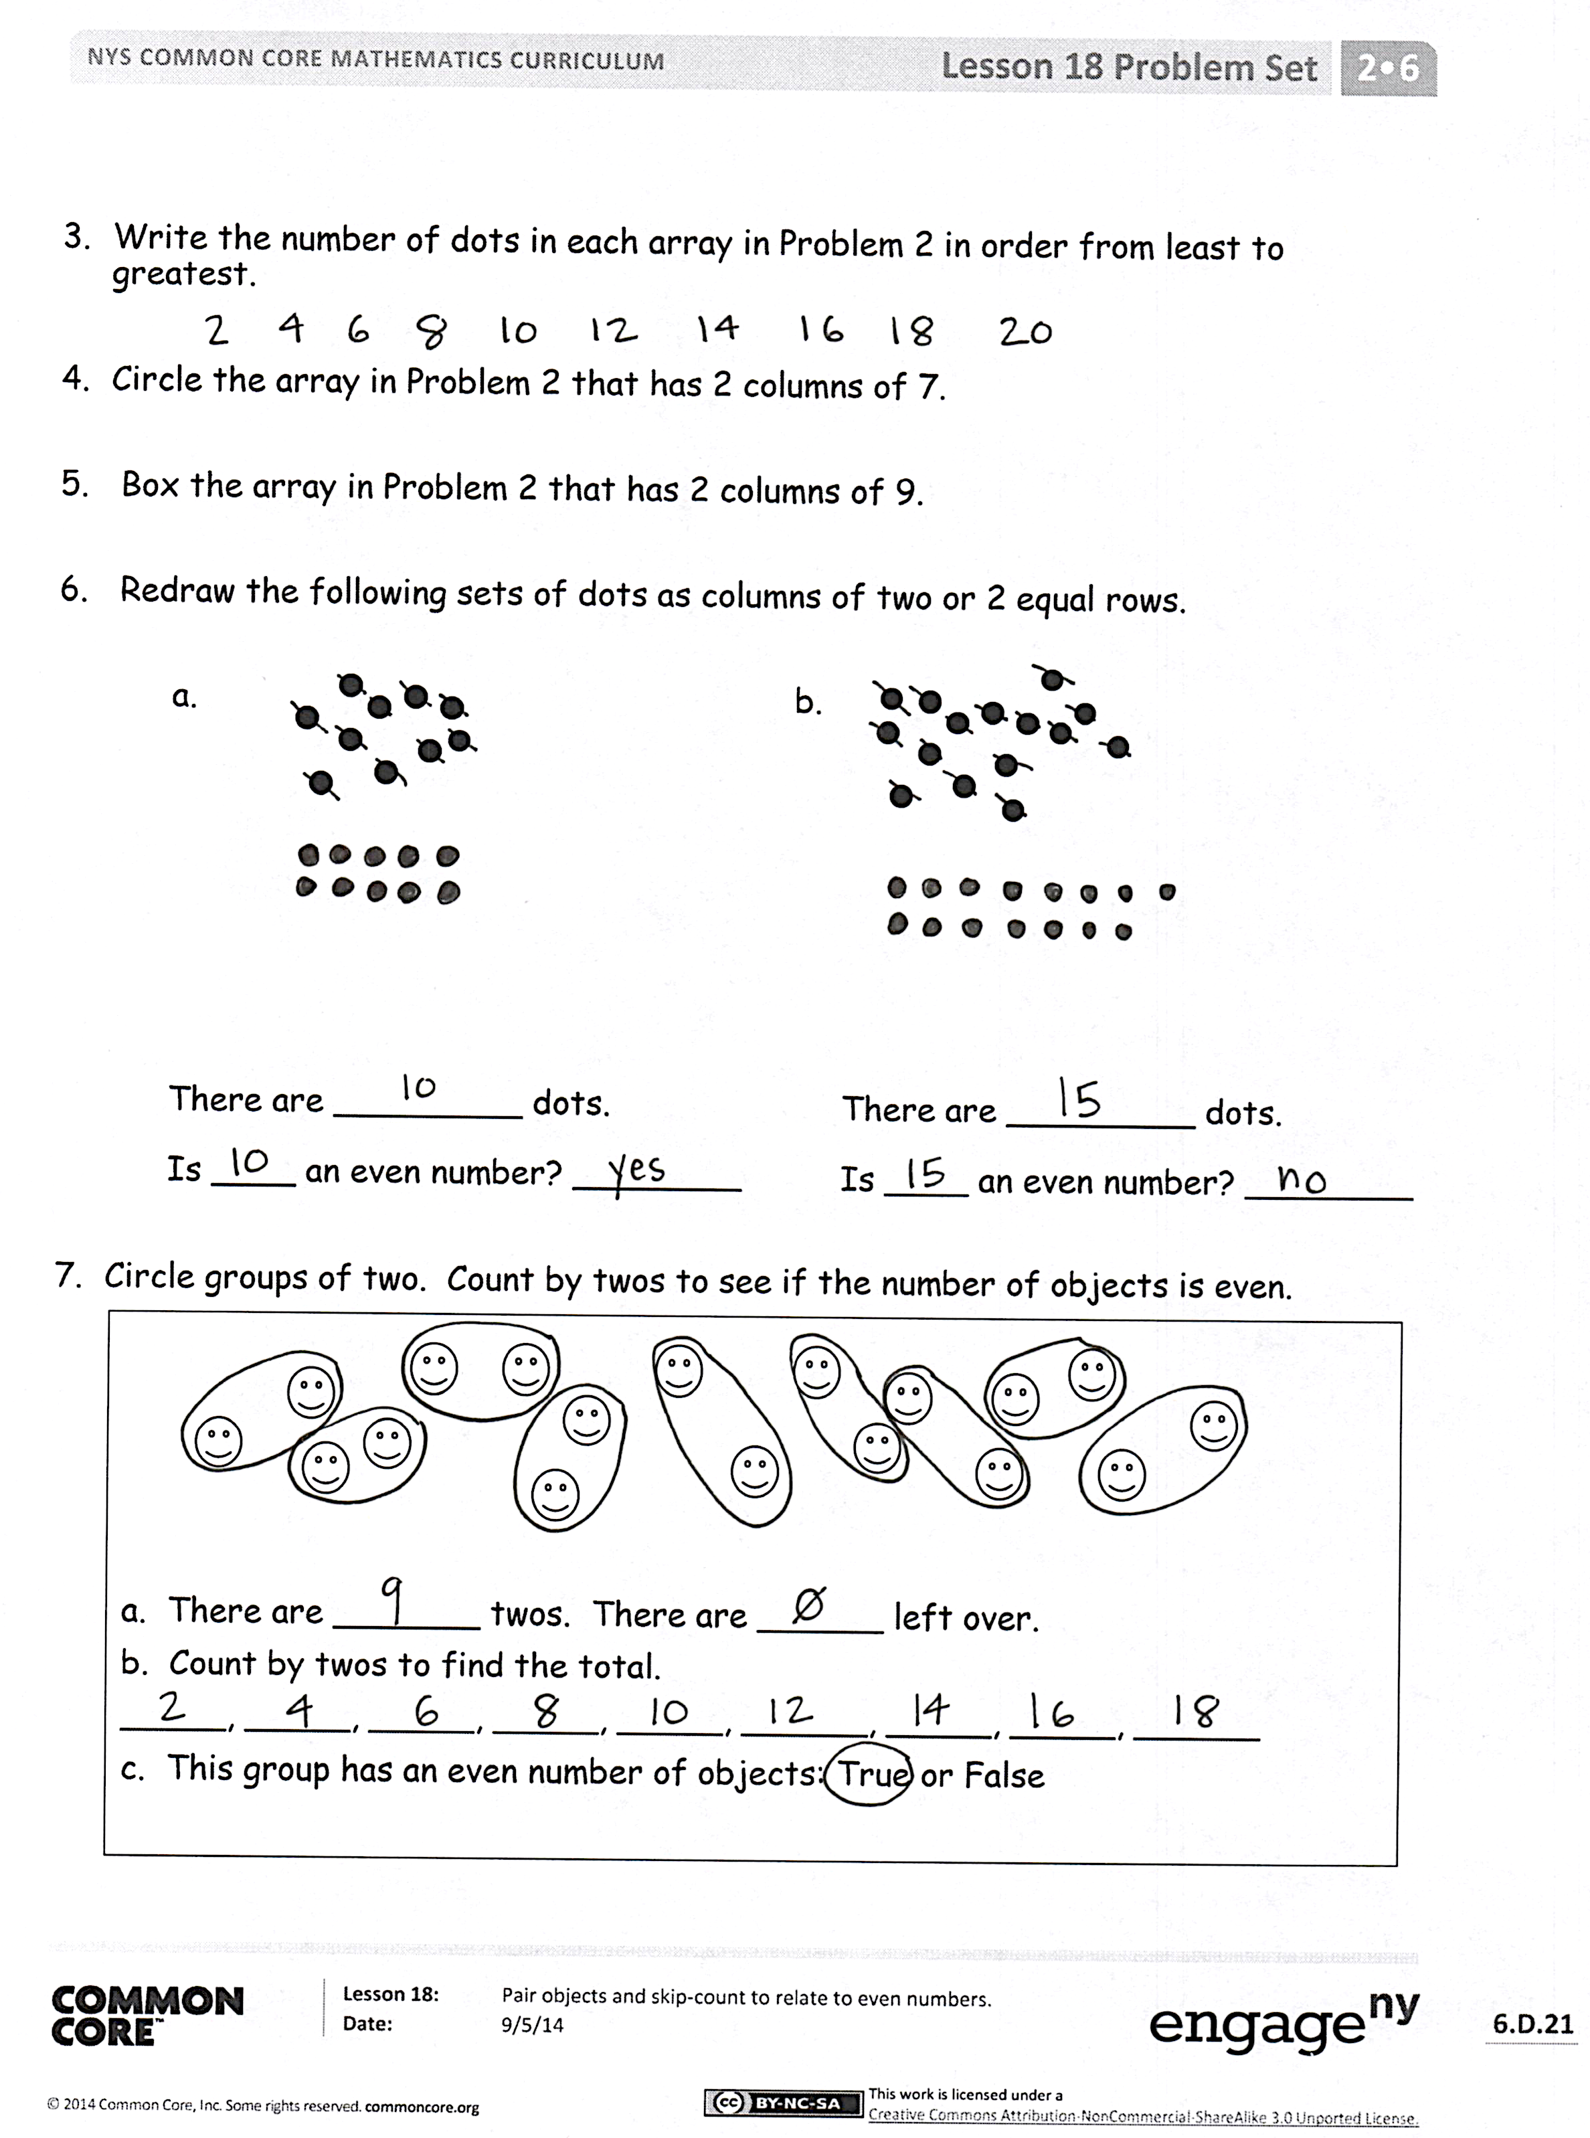
Invite students to review their solutions for the Problem Set. They should check work by comparing answers with a partner before going over answers as a class. Look for misconceptions or misunderstandings that can be addressed in the Debrief. Guide students in a conversation to debrief the Problem Set and process the lesson.
Any combination of the questions below may be used to lead the discussion.
- For Problem 1, what connections can you make between pairing objects and equal groups? If a number is even, can you make equal groups? If it is not even? If so, how many are in each equal group?
- Look at the pattern in Problem 2. How can you describe each picture in terms of rows or columns? Each time you add another pair, what happens to the rows and columns? (Use the frame, “There are ____ rows/columns of ____.”)
- For Problem 3, do you think we should start with 0? Does 0 follow the pattern?

- For Problem 6, which array matches a drawing in Problem 2? Describe it in terms of rows or columns.
- What is different about Problem 6(b)? Can you talk about your drawing in terms of rows and columns? Between which two even numbers does this number fall? Find those numbers in Problem 2. What is the difference between them?
- If you can circle groups of 2 with 0 left over, what do you know for sure?
- When you double a whole number, is the answer even or odd? How can you prove it?
Exit Ticket (3 minutes)
After the Student Debrief, instruct students to complete the Exit Ticket. A review of their work will help with assessing students’ understanding of the concepts that were presented in today’s lesson and planning more effectively for future lessons. The questions may be read aloud to the students.
Number Correct: _______
A
Subtraction from Teens
 | 10 – 3 = |  |  |  | 11 – 9 =
 | 11 – 3 = |  |  |  | 12 – 9 =
 | 12 – 3 = |  |  |  | 17 – 9 =
 | 10 – 2 = |  |  |  | 10 – 8 =
 | 11 – 2 = |  |  |  | 11 – 8 =
 | 10 – 5 = |  |  |  | 12 – 8 =
 | 11 – 5 = |  |  |  | 16 – 8 =
 | 12 – 5 = |  |  |  | 10 – 6 =
 | 14 – 5 = |  |  |  | 13 – 6 =
 | 10 – 4 = |  |  |  | 15 – 6 =
 | 11 – 4 = |  |  |  | 10 – 7 =
 | 12 – 4 = |  |  |  | 13 – 7 =
 | 13 – 4 = |  |  |  | 14 – 7 =
 | 10 – 7 = |  |  |  | 16 – 7 =
 | 11 – 7 = |  |  |  | 10 – 8 =
 | 12 – 7 = |  |  |  | 13 – 8 =
 | 15 – 7 = |  |  |  | 14 – 8 =
 | 10 – 6 = |  |  |  | 17 – 8 =
 | 11 – 6 = |  |  |  | 10 – 9 =
 | 12 – 6 = |  |  |  | 13 – 9 =
 | 14 – 6 = |  |  |  | 14 – 9 =
 | 10 – 9 = |  |  |  | 18 – 9 =
Number Correct: _______
Improvement: _______
B
[KEY]

Subtraction from Teens
 | 10 – 2 = |  |  |  | 11 – 7 =
 | 11 – 2 = |  |  |  | 12 – 7 =
 | 10 – 4 = |  |  |  | 16 – 7 =
 | 11 – 4 = |  |  |  | 10 – 9 =
 | 12 – 4 = |  |  |  | 11 – 9 =
 | 13 – 4 = |  |  |  | 12 – 9 =
 | 10 – 3 = |  |  |  | 18 – 9 =
 | 11 – 3 = |  |  |  | 10 – 5 =
 | 12 – 3 = |  |  |  | 13 – 5 =
 | 10 – 6 = |  |  |  | 10 – 6 =
 | 11 – 6 = |  |  |  | 13 – 6 =
 | 12 – 6 = |  |  |  | 14 – 6 =
 | 15 – 6 = |  |  |  | 10 – 7 =
 | 10 – 5 = |  |  |  | 13 – 7 =
 | 11 – 5 = |  |  |  | 15 – 7 =
 | 12 – 5 = |  |  |  | 10 – 8 =
 | 14 – 5 = |  |  |  | 13 – 8 =
 | 10 – 8 = |  |  |  | 14 – 8 =
 | 11 – 8 = |  |  |  | 16 – 8 =
 | 12 – 8 = |  |  |  | 10 – 9 =
 | 17 – 8 = |  |  |  | 16 – 9 =
 | 10 – 7 = |  |  |  | 17 – 9 =

Name Date
- Pair the objects to decide if the number of objects is even.
Even/Not Even

Even/Not Even

Even/Not Even

- Draw to continue the pattern of the pairs in the space below until you have drawn 10 pairs.

- Write the number of dots in each array in Problem 2 in order from least to greatest.

- Circle the array in Problem 2 that has 2 columns of 7.

- Box the array in Problem 2 that has 2 columns of 9.

- Redraw the following sets of dots as columns of two or 2 equal rows.

a. b.

There are _________ dots.
Is ____ an even number? ________

There are _________ dots.
Is ____ an even number? ________

- Circle groups of two. Count by twos to see if the number of objects is even.
a. There are _______ twos. There are ______ left over.
b. Count by twos to find the total.
_____, _____, _____, _____, _____, ______, _____, _____, ______
c. This group has an even number of objects: True or False

Name Date
Redraw the following sets of dots as columns of two or 2 equal rows.
1. 2.

There are _________ dots.
Is ____ an even number? ________

There are _________ dots.
Is ____ an even number? ________

Name Date
- Pair the objects to decide if the number of objects is even.
Even/Not Even

Even/Not Even

Even/Not Even

- Draw to continue the pattern of the pairs in the spaces below until you have drawn zero pairs.

- Write the number of hearts in each array in Problem 2 in order from greatest to least.

- Circle the array in Problem 2 that has 2 columns of 6.

- Box the array in Problem 2 that has 2 columns of 8.

- Redraw the set of stars as columns of two or 2 equal rows.

There are _________ stars.
Is ____ an even number? ________

- Circle groups of two. Count by twos to see if the number of objects is even.
a. There are _______ twos. There are ______ left over.

b. Count by twos to find the total.
_____, _____, _____, _____, _____, ______, _____, _____

c. This group has an even number of objects: True or False.

