Lesson 17
Objective: Relate doubles to even numbers, and write number sentences to express the sums.

Suggested Lesson Structure
 Fluency Practice (10 minutes)
 Application Problem (6 minutes)
 Concept Development (34 minutes)
 Student Debrief (10 minutes)
Total Time (60 minutes)
Fluency Practice (10 minutes)
- Subtraction Patterns 2.NBT.5 (5 minutes)
- Grade 2 Core Fluency Practice Sets 2.OA.2 (5 minutes)
Subtraction Patterns (5 minutes)
Materials: (S) Personal white board, math notebook or loose-leaf paper
Note: Students practice subtraction in order to gain mastery of the sums and differences within 20 and to see the relationship with larger numbers.
T: After I say a basic fact for you to solve, make a pattern sequence by adding 10 to the whole and then subtracting. Continue until I say to stop. So, after solving 11 – 9, you would solve 21 – 9, and then…?
S: 31 – 9, 41 – 9, 51 – 9.
T: Yes. Solve as many as you can on your personal white board before I give the signal to stop. Let’s begin. 11 – 9.
When every student has completed at least two problems, stop the class, and give the next expression.
Continue with the following possible sequence: 12 – 8, 11 – 8, and 13 – 9.
Grade 2 Core Fluency Practice Sets (5 minutes)
Materials: (S) Core Fluency Practice Sets (G2−M6−Lesson 12 Core Fluency Practice Sets)
Note: During Topic D and for the remainder of the year, each day’s fluency activities includes an opportunity for review and mastery of the sums and differences with totals through 20 by means of the Core Fluency Practice Sets or Sprints. Practice Sets, along with details about the process, are provided in Lesson 12.
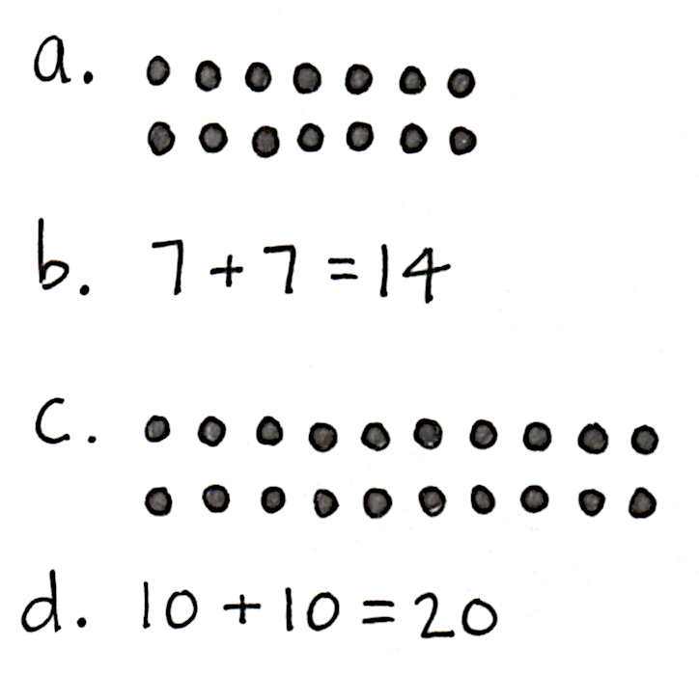
Application Problem (6 minutes)
Seven students sit on one side of a lunch table. Seven more students sit across from them on the other side of the table.
- Draw an array to show the students.
- Write an addition equation that matches the array.
Three more students sit down on each side of the table.
- Draw an array to show how many students there are now.
- Write an addition equation that matches the new array.
Note: This problem is intended for independent practice. It leads directly into today’s Concept Development, utilizing prior knowledge about arrays.
Concept Development (34 minutes)

NOTES ON
MULTIPLE MEANS
OF ENGAGEMENT:
Many students will quickly recognize the doubles pattern, but do not allow them to call out. They will be bursting to tell what they know by the time they reach 5 + 5, which heightens their excitement and engagement. It also allows think time for students who do not recognize the pattern as quickly.

Materials: (S) 20 counters (per pair), personal white board
T: Put your elbows on your desk with your thumbs pointing up.
T: What addition sentence, or equation, describes the number of fingers pointing up?
S: 1 + 1 = 2.
T: (Record the addition equation on the board.) Pop up your index fingers. What is our new addition sentence?
S: 2 + 2 = 4.
T: (Record the addition equation below 1 + 1 = 2.) Pop up the next finger on each hand. What is our next addition equation?

NOTES ON
MULTIPLE MEANS
OF ACTION AND EXPRESSION:
Many students will already have an understanding of even in the context of sharing fairly, as in, “That’s not fair; it’s not even!” Allow them to share these connections to deepen their understanding of the term.

S: 3 + 3 = 6.
T: (Record the addition equation.) Pop up the next finger, and give me the addition equation.
S: 4 + 4 = 8.
T: (Record the addition equation on the board.) Next finger up. What is our next addition equation?
S: 5 + 5 = 10.

T: (Point to the list of addition sentences.) What do we call it when both addends are the same?
S: Doubles!
T: What patterns do you see in the totals? Discuss with your partner.
S: It’s like skip-counting, 2, 4, 6, 8. Doubles is like counting by twos. Each addend goes up by 1, so the answer goes up by 2.
MP.8
T: All these numbers are even. Tell your partner a way to think about even numbers.
S: Even numbers mean it’s the same number, like in a game of handball, if we both have 8 points, the score is even. If you share with a friend fairly, you both have the same number of things. It’s even. When you add the same number two times, the answer is even. When you skip-count by twos, the answer is even.
T: Good thoughts. Let’s do some more work with even numbers. (Pass out counters.)
T: Partner A, make one row of 6 counters. (Pause.)
T: Partner B, double that row by creating a second row of 6. (Pause.)
T: Look at your array. There are 6 counters in each group. What addition equation describes it?
S: 6 + 6 = 12.
T: (Add this equation to the doubles facts on the board.) Partner B, make a row of 7 counters.
T: How many counters should Partner A add to double 7?
S: 7.
T: Do that, Partner A, and let’s add the doubles fact to our list. What should we write?
S: 7 + 7 = 14.
T: Is 14 even?
S: Yes!
T: What is the next addition equation we will write?
S: 8 + 8 = 16.
T: Of course! How did you know?
S: The addends are going in order, 1 + 1, 2 + 2, … so 8 + 8 comes after 7 + 7. The answers are going by twos, 2, 4, 6, 8, 10, 12, 14, so 16 is next.
T: Brilliant! We can express this idea in another way. We can say 5 doubled is 10. Say that with me.
T/S: 5 doubled is 10.
T: What is 3 doubled? Give me the complete sentence.
S: 3 doubled is 6.
T: Excellent! Continue using your counters to make all the combinations of even numbers that you can. For each set, record the doubles equation on your personal white board.
As students form and record the sets of doubles, work with students who need support. As individuals demonstrate understanding, allow them to move on to the Problem Set.

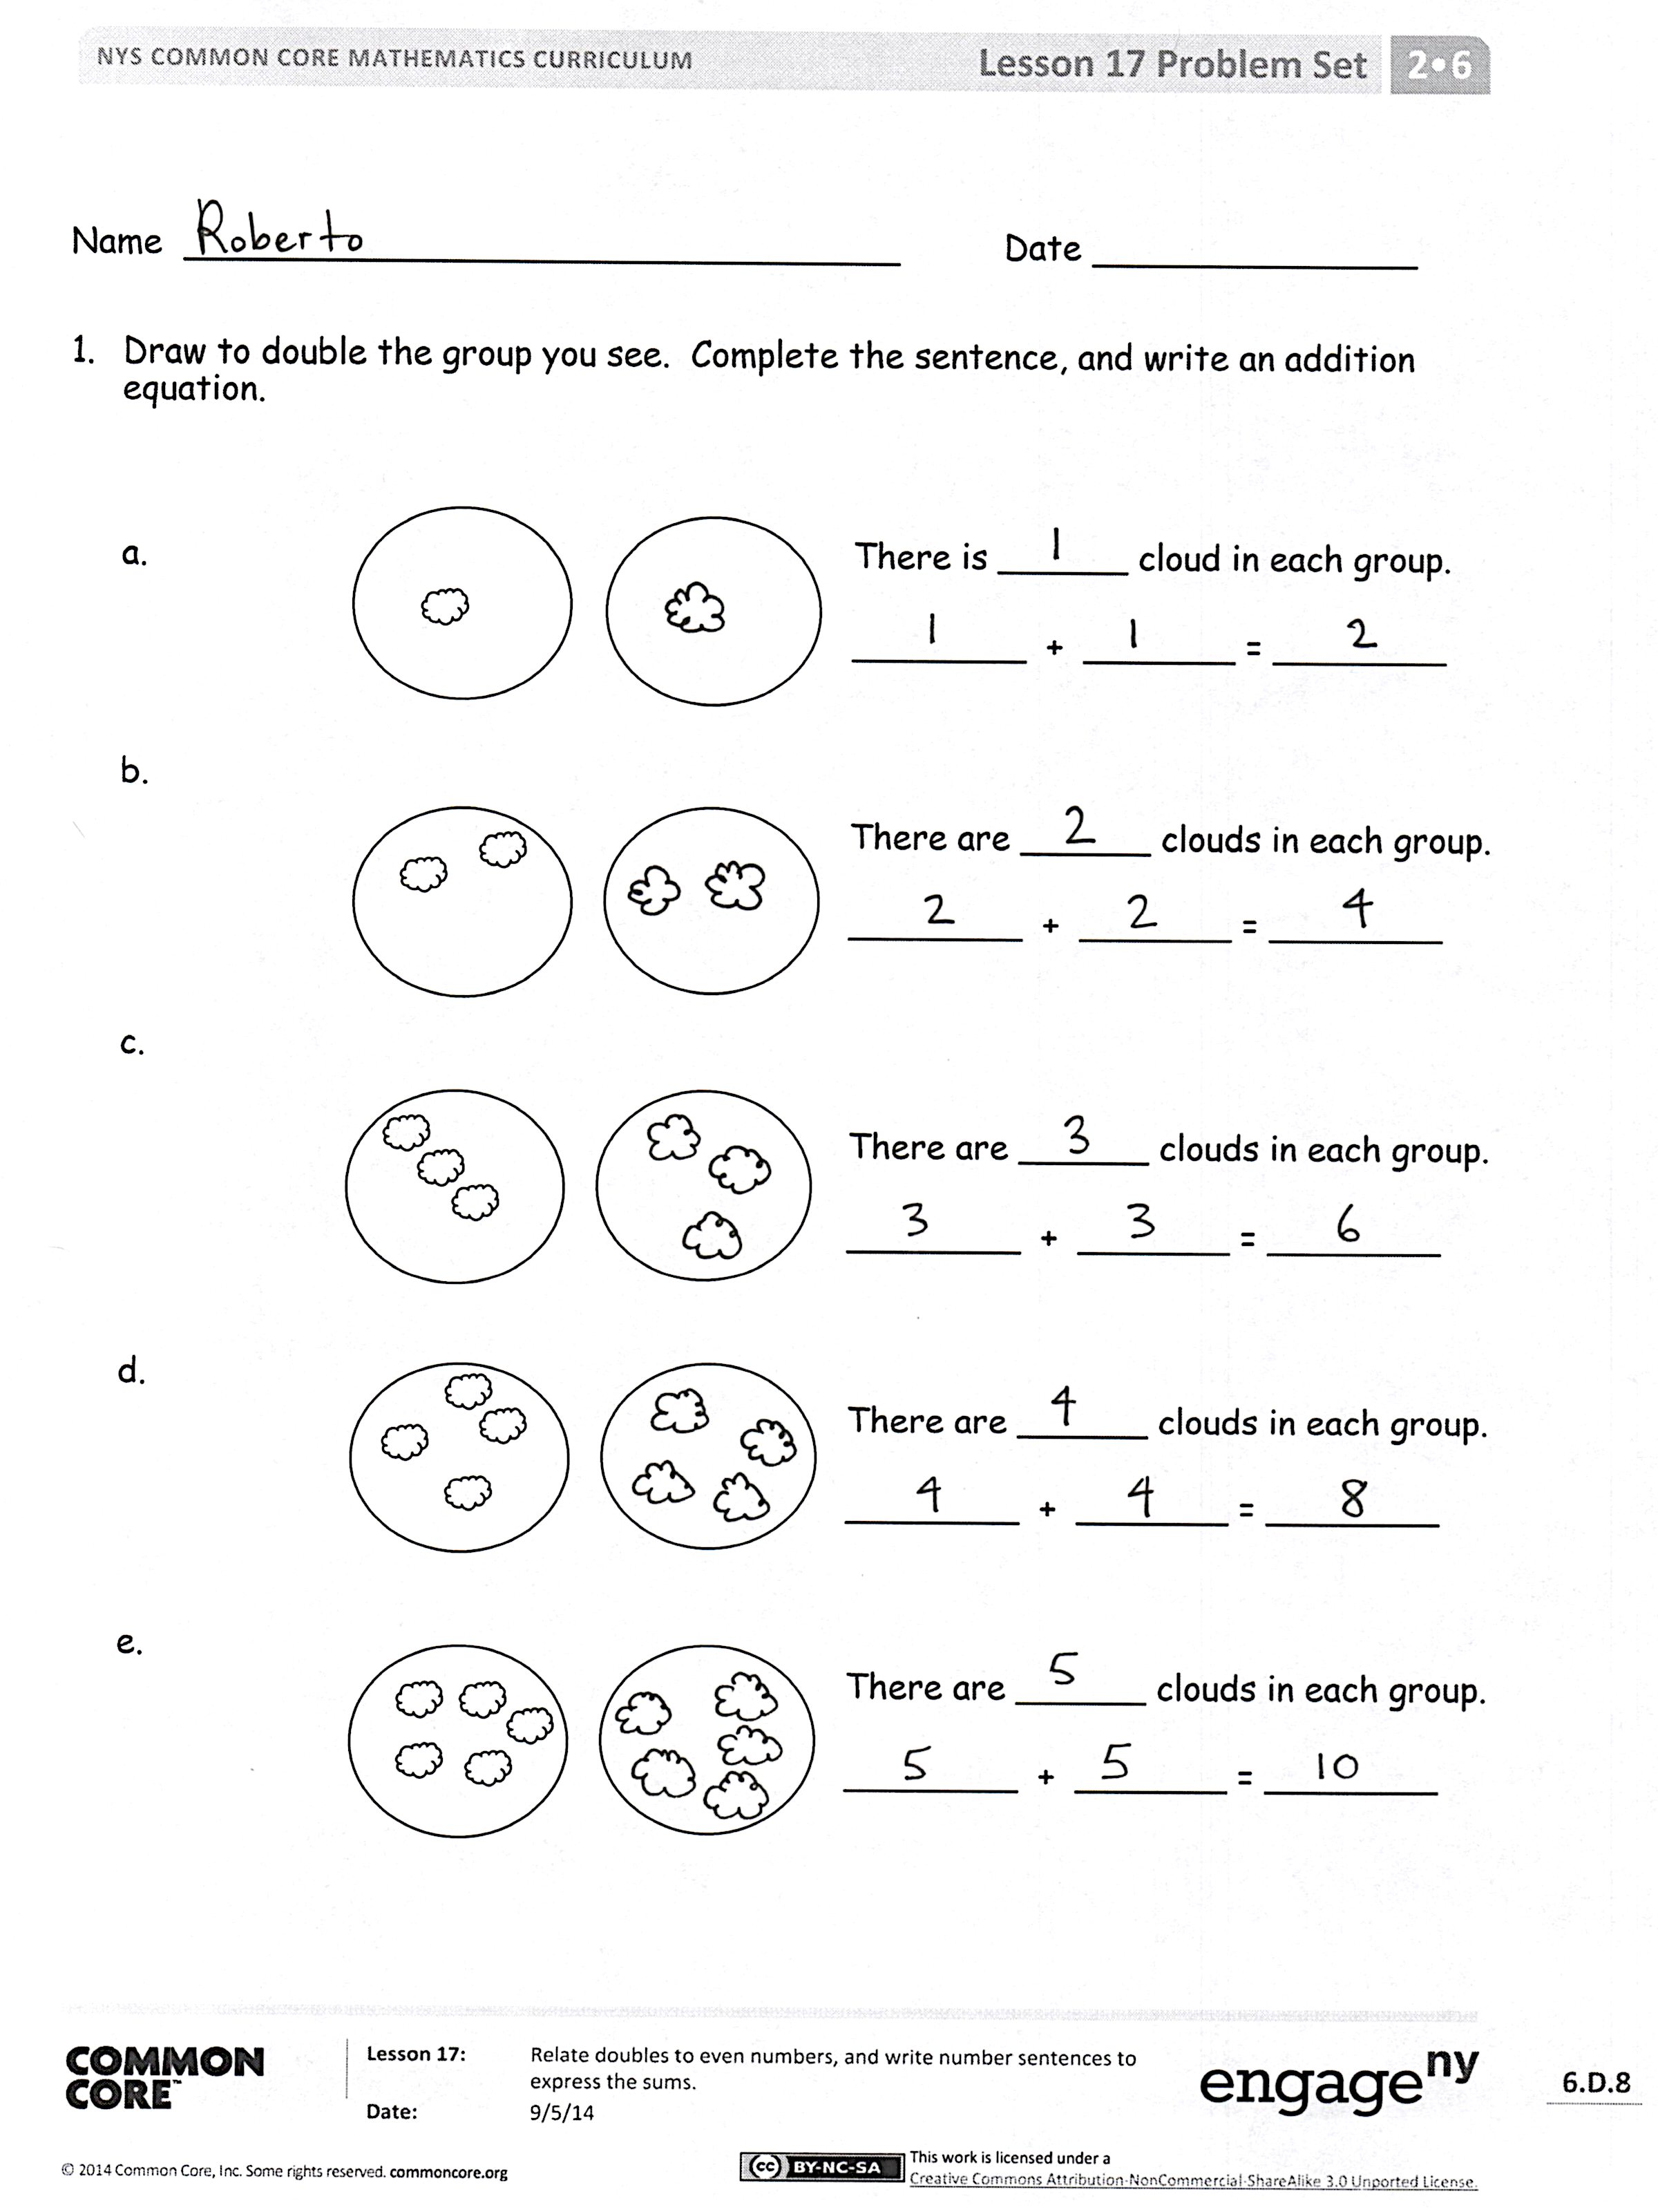
Problem Set (10 minutes)
Students should do their personal best to complete the Problem Set within the allotted 10 minutes. For some classes, it may be appropriate to modify the assignment by specifying which problems they work on first. Some problems do not specify a method for solving. Students should solve these problems using the RDW approach used for Application Problems.
Student Debrief (10 minutes)
Lesson Objective: Relate doubles to even numbers, and write number sentences to express the sums.
The Student Debrief is intended to invite reflection and active processing of the total lesson experience.
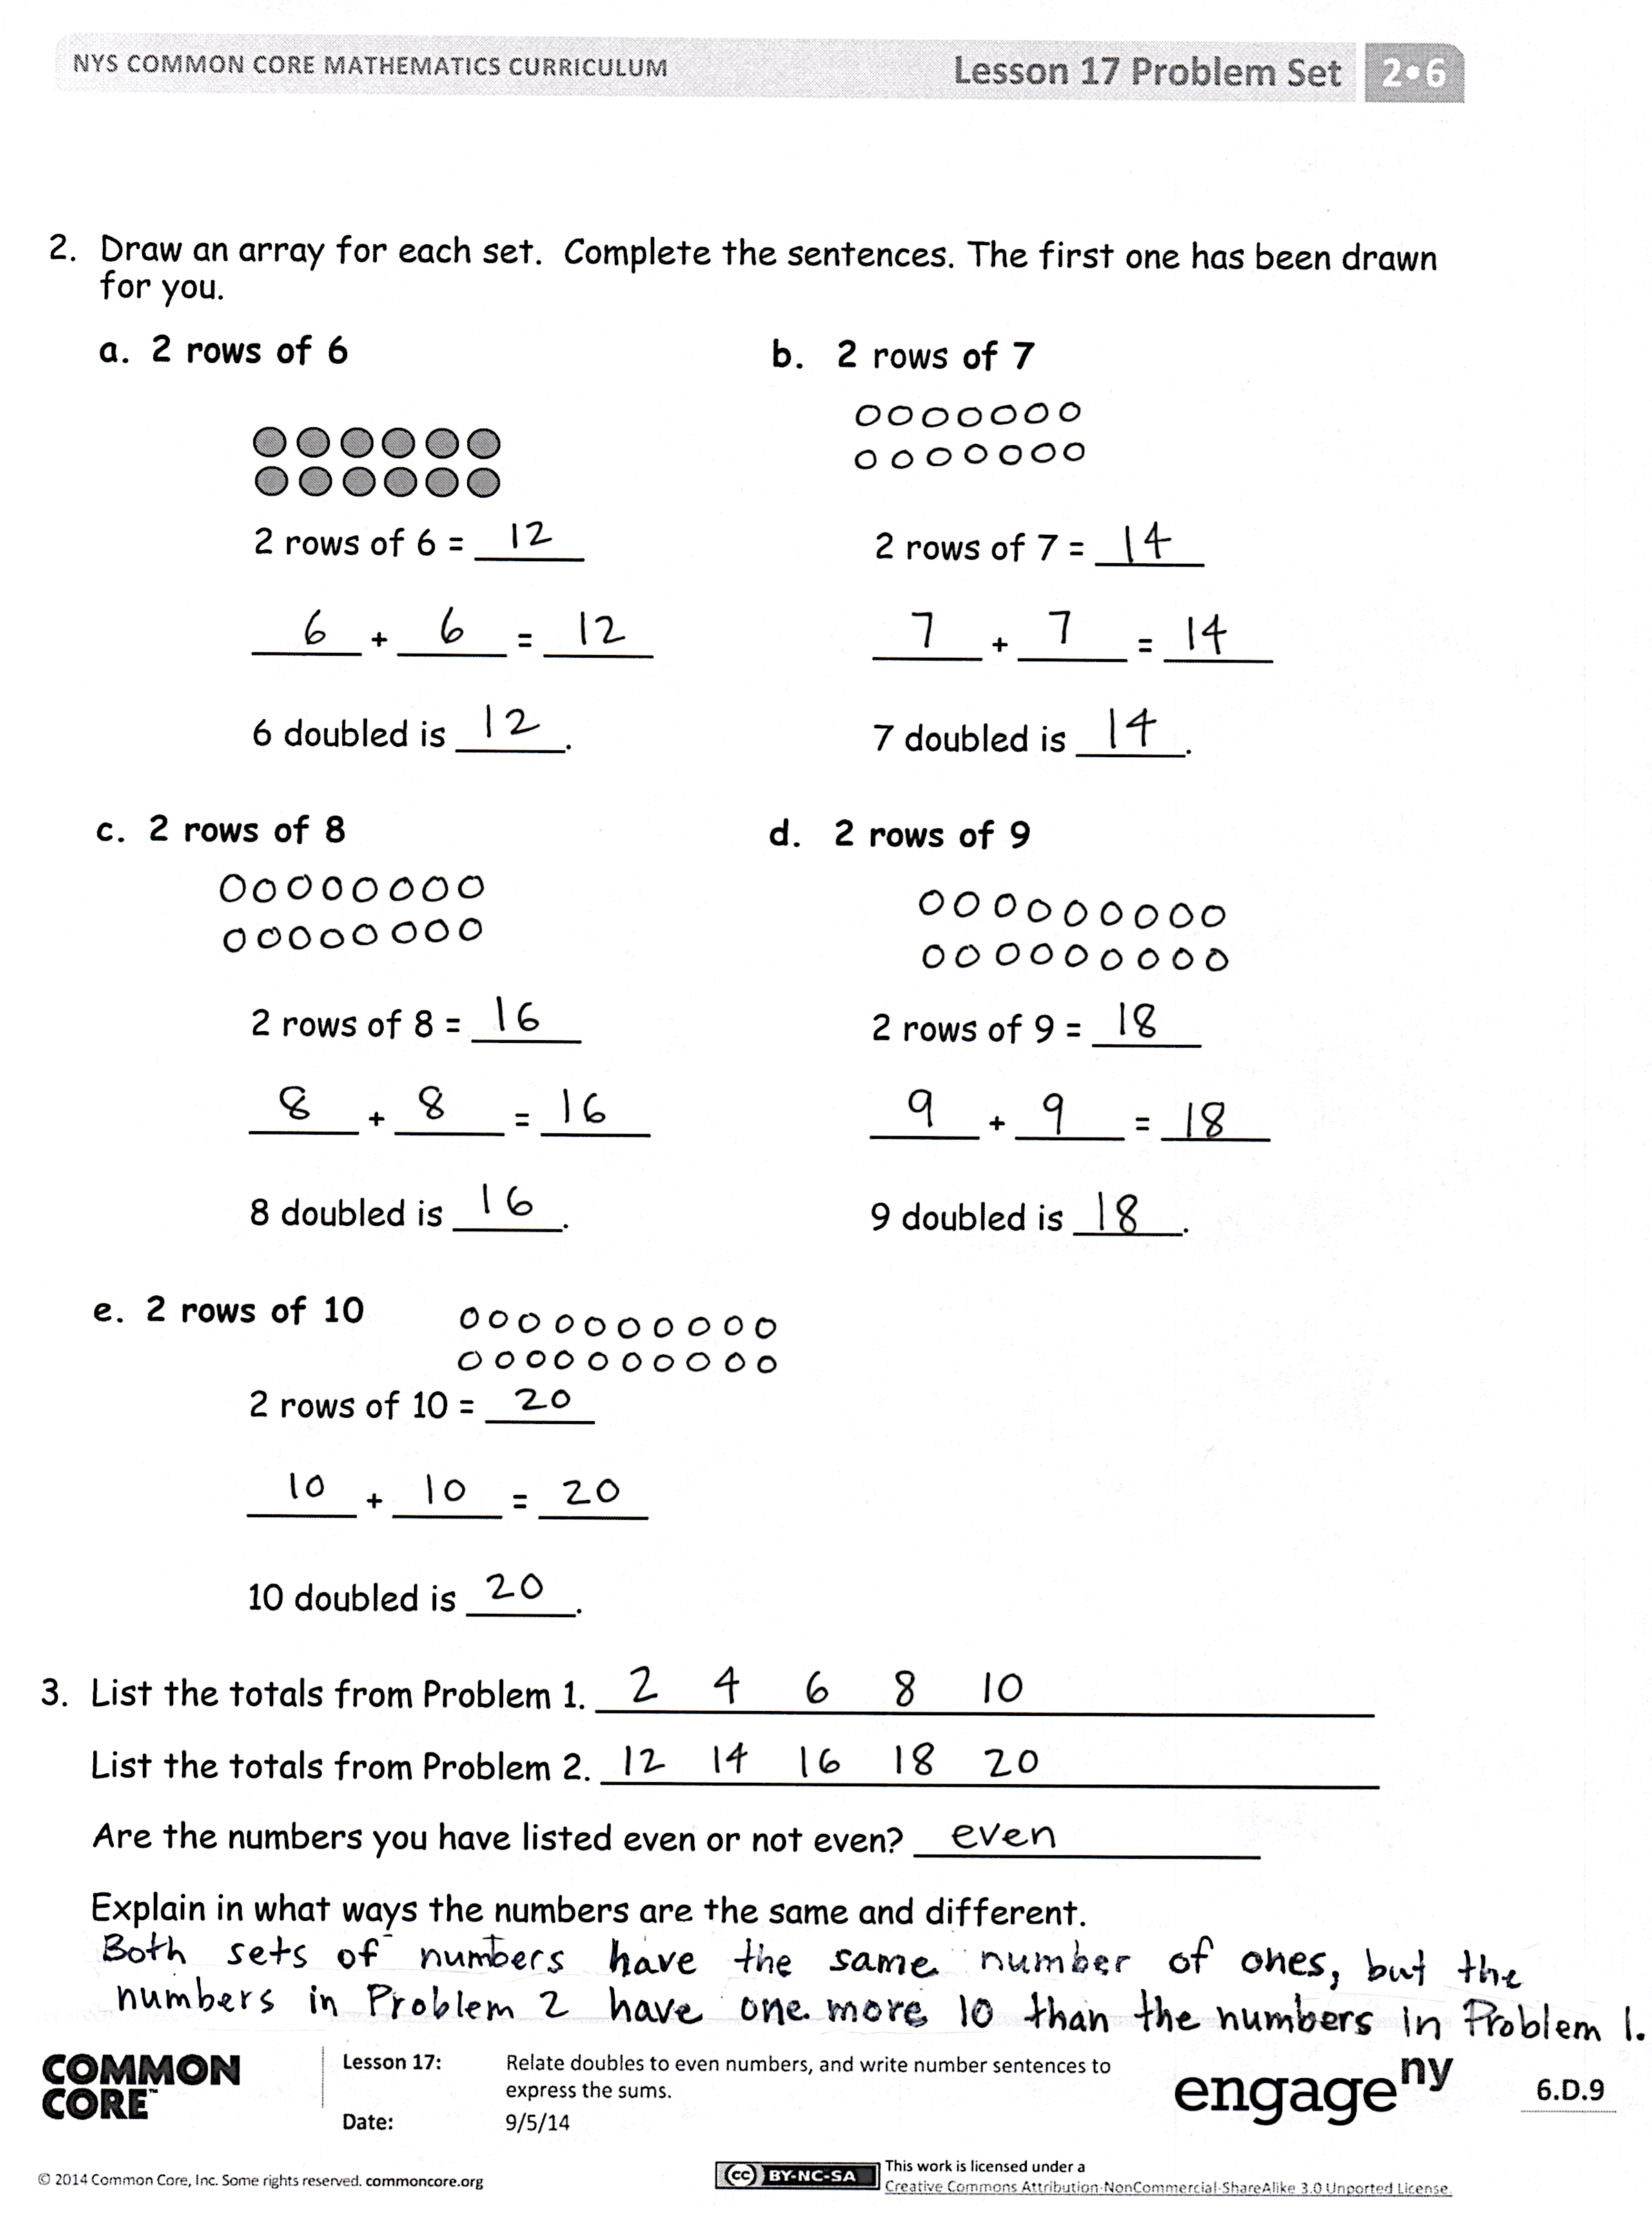
Invite students to review their solutions for the Problem Set. They should check work by comparing answers with a partner before going over answers as a class. Look for misconceptions or misunderstandings that can be addressed in the Debrief. Guide students in a conversation to debrief the Problem Set and process the lesson.
Any combination of the questions below may be used to lead the discussion.
- In Problem 1, does doubling a number always result in an even number? Does it matter how many clouds are in each group?
- For Problem 1, if 4 + 4 is even, is 5 + 4 even? Why not? Fill in 5 + 4 + ____ is an even number.
- Can you look at an array in Problem 2 and immediately determine if there is an even number of objects? How?
- What patterns do you notice in Problem 3? What connections do you see between even numbers and skip-counting?
- What new math word did we use today? How would you define an even number?
- How did the Application Problem connect to today’s lesson?

Exit Ticket (3 minutes)
After the Student Debrief, instruct students to complete the Exit Ticket. A review of their work will help with assessing students’ understanding of the concepts that were presented in today’s lesson and planning more effectively for future lessons. The questions may be read aloud to the students.

Name Date
- Draw to double the group you see. Complete the sentence, and write an addition equation.

There is ______ cloud in each group.
________ + _______ = ________

There are ______ clouds in each group.
________ + _______ = ________

c.
There are ______ clouds in each group.
________ + _______ = ________

d.
There are ______ clouds in each group.
________ + _______ = ________

e.
There are ______ clouds in each group.
________ + _______ = ________

- Draw an array for each set. Complete the sentences. The first one has been drawn for you.
- 2 rows of 6 b. 2 rows of 7

2 rows of 6 = _____ 2 rows of 7 = _____

_____ + _____ = _____ _____ + _____ = _____

6 doubled is _____. 7 doubled is _____.

c. 2 rows of 8 d. 2 rows of 9

2 rows of 8 = _____ 2 rows of 9 = _____

_____ + _____ = _____ _____ + _____ = _____

8 doubled is _____. 9 doubled is _____.

e. 2 rows of 10

2 rows of 10 = _____

_____ + _____ = _____

10 doubled is _____.

- List the totals from Problem 1. ____________________________________
List the totals from Problem 2. ____________________________________
Are the numbers you have listed even or not even? ________________
Explain in what ways the numbers are the same and different.

Name Date
Draw an array for each set. Complete the sentences.
- 2 rows of 5

2 rows of 5 = _____

_____ + _____ = _____

Circle one: 5 doubled is even/not even.

- 2 rows of 3

2 rows of 3 = _____

_____ + _____ = _____

Circle one: 3 doubled is even/not even.

Name Date
  - Draw to double the group you see. Complete the sentences, and write an addition equation.
There are ______ stars in each group.
________ + _______ = ________

b.
There are ______ stars in each group.
________ + _______ = ________

c.
There is ______ star in each group.
________ + _______ = ________

There are ______ stars in each group.
________ + _______ = ________

There are ______ stars in each group.
________ + _______ = ________

- Draw an array for each set. Complete the sentences. The first one has been drawn for you.
a. 2 rows of 6 b. 2 rows of 7

2 rows of 6 = _____ 2 rows of 7 = _____

_____ + _____ = _____ _____ + _____ = _____

6 doubled is _____. 7 doubled is _____.

c. 2 rows of 8 d. 2 rows of 9

____ rows of _____ = ____ 2 rows of 9 = _____

_____ + 8 = _____ _____ + _____ = _____

8 doubled is _____. 9 doubled is _____.

e. 2 rows of 10

_____ rows of _____ = _____

10 + _____ = _____

10 doubled is _____.

- List the totals from Problem 1. ____________________________________
List the totals from Problem 2. ____________________________________
Are the numbers you have listed even or not even? ________________
Explain in what ways the numbers are the same and different.

