Lesson 16
Objective: Use grid paper to create designs to develop spatial structuring.

Suggested Lesson Structure
 Fluency Practice (12 minutes)
 Application Problem (5 minutes)
 Concept Development (33 minutes)
 Student Debrief (10 minutes)
Total Time (60 minutes)
Fluency Practice (12 minutes)
- Get to 10, 20, or 30 2.OA.2 (4 minutes)
- Count by Ten or One with Dimes and Pennies 2.OA.2 (3 minutes)
- Grade 2 Core Fluency Practice Sets 2.OA.2 (5 minutes)
Get to 10, 20, or 30 (4 minutes)
Materials: (S) 3 dimes and 10 pennies
Note: This fluency activity uses dimes and pennies to help students become familiar with coins while simultaneously providing practice with missing addends to ten(s).
For the first two minutes:
- Step 1: Lay out 0–10 pennies in 5-group formation, and ask students to identify the amount shown (e.g., 9 cents).
- Step 2: Ask for the addition sentence to get to a dime (e.g., 9 cents + 1 cent = 1 dime).
For the next two minutes:
- Repeat Steps 1 and 2. Then, add a dime, and ask students to identify the amount shown (e.g., 1 dime 9 cents + 1 cent = 2 dimes).
Count by Ten or One with Dimes and Pennies (3 minutes)
Materials: (T) 10 dimes and 10 pennies
Note: This activity uses dimes and pennies as abstract representations of tens and ones to help students become familiar with coins, while simultaneously providing practice with counting forward and back by ten or one.
- First minute: Place and take away dimes in a 5-group formation as students count along by 10.
- Second minute: Begin with 2 pennies. Ask how many ones there are. Instruct students to start at 2 and add and subtract 10 as you place and take away dimes.
- Third minute: Begin with 2 dimes. Ask how many tens there are. Instruct students to begin at 20 and add and subtract 1 as you place and take away pennies.
Grade 2 Core Fluency Practice Sets (5 minutes)
Materials: (S) Core Fluency Practice Sets (G2−M6−Lesson 12 Core Fluency Practice Sets)
Note: During Topic C and for the remainder of the year, each day’s fluency activities include an opportunity for review and mastery of the sums and differences with totals through 20 by means of the Core Fluency Practice Sets or Sprints. Practice Sets, along with details about the process, are provided in Lesson 12.
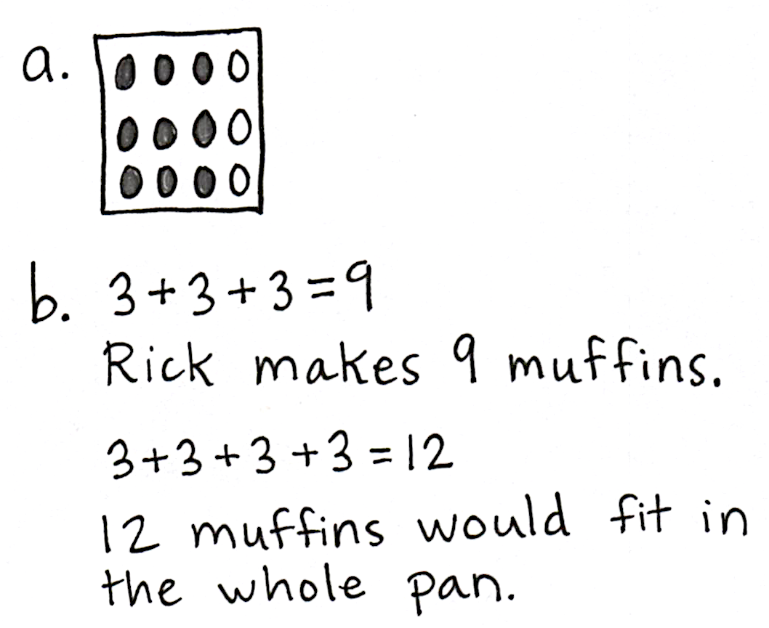
Application Problem (5 minutes)
Rick is baking muffins again. He filled 3 columns of 3 and left one column of 3 empty.
- Draw a picture to show what the muffin pan looked like. Shade the columns that Rick filled.
MP.3
- Write a repeated addition equation to tell how many muffins Rick makes. Then, write a repeated addition equation to tell how many muffins would fit in the whole pan.
Note: This problem is intended for independent practice of the previous day’s concept. Given an array with one column missing, students fill in the missing units to complete the array. Then, they find the total by relating the completed array to repeated addition.
Concept Development (33 minutes)
Materials: (T) Grid paper (Template), 1-inch tiles (S) Problem Set, grid paper (Template), scissors, colored pencils or crayons, personal white board, 2 grid papers (Template) on 2 different colored papers (per group of four students)
Note: The Problem Set will be completed during the course of the Concept Development today, rather than at the end.
In this lesson, students extend their earlier work of composing and decomposing rectangles using tiles. Here, they create tessellations by using 1-inch tiles to design a core unit. They then iterate that core unit with no gaps or overlaps to make patterns that could, theoretically, extend indefinitely. This highly engaging activity serves the important purpose of further developing students’ spatial structuring ability, preparing them to work with area in Grade 3, while generating work well suited for classroom display.
T: We’ve used square tiles to put together and break apart rectangles, but did you know we can also use them to create designs?
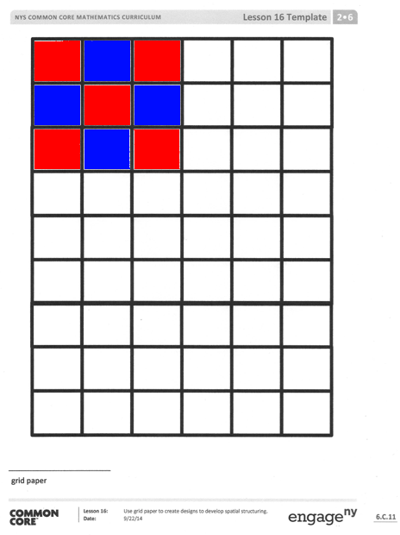
T: (Project grid paper.) Watch how I place my tiles. (Place tiles on top of the grid to create the image pictured.)
T: Talk with your partner about the design. How can you describe it?
S: It goes red, blue, red, blue, red, blue, red, blue, red. It shows 5 red squares and 4 blue squares. It looks like an array with 3 rows and 3 columns.
T: Good attention to detail, and I like the way you used math language! I can create the same design again by shading in this same pattern. (Shade in the identical design on the grid paper.)
Be sure students are seated in groups of four for this activity. Pass out one white grid paper template per student and two different colored grid paper templates for every four students. Instruct students to slide the white grid paper template into their personal white boards and have their dry-erase markers ready. Instruct each student to cut off one row of squares from each of the colored grid paper templates for themselves and then pass the papers to the next person in the group.
T: Now, it’s your turn to try! Cut out 5 single squares from each of the colored grid papers. (Pause.)
T: Use the squares to copy my design on top of the grid paper that is in your personal white board.
T: Then, carefully remove the squares and, with your marker, shade in the squares to create the design on your personal white board.
Circulate to check for understanding as students recreate the design.
T: Now, you get to create your own design! Listen and follow my directions carefully.

NOTES ON
MULTIPLE MEANS
OF ENGAGEMENT:
- Search online for tessellations to show their connection to artwork and patterns, including real life tessellations in quilts, historical mosaics, and tiling in buildings and homes, as well as many works by M.C. Escher.
- Offer students puzzles such as Perpetual Puzzles or other puzzles that use same-shaped pieces, and point out how they form tessellations.

Part 1: Create a design using 10 tiles.
T: Now, cut one square in half diagonally so that you have two triangles. (Pause.)
T: Use each of your 9 square tiles and the 2 triangle tiles to create a design on top of your grid. Then, use your marker to shade in your design on your personal white board.
T: Pay careful attention to which grid squares to color and how many spaces to leave.
T: When you have finished, share your design with a partner.
T: (Allow students time to work and share.) Now, hold up your design, so we can admire each other’s creative work!
Circulate to provide support as students work.
Part 2: Create a design using 16 tiles.
T: Cut out 3 more squares from each colored grid. (Allow students time to cut.)
T: Cut 2 of those square tiles in half diagonally. (Allow students time to cut.)
T: Now, create a new design with your tiles, and then shade in your design on your personal white board.
Part 3: Share and check your partner’s work.
T: Share your second design with your partner. Check each other’s copy to be sure it matches the tile design.
T: Describe your partner’s design: How would you describe it as an array? How many tiles do you see in the second row? Do any columns look the same? (Allow students time to discuss their partner’s work.)
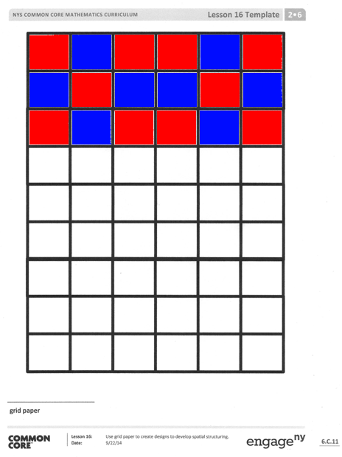
T: Hold up those designs again, and look around! Oh, I see how they are becoming more intricate with more tiles
and triangles!
Part 4: Create a tessellation.
T: Let’s look at my design again. (Project the original 9-tile core unit as shown.)
T: You noticed that this is a 3 by 3 array, made up of 3 rows and
3 columns, which is a total of 9 squares. I can also call it my core unit.
T: Watch how I can make this pattern go on and on by repeating the core unit. (Place the next core unit.)
T: Notice how the tiles touch but don’t overlap. I could keep going this way and cover the entire space of this page. Can
you visualize how this paper would look if I repeated my
design until the page was full?
T: I continue my pattern right up to the edge of the grid.
NOTES ON
MULTIPLE MEANS
OF ACTION AND EXPRESSION:
As a class project, create a mosaic from the tessellations your students create. If there is enough parental involvement, consider creating a class quilt from the pattern.

T: Now, you’re going to work in pairs.
T: One partner, take the grid paper out of your personal white board. You’ll be using your colored pencils for this activity.
T: You and your partner will now create your own 3 by 3 design, which will be your core unit.
T: Work together, starting in one corner of the paper, to create a pattern and color a design that covers a 3 by 3 area.
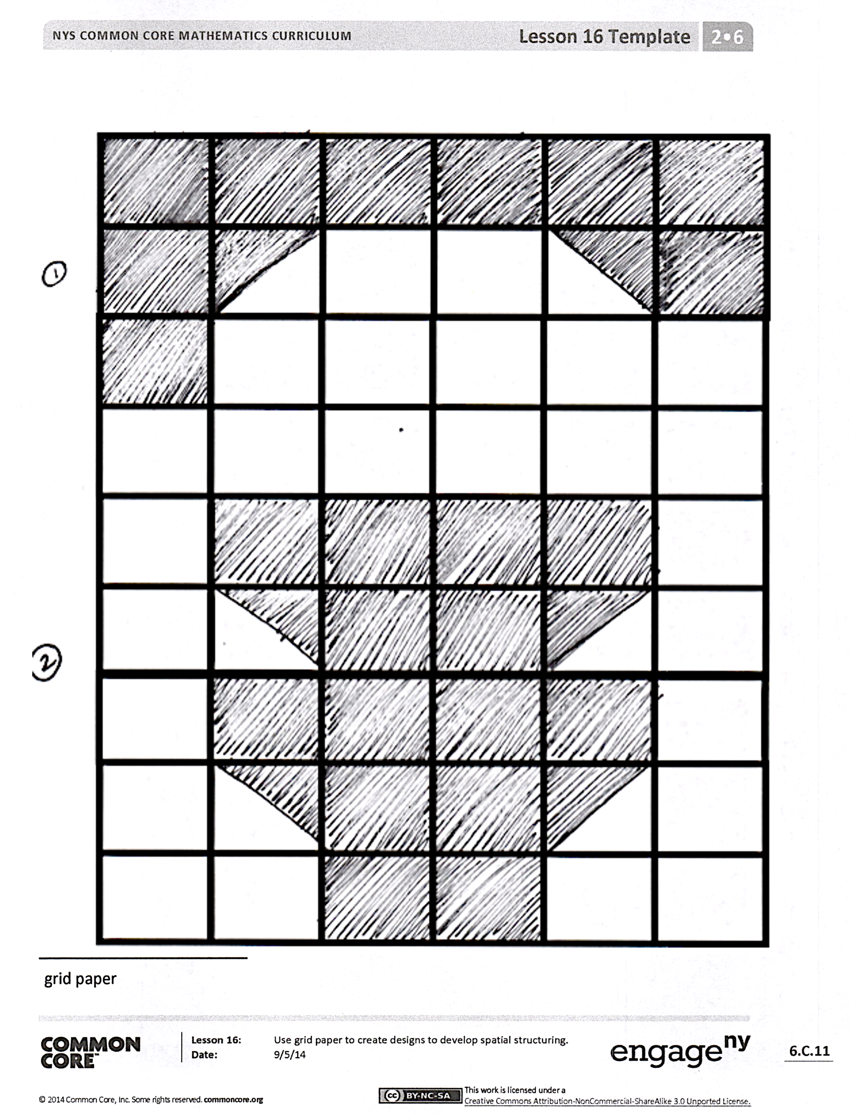
T: Next, fill your whole paper by copying that design over and over, repeating the core unit with no gaps or overlaps.
Circulate as students work. Once all have finished, consider having a gallery walk if time permits so that students can view each other’s tessellations.
T: What you and your partner just created is called a tessellation! Isn’t that a great word? Say it with me.
T/S: Tessellation!
T: How would you describe a tessellation?
S: It’s like a bunch of tiles! We made copies of a pattern over and over. We made tiles with a pattern on them and arranged them in an array.
T: Good descriptions! The process of creating a tessellation is often described as tiling.
Student Debrief (10 minutes)
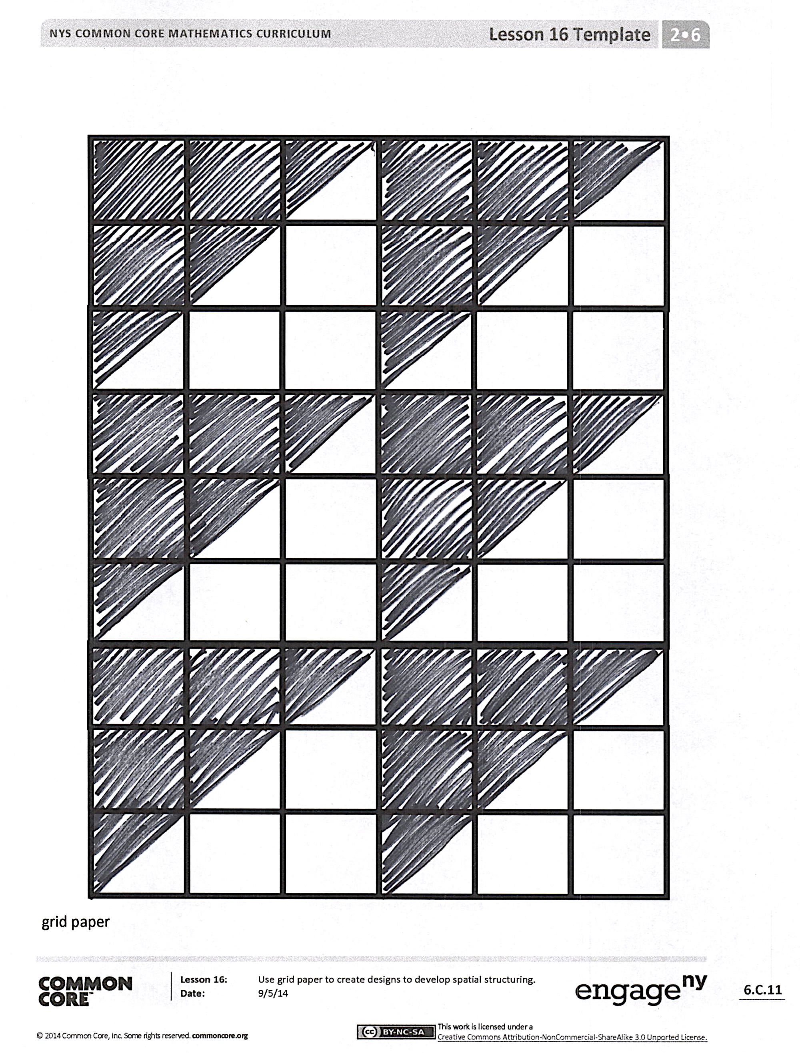
Lesson Objective: Use grid paper to create designs to develop spatial structuring.
The Student Debrief is intended to invite reflection and active processing of the total lesson experience.
Invite students to review their solutions for the Problem Set. They should check work by comparing answers with a partner before going over answers as a class. Look for misconceptions or misunderstandings that can be addressed in the Debrief. Guide students in a conversation to debrief the Problem Set and process the lesson.
Any combination of the questions below may be used to lead the discussion.
- For Problems 1–3, how is knowing how to build an array helpful in creating designs with the tiles?
- What was the most challenging part of today’s Problem Set? Why?
- What exciting new math vocabulary did we learn today? How would you describe a tessellation to a first grader?
- How is making copies of a unit similar to something we have done before?
- Where do you see tessellations at school? At home? Outside?
- Why do you think we spent time creating designs and learning about tessellations today?
Exit Ticket (3 minutes)
After the Student Debrief, instruct students to complete the Exit Ticket. A review of their work will help with assessing students’ understanding of the concepts that were presented in today’s lesson and planning more effectively for future lessons. The questions may be read aloud to the students.

Name Date
Use your square tiles and grid paper to complete the following problems.

Problem 1
- Cut out 10 square tiles.
- Cut one of your square tiles in half diagonally.
- Create a design.
- Shade in your design on grid paper.

Problem 2
- Use 16 square tiles.
- Cut two of your square tiles in half diagonally.
- Create a design.
- Shade in your design on grid paper.
- Share your second design with your partner.
- Check each other’s copy to be sure it matches the tile design.

Problem 3
- Create a 3 by 3 design with your partner in the corner of a new piece of grid paper.
- With your partner, copy that design to fill the entire paper.

Name Date
Use your square tiles and grid paper to complete the following.

- Create a design with the paper tiles you used in the lesson.
- Shade in your design on the grid paper.

Name Date
  - Shade to create a copy of the design on the empty grid.

Create two different designs.

  - Use colored pencils to create a design in the bolded square section. Create a tessellation by repeating the design throughout.

grid paper

