Lesson 15
Objective: Use math drawings to partition a rectangle with square tiles, and relate to repeated addition.

Suggested Lesson Structure
 Fluency Practice (12 minutes)
 Application Problem (6 minutes)
 Concept Development (32 minutes)
 Student Debrief (10 minutes)
Total Time (60 minutes)
Fluency Practice (12 minutes)
- Sprint: Subtract Crossing the Ten 2.OA.2, 2.NBT.5 (8 minutes)
- Using the Nearest Ten to Subtract 2.NBT.5 (2 minutes)
- Subtract Common Units 2.NBT.5, 2.NBT.7 (2 minutes)
Sprint: Subtract Crossing the Ten (8 minutes)
Materials: (S) Subtract Crossing the Ten Sprint
Note: Students practice crossing the ten in preparation for the lesson, as well as to gain mastery of the sums and differences within 20.
Using the Nearest Ten to Subtract (2 minutes)
Note: Reviewing the Grade 1 skill of counting up and down to 10 to subtract gives students a mental strategy to subtract fluently with larger numbers.
16 – 9 = ______
/ \
10 6

10 – 9 = 1
1 + 6 = 7
16 – 9 = 7
T: (Post 16 – 9 on the board.) Raise your hand when you know the answer to 16 – 9.
S: 7.
T: Break 16 apart into 10 and 6. (Write in the bond.) What is 10 – 9?
S: 1.
T: 1 + 6 is…?
S: 7.
Continue with the following possible sequence: 14 – 9, 15 – 8, 16 – 7, 13 – 7, 12 – 9, 12 – 7, 22 – 7, 25 – 7, 25 – 9, 26 – 9, 27 – 9, 27 – 19, 37 – 9, 37 – 19, 35 – 19, 45 – 19, 47 – 18, and 48 – 29.
Subtract Common Units (2 minutes)
Materials: (S) Personal white board
Note: Reviewing this mental math Fluency Practice prepares students for understanding the importance of the subtraction algorithm and place value.
T: (Project 44.) Say the number in unit form.
S: 4 tens 4 ones.
T: (Write 44 – 22 = ____.) Say the subtraction sentence and answer in unit form.
S: 4 tens 4 ones – 2 tens 2 ones = 2 tens 2 ones.
T: Write the subtraction sentence on your personal white board.
Continue with the following possible sequence: 77 – 33, 88 – 55, 99 – 33, 199 – 33, and 999 – 33.
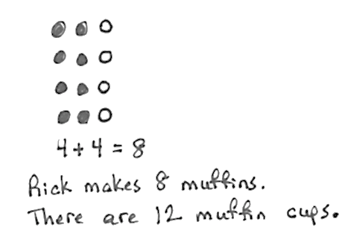
Application Problem (6 minutes)
Rick is filling his muffin pan with batter. He fills 2 columns of 4. One column of 4 is empty.
- Draw to show the muffins and the empty column.
- Write a repeated addition equation to tell how many muffins Rick makes.
Note: This problem is intended for independent practice. Students apply learning from the previous day’s lesson (distinguishing units within units) to a familiar situation. This leads into today’s Concept Development, wherein students shade in given arrays.
Concept Development (32 minutes)
Materials: (T) Extra 6 by 8 grids for independent practice (S) Problem Set, crayons or colored pencils
Note: In this lesson, the Problem Set comprises the Concept Development. Circulate as students complete arrays, monitoring comprehension.
T: Remind me what we discovered in the last lesson when we worked with rectangles.
S: We can cut up a rectangle into rows and columns. There are lots of small squares inside the rectangle. I was thinking how it’s kind of like there are smaller numbers inside bigger numbers.
T: What an interesting connection! Yes, in all kinds of ways, smaller units combine to make larger units, and larger units can be decomposed into smaller units.
T: We’re going to use the Problem Set again for today’s lesson. Look at Problem 1. Tell your partner what you see.
S: A large rectangle. A lot of small squares inside the large rectangle. An array.

T: That’s all true. Problem 1 says shade, or color in, an array with 2 rows of 3. Are we going to color in the whole rectangle?
S: No!
T: Starting in the upper left corner, how many squares are we going to color in the first row?

NOTES ON
MULTIPLE MEANS
OF REPRESENTATION:
Offer students who may be struggling a chance to model the lesson using square tiles on grid paper prior to coloring in the arrays.

S: 3 squares!
T: Let’s color that first row green. (Model as students do the same.)
T: What should we do next?
S: Color in another row of 3 under the first row.
T: Yes! Do that with me, this time using a different color. (Model as students do the same.)
T: Now, tell your partner what you see.
S: I see 2 rows of 3. I see 6 colored squares, 3 + 3. I see 2 threes.
T: Ah! I like the way you related repeated addition to the array. There are 2 threes, so 3 + 3. Let’s write that on the line next to the array. (Write 3 + 3 = 6 as students do the same.)
T: Let’s do Problem 2. How many rows are we going to color?
S: 4 rows!
T: How many squares in each row do we need to color?
MP.8
S: 3 squares!
T: Color in an array that shows 4 rows of 3. Use a different color for each row. (Model as students do the same.)
T: Now, write the repeated addition equation for the array, and share what you wrote with your partner.
S: 3 + 3 + 3 + 3 = 12.
T: That’s right! Let’s read Problem 3: Shade in an array with 5 columns of 4. How many columns are we going to color?
S: 5 columns!

NOTES ON
MULTIPLE MEANS
OF ENGAGEMENT:
Some early finishers may notice that a Sprint contains arrays of squares and rectangles. Encourage them to color in the squares and figure out the arrays they make. They may even cut out the squares and arrange them into different arrays.

T: How many squares should we color in each column?
S: 4 squares!
T: All right, color in 5 columns of 4. Again, use a different color for each column. (Model as students do the same.)
Before moving on to the next activity, provide support to struggling students. Allow students who demonstrate proficiency to work independently with the following sequence on the extra grids without changing colors for each row or column: 5 rows of 5, 3 columns of 4, and an array of their choosing, writing a repeated addition equation that represents each array.
T: Let’s try something different! Look at Problem 4. Draw one more column of 2 to make a new array.
T: Are we adding another row or another column?
S: Another column!
T: Draw another column of 2. (Model as students do the same.)
T: How many columns are there now?
S: 5 columns!
T: How many in each column?
S: 2.
T: Yes! Each column has a group, or unit, of two! How many twos are there altogether?
S: 5 twos!
T: What is a repeated addition equation for the new array?
S: 2 + 2 + 2 + 2 + 2 = 10.
T: Excellent! Now, work with your partner to complete Problems 5 and 6. Be sure to read the directions carefully, and use your models to explain why your repeated addition equations match.
Provide support for students who may be struggling while the rest of the class works independently.
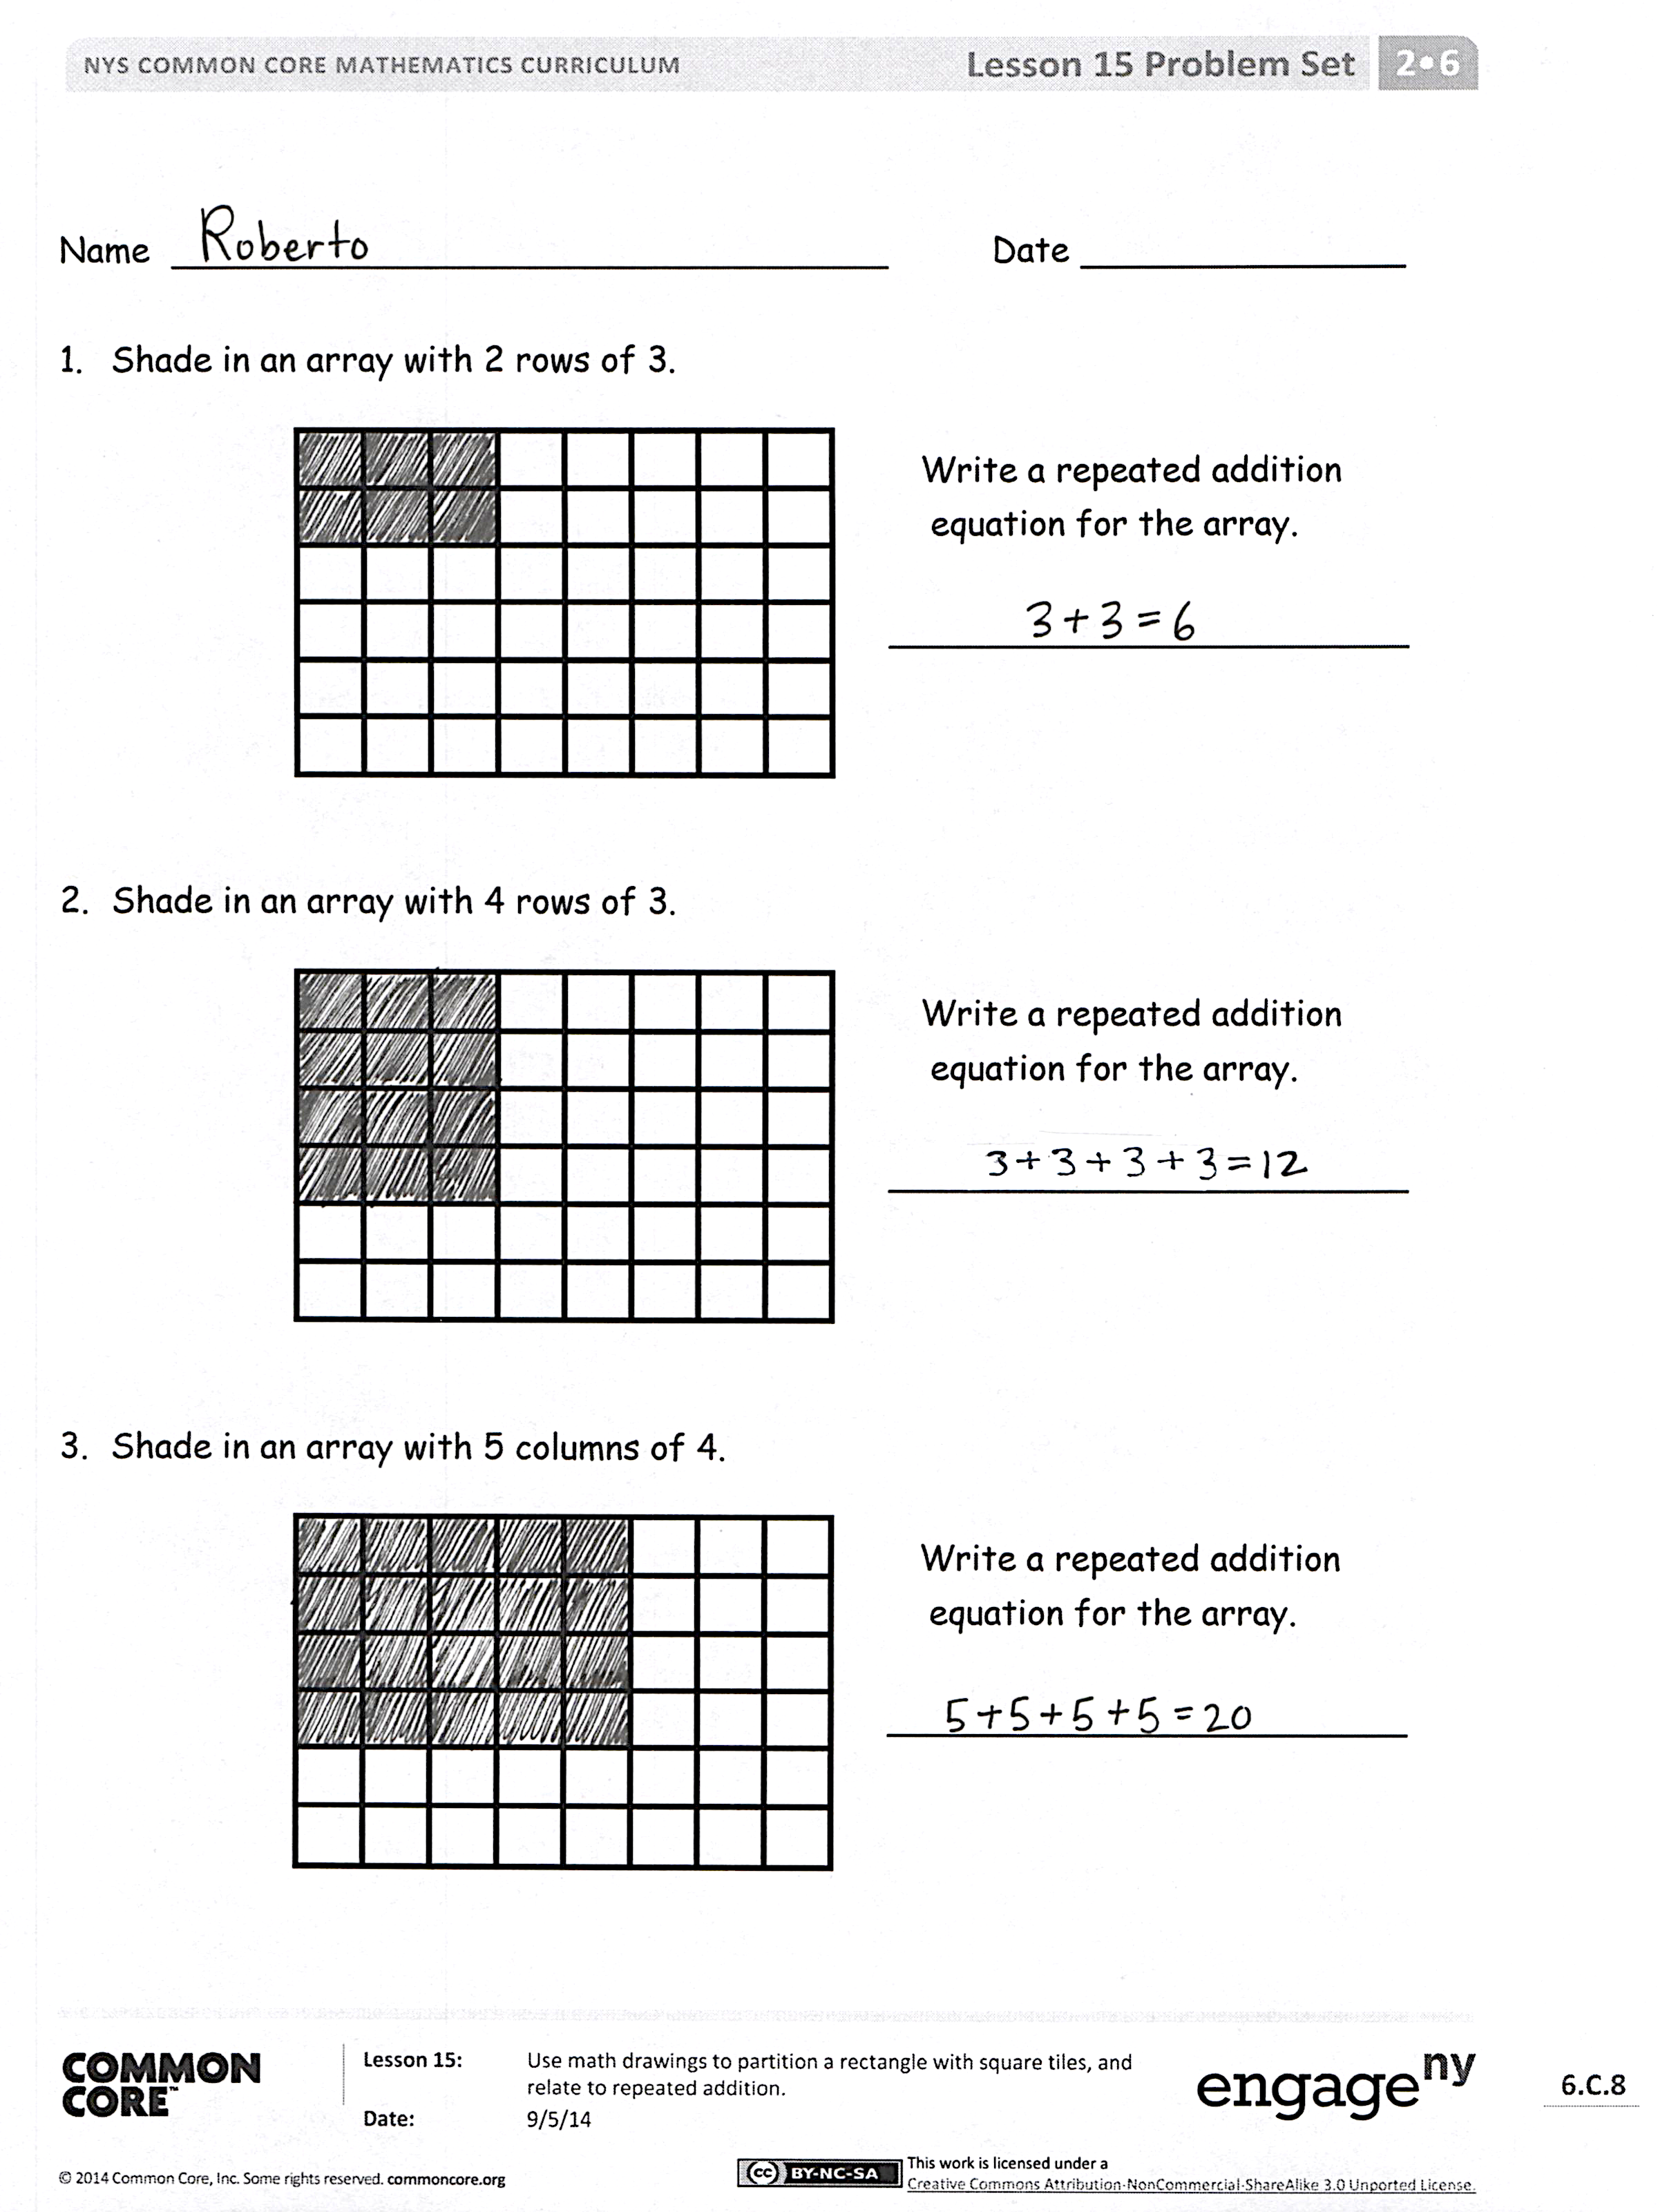
Student Debrief (10 minutes)
Lesson Objective: Use math drawings to partition a rectangle with square tiles, and relate to repeated addition.
The Student Debrief is intended to invite reflection and active processing of the total lesson experience.
Invite students to review their solutions for the Problem Set. They should check work by comparing answers with a partner before going over answers as a class. Look for misconceptions or misunderstandings that can be addressed in the Debrief. Guide students in a conversation to debrief the Problem Set and process the lesson.
Any combination of the questions below may be used to lead the discussion.
- In what way did your array change from Problem 1 to Problem 2? How did your equation change? How are the totals related?
- In Problem 3, each column is like a unit of how many? How does that relate to your equation?
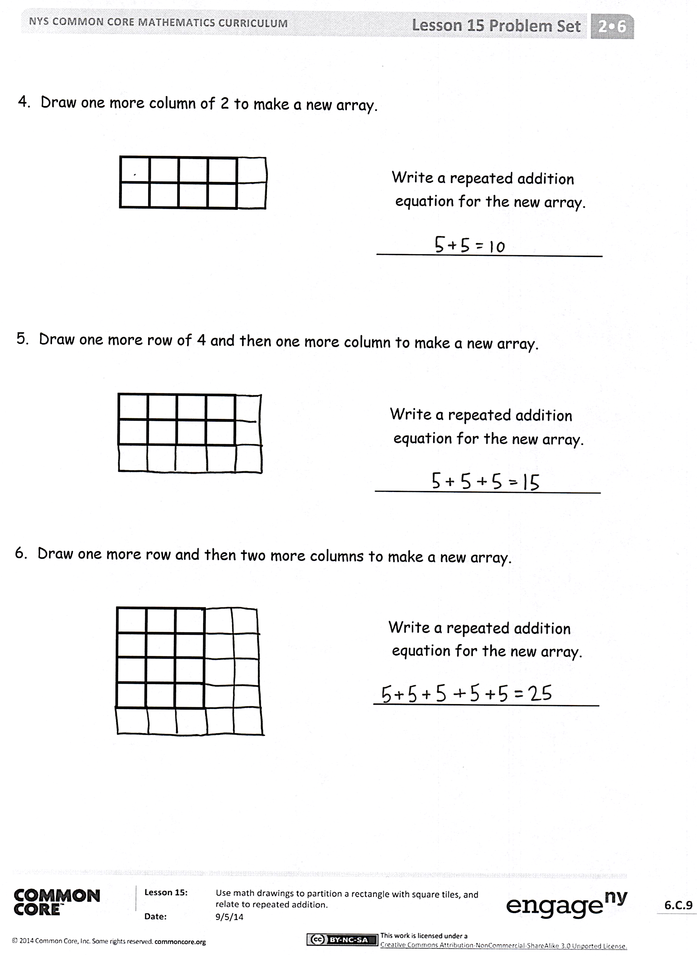
- For Problem 4, if you were to continue adding columns of 2, would your new array look more like a train or a tower? If you wanted to increase the total number of tiles quickly, would you suggest adding more rows or columns? Why?
- Why couldn’t you draw another column of 2 in Problem 5? Given what you know about rectangles, what did you need to be sure to do? Explain how you know that your equation is correct by matching it to your drawing.
- How many squares are in your 2 new columns in Problem 6? Why? In what way does this array show that big units are made up of smaller units? (Use rows, columns, square, and rectangle in your response.)
Exit Ticket (3 minutes)
After the Student Debrief, instruct students to complete the Exit Ticket. A review of their work will help with assessing students’ understanding of the concepts that were presented in today’s lesson and planning more effectively for future lessons. The questions may be read aloud to the students.

Number Correct: _______
A
Subtract Crossing the Ten
 | 10 – 1 = |  |  |  | 21 – 6 =
 | 10 – 2 = |  |  |  | 91 – 6 =
 | 20 – 2 = |  |  |  | 10 – 7 =
 | 40 – 2 = |  |  |  | 11 – 7 =
 | 10 – 2 = |  |  |  | 31 – 7 =
 | 11 – 2 = |  |  |  | 10 – 8 =
 | 21 – 2 = |  |  |  | 11 – 8 =
 | 51 – 2= |  |  |  | 41 – 8 =
 | 10 – 3 = |  |  |  | 10 – 9 =
 | 11 – 3 = |  |  |  | 11 – 9 =
 | 21 – 3 = |  |  |  | 51 – 9 =
 | 61 – 3 = |  |  |  | 12 – 3 =
 | 10 – 4 = |  |  |  | 82 – 3 =
 | 11 – 4 = |  |  |  | 13 – 5 =
 | 21 – 4 = |  |  |  | 78 – 5 =
 | 71 – 4 = |  |  |  | 14 – 6 =
 | 10 – 5 = |  |  |  | 84 – 6 =
 | 11 – 5 = |  |  |  | 15 – 8 =
 | 21 – 5 = |  |  |  | 95 – 8 =
 | 81 – 5 = |  |  |  | 16 – 7 =
 | 10 – 6 = |  |  |  | 46 – 7 =
 | 11 – 6 = |  |  |  | 68 – 9 =
Number Correct: _______
Improvement: _______
B
[KEY]

Subtract Crossing the Ten
 | 10 – 2 = |  |  |  | 21 – 6 =
 | 20 – 2 = |  |  |  | 41 – 6 =
 | 30 – 2 = |  |  |  | 10 – 7 =
 | 50 – 2 = |  |  |  | 11 – 7 =
 | 10 – 2 = |  |  |  | 51 – 7 =
 | 11 – 2 = |  |  |  | 10 – 8 =
 | 21 – 2 = |  |  |  | 11 – 8 =
 | 61 – 2 = |  |  |  | 61 – 8 =
 | 10 – 3 = |  |  |  | 10 – 9 =
 | 11 – 3 = |  |  |  | 11 – 9 =
 | 21 – 3 = |  |  |  | 31 – 9 =
 | 71 – 3 = |  |  |  | 12 – 3 =
 | 10 – 4 = |  |  |  | 92 – 3 =
 | 11 – 4 = |  |  |  | 13 – 5 =
 | 21 – 4 = |  |  |  | 43 – 5 =
 | 81 – 4 = |  |  |  | 14 – 6 =
 | 10 – 5 = |  |  |  | 64 – 6 =
 | 11 – 5 = |  |  |  | 15 – 8 =
 | 21 – 5 = |  |  |  | 85 – 8 =
 | 91 – 5 = |  |  |  | 16 – 7 =
 | 10 – 6 = |  |  |  | 76 – 7 =
 | 11 – 6 = |  |  |  | 58 – 9 =

Name Date
- Shade in an array with 2 rows of 3.

Write a repeated addition
equation for the array.

________________________

- Shade in an array with 4 rows of 3.

Write a repeated addition
equation for the array.

________________________

- Shade in an array with 5 columns of 4.

Write a repeated addition
equation for the array.

________________________

- Draw one more column of 2 to make a new array.

Write a repeated addition
equation for the new array.

________________________

- Draw one more row of 4, and then one more column to make a new array.

Write a repeated addition
equation for the new array.

________________________

- Draw one more row and then two more columns to make a new array.

Write a repeated addition
equation for the new array.

________________________

Name Date
Shade in an array with 3 rows of 5.

Write a repeated addition
equation for the array.

________________________

Name Date
- Shade in an array with 3 rows of 2.

Write a repeated addition
equation for the array.

________________________

- Shade in an array with 2 rows of 4.

Write a repeated addition
equation for the array.

________________________

- Shade in an array with 4 columns of 5.

Write a repeated addition
equation for the array.

________________________

- Draw one more column of 2 to make a new array.

Write a repeated addition
equation for the new array.

________________________

- Draw one more row of 3, and then one more column to make a new array.

Write a repeated addition
equation for the new array.

________________________

- Draw one more row and then two more columns to make a new array.

Write a repeated addition
equation for the new array.

________________________

