Lesson 14
Objective: Use scissors to partition a rectangle into same-size squares, and compose arrays with the squares.

Suggested Lesson Structure
 Fluency Practice (12 minutes)
 Concept Development (38 minutes)
 Student Debrief (10 minutes)
Total Time (60 minutes)
Fluency Practice (12 minutes)
- Sprint: Subtraction from Teens 2.OA.2 (8 minutes)
- Coin Drop 2.OA.2 (2 minutes)
- More and Less 2.NBT.5 (2 minutes)
Sprint: Subtraction from Teens (8 minutes)
Materials: (S) Subtraction from Teens Sprint
Note: Students practice subtraction from teens to gain mastery of the sums and differences within 20.
Coin Drop (2 minutes)
Materials: (T) 10 dimes, 10 pennies, metal or plastic can
Note: In this activity, students practice adding and subtracting ones and tens using coins in preparation for Module 7.
T: (Hold up a penny.) Name my coin.
S: A penny.
T: How much is it worth?
S: 1 cent.
T: Listen carefully as I drop coins in my can. Count along in your minds.
Drop in some pennies, and ask how much money is in the can. Take out some pennies, and show them. Ask how much money is still in the can. Continue adding and subtracting pennies for a minute or so. Repeat the activity with dimes and then with dimes and pennies.
More and Less (2 minutes)
Materials: (T) 10 dimes, 10 pennies
Note: In this activity, students practice adding and subtracting ones and tens using coins.
T: Let’s count by tens. (Move dimes to the side while counting.)
S: 10, 20, 30, 40, 50, 60.
T: How many dimes are shown?
S: 6 dimes.
T: What is the value of 6 dimes?
S: 60 cents.
T: What is 5 cents more? (Move 5 pennies.)
S: 65 cents.
T: Give the number sentence.
S: 60 cents + 5 cents = 65 cents.
T: What is 10 cents less? (Move one dime.)
S: 55 cents.
T: Give the number sentence.
S: 65 cents – 10 cents = 55 cents.
Repeat this line of questioning by starting with 7 dimes, removing 3 dimes, and asking for the number sentence. Continue by adding 3 pennies and asking for the number sentence, adding 4 dimes and asking for the number sentence, and so forth.
Concept Development (38 minutes)
Materials: (T) Rectangles (Template) (S) Rectangles (Template), Problem Set, scissors
In this lesson, the Problem Set is used during the Concept Development.

NOTES ON
MULTIPLE MEANS
OF ACTION AND EXPRESSION:
Assist students in using appropriate math vocabulary by providing a list of current words used in the module and adding to the list as new words are introduced. Post these words with definitions or illustrations prominently in the classroom, so students can refer to them during the lessons.

T: Today, we’re going to use the Problem Set for our lesson! We’ll use the sentence frames to record our answers and to speak in complete sentences.
Pass out the template, Problem Set, and scissors. For each step of the instructions, model as students work along with you. Circulate to be sure students are following the steps accurately.
T: Cut Rectangle A into rows, and complete Problem 1. Share your responses and thinking with your partner. (Allow students time to work and share.)

T: Cut Rectangle B into columns, and complete Problem 2. Share again.
T: Put both rectangles back together again, so there are no gaps or overlaps. Move the rows of Rectangle A so they are sitting directly above the columns of Rectangle B. Talk to your partner about what you notice.
MP.7
S: They both show the same amount, and they’re both the same size and shape. I can see the same rectangle different ways: It’s 2 rows of 4,
4 columns of 2, or 8 squares. They’re both made up of rows and columns with the same total.

NOTES ON
MULTIPLE MEANS
OF ENGAGEMENT:
If there are students who miss lessons in the module and others who struggle to grasp the concept, ask those who struggle to explain the array concepts to the previously absent students. This will help the students to clarify their thinking or discover what questions to ask to understand the concept better.

T: You’ve recognized that we can decompose the same rectangle into rows, columns, or individual square units.
T: Take both your rows of 4 and cut them to show 4 twos instead of 2 fours.
T: (Demonstrate as necessary.) Put together your twos to form one long rectangle that has 8 columns of 2.
T: Imagine we were going to put 2 rows on top to make the exact same rectangle. Talk to your partner. Explain what those rectangles would be.
S: I see it would be 2 rows of 8. We need 2 eights. They would be 2 of the long skinny rectangles.
T: We can decompose this rectangle into 2 rows of 8 or 8 columns of 2.
T: Cut out all your squares from Rectangles A and B. How many squares do you have now?
S: 16.
T: Use your 16 squares to answer Problem 3.
T: To answer Problem 4, cut out your squares from Rectangles A, B, and C.
Circulate as students experiment with their squares to form their rectangles. Ask them questions about each rectangle to support their spatial structuring, such as, “How many rows do you see in this rectangle?” or, “How many columns?” This lesson’s intent is to give practice in seeing the same rectangle both as rows and columns. It is important for students to work with more tiles to increase the complexity of the work. Encourage them to view the array with 24 squares as a rectangle rather than as 24 individual squares. Students who struggle can work with fewer squares.
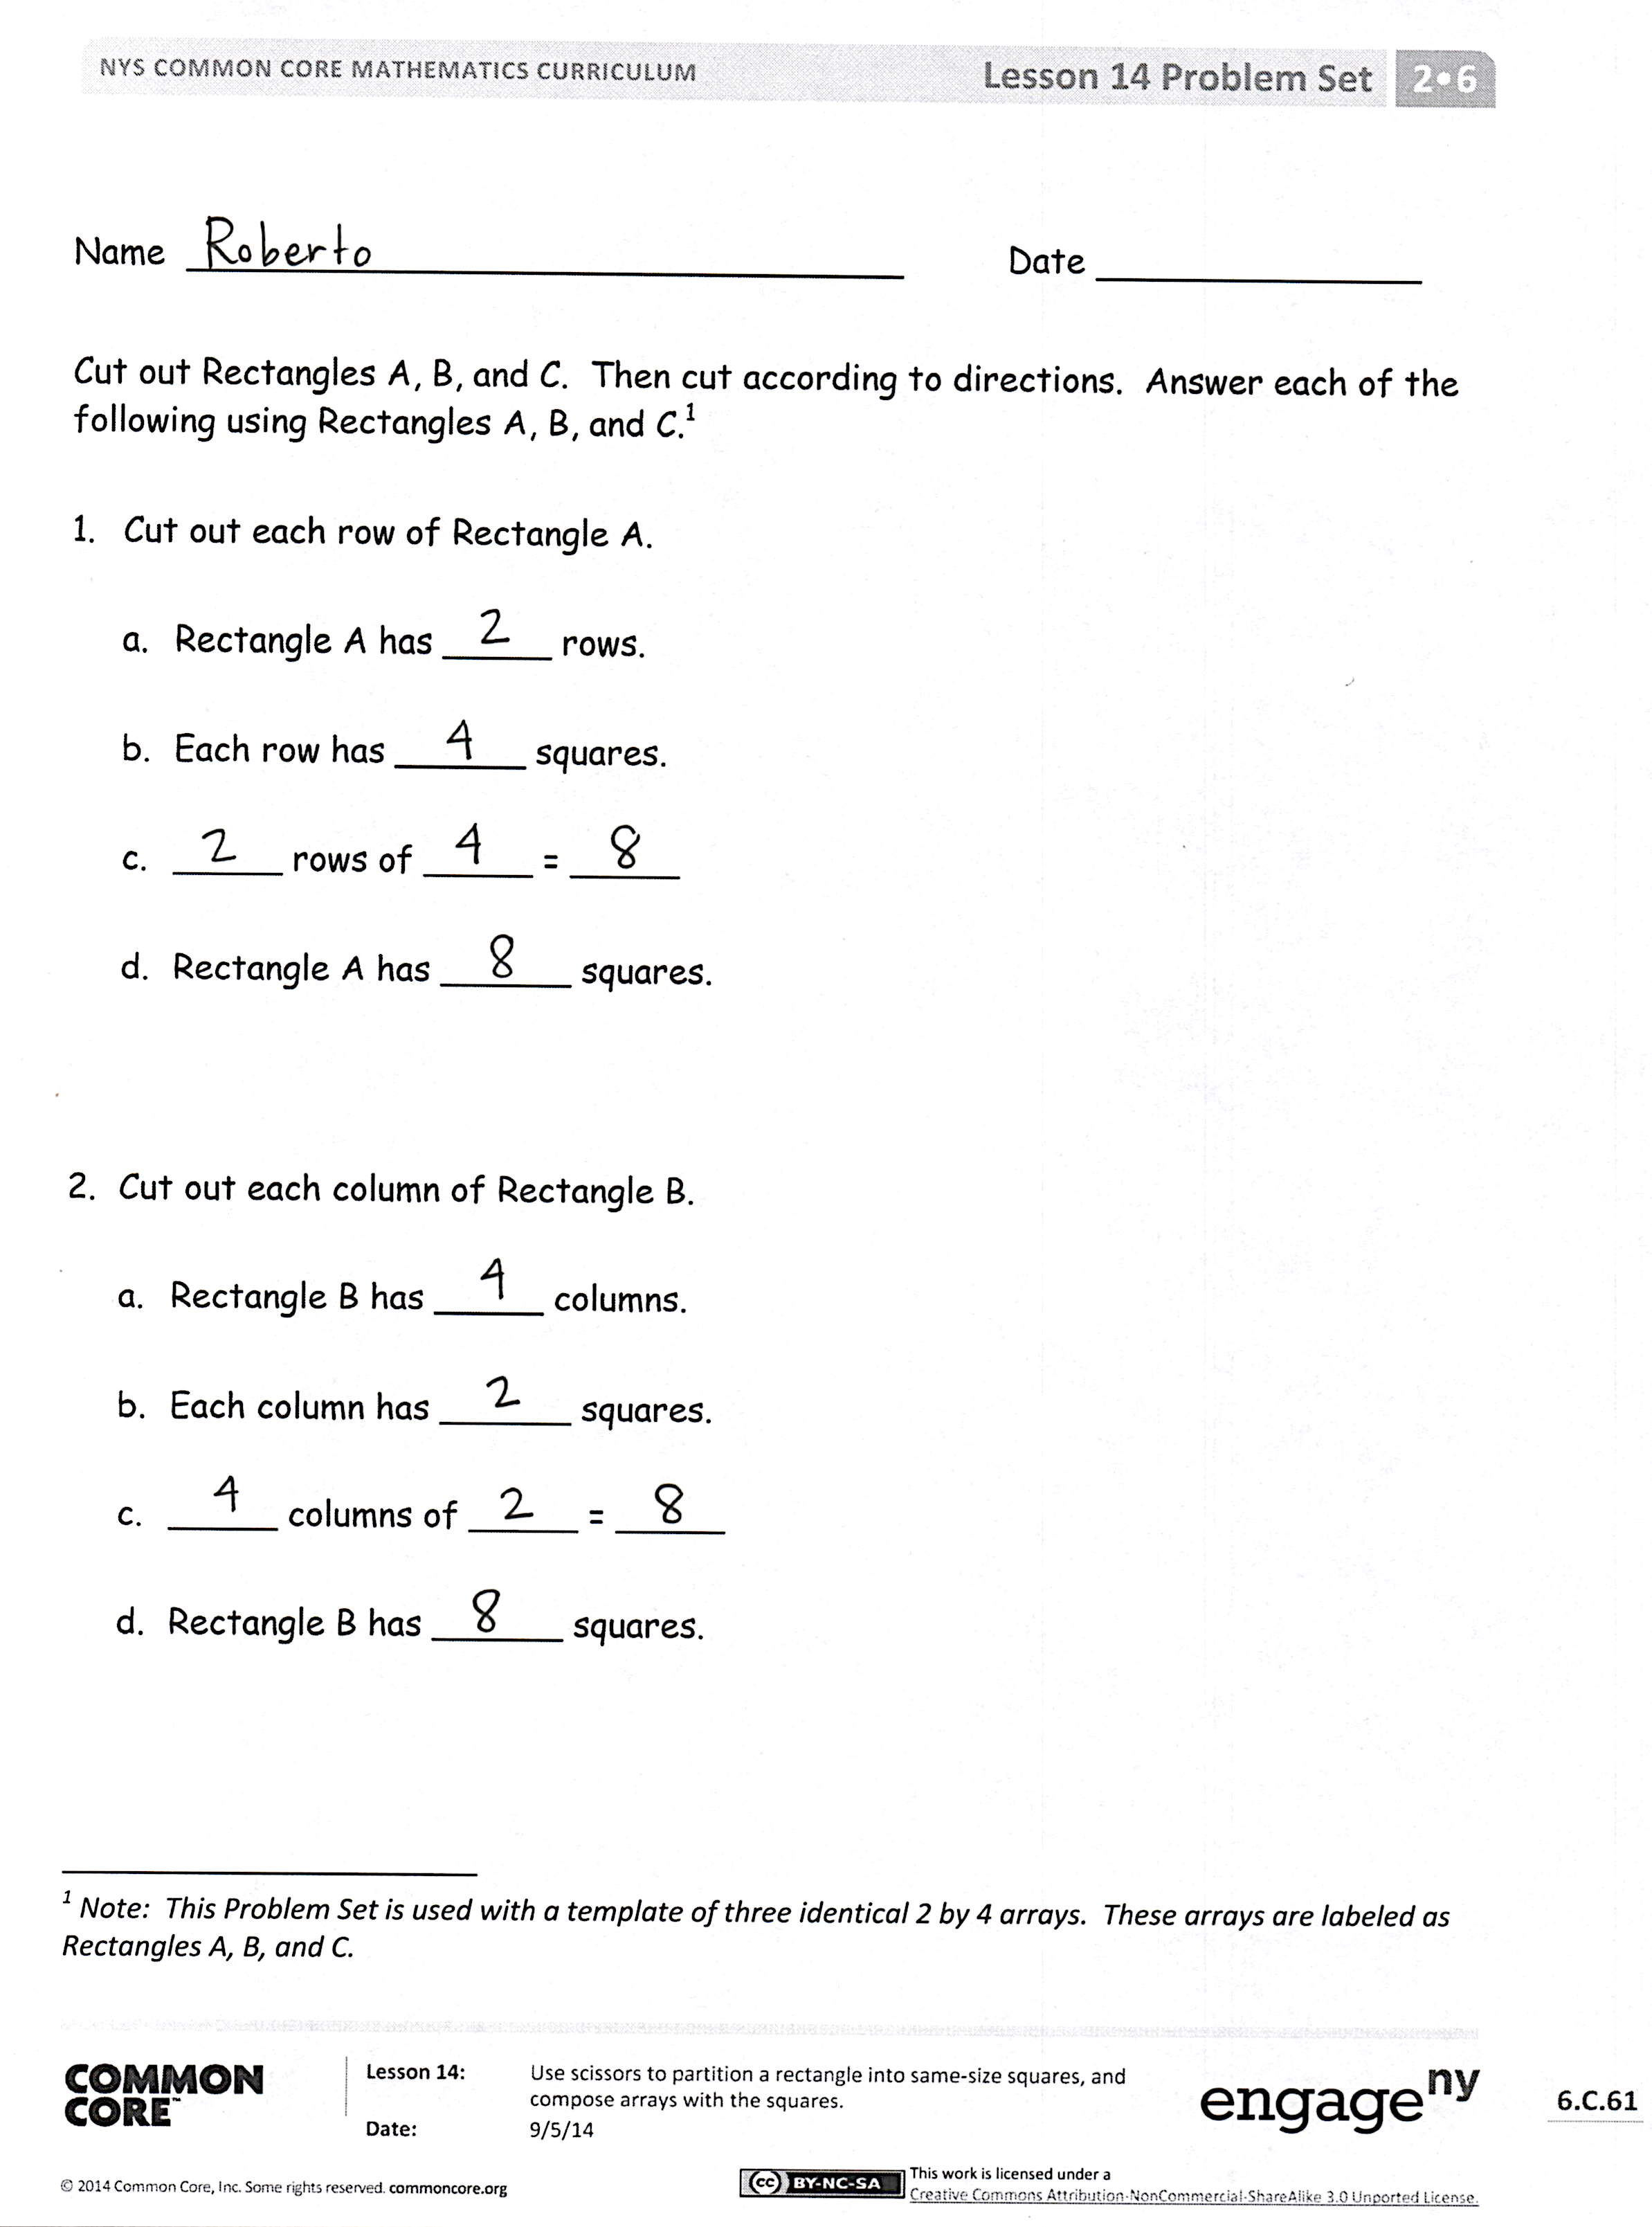
Student Debrief (10 minutes)
Lesson Objective: Use scissors to partition a rectangle into same-size squares, and compose arrays with the squares.
The Student Debrief is intended to invite reflection and active processing of the total lesson experience.
Invite students to review their solutions for the Problem Set. They should check work by comparing answers with a partner before going over answers as a class. Look for misconceptions or misunderstandings that can be addressed in the Debrief. Guide students in a conversation to debrief the Problem Set and process the lesson. At the end of the Debrief today, review and clarify the directions for the Homework to check for student understanding.
Any combination of the questions below may be used to lead the discussion.
- What did we learn about our rectangles by first cutting them into rows and columns before cutting out each individual square?
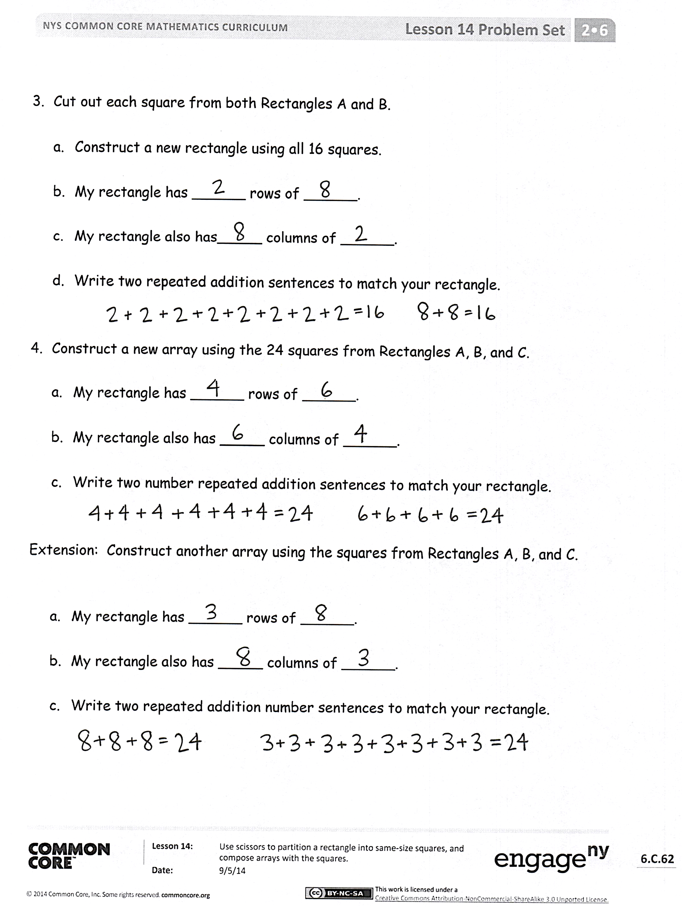
- If you were to write a repeated addition sentence to describe the work we did in Problem 2, what would it look like? Why? How does this relate to the columns you cut out?
- For Problem 3, what was your strategy for composing a new rectangle? How did the rows and columns change?
- For Problem 4, what strategy did you use to compose a new rectangle with 24 squares?
- How many different possibilities can you think of for composing a rectangle with 24 squares? How many different repeated addition sentences? How do they match the rows and columns of your array?
Exit Ticket (3 minutes)
After the Student Debrief, instruct students to complete the Exit Ticket. A review of their work will help with assessing students’ understanding of the concepts that were presented in today’s lesson and planning more effectively for future lessons. The questions may be read aloud to the students.
Number Correct: _______
A
Subtraction from Teens
 | 11 – 10 = |  |  |  | 19 – 9 =
 | 12 – 10 = |  |  |  | 15 – 6 =
 | 13 – 10 = |  |  |  | 15 – 7 =
 | 19 – 10 = |  |  |  | 15 – 9 =
 | 11 – 1 = |  |  |  | 20 – 10 =
 | 12 – 2 = |  |  |  | 14 – 5 =
 | 13 – 3 = |  |  |  | 14 – 6 =
 | 17 – 7 = |  |  |  | 14 – 7 =
 | 11 – 2 = |  |  |  | 14 – 9 =
 | 11 – 3 = |  |  |  | 15 – 5 =
 | 11 – 4 = |  |  |  | 17 – 8 =
 | 11 – 8 = |  |  |  | 17 – 9 =
 | 18 – 8 = |  |  |  | 18 – 8 =
 | 13 – 4 = |  |  |  | 16 – 7 =
 | 13 – 5 = |  |  |  | 16 – 8 =
 | 13 – 6 = |  |  |  | 16 – 9 =
 | 13 – 8 = |  |  |  | 17 – 10 =
 | 16 – 6 = |  |  |  | 12 – 8 =
 | 12 – 3 = |  |  |  | 18 – 9 =
 | 12 – 4 = |  |  |  | 11 – 9 =
 | 12 – 5 = |  |  |  | 15 – 8 =
 | 12 – 9 = |  |  |  | 13 – 7 =
Number Correct: _______
Improvement: _______
B
[KEY]

Subtraction from Teens
 | 11 – 1 = |  |  |  | 16 – 6 =
 | 12 – 2 = |  |  |  | 14 – 5 =
 | 13 – 3 = |  |  |  | 14 – 6 =
 | 18 – 8 = |  |  |  | 14 – 7 =
 | 11 – 10 = |  |  |  | 14 – 9 =
 | 12 – 10 = |  |  |  | 20 – 10 =
 | 13 – 10 = |  |  |  | 15 – 6 =
 | 18 – 10 = |  |  |  | 15 – 7 =
 | 11 – 2 = |  |  |  | 15 – 9 =
 | 11 – 3 = |  |  |  | 14 – 4 =
 | 11 – 4 = |  |  |  | 16 – 7 =
 | 11 – 7 = |  |  |  | 16 – 8 =
 | 19 – 9 = |  |  |  | 16 – 9 =
 | 12 – 3 = |  |  |  | 20 – 10 =
 | 12 – 4 = |  |  |  | 17 – 8 =
 | 12 – 5 = |  |  |  | 17 – 9 =
 | 12 – 8 = |  |  |  | 16 – 10 =
 | 17 – 7 = |  |  |  | 18 – 9 =
 | 13 – 4 = |  |  |  | 12 – 9 =
 | 13 – 5 = |  |  |  | 13 – 7 =
 | 13 – 6 = |  |  |  | 11 – 8 =
 | 13 – 9 = |  |  |  | 15 – 8 =

Name Date
Cut out Rectangles A, B, and C. Then, cut according to directions. Answer each of the following using Rectangles A, B, and C.

- Cut out each row of Rectangle A.

  - Rectangle A has _____ rows.

  - Each row has ______ squares.

  - _____ rows of _____ = _____

  - Rectangle A has ______ squares.

- Cut out each column of Rectangle B.

  - Rectangle B has _____ columns.

  - Each column has ______ squares.

  - _____ columns of _____ = _____

  - Rectangle B has ______ squares.

- Cut out each square from both Rectangles A and B.
  - Construct a new rectangle using all 16 squares.

  - My rectangle has ______ rows of ______.

  - My rectangle also has _____ columns of ______.

  - Write two repeated addition sentences to match your rectangle.

- Construct a new array using the 24 squares from Rectangles A, B, and C.
  - My rectangle has ______ rows of ______.

  - My rectangle also has _____ columns of ______.

  - Write two number repeated addition sentences to match your rectangle.

Extension: Construct another array using the squares from Rectangles A, B, and C.
  - My rectangle has ______ rows of ______.

  - My rectangle also has _____ columns of ______.

  - Write two repeated addition number sentences to match your rectangle.

Name Date
With your tiles, show 1 rectangle with 12 squares. Complete the sentences below.
I see _____ rows of ____.
In the exact same rectangle, I see _____ columns of _____.

Name Date
- Imagine that you have just cut this rectangle into rows.
  - What do you see? Draw a picture.

How many squares are in each row? _______

  - Imagine that you have just cut this rectangle into columns. What do you see? Draw a picture.

How many squares are in each column? _______

- Create another rectangle using the same number of squares.

How many squares are in each row? _______
How many squares are in each column? ______

- Imagine that you have just cut this rectangle into rows.
- What do you see? Draw a picture.

How many squares are in each row? _______

- Imagine that you have just cut this rectangle into columns. What do you see? Draw a picture.

How many squares are in each column? _______

- Create another rectangle using the same number of squares.

How many squares are in each row? _______
How many squares are in each column? ______

Rectangle A

Rectangle B

Rectangle C

Note: This Problem Set is used with a template of three identical 2 by 4 arrays. These arrays are labeled as Rectangles A, B, and C.
rectangles

