Lesson 13
Objective: Use square tiles to decompose a rectangle.

Suggested Lesson Structure
 Fluency Practice (10 minutes)
 Concept Development (33 minutes)
 Application Problem (7 minutes)
 Student Debrief (10 minutes)
Total Time (60 minutes)
Fluency Practice (10 minutes)
- Making the Next Ten to Add 2.OA.2, 2.NBT.5 (5 minutes)
- Grade 2 Core Fluency Practice Sets 2.OA.2 (5 minutes)
Making the Next Ten to Add (5 minutes)
Note: This fluency activity reviews making a ten to add.
T: When I say 9 + 4, you say 10 + 3. Ready? 9 + 4.
S: 10 + 3.
T: Answer.
S: 13.
Continue with the following possible sequences:
19 + 4, 29 + 4, 29 +14, 59 + 14 9 + 6, 19 + 6, 19 + 16, 49 + 16 8 + 3, 18 + 3, 18 + 13
8 + 5, 18 + 5, 18 + 15, 38 + 15 7 + 6, 17 + 6, 17 + 16, 37 + 16 7 + 4, 17 + 4, 67 + 4
Grade 2 Core Fluency Practice Sets (5 minutes)
Materials: (S) Core Fluency Practice Sets (G2−M6−Lesson 12 Core Fluency Practice Sets)
Note: During Topic C and for the remainder of the year, each day’s fluency activities include an opportunity for review and mastery of the sums and differences with totals through 20 by means of the Core Fluency Practice Sets or Sprints. Practice Sets, along with details about the process, are provided in Lesson 12.

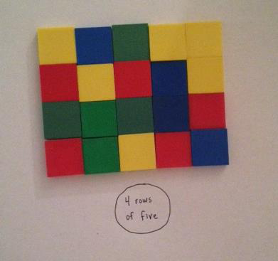
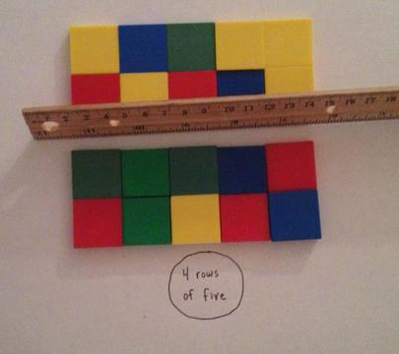
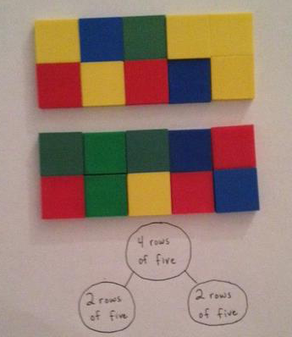
Concept Development (33 minutes)
Materials: (T/S) 25 square tiles, personal white board, ruler, square tiles (Template)
For the following Concept Development, model the work for students using an overhead projector or document camera.
T: With your partner, use the tiles to construct a rectangle with 4 rows of 5 on your personal white board. Tell your partner the total number of tiles in your rectangle and how you know.
T: (Model a rectangle with 4 rows of 5 using the overhead projector.)
S: There are 20 tiles because 5 + 5 + 5 + 5 = 20. 20 because 4 + 4 + 4 + 4 + 4 = 20.
T: Write the number of rows and the number in each row as the whole in your number bond as I do. (Model writing 4 rows of 5 under the rectangle.)
S: (Write 4 rows of 5, as pictured.)
T: Turn and talk: How can we decompose this rectangle into two equal parts?
S: I know that 10 + 10 makes 20, so we could put 10 on one side and 10 on the other. If we split it across the middle like how we spread out the rows of lima beans with a ruler, we can make it half and half. Two equal parts would be 2 rows of 5 on one side and 2 rows of 5 on the other.
T: Use your ruler to break your rectangle into two equal parts as I do. (Model using the ruler to split the rectangle.)
T: (Circulate as students decompose the rectangle as pictured.)
T: How many rows do you have in each part?
S: Two rows!
T: How many tiles in each row?
S: 5 tiles!
T: Write 2 rows of 5 for each part of your number bond.
T: (Model writing 2 rows of 5 in each part of the number bond.)
T: If 5 + 5 + 5 + 5 represented the rectangle before we decomposed it, what number sentence can you use to describe each part?
S: 5 + 5 = 10.
T: Write 5 + 5 = 10 below the parts of the number bond. (Model writing the number sentences under each part.)
S: (Write number sentences.)
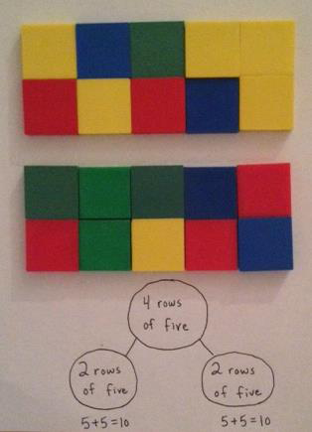
T: Tell your partner the two parts and the whole using a number sentence.
S: Two rows of 5 and 2 rows of 5 make 4 rows of 5.
Repeat the process with 6 columns of 2, decomposing by columns rather than by rows.
T: With your partner, count out 16 tiles. Then, construct a rectangle on your desk with 4 rows.
MP.7
T: (Circulate as students work.)
T: How many rows did you make?
S: 4 rows!
T: How many tiles are in each row?
S: 4 tiles!
T: Say the repeated addition sentence.
S: 4 + 4 + 4 + 4 =16.
T: What do 4 rows of 4 equal?
S: 16.
T: Take away a row.
T: Turn and talk: What is the new total for the rectangle and how do you know?

NOTES ON
MULTIPLE MEANS
OF ACTION AND EXPRESSION:
Some students will be able to express their arrays in multiplication number sentences and will be eager to show off their expertise. Encourage them to write both types of number sentences and share how they know with another student.
S: 12 because 4 + 4 + 4 = 12. 12 because 16 – 4 = 12. 3 fours is 12.
T: Remove one column.
T: Turn and talk: How many tiles do you have now, and how do you know?
S: 9 because there are 3 rows of 3 and 3 + 3 + 3 = 9.
I see 3 threes and that’s 9. 9, because 12 – 3 = 9.
Repeat the above process with a rectangle of 25 tiles.
Problem Set (10 minutes)
Students should do their personal best to complete the Problem Set within the allotted 10 minutes. For some classes, it may be appropriate to modify the assignment by specifying which problems they work on first. Some problems do not specify a method for solving. Students should solve these problems using the RDW approach used for Application Problems.

Application Problem (7 minutes)
Note: This Application Problem provides an opportunity for students to apply understandings from today’s lesson, so it follows the Concept Development. If necessary, provide manipulatives for students to use when solving the problem.
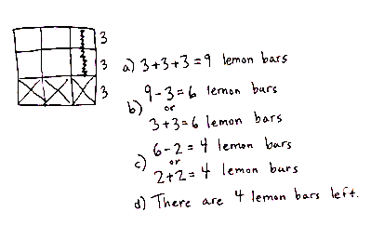
Ellie bakes a square pan of lemon bars, which she cut into nine equal pieces. Her brothers eat 1 row of her treats. Then, her mom eats 1 column.
- Draw a picture of Ellie’s lemon bars before any are eaten. Write a number sentence to show how to find the total.
- Write an X on the bars that her brothers eat. Write a new number sentence to show how many are left.
- Draw a line through the bars that her mom eats. Write a new number sentence to show how many are left.
- How many bars are left? Write a statement.
Student Debrief (10 minutes)
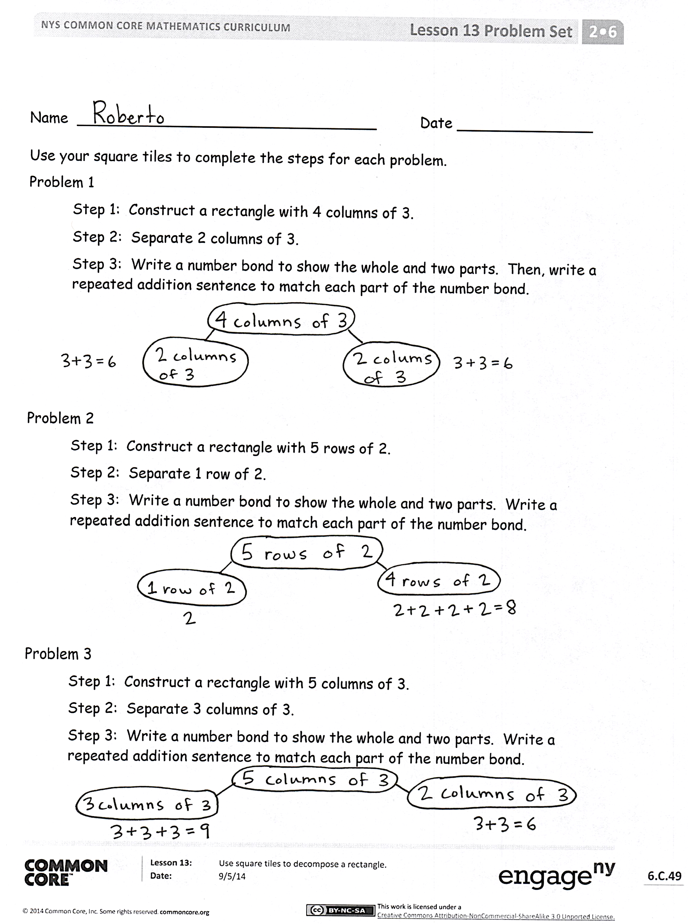
Lesson Objective: Use square tiles to decompose a rectangle.
The Student Debrief is intended to invite reflection and active processing of the total lesson experience.
Invite students to review their solutions for the Problem Set. They should check work by comparing answers with a partner before going over answers as a class. Look for misconceptions or misunderstandings that can be addressed in the Debrief. Guide students in a conversation to debrief the Problem Set and process the lesson.
Any combination of the questions below may be used to lead the discussion.
- How does your number bond show how you decomposed, or broke apart, your rectangle in Problem 1?
- In Problem 2, what do you notice is the same in the whole and parts of your number bond?
(A unit of two.) How does your repeated addition sentence change without one row?
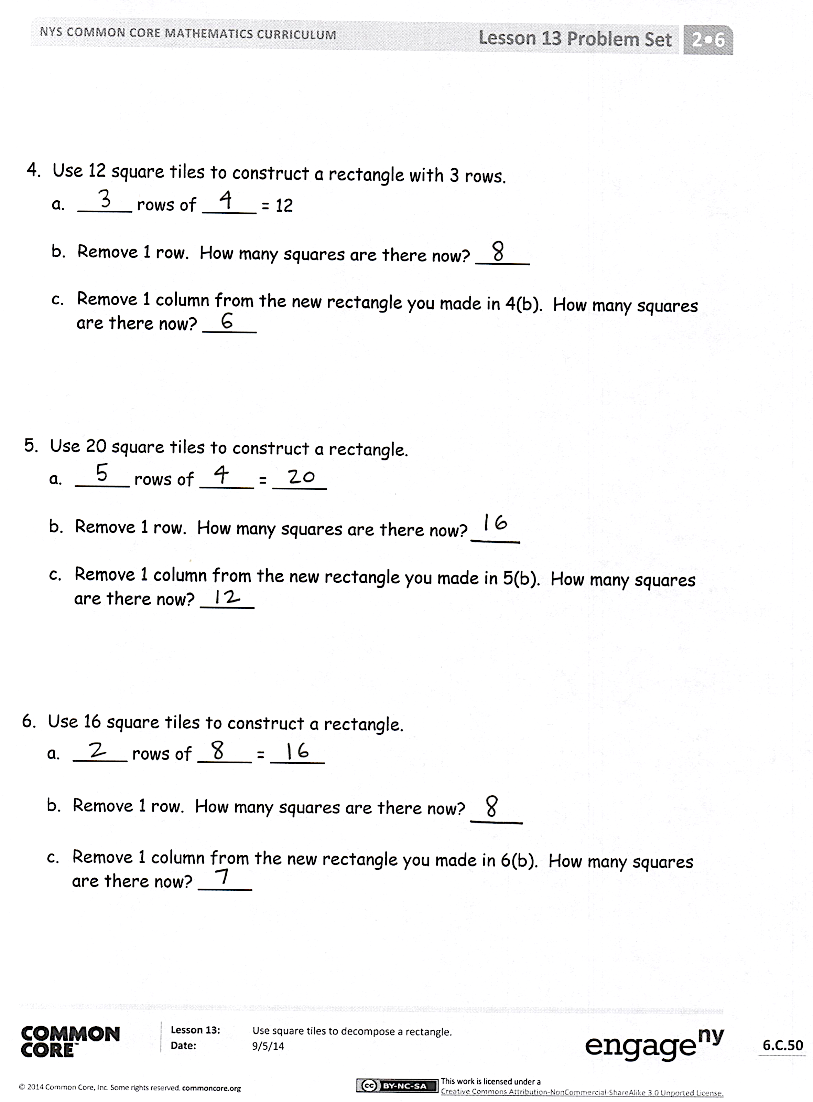
- In Problem 3, defend how you know that a rectangle can be decomposed into smaller rectangles. Describe the two smaller rectangles that you found in 5 columns of 3. Use the terms rows, columns, units, and repeated addition.
- What was your strategy for composing a rectangle with 12 squares for Problem 4? How many different possibilities are there?
- For Problem 5, how is removing a row from a rectangle with 2 rows of 10 different from removing a row from 5 rows of 4? Which one will leave you with more squares?
- For Problem 6, share with a partner all of the different ways that you could break apart a rectangle made up of 16 square tiles.
Exit Ticket (3 minutes)
After the Student Debrief, instruct students to complete the Exit Ticket. A review of their work will help with assessing students’ understanding of the concepts that were presented in today’s lesson and planning more effectively for future lessons. The questions may be read aloud to the students.

Name Date
Use your square tiles to complete the steps for each problem.
Problem 1
Step 1: Construct a rectangle with 4 columns of 3.
Step 2: Separate 2 columns of 3.
Step 3: Write a number bond to show the whole and two parts. Then, write a repeated addition sentence to match each part of the number bond.

Problem 2
Step 1: Construct a rectangle with 5 rows of 2.
Step 2: Separate 1 row of 2.
Step 3: Write a number bond to show the whole and two parts. Write a repeated addition sentence to match each part of the number bond.

Problem 3
Step 1: Construct a rectangle with 5 columns of 3.
Step 2: Separate 3 columns of 3.
Step 3: Write a number bond to show the whole and two parts. Write a repeated addition sentence to match each part of the number bond.

- Use 12 square tiles to construct a rectangle with 3 rows.
- _____ rows of _____ = 12
- Remove 1 row. How many squares are there now? _____
- Remove 1 column from the new rectangle you made in 4(b). How many squares are there now? _____

- Use 20 square tiles to construct a rectangle.
- _____ rows of _____ = _____
- Remove 1 row. How many squares are there now? _____
- Remove 1 column from the new rectangle you made in 5(b). How many squares are there now? _____

- Use 16 square tiles to construct a rectangle.
- _____ rows of _____ = _____
- Remove 1 row. How many squares are there now? _____
- Remove 1 column from the new rectangle you made in 6(b). How many squares are there now? _____
Name Date
Use your square tiles to complete the steps for each problem.
Step 1: Construct a rectangle with 3 columns of 4.
Step 2: Separate 2 columns of 4.
Step 3: Write a number bond to show the whole and two parts. Write a repeated addition sentence to match each part of the number bond.
Name Date
Cut out and use your square tiles to complete the steps for each problem.
Problem 1
Step 1: Construct a rectangle with 5 rows of 2.
Step 2: Separate 2 rows of 2.
Step 3: Write a number bond to show the whole and two parts. Write a repeated addition sentence to match each part of your number bond.

Problem 2
Step 1: Construct a rectangle with 4 columns of 3.
Step 2: Separate 2 columns of 3.
Step 3: Write a number bond to show the whole and two parts. Write a repeated addition sentence to match each part of your number bond.

- Use 9 square tiles to construct a rectangle with 3 rows.
  - _____ rows of _____ = _____
  - Remove 1 row. How many squares are there now? _____
  - Remove 1 column from the new rectangle you made in 3(b). How many squares are there now? _____

- Use 14 square tiles to construct a rectangle.
  - _____ rows of _____ = _____
  - Remove 1 row. How many squares are there now? _____
  - Remove 1 column from the new rectangle you made in 4(b). How many squares are there now? _____

square tiles

