Lesson 12
Objective: Use math drawings to compose a rectangle with square tiles.

Suggested Lesson Structure
 Fluency Practice (10 minutes)
 Concept Development (34 minutes)
 Application Problem (6 minutes)
 Student Debrief (10 minutes)
Total Time (60 minutes)
Fluency Practice (10 minutes)
- Compensation 2.NBT.5 (5 minutes)
- Grade 2 Core Fluency Practice Sets 2.OA.2 (5 minutes)
Compensation (5 minutes)
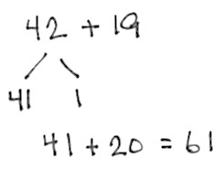
Note: This activity reviews the mental math strategy of compensation. By making a multiple of 10, students solve a much simpler addition problem. Draw a number bond for the first problem on the board to help students visualize the decomposition.
T: (Write 42 + 19 = _____.) Let’s use a mental math strategy to add. How much more does 19 need to make the next ten?
S: 1 more.
T: Where can 19 get 1 more from?
S: From the 42.
T: Take 1 from 42 and give it to 19. Say the new simplified number sentence with the answer.
S: 41 + 20 = 61.
T: So, 42 + 19 is…?
S: 61.
T: 37 + 19.
S: 36 + 20 = 56.
Continue with the following possible sequence: 29 + 23, 38 + 19, 52 + 19, 24 + 18, and 34 + 28.

Grade 2 Core Fluency Practice Sets (5 minutes)
Materials: (S) Core Fluency Practice Sets
Note: During Topic C and for the remainder of the year, each day’s fluency activities include an opportunity for review and mastery of the sums and differences with totals through 20 by means of the Core Fluency Practice Sets or Sprints. Five options are provided in this lesson for the Core Fluency Practice Set, with Set A being the most simple and Set E being the most complex. Start all students on Set A.
Students complete as many problems as they can in 120 seconds. We recommend 100% accuracy and completion before moving to the next level. Collect any Practice Sets that have been completed within the 120 seconds, and check the answers. The next time Core Fluency Practice Sets are used, students who have successfully completed their set can be provided with the next level. Keep a record of student progress.
NOTES ON
MULTIPLE MEANS
OF REPRESENTATION:
Offer grid paper to students who need extra support to draw the grids. If the paper at your disposal does not match the size of your tiles, measure the tiles, and use a computer or pencil and ruler to create a custom grid that can be duplicated.
Students who have trouble drawing around small objects such as the tiles may work better with patty paper.

Consider assigning early finishers a counting pattern and start number (e.g., count by fives from 195). Celebrate improvement as well as advancement. Students should be encouraged to compete with themselves rather than their peers. Discuss with students possible strategies to solve. Notify caring adults of each student’s progress.
Important note: These Practice Sets are different from the Practice Sets used in Topic A.
Concept Development (34 minutes)
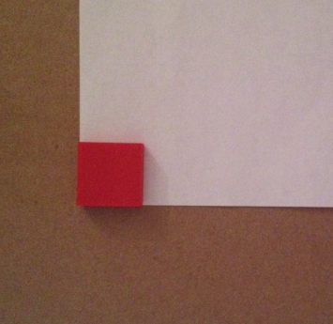
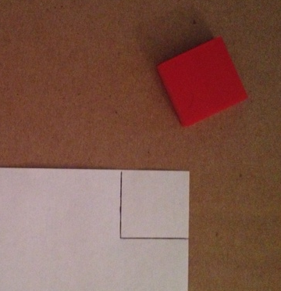
Materials: (T) 1 1-inch tile, plain white paper (S) 6 1-inch tiles, plain white paper
Note: For this lesson, students may convene in a circle on the floor with clipboards (or another solid work surface), or they may remain at their seats if there is a document camera or projector available.
Part 1: Trace a unit square to draw an array.
T: Make an array with 2 rows of 3 on your paper using the tiles in your bag.
S: (Create a 2 by 3 array.)
T: To draw the same array, we can trace the tile 3 times to make a row, and then trace to make another row underneath.
T: Remove the tiles from your paper. Using one tile, make a square in the very top left corner of your paper like I do.
T: We can use the edge of the paper as one of our lines to help keep the array straight.
S: (Draw first square as shown.)
T: Turn and talk: What should we do next to create 2 rows of 3?
S: Make another square in the top row. Make a square underneath the first one to start the second row.
T: We could do it either way. For now, let’s finish the row of 3, just as we did when we were building arrays row by row. Add two more squares by tracing your tile as I do.
T: (Complete the first row as students do the same.)
T: Turn and talk: What is our next step?
S: Add another row. Trace a tile on the bottom to start the second row.
T: Let’s try that. Add another square just below the first one. Do we need to trace the entire square?
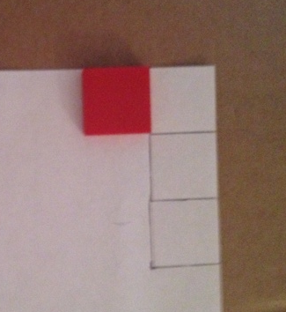
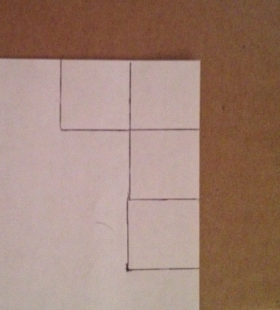
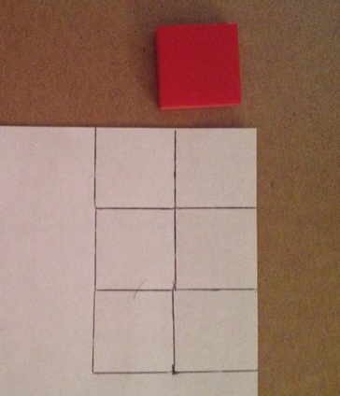
S: No!
T: Why not?
S: The bottom line from the first square will be the top line of this square!
T: Draw what I draw. (Add the first square in the second row as pictured.)
T: How many more squares do we need to complete this array?
S: 2.
T: Add the last two squares as I do. (Complete the array as pictured.)
S: (Complete arrays.)
T This process reminds me of creating our rulers. How is it the same? Talk to your partner.
S: We are repeating a unit. We are using a tool to help us make the spaces the same. We are measuring using the mark and advance technique but going down, too!
T: I hear good observations. This time, we are making a unit that is a square. Before, we were making a length unit.
Have students repeat the above process independently to create an array that is 2 units wide and 4 units long, below the first array. This time, the side of the paper will guide them. Then, distribute another piece of paper.
Part 2: Draw an array without the use of a tile.
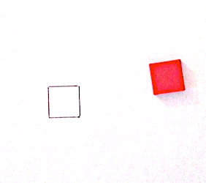

NOTES ON
MULTIPLE MEANS
OF ACTION AND EXPRESSION:
Model this process outdoors, drawing with sidewalk chalk on pavement around foam squares or a square piece of construction paper.

T: This time, we will draw most of the array without the tile. To start, let’s make one square in the middle of the page. (Model tracing to make one square in the middle of the page as pictured.)
T: Let’s start with the top side of the next square. Tell me when to stop drawing. (Make the line as pictured above.)
S: Stop!
T: Is the length of the line about the same length as the first tile?
S: Yes!
T: Your turn. Draw that line on your paper.
T: Let’s draw the bottom of the square. Again, say when to stop. (Add the line as pictured.)
S: Stop!
T: Is the bottom line the same length as the top line?
S: Yes!
T: Add that line to your drawing.
T: Let’s close the square by making a third line. (Add the last line of the square as pictured.)
T: Does the square I drew look pretty much the same as the square I traced?
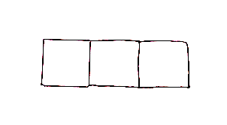
S: Yes!
T: Now, it’s your turn. Complete your square on your paper.
S: (Draw the line to close the square.)
T: How many more squares do we need in this row to make 1 row of 3?
S: 1.
T: Draw one more square the way we made the last one. Then, hold your paper up with two hands for me to see.
T: (Check student work.)
T: Let’s start the second line together.
T: I will draw the line, and you say when to stop. (Add another line to start the first square in the second row.)
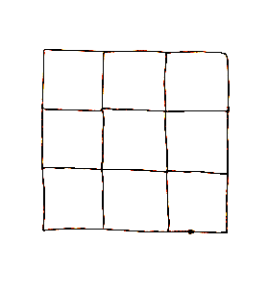
S: Stop!
T: Is this line the same length as the side of the first square?
S: Yes!
T: Add that line to your drawing. (Circulate.)
S: (Draw.)
T: Work to draw 3 rows of 3 squares.
T: What shape did you end up making?
S: A square!
T: What shape had you made after making 2 rows of 3?
S: A rectangle!
Check student work before moving on. When students are ready, have them finish the second row of the array independently. If more practice is needed, have them complete an array with 2 rows of 5, offering support when needed. Otherwise, move students directly to the Problem Set and then to the Application Problem.

Problem Set (10 minutes)
Students should do their personal best to complete the Problem Set within the allotted 10 minutes. For some classes, it may be appropriate to modify the assignment by specifying which problems they work on first. Some problems do not specify a method for solving. Students should solve these problems using the RDW approach used for Application Problems.
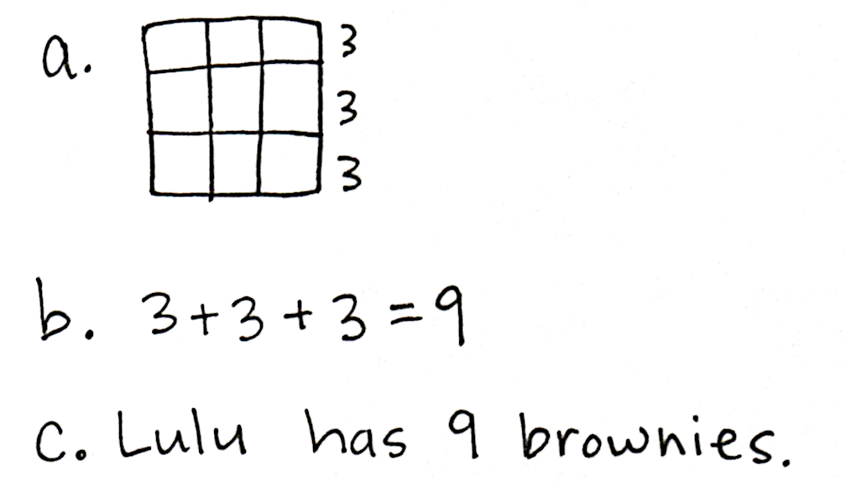
Application Problem (6 minutes)
Note: This Application Problem serves as a practice of the previous day’s lesson. The extension, however, invites students to apply understandings from today’s lesson as well. For this reason, it follows the Concept Development.
Lulu made a pan of brownies. She cut them into 3 rows and 3 columns.
MP.3
- Draw a picture of Lulu’s brownies in the pan.

- Write a number sentence to show how many brownies Lulu has.
- Write a statement about Lulu’s brownies.
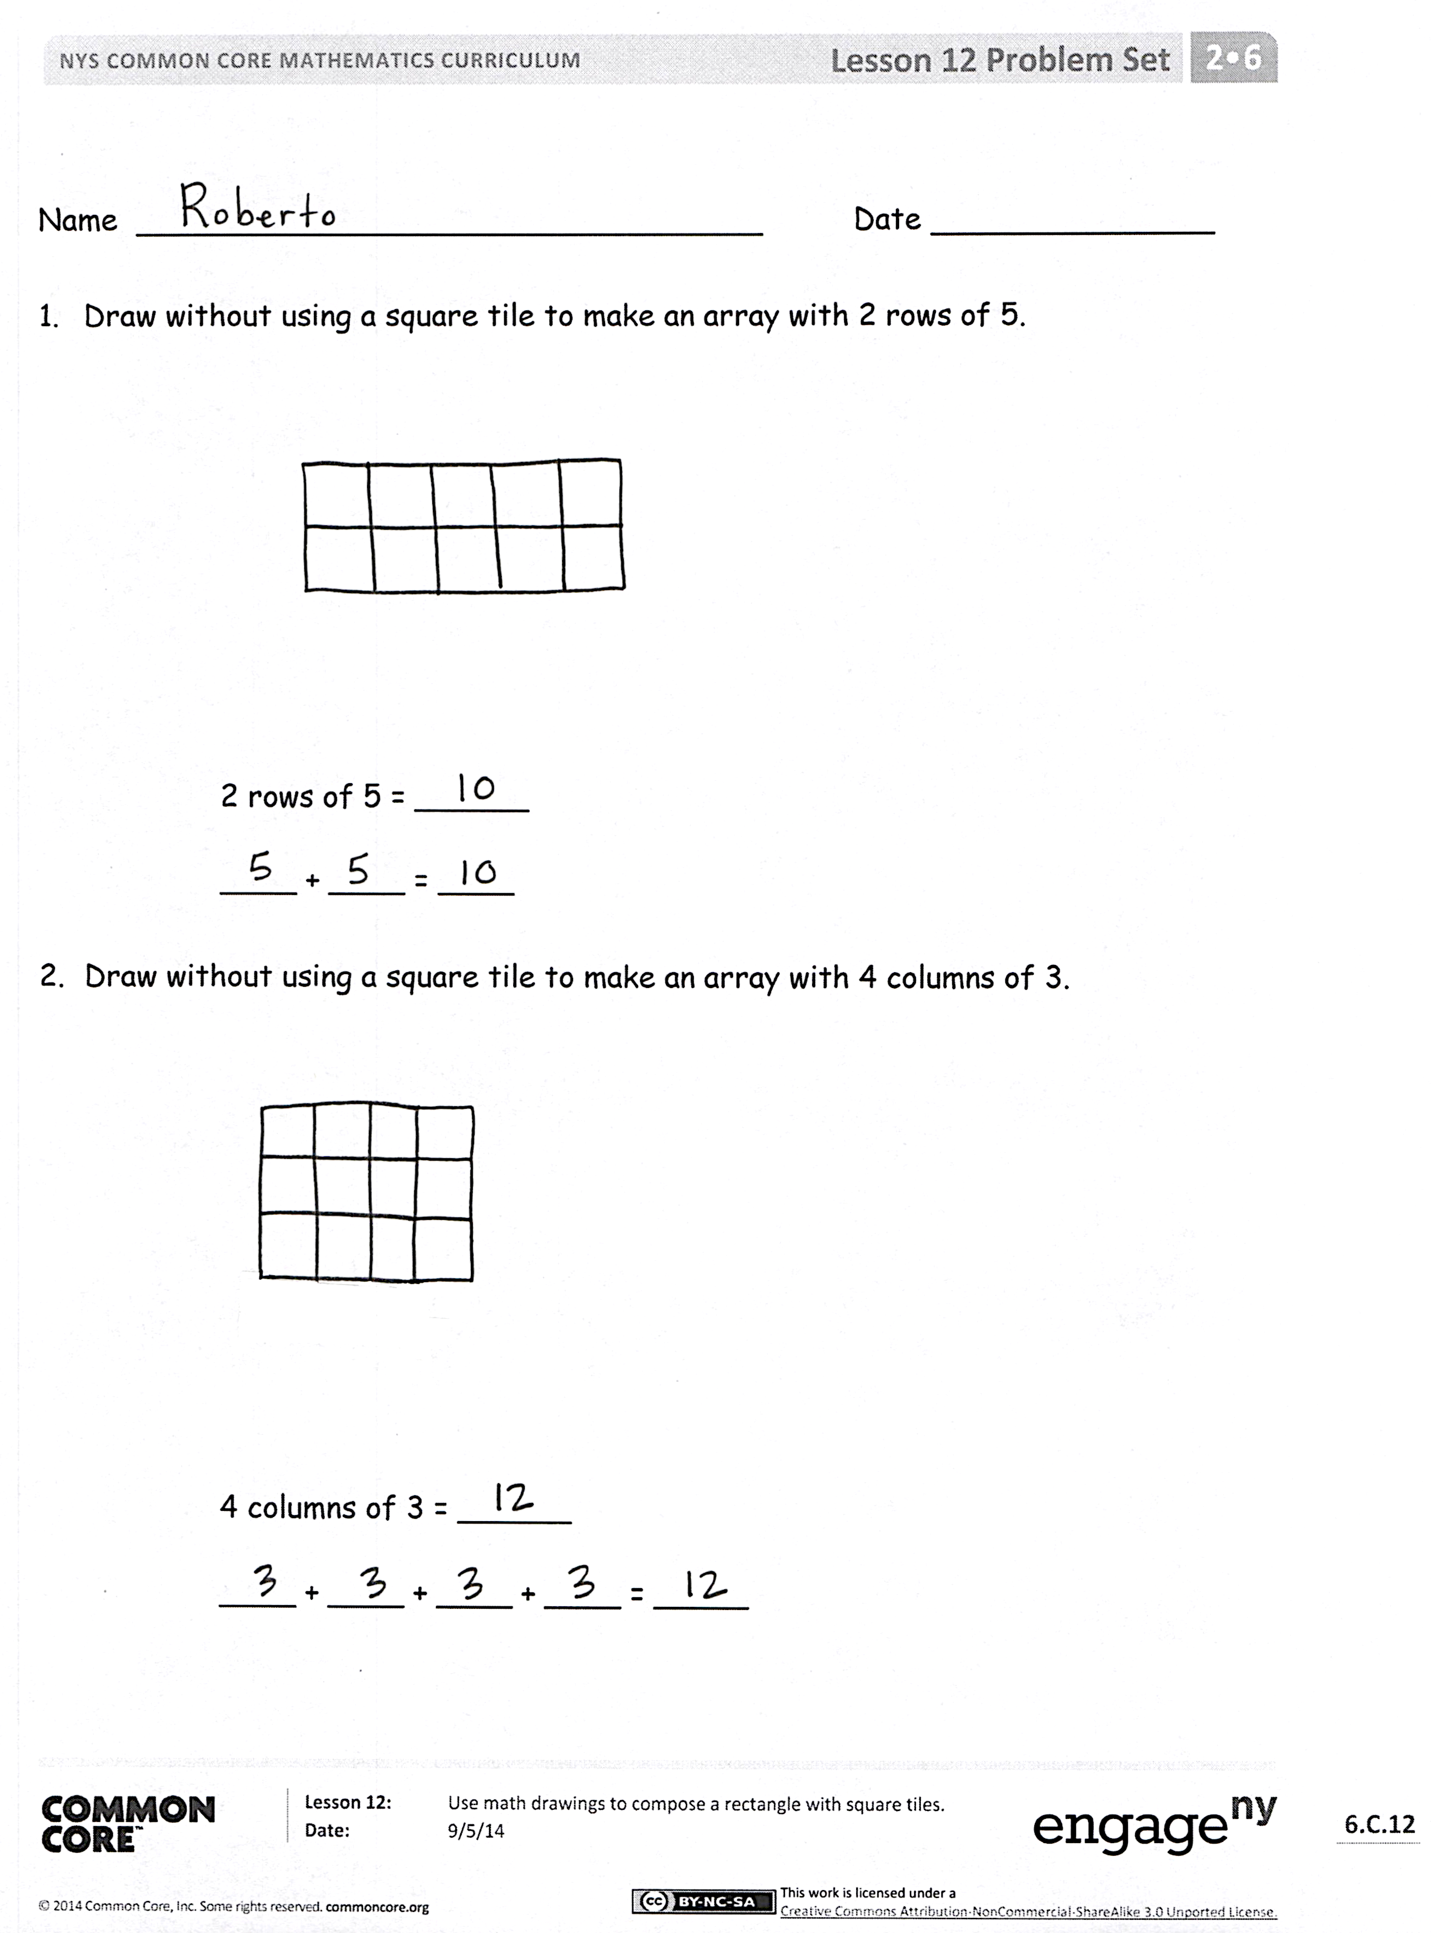
Extension: How should Lulu cut her brownies if she wants to equally serve 12 people? 16 people?
20 people?
Student Debrief (10 minutes)
Lesson Objective: Use math drawings to compose a rectangle with square tiles.
The Student Debrief is intended to invite reflection and active processing of the total lesson experience.
Invite students to review their solutions for the Problem Set. They should check work by comparing answers with a partner before going over answers as a class. Look for misconceptions or misunderstandings that can be addressed in the Debrief. Guide students in a conversation to debrief the Problem Set and process the lesson.

Any combination of the questions below may be used to lead the discussion.
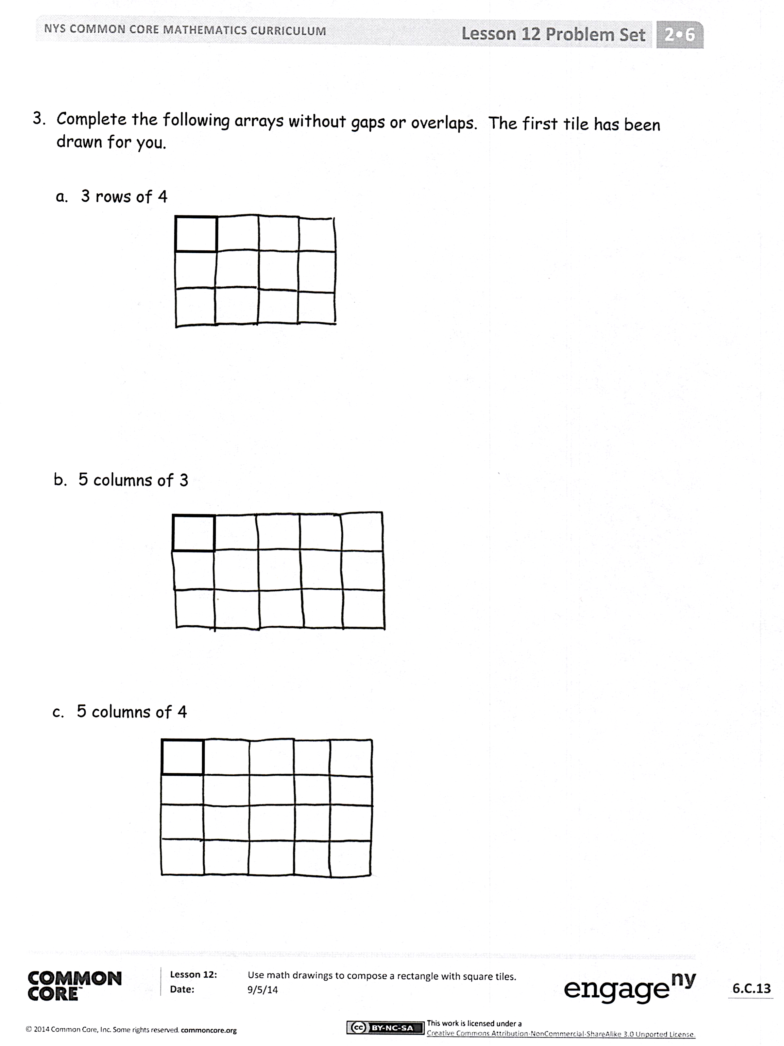
- For Problems 3 (a) and (b), what was your first step in drawing a rectangle?
- Explain to your partner how to draw a rectangle with one square tile. Why was precision important today? How is this different from drawing an array with Xs?
- For Problems 1 and 2, discuss with your partner how the repeated addition equation relates to the number of units in each rectangle.
- What was challenging about drawing a rectangle without tracing the square tile in Problem 3? What did you need to be sure to do?
- How does drawing a rectangle support the idea of composing a larger unit from smaller units? Use the terms square, rows, and columns in your response.
Exit Ticket (3 minutes)
After the Student Debrief, instruct students to complete the Exit Ticket. A review of their work will help with assessing students’ understanding of the concepts that were presented in today’s lesson and planning more effectively for future lessons. The questions may be read aloud to the students.

Name Date
1. | 10 + 2 = | 21. | 7 + 9 =
2. | 10 + 7 = | 22. | 5 + 8 =
3. | 10 + 5 = | 23. | 3 + 9 =
4. | 4 + 10 = | 24. | 8 + 6 =
5. | 6 + 11 = | 25. | 7 + 4 =
6. | 12 + 2 = | 26. | 9 + 5 =
7. | 14 + 3 = | 27. | 6 + 6 =
8. | 13 + 5 = | 28. | 8 + 3 =
9. | 17 + 2 = | 29. | 7 + 6 =
10. | 12 + 6 = | 30. | 6 + 9 =
11. | 11 + 9 = | 31. | 8 + 7 =
12. | 2 + 16 = | 32. | 9 + 9 =
13. | 15 + 4 = | 33. | 5 + 7 =
14. | 5 + 9 = | 34. | 8 + 4 =
15. | 9 + 2 = | 35. | 6 + 5 =
16. | 4 + 9 = | 36. | 9 + 7 =
17. | 9 + 6 = | 37. | 6 + 8 =
18. | 8 + 9 = | 38. | 2 + 9 =
19 | 7 + 8 = | 39. | 9 + 8 =
20. | 8 + 8 = | 40. | 7 + 7 =

Name Date
1. | 10 + 6 = | 21. | 3 + 8 =
2. | 10 + 9 = | 22. | 9 + 4 =
3. | 7 + 10 = | 23. | ____ + 6 = 11
4. | 3 + 10 = | 24. | ____ + 9 = 13
5. | 5 + 11 = | 25. | 8 + ____ = 14
6. | 12 + 8 = | 26. | 7 + ____ = 15
7. | 14 + 3 = | 27. | ____ = 4 + 8
8. | 13 + ____ = 19 | 28. | ____ = 8 + 9
9. | 15 + ____ = 18 | 29. | ____ = 6 + 4
10. | 12 + 5 = | 30. | 3 + 9 =
11. | ____ = 2 + 17 | 31. | 5 + 7 =
12. | ____ = 3 + 13 | 32. | 8 + ____ =14
13. | ____ = 16 + 2 | 33. | ____ = 5 + 9
14. | 9 + 3 = | 34. | 8 + 8 =
15. | 6 + 9 = | 35. | ____ = 7 + 9
16. | ____ + 5 = 14 | 36. | ____ = 8 + 4
17. | ____ + 7 = 13 | 37. | 17 = 8 + ____
18. | ____ + 8 = 12 | 38. | 19 = ____ + 9
19 | 8 + 7 = | 39. | 12 = ____ + 7
20. | 7 + 6 = | 40. | 15 = 8 + ____

Name Date
1. | 13 - 3 = | 21. | 16 - 8 =
2. | 19 - 9 = | 22. | 14 - 5 =
3. | 15 - 10 = | 23. | 16 – 7 =
4. | 18 - 10 = | 24. | 15 – 7 =
5. | 12 - 2 = | 25. | 17 – 8 =
6. | 11 - 10 = | 26. | 18 – 9 =
7. | 17 - 13 = | 27. | 15 – 6 =
8. | 20 – 10 = | 28. | 13 – 8 =
9. | 14 – 11 = | 29. | 14 – 6 =
10. | 16 - 12 = | 30. | 12 - 5 =
11. | 11 – 3 = | 31. | 11 - 7 =
12. | 13 – 2 = | 32. | 13 – 8 =
13. | 14 – 2 = | 33. | 16 – 9 =
14. | 13 – 4 = | 34. | 12 – 8 =
15. | 12 – 3 = | 35. | 16 – 12 =
16. | 11 – 4 = | 36. | 18 – 15 =
17. | 12 - 5 = | 37. | 15 – 14 =
18. | 14 – 5 = | 38. | 17 – 11 =
19 | 11 - 2 = | 39. | 19 – 13 =
20. | 12 - 4 = | 40. | 20 - 12 =

Name Date
1. | 17 - 7 = | 21. | 16 - 7 =
2. | 14 - 10 = | 22. | 17 - 8 =
3. | 19 - 11 = | 23. | 18 - 7 =
4. | 16 - 10 = | 24. | 14 - 6 =
5. | 17 - 12 = | 25. | 17 - 8 =
6. | 15 - 13 = | 26. | 12 – 8 =
7. | 12 - 3 = | 27. | 14 - 7 =
8. | 20 – 11 = | 28. | 15 – 8 =
9. | 18 - 11 = | 29. | 13 - 5 =
10. | 13 - 5 = | 30. | 16 - 8 =
11. | ____ = 11 - 2 | 31. | 14 - 9 =
12. | ____ = 12 - 4 | 32. | 15 - 6 =
13. | ____ = 13 - 5 | 33. | 13 – 6 =
14. | ____ = 12 - 3 | 34. | ____ = 13 - 8
15. | ____ = 11 - 4 | 35. | ____ = 15 - 7
16. | ____ = 13 - 2 | 36. | ____ = 18 - 9
17. | ____ = 11 - 3 | 37. | ____ = 20 - 14
18. | 17 – 8 = | 38. | ____ = 20 - 7
19 | 14 - 6 = | 39. | ____ = 20 - 11
20. | 16 - 9 = | 40. | ____ = 20 - 8

Name Date
1. | 11 + 9 = | 21. | 13 - 7 =
2. | 13 + 5 = | 22. | 11 - 8 =
3. | 14 + 3 = | 23. | 15 – 6 =
4. | 12 + 7 = | 24. | 12 + 7 =
5. | 5 + 9 = | 25. | 14 + 3 =
6. | 8 + 8 = | 26. | 8 + 12 =
7. | 14 - 7 = | 27. | 5 + 7 =
8. | 13 - 5 = | 28. | 8 + 9 =
9. | 16 - 7 = | 29. | 7 + 5 =
10. | 17 - 9 = | 30. | 13 - 6 =
11. | 14 - 6 = | 31. | 14 - 8 =
12. | 18 - 5 = | 32. | 12 – 9 =
13. | 9 + 9 = | 33. | 11 – 3 =
14. | 7 + 6 = | 34. | 14 – 5 =
15. | 3 + 9 = | 35. | 13 - 8 =
16. | 6 + 7 = | 36. | 8 + 5 =
17. | 8 + 5 = | 37. | 4 + 7 =
18. | 13 - 8 = | 38. | 7 + 8 =
19 | 16 - 9 = | 39. | 4 + 9 =
20. | 14 - 8 = | 40. | 20 - 8 =

Name Date
- Draw without using a square tile to make an array with 2 rows of 5.

2 rows of 5 = ______

____ + ____ = ____

- Draw without using a square tile to make an array with 4 columns of 3.

4 columns of 3 = ______

____ + ____ + ____ + ____ = _____

- Complete the following arrays without gaps or overlaps. The first tile has been drawn for you.

  - 3 rows of 4

- 5 columns of 3

- 5 columns of 4

Name Date
Draw an array of 3 columns of 3 starting with the square below without gaps or overlaps.

Name Date
  - Cut out and trace the square tile to draw an array with 2 rows of 4.

Cut out and trace.

2 rows of 4 = ______

____ + ____ = ____

- Trace the square tile to make an array with 3 columns of 5.

3 columns of 5 = ______

____ + ____ + ____ = _____
- Complete the following arrays without gaps or overlaps. The first tile has been drawn for you.

  - 4 rows of 5

- 5 columns of 2

- 4 columns of 3

