Lesson 11
Objective: Use square tiles to compose a rectangle, and relate to the array model.

Suggested Lesson Structure
 Fluency Practice (12 minutes)
 Application Problem (6 minutes)
 Concept Development (32 minutes)
 Student Debrief (10 minutes)
Total Time (60 minutes)
Fluency Practice (12 minutes)
- Happy Counting by Tens: Crossing 100 2.NBT.2 (3 minutes)
- Sprint: Subtraction Crossing Ten 2.OA.2 (9 minutes)
Happy Counting by Tens: Crossing 100 (3 minutes)
Note: Students skip-count by tens as review of counting equal groups.
T: Let’s count by tens, starting at 360. Ready? (Point up rhythmically until a change is desired. Close hand to stop. Point down to count in the opposite direction.)
S: 360, 370, 380, 390, 400, 410, 420, 430, 440 (switch) 430, 420, 410, 400, 390 (switch) 400, 410, 420, 430, 440, 450, 460, 470, 480, 490, 500, 510, 520 (switch) 510, 500, 490, 480.
T: Excellent! Try it for 30 seconds with your partner, starting at 440. Partner B, you are the teacher today.
Sprint: Subtraction Crossing Ten (9 minutes)
Materials: (S) Subtraction Crossing Ten Sprint
Note: Students subtract a single-digit number from a teen number and continue the subtraction pattern when subtracting from multiples of ten and some ones.
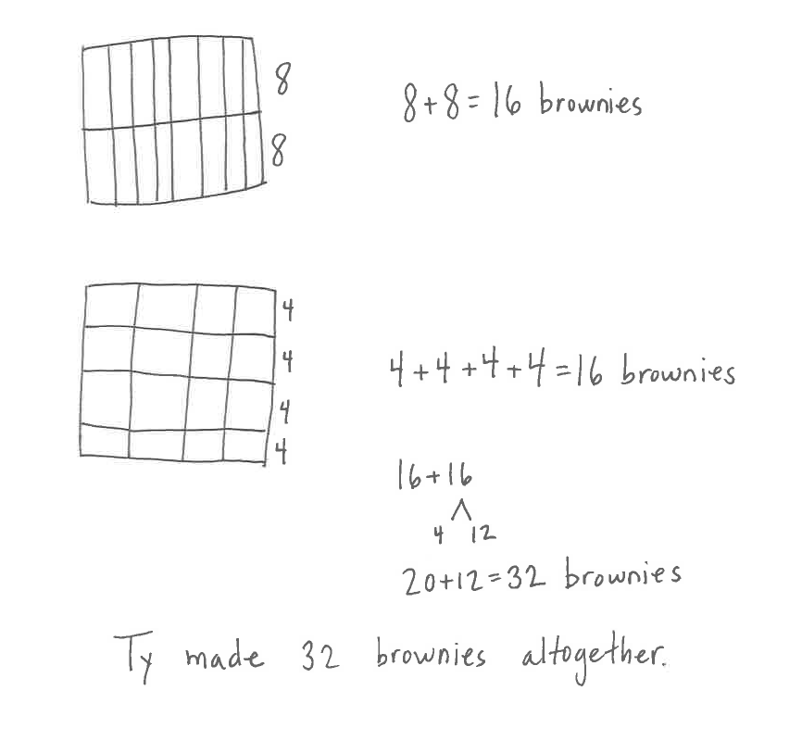
Application Problem (6 minutes)
Ty bakes two pans of brownies. In the first pan, he cuts 2 rows of 8. In the second pan he cuts 4 rows of 4.
MP.3
- Draw a picture of Ty’s brownie pans.
- Write a repeated addition equation to show the total number of brownies in each pan.
- How many brownies did Ty bake altogether? Write an equation and a statement to show your answer.
Note: This Application Problem gives students another real world context for seeing arrays. Encourage them to see the rectangular shape of the rows and columns as you share student work samples.
Concept Development (32 minutes)
Materials: (T) 5 red 1-inch tiles, 5 green 1-inch tiles (S) 25 1-inch tiles, personal white board
Assign Partners A and B, and call students to sit in a circle at the front of the room.
Part 1: Compose rectangles from one row of tiles, and write addition sentences to match.
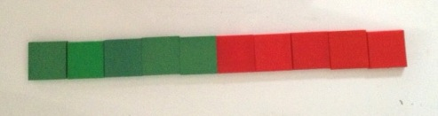
T: (Show a row of 10 tiles made with two colors as pictured.)
T: How many rows do you see?
S: 1 row.
T: How many tiles are in the row?
S: 10 tiles.
T: Did I make a rectangle with my tiles?
S: Yes. It’s long and skinny!
T: It is also an array. Tell me about its rows and columns.
S: It has 1 row of 10. Yes, you could say 10 columns of 1.
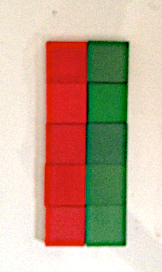
T: Turn and talk: How can we arrange these 10 tiles in a different way to form another rectangle?
S: Move the green tiles so they are under the red tiles. I know I can count by 2s to 10, so you can make columns of 2 instead of columns of 1. You can break the row apart, so there are 2 rows of 5.
T: Let’s try that. (Move the green tiles to show 2 rows of 5 as pictured.)
T: Now, how many rows do you see?
S: 2 rows!
T: How many tiles in each row?
S: 5 tiles!
T: How many columns do you see?
S: 5 columns!
T: How many tiles in each column?
S: 2 tiles!
T: Turn and talk: What repeated addition equations can we make to represent either the columns or rows of this rectangle?
S: 5 + 5 = 10. 2 + 2 + 2 + 2 + 2 = 10.
T: Now, make a row of 14 tiles on your personal white board.
S: (Create a row.)
T: Now, rearrange the tiles to make another array.
S: (Make arrays.)
T: How did you arrange the tiles to make the arrays?
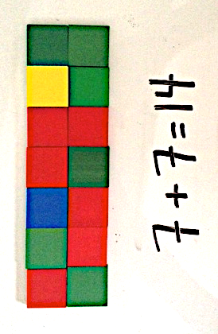
S: I broke the row into 2 rows and slid one under the other. I made 2 rows of 7 since 7 + 7 is 14.
It’s like the last rectangle; I used the doubles fact to make 2 rows of 7, which makes 14.
T: Add an equation underneath your rectangle.
T: What equation did you write?
S: I made columns of two. 2 + 2 + 2 + 2 + 2 + 2 + 2 = 14. I broke the rectangle in half like we did with 10. I moved half the array to the bottom row, so I have 7 + 7 = 14.
Repeat the above process with 16 tiles.
Part 2: Compose varied rectangles from a given number of tiles.
T: Turn and talk: Is there another rectangle we can make using the same 16 tiles?

NOTES ON
MULTIPLE MEANS
OF ENGAGEMENT:
Encourage students to play games that involve arrays, such as Memory and Tic-Tac-Toe. This can also be a good home connection for families to connect with what students are learning in school.

S: We can break it in half again and make 4 rows of 4.
We can make a square like we did yesterday.
T: Partner A, with the help of Partner B, make a new array.
T: Turn and talk: How are your arrays similar, and how are they different?
S: They both have 16 tiles. One has the same number of rows and columns and the other doesn’t. You can turn an array with 4 rows of 4 on its side, and it looks exactly the same. You can’t do that with 2 rows of 8.
T: Now, each partner count out 12 tiles and arrange them in a row.
T: With your partner, construct two different rectangles using 12 tiles each. Write repeated addition equations below each rectangle. As you work, talk and compare your rectangles. (Circulate as students create their rectangles and write their equations.)

S: We can make one array that has 2 rows of 6 because we can break the row in half like we did before. Let’s try making a rectangle that has more than 2 rows. Hey, we can make 3 groups of 4
or 4 groups of 3. We can make an array that has 3 rows of 4 because 4 + 4 + 4 = 12.
T: How are your rectangles similar and how are they different? Discuss with your partner.
S: They both have 12 tiles total. My array has columns of 2, and yours has columns of 3. Mine is 2 rows of 6 and yours is 3 rows of 4. They are all rectangles.
Problem Set (10 minutes)
Students should do their personal best to complete the Problem Set within the allotted 10 minutes. For some classes, it may be appropriate to modify the assignment by specifying which problems they work on first. Some problems do not specify a method for solving. Students should solve these problems using the RDW approach used for Application Problems.
Student Debrief (10 minutes)
Lesson Objective: Use square tiles to compose a rectangle, and relate to the array model.
The Student Debrief is intended to invite reflection and active processing of the total lesson experience.
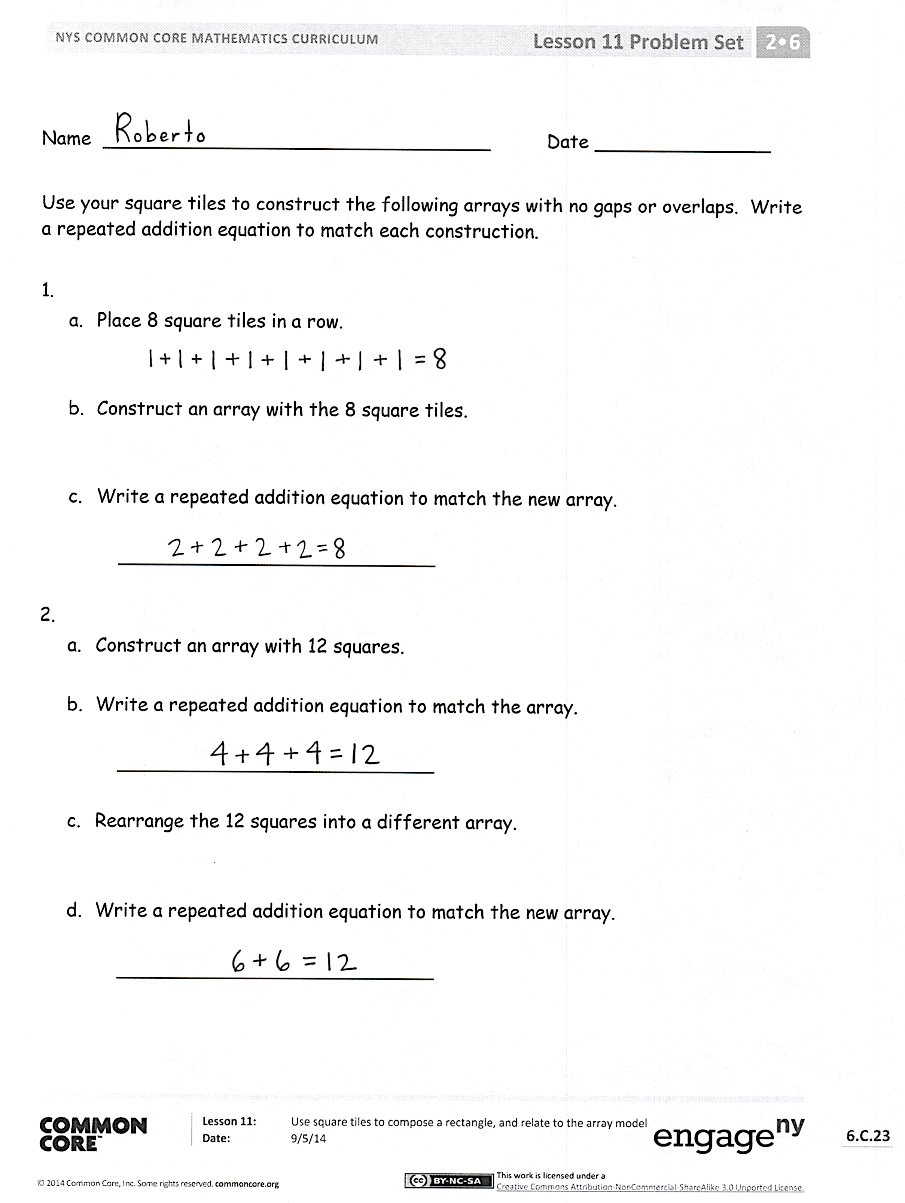
Invite students to review their solutions for the Problem Set. They should check work by comparing answers with a partner before going over answers as a class. Look for misconceptions or misunderstandings that can be addressed in the Debrief. Guide students in a conversation to debrief the Problem Set and process the lesson.
Any combination of the questions below may be used to lead the discussion.
- Can we call the arrangement in Problem 1(a) an array? How can you describe it in terms of both rows and columns?
- For Problem 1, how is knowing how to make equal groups helpful in constructing a rectangle with 8 tiles? Explain how your equation matches your array.
- What strategy did you use in Problem 2 to construct a rectangle with 12 tiles? How are your two rectangles different? How are they the same? How did your rows and columns change when you rearranged your tiles to create a new rectangle for Problem 3?

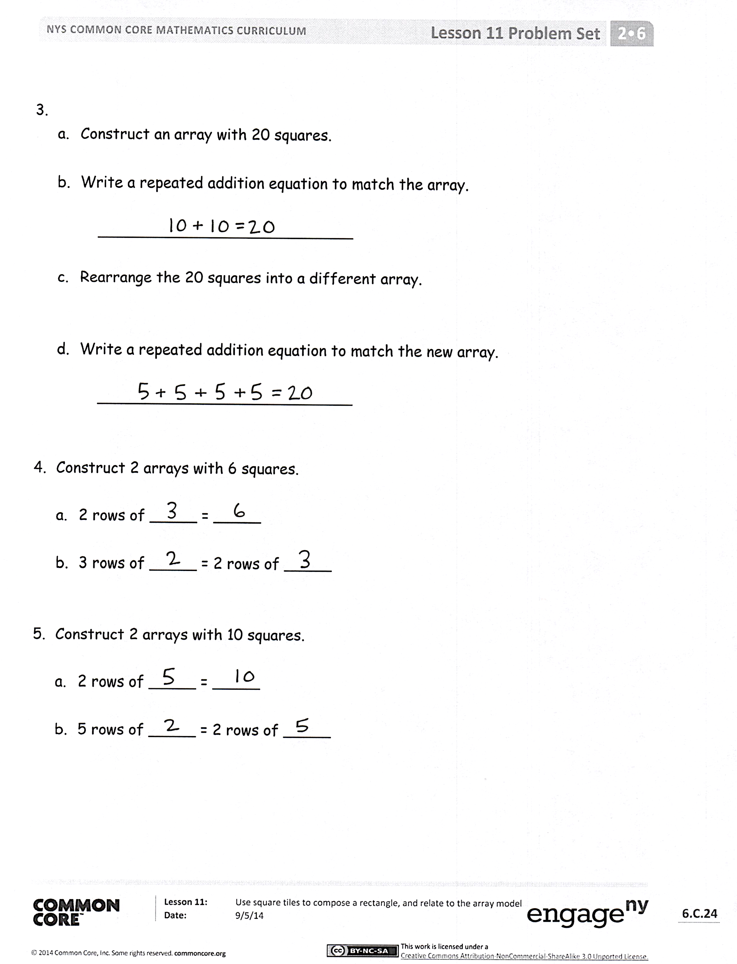
- For Problem 4, explain how you know that 3 + 3 = 2 + 2 + 2?
- You constructed two rectangles with 10 tiles for Problem 5. Is it possible to do the same with 11 tiles? Why not?
Exit Ticket (3 minutes)
After the Student Debrief, instruct students to complete the Exit Ticket. A review of their work will help with assessing students’ understanding of the concepts that were presented in today’s lesson and planning more effectively for future lessons. The questions may be read aloud to the students.

Number Correct: _______
A
Subtraction Crossing Ten
 | 10 – 5 = |  |  |  | 14 – 6 =
 | 20 – 5 = |  |  |  | 24 – 6 =
 | 30 – 5 = |  |  |  | 34 – 6 =
 | 10 – 2 = |  |  |  | 15 – 7 =
 | 20 – 2 = |  |  |  | 25 – 7 =
 | 30 – 2 = |  |  |  | 35 – 7 =
 | 11 – 2 = |  |  |  | 11 – 4 =
 | 21 – 2 = |  |  |  | 21 – 4 =
 | 31 – 2 = |  |  |  | 31 – 4 =
 | 10 – 8 = |  |  |  | 12 – 6 =
 | 11 – 8 = |  |  |  | 22 – 6 =
 | 21 – 8 = |  |  |  | 32 – 6 =
 | 31 – 8 = |  |  |  | 21 – 6 =
 | 14 – 5 = |  |  |  | 31 – 6 =
 | 24 – 5 = |  |  |  | 12 – 8 =
 | 34 – 5 = |  |  |  | 32 – 8 =
 | 15 – 6 = |  |  |  | 21 – 8 =
 | 25 – 6 = |  |  |  | 31 – 8 =
 | 35 – 6 = |  |  |  | 28 – 9 =
 | 10 – 7 = |  |  |  | 27 – 8 =
 | 20 – 8 = |  |  |  | 38 – 9 =
 | 30 – 9 = |  |  |  | 37 – 8 =
Number Correct: _______
Improvement: _______
B
[KEY]

Subtraction Crossing Ten
 | 10 – 1 = |  |  |  | 13 – 5 =
 | 20 – 1 = |  |  |  | 23 – 5 =
 | 30 – 1 = |  |  |  | 33 – 5 =
 | 10 – 3 = |  |  |  | 16 – 8 =
 | 20 – 3 = |  |  |  | 26 – 8 =
 | 30 – 3 = |  |  |  | 36 – 8 =
 | 12 – 3 = |  |  |  | 12 – 5 =
 | 22 – 3 = |  |  |  | 22 – 5 =
 | 32 – 3 = |  |  |  | 32 – 5 =
 | 10 – 9 = |  |  |  | 11 – 5 =
 | 11 – 9 = |  |  |  | 21 – 5 =
 | 21 – 9 = |  |  |  | 31 – 5 =
 | 31 – 9 = |  |  |  | 12 – 7 =
 | 13 – 4 = |  |  |  | 22 – 7 =
 | 23 – 4 = |  |  |  | 11 – 7 =
 | 33 – 4 = |  |  |  | 31 – 7 =
 | 16 – 7 = |  |  |  | 22 – 9 =
 | 26 – 7 = |  |  |  | 32 – 9 =
 | 36 – 7 = |  |  |  | 38 – 9 =
 | 10 – 6 = |  |  |  | 37 – 8 =
 | 20 – 7 = |  |  |  | 28 – 9 =
 | 30 – 8 = |  |  |  | 27 – 8 =

Name Date
Use your square tiles to construct the following arrays with no gaps or overlaps. Write a repeated addition equation to match each construction.

a. Place 8 square tiles in a row.

- Construct an array with the 8 square tiles.

- Write a repeated addition equation to match the new array.

___________________________

- Construct an array with 12 squares.

- Write a repeated addition equation to match the array.

___________________________

- Rearrange the 12 squares into a different array.

- Write a repeated addition equation to match the new array.

___________________________

a. Construct an array with 20 squares.

- Write a repeated addition equation to match the array.

___________________________

- Rearrange the 20 squares into a different array.

- Write a repeated addition equation to match the new array.

___________________________

- Construct 2 arrays with 6 squares.

  - 2 rows of _____ = _____

- 3 rows of _____ = 2 rows of _____

- Construct 2 arrays with 10 squares.

  - 2 rows of _____ = _____

- 5 rows of _____ = 2 rows of _____

Name Date
- Construct an array with 12 square tiles.

- Write a repeated addition equation to match the array.

___________________________

Name Date

- Construct an array with 9 square tiles.
- Write a repeated addition equation to match the array.

___________________________

- Construct an array with 10 squares.
- Write a repeated addition equation to match the array.

___________________________

- Rearrange the 10 squares into a different array.
- Write a repeated addition equation to match the new array.

___________________________

Cut out each square tile and use to construct the arrays in Problems 1–4.

- Construct an array with 12 squares.
- Write a repeated addition equation to match the array.

___________________________

- Rearrange the 12 squares into a different array.
- Write a repeated addition equation to match the new array.

___________________________

- Construct 2 arrays with 14 squares.

  - 2 rows of _____ = _____

- 2 rows of _____ = 7 rows of _____

