Lesson 10
Objective: Use square tiles to compose a rectangle, and relate to the array model.

Suggested Lesson Structure
 Fluency Practice (12 minutes)
 Application Problem (6 minutes)
 Concept Development (32 minutes)
 Student Debrief (10 minutes)
Total Time (60 minutes)
Fluency Practice (12 minutes)
- Happy Counting by Tens: Crossing 100 2.NBT.2 (3 minutes)
- Sprint: Sums to the Teens 2.OA.2 (9 minutes)
Happy Counting by Tens: Crossing 100 (3 minutes)
Note: Students skip-count by tens as review of counting equal groups.
T: Let’s count by tens, starting at 270. Ready? (Point up rhythmically until a change is desired. Close hand to indicate a stopping point. Point down to count in the opposite direction. Continue, periodically changing direction.)
S: 270, 280, 290, 300, 310, 320, 330, 340 (switch) 330, 320, 310, 300, 290 (switch) 300, 310, 320, 330, 340, 350, 360, 370, 380, 390, 400, 410, 420 (switch) 410, 400, 390, 380 (switch) 390, 400, 410.
T: Excellent! Try it for 30 seconds with your partner, starting at 300. Partner A, you are the teacher today.
Sprint: Sums to the Teens (9 minutes)
Materials: (S) Sums to the Teens Sprint
Note: This Sprint gives practice in the grade-level fluency goal of sums to 20.

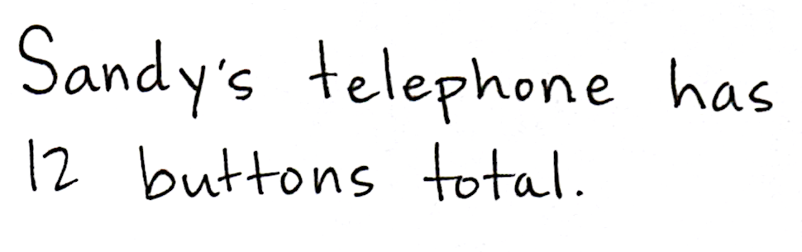
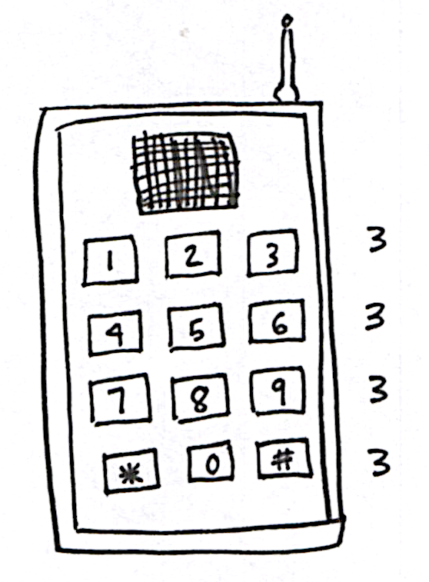
Application Problem (6 minutes)
Sandy’s toy telephone has buttons arranged in 3 columns and 4 rows.
- Draw a picture of Sandy’s telephone.
- Write a repeated addition equation to show the total number of buttons on Sandy’s telephone.
Note: The students have a chance to apply their understanding of arrays to a real world context.
Concept Development (32 minutes)
Materials: (S) 25 square tiles
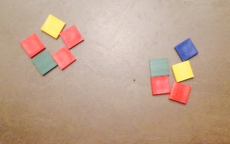
Part 1: Compose a rectangle with square tiles that has no gaps or overlaps.
T: Place 10 tiles into 2 equal groups.
T: Organize your tiles into 2 equal rows like you did yesterday, but this time, leave no spaces between the rows.
S: (Count out 10 tiles, and create arrays.)
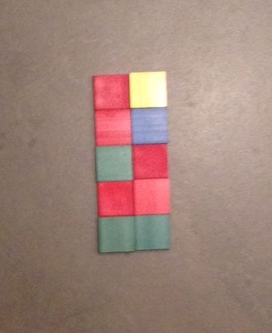
T: How many rows did you make?
S: 2 rows!
T: How many tiles are in each row?
S: 5 tiles!
T: What repeated addition equation can we use to find the total for 2 rows of five?
S: 5 + 5 = 10.
T: What do you notice about the shape of this array?
S: It has corners like an L. The top and bottom sides are the same length. It’s a rectangle!
T: Using the same tiles, make 2 columns of 5, and again, leave no spaces between the columns to make a rectangle.
S: (Construct array.)
T: Turn and talk: What repeated addition equation can we use to find the total for 2 columns of 5?
S: 5 + 5 = 10.
T: Are the equations and totals equal for both arrays?
S: Yes!
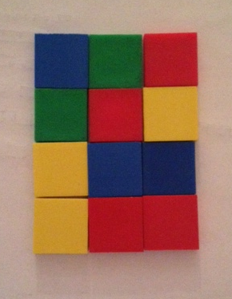
T: How is that so? Talk to your partner.
S: It is the same rectangle, just turned on its side. It uses the same number of tiles. It doesn’t matter whether you have 2 columns of 5 or 2 rows of 5, because you have 2 groups of 5. It’s a rectangle, too.
T: Is this shape also a rectangle?
S: Yes!
Repeat the above process with 15 tiles (5 by 3) and 12 tiles (3 by 4).
Part 2: Compose a square from rows and columns.
T: Let’s look at the array we just made (3 by 4). How can we change this rectangle from 3 columns of four to have the same number of rows and columns? Talk to your partner.
S: Change it to 3 groups of 3. Add another column to make it 4 groups of 4. Take away one of the rows.
NOTES ON
MULTIPLE MEANS
OF ACTION AND EXPRESSION:
- Large foam floor tiles can be a tool to engage the class in a whole-group activity prior to giving the children small tiles to handle themselves.
- In the absence of tiles, square sticky notes can be a good substitute for this activity.

T: (Model taking away a row to make equal rows and columns.)
T: What do you notice about the shape of this array?
S: It’s a square. The columns and rows are equal.
There are 3 rows and 3 columns.
T: Let’s see if we can make another square array. Talk to your partner about your thinking as you use all 25 tiles from your bag to create an array with equal rows and columns. (Circulate and offer hints to encourage all students to find the array.)
MP.4
S: I am going to start by making a row of 5, because I know I can count to 25 by fives. I will separate the tiles into groups until they are all equal.
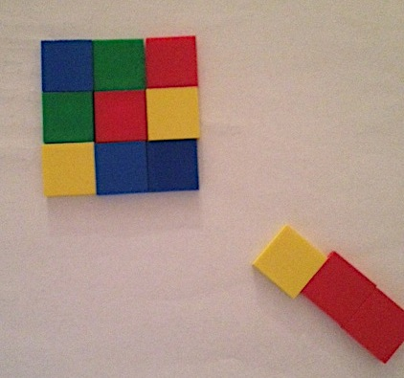
T: What does your array look like?
S: 5 rows of five! 5 columns and 5 rows! A square!
T: Now, keep 16 tiles on your desk, and put the rest in your bag.
T: Create an array with equal rows and columns.
S: (Create equal rows and columns.)
T: What strategies did you use to figure out how many rows and how many columns?
S: I started by creating groups of 2. Then, I realized that if I made groups of 4, I would have 4 groups. I know that 4 + 4 + 4 + 4 = 16, so I made 4 rows of 4. I made two rows of eight, and then saw it was a double of 2 rows of 4, so I just moved half the tiles down.
T: So, what do you know about making an array with equal rows and columns?
S: I know that if you have 4 rows, then there has to be 4 in each row. I know that you need the same number of groups and the same number in each group. You need the same number of tiles in the rows as in the columns. It’s a special rectangle: a square!
T: Turn and talk: Could we make a square array with 10 tiles?
S: No, because you can’t make equal rows and columns. Ten tiles can only be 2 rows of 5
or 1 row of 10. Only certain numbers can make equal rows and columns.
Direct students to move on to the Problem Set.
Problem Set (10 minutes)
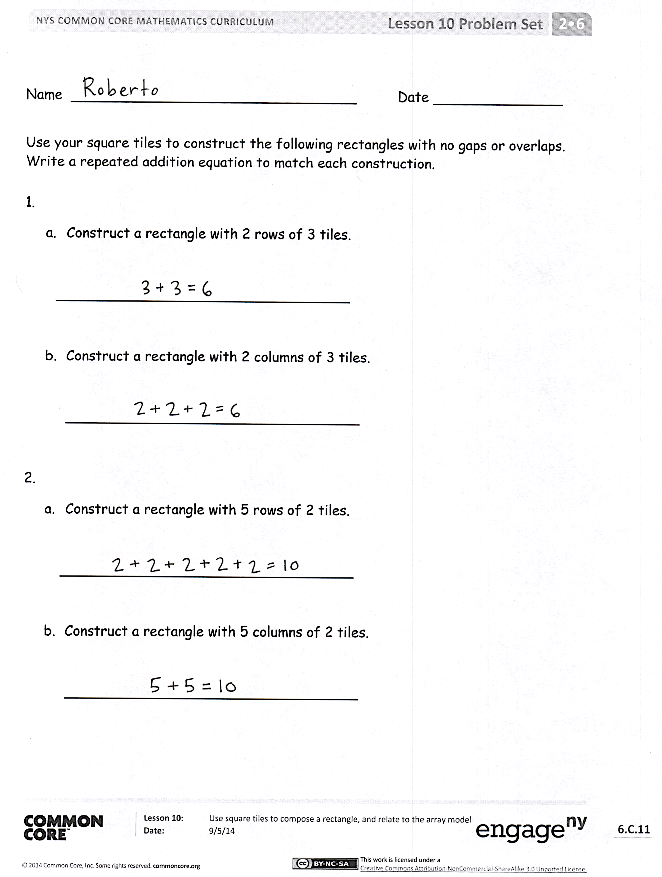
Students should do their personal best to complete the Problem Set within the allotted 10 minutes. For some classes, it may be appropriate to modify the assignment by specifying which problems they work on first. Some problems do not specify a method for solving. Students should solve these problems using the RDW approach used for Application Problems.
Student Debrief (10 minutes)
Lesson Objective: Use square tiles to compose a rectangle, and relate to the array model.
The Student Debrief is intended to invite reflection and active processing of the total lesson experience.
Invite students to review their solutions for the Problem Set. They should check work by comparing answers with a partner before going over answers as a class. Look for misconceptions or misunderstandings that can be addressed in the Debrief. Guide students in a conversation to debrief the Problem Set and process the lesson.
Any combination of the questions below may be used to lead the discussion.
- For Problems 1 (a) and (b), share your rectangles with a partner, and describe them using the words rows and columns. How do your rectangles match the repeated addition equations?
- For Problems 2 (a) and (b), share your rectangles with a partner. How are rectangles composed of equal groups? How does your rectangle match your equation?
- For Problem 3, explain to your partner how you arranged the tiles into a rectangle. How did making equal rows and columns help you to construct the rectangle?
- Squares are special rectangles that have the same number of rows and columns. In Problem 4, you changed a rectangle into a square by removing a column. Is there a different way to make a square from the array?

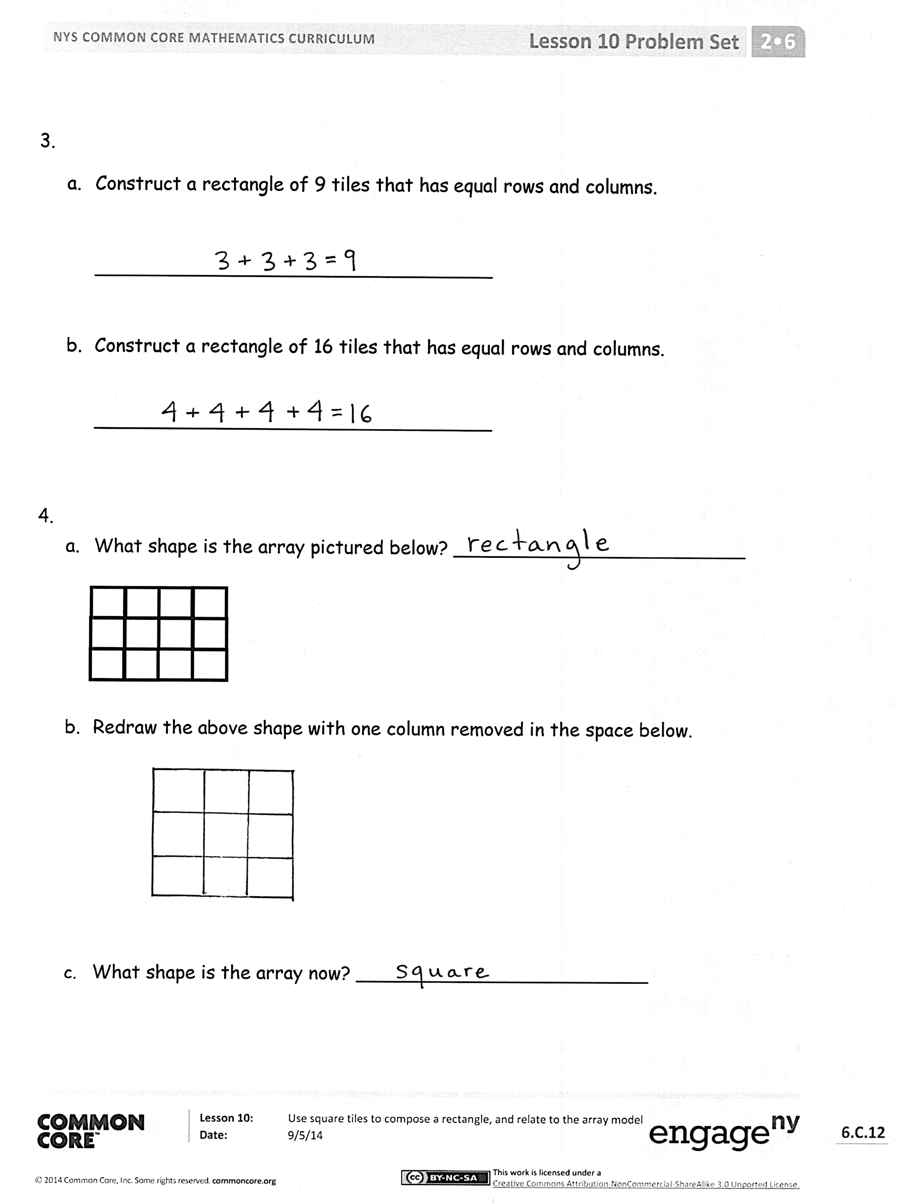
- What repeated addition equation would we use to describe a square array with rows of 2? 3? 4? 5? What do you notice?
- Why don’t we relate triangles to an array model?
Exit Ticket (3 minutes)
After the Student Debrief, instruct students to complete the Exit Ticket. A review of their work will help with assessing students’ understanding of the concepts that were presented in today’s lesson and planning more effectively for future lessons. The questions may be read aloud to the students.
Note: To assess student understanding using today’s Exit Ticket, walk around and directly observe students as they work with the tiles. Take note of how students are building their arrays. Look for understanding of rows and columns, as well as the importance of building with no gaps or spaces between the tiles.

Number Correct: _______
A
Sums to the Teens
 | 9 + 1 = |  |  |  | 7 + 3 =
 | 9 + 2 = |  |  |  | 7 + 4 =
 | 9 + 3 = |  |  |  | 7 + 5 =
 | 9 + 9 = |  |  |  | 7 + 9 =
 | 8 + 2 = |  |  |  | 6 + 4 =
 | 8 + 3 = |  |  |  | 6 + 5 =
 | 8 + 4 = |  |  |  | 6 + 6 =
 | 8 + 9 = |  |  |  | 6 + 9 =
 | 9 + 1 = |  |  |  | 5 + 5 =
 | 9 + 4 = |  |  |  | 5 + 6 =
 | 9 + 5 = |  |  |  | 5 + 7 =
 | 9 + 8 = |  |  |  | 5 + 9 =
 | 8 + 2 = |  |  |  | 4 + 6 =
 | 8 + 5 = |  |  |  | 4 + 7 =
 | 8 + 6 = |  |  |  | 4 + 9 =
 | 8 + 8 = |  |  |  | 3 + 7 =
 | 9 + 1 = |  |  |  | 3 + 9 =
 | 9 + 7 = |  |  |  | 5 + 8 =
 | 8 + 2 = |  |  |  | 2 + 8 =
 | 8 + 7 = |  |  |  | 4 + 8 =
 | 9 + 1 = |  |  |  | 1 + 9 =
 | 9 + 6 = |  |  |  | 2 + 9 =
Number Correct: _______
Improvement: _______
B
[KEY]

Sums to the Teens
 | 8 + 2 = |  |  |  | 7 + 3 =
 | 8 + 3 = |  |  |  | 7 + 4 =
 | 8 + 4 = |  |  |  | 7 + 5 =
 | 8 + 8 = |  |  |  | 7 + 8 =
 | 9 + 1 = |  |  |  | 6 + 4 =
 | 9 + 2 = |  |  |  | 6 + 5 =
 | 9 + 3 = |  |  |  | 6 + 6 =
 | 9 + 8 = |  |  |  | 6 + 8 =
 | 8 + 2 = |  |  |  | 5 + 5 =
 | 8 + 5 = |  |  |  | 5 + 6 =
 | 8 + 6 = |  |  |  | 5 + 7 =
 | 8 + 9 = |  |  |  | 5 + 8 =
 | 9 + 1 = |  |  |  | 4 + 6 =
 | 9 + 4 = |  |  |  | 4 + 7 =
 | 9 + 5 = |  |  |  | 4 + 8 =
 | 9 + 9 = |  |  |  | 3 + 7 =
 | 9 + 1 = |  |  |  | 3 + 9 =
 | 9 + 7 = |  |  |  | 5 + 9 =
 | 8 + 2 = |  |  |  | 2 + 8 =
 | 8 + 7 = |  |  |  | 4 + 9 =
 | 9 + 1 = |  |  |  | 1 + 9 =
 | 9 + 6 = |  |  |  | 2 + 9 =

Name Date
Use your square tiles to construct the following rectangles with no gaps or overlaps. Write a repeated addition equation to match each construction.

a. Construct a rectangle with 2 rows of 3 tiles.

__________________________________

- Construct a rectangle with 2 columns of 3 tiles.

__________________________________

a. Construct a rectangle with 5 rows of 2 tiles.

__________________________________

- Construct a rectangle with 5 columns of 2 tiles.

__________________________________

a. Construct a rectangle of 9 tiles that has equal rows and columns.

__________________________________

- Construct a rectangle of 16 tiles that has equal rows and columns.

__________________________________

a. What shape is the array pictured below? _________________________

- Redraw the above shape with one column removed in the space below.

- What shape is the array now? _________________________

Name Date
On this sheet, use your square tiles to construct the following arrays with no gaps or overlaps on this sheet. Write a repeated addition equation to match your construction.

- Construct a rectangle with 2 rows of 5 tiles.

- Write the repeated addition equation. ___________________________

- Construct a rectangle with 5 columns of 2 tiles.

b. Write the repeated addition equation. ___________________________

Name Date
Cut out the square tiles below, and construct the following arrays with no gaps or overlaps. On the line, write a repeated addition equation to match each construction on the line.

1. a. Construct a rectangle with b. Construct a rectangle with
2 rows of 4 tiles. 2 columns of 4 tiles.

_________________________ _________________________

2. a. Construct a rectangle with b. Construct a rectangle with
3 rows of 2 tiles. 3 columns of 2 tiles.

_________________________ _________________________

3. a. Construct a rectangle b. Construct a rectangle
using 10 tiles. using 12 tiles.

_________________________ _________________________

a. What shape is the array pictured below? ___________________________

- In the space below, redraw the above shape with one more column.

- What shape is the array now? _______________________________
- Draw a different array of tiles that is the same shape as 4(c).

