Lesson 9
Objective: Solve word problems involving addition of equal groups in rows and columns.

Suggested Lesson Structure
 Fluency Practice (12 minutes)
 Concept Development (38 minutes)
 Student Debrief (10 minutes)
Total Time (60 minutes)
Fluency Practice (12 minutes)
- Get the Ten Out and Subtract 2.NBT.5 (4 minutes)
- Grade 2 Core Fluency Practice Sets 2.OA.2 (5 minutes)
- Happy Counting by Tens: Crossing 100 2.NBT.2 (3 minutes)
Get the Ten Out and Subtract (4 minutes)
Note: Students practice taking out the ten when subtracting.
T: For every number sentence I give, subtract the ones from ten. When I say, 12 – 4, you say,
10 – 4 = 6. Ready?
T: 12 – 8.
S: 10 – 8 = 2.
T: 13 – 7.
S: 10 – 7 = 3.
Students practice taking the ten out of number sentences fluently before adding the ones back.
T: Now, let’s add back the ones.
T: 12 – 8. Take from ten.
S: 10 – 8 = 2.
T: Now, add back the ones.
S: 2 + 2 = 4.
T: 12 – 8 is…?
S: 4.
T: True or false: 2 + 2 = 12 – 8.
S: True.
Continue with the following possible sequence: 13 – 7, 11 – 8, 13 – 9, 15 – 7, and 14 – 8.
Grade 2 Core Fluency Practice Sets (5 minutes)
Materials: (S) Core Fluency Practice Sets (G2−M6−Lesson 1 Core Fluency Practice Sets)
Note: During Topic B and for the remainder of the year, each day’s Fluency Practice includes an opportunity for review and mastery of the sums and differences with totals through 20 by means of the Core Fluency Practice Sets or Sprints. Practice Sets, along with details about the process, are provided in Lesson 1.
Happy Counting by Tens: Crossing 100 (3 minutes)
Note: Students skip-count by tens as a foundation for counting equal groups in today’s lesson.
T: Let’s count by tens, starting at 160. Ready? (Point up rhythmically until a change is desired. Close hand to indicate a stopping point. Point down to count in the opposite direction. Continue, periodically changing direction.)
S: 160, 170, 180, 190, 200, 210, 220, 230, 240 (switch) 230, 220, 210, 200, 190 (switch) 200, 210, 220, 230, 240, 250, 260, 270, 280, 290, 300, 310, 320 (switch) 310, 300, 290, 280.
T: Excellent! Try it for 30 seconds with your partner, starting at 300. Partner B, you are the teacher today.
Concept Development (38 minutes)
Materials: (S) Personal white board
Problem 1: Anu wants to know how many eggs are in the carton. She sees 4 eggs in both rows. How many eggs are there?
T: Read the problem aloud.
T: Draw to show Anu’s eggs.
T: (Circulate as students draw.)
T: What equation should we write to find the total?

NOTES ON
MULTIPLE MEANS
OF ENGAGEMENT:
Challenge students with the following extension:
If there are 4 legs on each desk, how many legs are there altogether?

MP.7
S: 4 + 4 = 8.
T: Write your equation, and label your answer.
T: What did you draw?
S: I drew 4 columns of 2 eggs. I drew 2 rows of 4 eggs. I drew mine by twos. It’s just easier for me to match them up, and I knew there are 4 twos in 8.
T: Read your statement to your partner.
S: There are 8 eggs. There are 8 eggs in the carton.
Problem 2: Miss Tam arranges desks into 4 rows of 5. How many desks are in her classroom?
Draw a picture to solve, and write a repeated addition equation. Then, write a statement of your answer.
T: Read the problem aloud.
T: Draw to show Miss Tam’s desks.
T: (Circulate as students draw.)
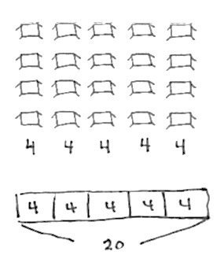
T: How many desks are in each column, or unit?
S: 4 desks!
T: Let’s write that unit of 4 at the bottom of each column. (See figure at right.)
T: So, what equation could we write to find the total?
S: 4 + 4 + 4 + 4 + 4 = 20.
T: Yes! Turn and talk: How could we represent this problem using a tape diagram?
S: I would make 5 parts, each with a four inside. A bar that is separated into 5 fours. Since we wrote units of 4 at the bottom of each column, we can make bars with fours inside.
T: Great! Let’s build our tape diagram together. (Draw one part at a time as students do the same.)
T: Let’s represent the first column of desks. How many units are inside?
S: 4.
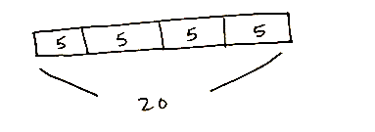
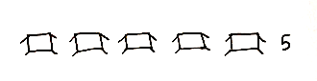
T: Yes, and how many in the second part? (Continue for all five parts until the tape diagram is built.)
Students may also solve the problem by adding the rows as pictured above.
T: Remind me, why are there 5 parts to our tape diagram?
S: Because we drew 5 columns. Well, there are 5 addends in the repeated addition.
T: Yes, our tape diagram is just another way to represent the problem. It’s a great problem-solving strategy!
T: Write an equation under your tape diagram and a statement of your answer. When you are writing your statement, be sure to check the original question. What is your statement?
S: There are 20 desks in Miss Tam’s room.
T: You’re on a roll! (Possibly repeat the sequence, this time
making each row the unit of the tape diagram.)
T: Let’s represent this next problem using only a tape diagram. Here we go…

Problem 3: Yehuda ate 4 cherries each in the morning, in the afternoon, and in the evening. How many cherries did Yehuda eat altogether?
NOTES ON
MULTIPLE MEANS
OF ACTION AND EXPRESSION:
Provide manipulatives to students who may still need to use them as a step before drawing the picture and then writing the repeated addition equation.

T: Read the problem aloud.
T: Draw a tape diagram to show the cherries Yehuda eats.
T: (Circulate as students draw.)
T: How did you draw your tape diagram?
S: I made 3 parts, each with a 4 inside. I did a part that shows 4, then another that shows 4, and then another that shows 4. I thought of 3 groups of 4. So, the tape diagram shows 3 fours.
NOTES ON
MULTIPLE MEANS
OF REPRESENTATION:
Some students may still need to draw dots instead of or before writing numbers to show the equal parts in the tape diagram.

T: What repeated addition equation should we write to solve?
S: 4 + 4 + 4 = 12.
T: Share your statement with your partner.
S: Yehuda ate 12 cherries. 4 in the morning plus 4 in the afternoon plus 4 in the evening is 12 altogether.
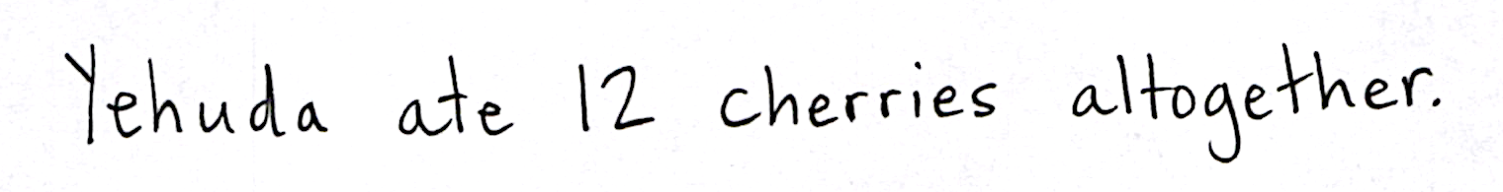
If students need more practice, create simple word problems using subjects that lend themselves to the drawing of arrays, e.g., windowpanes, muffin tins, or flowerbeds.
Problem Set (10 minutes)
Students should do their personal best to complete the Problem Set within the allotted 10 minutes. For some classes, it may be appropriate to modify the assignment by specifying which problems they work on first. Some problems do not specify a method for solving. Students should solve these problems using the RDW approach used for Application Problems.
Student Debrief (10 minutes)
Lesson Objective: Solve word problems involving addition of equal groups in rows and columns.
The Student Debrief is intended to invite reflection and active processing of the total lesson experience. Invite students to review their solutions for the Problem Set. They should check work by comparing answers with a partner before going over answers as a class. Look for misconceptions or misunderstandings that can be addressed in the Debrief. Guide students in a conversation to debrief the Problem Set and process the lesson.
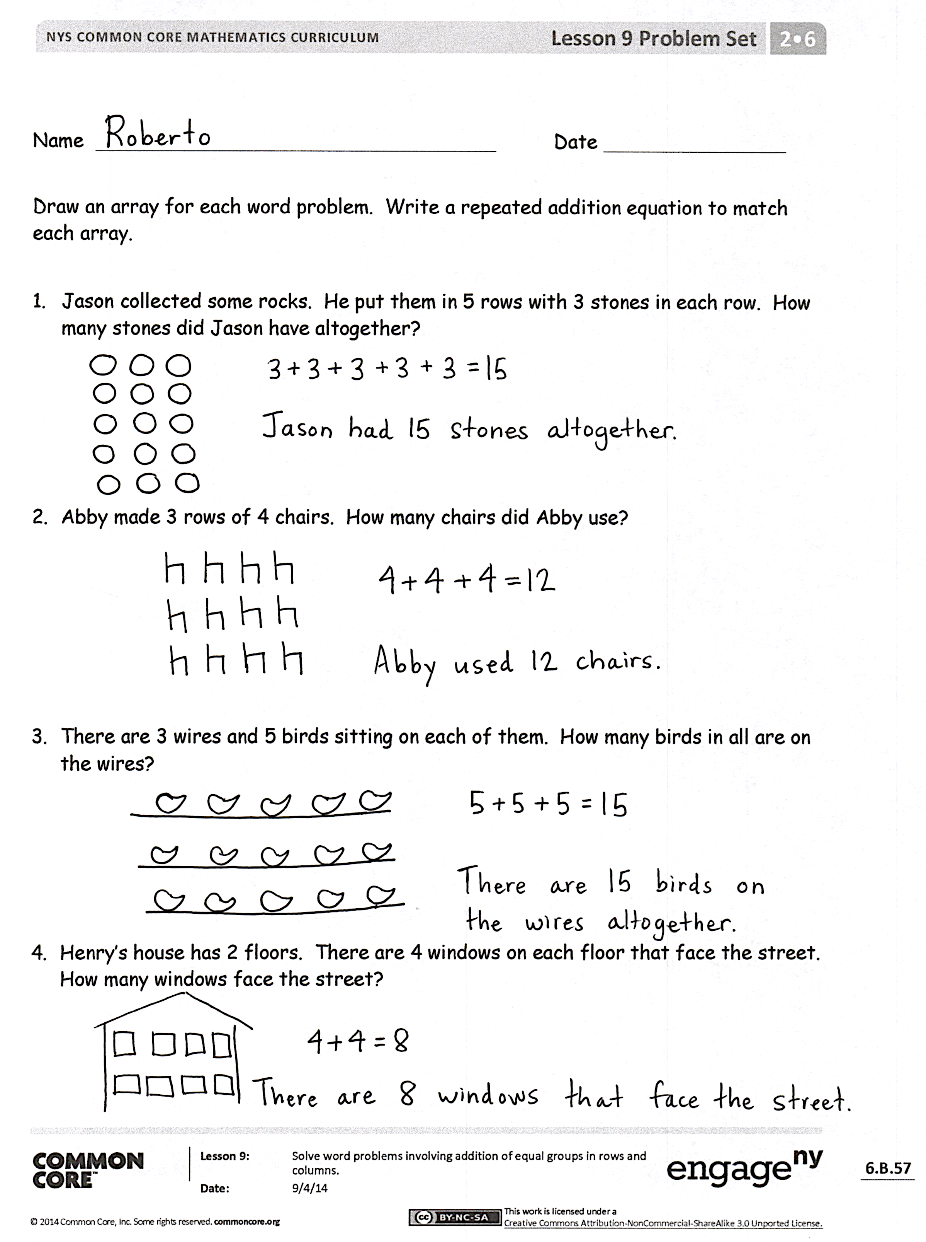
Any combination of the questions below may be used to lead the discussion.
- For Problem 1, share your array with a partner. How did Jason arrange his rocks? What addition equation matches your array?
- How did you determine how many chairs to put in each row in Problem 2? How did this match your equation?
- Share your array for Problem 3 with a partner. Did you draw rows or columns of 5? How did you solve?
- In Problem 4, how did you figure out how many windows face the street? Why are there 2 addends in the equation?
- How did you represent the situation in Problem 5 as a tape diagram? How did your tape diagram change for Problem 6? How is this like something we have done before (i.e., adding or removing rows and columns)?
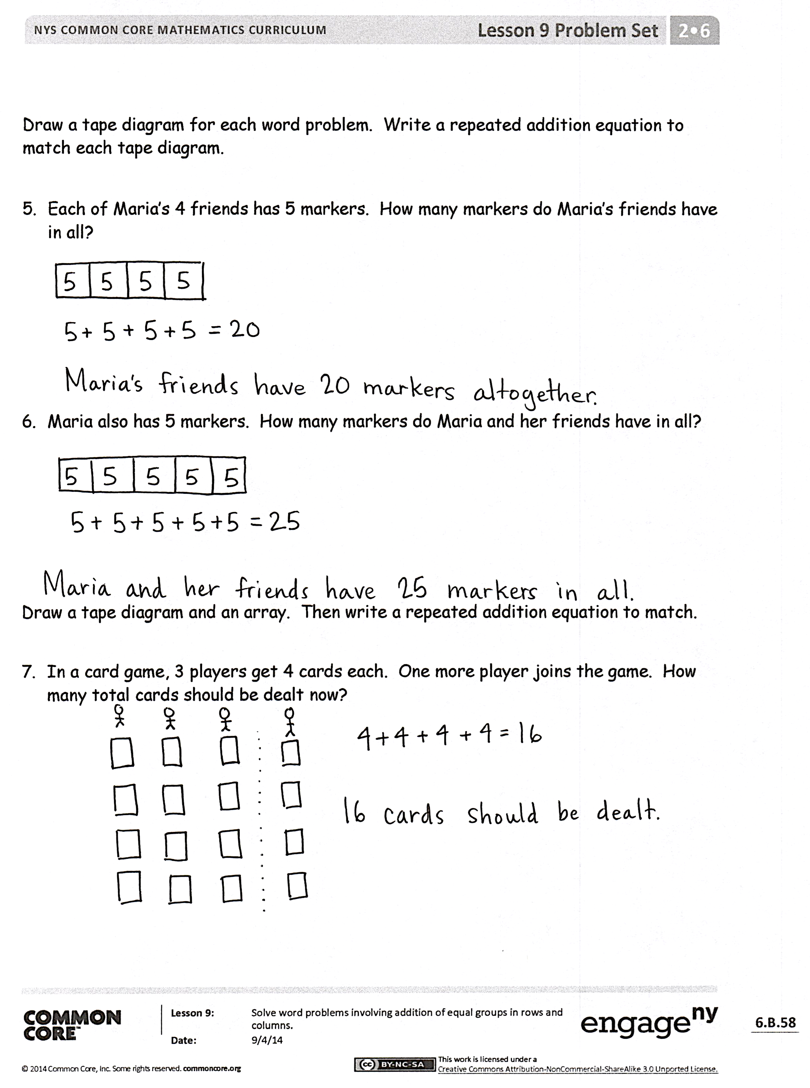
- For Problem 6, how did you represent the situation as a tape diagram? Could you also have drawn an array for this problem? What would it look like?
Exit Ticket (3 minutes)
After the Student Debrief, instruct students to complete the Exit Ticket. A review of their work will help with assessing students’ understanding of the concepts that were presented in today’s lesson and planning more effectively for future lessons. The questions may be read aloud to the students.
Name Date
Draw an array for each word problem. Write a repeated addition equation to match each array.
- Jason collected some rocks. He put them in 5 rows with 3 stones in each row. How many stones did Jason have altogether?

- Abby made 3 rows of 4 chairs. How many chairs did Abby use?

- There are 3 wires and 5 birds sitting on each of them. How many birds in all are on the wires?

- Henry’s house has 2 floors. There are 4 windows on each floor that face the street. How many windows face the street?

Draw a tape diagram for each word problem. Write a repeated addition equation to match each tape diagram.
- Each of Maria’s 4 friends has 5 markers. How many markers do Maria’s friends have in all?

- Maria also has 5 markers. How many markers do Maria and her friends have in all?

Draw a tape diagram and an array. Then, write a repeated addition equation to match.
- In a card game, 3 players get 4 cards each. One more player joins the game. How many total cards should be dealt now?

Name Date
Draw a tape diagram or an array for each word problem. Then, write a repeated addition equation to match.
- Joshua cleans 3 cars every hour at work. He worked 4 hours on Saturday. How many cars did Joshua clean on Saturday?

- Olivia put 5 stickers on each page in her sticker album. She filled 5 pages with stickers. How many stickers did Olivia use?

Name Date
Draw an array for each word problem. Write a repeated addition equation to match each array.
- Melody stacked her blocks in 3 columns of 4. How many blocks did Melody stack in all?

- Marty arranged the desks in the classroom into 5 equal rows. There were 5 desks in each row. How many desks were arranged?

- The baker made 5 trays of muffins. Each tray holds 4 muffins. How many muffins did the baker make?

- The library books were on the shelf in 4 stacks of 4. How many books were on the shelf?

Draw a tape diagram for each word problem. Write a repeated addition equation to match each tape diagram.
- Mary placed stickers in columns of 4. She made 5 columns. How many stickers did she use?

- Jayden put his baseball cards into 5 columns of 3 in his book. How many cards did Jayden put in his book?

Draw a tape diagram and an array. Then, write a repeated addition equation to match.
- The game William bought came with 3 bags of marbles. Each bag had 3 marbles inside. How many total marbles came with the game?

