Lesson 8
Objective: Create arrays using square tiles with gaps.

Suggested Lesson Structure
 Fluency Practice (14 minutes)
 Concept Development (31 minutes)
 Application Problem (5 minutes)
 Student Debrief (10 minutes)
Total Time (60 minutes)
Fluency Practice (14 minutes)
- Using the Nearest Ten to Subtract 2.NBT.5 (5 minutes)
- Sprint: Subtraction from Teens 2.OA.2 (9 minutes)
Using the Nearest Ten to Subtract (5 minutes)
Note: Students use bonds of 10 when subtracting as a mental strategy to help subtract fluently with larger numbers.
T: (Post 16 – 9 on the board.) Raise your hand when you know 16 – 9.
S: 7.
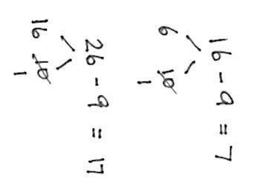
T: (Write in the bond.) 10 – 9 is…?
S: 1.
T: 6 + 1 is…?
S: 7.
T: 16 – 9 again is…?
S: 7.
T: (Post 26 – 9 on the board.) Raise your hand when you know 26 – 9.
S: 17.
T: (Write in the bond.) 10 – 9 is…?
S: 1.
T: 16 + 1 is…?
S: 17.
T: 26 – 9 again is…?
S: 17.
Continue with the following possible sequence:
- 26 – 9, 36 – 9
- 11 – 9, 21 – 9, 41 – 9
- 12 – 8, 22 – 8, 42 – 8
- 11 – 8, 41 – 8, 61 – 8
- 25 – 9, 26 – 9, 27 – 9
- 35 – 19, 45 – 19, 55 – 9
Sprint: Subtraction from Teens (9 minutes)
Materials: (S) Subtraction from Teens Sprint
Note: This Sprint builds fluency with the grade-level fluency goal of subtracting within 20 using mental strategies.
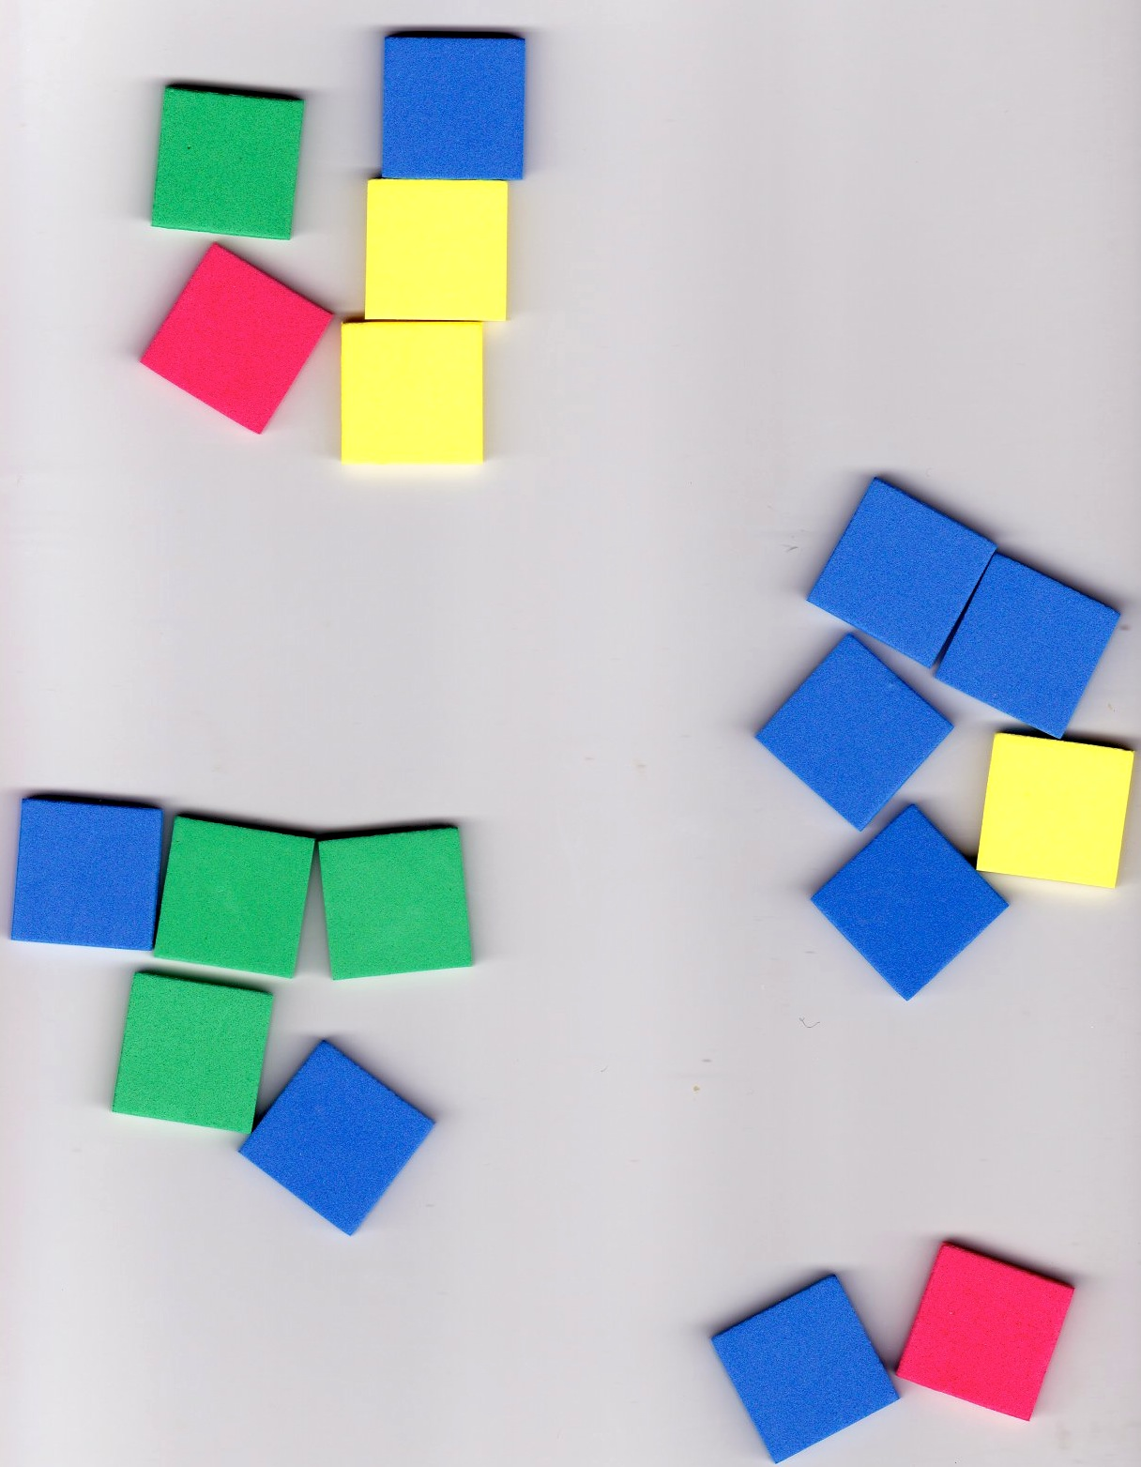
Concept Development (31 minutes)
Materials: (T/S) 25 square tiles, ruler
Distribute materials to each student before beginning the lesson.
T: Take out 17 tiles and separate them into groups of 5 without putting them in rows or columns.
S: (Create equal groups of 5 tiles.)
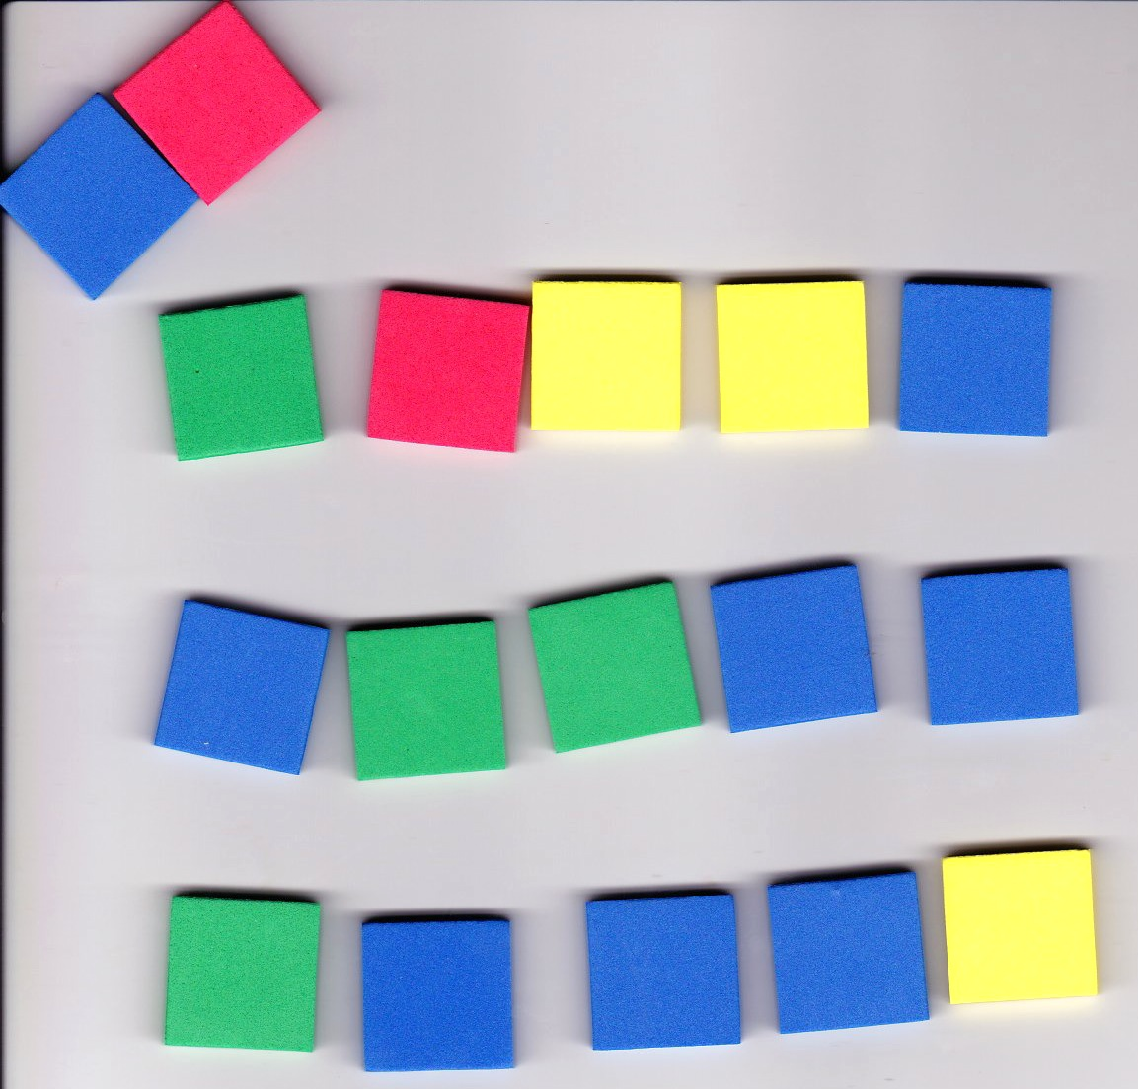
T: How many groups of 5 did you make?
S: 3 groups!
T: Were there any tiles left?
S: Yes!
T: Why not put them into a group?
S: That’s not enough to make another group of 5. They are extra.
T: Put your remaining tiles, the ones not in a group, off to the side.

NOTES ON
MULTIPLE MEANS
OF ENGAGEMENT:
Deepen the meaning of the word array by showing real life examples, such as arrays of solar panels in the desert, soldiers on parade, or even bumps on a Lego piece.

T: Arrange your groups into 3 equal rows to make an array.
T: How many rows, or groups, do you see?
S: 3 rows!
T: How many tiles are in each group?
S: 5 tiles!
T: What repeated addition sentence can we use to find the total?
S: 5 + 5 + 5 = 15.
T: Describe the array using the number of rows and the number of tiles in each row.
S: Three rows of 5 tiles.
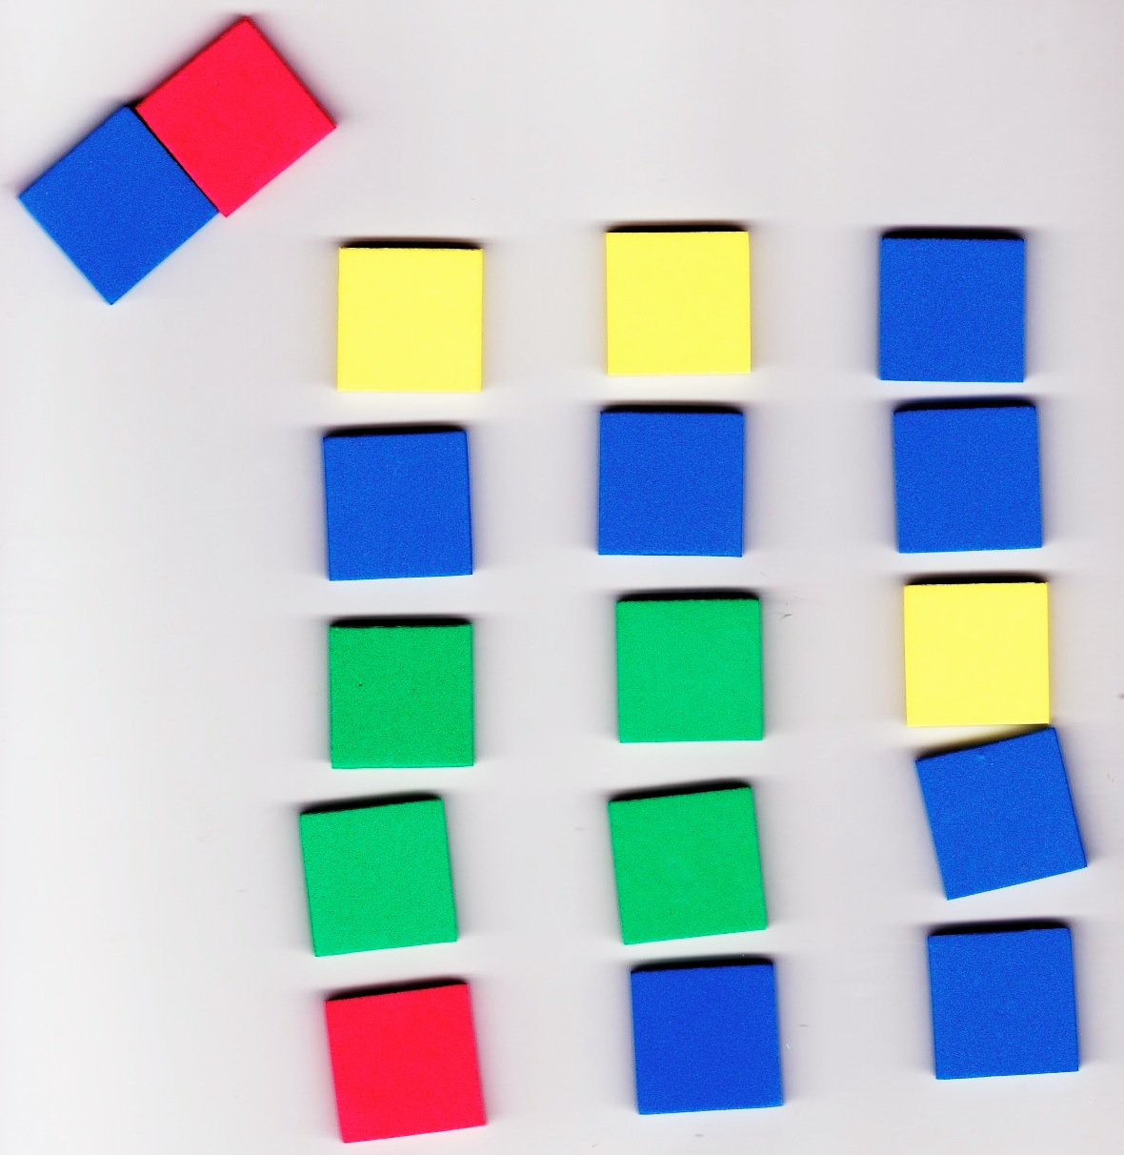
T: This time, let’s use the same groups, but make columns instead. (Pause as students work.)
T: How many columns, or groups, do you see?
S: 3 columns!
T: How many tiles are in each group?
S: 5 tiles!
T: So, how many fives are there?
S: 3 fives!
T: Describe the array using the number of columns and the number of tiles in each column.
S: Three columns of 5 tiles.
T: What repeated addition equation can we use to find the total?

NOTES ON
MULTIPLE MEANS
OF REPRESENTATION:
Students who struggle to line up manipulatives may benefit from the use of a Rekenrek, which will make even rows for them.

S: 5 + 5 + 5 = 15.
T: Turn and talk: What is the same or different about the two arrays we made?
S: They have the same total. We made one with rows and one with columns. They both had the same number of rows and columns. They both had 3 groups of 5.
Repeat the above process with the following sequence: 15 tiles for a 2 by 7 array, 17 tiles for a 4 by 4 array, and 23 tiles for a 4 by 5 array.
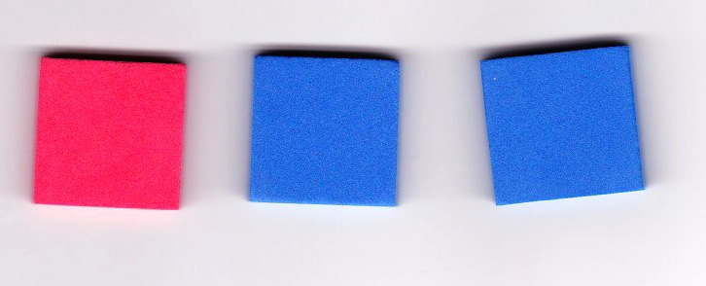
T: Now, let’s make some arrays one row at a time. Place 3 tiles in one row.
MP.4
S: (Make 1 row of 3.)
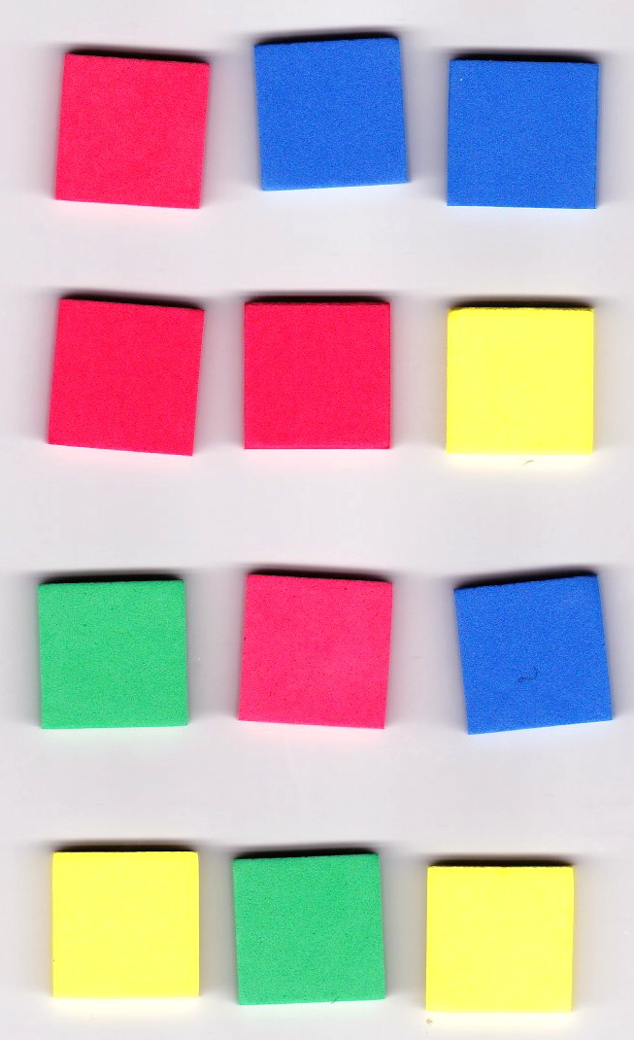
T: Now, keep adding a row and then another row until you have a total of 12 tiles.
S: (Add 3 more rows of 3.)
T: How many rows of 3 did you make?
S: 4 rows!
T: How many equal groups of 3 did you make?
S: 4 equal groups!
T: Say the repeated addition equation to find the total.
S: 3 + 3 + 3 + 3 = 12.
T: Describe the array using the number of rows and the number of tiles in each row.
S: 4 rows of 3 tiles.
T: This time, let’s use our rulers to push our rows together to make one rectangle without spaces in between. (Model for students, if necessary.)
S: (Push tiles together using rulers.)
T: Now, using your ruler, separate your array into columns. (Model for students, if necessary.)
S: (Separate columns using rulers.)
T: How many columns did you make?
S: 3 columns!
T: How many tiles are in each column?
S: 4 tiles!
T: How many equal groups of 4 did you make?
S: 3 equal groups!
T: So, what repeated addition equation can we use to find the total?
S: 4 + 4 + 4 = 12.
T: Describe the array using the number of columns and the number of tiles in each column.
S: Three columns of 4 tiles.
T: Did the total number of tiles change?
S: No!
T: Does an array made of 4 rows of 3 show the same total as an array made of 3 columns of 4?
S: Yes!
Repeat the above process with the following sequence: 2 by 4, 3 by 2, and 4 by 4.
Problem Set (10 minutes)
Students should do their personal best to complete the Problem Set within the allotted 10 minutes. For some classes, it may be appropriate to modify the assignment by specifying which problems they work on first. Some problems do not specify a method for solving. Students should solve these problems using the RDW approach used for Application Problems.
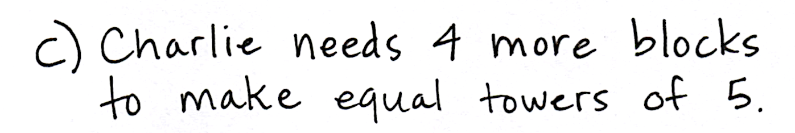
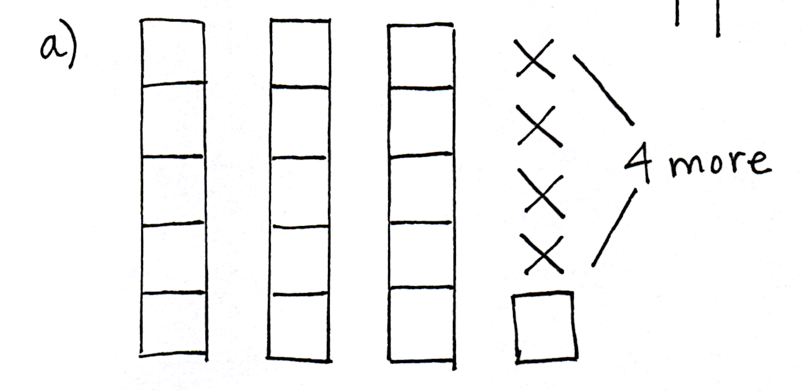
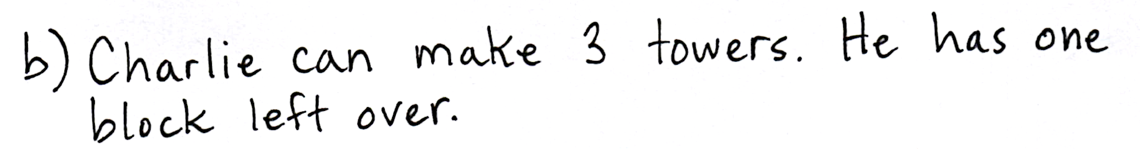
Application Problem (5 minutes)
Charlie has 16 blocks in his room. He wants to build equal towers with 5 blocks each.
- Draw a picture of Charlie’s towers.
- How many towers can Charlie make?
- How many more blocks does Charlie need to make equal towers of 5?
- Draw a picture of a different way Charlie could make equal towers using exactly 16 blocks.
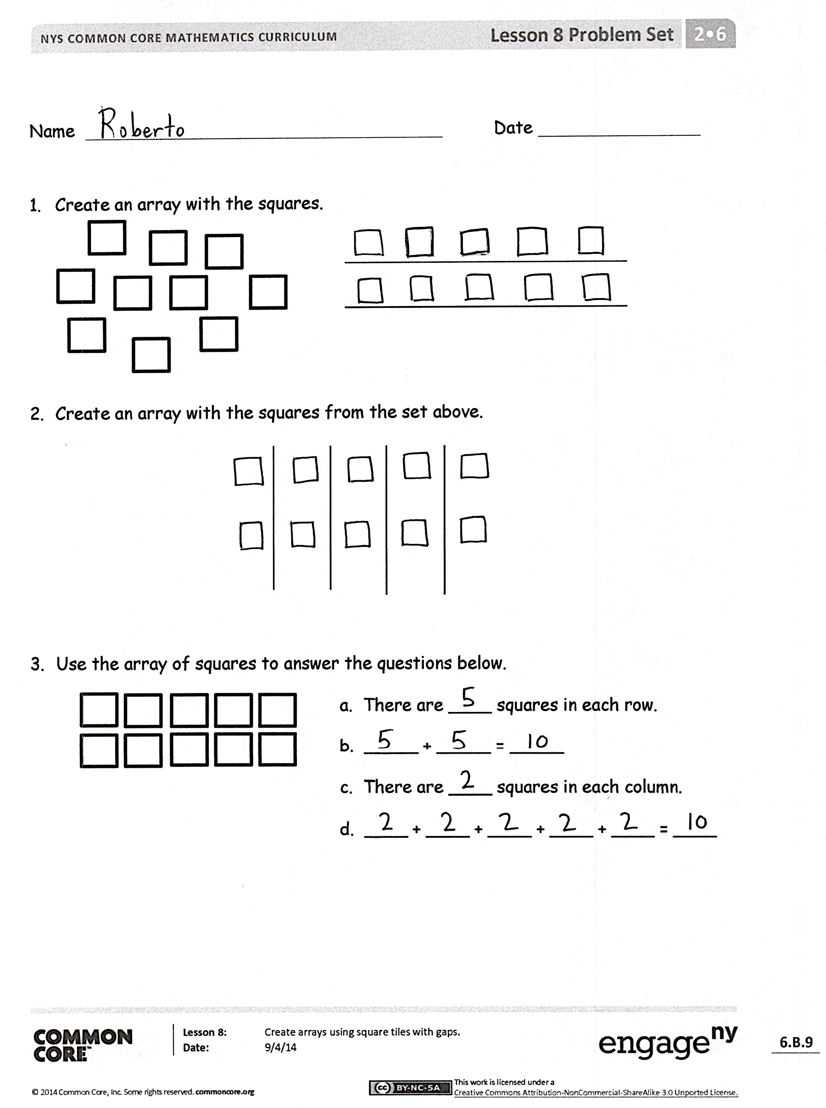
Note: This Application Problem comes after the Concept Development to give students an opportunity to apply the skills learned during the lesson. Students practice moving from the concrete to the pictorial stage of understanding in this problem, which prepares them for the Problem Set.
Student Debrief (10 minutes)
Lesson Objective: Create arrays using square tiles with gaps.
The Student Debrief is intended to invite reflection and active processing of the total lesson experience.
Invite students to review their solutions for the Problem Set. They should check work by comparing answers with a partner before going over answers as a class. Look for misconceptions or misunderstandings that can be addressed in the Debrief. Guide students in a conversation to debrief the Problem Set and process the lesson.
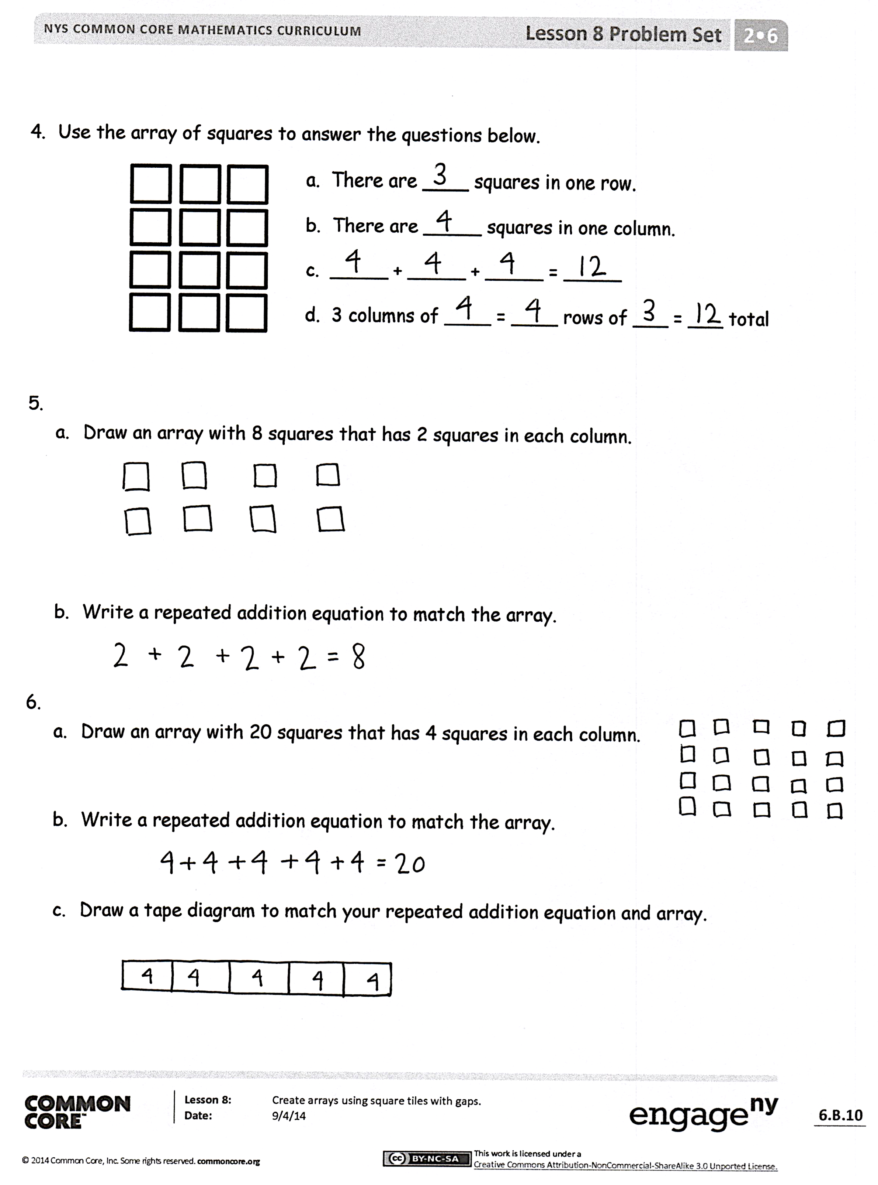
Any combination of the questions below may be used to lead the discussion.
- For Problem 1, how did you determine how many squares to put in each row? Describe the array: “There are ____ rows of ____.”
- For Problem 2, how did you determine how many squares to put in each column? How is this array different from Problem 1, even though the total is the same?
- For Problem 4, compare your answers with a partner. What repeated addition equation would describe 4 rows of 3? Could you redraw the squares to show an array with equal groups of 2? What would the repeated addition equation look like?
- For Problems 5 and 6, what steps did you take to draw the arrays? How many squares were in each group?
- For Problem 5(b), Soo Min wrote 4 + 4 = 8. Tasha wrote 2 + 2 + 2 + 2 = 8. Are they both correct? How do you know?
Exit Ticket (3 minutes)
After the Student Debrief, instruct students to complete the Exit Ticket. A review of their work will help with assessing students’ understanding of the concepts that were presented in today’s lesson and planning more effectively for future lessons. The questions may be read aloud to the students.

Number Correct: _______
A
Subtraction from Teens
 | 11 – 10 = |  |  |  | 19 – 9 =
 | 12 – 10 = |  |  |  | 15 – 6 =
 | 13 – 10 = |  |  |  | 15 – 7 =
 | 19 – 10 = |  |  |  | 15 – 9 =
 | 11 – 1 = |  |  |  | 20 – 10 =
 | 12 – 2 = |  |  |  | 14 – 5 =
 | 13 – 3 = |  |  |  | 14 – 6 =
 | 17 – 7 = |  |  |  | 14 – 7 =
 | 11 – 2 = |  |  |  | 14 – 9 =
 | 11 – 3 = |  |  |  | 15 – 5 =
 | 11 – 4 = |  |  |  | 17 – 8 =
 | 11 – 8 = |  |  |  | 17 – 9 =
 | 18 – 8 = |  |  |  | 18 – 8 =
 | 13 – 4 = |  |  |  | 16 – 7 =
 | 13 – 5 = |  |  |  | 16 – 8 =
 | 13 – 6 = |  |  |  | 16 – 9 =
 | 13 – 8 = |  |  |  | 17 – 10 =
 | 16 – 6 = |  |  |  | 12 – 8 =
 | 12 – 3 = |  |  |  | 18 – 9 =
 | 12 – 4 = |  |  |  | 11 – 9 =
 | 12 – 5 = |  |  |  | 15 – 8 =
 | 12 – 9 = |  |  |  | 13 – 7 =

Number Correct: _______
Improvement: _______
B
[KEY]

Subtraction from Teens
 | 11 – 1 = |  |  |  | 16 – 6 =
 | 12 – 2 = |  |  |  | 14 – 5 =
 | 13 – 3 = |  |  |  | 14 – 6 =
 | 18 – 8 = |  |  |  | 14 – 7 =
 | 11 – 10 = |  |  |  | 14 – 9 =
 | 12 – 10 = |  |  |  | 20 – 10 =
 | 13 – 10 = |  |  |  | 15 – 6 =
 | 18 – 10 = |  |  |  | 15 – 7 =
 | 11 – 2 = |  |  |  | 15 – 9 =
 | 11 – 3 = |  |  |  | 14 – 4 =
 | 11 – 4 = |  |  |  | 16 – 7 =
 | 11 – 7 = |  |  |  | 16 – 8 =
 | 19 – 9 = |  |  |  | 16 – 9 =
 | 12 – 3 = |  |  |  | 20 – 10 =
 | 12 – 4 = |  |  |  | 17 – 8 =
 | 12 – 5 = |  |  |  | 17 – 9 =
 | 12 – 8 = |  |  |  | 16 – 10 =
 | 17 – 7 = |  |  |  | 18 – 9 =
 | 13 – 4 = |  |  |  | 12 – 9 =
 | 13 – 5 = |  |  |  | 13 – 7 =
 | 13 – 6 = |  |  |  | 11 – 8 =
 | 13 – 9 = |  |  |  | 15 – 8 =

Name Date
- Create an array with the squares.

- Create an array with the squares from the set above.

- Use the array of squares to answer the questions below.
a. There are ____ squares in each row.
b. _____ + _____ = _____
c. There are ____ squares in each column.
d. ____ + ____ + ____ + ____ + ____ = ____

- Use the array of squares to answer the questions below.
a. There are ____ squares in one row.
b. There are _____ squares in one column.
c. _____ + _____ + _____ = _____
d. 3 columns of ____ = ____ rows of ___ = ___ total.

  - Draw an array with 8 squares that has 2 squares in each column.

  - Write a repeated addition equation to match the array.

  - Draw an array with 20 squares that has 4 squares in each column.

  - Write a repeated addition equation to match the array.

  - Draw a tape diagram to match your repeated addition equation and array.

Name Date
- Use the array of squares to answer the questions below.
a. There are ____ squares in one row.
b. There are _____ squares in one column.
c. _____ + _____ + _____ = _____
d. 3 columns of ____ = ____ rows of ___ = ___ total.

  - Draw an array with 10 squares that has 5 squares in each column.

  - Write a repeated addition equation to match the array.

Name Date
- Create an array with the squares.

- Create an array with the squares from the set above.

- Use the array of squares to answer the questions below.
a. There are ____ squares in each row.
b. _____ + _____ + _____ = _____
c. There are ____ squares in each column.
d. ____ + ____ + ____ + ____ + ____ = ____

- Use the array of squares to answer the questions below.
a. There are ____ squares in one row.
b. There are _____ squares in one column.
c. _____ + _____ = _____
d. 2 columns of ____ = ____ rows of ___ = ___ total.

  - Draw an array with 15 squares that has 3 squares in each column.

  - Write a repeated addition equation to match the array.

  - Draw an array with 20 squares that has 5 squares in each column.

  - Write a repeated addition equation to match the array.

  - Draw a tape diagram to match your repeated addition equation and array.

