Lesson 7
Objective: Represent arrays and distinguish rows and columns using math drawings.

Suggested Lesson Structure
 Fluency Practice (12 minutes)
 Concept Development (34 minutes)
 Application Problem (4 minutes)
 Student Debrief (10 minutes)
Total Time (60 minutes)
Fluency Practice (12 minutes)
- Coin Drop 2.OA.2 (3 minutes)
- Sprint: Sums to the Teens 2.NBT.5 (9 minutes)
Coin Drop (3 minutes)
Materials: (T) 10 dimes, 30 pennies, metal can or plastic container
Note: In this fluency activity, students prepare for Module 7 by adding and subtracting ones and tens using coins.
T: (Hold up a penny.) Name my coin.
S: A penny.
T: How much is it worth?
S: 1 cent.
T: Listen carefully as I drop coins in my can. Count along in your minds.
Drop in some pennies, and ask how much money is in the can. Take out some pennies, and show them. Ask how much money is still in the can. Continue adding and subtracting pennies for a minute or so. Repeat the activity with dimes and then with dimes and pennies.
Sprint: Sums to the Teens (9 minutes)
Materials: (S) Sums to the Teens Sprint
Note: This Sprint gives practice in the grade-level fluency of sums to 20.

Concept Development (34 minutes)
Materials: (S) Personal white board, 30 lima beans (per pair)
Note: Assign student partners with one Partner A and one Partner B.
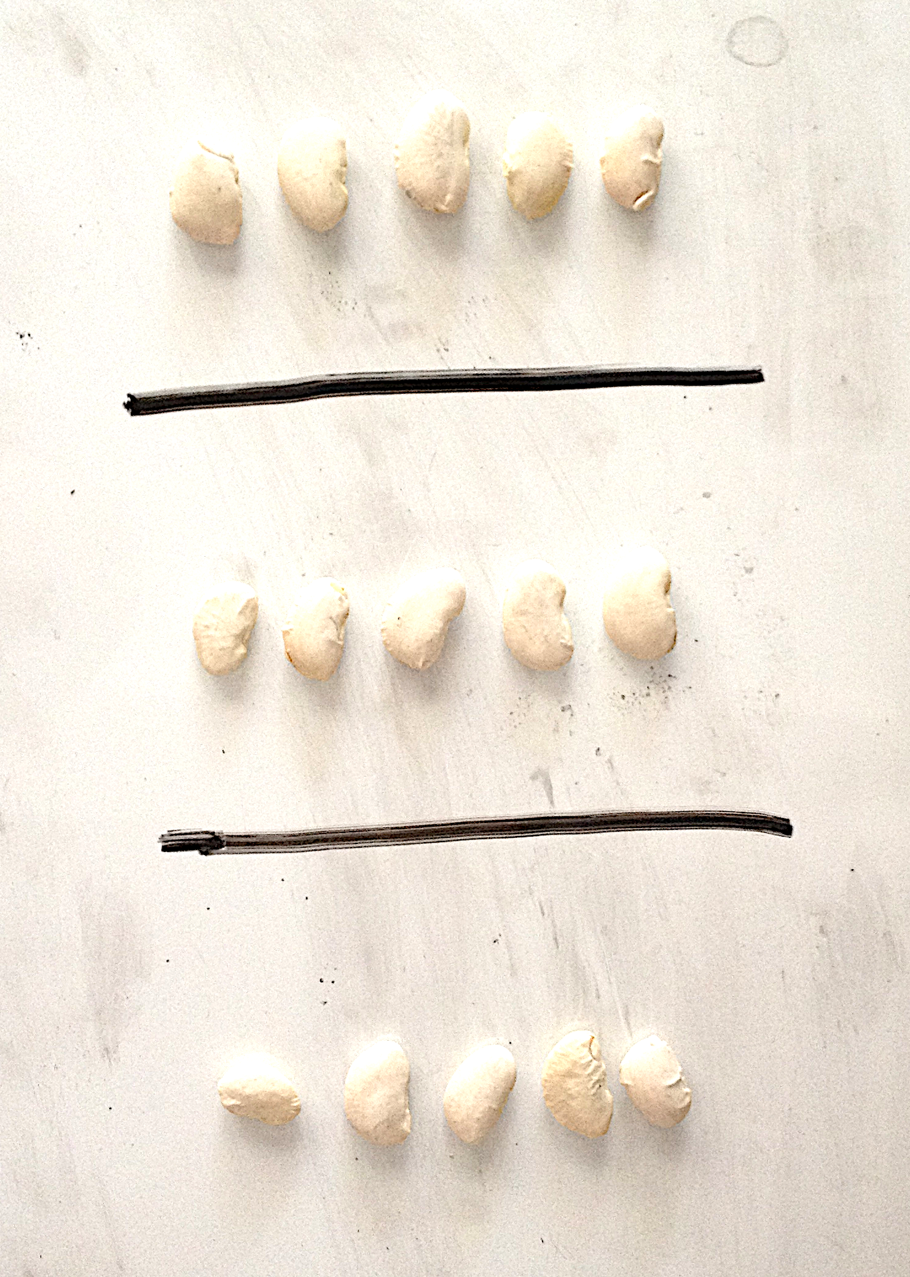
T: In our last lesson, we composed arrays with objects. Let’s review together. With your partner and your lima beans, show me 3 groups of 5 on each of your personal white boards. Let’s say that for right now, a group is a column.
T: Remind your partner, should the column be vertical or horizontal?
S: Vertical!
T: Count with your partner to make each column.
S: (Count as 5 beans are laid down in a column, then 5 more, and then 5 more.)
T: Now, add a line between each column.
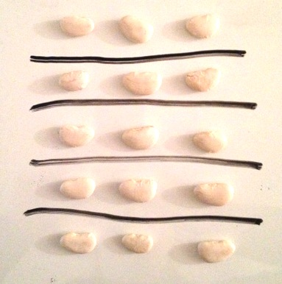
S: (Draw lines.)
T: These lines between each column will help us keep our array organized. They also help us see each column as a group, or unit, of 5.
T: How many columns did you make?
S: 3 columns!
T: How many beans in each column?
S: 5 beans!
T: What repeated addition sentence can we use to find the total?
S: 5 + 5 + 5 = 15.

NOTES ON
MULTIPLE MEANS
OF ENGAGEMENT:
Post a picture of Greek or Roman columns with the word column beneath it and a photo of rows, such as rows of bleacher seats, to help students recall what the words mean.

Column
Row
T: Now, Partner A, change your array to show 5 rows of three. Don’t forget to add lines between the rows.
S: (Reorganize beans.)
T: Turn and talk with your partner: How do the arrays look similar, and how are they different?
S: They look the same, but the lines show rows instead of columns. They both have a total of 15 beans.
T: Partner A, erase your lines between the rows of beans. Now, draw lines to show the columns.
T: Partner B, erase your lines between the columns, and redraw them to show the rows.
T: (Prompt students to compare their arrays again.)
T: If we want to show 3 rows of 5, what do we do first? Should we make a row first or organize the beans into equal groups of three?
S: Make a row of 5. The beans are already in groups. Just move them to make rows.
T: Remind me, should the row be vertical or horizontal?
S: Horizontal!
T: With your partner, create an array using the same beans. Make 3 rows of 5. Then, draw lines between your rows to keep them organized.
S: (Make array.)
T: How many rows did you make?
S: 3 rows!
T: How many beans in each row?
S: 5 beans!
T: So, each row is also a group, or unit, of…?
MP.4
S: 5.
T: Say the repeated addition sentence.
S: 5 + 5 + 5 = 15.
T: What was the total for 3 columns of 5 beans?
S: 15.

NOTES ON
MULTIPLE MEANS
OF ENGAGEMENT:
Some students may want to distribute one X each into the four columns and build the arrays that way. Have these students show and explain this alternate procedure to the class after the modeling portion of the Concept Development.

T: Yes! And what is the total for 3 rows of 5 beans?
S: 15.
T: So, how are 3 columns of 5 and 3 rows of 5 related?
S: They equal the same amount! It’s just a different way of grouping things to make 15.
T: This time, let’s draw our arrays. (Direct students to put their beans away.)
T: If we want to make an array of 4 columns of 2, what should we do first?
S: Make a column of 2. Start with the first column.
T: Yes, follow me! (Draw a column with 2 Xs, as students do the same on their personal white boards.)
T: (Model drawing the first column in the array as pictured.)
T: Turn and talk: How can we finish the array from here?
S: Draw more columns of 2. Draw another group, and then another group, and then another group. Draw 3 more groups with 2 Xs in each one.
T: Let’s do that together. What I draw, you draw. (Model drawing 3 more columns of two with vertical lines in between each group, as students do the same.)
T: What do the vertical lines remind us of?
S: That each column is a group. It separates the groups of two. It’s like each column is
its own unit of two.
T: (Circulate to check for understanding as students complete the arrays.)
T: Turn and talk: What repeated addition sentence can we use to find the total?
S: 2 + 2 + 2 + 2 = 8.
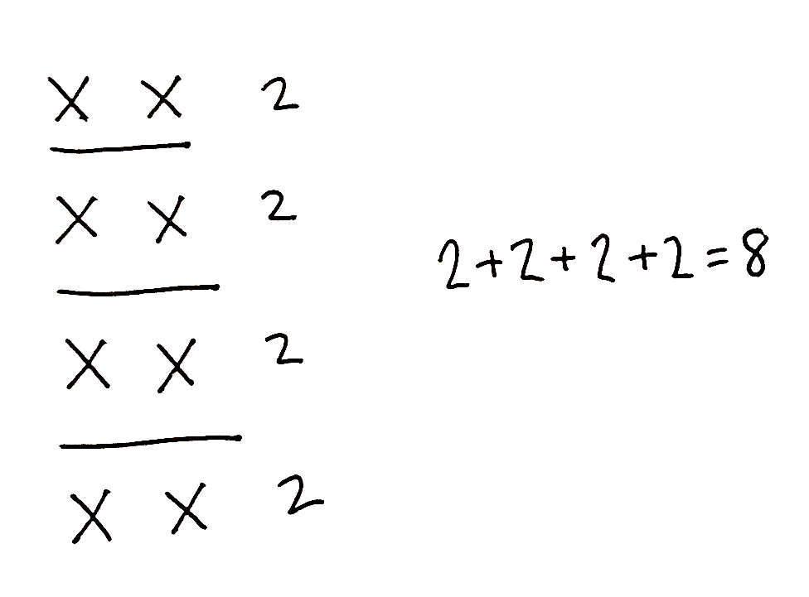
T: Now, let’s switch it like we did before. Show me 4 rows of 2 Xs. Write an equation to find the total. (Repeat the process above for the new array. Circulate as students draw 4 rows of 2, reminding them to draw horizontal lines between each row.)
T: What was the total for 4 columns of 2 Xs?
S: 8.
T: And what is the total for 4 rows of 2 Xs?
S: 8.
T: This time, you will draw your array without my help.
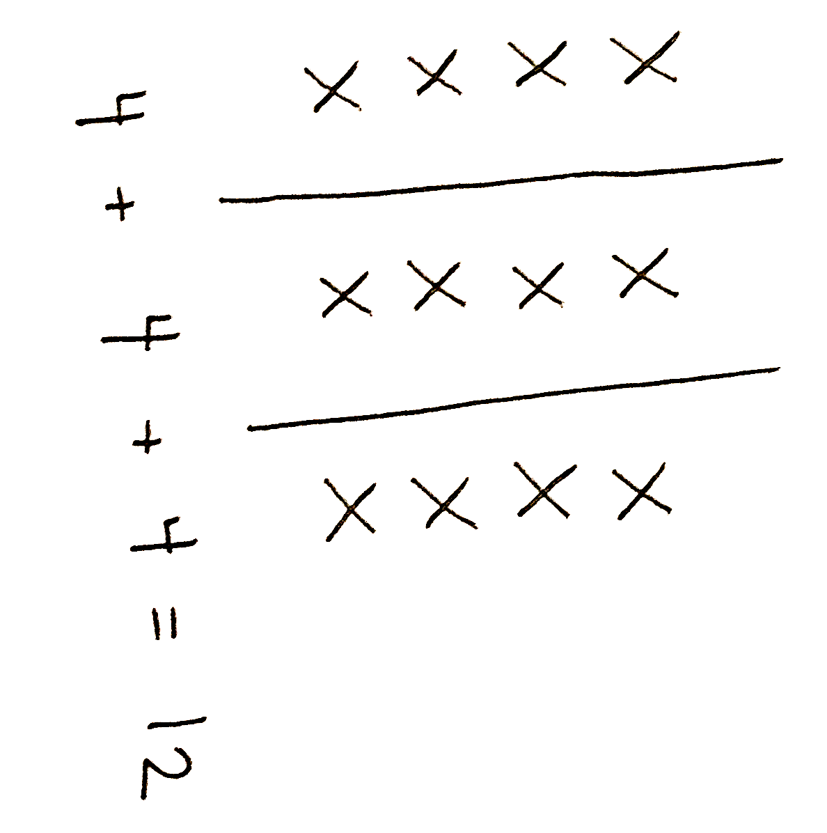
T: Draw an array with 3 columns of 4 Xs. Don’t forget your vertical lines in between each column! Write a repeated addition equation below your array to find the total.
T: (Circulate as students draw the array and write the corresponding equation.)
T: How many columns did you draw?
S: 3 columns.
T: How many Xs are in each column?
S: 4 Xs.
T: So, each column is a group, or unit, of…?
S: 4.
T: What repeated addition equation can we use to find the total?
S: 4 + 4 + 4 = 12.
T: Turn and talk: What would happen if you added one more column of 4?
S: The total would go up by 4. There would be another group of 4. The total would be 16.
T: Add another column of 4 to your array, and show me your new equation.
T: (Circulate as students add another column of 4 to their arrays and change their equations.)
T: Let’s read our repeated addition equations together, including the total.
S: 4 + 4 + 4 + 4 = 16.
T: Turn and talk: What would happen now if you erased two columns of 4? Go ahead and try that. Don’t forget about your equation! (Circulate as students erase two columns and change their equations.)
T: What happened?
S: The total went down by 8. There are only 2 columns of 4. Since we took away 8, I thought 16 – 8 = 8.
T: Let’s read our new repeated addition sentence together, including the total.
S: 4 + 4 = 8.
Complete the Concept Development by having students create an array with 4 rows of 3. Then, direct them to move on to the Problem Set.
Problem Set (10 minutes)
Students should do their personal best to complete the Problem Set within the allotted 10 minutes. For some classes, it may be appropriate to modify the assignment by specifying which problems they work on first. Some problems do not specify a method for solving. Students should solve these problems using the RDW approach used for Application Problems.
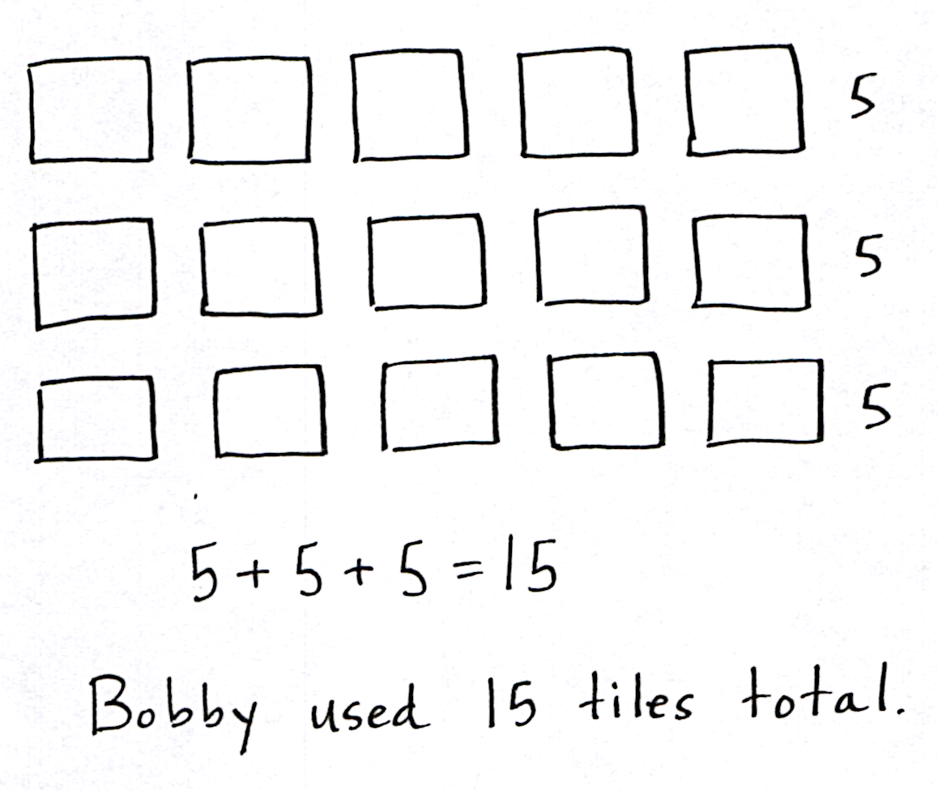
Application Problem (4 minutes)
Bobby puts 3 rows of tile in his kitchen to make a design. He lays 5 tiles in each row.
- Draw a picture of Bobby’s tiles.
- Write a repeated addition equation to solve for the total number of tiles Bobby used.
Note: This Application Problem comes after the Concept Development to give students the chance to practice new material.
Student Debrief (10 minutes)
Lesson Objective: Represent arrays and distinguish rows and columns using math drawings.
The Student Debrief is intended to invite reflection and active processing of the total lesson experience. Invite students to review their solutions for the Problem Set. They should check work by comparing answers with a partner before going over answers as a class. Look for misconceptions or misunderstandings that can be addressed in the Debrief. Guide students in a conversation to debrief the Problem Set and process the lesson.
Any combination of the questions below may be used to lead the discussion.
- In Problems 1 (a) and (b), how do the vertical and horizontal lines help us?
- For Problems 2 (a) and (b), compare your array drawings. How are they similar and different? Why did you write the same equation for both arrays?
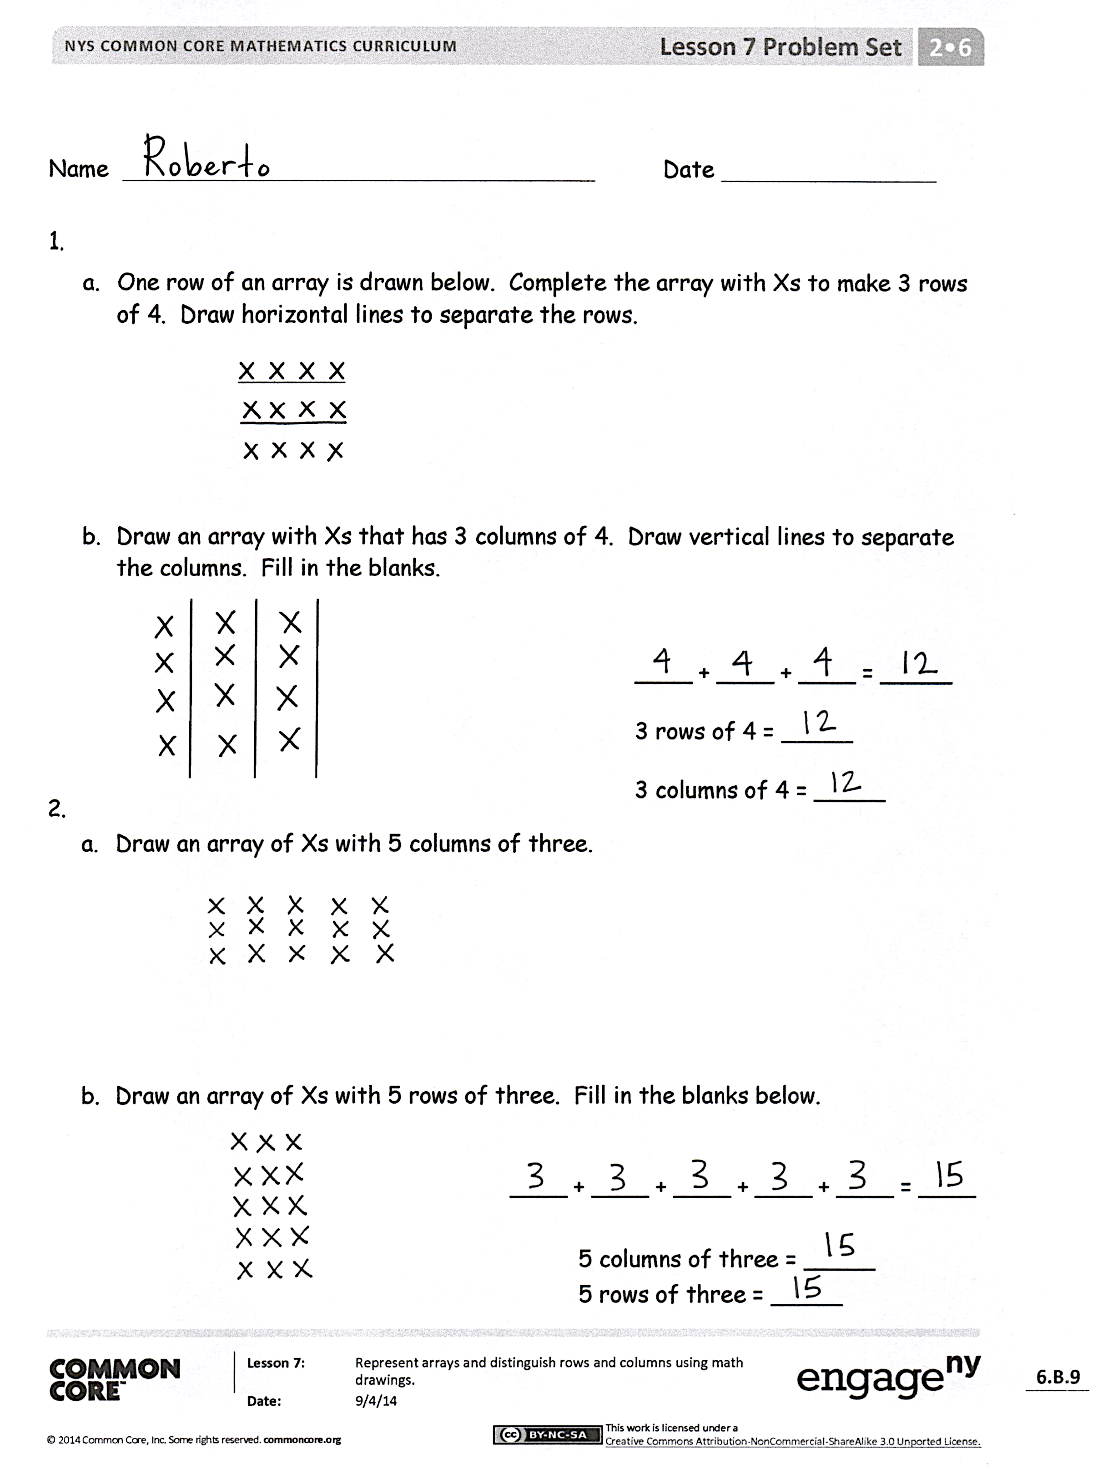
- For Problem 3, share your array drawing with a partner. Which lines did you draw within the array: vertical or horizontal? Why? How many Xs were in each group? Why is it important to know this?
- For Problem 4, share your new array with a partner. How did your drawing and equation change when you added 1 more row?
- For Problem 5, share your new array with a partner. How did your drawing and equation change when you removed 1 column? How many were in each group then? How did you group the Xs to write a repeated addition equation (i.e., by groups of 2 or 5)?
Exit Ticket (3 minutes)
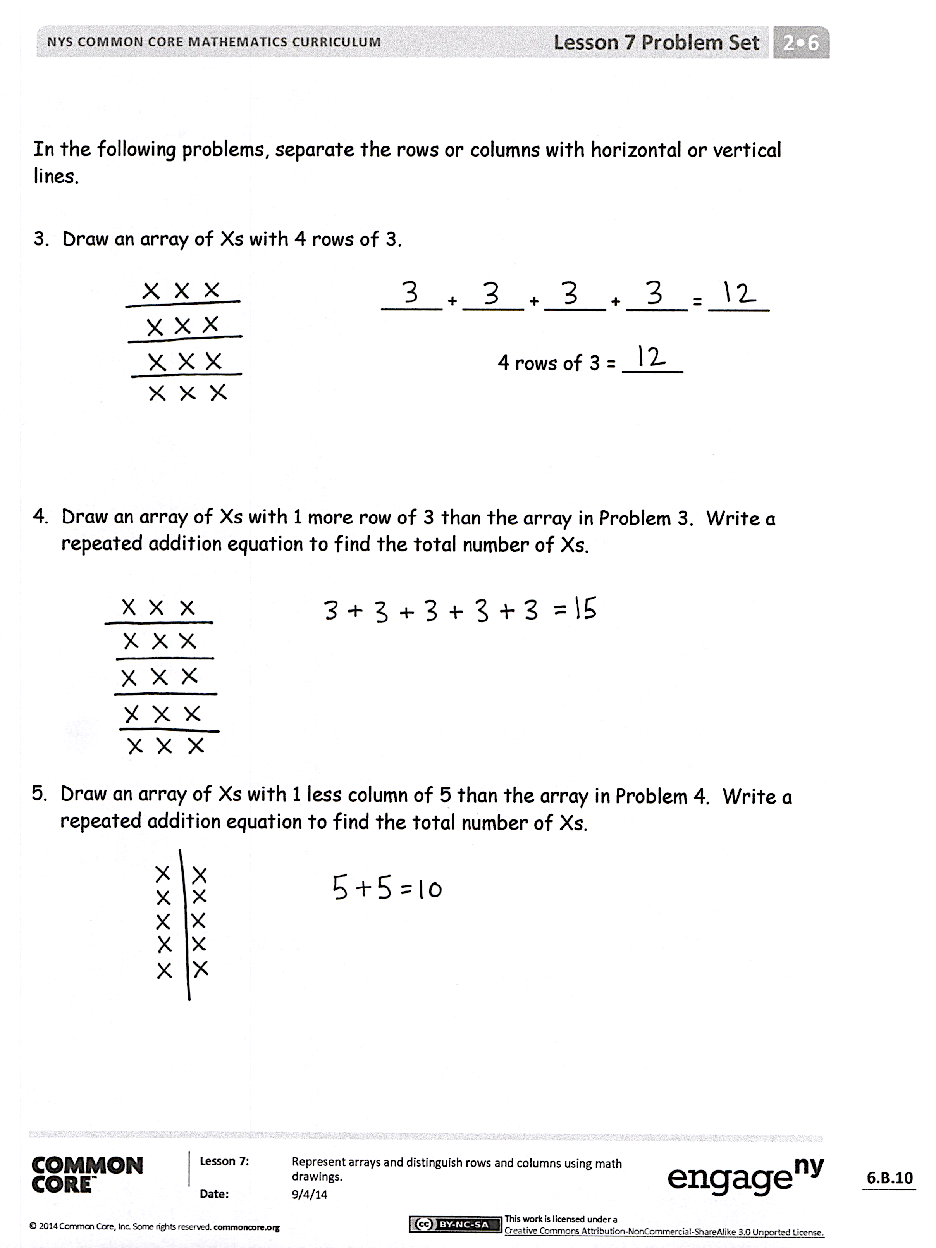
After the Student Debrief, instruct students to complete the Exit Ticket. A review of their work will help with assessing students’ understanding of the concepts that were presented in today’s lesson and planning more effectively for future lessons. The questions may be read aloud to the students.

Number Correct: _______
A
A
Sums to the Teens
 | 9 + 2 = |  |  |  | 4 + 7 =
 | 9 + 3 = |  |  |  | 4 + 8 =
 | 9 + 4 = |  |  |  | 5 + 6 =
 | 9 + 7 = |  |  |  | 5 + 7 =
 | 7 + 9 = |  |  |  | 3 + 8 =
 | 10 + 1 = |  |  |  | 3 + 9 =
 | 10 + 2 = |  |  |  | 2 + 9 =
 | 10 + 3 = |  |  |  | 5 + 10 =
 | 10 + 8 = |  |  |  | 5 + 8 =
 | 8 + 10 = |  |  |  | 9 + 6 =
 | 8 + 3 = |  |  |  | 6 + 9 =
 | 8 + 4 = |  |  |  | 7 + 6 =
 | 8 + 5 = |  |  |  | 6 + 7 =
 | 8 + 9 = |  |  |  | 8 + 6 =
 | 9 + 8 = |  |  |  | 6 + 8 =
 | 7 + 4 = |  |  |  | 8 + 7 =
 | 10 + 5 = |  |  |  | 7 + 8 =
 | 6 + 5 = |  |  |  | 6 + 6 =
 | 7 + 5 = |  |  |  | 7 + 7 =
 | 9 + 5 = |  |  |  | 8 + 8 =
 | 5 + 9 = |  |  |  | 9 + 9 =
 | 10 + 6 = |  |  |  | 4 + 9 =
Number Correct: _______
Improvement: _______
B
[KEY]

Sums to the Teens
 | 10 + 1 = |  |  |  | 5 + 6 =
 | 10 + 2 = |  |  |  | 5 + 7 =
 | 10 + 3 = |  |  |  | 4 + 7 =
 | 10 + 9 = |  |  |  | 4 + 8 =
 | 9 + 10 = |  |  |  | 4 + 10 =
 | 9 + 2 = |  |  |  | 3 + 8 =
 | 9 + 3 = |  |  |  | 3 + 9 =
 | 9 + 4 = |  |  |  | 2 + 9 =
 | 9 + 8 = |  |  |  | 5 + 8 =
 | 8 + 9 = |  |  |  | 7 + 6 =
 | 8 + 3 = |  |  |  | 6 + 7 =
 | 8 + 4 = |  |  |  | 8 + 6 =
 | 8 + 5 = |  |  |  | 6 + 8 =
 | 8 + 7 = |  |  |  | 9 + 6 =
 | 7 + 8 = |  |  |  | 6 + 9 =
 | 7 + 4 = |  |  |  | 9 + 7 =
 | 10 + 4 = |  |  |  | 7 + 9 =
 | 6 + 5 = |  |  |  | 6 + 6 =
 | 7 + 5 = |  |  |  | 7 + 7 =
 | 9 + 5 = |  |  |  | 8 + 8 =
 | 5 + 9 = |  |  |  | 9 + 9 =
 | 10 + 8 = |  |  |  | 4 + 9 =

Name Date

- One row of an array is drawn below. Complete the array with Xs to make 3 rows of 4. Draw horizontal lines to separate the rows.
X X X X

- Draw an array with Xs that has 3 columns of 4. Draw vertical lines to separate the columns. Fill in the blanks.
____ + ____ + ____ = _____
3 rows of 4 = _____
3 columns of 4 = _____

  - Draw an array of Xs with 5 columns of three.

  - Draw an array of Xs with 5 rows of three. Fill in the blanks below.

____ + ____ + ____ + ____ + ____ = ____

5 columns of three = _____
5 rows of three = _____

In the following problems, separate the rows or columns with horizontal or vertical lines.

- Draw an array of Xs with 4 rows of 3.

_____ + _____ + _____ + _____ = _____

4 rows of 3 = _____

- Draw an array of Xs with 1 more row of 3 than the array in Problem 3. Write a repeated addition equation to find the total number of Xs.

- Draw an array of Xs with 1 less column of 5 than the array in Problem 4. Write a repeated addition equation to find the total number of Xs.

Name Date
Use horizontal or vertical lines to separate the rows or columns.

- Draw an array of Xs with 3 rows of 5.

___ + ___ + ___ = ___

3 rows of 5 = ____

- Draw an array of Xs with 1 more row than the above array. Write a repeated addition equation to find the total number of Xs.

Name Date

  - One row of an array is drawn below. Complete the array with Xs to make 4 rows
of 5. Draw horizontal lines to separate the rows.
X X X X X

  - Draw an array with Xs that has 4 columns of 5. Draw vertical lines to separate the columns. Fill in the blanks.
____ + ____ + ____ + ____= ____
4 rows of 5 = _____
4 columns of 5 = _____

  - Draw an array of Xs with 3 columns of 4.

  - Draw an array of Xs with 3 rows of 4. Fill in the blanks below.
____ + ____ + ____ = ____

3 columns of 4 = _____
3 rows of 4 = _____

In the following problems, separate the rows or columns with horizontal or vertical lines.
- Draw an array of Xs with 3 rows of 3.

____ + ____ + ____ = ____

3 rows of 3 = ____

- Draw an array of Xs with 2 more rows of 3 than the array in Problem 3. Write a repeated addition equation to find the total number of Xs.

- Draw an array of Xs with 1 less column than the array in Problem 4. Write a repeated addition equation to find the total number of Xs.

