Lesson 5
Objective: Compose arrays from rows and columns, and count to find the total using objects.

Suggested Lesson Structure
 Fluency Practice (12 minutes)
 Concept Development (34 minutes)
 Application Problem (4 minutes)
 Student Debrief (10 minutes)
Total Time (60 minutes)
Fluency Practice (12 minutes)
- Making the Next Ten to Add 2.NBT.5 (4 minutes)
- Grade 2 Core Fluency Practice Sets 2.OA.2 (5 minutes)
- Happy Counting by Tens: Crossing 100 2.NBT.2 (3 minutes)
Making the Next Ten to Add (4 minutes)
Note: This fluency activity reviews the make ten addition strategy.
Post on board:
9 + 4 = ___
/\
1 3
10 + 3 = 13

T: When I say 9 + 4, you say 10 + 3. Ready? 9 + 4.
S: 10 + 3.
T: Answer.
S: 13.
Continue with the following possible sequence, one column at a time:

19 + 4, 49 + 4
9 + 6, 19 + 6, 59 + 6
8 + 3, 18 + 3, 68 + 3
8 + 5, 18 + 5, 78 + 5
7 + 4, 17 + 4, 87 + 4
7 + 6, 17 + 6, 97 + 6

Grade 2 Core Fluency Practice Sets (5 minutes)
Materials: (S) Core Fluency Practice Sets (G2−M6−Lesson 1 Core Fluency Practice Sets)
Note: During Topic B and for the remainder of the year, each day’s Fluency Practice includes an opportunity for review and mastery of the sums and differences with totals through 20 by means of the Core Fluency Practice Sets or Sprints. Practice Sets, along with details about the process, are provided in Lesson 1.
Happy Counting by Tens: Crossing 100 (3 minutes)
Note: Students skip-count by tens as a foundation for counting rows and columns in today’s lesson.
T: This time, let’s play Happy Counting, skip-counting by tens!
T: Watch my fingers to know whether to count up or down. A closed hand means stop. (Show signals as you explain.)
T: Let’s count by tens, starting at 60. Ready? (Point up rhythmically until a change is desired. Close hand to indicate a stopping point. Point down to count in the opposite direction. Continue, periodically changing direction.)
S: 60, 70, 80, 90, 100, 110, 120, 130, 140 (switch) 130, 120, 110, 100, 90 (switch) 100, 110, 120, 130, 140, 150, 160, 170, 180, 190, 200, 210, 220 (switch) 210, 200, 190, 180.
T: Excellent! Try it for 30 seconds with your partner, starting at 80. Partner A, you are the teacher today.
Concept Development (34 minutes)
Materials: (T/S) 6 counting bears, 12 beans
Call students to the carpet or communal area for Problem 1.
Problem 1: Arrays with 6 objects.
T: (Show 2 groups of 3 bears.)
T: Look at my bears. How many are in each group?
S: 3 bears!
T: How many groups?
S: 2 groups!
T: How many bears altogether?
S: 6 bears!
T: How did you know?
S: Because I counted 1, 2, 3, 4, 5, 6. 3 + 3 = 6.
T: Turn and talk: How can we arrange these groups of 3 into rows of 3?
S: Make them go straight across instead of in a group. Line them up.
T: To put them in rows, we can place them in straight horizontal lines.
T: (Call on a student volunteer to organize the bears into 2 equal rows.)
T: What do you notice about the rectangular array we just created?
S: The same number is in each row. It looks like a ten-frame, but there are only 3 in each row. There are 2 groups of three.
T: How many bears are in each row?
S: 3 bears!
T: How many rows are there?

NOTES ON
MULTIPLE MEANS
OF ENGAGEMENT:
Make the connection with students between the words array and arrange. Show the spelling and how the roots relate, and discuss how an array is an orderly arrangement of things. This connection will especially support English language learners.

S: 2 rows!
T: So, there are two equal groups of…?
S: 3.
T: How many bears altogether?
S: 6 bears!
T: Did the total number of bears change when I organized them into a rectangular array?
S: No.
T: (Scatter the counters so they are no longer arranged in an array.)

NOTES ON
MULTIPLE MEANS
OF ACTION AND EXPRESSION:
The concept of rows and columns is introduced here to support the understanding of repeated addition rather than as a goal unto itself. Students should not be assessed on their understanding of rows and columns. Encourage correct answers regardless of directionality.

T: Turn and talk: What if we want to arrange them into two columns of 3? Columns are groups that are arranged vertically, or up and down. Tell your partner what that would look like.
S: It would have 3 on one side and 3 on the other side.
It would look the same as the other one but facing sideways.
T: Let’s try that. (Model arranging the counters into 2 columns of 3.)
T: How many columns do you see?
S: 2 columns!
T: How many bears are in each column?
S: 3 bears!
T: So, there are two equal groups of…?
S: 3.
T: And the total number of bears is…?
S: 6.
T: Turn and talk: Is there another way I can group the bears other than into 2 groups of 3?
S: They can stay in 1 group of 6. You can make 6 groups of 1. You can put them in 3 groups of 2.
T: Yes, let’s try that! Organize your bears with your partner into 3 groups of 2.
T: How many rows did you make?
S: 3 rows!
T: How many bears are in each row?
S: 2 bears!
T: Let’s count together to find the total.
T: Count with me.
S: 1, 2, 3, 4, 5, 6.
T: Now, let’s count them row-by-row. Count the top row with me.
S: 1, 2.
T: Move down and count the next row with me.
S: 1, 2.
T: Let’s count the last row together.
S: 1, 2.
T: How many groups of 2 was that?
S: 3 groups of 2.
T: This time, let’s count the columns together. Start with the column on the left and move from top to bottom with me.
S: 1, 2, 3.
MP.7
T: Count the other column.
S: 1, 2, 3.
T: How many bears are in each column?
S: 3 bears!
T: How many columns?
S: 2 columns!
T: How many bears are in the array altogether? How do you know?
S: There are 6 bears altogether. There are 3 in each column, and 3 + 3 = 6. I know that 2 + 2 + 2 = 6. I counted 2, 4, 6.
T: Did the number of bears change when we reorganized them into rows of two?
S: No!
Problem 2: Making Arrays with 12 Objects.
T: Let’s try another one. (Take out 12 beans, and tell students to do the same.)
T: How can we put these beans into equal groups?
S: You can make groups of 2. You can make groups of 3. Put them into groups of 4.
T: Let’s start with groups of 2. (Call on a volunteer to separate the beans into groups of two.)
T: How many groups of two beans did we make?
S: 6 groups.
T: Turn and talk: How can we arrange the 6 groups of two beans into a rectangular array?
S: You can make 6 rows of two. You can make 6 columns of two. Make 2 rows of six.
T: Let’s start with 2 rows of six. (Model arranging the beans into 2 rows of six.)
T: How many rows did you make?
S: 2 rows.
T: How many beans in each row?
S: 6 beans.
T: So, there are 2 equal groups of…?
S: 6.
If students need more practice arranging objects into arrays, continue with the above sequence with the following numbers: 8, 9, and 20. Otherwise, allow students to begin the Problem Set.
Problem Set (10 minutes)
Students should do their personal best to complete the Problem Set within the allotted 10 minutes. For some classes, it may be appropriate to modify the assignment by specifying which problems they work on first. Some problems do not specify a method for solving. Students should solve these problems using the RDW approach used for Application Problems.
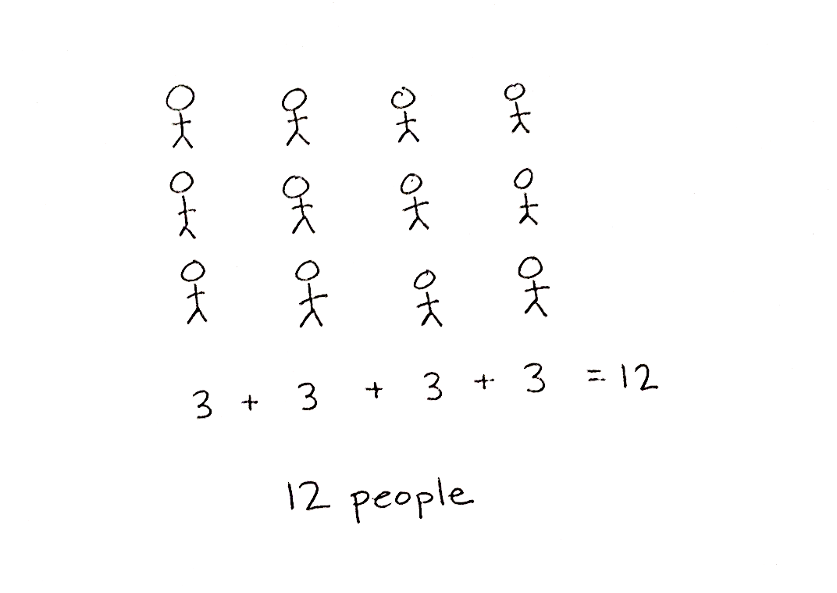
Application Problem (4 minutes)
Mrs. White is in line at the bank. There are 4 teller windows, and 3 people are standing in line at each window.
- Draw an array to show the people in line at the bank.
- Write the total number of people.
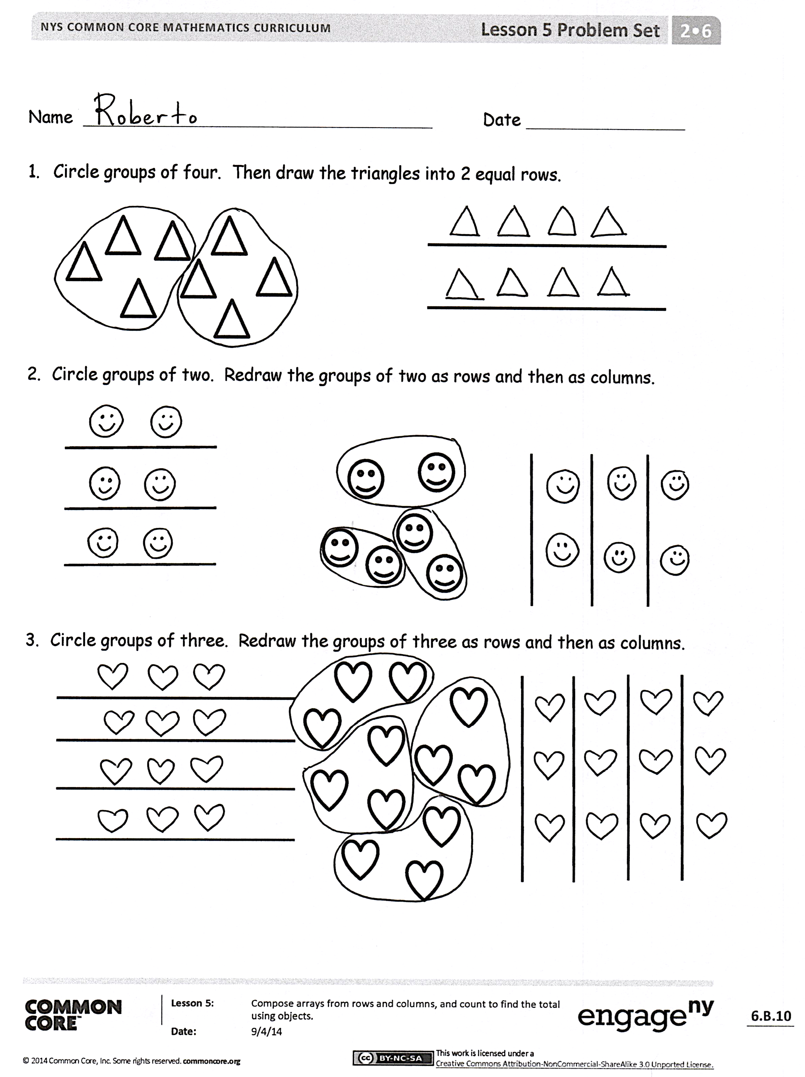
Note: This Application Problem comes after the Problem Set to reinforce the concepts learned in the Concept Development.
Student Debrief (10 minutes)
Lesson Objective: Compose arrays from rows and columns, and count to find the total using objects.
The Student Debrief is intended to invite reflection and active processing of the total lesson experience.
Invite students to review their solutions for the Problem Set. They should check work by comparing answers with a partner before going over answers as a class. Look for misconceptions or misunderstandings that can be addressed in the Debrief. Guide students in a conversation to debrief the Problem Set and process the lesson.

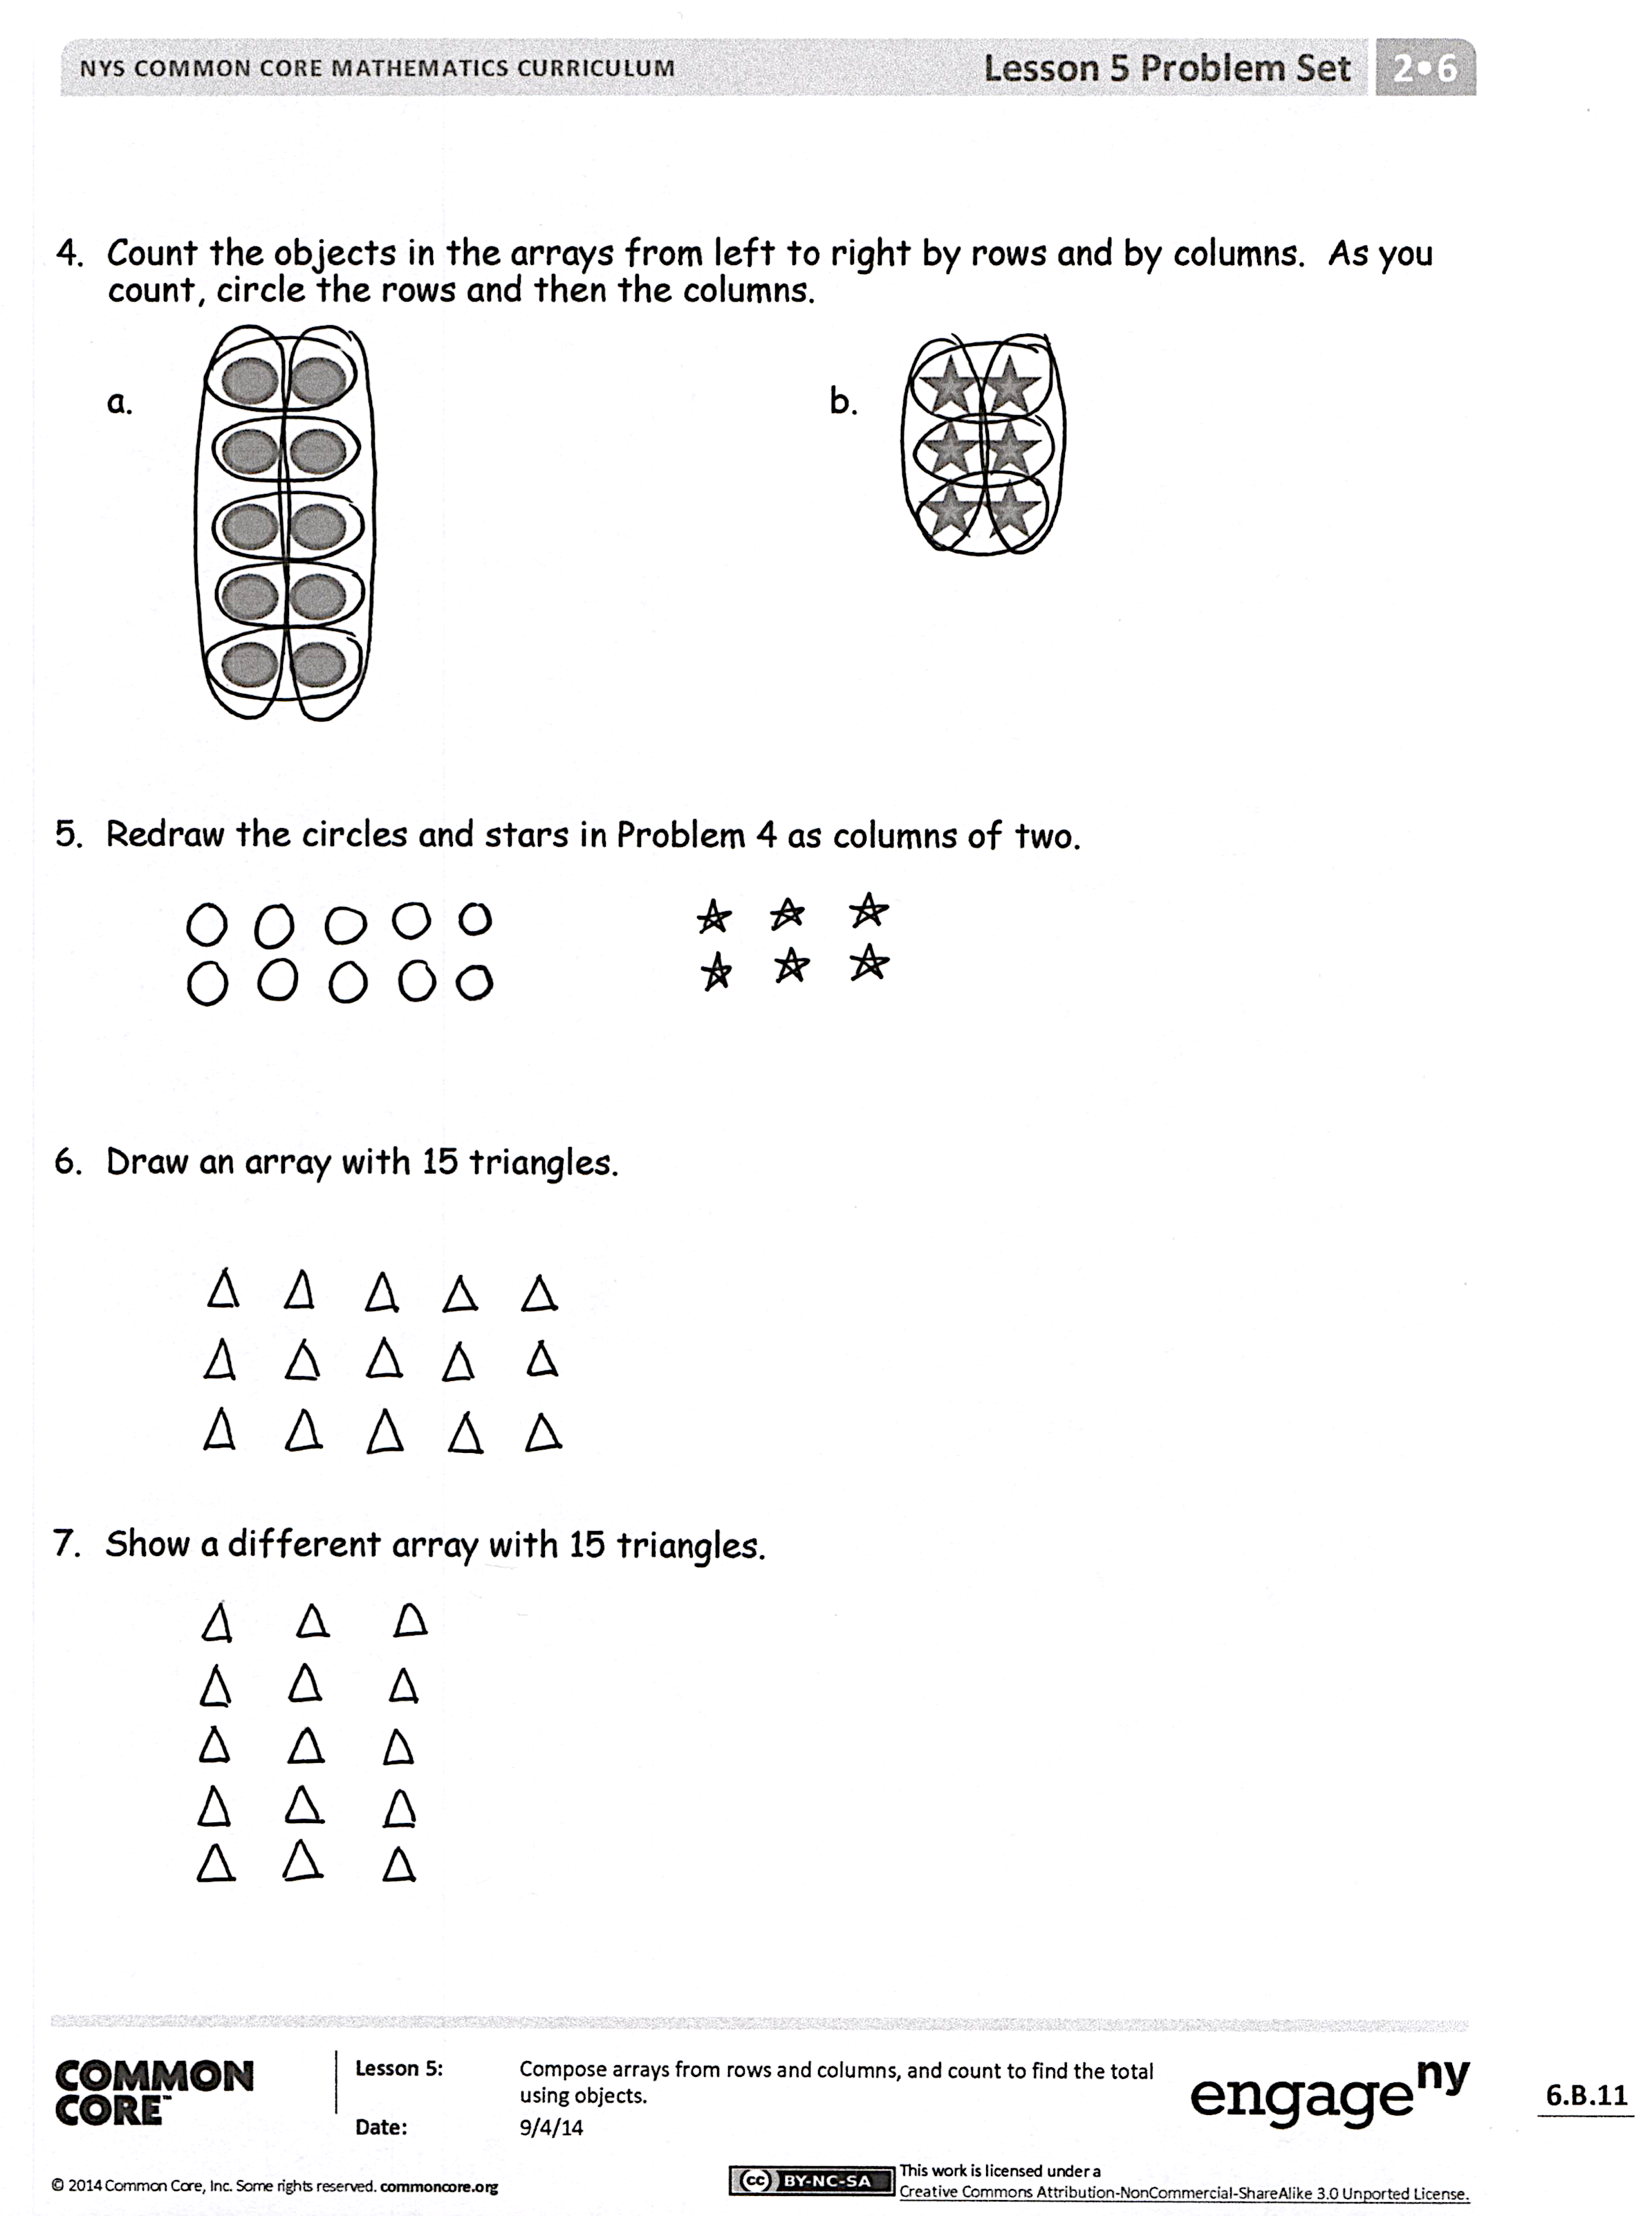
Any combination of the questions below may be used to lead the discussion.
- For Problem 1, how did circling equal groups prepare you for arranging the triangles into an array?
- For Problem 2, why did you make 3 rows or 3 columns? Could you have made an array with only 2 rows or columns? How?
- For Problem 3, what does the number of rows or columns represent? What does the number in each row or column represent? How does arranging the hearts into an array help you find the total more efficiently or easily?
- For Problem 5, show your partner how you redrew the arrays in Problem 4. What is the same between the new arrays and the old ones in Problem 4?
- For Problem 6, compare your arrays with a partner. How could you describe your arrays in terms of equal groups? How do rows and columns help us to organize groups?
Exit Ticket (3 minutes)
After the Student Debrief, instruct students to complete the Exit Ticket. A review of their work will help with assessing students’ understanding of the concepts that were presented in today’s lesson and planning more effectively for future lessons. The questions may be read aloud to the students.

Name Date
- Circle groups of four. Then, draw the triangles into 2 equal rows.

- Circle groups of two. Redraw the groups of two as rows and then as columns.

- Circle groups of three. Redraw the groups of three as rows and then as columns.

- Count the objects in the arrays from left to right by rows and by columns. As you count, circle the rows and then the columns.

  - b.

- Redraw the circles and stars in Problem 4 as columns of two.

- Draw an array with 15 triangles.

- Show a different array with 15 triangles.

Name Date
- Circle groups of three. Redraw the groups of three as rows and then as columns

- Complete the array by drawing more triangles. The array should have 12 triangles in all.

Name Date
- Circle groups of five. Then, draw the clouds into two equal rows.

- Circle groups of four. Redraw the groups of four as rows and then as columns.

- Circle groups of four. Redraw the groups of four as rows and then as columns.

- Count the objects in the arrays from left to right by rows and by columns. As you count, circle the rows and then the columns.

- b.

- Redraw the smiley faces and triangles in Problem 4 as columns of three.

- Draw an array with 20 triangles.

- Show a different array with 20 triangles.

