Lesson 18
Objective: Draw symmetric figures on the coordinate plane.

Suggested Lesson Structure
 Application Problem (6 minutes)
 Fluency Practice (11 minutes)
 Concept Development (33 minutes)
 Student Debrief (10 minutes)
Total Time (60 minutes)
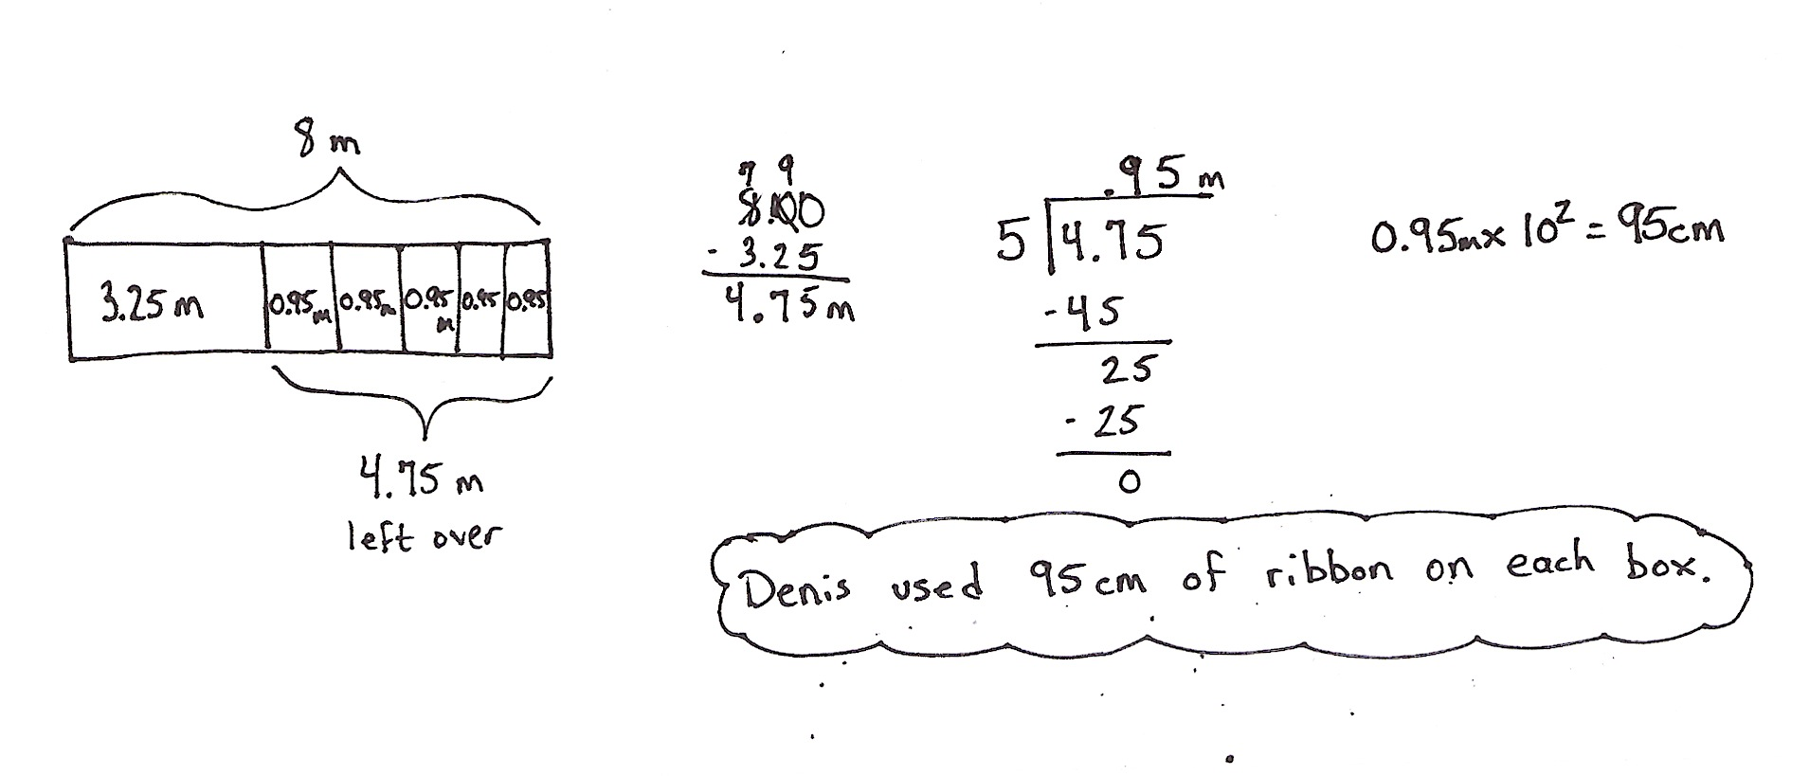
Application Problem (6 minutes)
Denis buys 8 m of ribbon. He uses 3.25 m for a gift. He uses the remaining ribbon equally to tie bows on 5 boxes. How much ribbon did he use on each box?
Note: This problem reviews subtracting decimals and dividing decimal numbers by single digit whole numbers, concepts from G5─Module 1.
Fluency Practice (11 minutes)
- Make Larger Units 4.NF.1 (4 minutes)

NOTES ON
MULTIPLE MEANS FOR ACTION AND EXPRESSION:
When giving directions for Simplify Fractions, challenge advanced learners to both simplify the fraction and write others that simplify to the same fraction with denominators greater than 144.
- Unknown Angles 4. MD.6 (7 minutes)
Make Larger Units (4 minutes)
Materials: (S) Personal white boards
Note: This fluency activity reviews G5─Module 3 concepts.
T: (Write $\frac{5}{10}.$) Simplify the fraction by writing it using a larger fractional unit.
S: $\frac{1}{2}$.
T: (Write $\frac{5}{15}$.) Simplify.
S: $\frac{1}{3}$.
T: (Write $\frac{5}{25}$.) Simplify.
S: (Write $\frac{5}{25}$ = $\frac{1}{5}$.)
Continue the process for $\frac{10}{25}$, $\frac{2}{6}$, $\frac{2}{8}$, $\frac{6}{8}$, $\frac{4}{12}$, $\frac{8}{12}$, $\frac{9}{27}$, $\frac{18}{27}$, $\frac{6}{24}$, and $\frac{18}{24}$.
Unknown Angles (7 minutes)
Materials: (S) Blank paper, ruler, protractor
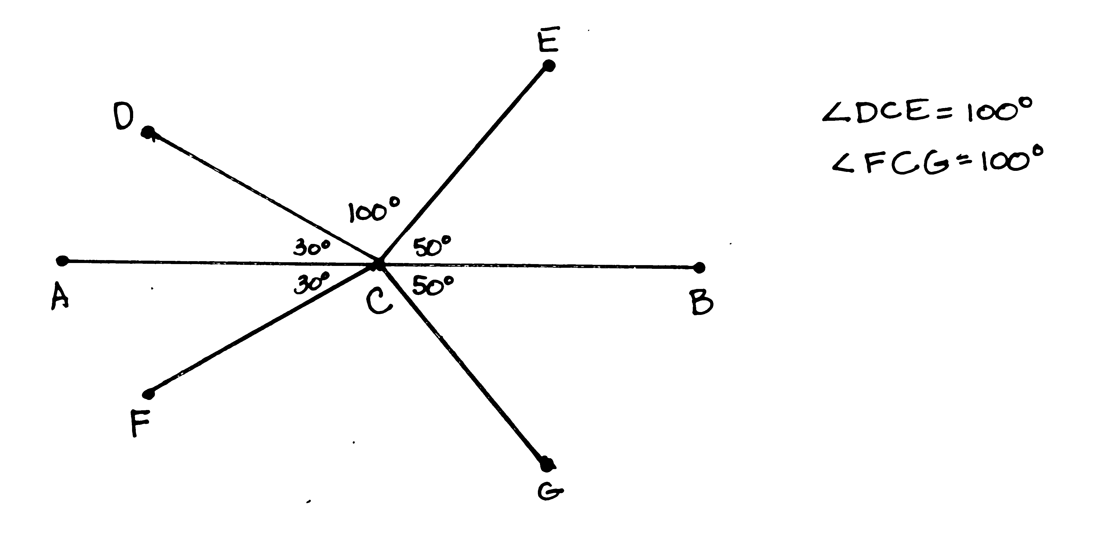
T: Draw a 4-inch segment $AB$.
T: Plot point $C$at the 2-inch mark.
T: Draw a 30$°$ degree angle opening to the left from point $C$ with $\overline{AB}$ as one side. Label its endpoint $D$.
T: Draw a segment symmetric to $\overline{CD}$ about $\overline{AB}$ and label its endpoint $F$
T: Draw an angle less than 90$°$ opening to the right from point $C$ with $\overline{AB}$ as one side. Label its endpoint $E$.
T: Draw segment symmetric to $\overline{CE}$ about $\overline{AB}$ and label its endpoint $G.$
T: What is the measure of angle $∠DCE$?
T: What angle has the same measure?
T: Share your work with a partner. What is the measure of $∠DCE$ in your partner’s drawing?
Repeat as time permits possibly beginning with a 75$°$ angle.
Note: This fluency activity reviews concepts from Grade 4 in preparation for today’s lesson.
Concept Development (33 minutes)
Materials: (S) Coordinate plane template, ruler, protractor
Problem 1: Create symmetrical figures across a vertical line of symmetry.
Note: Demonstrate, give work time, and have students partner-share as needed to meet their needs.
T: (Distribute coordinate plane template and display image of plane with points $A\text{─}E$.) Record the coordinates of points $A$ through $E$ in Table A.
T: Use your ruler to connect these points in alphabetical order.
T: Use your ruler to construct a line of symmetry, $l$, whose rule is $x$ is always 5.
T: Remind your neighbor how we drew symmetric figures yesterday.
S: We used a set square to see a line perpendicular to the line of symmetry. We measured to make sure the corresponding points were the same distance from the line of symmetry.
T: Imagine a line that is perpendicular to $l$ that goes through $A$. What is the distance from $A$to the line of symmetry along this perpendicular line?
S: 4 units.
T: Imagine that perpendicular line continuing past $l$. Show your neighbor where the point symmetric to $A$ about $l$ would fall. Then, say the coordinates of this new point, $F$.
S: (Share and say (9, 6).)
T: Plot point $F$, then record the coordinates of $F$ in Table B. Work with a partner to plot and record the coordinates of points $G, H,$and $I$ which are symmetric to points $B, C,$and $D$ about $l$.
T: (Allow students time to work.) Connect the points you’ve plotted to create a figure that is symmetric about line $l$.
T: Compare the coordinates of the symmetric points in Tables A and B. Turn and talk.
S: The $y$-coordinates are always the same. The $x$-coordinate changes but the $y$-coordinates don’t.
T: Why is this true?
S: We are moving across a vertical line to draw the points, so moving left and right changes $x$, but not $y.$ We are moving parallel to the $x$ axis to find the symmetric points, so the points are on a line that is perpendicular to $y$. So, the points must have the same $y$-coordinate.
Problem 2: Create symmetrical figures across a horizontal line of symmetry.
T: Let’s create a new line of symmetry. Use your ruler to construct a horizontal line, $m$, whose rule is $y$ is always 6.
Table D
T: (Allow students time to draw.) Let’s complete the drawing and create a figure that is symmetric about line $m$. Tell your neighbor how far point $A$ is from line $m$.
S: It’s on the line. The distance is zero from $A$ to line$m$.
T: Label the point symmetric to $B$. What are its coordinates?
S: (1, 4).
T: Plot and record the coordinates of each symmetric point in Table C. Check your work with a neighbor as you go.
T: Use your ruler to connect the points you plotted to draw the symmetric figure.
T: Compare the coordinates in Tables A and B, with their symmetric point in Table C. What do you notice about points when they’re symmetric about a horizontal line? Turn and talk.
S: It’s the opposite of a vertical line of symmetry. The $x$-coordinates don’t change, but the $y$-coordinates do. The $y$-coordinates are the same amount greater than or less than 6.
T: When a figure is drawn about a horizontal line of symmetry, the $x$-coordinates remain constant, while the $y$-coordinates change.
Problem 3: Create symmetrical figures across a diagonal line of symmetry.
T: (Display image of second coordinate plane on board.) Plot the coordinate pairs in Table D.
T: Now use your ruler to connect the points in alphabetical order. Then connect $H$ to $A$.
S/T: (Draw.)
T: Is this figure symmetrical? Turn and talk.
S: Yes it’s kind of like a leaf and if I turn the plane at an angle the left and right are symmetrical. Yes, if I drew a line from $A$ to $E$, then that would make 2 symmetrical halves.
T: This figure is symmetrical about a diagonal line. It begins at the origin and goes through points (1, 1), (2, 2), ($\text{3}\frac{1}{2}$, $\text{3}\frac{1}{2}$), and so on. (Draw line on board.) We’ll name this line$n$.
T: Use your pencil to lightly connect the points that are symmetrical to one another about $n$. Predict the angle at which these segments intersect $n$.
S: They should intersect at 90-degree angles. If the points are symmetric, the line and segments should intersect at right angles.
T: Test your prediction by measuring with your protractor.
S: (Measure.)
T: In order for these points to be symmetric, what else must be true?
S: They have to be the same distance from the line of symmetry. The distance along the perpendicular must be the same from the line to the points that correspond to each other.
T: Measure the distances of these points to the line of symmetry to confirm that they are truly symmetric.
S: (Measure the distance of the points.)
T: If I wanted to plot another pair of points that were symmetric about $n$, what would I do? Turn and talk.
If time permits, ask students to compare the coordinates for the symmetric points. While the reversal of the coordinates is apparent for the line $y \text{=} x$, challenge students to test whether this pattern holds for other diagonal lines (e.g., $y$ is twice as much as $x$).
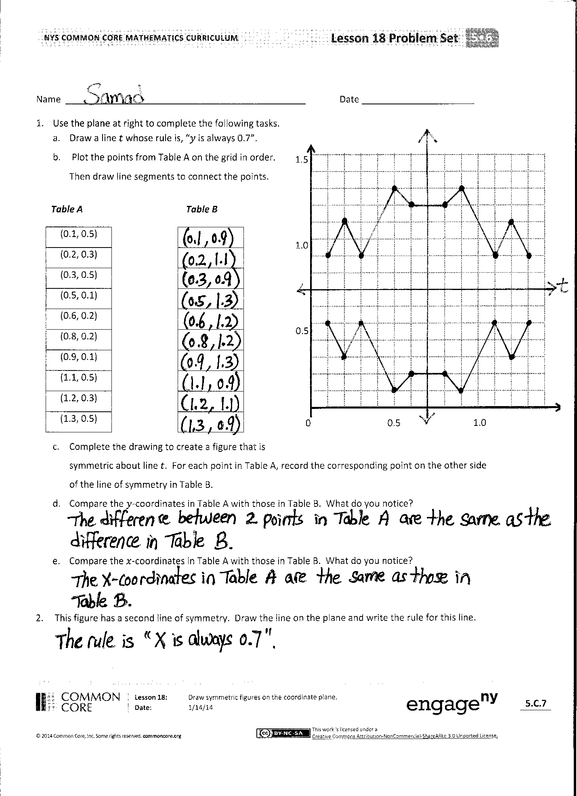
Problem Set (10 minutes)
Students should do their personal best to complete the Problem Set within the allotted 10 minutes. For some classes, it may be appropriate to modify the assignment by specifying which problems they work on first. Some problems do not specify a method for solving. Students solve these problems using the RDW approach used for Application Problems.
Student Debrief (10 minutes)
Lesson Objective: Draw symmetric figures on the coordinate plane.
The Student Debrief is intended to invite reflection and active processing of the total lesson experience.
Invite students to review their solutions for the Problem Set. They should check work by comparing answers with a partner before going over answers as a class. Look for misconceptions or misunderstandings that can be addressed in the Debrief. Guide students in a conversation to debrief the Problem Set and process the lesson.

NOTES ON
MULTIPLE MEANS OF ENGAGEMENT:
When asking questions, provide visuals to support understanding. For example, when asking the fourth question, draw before you speak.
Step 1: Draw a vertical line of symmetry on the coordinate plane. Step 2: Say, “Here is a vertical line of symmetry on the coordinate plane.”
Step 3: Draw two symmetric coordinate pairs.
Step 4: Say, “Explain why only the $x$-coordinate differs in symmetric pairs.”
You may choose to use any combination of the questions below to lead the discussion.
- Compare drawing symmetric figures on the coordinate grid to drawing them on blank paper.
- Does the orientation of the line of symmetry change the way symmetric points must be drawn? Why or why not?
- What must be true for a pair of points to be symmetric about a line?
- When drawing figures about a vertical line of symmetry on a coordinate plane, explain why only the $x$-coordinate differs in symmetric coordinate pairs. Explain what happens to the coordinate pairs when drawing symmetric points about a horizontal line on the coordinate plane.
- In Problem 3, did your partner plot any points on line $u$? If so, did the pattern of how the $x$- and $y$-coordinates change continue for these fixed points?

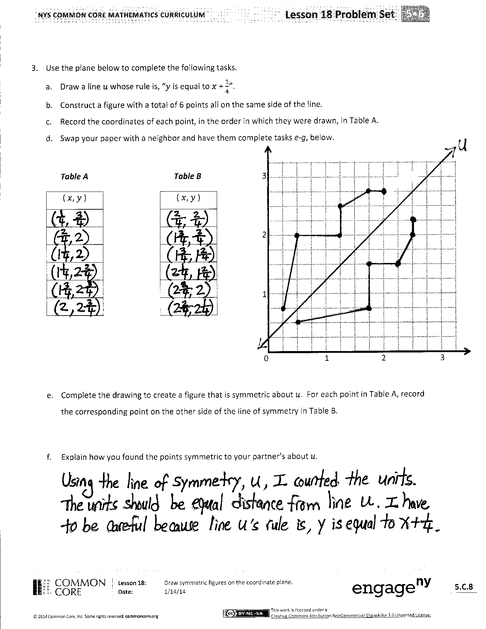
Exit Ticket (3 minutes)
After the Student Debrief, instruct students to complete the Exit Ticket. A review of their work will help you assess the students’ understanding of the concepts that were presented in the lesson today and plan more effectively for future lessons. You may read the questions aloud to the students.

Name Date
- Use the plane at right to complete the following tasks.
- Draw a line $t$ whose rule is, $y$ is always 0.7.
0 0.5 1.0
0.5
1.0
1.5
- Plot the points from Table A on the grid in order. Then draw line segments to connect the points.
Table A Table B
(0.1, 0.5)
(0.2, 0.3)
(0.3, 0.5)
(0.5, 0.1)
(0.6, 0.2)
(0.8, 0.2)
(0.9, 0.1)
(1.1, 0.5)
(1.2, 0.3)
(1.3, 0.5)

- Complete the drawing to create a figure that is symmetric about line $t$. For each point in Table A, record the corresponding point on the other side of the line of symmetry in Table B.
- Compare the $y$-coordinates in Table A with those in Table B. What do you notice?

- Compare the$x$-coordinates in Table A with those in Table B. What do you notice?

- This figure has a second line of symmetry. Draw the line on the plane and write the rule for this line.

- Use the plane below to complete the following tasks.
  - Draw a line $u$ whose rule is, $y$ is equal to $x$ + $\frac{1}{4}$.
  - Construct a figure with a total of 6 points all on the same side of the line.
  - Record the coordinates of each point, in the order in which they were drawn, in Table A.
  - Swap your paper with a neighbor and have him or her complete Parts (e–f), below.
0 1 2 3
1
2
3
Table A Table B
( $x$, $y$ ) |  | ( $x$, $y$ )

  - Complete the drawing to create a figure that is symmetric about $u$. For each point in Table A, record the corresponding point on the other side of the line of symmetry in Table B.

  - Explain how you found the points symmetric to your partner’s about $u.$

Name Date
- Kenny plotted the following pairs of points and said they made a symmetric figure about a line with the rule:
$y$ is always 4.

(3, 2) and (3, 6)
(4, 3) and (5, 5)
(5, $\frac{3}{4}$) and (5, 7$\frac{1}{4}$)
(7, $\text{1}\frac{1}{2}$) and (7, 6$\frac{1}{2}$)

Is his figure symmetrical about the line? How do you know?

Name Date
- Use the plane at right to complete the following tasks.
0 5 10
5
10
15
  - Draw a line $s$ whose rule is, $x$ is always 5.
  - Plot the points from Table A on the grid in order. Then draw line segments to connect the points in order.
Table A Table B
(1, 13)
(1, 12)
(2, 10)
(4, 9)
(4, 3)
(1, 2)
(5, 2)

  - Complete the drawing to create a figure that is symmetric about line $s$. For each point in Table A, record the symmetric point on the other side of $s$.

  - Compare the $y$-coordinates in Table A with those in Table B. What do you notice?

  - Compare the $x$-coordinates in Table A with those in Table B. What do you notice?

- Use the plane at right to complete the following tasks.
- Draw a line $p$ whose rule is, $y$ is equal to $x$.
- Plot the points from Table A on the grid in order. Then draw line segments to connect the points.
0 1 2 3 4 5 6
1
2
3
4
5
6
Table A Table B
($\frac{1}{2}$, $\frac{1}{2}$)
(1, 2)
($1\frac{1}{2}$, $1\frac{1}{2}$)
(2, 4)
(3$\frac{1}{2}$, 3$\frac{1}{2}$)
(4, 4$\frac{1}{2}$)
(5, 5)

- Complete the drawing to create a figure that is symmetric about line $p$. For each point in Table A, record the symmetric point on the other side of the line $p$ in Table B.

- Compare the $y$-coordinates in Table A with those in Table B. What do you notice?

- Compare the $x$-coordinates in Table A with those in Table B. What do you notice?

Table A
Point | ($x$, $y$)
$$A$$
$$B$$
$$C$$
$$D$$
$$E$$

Table B
Point | ($x$, $y$)
$$I$$
$$H$$
$$G$$
$$F$$

Table C
($x$, $y$)

($x$, $y$)

Table D
$A$•
$B$•
$C$•
$D$•
$E$•
Table D
Point | ($x$, $y$)
$$A$$ | (1, 1)
$$B$$ | (1 $\frac{1}{2}$, 3 $\frac{1}{2}$)
$$C$$ | (2, 3)
$$D$$ | (2 $\frac{1}{2}$, 3 $\frac{1}{2}$)
$$E$$ | (2 $\frac{1}{2}$, 2 $\frac{1}{2}$)
$$F$$ | (3 $\frac{1}{2}$, 2 $\frac{1}{2}$)
$$G$$ | (3, 2)
$$H$$ | (3 $\frac{1}{2}$, 1 $\frac{1}{2}$)

10
8

6

4

2

0 2 4 6 8 10
0 1 2 3 4 5
1
2
3
4
5

