Lesson 17

Objective: Draw symmetric figures using distance and angle measure from the line of symmetry.

Suggested Lesson Structure

 Fluency Practice (11 minutes)

 Application Problem (7 minutes)

 Concept Development (32 minutes)

 Student Debrief (10 minutes)

**Total Time (60 minutes)**

Fluency Practice (11 minutes)

* Make Larger Units **4.NF.1** (3 minutes)
* Subtract a Fraction from a Whole  **4.NF.3** (4 minutes)
* Draw Perpendicular Lines Using a Set Square **4.G.1** (4 minutes)

Make Larger Units (3 minutes)

Materials: (S) Personal white boards

Note: This fluency activity reviews G5─Module 3 concepts.

T: (Write .) Say 3 sixths in larger units.

S: 1 half.

T: (Write .) Say 3 ninths in larger units.

S: 1 third.

T: (Write .) Write 3 fifteenths in larger units.

S: (Write = .)

Continue the process for , , , , , , , , , and .

Subtract a Fraction from a Whole (4 minutes)

Materials: (S) Personal white boards

Note: This fluency activity reviews G5─Module 3 concepts.

T: What’s 1 ─ ?

S: . 🡪 .

T: What’s ─ ?

S: .

T: (Write – =

T: (Beneath – = , write – ) What’s – ?

S:

T: (Write – =

T: (Beneath 1 – = write – ) What’s – ?

S:

T: (Write – =

Continue the process for the following possible suggestions: – , – , – , – , – , – ,   
 – , and – .

Draw Perpendicular Lines using a Set Square (4 minutes)

Materials: (S) Set square, unlined paper

T: Draw a horizontal 4 inch segment on your paper.

T: Use your set square to draw a inch segment perpendicular to.

T: Extend that segment inch on the other side of

T: What is the total length of the segment perpendicular to ?

Repeat the sequence drawing other lines perpendicular to using the following suggested lengths: 2.5 cm, cm, and cm.

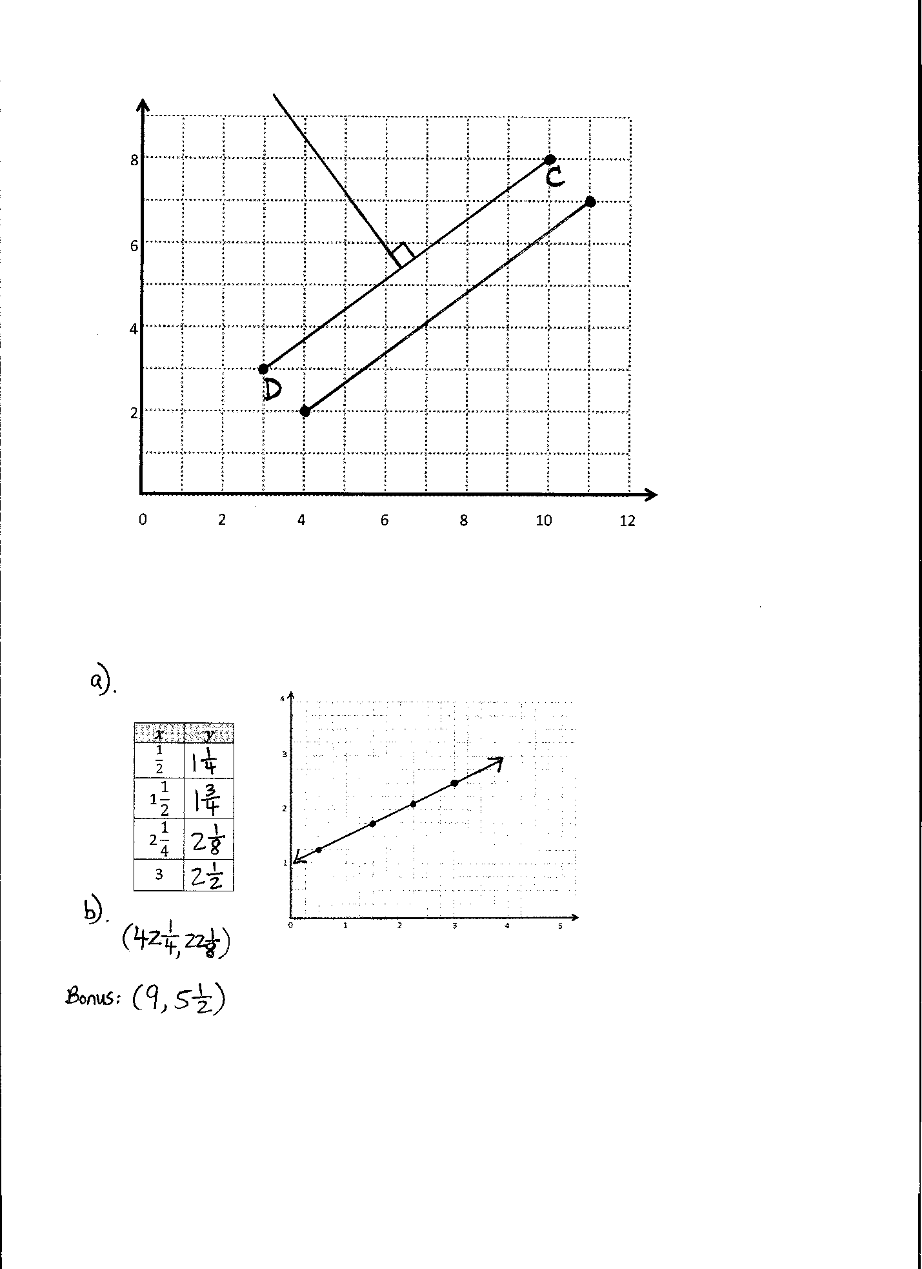Application Problem (7 minutes)

Materials: (S) Straightedge

Plot (10, 8) and (3, 3) on the coordinate plane, connect with a straightedge, and label as and .

1. Draw a segment parallel to .
2. Draw a segment perpendicular to .

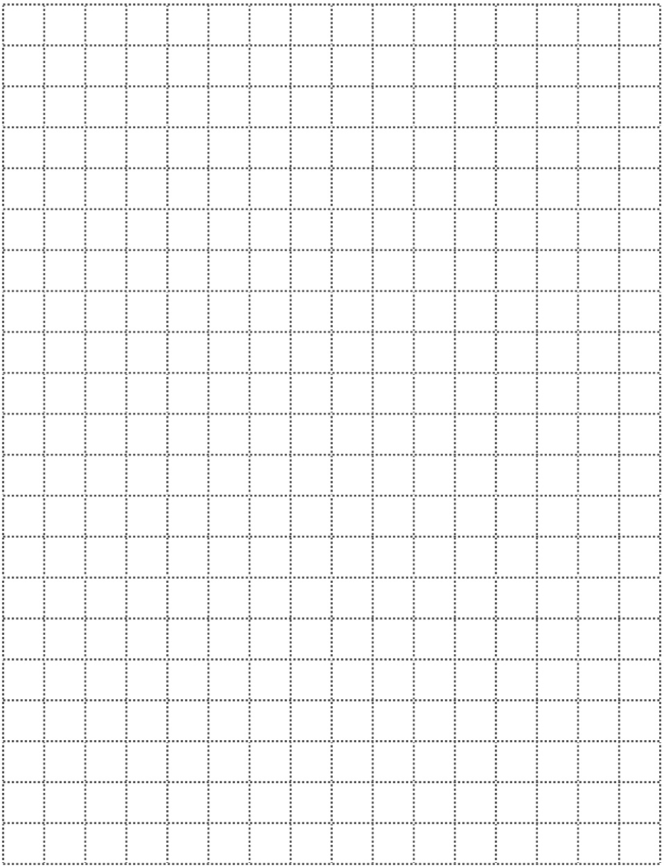

2

4

6

8

0 2 4 6 8 10 12

Note: This Application Problem applies plotting concepts from G5–M6–Lessons 14 and 16.

Concept Development (32 minutes)

Materials: (S) Unlined paper, set square, ruler

Problem 1: Draw symmetric points about a line of symmetry.

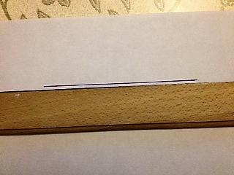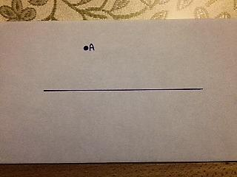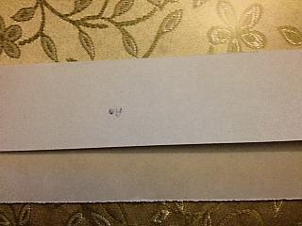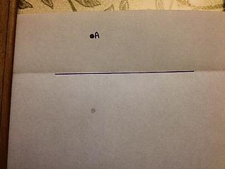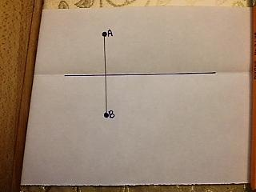

**Step 2**

**Step 3**

**Step 4**

**Step 5**

**Step 1**

Note: Demonstrate each of the following steps for students giving the work time appropriate for students in the class.

T: (Distribute unlined paper to each student.) Use your ruler as a straightedge to draw a segment on your paper. This will be our line of symmetry. (This is Step 1, as pictured to the right.)

T: Next, draw a dark point off the line and label it . F. (This is Step 2.)

T: Fold the page along this line of symmetry.

T: Then, rub the area of the paper behind using some pressure with your finger or eraser. (This is Step 3.)

T: Unfold your paper. You should be able to now see a faint point on the other side of the line. (This is Step 4.)

T: Darken this point and label it . Then, use your straightedge to lightly draw a segment connecting these two points. (This is Step 5.)

T: Measure the angles formed by the segment and . What do you find?

S: All the angles are 90 🡪 The segment is perpendicular to the line.

T: Use your ruler to measure the distance between each point and the line along the segment. What do you find?

S: The segments are the same length. 🡪 The points are the same distance from the line along the segments.

Repeat this sequence for another point off the line.

T: Using what we’ve just discovered about this pair of symmetric points, draw another pair of points without folding and rubbing our paper. Talk to your partner as you work.

S: (Work and discuss.)

T: Let’s do another together. I’ll guide you through. Draw another point off the line.

T: Use your set square to draw a segment that crosses the line of symmetry at a 90 degree angle and includes your point. (Demonstrate.)

T: Use your ruler to measure the distance from your point to the line of symmetry along the perpendicular segment that you drew.

T: Measure the same distance along the perpendicular segment on the opposite side of the line of symmetry and draw a point.

T: Since these points were drawn using a line perpendicular to the line of symmetry and are equidistant from the line of symmetry, we say they are symmetric about the line.

T: Practice drawing other sets of corresponding points about different lines of symmetry. Use any method that works for you.

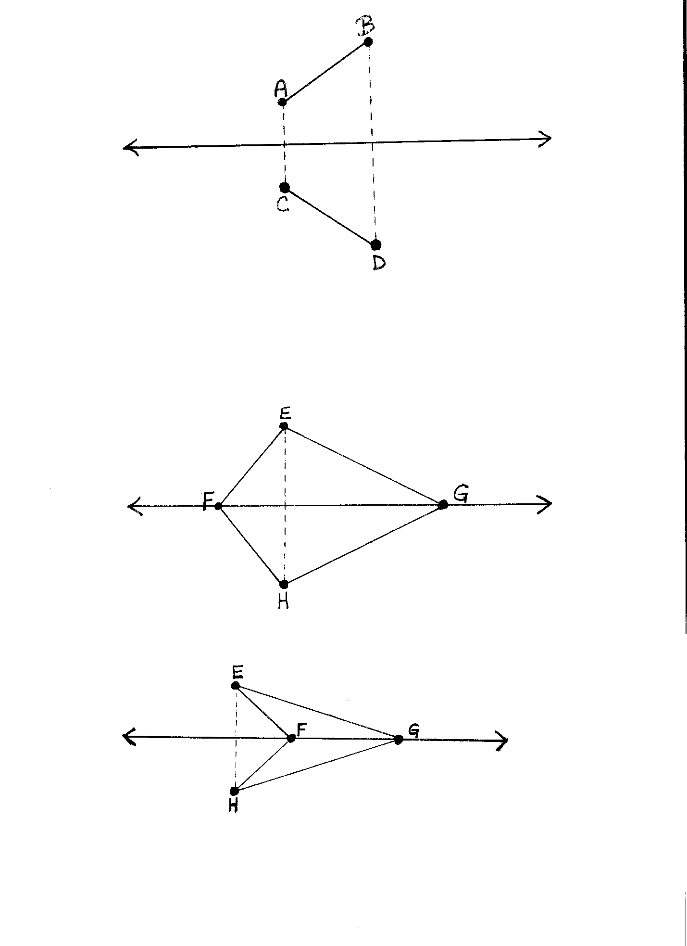Problem 2: Draw symmetric figures about a line of symmetry.

T: Draw a line of symmetry.

T: Draw a point, off the line.

T: Draw a second point, on the same side of the line as .

T: Draw .

T: How is this drawing different from the ones we did earlier?

S: We drew 2 points this time. 🡪 The other ones were just a point, but now we have a segment.

|  |  |
| --- | --- |
|  | NOTES ON  MULTIPLE MEANS OF ENGAGEMENT: |

Students with fine motor deficits may benefit from being paired with another student for drawing the figures. One partner might draw while the other is responsible for measuring the segments in order to place the points.

T: Show your neighbor how you’ll draw a point symmetric to about the line. Name it . (Allow students time to share.)

**MP.7**

T: Work independently to draw a point symmetric to . Name it .

T: Draw . Compare to What do you notice? Turn and talk.

S: They’re the same length. 🡪 They’re the same length, but they are mirror images of each other.

T: We can say that is symmetric to about the line symmetry.



**Possible quadrilaterals:**

T: Draw another line of symmetry.

T: Draw a point, , off the line.

T: Draw a second point, , ***on*** the line.

T: Draw .

T: Draw a third point, , ***on*** the line.

T: Draw .

T: How is this figure different from the one we just did?

S: We drew 3 points this time. 🡪 This one is 2 segments. 🡪 This figure has 2 points on the line of symmetry, and 1 off of it.

T: You drew points and on the line of symmetry. Point , is off the line. Draw a point, , symmetric to about .

T: Draw segments and .

|  |  |
| --- | --- |
|  | NOTES ON  MULTIPLE MEANS OF ENGAGEMENT: |

Drawing symmetric figures lends itself well to connections with art. Students might use these construction techniques to create symmetric figures by cutting and gluing colored strips of paper or through other media.

Students might also enjoy creating inkblots by placing paint in the center of paper, folding, and unfolding. Once the blots are dry, students might measure various parts of their creation from the line of symmetry to confirm the concepts developed in the lesson.

T: (Allow students time to work.) Compare the figures on either side of . What do you notice? Turn and talk.

S: They’re symmetric. 🡪 They’re the same size and the angles are all the same.

T: Yes, we can say that quadrilateral is symmetric about . Turn and share your quadrilateral with your neighbor.

S: (Discuss with neighbor.)

Problem Set (10 minutes)

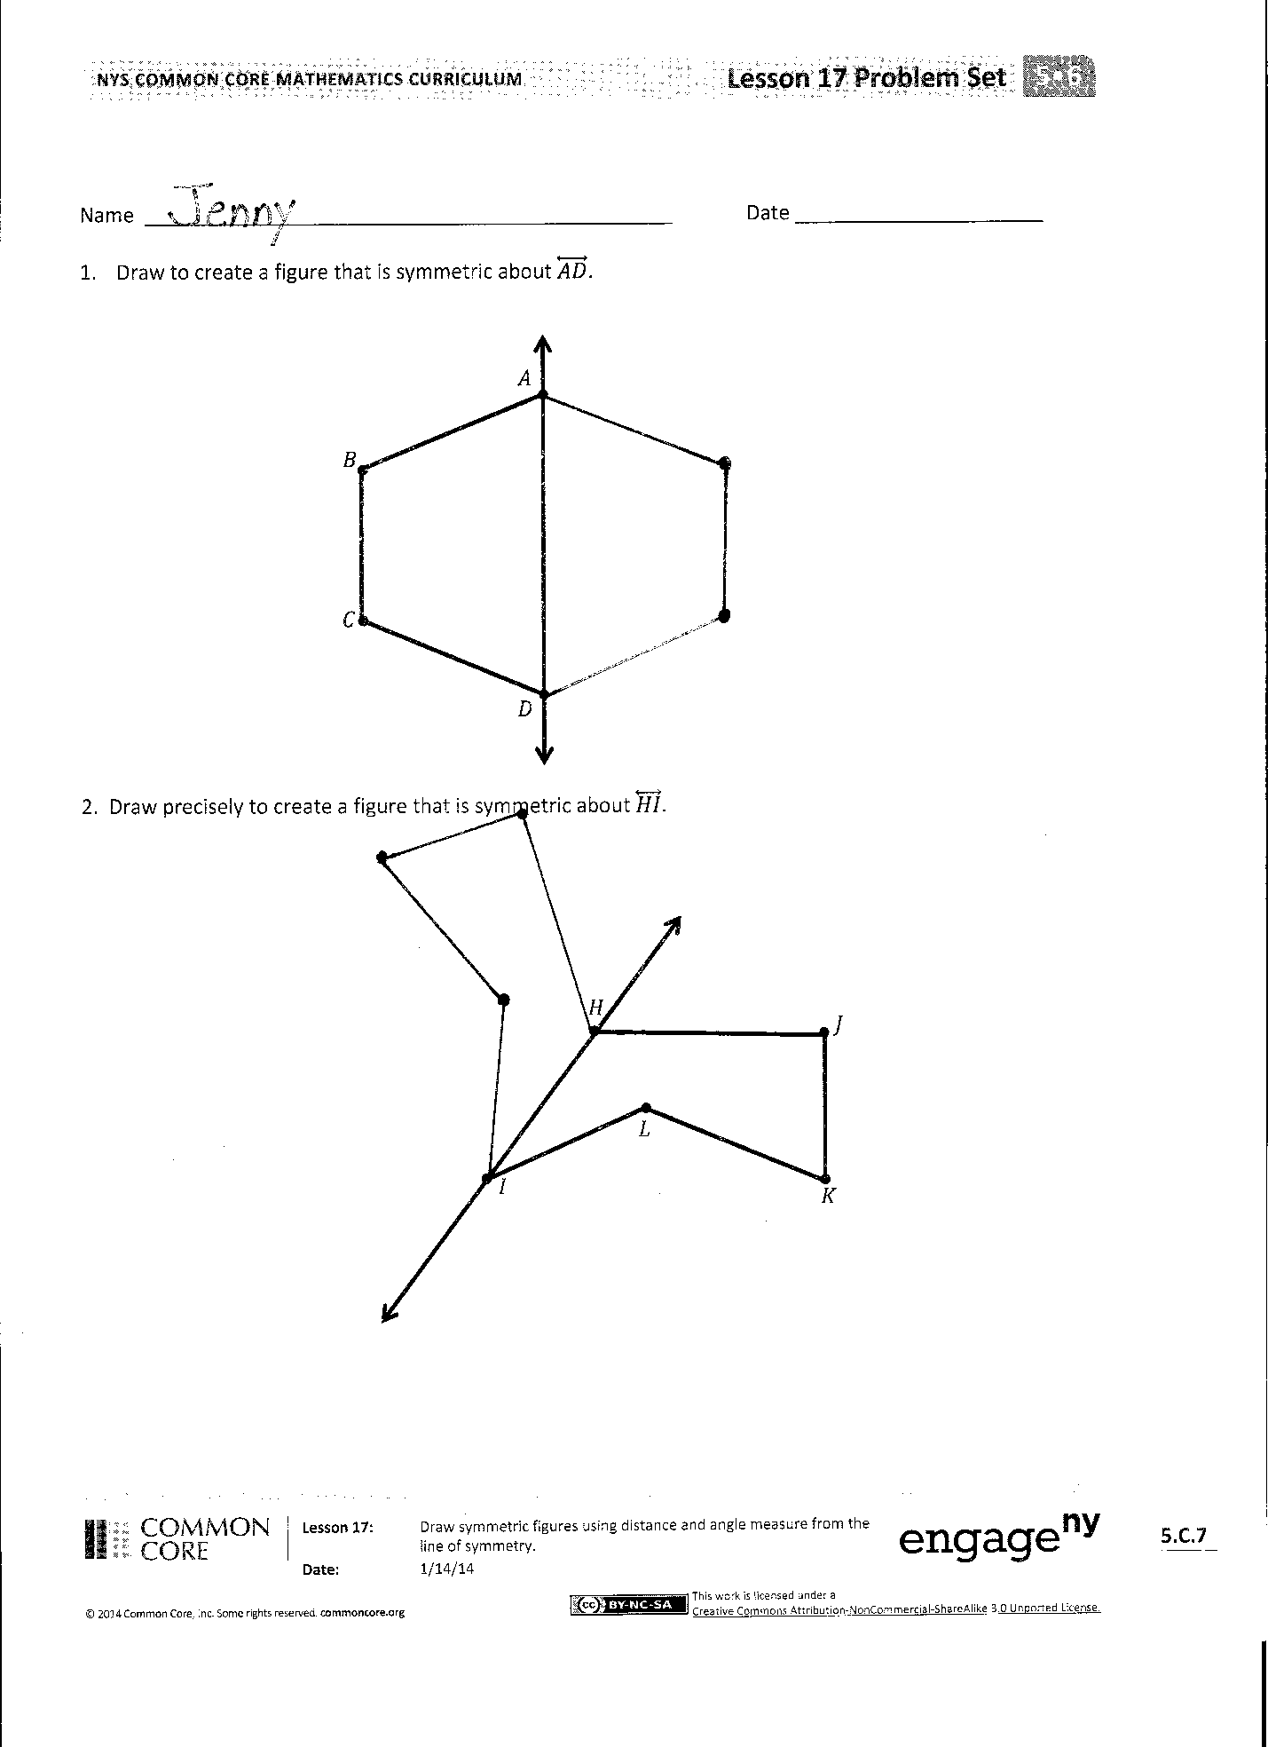Students should do their personal best to complete the Problem Set within the allotted 10 minutes. For some classes, it may be appropriate to modify the assignment by specifying which problems they work on first. Some problems do not specify a method for solving. Students solve these problems using the RDW approach used for Application Problems.

Student Debrief (10 minutes)

**Lesson Objective:** Draw symmetric figures using distance and angle measure from the line of symmetry.

The Student Debrief is intended to invite reflection and active processing of the total lesson experience.

Invite students to review their solutions for the Problem Set. They should check work by comparing answers with a partner before going over answers as a class. Look for misconceptions or misunderstandings that can be addressed in the Debrief. Guide students in a conversation to debrief the Problem Set and process the lesson.

You may choose to use any combination of the questions below to lead the discussion.

* In Problem 1, should everyone’s solutions look the same? Explain why.
* In Problem 2, did you draw symmetric points for or ? Why?
* Help Stu fix his mistake. What should he do the next time he draws a symmetric figure?
* What name can we give to all the quadrilaterals we drew in Problem 3? Explain your reasoning.

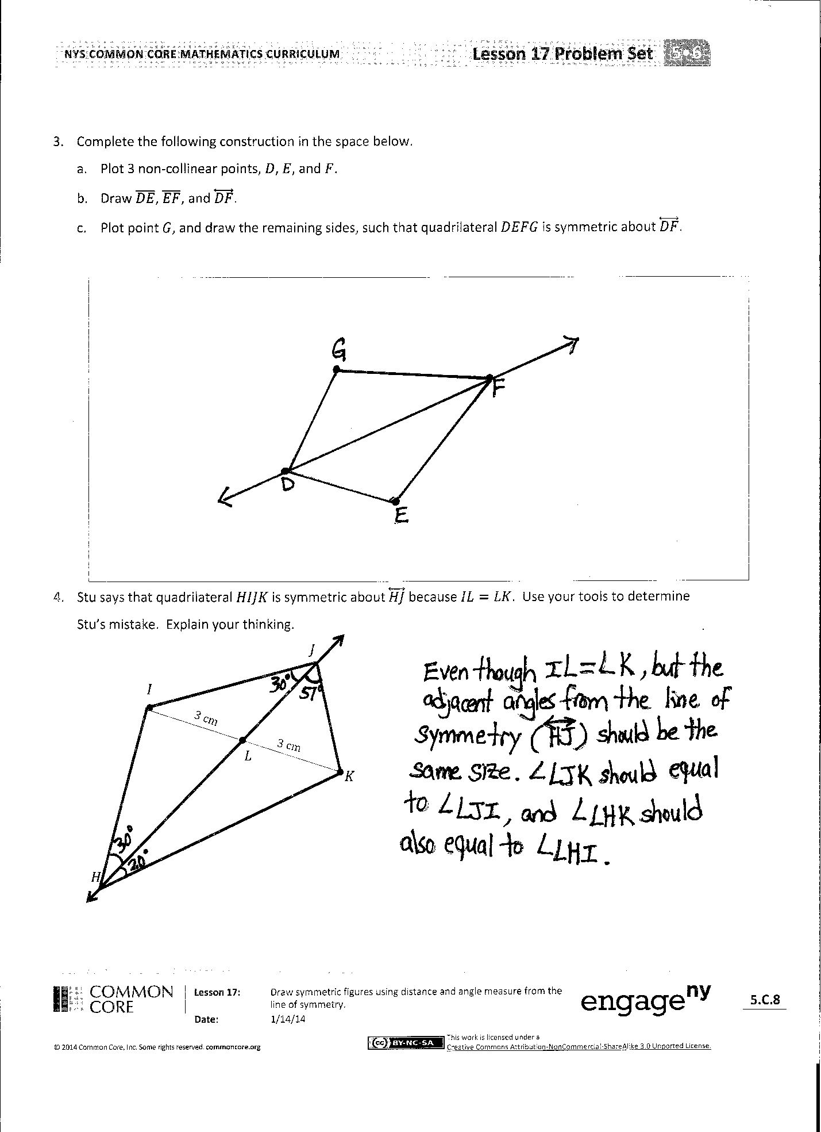Exit Ticket (3 minutes)

After the Student Debrief, instruct students to complete the Exit Ticket. A review of their work will help you assess the students’ understanding of the concepts that were presented in the lesson today and plan more effectively for future lessons. You may read the questions aloud to the students.

Name Date

1. Draw to create a figure that is symmetric about .
2. Draw precisely to create a figure that is symmetric about .
3. Complete the following construction in the space below.
   1. Plot 3 non-collinear points , , and .
   2. Draw , , and .
   3. Plot point , and draw the remaining sides, such that quadrilateral is symmetric about .
4. Stu says that quadrilateral is symmetric about because . Use your tools to determine Stu’s mistake. Explain your thinking.

3 cm

3 cm

Name Date

1. Draw 2 points on one side of the line below and label them and .
2. Use your set square and ruler to draw symmetrical points about your line that correspond to and and label them and

Name Date

1. Draw to create a figure that is symmetric about .
2. Draw to create a figure that is symmetric about .
3. Complete the following construction in the space below.
   1. Plot 3 non-collinear points, , , and .
   2. Draw , , and .
   3. Plot point , and draw the remaining sides, such that quadrilateral is symmetric about .
4. In the space below, use your tools to draw a symmetric figure around a line.