Lesson 16
Objective: Construct perpendicular line segments, and analyze relationships of the coordinate pairs.

Suggested Lesson Structure
 Fluency Practice (12 minutes)
 Application Problem (7 minutes)
 Concept Development (31 minutes)
 Student Debrief (10 minutes)
Total Time (60 minutes)
Fluency Practice (12 minutes)
- Make Larger Units 4.NF.1 (4 minutes)
- Draw Angles 4.NF.1 (8 minutes)
Make Larger Units (4 minutes)
Materials: (S) Personal white boards
Note: This fluency activity reviews G5─Module 3 concepts.
T: (Write $\frac{2}{4}$ = .) Say 2 fourths in larger units.
S: 1 half.
T: (Write $\frac{2}{6}$ = .) Say 2 sixths in larger units.
S: 1 third.
T: (Write $\frac{2}{10}$ = .) Write 2 tenths in larger units.
S: (Write $\frac{2}{10}$ = $\frac{1}{5}.$)
Continue the process for $\frac{5}{10}$, $\frac{3}{9}$, $\frac{6}{9}$, $\frac{5}{15}$, $\frac{10}{15}$, $\frac{3}{12}$, $\frac{9}{12}$, $\frac{8}{24}$, $\frac{16}{24}$, $\frac{7}{28}$, and $\frac{21}{28}$.
Draw Angles (8 minutes)
Materials: (S) Blank paper, ruler, protractor
Note: This fluency activity informally prepares students for today’s lesson.
T: Use your ruler to draw a 4-inch segment, $\overline{AB}$.
T: Plot a point at the third inch from point $A$.
T: From that point, draw a 30$°$angle that opens to the left. Label its endpoint C.
T: From the same point and also opening to the left, draw a 60$°$angle below AB. Extend the angle’s side so that it is at least 4 inches long. Label its endpoints D and E. (Demonstrate.)
T: Use any tool to draw a segment perpendicular to $\overline{AB}$ with endpoints at $C$ that intersects $\overline{DE.}$
Have students label the intersection of $\overline{AB}$ and $\overline{CF}$as point $G$. See if they notice that $⊿GCE$, $⊿GFE$ and $⊿FEC$ have angles that are the same measure.
Repeat with other angle pairs as time permits.
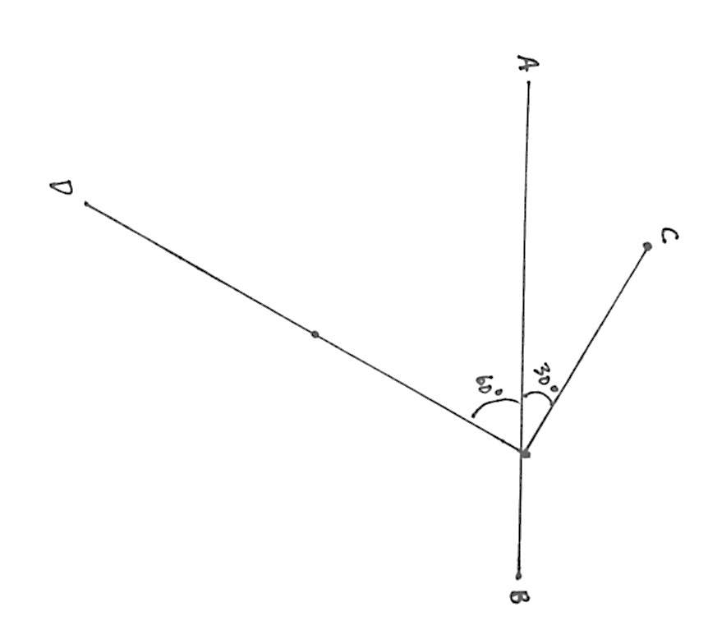
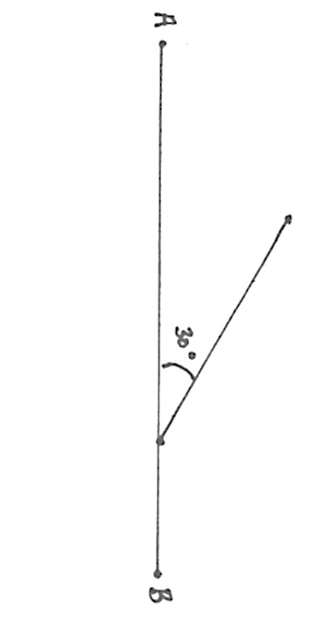

Application Problem (7 minutes)
- Complete the table for the rule $y$ is 1 more than half $x$, graph the coordinate pairs and draw a line to connect them.
- Give the $y$ coordinate for the point on this line whose $x$-coordinate is $\text{42}\frac{1}{4}$.
Bonus: Give the $x$-coordinate for the point on this line whose $y$-coordinate is $\text{5}\frac{1}{2}$.
Note: The Application Problem reviews coordinate graphing and fraction multiplication.

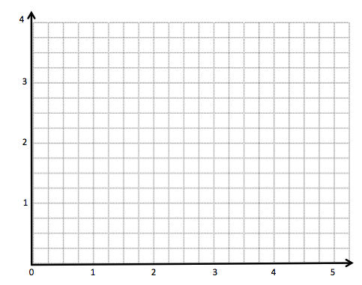
$$x$$ | $$y$$
$$\frac{1}{2}$$
$$\text{1}\frac{1}{2}$$
$$\text{2}\frac{1}{4}$$
3

Concept Development (31 minutes)
Materials: (T) Triangle $RST$ Template A (used in G5–M6–Lesson 15), images of coordinate plane with $A, B$plotted for display (S) Personal white board, coordinate plane template, straightedge, right angle template $RST$ (from G5–M6–Lesson 13)
Problem 1: Slide and rotate right triangle template along coordinate plane to create perpendicular segments.
T: (Distribute coordinate plane template to students and display images of coordinate plane on board with Point A plotted at (3, 1) and Point B plotted at (8, 3).) Say the coordinates of point $A$.
S: (3, 1.)

T: Record the coordinates of $A$ in the table. Then, plot $A$ on your plane.
T: Tell your neighbor the coordinates of $B$, record in the table, and plot.
S: (Share, record, and plot.)
MP.7
T: Use your straightedge to draw $\overline{AB}$.
T: Visualize a right triangle that has $\overline{AB}$ as its longest side and follows the grid lines on its other two sides. Describe this triangle to your partner.
S: I see a triangle below $\overline{AB}$. The longer side is 5 units long and the shorter side is 2 units high. The right angle is directly below $B.$ I see a triangle that is above $\overline{AB}$. The right angle is 2 units above $A$. The longer side is 5 units long.
T: Let’s draw the triangle below the segment that you described. Use a dashed line to draw the other sides of the right triangle that has $\overline{AB}$ as its long side and its right angle’s vertex at (8, 1). (Demonstrate.)
T: Tell me what you know about the measures of the acute angles in this triangle.
S: If we folded them over the right angle, they’d cover it perfectly. The sum of the two acute angles is 90 degrees.
T: Imagine how we could use this triangle and the grid lines to help us draw another segment whose endpoint is $A$ and is perpendicular to $\overline{AB}$. Turn and talk.
S: We could slide the triangle to the left like we did yesterday, then turn the triangle up and mark the top vertex. If we connect that point and $A$, it will be perpendicular. We don’t have a ruler today, but the grid lines are straight, so we could slide the triangle along the line until the right angle touches $A$. Then, rotate it 90$°$ clockwise. We mark the top corner and then connect it to $A$. That segment would be perpendicular to $\overline{AB}$.
T: After we slide and rotate our imaginary triangle, give the coordinates of the top vertex.
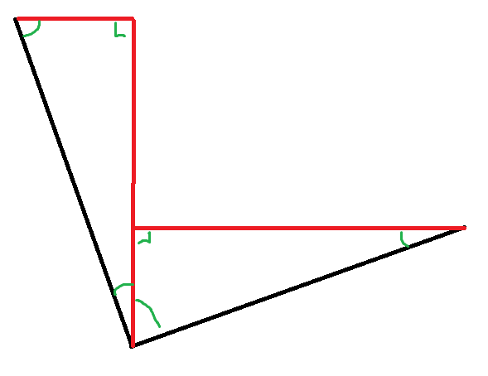
S: (1, 6).

NOTES ON
MULTIPLE MEANS OF ACTION AND EXPRESSION:
It may have been noted that the triangles that are visualized and drawn by the teacher are consistently those triangles “below” the segment being considered. These are by no means the only triangles that might be used to draw the perpendicular segments. Consider the following figure in which the upper triangles for each segment (drawn in red) are used to construct perpendicular segments (drawn in black).

The use of the triangles below give rise to greater opportunity to reason about angles and their relationships, but students who visualize alternate triangles should not be discouraged from using them to produce the segments.

T: Put these coordinates in your table, plot this point and label it $C$. Use your straightedge to connect $C$ and $A$. What can we say about $\overline{CA}$ and $\overline{AB}$? How do you know?
S: It’s what we did yesterday. The longer side of the first triangle and the shorter side of the second triangle form a straight angle at the bottom of the figure. We know the acute angles add up to 90$°$, so the angle between them, $∠CAB$, must also be 90$°$.
T: Segments $AB$ and $CA$ are perpendicular segments. Write this in symbols on your personal board. (Write $\overline{AB}⊥\overline{CA}$ on the board.)
Problem 2: Analyze the differences in the coordinate pairs of the perpendicular segments.
T: Put your finger on $A$, the vertex of $∠CAB$.
T: Use the table to compare the $x$-coordinates of points $A$ and $B$. Tell your neighbor which point has a larger $x$-coordinate and why that is true.
S: $B$ has the larger $x$ because we traveled to the right on the coordinate plane to get to point $B$. We traveled 5 units to the right on the coordinate plane to get to $B$. The triangle that has$\overline{ AB}$ as its longest side had a base of 5 units.
T: Now, compare the $y$-coordinate of points $A$ and $B$. Tell your neighbor which point has a larger $y$-coordinate and why that is true.
S: $B$ also has the larger $y$ because we traveled up to get to point $B$. We traveled 2 units up on the coordinate plane to get to $B$. The triangle that was used to draw segment $\overline{AB}$, had a height of 2 units.
T: Put your finger back on $A$, the vertex of $∠CAB$.
T: Think about how many units to the left the triangle was slid and how rotating the triangle located point $C.$ Compare the way you moved your finger for each triangle. Turn and talk.
S: Instead of moving right and then up, this time we moved left and then up. First, we moved over 5 then up 2, now we move over 2 then up 5. The number of units is the same but they’re switched.
In both cases the $y$-coordinate is being increased, but this time we’re moving left 2 units, and that will make the $x$-coordinate less. That’s because we rotated the triangle!
T: Compare the coordinates of$A$ and $C$. How do they differ?
S: The $x$-coordinate of $C$ is 2 less than $A$, but the $y$-coordinate is 5 more. You have to move 2 to the left and 5 up from $A$ to get to $C$.
T: What do you notice about how the coordinates of $A$and $B$ differ, compared to how the coordinates of $A$ and $C$differ? Turn and talk.
S: Both times there’s a difference of 5 units and 2 units. In $A$ and $B$, the difference in the $x$-coordinates is 5, then 5 is the difference between the $y$-coordinates in $A$ and $C$. It all has to do with the triangles on the plane. They’re the same triangle, but they’re being moved and rotated so they change the coordinates by 5 units and 2 units.
T: What are the other side lengths of the triangle we used to construct the perpendicular lines?
S: 5 units and 2 units. It’s the base and height of the triangles that tell us the change in the coordinates!
T: Right, so in this case the coordinates change by 5 and 2 units. Since the same sized triangle is used to construct the perpendicular segments, the $x$-coordinates changes by 5 or by 2 and the $y$-coordinate changes by 5 or by 2. (Point to clarify.)
Repeat the process with $DEF$ and $GHI$ (as pictured below).
Problem Set (10 minutes)
Students should do their personal best to complete the Problem Set within the allotted 10 minutes. For some classes, it may be appropriate to modify the assignment by specifying which problems they work on first. Some problems do not specify a method for solving. Students solve these problems using the RDW approach used for Application Problems.
Student Debrief (10 minutes)
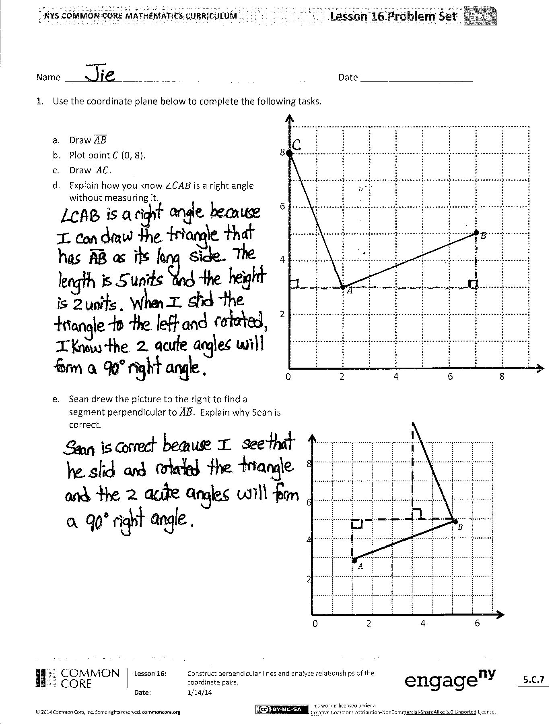
Lesson Objective: Construct perpendicular line segments, and analyze relationships of the coordinate pairs.
The Student Debrief is intended to invite reflection and active processing of the total lesson experience.
Invite students to review their solutions for the Problem Set. They should check work by comparing answers with a partner before going over answers as a class. Look for misconceptions or misunderstandings that can be addressed in the Debrief. Guide students in a conversation to debrief the Problem Set and process the lesson.
You may choose to use any combination of the questions below to lead the discussion.
- Talk about the triangle that you see when you look at $\overline{AB}$ and $\overline{AC}$.
- Tell your neighbor about how visualizing the triangles helps you locate the points needed to draw a perpendicular line.
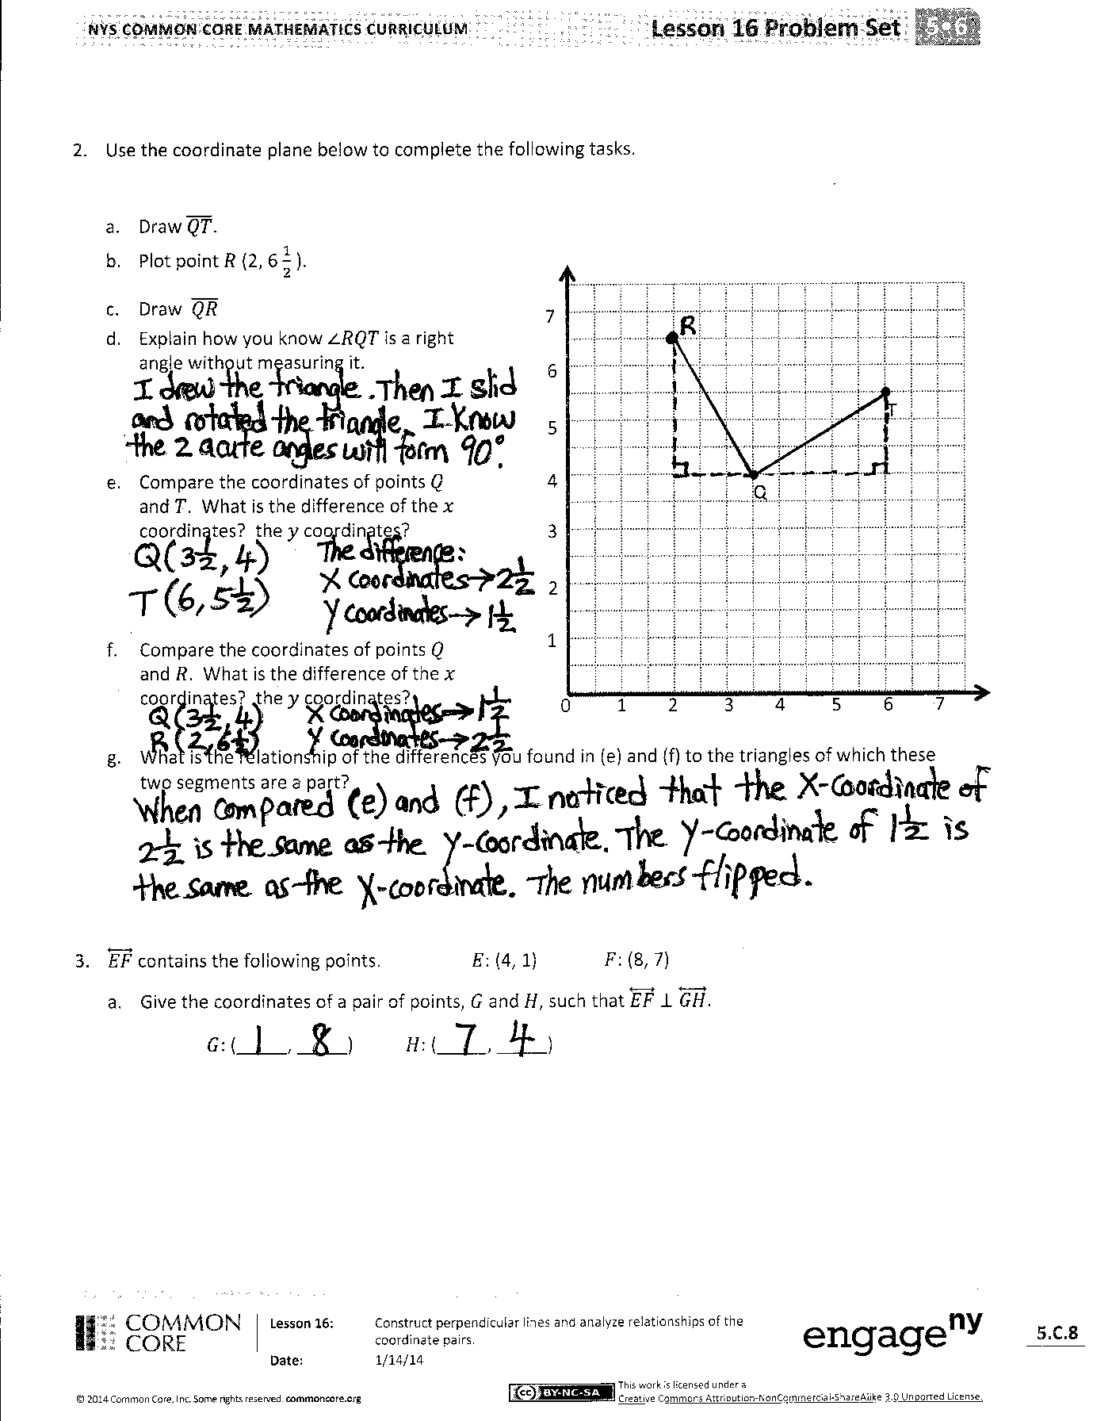
- In Problem 1, are there other segments that are perpendicular to $\overline{AB}$? Explain how you know.
- Explain your thought process as you solved Problem 3.
Exit Ticket (3 minutes)
After the Student Debrief, instruct students to complete the Exit Ticket. A review of their work will help you assess the students’ understanding of the concepts that were presented in the lesson today and plan more effectively for future lessons. You may read the questions aloud to the students.
Name Date
- Use the coordinate plane below to complete the following tasks.
0 2 4 6 8
2
4
6
8
•$A$
•$B$
- Draw $\overline{AB}$
- Plot point $C$ (0, 8).
- Draw $\overline{AC}$.
- Explain how you know $∠CAB$ is a right angle without measuring it.

- Sean drew the picture to the right to find a segment perpendicular to $\overline{AB}$. Explain why Sean is correct.
0 2 4 6 8
2
4
6
8
•$A$
•$B$
$$A$$
$$B$$

- Use the coordinate plane below to complete the following tasks.

- Draw $\overline{QT}$.

0 1 2 3 4 5 6 7
1
2
3
Q

T

7
6
5
4
- Plot point $R$ (2, 6 $\frac{1}{2}$ ).
- Draw $\overline{QR}$.
- Explain how you know $∠RQT$ is a right angle without measuring it.

- Compare the coordinates of points $Q$ and $T$. What is the difference of the $x$-coordinates? The $y$-coordinates?

- Compare the coordinates of points $Q$ and $R$. What is the difference of the $x$-coordinates? The $y$-coordinates?

- What is the relationship of the differences you found in (e) and (f) to the triangles of which these
two segments are a part?

- $\overset{⃡}{EF}$ contains the following points. $E$: (4, 1) $F$: (8, 7)
  - Give the coordinates of a pair of points $G$ and $H$, such that $\overset{⃡}{EF}$ $⊥\overset{⃡}{GH}$.
$G$: (_____, _____) $H$: (_____, _____)

Name Date
  - Show your thinking on the plane.
- Draw $\overline{UV}$.
- Plot point $W$ ($4\frac{1}{2}$ , 6).
- Draw $\overline{VW}$.
- Explain how you know that $∠UVW$ is a right angle without measuring it.
•$U$
•$V$

0 1 2 3 4 5 6 7
1
2
3
7
6
5
4

Name Date
- Use the coordinate plane below to complete the following tasks.
0 2 4 6 8
2
4
6
8
•$P$
•$Q$
- Draw $\overline{PQ}$.
- Plot point $R$ (7, 7).
- Draw $\overline{PR}$.
- Explain how you know $∠PQR$is a right angle without measuring it.

- Compare the coordinates of points $P$ and $Q$. What is the difference of the $x$-coordinates? The $y$-coordinates?

- Compare the coordinates of points $P$ and $R$. What is the difference of the $x$-coordinates? The $y$-coordinates?

- What is the relationship of the differences you found in (e) and (f) to the triangles of which these two segments area a part?

- Use the coordinate plane below to complete the following tasks.

- Draw $\overline{BC}$.

0 1 2 3 4 5 6 7
1
2
3
7
6
5
4
- Plot point $D$ (3, $\text{2}\frac{1}{2}$ ).
- Draw $\overline{BD}.$
- Explain how you know $∠BCD$ is a right angle without measuring it.
•$B$

•$c$
- Compare the coordinates of points $B$ and $C$. What is the difference of the $x$-coordinates? The $y$-coordinates?

- Compare the coordinates of points $B$ and $D$. What is the difference of the $x$-coordinates? The $y$-coordinates?

- What is the relationship of the differences you found in (e) and (f) to the triangles of which these two segments area a part?

- $\overset{⃡}{ST}$ contains the following points. $S$: (2, 3) $T$: (9, 6)
  - Give the coordinates of a pair of points, $U$ and $V$, such that $\overset{⃡}{ST}$ $⊥\overset{⃡}{UV}$.
$S$: (_____, _____) $T$: (_____, _____)

0 5 10
5
10
0 2 4 6 8
2
4
6
1
2
3
4
0 1 2 3
($x$, $y$)
$$A$$
$$B$$
$$C$$

($x$, $y$)
$$D$$
$$E$$
$$F$$

($x$, $y$)
$$G$$
$$H$$
$$I$$

