Lesson 15
Objective: Construct perpendicular line segments on a rectangular grid.

Suggested Lesson Structure
 Fluency Practice (12 minutes)
 Concept Development (38 minutes)
 Student Debrief (10 minutes)
Total Time (60 minutes)
Fluency Practice (12 minutes)
- Multiply and Divide Decimals 5.NBT.7 (3 minutes)
- Draw Angles 4.MD.6 (9 minutes)
Multiply and Divide Decimals (3 minutes)
Materials: (S) Personal white boards
Note: This fluency activity reviews G5─Module 2 concepts.
T: (Write 3 $\text{×}$ 2 = .) What’s 3 $\text{×}$ 2?
S: 6.
T: (Write 3 $\text{×}$ 2 = 6. Beneath it, write 0.3 $\text{×}$ 2 = .) What’s 0.3 $\text{×}$ 2?
S: 0.3 $\text{×}$ 2 = 0.6.
T: (Write 0.3 $\text{×}$ 2 = 0.6. Beneath it, write 0.03 $\text{×}$ 2 = .) Write the number sentence.
S: (Write 0.03 $\text{×}$ 2 = 0.06.)
T: (Write 60 ÷ 10 = .) What’s 60 ÷ 10?
S: 6.
T: (Write 60 ÷ 10 = 6. Beneath it, write 6 ÷ 10 = .) Write the number sentence.
S: (Write 6 ÷ 10 = 0.6.)
T: (Write 6 ÷ 10 = 0.6. Beneath it, write 6 ÷ 20 = .) Write the number sentence.
S: (Write 6 ÷ 20 = 0.3.)
Continue the process for the following possible suggestions: 6 ÷ 30, 25 ÷ 5, 25 ÷ 50, 1.5 ÷ 10, 1.5 ÷ 30, 0.12 ÷ 4, and 0.12 ÷ 40.

Draw Angles (9 minutes)
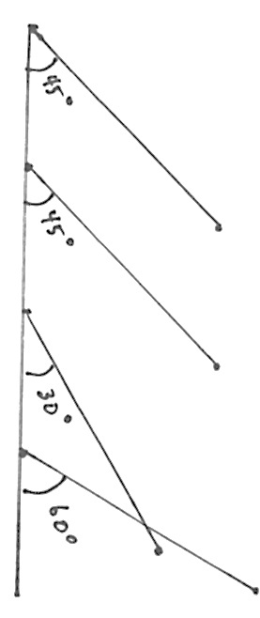
Materials: (S) Blank paper, ruler, protractor
Note: This fluency activity informally prepares students for today’s lesson.
Part 1:
T: Use your ruler to draw a 4-inch horizontal line about 3 inches down from the top of your paper.
T: Plot 5 points, one at each inch including 0 inches.
T: Turn to your partner and name pairs of angles whose sums are 90 degree.
S: 45$°$ and 45$°.$ 30$°$ and 60$°.$ 25$°$ and 65$°.$
T: Use the points at zero and 1 inch as the vertices of 2 angles whose sum is 90$°.$
Part 2:
T: Use your ruler to draw another 4-inch horizontal line about 3 inches below your first one.
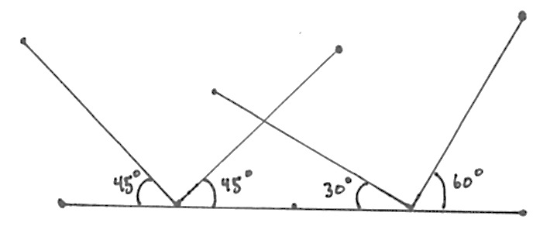
T: Plot 5 points, one at each inch including 0 inches.
T: Draw the same angle you made on the top line at the first third inch.
T: Draw the same angle pair you made on the top line but this time, open the angles to the left and let the angle share a vertex with its pair.
Repeat as time allows. Take note informally as to whether the students observe which lines are perpendicular. Students will return to these lines in the Debrief to more closely analyze.
Concept Development (38 minutes)
Materials: (T) Triangle $RST$ template A (with a base of 5 units and a height of 2 units), triangle $RST$template B (with a height of 2 units and a base of 3 units), angle templates in other various sizes
(S) Straightedge, perpendicular lines recording sheet, angle templates (in various sizes, from G5–M6–Lesson 13) unlined paper
Note: An Application Problem is not included in this lesson in order to provide adequate time for the Concept Development.
Problem 1: Identify perpendicular lines on the grid.
T: (Distribute 1 copy of the perpendicular lines recording sheet to students and display image of Problem (a) on the board.) How do you know if the lines in Problem (a) are perpendicular? Turn and talk.
S: I can just see it, the lines intersect at the corner of these grid squares, so I know they’re perpendicular. They’re perpendicular. I can put the corner of my paper at the vertex and I can see that it’s 90 degrees. I can use my set square to prove that they’re perpendicular.
T: Talk to your partner about what you know about perpendicular lines.
S: Lines that intersect and create 90-degree angles are perpendicular. Perpendicular lines are intersecting lines that form right angles. The sides of right angles are perpendicular. The sum of the four angles of two intersecting perpendicular lines is 360 degrees or 4 times 90 degrees.
T: Analyze the rest of the lines Problems (b─d) to see if they are perpendicular.
Problem 2: Prove the sum of the acute angles of a given right triangle is 90 degrees by folding.
Note: Demonstrate and pause throughout the constructions as necessary for your students.
T: Take out triangle $RST$ that we used during G5–M6–Lesson 14. (Distribute an unlined piece of paper to each student.)
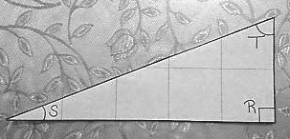
T: Fold the triangle so that vertex $T$ and vertex $S$ match up with vertex $R.$
T: What do you notice? Turn and talk.
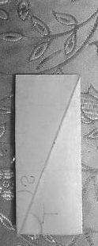
S: $∠S$and $∠T$ completely cover $∠R$, with no overlap. $∠S$and $∠T$ must add up to 90 degrees, because when they’re put together at $∠$R, they’re the same as $∠R$. I did this in fourth grade, $R$ is 90 degrees, so the sum of $S$ and $T$ must be 90 degrees also.
T: Work with your partner. Cut the bottom corner off your blank paper and fold it the same way you folded $△RST$. What do you notice?
T: When one angle of a triangle is a right angle, the measures of the other two angles add up to 90 degrees. (Write $∠S \text{+} ∠T$= 90°.) Keep this in mind as we work today.
Problem 3: Construct perpendicular line segments using the sum of the acute angles and a straightedge.
Step 1
Step 2
T: Place your straightedge horizontally across your paper. Then, position triangle $RST$ so that $\overline{SR}$ runs along your straightedge. (See images to the right.)
T: Use the triangle template to trace $\overline{ST}$. Then, trace the base and height of the triangle using a dashed line and label the interior angles as $r°,s° t°.$
MP.1
T: Next, slide triangle $RST$ to the left along your straightedge until $∠R$ shares a vertex with angle $s°.$
T: Finally, rotate triangle $RST$ 90 degrees clockwise, and arrange $\overline{RT}$ so that it forms a straight angle with $\overline{SR}$ along your straightedge.
T: A straight angle measures how many degrees?
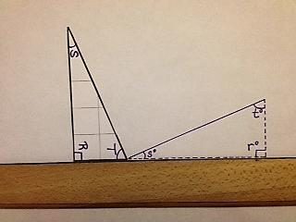
S: 180$°$.
Step 3
Step 4
Step 5
T: Trace $\overline{ST}$, then use dashed lines to trace the shorter sides of the triangle.
T: Now, let’s label the interior angles. (Point to the topmost angle.) This angle has the same measure as which angle in triangle $RST$?
MP.1
S: $∠S.$
T: Since it is equal in measure, let’s label it as $s°$ also.
Repeat with the other interior angles.
T: Label the angle formed by the solid segments (as opposed to dashed lines) we’ve drawn as$u°.$
T: (Drag finger along straight line angle at base of figure.) What is the sum of angles on a straight line? In this case, the measures of angles$s°, t°,$ and$u°$?
S: 180 degrees.
T: What did we learn about the sum of $s°$ and $t°$?
S: They add up to 90 degrees.
T: So, if this straight angle measures 180°, and the sum of these measures (point to $s°$ and $t°\text{) }$is 90°, what do we know about the measure of the third angle (point to $u°$).
S: It’s a right angle. It measures 90 degrees.
T: (Draw right angle symbol on figure.) What is the name we use for segments that form right angles?
S: Perpendicular lines.
T: After sliding and rotating $△RST$, the two longest sides of triangles created perpendicular segments. Use some of the other triangle templates from G5–M6–Lesson 13, and work with a partner to draw other examples of perpendicular segments using this method.
Some students may be ready to work independently, while others may need another guided experience. As students are ready, encourage them to orient their straightedges in a variety of ways on their paper.
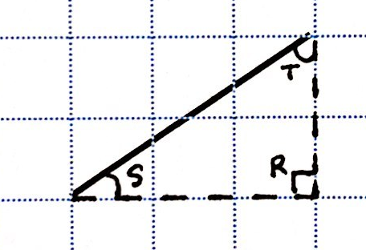
Problem 4: Construct perpendicular segments on grid paper.
T: Let’s look again at the perpendicular lines sheet we used earlier. (Display segment (1).) Look at segment (1). Turn and tell your neighbor about a right triangle that has $\overline{ST}$ as its longest side.
T: I see a triangle with a height of 2 units and a base of 3 units. (Draw dashed lines to show this triangle.) Draw the base and height of this triangle on your paper too.
T: Label the vertex of the right angle as $R$.

NOTES ON
MULTIPLE MEANS OF ENGAGEMENT:
There may be a great disparity in the spatial reasoning abilities among students in the same classroom. Some students may be ready for independent practice rather quickly. If so, let them work independently while others work in a smaller group provided with another guided experience.
T: Label the vertices of the acute angles of the triangle as $S$ and $T$.
T: Remind your neighbor what you know about the measures of $∠S$ and $∠T$ and how you know it.
S: We found out when we folded the triangle that they are the same as the right angle. They add up to the right angle. The sum of $∠S and ∠T$is 90°.
T: Use triangle $RST$ to draw a segment perpendicular to $\overline{ST}.$ Talk with a partner as you do so.
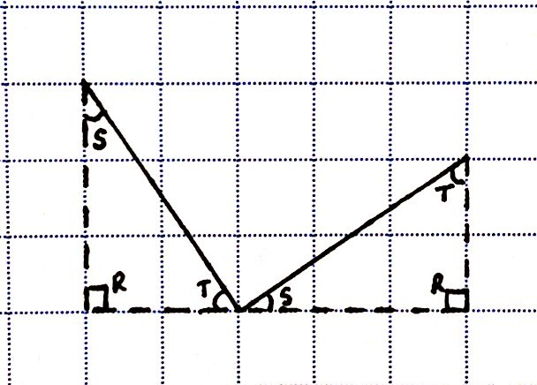
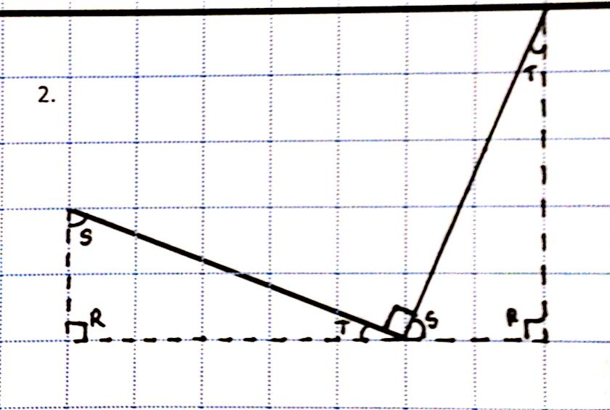
S: We can use the grid lines like we used the ruler. I’m going to slide over triangle $RST$ and then rotate it so that it now has a base of 2 units and a height of 3 units. The sum of $∠T$ and $∠S$ is 90 degrees so the third angle must be 90 degrees since the sum of all three angles is 180.
T: (Allow students time to work.) Yes, you sketched a new triangle, the same as triangle $RST,$ moved over 3 units and rotated clockwise 90°, so that $\overline{ SR }$and $\overline{RT}$ create a straight angle. (Slide and rotate.) I’ll use a dashed line to sketch $\overline{RT}$ and $\overline{RS}$ and a solid line to sketch the longest side, $\overline{ST}$. (Sketch second triangle on board.)
T: (Drag finger along straight line angle at base of figure.) What is the sum of angles on a straight line?
S: 180 degrees.
T: So, if this straight line measures 180°, and $∠S$ and $∠T$ add up to 90°, what do we know about the angle that’s formed by our solid segments? (Point to area of figure between $∠T$ and $∠S$.)

NOTES ON
MULTIPLE MEANS OF REPRESENTATION:
The method used to construct the perpendicular segments in this lesson may, at first, seem to be an unnecessarily complicated process if the end result is simply to create perpendicular segments. After all, isn’t that what a set square is for? However, taking the time to slide and draw the triangles gives students opportunity to reason about what’s presented on the grid and its foreshadowing of slope which will form the basis of many concepts in future learning.
S: It’s a right angle. It measures 90 degrees. The two longest sides of these triangles intersect to make perpendicular segments. (Display segment (2) on board.)
T: Continue to sketch a right triangle for each remaining segment. Then show how that triangle can be moved and sketched again to create a perpendicular segment. Share your work with a neighbor when you’re through. (Circulate to assess progress.)
S: (Work and share.)

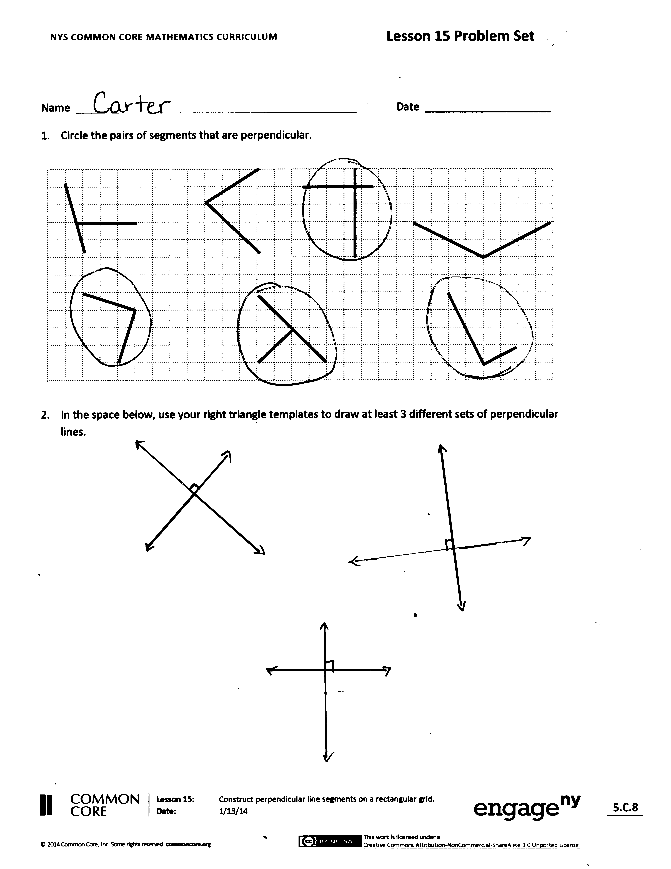
Problem Set (10 minutes)
Students should do their personal best to complete the Problem Set within the allotted 10 minutes. For some classes, it may be appropriate to modify the assignment by specifying which
problems they work on first. Some problems do not specify a method for solving. Students solve these problems using the RDW approach used for Application Problems.
Student Debrief (10 minutes)
Lesson Objective: Construct perpendicular line segments on a rectangular grid.
The Student Debrief is intended to invite reflection and active processing of the total lesson experience.
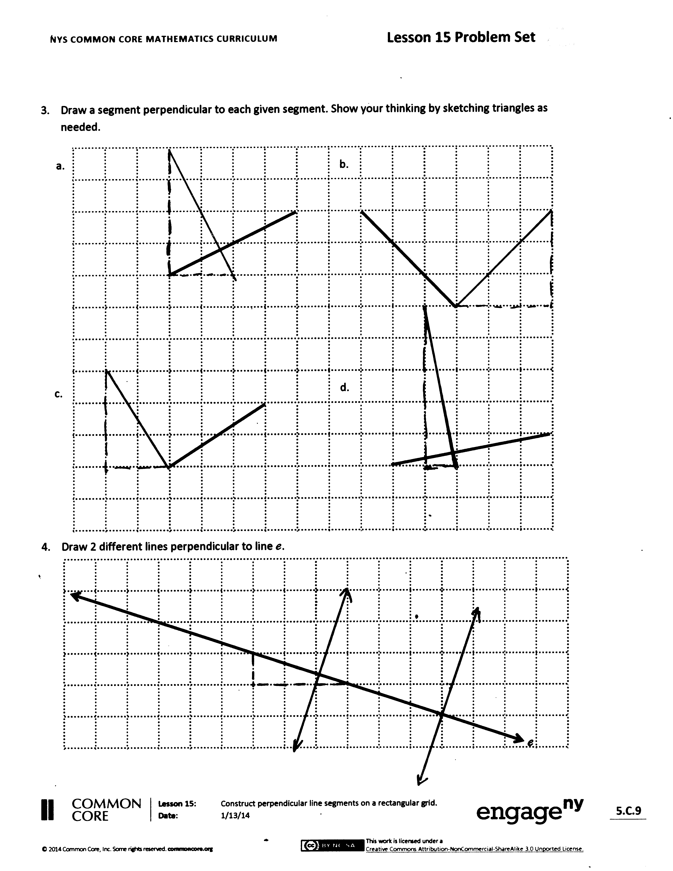
Invite students to review their solutions for the Problem Set. They should check work by comparing answers with a partner before going over answers as a class. Look for misconceptions or misunderstandings that can be addressed in the Debrief. Guide students in a conversation to debrief the Problem Set and process the lesson.
You may choose to use any combination of the questions below to lead the discussion.
- In Problem 1, explain how you determined which sets of segments were perpendicular.
- In Problem 3, do your segments look like your neighbor’s line segments? Are there other lines that are perpendicular to the given segments, or is your figure the only correct response?
- How is drawing perpendicular lines similar to and different from drawing parallel lines?
- How do the dimensions of the triangle affect the size of its interior angles?
- Think back on our fluency activity drawing angles. What can you say about the unmarked angles on the line? How was this similar to our work with the triangle templates?

Exit Ticket (3 minutes)
After the Student Debrief, instruct students to complete the Exit Ticket. A review of their work will help you assess the students’ understanding of the concepts that were presented in the lesson today and plan more effectively for future lessons. You may read the questions aloud to the students.

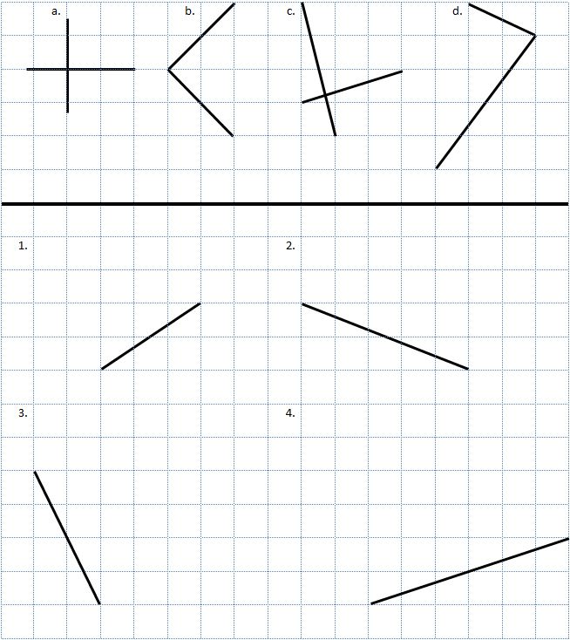
Name Date
- Circle the pairs of segments that are perpendicular.

- In the space below, use your right triangle templates to draw at least 3 different sets of perpendicular lines.

- Draw a segment perpendicular to each given segment. Show your thinking by sketching triangles as needed.
a.
d.

c.
b.

- Draw 2 different lines perpendicular to line $e$.
$$e$$

Name Date
- Draw a segment perpendicular to each given segment. Show your thinking by sketching triangles as needed.
a.
d.

c.
b.

Name Date
- Circle the pairs of segments that are perpendicular.

- In the space below, use your right triangle templates to draw at least 3 different sets of perpendicular lines.

- Draw a segment perpendicular to each given segment. Show your thinking by sketching triangles as needed.
a.
d.

c.
b.

- Draw 2 different lines perpendicular to line $b$.
$$b$$

$$R$$
$$S$$
$$T$$
Triangle $RST$ Template A

Triangle $RST$ Template B

$$R$$
$$T$$
$$S$$

