Lesson 14
Objective: Construct parallel line segments, and analyze relationships of the coordinate pairs.

Suggested Lesson Structure
 Application Problem (7 minutes)
 Fluency Practice (14 minutes)
 Concept Development (29 minutes)
 Student Debrief (10 minutes)
Total Time (60 minutes)
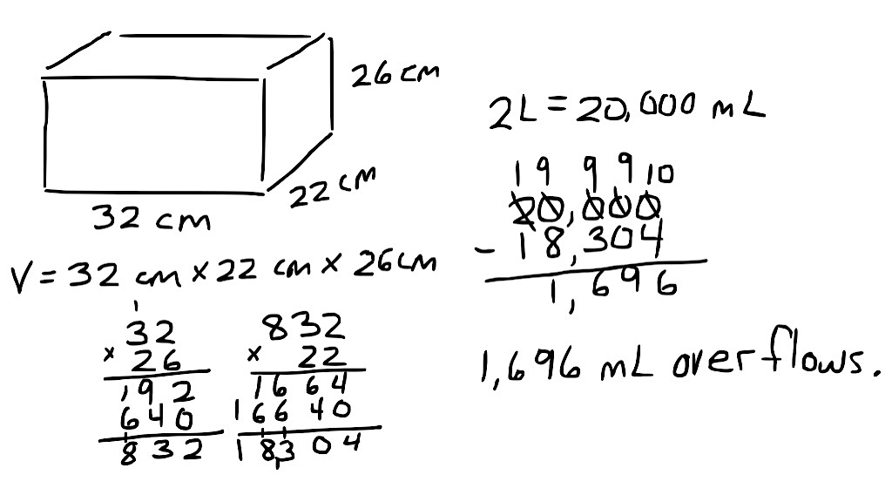
Application Problem (7 minutes)
Drew’s fish tank measures 32 cm by 22 cm by 26 cm. He pours 20 liters of water into it, and some water overflows the tank. Find the volume of water, in milliliters, that overflows.
Note: Today’s Application Problem reviews volume concepts from G5─Module 5.
Fluency Practice (14 minutes)
- Multiply Multi-Digit Whole Numbers 5.NBT.5 (4 minutes)
- Multiply and Divide Decimals 5.NBT.7 (3 minutes)
- Draw Angles 4.G.1 (7 minutes)
Multiply Multi-Digit Whole Numbers (4 minutes)
Materials: (S) Personal white boards
Note: This drill reviews year-long fluency standards.
T: Solve 45 $\text{×}$ 25 using the standard algorithm.
S: (Write 45 $\text{×}$ 25 = 1,125 using the standard algorithm.)
Continue process for 345 $\text{×}$25, 59 $\text{×}$ 23, 149 $\text{×}$ 23, and 756 $\text{×}$ 43.

Multiply and Divide Decimals (3 minutes)

NOTES ON
MULTIPLE MEANS FOR ACTION AND EXPRESSION:
Depending on the needs of students working below grade level, scaffold the Multiply and Divide Decimals fluency activity with visuals, such as arrays of number disks, that clearly illustrate the number patterns.

Materials: (S) Personal white boards
Note: This fluency activity reviews G5─Module 2 concepts.
T: (Write 4 $\text{×}$ 2 = .) What’s 4 $\text{×}$ 2?
S: 8.
T: (Write 4 $\text{×}$2 = 8. Beneath it, write 0.4 $\text{×}$ 2 = .) What’s 0.4 $\text{×}$ 2?
S: 0.4 $\text{×}$ 2 = 0.8.
T: (Write 0.4 $\text{×}$ 2 = 0.8. Beneath it, write 0.04 $\text{×}$ 2 = .) Write the number sentence.
S: (Write 0.04 $\text{×}$ 2 = 0.08.)
T: (Write 800 ÷ 10 = .) What’s 800 ÷ 10?
S: 80.
T: (Write 800 ÷ 10 = 80. Beneath it, write 80 ÷ 10 = .) What’s 80 ÷ 10?
S: 8.
T: (Write 80 ÷ 10 = 8. Beneath it, write 8 ÷ 10 = .) Write the number sentence.
S: (Write 8 ÷ 10 = 0.8.)
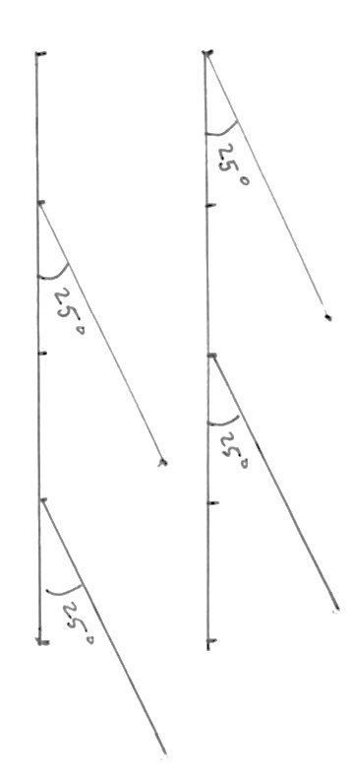
T: (Write 8 ÷ 10 = 0.8. Beneath it, write 8 ÷ 20 = .) Write the number sentence.
S: (Write 8 ÷ 20 = 0.4.)
Continue the process for the following possible suggestions: 8 ÷ 40, 15 ÷ 5, 15 ÷ 50, 2.5 ÷ 10, 2.5 ÷ 50, 0.12 ÷ 3, and 0.12 ÷ 30.
Draw Angles (7 minutes)
Materials: (S) Blank paper, ruler, protractor
Note: This fluency activity informally prepares students for today’s lesson. Provide students time to work following each step.
T: Use your ruler to draw two parallel 4-inch horizontal lines on your paper.
T: Plot 5 points, one at each inch, including 0 inches.
T: Use the points at 0 and 2 inches on the upper line as the vertices of two angles with the same measure.
T: Use the points at 1 inch and 3 inches on the lower line as the vertices of two angles with the same measure as those on the upper line.
Repeat as time allows. Take note as to whether the students observe which lines are parallel as they attempt to explain why.
Concept Development (29 minutes)
Materials: (T) Right angle template $RST$ (with a base of 5 units and a height of 2 units) (S) Personal white board, coordinate plane template , straightedge, right angle template $RST$ (created in G5–M6–Lesson 13)
Problem 1: Slide right triangle template parallel to the axes along coordinate plane to create parallel segments.
Note: Demonstrate and give work time to the level your students need throughout this process.
T: (Distribute coordinate plane template to students and display coordinate plane on board.) Plot points $A$ and $B$ at the following locations. (Display $A$: (2, 3) and $B$: (7, 5) on the board.)
T: Draw $\overline{AB}$.
T: Turn and tell your neighbor about a right triangle that you can see that has $\overline{AB}$ as its longest side. Use the grid lines to help you.
S: I see one with a base of 5 units and height of 2 units. It has two acute angles. The bottom left angle is less than the top right one because the triangle is going across more than it is going up.
MP.7
T: Find triangle $RST$ that you cut out during yesterday’s lesson. Remember that the letters name the vertices of the angles in this triangle.
T: Tell your neighbor how you can use triangle $RST$ to draw a segment parallel to $\overline{AB}$.
S: It’s just like we did yesterday. I can slide triangle $RST$ to the right or to the left and trace the long side of the triangle. I can move the triangle along the grid lines like yesterday. Up, down, left, right, or a combination of horizontal and vertical movements are ok as long as I keep the horizontal side parallel to the gridlines. It’s like we did in Fluency Practice: Because $∠S$ is the same as $∠A$ coming off the same base line, the lines will be parallel.
T: Yes, we can slide triangle $RST$ along the grid lines, in a variety of directions, and then trace side $\overline{ST}$ to make parallel segments. (Demonstrate.)
T: Place your triangle back where it would be if you were first drawing $\overline{AB}$. (Show right triangle template $RST$ on coordinate plane, just beneath $\overline{AB}$.)
T: Slide triangle $RST$ to the right, one full grid square. (Model on the board.) Is side $\overline{ST}$ parallel to segment $\overline{AB}$?
S: Yes.
T: What coordinates does the vertex of $∠$ $S$ touch now?
S: (3, 3).
T: The vertex of $∠$ $T$?
S: (8, 5).
T: Tell your neighbor how the $x$-coordinates of the endpoints changed when I slid the triangle one unit to the right.
S: They went from 2 to 3, and 7 to 8. Both $x$-coordinates are 1 more than they were.
T: Do the $y$-coordinates of the endpoints change?
S: No.
T: As triangle $RST$ slides one unit to the right, the $x$-coordinates of the vertices are increased by 1. (Move the triangle template back to original position.) Tell a neighbor how the $x$-coordinates would change if the triangle were slid along the gridlines 2 units to the left. (Slide the triangle template to the left.)
S: Both $x$-coordinates would be 2 less. It’s subtracting 2 from the $x$-coordinates of the vertices.
Repeat the process, moving 3 to the right and 3 to the left, asking students to analyze the change in the $x$-coordinate.
T: Position your triangle back at its original location. (Demonstrate.)
T: Watch as I slide the triangle up, along the grid lines two units. Is $\overline{ST}$ parallel to $\overline{AB}$? How do you know?
S: Yes. You kept the base parallel to the $x$-axis while you were sliding it up. You slid it like there was a ruler on the left which is perpendicular to the $x$-axis, and you kept the triangle up against it the whole time.
T: What coordinates does the vertex of $∠S$ touch ?
S: (2, 5).
T: The vertex of $∠T$?
S: (7, 7).
T: Tell your neighbor how the $y$-coordinates of the vertices changed when I slid the triangle along the gridlines 2 units up. (Allow students time to share.)
T: Did the $x$-coordinates of the vertices change?
S: No.
T: As triangle $RST$ slides 2 units up parallel to the $y$-axis, the $y$-coordinates are increased by 2. (Move the triangle template back to the original position.)
Repeat the process, sliding the triangle both up and down and analyzing the change in the $y$ coordinates.
Problem 2: Slide right triangle template two directions along coordinate plane to create parallel segments.
T: Return triangle $RST$ to its original location. Slide your triangle 2 units to the right and one unit down. Tell your neighbor how the coordinates of the vertices of $∠S$ and $∠T$ have changed.
T: Trace $\overline{ST}$ on your plane. (Demonstrate.) Label the endpoints of your segment, as $S$ and $T$.
T: Remove your triangle. Are $\overline{AB}$ and $\overline{ST}$ parallel? How do you know? Turn and talk.
S: They don’t form a right angle, so they’re not perpendicular. They never touch, so they’re parallel. This is like yesterday. When we slide the triangle down, we can think about a parallel imaginary segment. Then, when we slide it over, we find a third segment that’s parallel to the imaginary one and then we draw it.
T: $\overline{AB}$ and $\overline{ST}$ are parallel to each other because they are both parallel to the imaginary segment we found when we first slid the triangle down. We can also think about the angles in the triangles. $∠A$ and $∠S$ are the same measure because they were drawn from parallel baselines. So we can write, $\overline{AB}$ is parallel to $\overline{ST}.$ (Write $\overline{AB} ∥ \overline{ST}$ on the board.) Show me this statement on your personal board.
T: Record the coordinates of points $S$ and $T$.
T: Compare the coordinates of points $A$and $B$ to the coordinates of points $S$ and $T$. Tell your neighbor why each $x$-coordinate in points $S$ and $T$ are 2 more than the $x$-coordinates in points $A$ and $B$.
S: We shifted the triangle to the right, so the $x$-coordinate increased. We slid the triangle over 2 units along the gridlines, so both $x$-coordinates are 2 more.
T: Tell your neighbor why the $y$-coordinates are 1 less.
S: We shifted the triangle to down, so the $y$-coordinate decreased. We slid the triangle 1 grid squares down, so both $y$-coordinates are 1 less.
Problem 2: Identify coordinate pairs that create parallel lines.
T: (Display image of the second coordinate plane.) On the coordinate plane at the bottom of your page, plot the following points. (Write $C$($\text{1}\frac{1}{2}$, $\text{2}\frac{1}{2}$) and $D$(3, 2) on the board.)
T: Use your straightedge to draw $\overline{CD}$.
T: Tell your neighbor about a right triangle that has $\overline{CD}$ as its long side and its right angle’s vertex at ($\text{1}\frac{1}{2}$, 2).
S: I see a triangle with a height of 1 unit and a length of 3 units. The right angle is to the left, 1 unit beneath point $C$.
T: Focus for a moment on the vertex of the triangle that is at point $C$. Now, visualize that triangle moving 2 grid units to the left. Tell your neighbor the location of that vertex now.
S: ($\frac{1}{2}$, $\text{2}\frac{1}{2}$).
T: Plot a point, $E$, at that location.
S: (Plot $E$.)
T: Plot another point, $F$, on the plane, that when connected to $E$ will create a segment parallel to $\overline{CD}$. Tell your neighbor how you’ll identify the location of point $F$.
S: It looks like point $C$ slid 2 units to the left, so I can slide point $D$ 2 units to the left also. If I think of the triangle I saw with $\overline{CD}$, I can go down 1 unit from $E$ and then right 3 units. That will be point $F$. The $x$-coordinate of $E$ is 1 less than $C$, so I can subtract 1 from $D$ to find the $x$-coordinate of $F$.
T: Name the location of point $F$.
S: (2, 2).
T: Plot point $F$, then draw $\overline{EF}$ on your plane.
T: Imagine the lines that contain $\overline{CD}$ and $\overline{EF}$. If the part of these lines that we’ve drawn here are parallel to each other, we can say that the lines that contain them are also parallel. Write a statement naming the relationship between these two lines. (Draw arrows to show lines.)
S: Lines $CD$ and $EF$ are parallel. (Write $\overset{⃡}{CD} ∥ \overset{⃡}{EF}$.)
T: Plot a point, $G,$ at ($\text{3}\frac{1}{2}$, $\text{2}\frac{1}{2}$).
S: (Plot point.)
T: Compare the coordinates of point $C$ to point $G$. Tell your neighbor how are they different.
S: (Discuss differences.)
T: Name the location of a point, $H$, that when connected to $G$, would create a segment parallel to line $\overset{⃡}{CD}$.
S: (2, 3). (5, 2). ($\frac{1}{2}$, $\text{3}\frac{1}{2}$).
T: Tell your neighbor how you identified the location of point $H$.
S: (Discuss with neighbor.)
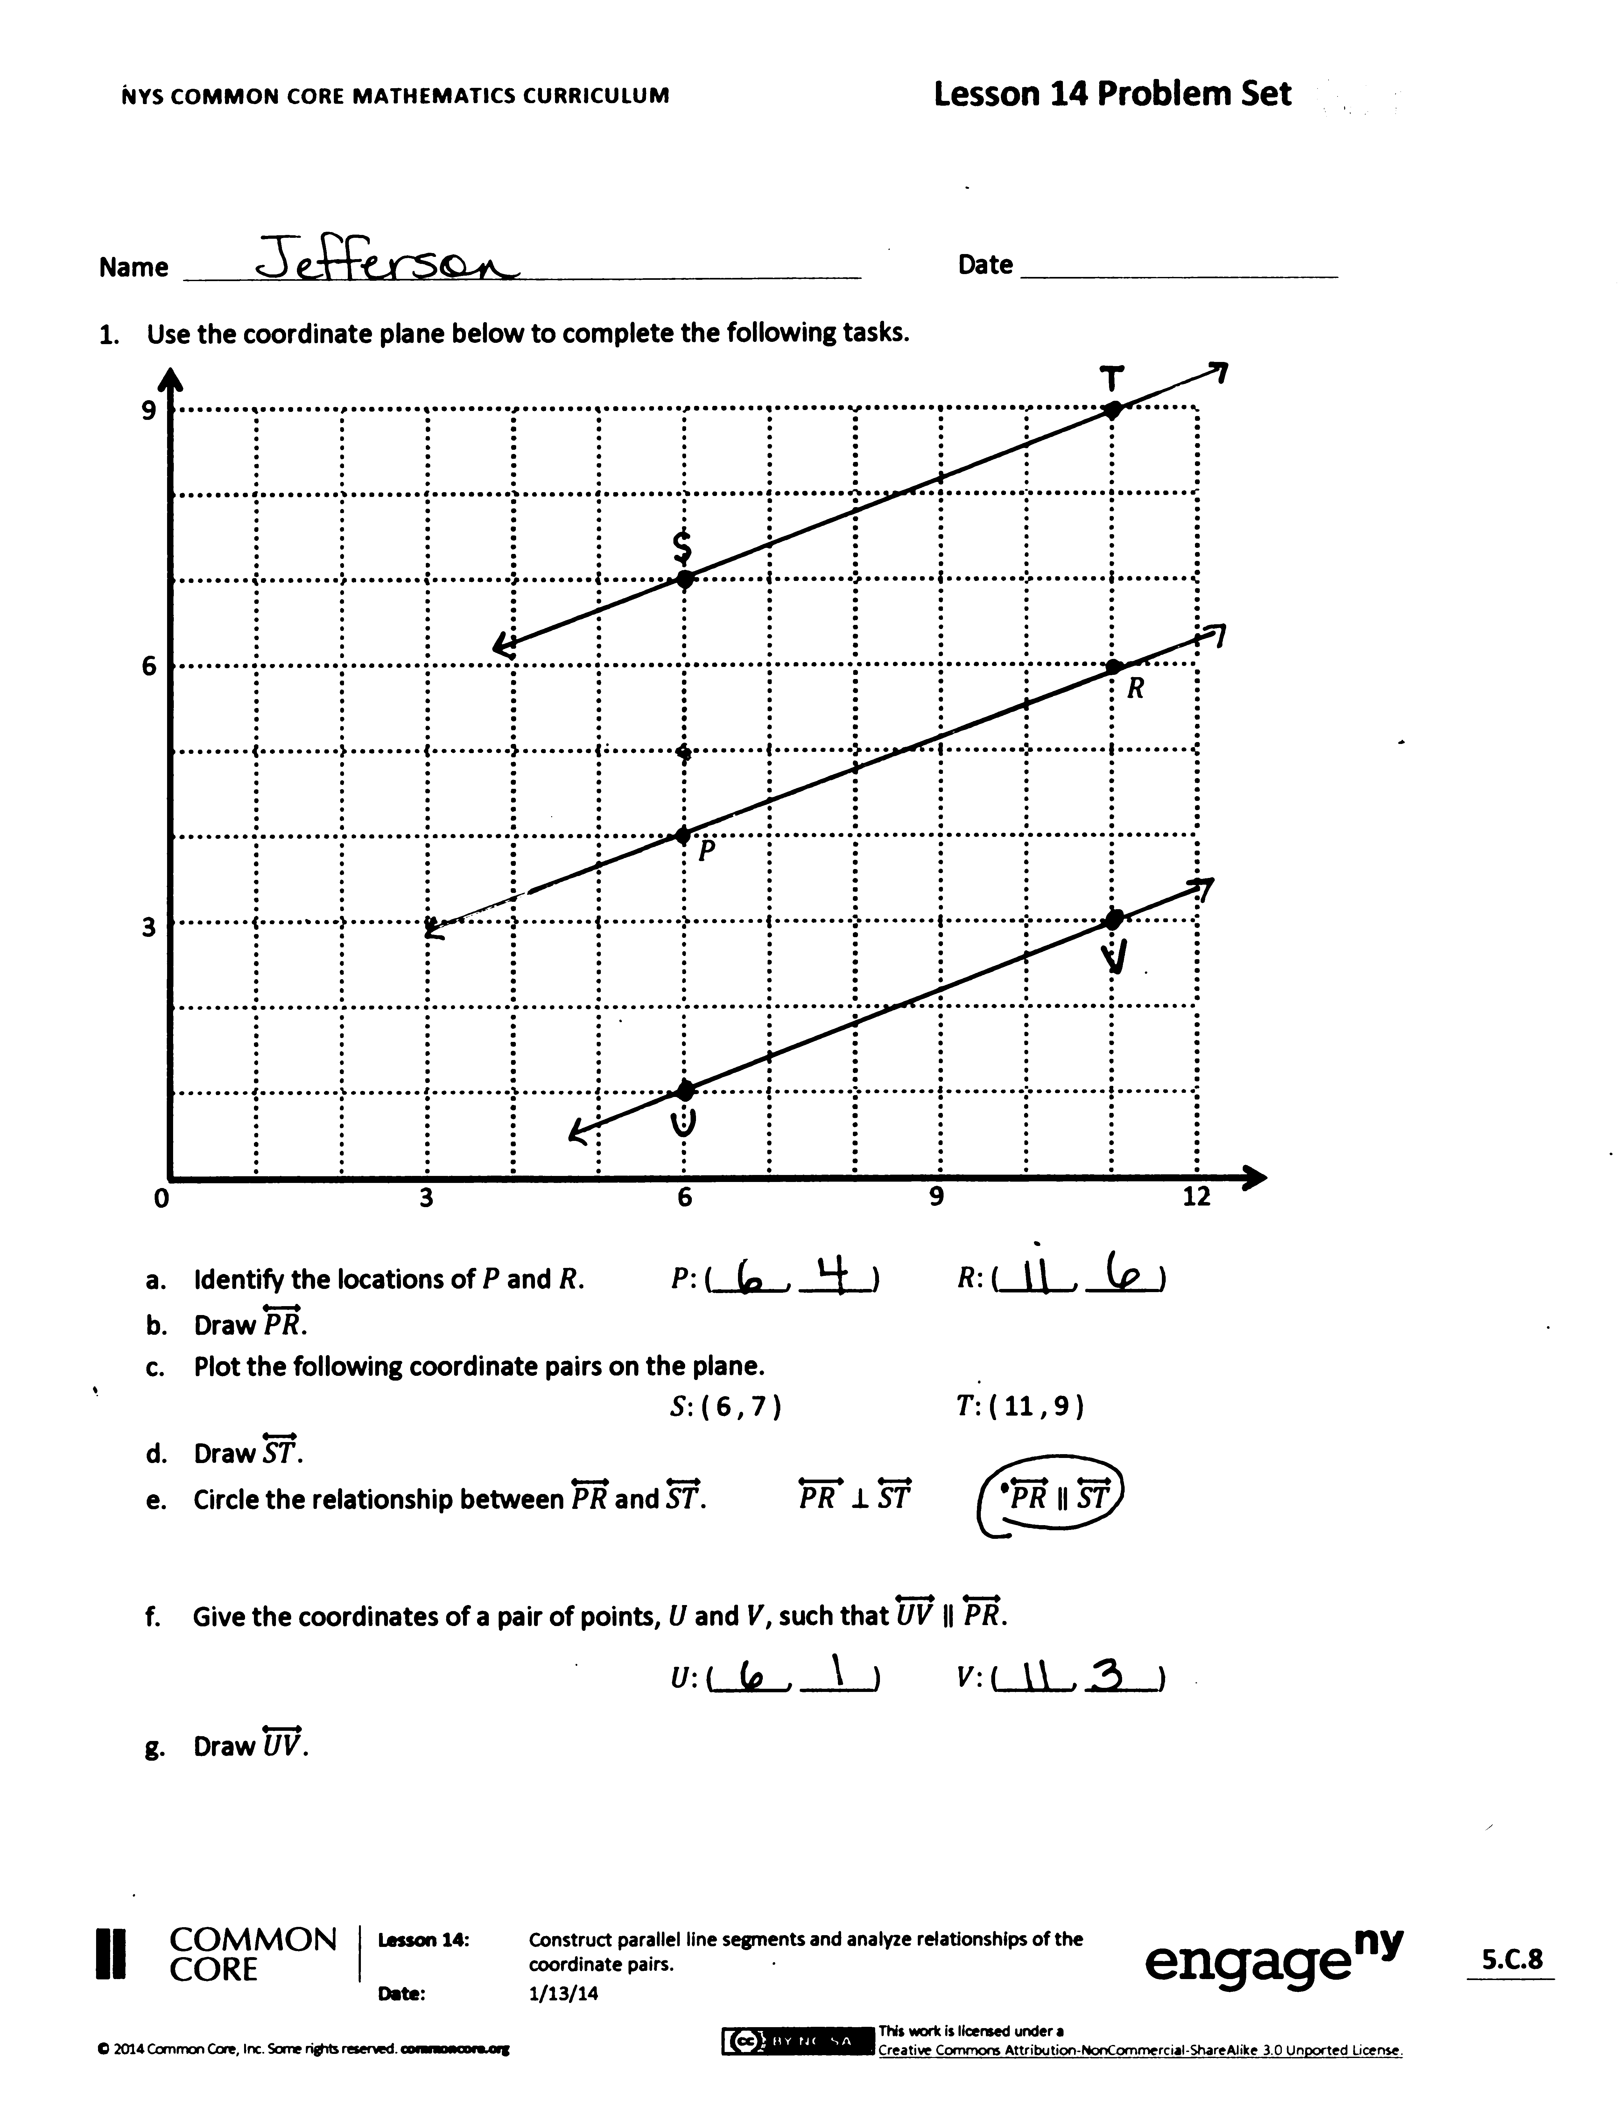
T: Draw $\overset{⃡}{GH}$ and write a statement about the relationship between these lines.
Problem Set (10 minutes)
Students should do their personal best to complete the Problem Set within the allotted 10 minutes. For some classes, it may be appropriate to modify the assignment by specifying which problems they work on first. Some problems do not specify a method for solving. Students solve these problems using the RDW approach used for Application Problems.
Student Debrief (10 minutes)
Lesson Objective: Construct parallel line segments, and analyze relationships of the coordinate pairs.
The Student Debrief is intended to invite reflection and active processing of the total lesson experience.
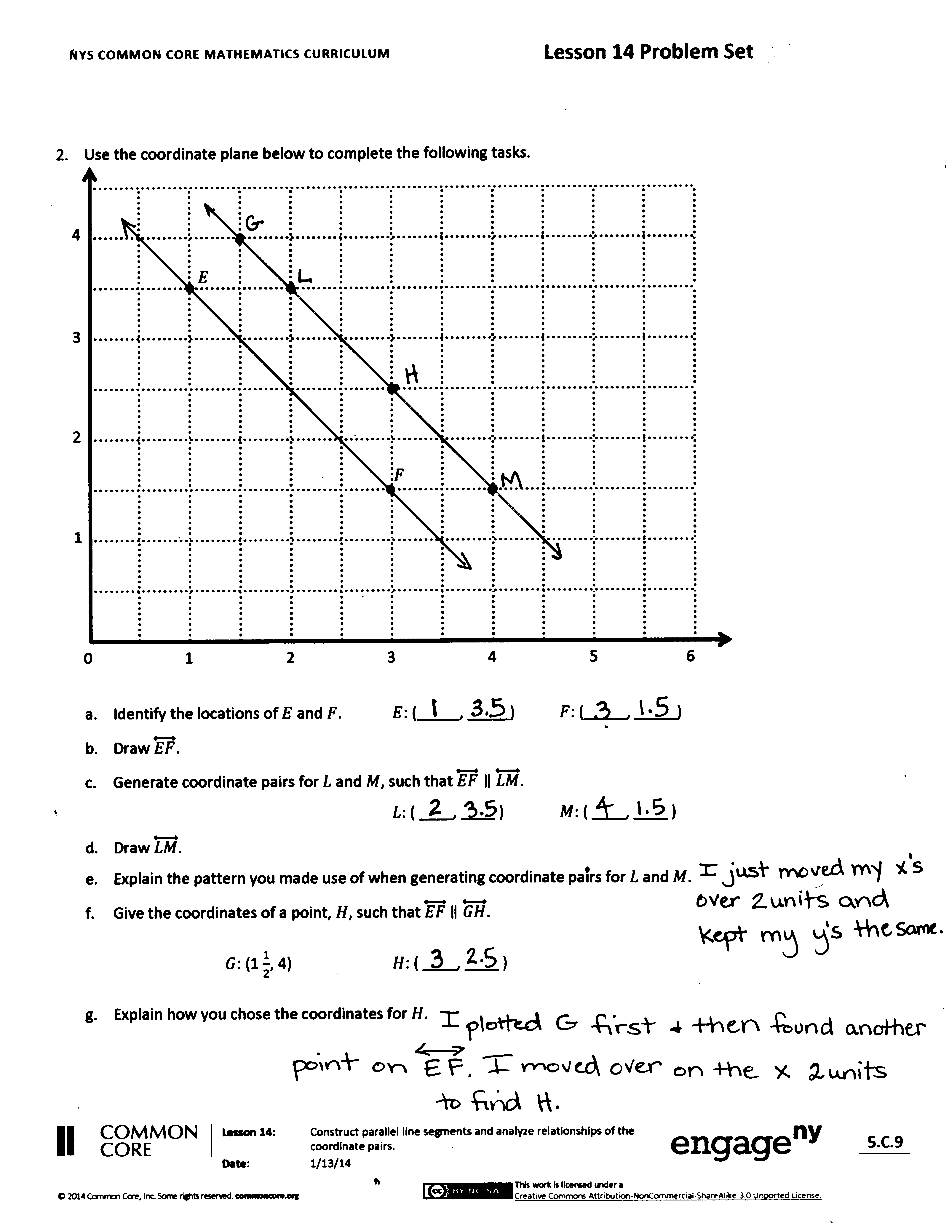
Invite students to review their solutions for the Problem Set. They should check work by comparing answers with a partner before going over answers as a class. Look for misconceptions or misunderstandings that can be addressed in the Debrief. Guide students in a conversation to debrief the Problem Set and process the lesson.
You may choose to use any combination of the questions below to lead the discussion.
- Tell your neighbor about the triangle you visualized In Problem 1. Do the same for Problem 2.
- Show your coordinate pairs from Problem 1(g) to your neighbor. Can they identify how you manipulated the coordinates?
- Share the coordinate pairs you found for $L$and $M$ in Problem 2(c). Explain how a triangle template could have been used to construct $\overset{⃡}{LM}$ parallel to $\overset{⃡}{EF}$. How many different ways would there be to slide the triangle template and get the same line?
- Explain your thought process as you identified the location of point $H$ in Problem 2(f).
- Will any movement of a triangle on a grid produce parallel lines? Why or why not? What must we remember when we are using a triangle or set square to draw parallel lines either on a grid or off? (Students should mention the importance of keeping the movements parallel to one axis while perpendicular to the other.)
Exit Ticket (3 minutes)
After the Student Debrief, instruct students to complete the Exit Ticket. A review of their work will help you assess the students’ understanding of the concepts that were presented in the lesson today and plan more effectively for future lessons. You may read the questions aloud to the students.

Name Date
- Use the coordinate plane below to complete the following tasks.
3
6
9
0 3 6 9 12
•
•
$$P$$
$$R$$

  - Identify the locations of $P$ and $R$. $P$: (_____, _____) $R$: (_____, _____)
  - Draw $\overset{⃡}{PR}$.
  - Plot the following coordinate pairs on the plane.
$S:$ (6, 7) $T:$ (11, 9)
  - Draw $\overset{⃡}{ST}$.
  - Circle the relationship between $\overset{⃡}{PR}$ and $\overset{⃡}{ST}$. $\overset{⃡}{PR }\text{⊥}\overset{⃡}{ ST}$ $\overset{⃡}{PR}∥\overset{⃡}{ST}$

  - Give the coordinates of a pair of points, $U$ and $V$, such that $\overset{⃡}{UV}$ $∥\overset{⃡}{PR}$.
$U$: (_____, _____) $V$: (_____, _____)
  - Draw $\overset{⃡}{UV}$.

- Use the coordinate plane below to complete the following tasks.
1
2
3
4
0 1 2 3 4 5 6
•
•
$$E$$
$$F$$

  - Identify the locations of $E$ and $F$. $E$: (_____, _____) $F$: (_____, _____)
  - Draw $\overset{⃡}{EF}$.
  - Generate coordinate pairs for $L$ and $M$, such that $\overset{⃡}{EF}∥\overset{⃡}{LM}$.
$L:$ (____, ____) $M:$ (____, ____)
  - Draw $\overset{⃡}{LM}$.
  - Explain the pattern you made use of when generating coordinate pairs for $L$ and $M$.
  - Give the coordinates of a point, $H$, such that $\overset{⃡}{EF}$ $∥\overset{⃡}{GH}$.
$G$: (1$\frac{1}{2}$, 4) $H$: (____, ____)
  - Explain how you chose the coordinates for $H$.

Name Date
- Use the coordinate plane below to complete the following tasks.
2
4
6
8
0 2 4 6 8 10 12
$$E$$
$$F$$

  - Identify the locations of $E$ and $F$. $E$: (_____, _____) $F$: (_____, _____)
  - Draw $\overset{⃡}{EF}$.
  - Generate coordinate pairs for $L$ and $M$, such that $\overset{⃡}{EF}∥\overset{⃡}{LM}$.
$L:$ (____, ____) $M:$ (____, ____)
  - Draw $\overset{⃡}{LM}$.

Name Date
- Use the coordinate plane below to complete the following tasks.
0 3 6 9 12
3
6
9
$$N$$
$$M$$

  - Identify the locations of $M$ and $N$. $M$: (_____, _____) $N$: (_____, _____)
  - Draw $\overset{⃡}{MN}$.
  - Plot the following coordinate pairs on the plane.
$J:$ (5, 7) $K:$ (8, 5)
  - Draw $\overset{⃡}{JK}$.
  - Circle the relationship between $\overset{⃡}{MN}$ and $\overset{⃡}{JK}$. $\overset{⃡}{MN }\text{⊥}\overset{⃡}{ JK}$ $\overset{⃡}{MN}∥\overset{⃡}{JK}$

  - Give the coordinates of a pair of points, $F$ and $G$, such that $\overset{⃡}{FG}$ $∥\overset{⃡}{MN}$.
$F$: (_____, _____) $G$: (_____, _____)
  - Draw $\overset{⃡}{FG}$.

- Use the coordinate plane below to complete the following tasks.
1
2
3
4
0 1 2 3 4 5 6
$$A$$
$$B$$

  - Identify the locations of $A$ and $B$. $A$: (____, ____) $B$: (____, ____)
  - Draw $\overset{⃡}{AB}$.
  - Generate coordinate pairs for $C$ and $D$, such that $\overset{⃡}{AB}∥\overset{⃡}{CD}$.
$C:$ (____, ____) $D:$ (____, ____)
  - Draw $\overset{⃡}{CD}$.
  - Explain the pattern you you used when generating coordinate pairs for $C$ and $D$.
  - Give the coordinates of a point, $F$, such that $\overset{⃡}{AB}$ $∥\overset{⃡}{EF}$.
$E$: ($2\frac{1}{2}$, $2\frac{1}{2}$) $F$: (____, ____)
  - Explain how you chose the coordinates for $F$.
0 1 2 3 4 5 6
1
2
3
4
0 5 10
5

