Lesson 13
Objective: Construct parallel line segments on a rectangular grid.

Suggested Lesson Structure
 Fluency Practice (12 minutes)
 Concept Development (38 minutes)
 Student Debrief (10 minutes)
Total Time (60 minutes)
Fluency Practice (12 minutes)
- Multiply 5.NBT.5 (5 minutes)
- Draw Angles 4.G.6 (7 minutes)
Multiply (5 minutes)
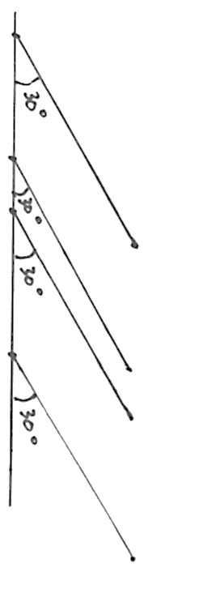
Materials: (S) Personal white boards
Note: This drill reviews year-long fluency standards.
T: Solve 43 $\text{×}$ 23 using the standard algorithm.
S: (Write 43 $\text{×}$ 23 = 989 using the standard algorithm.)
Continue the process for 543 $\text{×}$ 23, 49 $\text{×}$ 32, 249 $\text{×}$ 32, and 954 $\text{×}$ 25.
Draw Angles (7 minutes)
Materials: (S) Blank paper, ruler, protractor
Note: This fluency activity reviews Grade 4 concepts and prepares students for today’s lesson.
T: Use your ruler to draw a 4-inch horizontal line on your paper.
T: Plot four points at random on the line.
T: Use each point as a vertex. Above the line, draw and label 30$°$ angles that open to the right.
Repeat with 60$°$ and 45$°$ angles as time permits. Students should notice each set of lines is parallel.

Concept Development (38 minutes)
Materials: (T) Triangle templates in various sizes (made from rectangle template) (S) Straightedge, rectangle template (used to make triangle templates), recording sheet, scissors, unlined paper
Note: An Application Problem is not included in this lesson in order to provide adequate time for the Concept Development.
Problem 1: Construct parallel lines using a triangle template and straightedge.
Note: Demonstrate and give work time to the level your students need throughout this process.
T: (Distribute 1 rectangle template and unlined paper to each student.)
T: Cut out the 5 unit by 2 unit rectangle.
T: (Allow students time to cut.) Position your rectangle on your paper so that the horizontal side is 5 units.
T: With your straightedge, draw the diagonal from the lower left to the upper right vertex.
T: Cut along the diagonal.
T: Put one of the right triangles away. Tell your neighbor some things that you know about it.
S: One angle is a right angle and measures 90 degrees. One side is 2 units long and the other side is 5 units. The angles that aren’t 90 degrees are acute.
T: Place your triangle on your paper so that the horizontal side is 5 units and the 90-degree angle is to the right.
MP.6
T: Label the right angle and name its vertex $R$.
T: Name the vertex of the angle at the top of the triangle as $T$ and the vertex of the angle at left as $S$.
T: Place your straightedge horizontally across your paper, then place the base of the triangle along the straightedge. Trace a line across $\overline{ST}$.
T: Slide triangle $RST$ to the right, about an inch, along your straightedge, without moving the straightedge. Trace a second line across $\overline{ST}$.
T: Remove the triangle and straightedge from your paper. What do you notice about the two line segments you’ve drawn? Turn and talk.
S: We traced the same segment twice, so they’re the same length. They are parallel because angle S is the same and comes out of the same line.
T: Let’s try it again, but this time we’ll arrange our straightedge so that it’s oriented vertically on our paper.
Repeat the same construction along a vertical straightedge, moving the triangle down about an inch before tracing the parallel segment. Then, have students work with a partner to cut out the remaining rectangles and bisect them on the diagonal to create a variety of right triangles.

NOTES ON
MULTIPLE MEANS OF ACTION AND EXPRESSION:
Cutting paper with scissors may be a challenge for some learners. Try the following tips:
- Provide rectangle template on cardstock or thicker paper.
- Darken and thicken the cutting lines.
- Provide left-handed, loop, spring, self-opening, or other adaptive scissors, if needed.
- Instruct students to turn the paper, not the scissors.
- Offer precut triangles.

T: Continue to construct parallel segments using a variety of angle templates. Place your straightedge in a variety of ways on your paper. Share your work with a neighbor as you work. Think about how the angles of your triangles change as the sides change.
Problem 2: Identify parallel segments on grid paper.
T: (Distribute parallel lines recording sheet to students. Display image of segments $\overline{AB}$ and $\overline{CD}$ on board.) Put your finger on line segment $\overline{AB}$.
S: (Put finger on line segment.)
T: Using the gridlines, visualize a right triangle that has $\overline{AB}$ as its longer side. Tell your neighbor what you see.
S: The triangle is here. It has a height of 2 units and a base of 3 units. The right angle would be at the bottom and across from segment $\overline{AB}$. I see a triangle that is above $\overline{AB}$. The right angle is on the top right across from $\overline{AB}$.
T: (Shade triangle.) The triangle has a height of 2 units and a base of 3 units. (Mark right angle with right angle symbol.) Shade the triangle on your paper.
T: Now look at segment $\overline{CD}$. Shade a right triangle that has $\overline{CD}$ as its longer side.
T: What do you notice about the two triangles that were used to construct each segment? Turn and talk.
S: They’re the exact same triangle. For $\overline{CD}$ the triangle just moved over to the right. The triangles have the same side lengths and the angles look like they are the same size too.
T: This is the same as when we slid our triangles along the straightedge. Now the triangle is sliding along the grid lines. (Drag finger along the grid line to show the movement of the triangle.) Can we say then, that segment $\overline{AB}$ is parallel to $\overline{CD}$? Why or why not?
S: Yes, they’re parallel because they intersect the grid line at the same angle.
Repeat the process with $\overline{EF}$ and $\overline{GH}.$
T: If $\overline{EF}$ was drawn first, how was the triangle moved before $\overline{GH}$ was constructed? Turn and talk.
S: The triangle moved to the right and then down. I can see that the triangle moved 1 grid square down and 1 grid square to the right. So that means that the segment’s endpoints moved the same way.
T: (Display segments $\overline{IJ}$ and $\overline{KL}$ on board.) Look at segments $\overline{IJ}$ and $\overline{KL}$. Shade the right triangles that have these segments as one of their longer sides.
T: Are the segments parallel? Turn and talk.
S: No. The triangle for$\overline{ IJ}$ is taller. $\overline{KL}$ has a height of 2 and $\overline{IJ}$ has a height of 3. I can see that if we extend each segment, they intersect.
T: (Model extension of segments and their intersection.) As I extend these segments, are they parallel?
S: No, they intersect so they can’t be parallel.
T: Let’s consider something else about these segments. Imagine that we slid the longer segment over 1 unit to the right. Would the segments line up perfectly? Why or why not?
S: I can see the little one inside the big one. They are at different angles. They won’t line up. The acute angles in the triangles are different sizes so they don’t have the same steepness which means they won’t line up. One segment is over 1 up 2 and the other one is over 1 up 4. That makes the angles in the triangles different sizes.
T: (Display segments $\overline{MN}$ and $\overline{OP}$ on board.) Look at segments $\overline{MN}$ and $\overline{OP}$. Are they parallel segments?
S: They look like they’re parallel, but the triangle that includes $\overline{MN}$ has a height of 2 units and a base of 2 units, and the triangle for $\overline{OP}$ has a height of 4 units and a base of 4 units. I extended segment$\overline{ MN}$, and now it’s the same length as $\overline{OP}$, and they are parallel.
T: The triangle that I can see for $\overline{MN}$ has a height of 2 units and a base of 2 units. (Shade triangle.) It looks like $\overline{OP}$ is the side of a triangle with a height and base of 4 units.
T: Look inside the larger triangle. Do you see two triangles like the one related to $\overline{MN}$? (Point out the two triangles.)
S: (Shade two separate triangles beneath $\overline{MN}$.) I can also see two triangles, each with heights and bases of 2 units, just like the triangle that includes $\overline{MN}$.
T: What do you think now? Are the segments parallel?
S: I see it now, they are parallel. $\overline{OP}$ is just longer. We could have also just extended $\overline{MN}$ to make it longer, and then it could be part of a triangle with a height and base of 4 units.
Problem 3: Construct parallel segments on grid paper.
T: (Display image of segment$\overline{ QR}$ on board.) Tell your neighbor about the triangle that you see that has segment $\overline{QR}$ as a side.
S: (Discuss triangle.)
T: Draw a segment parallel to $\overline{QR}$ that goes through point $S$. Tell your neighbor what you did.
S: I drew a triangle that’s the same as the one that includes $\overline{QR}$with a height of 2 units and a base of 1 unit directly below point $S$. Then, I put a point at the right end of the base, and connected it to point $S$. I went down 2 units from $Q$ and then right 1 unit to point $R$. So I went down 2 units from $S$ and right 1 unit and made a point to connect to $S$.
T: Watch me. I visualized a triangle with a height of 2 and a base of 1 beneath segment $\overline{QR}$. (Demonstrate.) If I visualize the same triangle beneath point $S$, I can find a point to connect with point $S$, to make a parallel segment. (Demonstrate.)
T: Draw parallel segments for the other two examples on your paper. Share your work with a neighbor. (Allow students time to work.)
T: (Display image of line $l$ on board.) Look at line $l$. Think about the triangle that you are visualizing for line $l$. (Give students time to think.) Tell your neighbor about what you visualized.
S: I can see a triangle with a height to 3 and a base of 12. I see a triangle with a height of 2 and a base of 8. I can see a bunch of triangles each with a height of 1 and a base of 4.
T: I heard that you saw several different triangles for line $l$. Some of you saw a large triangle with a height of 3 units and a base of 12 units. (Use finger to show on board.) Others saw a series of smaller triangles with a height of 1 unit and a base of 4 units. Let’s construct a line that is parallel to line $l$. Draw a point on the grid somewhere above line $l$. (Model on board.)
S: (Draw point.)
T: Now, plot a second point that creates the side of the triangle you visualized. For example, some of you visualized a triangle with a height of 2 units and a base of 8 units, so you’ll move 2 units down and 8 units to the right, then plot a point. (Model on board.)
S: (Plot point.)
T: Use your straightedge to draw a line parallel to line $l$ through the two points you’ve plotted. (Allow students time to draw line.)
T: Do the same thing again, but this time, construct your line below line $l$.
Note: The triangle templates the students created today will be used in future lessons. It may be helpful to keep them in individually labeled plastic bag.
Problem Set (10 minutes)
Students should do their personal best to complete the Problem Set within the allotted 10 minutes. For some classes, it may be appropriate to modify the assignment by specifying which problems they work on first. Some problems do not specify a method for solving. Students solve these problems using the RDW approach used for Application Problems.
Student Debrief (10 minutes)
Lesson Objective: Construct parallel line segments on a rectangular grid.
The Student Debrief is intended to invite reflection and active processing of the total lesson experience.
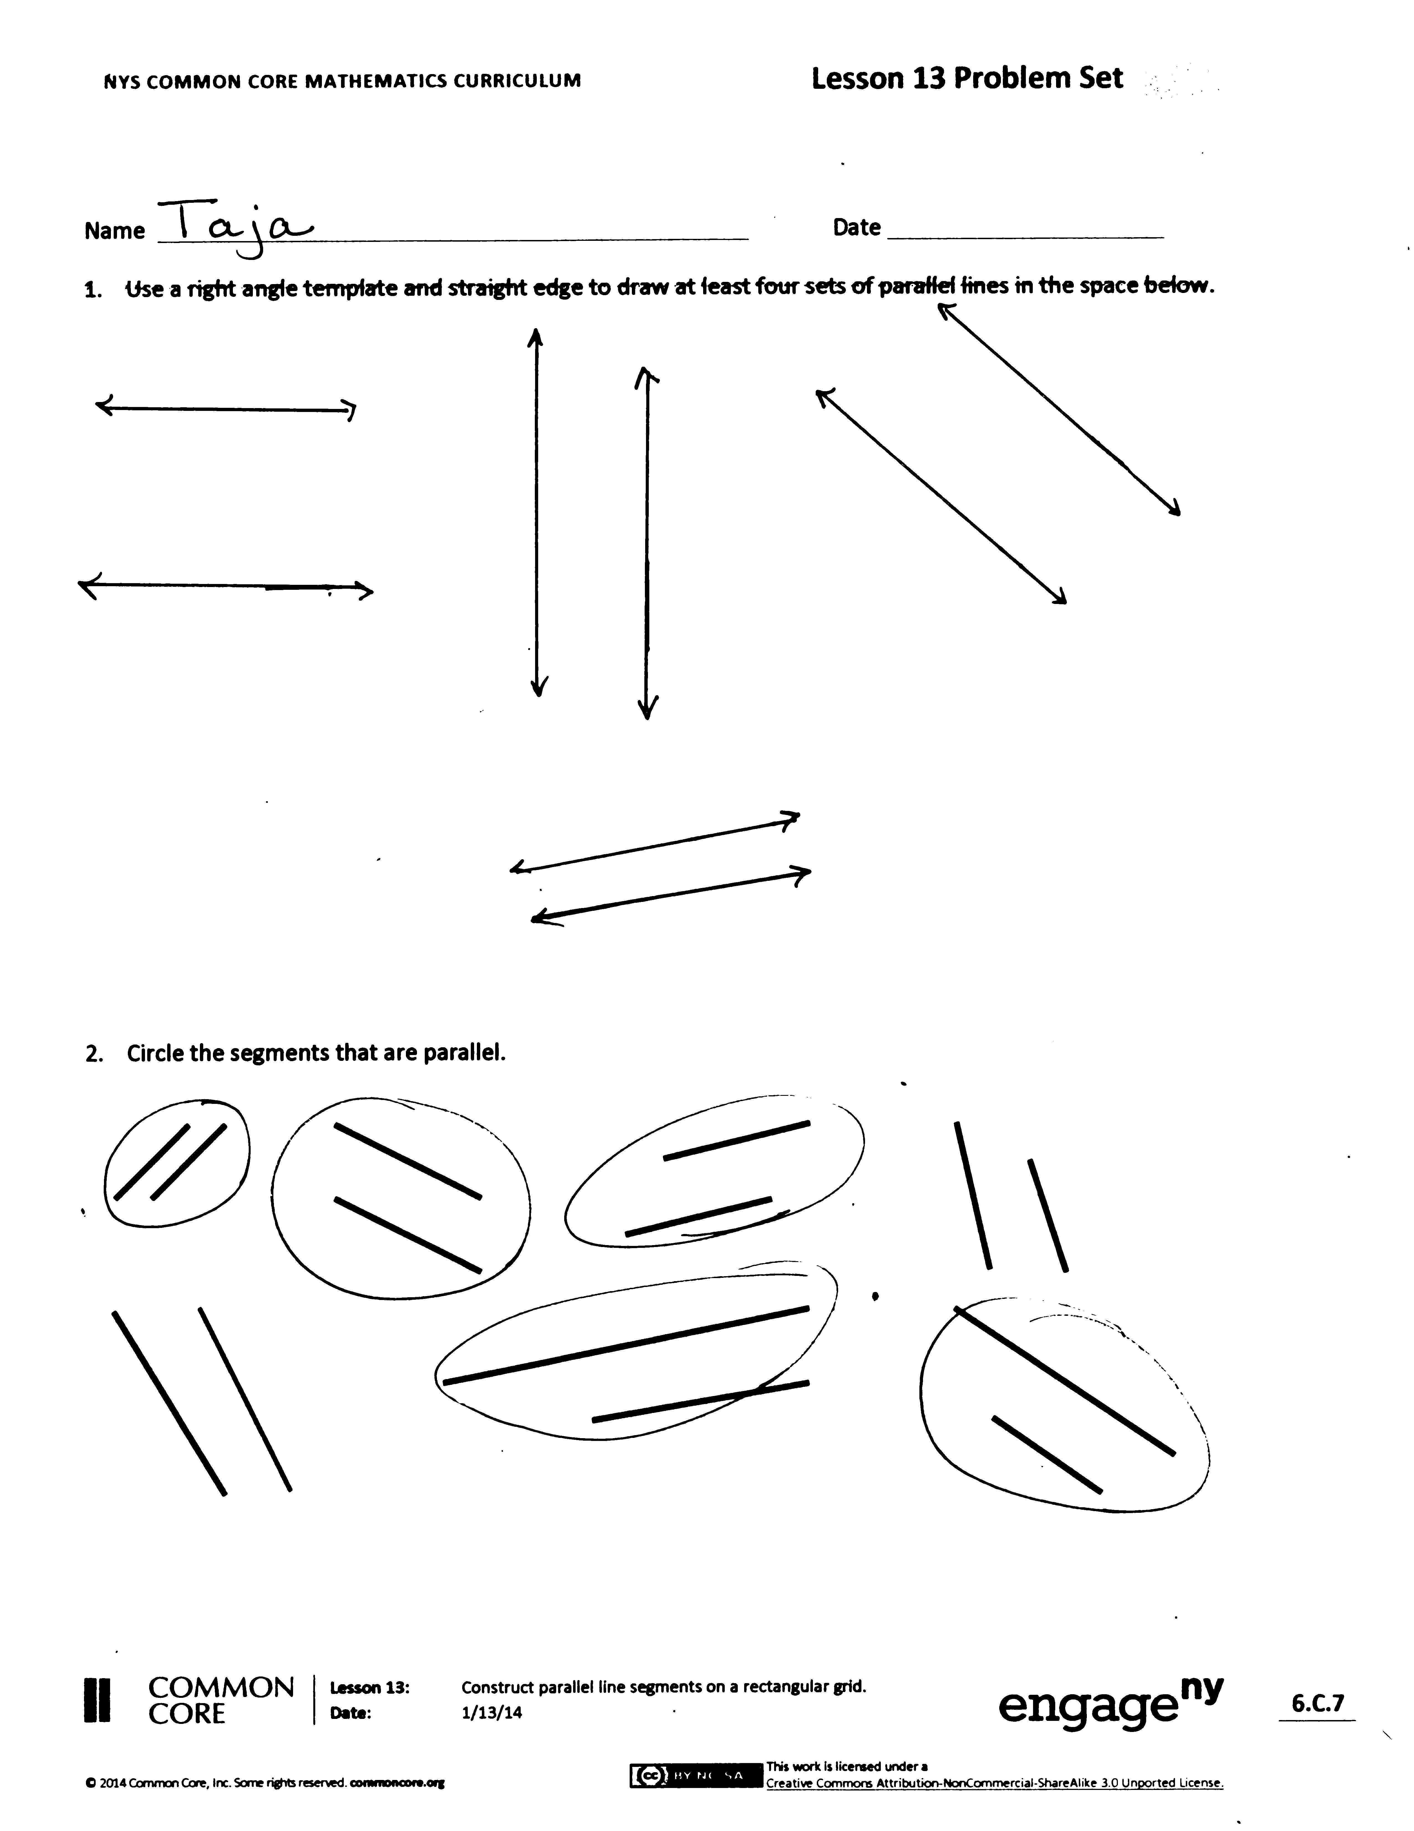
Invite students to review their solutions for the Problem Set. They should check work by comparing answers with a partner before going over answers as a class. Look for misconceptions or misunderstandings that can be addressed in the Debrief. Guide students in a conversation to debrief the Problem Set and process the lesson.
You may choose to use any combination of the questions below to lead the discussion.
- In Problem 1, share your parallel lines with a partner. Explain how you drew the lines.
- Compare and share your solution for Problem 2 with a partner. Explain how you know the lines are parallel. For the segments that were not circled, how did you determine that they were not parallel?
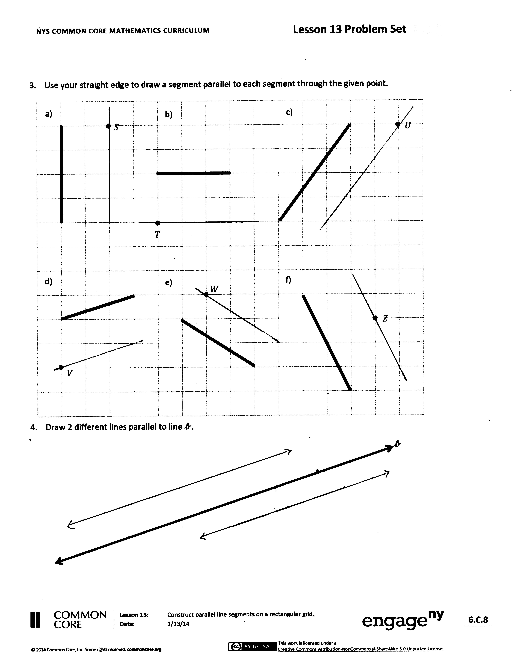
- Compare and check your answers for Problem 3 with a partner. Do you have the same answer? (It is possible that two students may create different segments that lie on the same parallel line, perhaps on Problem 3(f). Be sure to point out that while the segments aren’t the same, they do lie on the same line.)
- On Problem 4, did you draw the same lines as your neighbor? If your answers are different, are you both correct? How is that possible?
- Go back to $\overline{EF}$ and $\overline{GH}$. We draw $\overline{EF}$. We slide down 1 grid square and draw the same segment. That new segment is parallel to $\overline{EF}$. Then, slide over 1 grid square and draw $\overline{GH}$. $\overline{GH}$is parallel to our new segment. $\overline{EF}$ is parallel to the new segment and $\overline{GH}$ is parallel to the new segment. Then what do we know about $\overline{EF}$ and $\overline{GH}$?
- How does drawing these parallel segments relate to our fluency activity with angles?
Exit Ticket (3 minutes)
After the Student Debrief, instruct students to complete the Exit Ticket. A review of their work will help you assess the students’ understanding of the concepts that were presented in the lesson today and plan more effectively for future lessons. You may read the questions aloud to the students.
Name Date
- Use a right angle template and straightedge to draw at least four sets of parallel lines in the space below.

- Circle the segments that are parallel.

- Use your straightedge to draw a segment parallel to each segment through the given point.
$$T$$

$$U$$

$$S$$

a.
b.
c.

d.
e.
f.
$$V$$
$$W$$
$$Z$$

- Draw 2 different lines parallel to line $b$.

$$b$$

Name Date
- Use your straightedge to draw a segment parallel to each segment through the given point.

$$I$$

$$H$$

a.
b.
c.
$$J$$

Name Date
- Use your right angle template and straightedge to draw at least three sets of parallel lines in the space below.

- Circle the segments that are parallel.

- Use your straightedge to draw a segment parallel to each segment through the given point.

$$T$$

$$U$$

$$S$$

a.
b.
c.
d.
e.
f.
$$V$$
$$W$$
$$Z$$

- Draw 2 different lines parallel to line $b$.

$$b$$

 | a.⬇ |  |  |  |  |  | b.⬇ |  | c.⬇
 |  |  |  |  |  |  |  |  |  |  |  |  | d.⬇
 | e.➔
 | f.⬇ |  |  |  | g.➔ |  |  |  |  | h.➔

$$Q$$
$$R$$
$$C$$
$$T$$
$$J$$
$$F$$

$$A$$
$$B$$
$$C$$
$$D$$
$$E$$
$$F$$
$$G$$
$$H$$
$$I$$
$$J$$
$$K$$
$$L$$
$$M$$
$$N$$
$$O$$
$$P$$
•$S$
•$V$
•$W$
$$l$$

