Lesson 12
Objective: Create a rule to generate a number pattern, and plot the points.

Suggested Lesson Structure
 Application Problem (7 minutes)
 Fluency Practice (12 minutes)
 Concept Development (31 minutes)
 Student Debrief (10 minutes)
Total Time (60 minutes)
Application Problem (7 minutes)
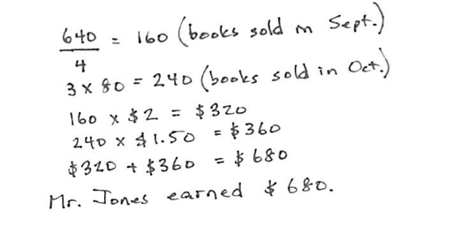
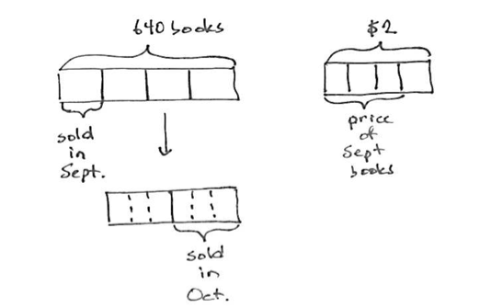
Mr. Jones had 640 books. He sold $\frac{1}{4}$ of them for $2.00 each in the month of September. He sold half of the remaining books in October. Each book he sold in October earned $\frac{3}{4}$ of what each book sold for in September. How much money did Mr. Jones earn selling books? Show your thinking with a tape diagram.

Note: This Application Problem reviews fraction skills taught in G5-Module 2 and opens the lesson, as the fluency activity’s graphing flows well into the Concept Development. This problem is quite complex and given only seven minutes of instructional time. A simpler version of the problem can be used: Mr. Jones had 640 books. He sold $\frac{1}{4}$ of them in the month of September. He sold half of the remaining books in October. How many books did he sell in all?
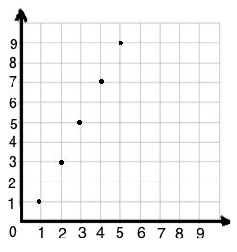
Fluency Practice (12 minutes)
Rule: Double x, then subtract 1.
$$x$$ | $$y$$ | $$(x,y)$$
1 | 1 | (1,1)
2 | 3 | (2,3)
3 | 5 | (3,5)
4 | 7 | (4,7)
5 | 9 | (5,9)

- Sprint: Subtract Decimals 5.NBT.7 (9 minutes)
- Make a Number Pattern 5.OA.3 (3 minutes)
Sprint: Subtract Decimals (9 minutes)
Materials: (S) Subtract Decimals Sprint
Note: This Sprint reviews G5–Module 1 concepts.
Make a Number Pattern (3 minutes)
Materials: (S) Personal white boards with coordinate grid insert
Note: This fluency activity reviews G5–M6–Lesson 11.
T: (Project table with only the $x$-values filled in. Write Rule: Double $x$, then subtract 1.) Fill in the table and plot the points.
S: (Complete the table and plot (1, 1), (2, 3), (3, 5), (4, 7), and (5, 9).)
T: (Write the next two coordinates in the pattern.)
S: (Write (6, 11) and (7, 13).)
Concept Development (31 minutes)
Materials: (S) Personal white board, coordinate plane template
Problem 1: Generate a rule from two given coordinates.
T: (Plot ($\text{1}\frac{1}{2}, \text{3}.$) What do you notice about the relationship between the $x$-and $y$-coordinates? Turn and talk.
S: The $y$-coordinate is twice as much as the $x$-coordinate. The $x$-coordinate is $\text{1}\frac{1}{2}$ less than the $y$-coordinate.
T: I’m visualizing line $l,$ which contains point $A$. Take a moment to think about what line $l$ might look like. (Pause.) Draw your line on the plane with your finger for your neighbor.
S: (Draw line with finger.)
T: The line you showed may or may not have been like your neighbor’s. Why is knowing the location of one point that falls on the line not enough to name the rule for line $l$? Turn and talk.
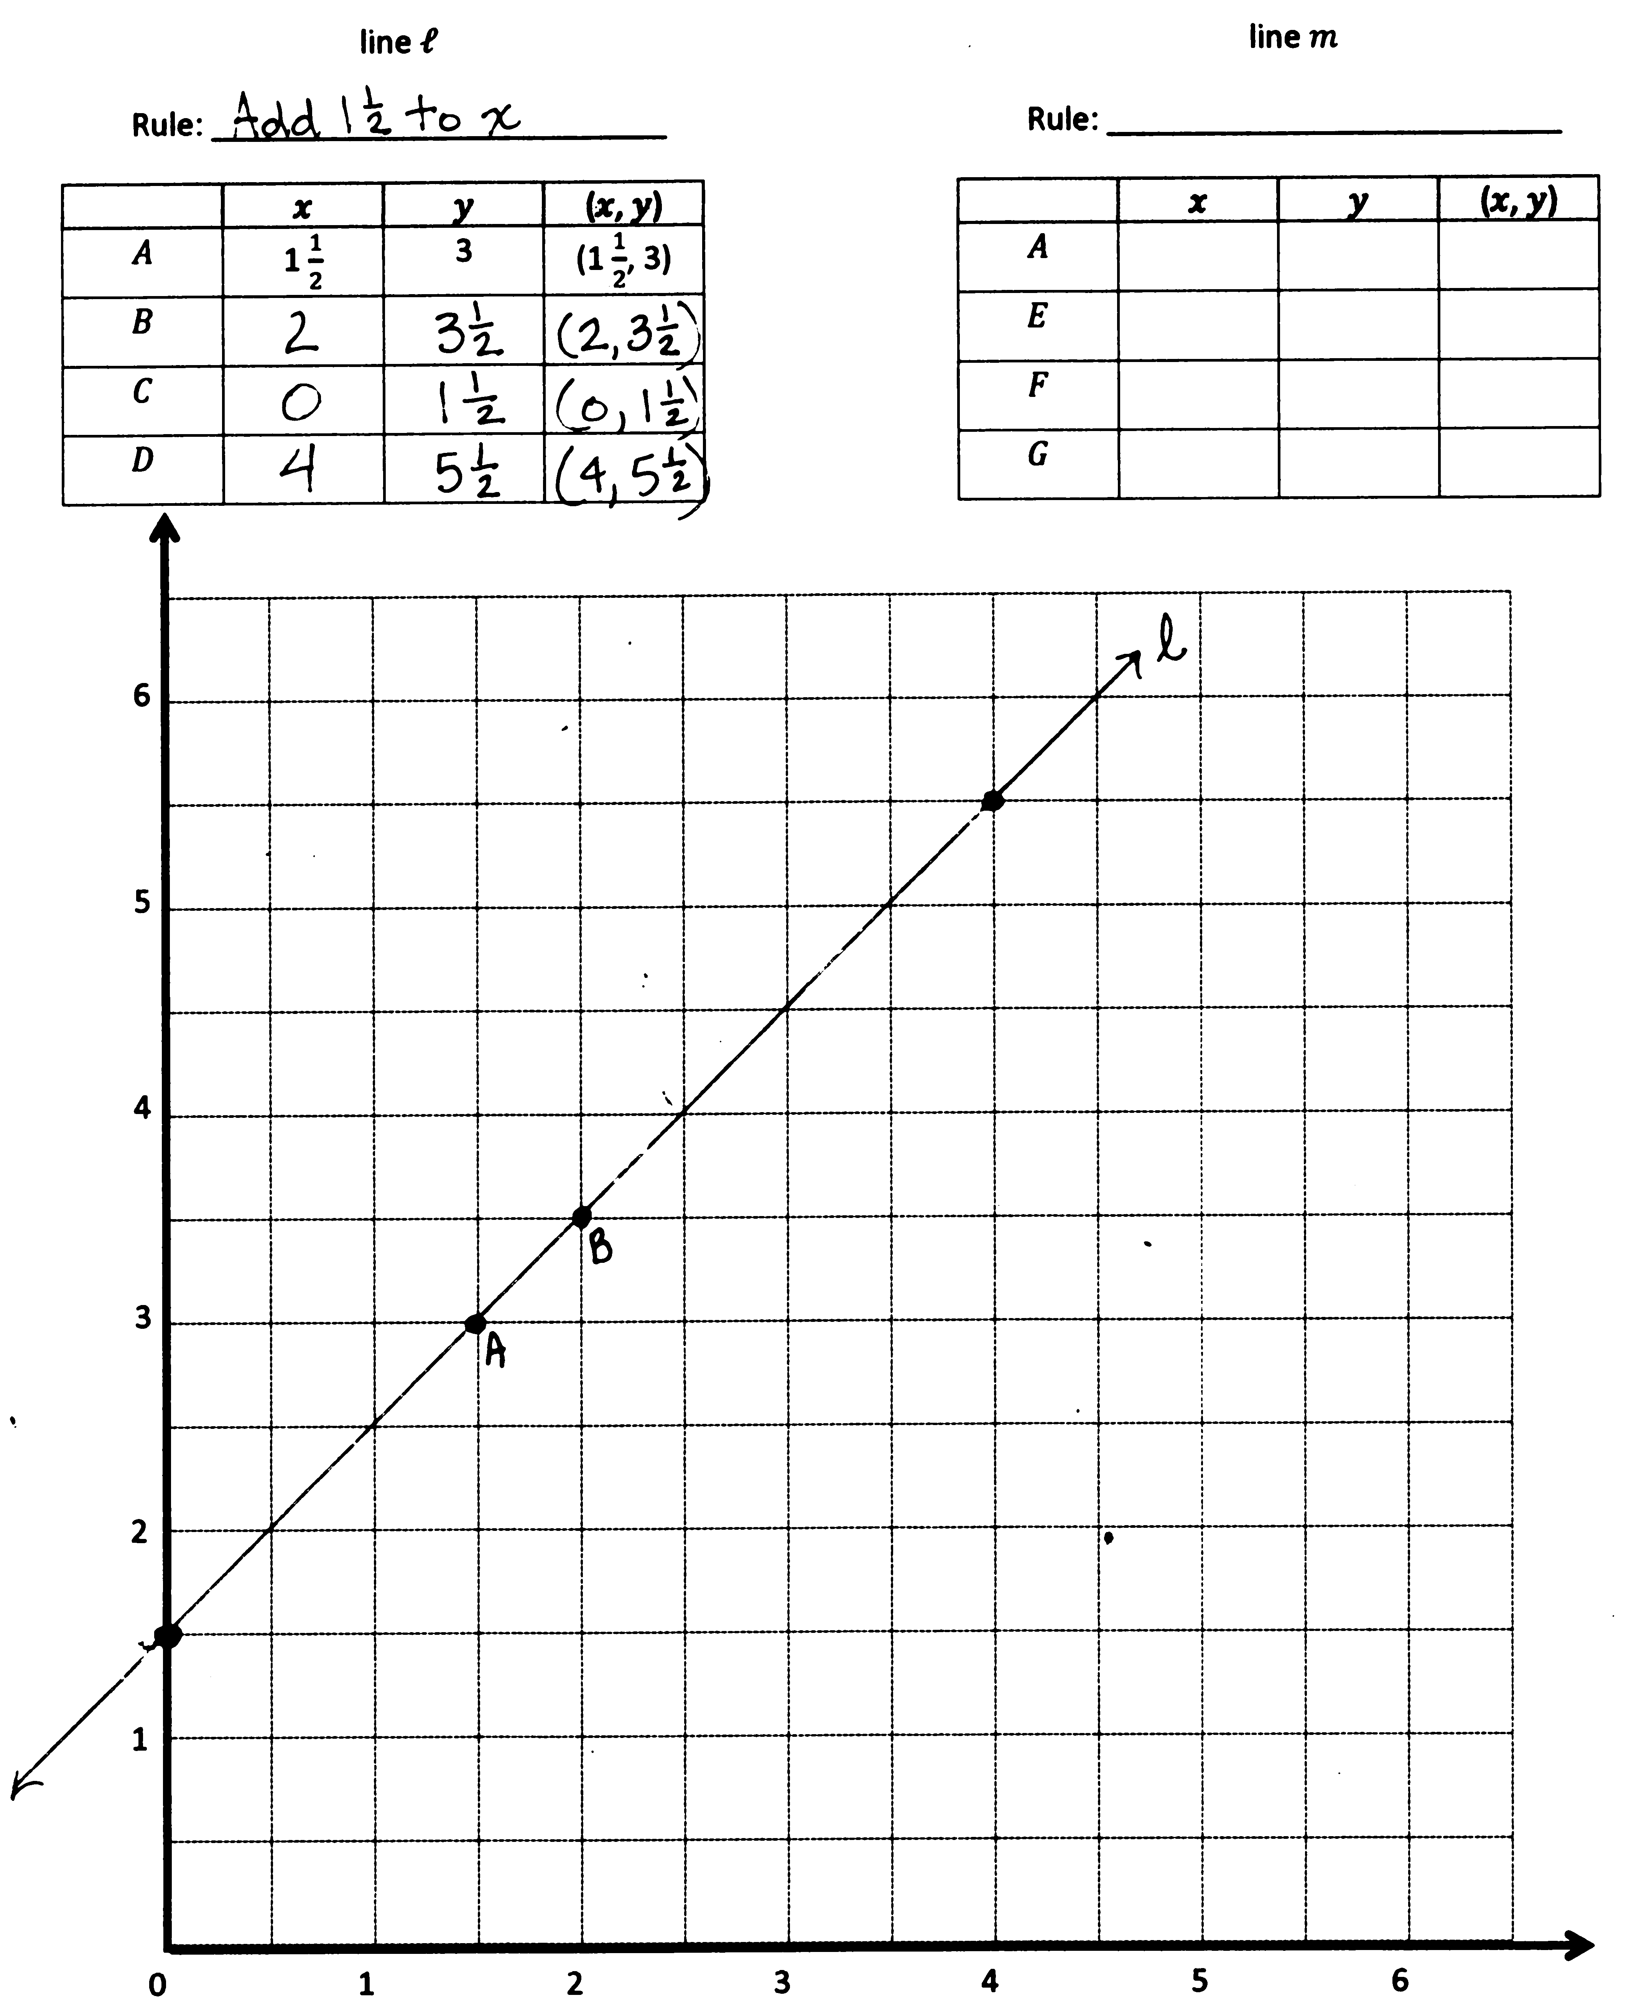
S: It could be almost any line, as long as it goes through $A$. The line could be horizontal, vertical, or a steep line. With just one point, I could imagine drawing one line and then spinning it around like a propeller to get lots of lines.
T: (Display $B$: (2, $\text{3}\frac{1}{2}$) on board.) Record the location of $B$ in your chart; then, plot it on your plane. (Record and plot $B.$)
S: (Record and plot $B$.)
T: Line $l$, the line I have been thinking of, also contains point $B$. What pattern do you notice in the coordinate pairs of line $l$? Turn and talk.
S: The $y$-coordinate is always more than the $x$-coordinate. At first, I thought we were going to be doubling $x$, but now I can see that we’re adding $\text{1}\frac{1}{2}$ to $x$.
T: Use your finger again to show your neighbor what you think line $l$ looks like.
S: (Share with neighbor.)
T: Raise your hand if your neighbor’s line was still different than yours.
S: (Hands should remain down.)

NOTES ON
MULTIPLE MEANS OF REPRESENTATION:
Scaffold finding the unknown rule for students working below grade level as follows:
Ask, “Write the two possible rules for
($\text{1}\frac{1}{2}$ , 3).”
___ $×$2
___ $+$ $\text{1}\frac{1}{2}$

T: Once we know the location of 2 points on a line, we know exactly where the line falls. Line $l$ is here. (Drag your finger across the plane to show $l$.) But, I still need you to tell me a rule to describe this line. Do you have enough information, now, to name a rule for line $l$?
S: Yes.
T: Show me the rule for line $l$.
S: (Add $\text{1}\frac{1}{2}$ to $x.$ $y$ is $1\frac{1}{2}$ more than $x.$ $y$ is $x$ plus $\text{1}\frac{1}{2}.$)
T: Record the rule you created on the chart for line $l$.
T: Identify the coordinates of two other points that line $l$contains; then, plot them on your plane and use your straight edge to draw line $l$.
Problem 2: Generate rules that describe multiple lines that share a common point.
T: Line $m$ also contains point $A$. Record the location of $A$in the chart for line $m$.
S: (Record the location.)
T: Is it possible that more than one line can contain point $A$? Turn and talk.
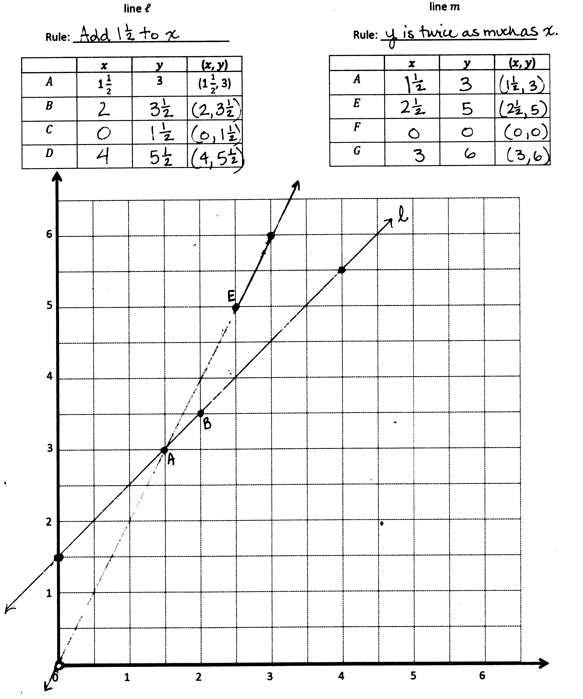
S: (Discuss with partner.)
$$m$$
T: In order to name a rule to describe line $m$, what else do you need?
S: Another point on the line.
T: (Display $E$: ($\text{2}\frac{1}{2}$, 5) on the board.) Record the location of $E$ on the coordinate plane.
S: (Record the location.)
T: What patterns do you see in the coordinate pairs for line $m$? Turn and talk.
S: It’s not addition anymore because $\text{2}\frac{1}{2}$ plus $\text{1}\frac{1}{2}$ is 4, not 5. In both coordinate pairs, the $y$-coordinate is twice as much as the $x$-coordinate. I think the rule for line $m$ is multiply $x$ by 2.
T: Give the rule that describes line $m$.
S: Multiply $x$by 2. Double $x$. $y$ is twice as much as $x$.
T: Identify two more points that lie on line $m$ and then draw the line on your plane. (Draw line $m$.)
S: (Draw line $m.\text{)}$
T: Do you think there are still other lines that could contain point $A$? Turn and talk.
S: I think that there could be a horizontal line that goes through point $A$. We could have a line that’s perpendicular to the $x$-axis and contains point $A$. We learned about rules with mixed operations yesterday. Maybe there’s a line with a mixed operation rule that could contain point $A$. There are lots of lines that go through that point.
T: Use your arm to show what a line parallel to the $y$-axis would look like.
S: (Raise an arm vertically.)
T: Work with a neighbor to identify a rule that describes a line that is parallel to the$y$-axis and contains point $A$.
S: (Work and show rule $x$ is always $\text{1}\frac{1}{2}$.)
T: A vertical line where $x$ is always $\text{1}\frac{1}{2}$ would contain point $A$. (Drag your finger along plane to show the location of this line. Write on the board: Rule for a line parallel to the $y$-axis: $x$ is always $\text{1}\frac{1}{2}.$) Show me another coordinate pair that this line would contain.
S: (Show a coordinate pair with $\text{1}\frac{1}{2}$ as the $x$-coordinate and any value for the $y$-coordinate.)
T: Give a rule for a line that is perpendicular to the $y$-axis and contains point $A$.
S: (Work and show rule $y$ is always 3.)
T: Show your neighbor another coordinate pair that this horizontal line would contain.
S: (Work and share.)
Problem 3: Generate a mixed operation rule from a coordinate pair.
T: Let’s find a mixed operation rule that would contain point $A$. Let’s begin by creating a rule with multiplication and addition. Let’s write a sentence frame for our mixed operation rule. (Write multiply $x$by ____, then add ____ on the board.)
T: If our rule is to include multiplication and addition, we need to make sure that after we multiply, the product is less than 3. Tell a neighbor why.
S: The product needs to be less than 3 so that we still have some room to add. If the product were more than 3, then we would need to subtract to get the $y$-coordinate.
T: Tell your neighbor what we could multiply $\text{1}\frac{1}{2}$ by and get a product less than 3.
S: Well $1\frac{1}{2}$ times 2 is exactly 3, so it needs to be less than 2. We could multiply by $\frac{1}{2};$ that will definitely be less than 3.
T: Let’s see what happens if we multiply by $\text{1}\frac{1}{2}$. (Write $\text{1}\frac{1}{2}$ in sentence frame.) Work with a partner and show me the product of $\text{1}\frac{1}{2}$ times $\text{1}\frac{1}{2}$ as a fraction in its simplest form.
S: (Work and show $\text{2}\frac{1}{4}$.)
T: So far, our rule says, multiply $x$ by $\text{1}\frac{1}{2}$, then add…. What must we add to $\text{2}\frac{1}{4}$ so that our $y$-coordinate is 3?
S: $\frac{3}{4}$.
T: (Write $\frac{3}{4}$ in sentence frame.) Say the mixed operation rule for the line that contains point $A$.
S: Multiply $x$ by $\text{1}\frac{1}{2}$, then add $\frac{3}{4}$.
T: Work with a neighbor to name 2 other coordinate pairs that this line would contain.
S: (Work and share.)
T: Work with a neighbor to see if you can identify another mixed operation rule that would contain point $A$. It may involve multiplication and addition again, or you can try one with multiplication and subtraction.
S: (Work and share.)
Circulate around room to check work and support struggling learners. After some time, allow students to share their mixed operation rules with the class. As rules are presented, students may identify other coordinate pairs that each line would contain.
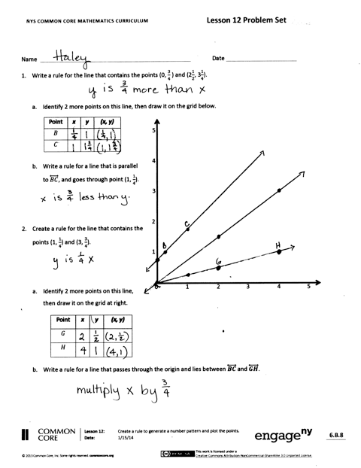
Problem Set (10 minutes)
Students should do their personal best to complete the Problem Set within the allotted 10 minutes. For some classes, it may be appropriate to modify the assignment by specifying which problems they work on first. Some problems do not specify a method for solving. Students solve these problems using the RDW approach used for Application Problems.
Student Debrief (10 minutes)
Lesson Objective: Create a rule to generate a number pattern, and plot the points.
The Student Debrief is intended to invite reflection and active processing of the total lesson experience.
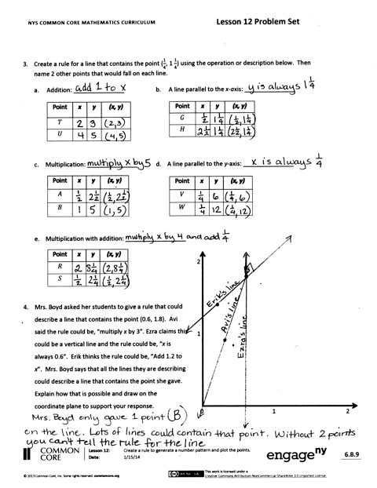
Invite students to review their solutions for the Problem Set. They should check work by comparing answers with a partner before going over answers as a class. Look for misconceptions or misunderstandings that can be addressed in the Debrief. Guide students in a conversation to debrief the Problem Set and process the lesson.
You may choose to use any combination of the questions below to lead the discussion.
- Compare your rules from Problem 3 with a neighbor. Which rule is the only one that might be different from a neighbor? Why?
MP.3
- In Problem 4, did Avi, Ezra, and Erik name all of the rules that contain the point (0.6, 1.8)? Name some other rules that would contain this point.
- In Problem 5, what was your thought process or strategy as you worked to identify a mixed operation rule? In order to create a rule for a line parallel to $\overset{⃡}{OP}$, what part of the rule did you need to change?
- If you know the location of one point on the plane, how many lines contain that point? If you know the location of two points on the plane, how many lines contain both of those points?
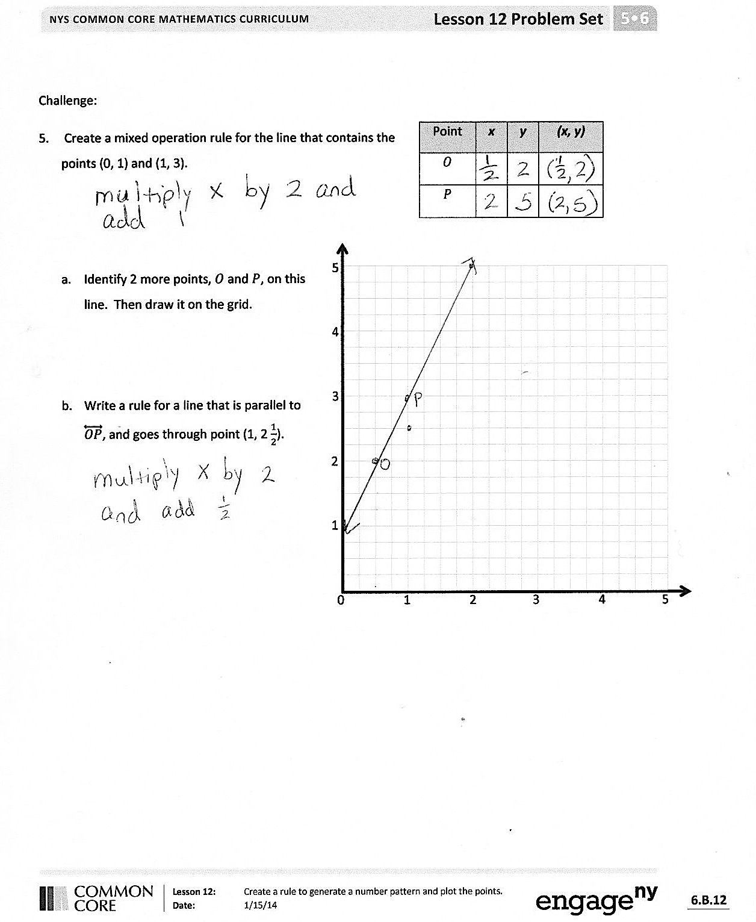
Exit Ticket (3 minutes)
After the Student Debrief, instruct students to complete the Exit Ticket. A review of their work will help you assess the students’ understanding of the concepts that were presented in the lesson today and plan more effectively for future lessons. You may read the questions aloud to the students.

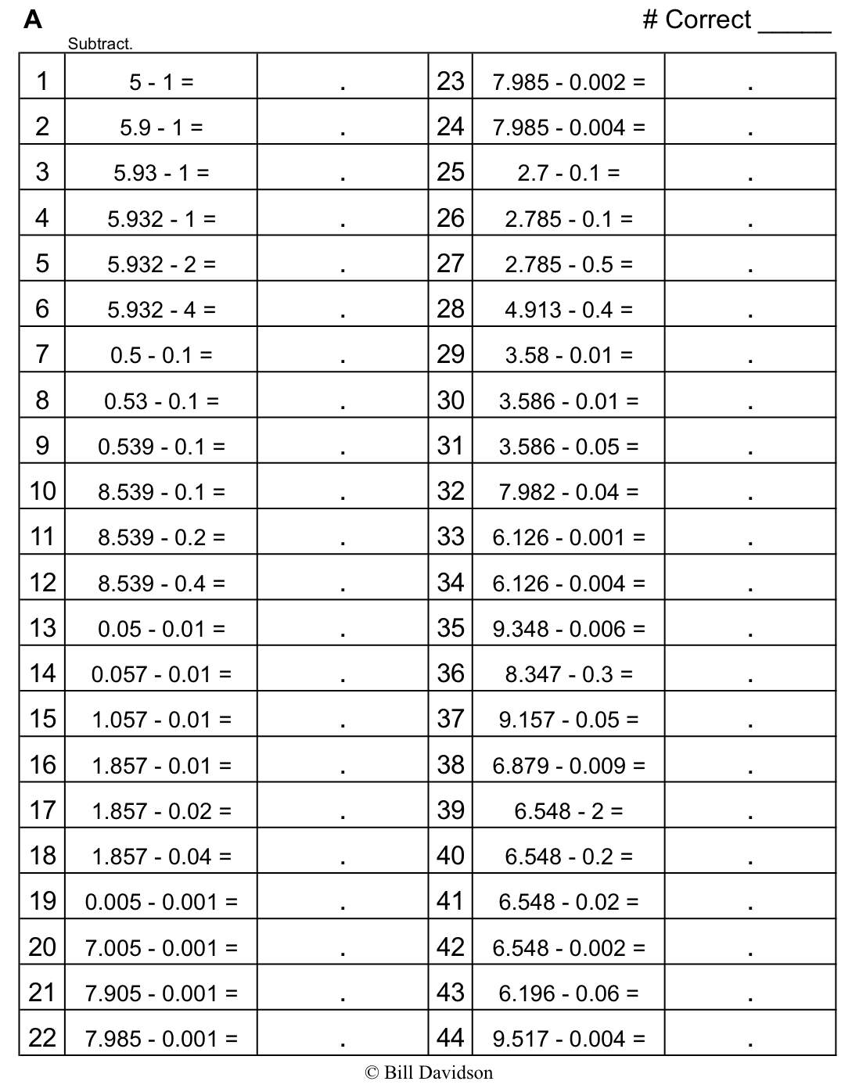

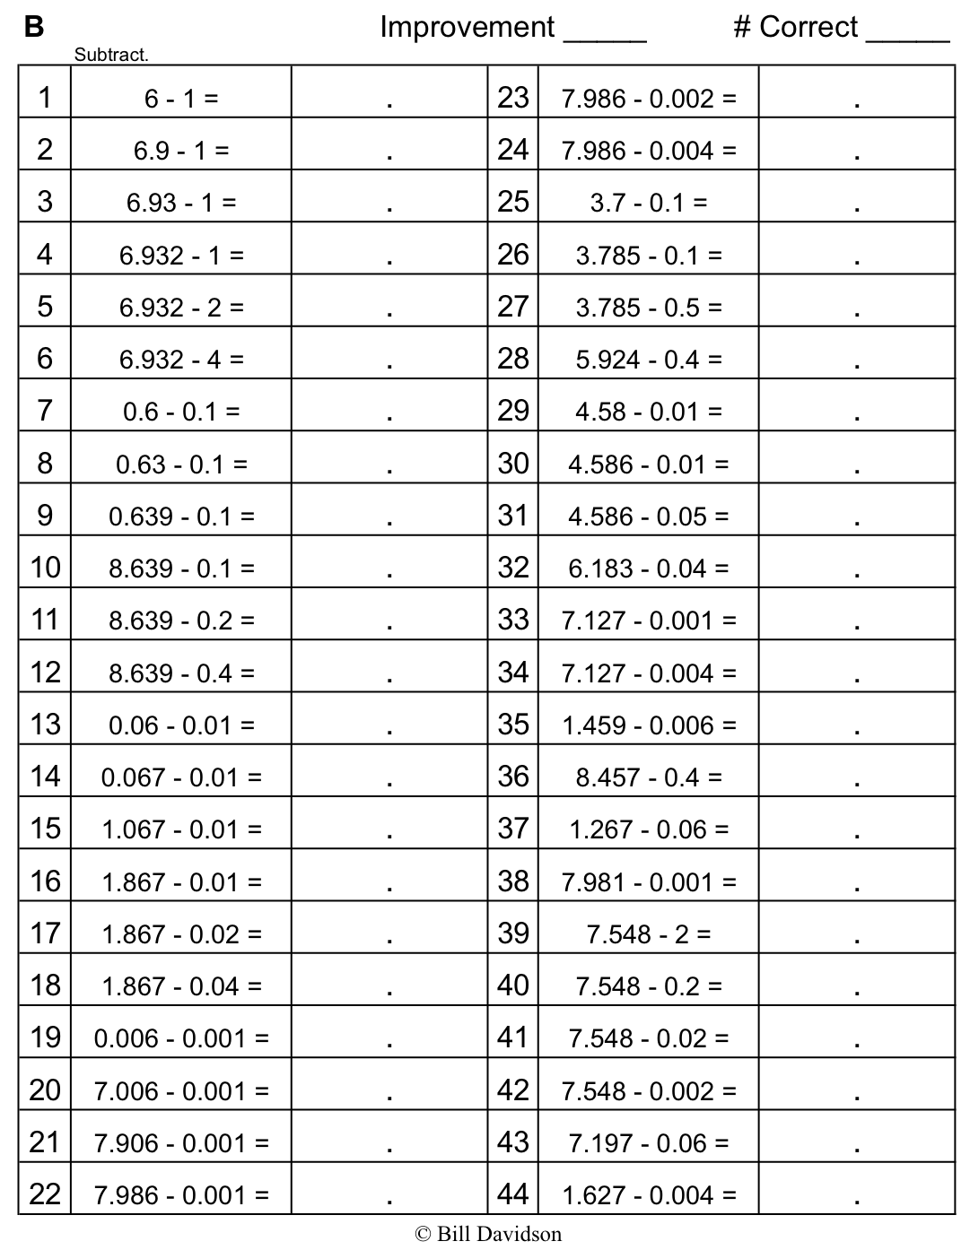
Name Date
- Write a rule for the line that contains the points (0, $\frac{3}{4}$) and ($2\frac{1}{2}$, $2\frac{1}{4}$).

  - Identify 2 more points on this line, then draw it on the grid below.
0 1 2 3 4 5

1
2
3
4
5
Point | $$x$$ | $$y$$ | ($x$, $y$)
$$B$$
$$C$$

Write a rule for a line that is parallel to $\overset{⃡}{BC}$ and goes through point (1, $\frac{1}{4}$).

- Create a rule for the line that contains the points (1, $\frac{1}{4}$) and (3, $\frac{3}{4}$).

- Identify 2 more points on this line, then draw it on the grid at right.
Point | $$x$$ | $$y$$ | ($x$, $y$)
$$G$$
$$H$$

- Write a rule for a line that passes through the origin and lies between $\overset{⃡}{BC}$and $\overset{⃡}{GH}$.

- Create a rule for a line that contains the point ($\frac{1}{4}$, $1\frac{1}{4}$), using the operation or description below. Then, name 2 other points that would fall on each line.

  - Addition: _______________ b. A line parallel to the $x$-axis: _______________
Point | $$x$$ | $$y$$ | ($x$, $y$)
$$T$$
$$U$$

Point | $$x$$ | $$y$$ | ($x$, $y$)
$$G$$
$$H$$

Multiplication: _______________ d. A line parallel to the $y$-axis: _______________
Point | $$x$$ | $$y$$ | ($x$, $y$)
$$V$$
$$W$$

Point | $$x$$ | $$y$$ | ($x$, $y$)
$$A$$
$$B$$

Multiplication with addition: __________________
Point | $$x$$ | $$y$$ | ($x$, $y$)
$$R$$
$$S$$

0 1 2
1
2

- Mrs. Boyd asked her students to give a rule that could describe a line that contains the point (0.6, 1.8). Avi said the rule could be multiply $x$ by 3. Ezra claims this could be a vertical line, and the rule could be $x$ is always 0.6. Erik thinks the rule could be add 1.2 to $x.$ Mrs. Boyd says that all the lines they are describing could describe a line that contains the point she gave. Explain how that is possible, and draw the lines on the coordinate plane to support your response.
Challenge:
- Create a mixed operation rule for the line that contains the points (0, 1) and (1, 3).
Point | $$x$$ | $$y$$ | ($x$, $y$)
$$O$$
$$P$$

  - Identify 2 more points, $O$ and $P$, on this line, and draw it on the grid.
0 1 2 3 4 5

1
2
3
4
5

  - Write a rule for a line that is parallel to $\overset{⃡}{OP}$ and goes through point (1, $2\frac{1}{2}$).

Name Date
- Write the rule for the line that contains the points (0, $1\frac{1}{2}$) and ($1\frac{1}{2}$, 3).
0 1 2 3 4 5

1
2
3
4
5
  - Identify 2 more points on this line, then draw it on the grid below.
Point | $$x$$ | $$y$$ | ($x$, $y$)
$$B$$
$$C$$

Write a rule for a line that is parallel to $\overset{⃡}{BC}$ and goes through point (1, $\frac{1}{2}$).

Name Date
      - Write a rule for the line that contains the points (0, $\frac{1}{4}$) and ($2\frac{1}{2}$, $2\frac{3}{4}$).

        - Identify 2 more points on this line, then draw it on the grid below.
0 1 2 3 4 5

1
2
3
4
5
Point | $$x$$ | $$y$$ | ($x$, $y$)
$$B$$
$$C$$

Write a rule for a line that is parallel to $\overset{⃡}{BC}$ and goes through point (1, 2$\frac{1}{4}$).

- Give the rule for the line that contains the points (1, $2\frac{1}{2}$) and ($2\frac{1}{2}$, $2\frac{1}{2}$).

        - Identify 2 more points on this line, then draw it on the grid above.
Point | $$x$$ | $$y$$ | ($x$ , $y$)
$$G$$
$$H$$

  - Write a rule for a line that is parallel to $\overset{⃡}{GH}.$

- Give the rule for a line that contains the point ($\frac{3}{4}$, $1\frac{1}{2}$), using the operation or description below. Then, name 2 other points that would fall on each line.

- Addition: _______________ b. A line parallel to the $x$-axis: _______________
Point | $$x$$ | $$y$$ | ($x$, $y$)
$$T$$
$$U$$

Point | $x$ | $$y$$ | ($x$, $y$)
$$G$$
$$H$$

Multiplication: _______________ d. A line parallel to the $y$-axis: _______________
Point | $$x$$ | $$y$$ | ($x$, $y$)
$$V$$
$$W$$

Point | $$x$$ | $$y$$ | ($x$, $y$)
$$A$$
$$B$$

0 1 2
1
2
Multiplication with addition: __________________
Point | $x$ | $$y$$ | ($x$, $y$)
$$R$$
$$S$$

- On the grid, two lines intersect at (1.2, 1.2). If line $a$
passes through the origin, and line $b$contains the point at (1.2,0), write a rule for line $a$ and line $b.$

