Lesson 11
Objective: Analyze number patterns created from mixed operations.

Suggested Lesson Structure
 Fluency Practice (12 minutes)
 Application Problem (7 minutes)
 Concept Development (31 minutes)
 Student Debrief (10 minutes)
Total Time (60 minutes)
Fluency Practice (12 minutes)
- Sprint: Round to the Nearest One 5.NBT.4 (9 minutes)
- Add and Subtract Decimals 5.NBT.7 (3 minutes)
Sprint: Round to the Nearest One (9 minutes)
Materials: (S) Round to the Nearest One Sprint
Note: This Sprint reviews G5–Module 1 concepts.
Add and Subtract Decimals (3 minutes)
Materials: (S) Personal white boards
Note: This fluency activity reviews G5─Module 1 concepts.
T: (Write 5.634 + 1.) Write the number sentence.
S: (Write 5.634 + 1 = 6.634.)
T: (Write 5.634 – 1.) Write the number sentence.
S: (Write 5.634 – 1 = 4.634.)
Continue the process with 5.634 – 0.1, 5.634 + 0.1, 5.937 + 0.02, 5.937 – 0.02, 7.056 – 0.003, 7.056 + 0.003, and 4.304 – 0.004.
Application Problem (7 minutes)
Michelle has 3 kg of strawberries that she divided equally into small bags with $\frac{1}{5}$ kg in each bag.
- How many bags of strawberries did she make?
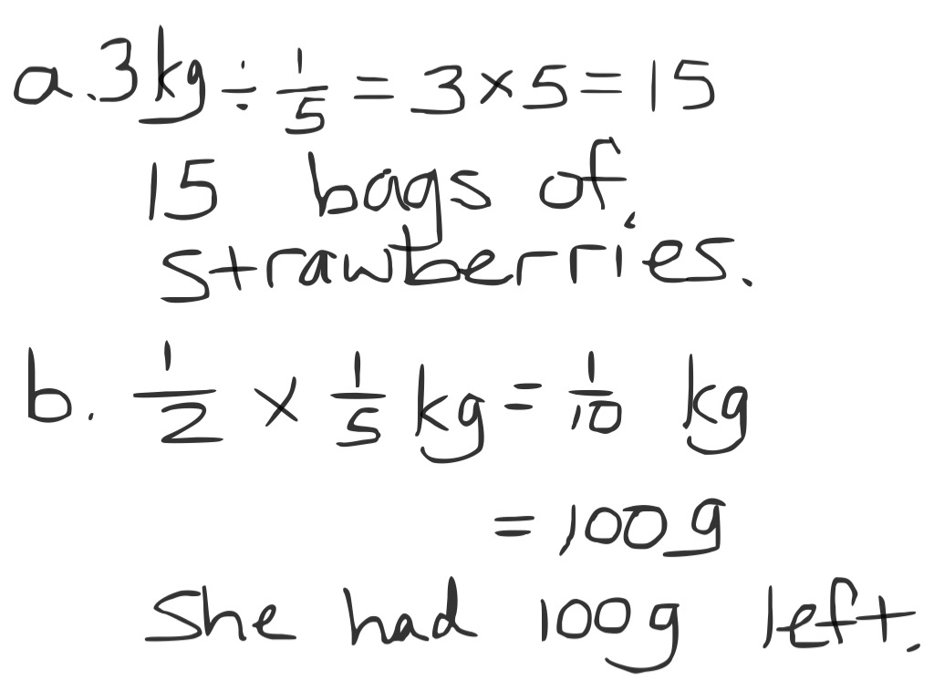
- She gave a bag to her friend, Sarah. Sarah ate half of her strawberries. How many grams of strawberries does Sarah have left?
Note: The Application Problem requires that students convert kilograms to grams and use fraction division and multiplication to answer this multi-step problem. Students may use decimals to solve.
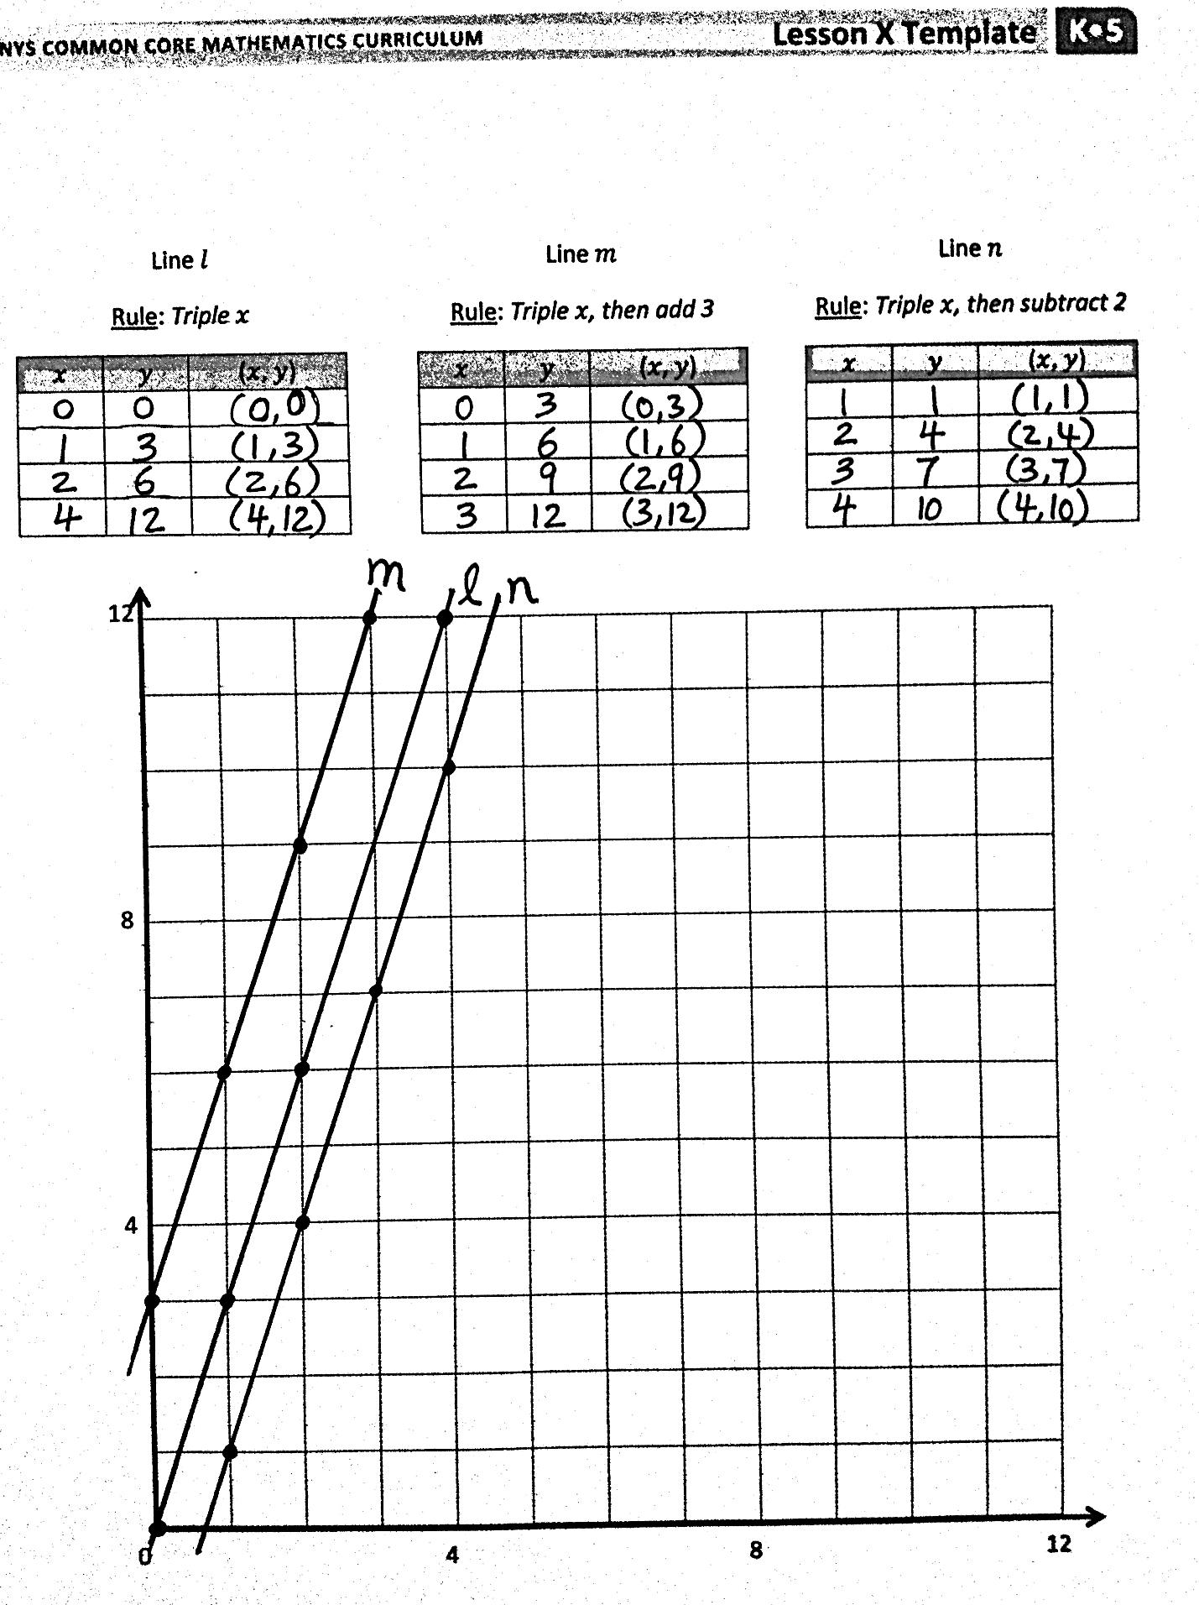
Concept Development (31 minutes)
Materials: (S) Personal white board, straightedge, coordinate plane template
Problem 1: Compare the lines and patterns generated by mixed operations rules.
T: (Distribute coordinate plane template to students. Display coordinate plane on board.) Say the rule for line $l.$
S: Multiply $x$ by 3.
T: What is the $y$-coordinate of the point whose $x$ is 2?
S: 6.
T: Before you complete the chart, plot the points and draw line $l;$ tell your neighbor what you predict it will look like.
S: It’s a multiplication rule, so it will pass through the origin. The $y$-coordinates are 3 times the $x$-coordinates, so it will be pretty steep. (Draw line.)

NOTES ON
MULTIPLE MEANS OF REPRESENTATION:
Students who are not yet finding the value of $y$ mentally may benefit from writing equations. You may guide students working below grade level with the following frames:
For triple $x$,
___ $\text{×}$3.
For triple $x$then add 3,
(___ $×$3) + 3.
For triple $x$then subtract 2,
(___ $×$3) – 2.

S: (Draw line .)
T: Say the rule for line $m$.
S: Multiply $x$ by 3; then, add 3.
T: How is the rule for line $m$ different from the other rules we’ve used to describe lines? Turn and talk.
S: We’ve only had rules that showed lines for adding something to $x$ or multiplying $x$by a number. This rule has two operations.
T: Show me the coordinate pair for the point whose $x$-coordinate is 2.
S: (Show (2, 9).)
T: Fill in the rest of the missing $y$-coordinates in the chart for line $m$.
S: (Fill in coordinates.)
T: Plot each point from the chart; then, use your straightedge to draw line $m$.
S: (Draw line.)
T: What do you notice about these lines? Turn and talk.
S: They are parallel lines. Line $m$ doesn’t go through the origin. It’s a multiplication rule that doesn’t go through the origin. The lines are equally steep, but line $m$ is just farther from the $x$-axis. The lines are identical, except line $m$ doesn’t pass through the origin. It passes through the $y$-axis at (0, 3).
T: Do lines $l$and $m$ intersect?
S: No, they’re parallel.
T: Which line is steeper?
S: They’re equally steep.
T: What is different about the lines?
S: The points on line $m$ are farther from the $x$-axis than the point on line $l$. Line $m$ does not pass through the origin.

T: Let’s look at another mixed operation rule. Say the rule for line $n$.
S: Triple $x$, then subtract 2.
T: Show me the coordinate pair for this rule when $x$ is 1.

NOTES ON
MULTIPLE MEANS OF REPRESENTATION:
Depending on the level of English proficiency of English language learners, consider rephrasing questions for discussion or making them available in the students’ first language, if possible.
S: (Show (1, 1).)
T: Fill in the rest of the missing $y$-coordinates for line $n$.
S: (Fill in missing coordinates.)
MP.7
T: Based on the patterns we’ve seen, predict what line $n$ will look like.
S: It won’t go through the origin, because when $x$is 0, we get $0-\text{2}$, but I don’t know what to do with that. It’s going to be parallel again, but this time it will fall below line $l$ because we’re subtracting this time.
T: Plot each point and draw line $n$.
S: (Draw line $n$.)
T: What have lines $l, m,$and $n$ taught you about lines generated from mixed operations? Turn and talk.
S: You can generate parallel lines involving multiplication, but you have to add or subtract after multiplying. Not every rule with multiplication will produce a line that passes through the origin. If the multiplication part of the rule is the same for both lines, adding after multiplying makes the points on the line shift up by whatever you are adding. Subtracting after multiplying makes the points on the line shift down if the multiplication part of the rule is the same.
Problem 2: Identify coordinate pairs to satisfy mixed operation rules.
T: (Post rule, multiply $x$ by $\frac{1}{2}$, then add $\frac{3}{4}$ on the board.) Tell a neighbor what the line described by this rule would look like.
S: We’d have to add $\frac{3}{4}$ after multiplying by $\frac{1}{2};$ so, that means the points on this line would shift up $\frac{3}{4}$ more than the points on the line that you see when just multiplying by $\frac{1}{2}$. The rule has you multiply by one-half first. Multiplying by a half will be a line that is less steep than multiplying by a whole number. It’s a mixed operation, so it won’t go through the origin.
T: Tell your neighbor how you’ll find the $y$-coordinate for this point if $x$ is 1.
S: You have to multiply by $\frac{1}{2}$ first. So, 1 times $\frac{1}{2}$ is $\frac{1}{2}$. Then, you have to add $\frac{3}{4}$ to $\frac{1}{2}$. I’ll multiply first, and that’s easy since any number times 1 is just that number. So, I’ll end up adding $\frac{3}{4}$ to $\frac{1}{2}$, or $\frac{2}{4}$, which will be $\frac{5}{4}$. The $y$-coordinate is $\frac{5}{4}$.
T: Show me the coordinate pair for this rule when $x$ is 1.
S: (Show (1, $\frac{5}{4}$) or (1, $\text{1}\frac{1}{4}$).)
T: What is the first step in finding the $y$-coordinate when $x$ is $\text{1}\frac{1}{2}$ ?
S: Multiply by $\frac{1}{2}$.
T: Show me the multiplication sentence.
S: (Show $1\frac{1}{2}$ $\text{×}$ $\frac{1}{2}\text{=}\frac{3}{4}$ or $\frac{3}{2} \text{×} \frac{1}{2}\text{=}\frac{3}{4}.$)
T: What is the next step in finding the $y$-coordinate?
S: Add 3 fourths.
T: Show me the addition sentence.
S: (Show $\frac{3}{4}$ + $\frac{3}{4}\text{=}\text{1}\frac{1}{2 }$ or $\frac{3}{4}$ + $\frac{3}{4}\text{=}\frac{6}{4}\text{=}\frac{3}{2}.$)
T: Show me the coordinate pair for this rule when $x$ is $\text{1}\frac{1}{2}$.
S: (Show ($\text{1}\frac{1}{2}$, $\text{1}\frac{1}{2}$).)
T: Work independently, and show me the coordinate pair for this rule when $x$ is $\frac{3}{4}$.
S: (Work and show ($\frac{3}{4}$, $\text{1}\frac{1}{8}$).)
T: Would the line for this rule contain the point (3, $\text{2}\frac{1}{4}$)? Turn and talk.
S: It would. 3 times $\frac{1}{2}$ is 3 halves. And, 3 halves plus 3 fourths is equal to 9 fourths. 9 fourths is the same as $\text{2}\frac{1}{4}$. Yes. If I take the $x$-coordinate and multiply it by one-half, then add 3 fourths to the product, I get 2 and one-fourth.
T: What about coordinate pair ($\text{3}\frac{1}{2}$, $\text{2}\frac{1}{4}$)?
S: (Work.) No.
T: Tell a neighbor how you know.
S: I tried it, and when I multiplied and then added, I found that when $x$ is $\text{3}\frac{1}{2}$, the $y$-coordinate is $\text{2}\frac{1}{2}$. I actually worked backwards. I subtracted $\frac{3}{4}$ from $\text{2}\frac{1}{4}$ and got $\text{1}\frac{1}{2}$. Then, I doubled $\text{1}\frac{1}{2}$ and got 3, but the coordinate pair we were given had an $x$-coordinate of $\text{3}\frac{1}{2}$, so I knew that this pair wouldn’t be on the line.
T: Generate another coordinate pair that the line for rule multiply $x$ by $\frac{1}{2}$, then add $\frac{3}{4}$ would contain. Have a neighbor check your work when you’re finished.
S: (Work, share, and check.)
Problem Set (10 minutes)
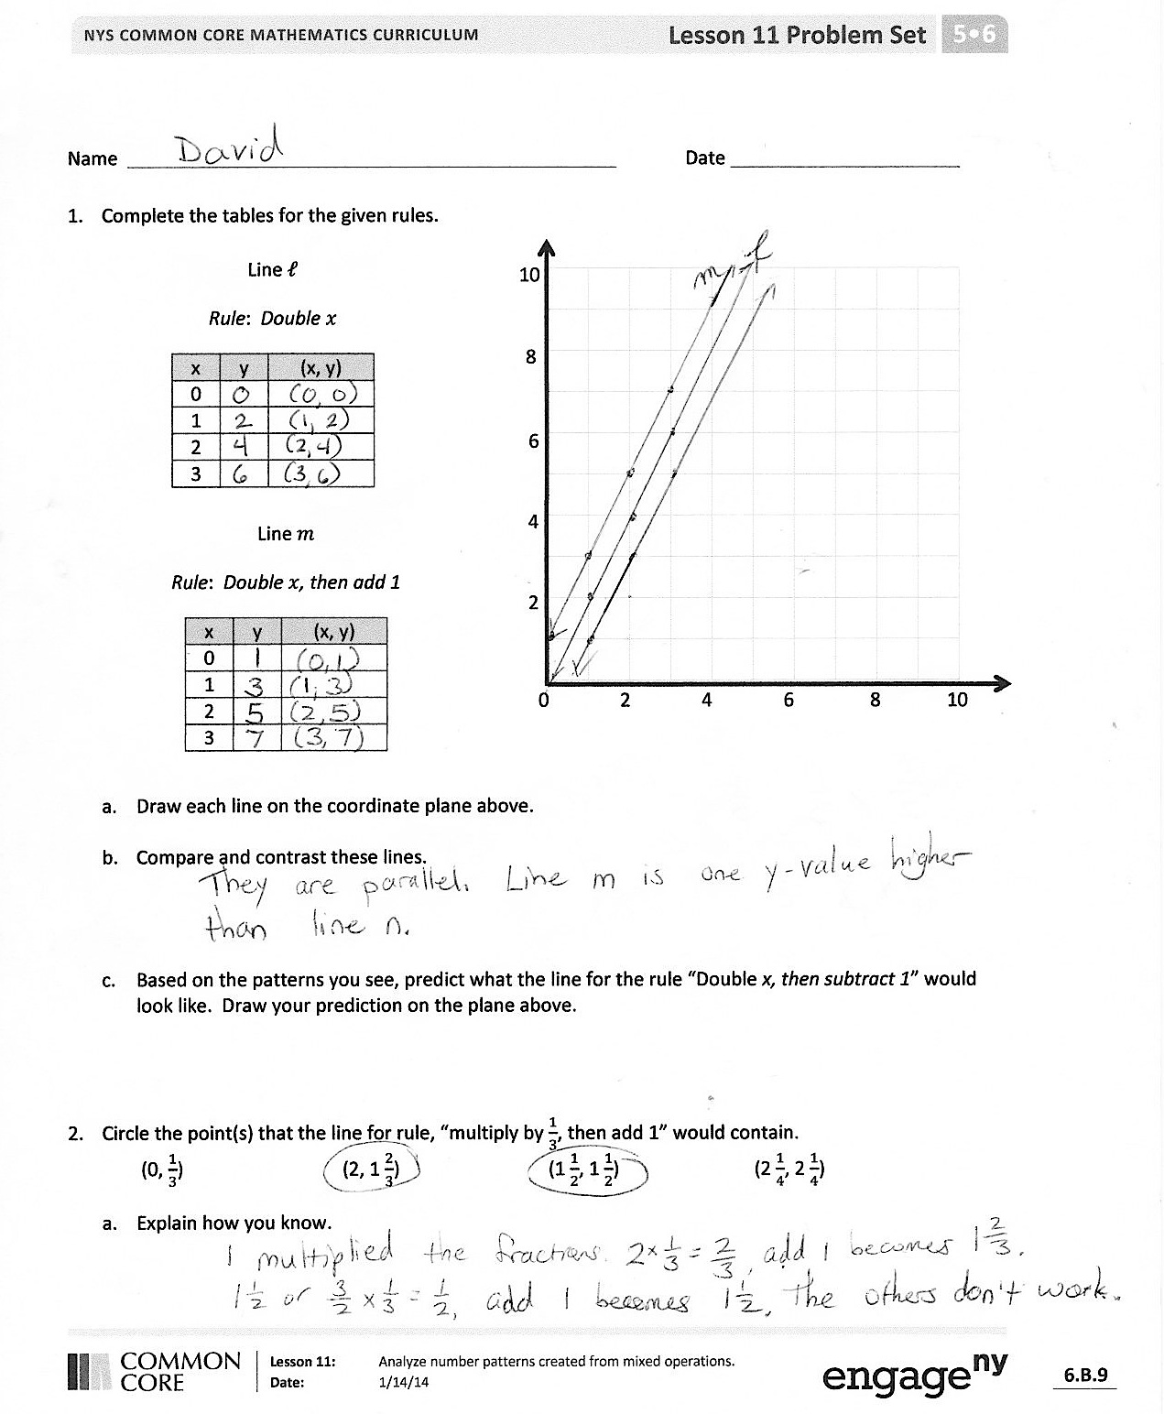
Students should do their personal best to complete the Problem Set within the allotted 10 minutes. For some classes, it may be appropriate to modify the assignment by specifying which problems they work on first. Some problems do not specify a method for solving. Students solve these problems using the RDW approach used for Application Problems.
Student Debrief (10 minutes)
Lesson Objective: Analyze number patterns created from mixed operations.
The Student Debrief is intended to invite reflection and active processing of the total lesson experience.
Invite students to review their solutions for the Problem Set. They should check work by comparing answers with a partner before going over answers as a class. Look for misconceptions or misunderstandings that can be addressed in the Debrief. Guide students in a conversation to debrief the Problem Set and process the lesson.
You may choose to use any combination of the questions below to lead the discussion.
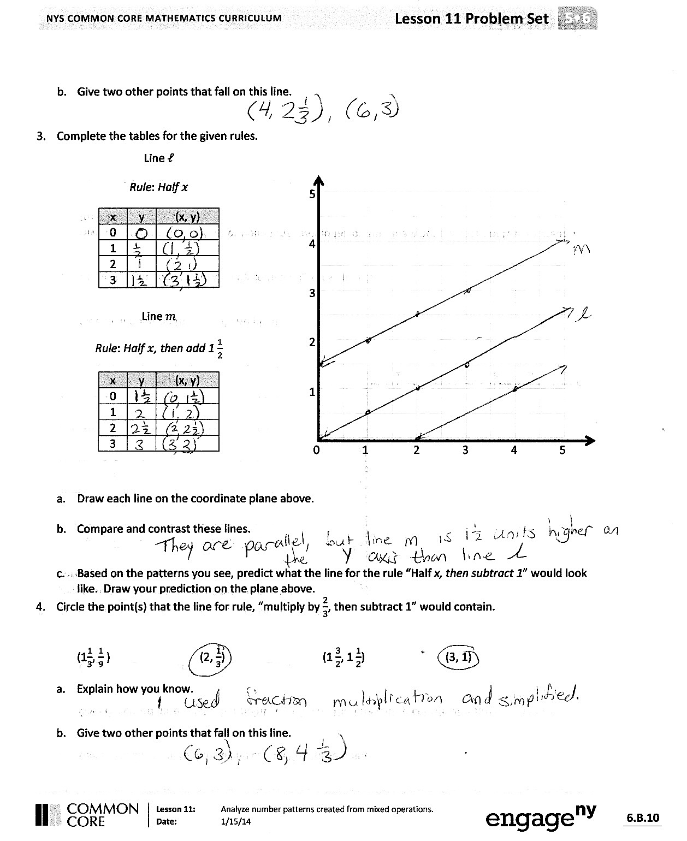
- Make a statement that describes how the lines generated from mixed operations behave. How are they similar and different from multiplication only or addition or subtraction only rules?
- Share your answers to Problems 2(b) and 4(b) with a neighbor. Explain your thought process as you generated the coordinate pairs.
- Predict what line $m$ would look like if you added first and then multiplied.
Exit Ticket (3 minutes)
After the Student Debrief, instruct students to complete the Exit Ticket. A review of their work will help you assess the students’ understanding of the concepts that were presented in the lesson today and plan more effectively for future lessons. You may read the questions aloud to the students.

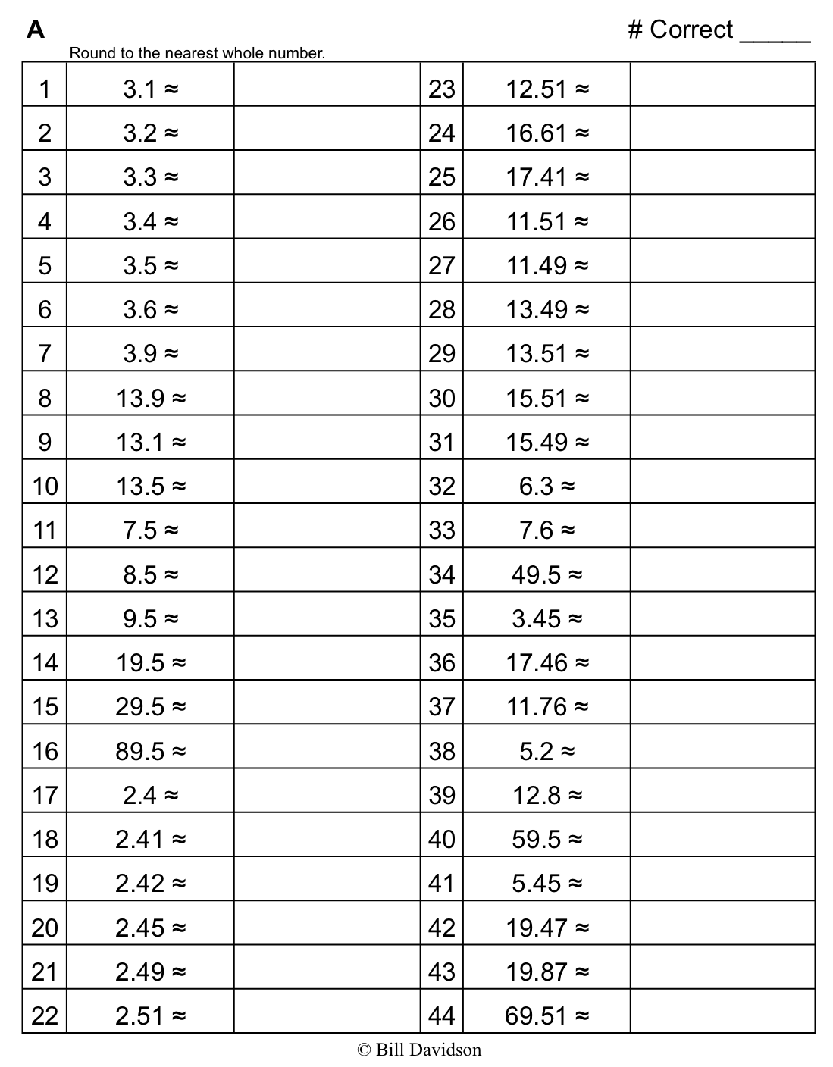
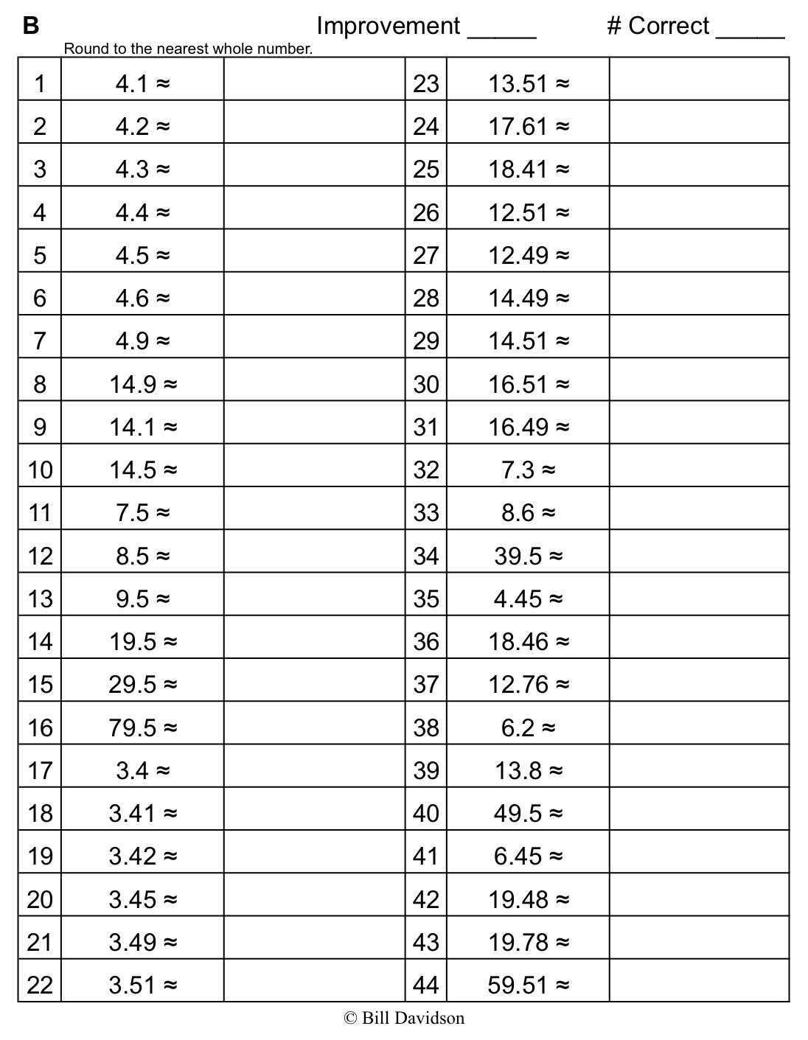

Name Date
- Complete the tables for the given rules.
Line $l$
Rule: Double $x$
$$x$$ | $$y$$ | ($x$, $y$)
0
1
2
3

0 2 4 6 8 10
2
4
6
8
10

Line $m$
Rule: Double $x$, then add 1
$$x$$ | $$y$$ | ($x$, $y$)
0
1
2
3

- Draw each line on the coordinate plane above.

- Compare and contrast these lines.

- Based on the patterns you see, predict what the line for the rule double $x$, then subtract 1 would look like. Draw the line on the plane above.

- Circle the point(s) that the line for rule multiply by $\frac{1}{3}$, then add 1 would contain.
(0, $\frac{1}{3}$) (2, $1\frac{2}{3}$) ( $1\frac{1}{2}$, $1\frac{1}{2}$) ($2\frac{1}{4}$, $2\frac{1}{4}$)
- Explain how you know.

- Give two other points that fall on this line.

- Complete the tables for the given rules.
Line $l$
Rule: Half $x$
$$x$$ | $$y$$ | ($x$, $y$)
0
1
2
3

0 1 2 3 4 5
1
2
3
4
5

Line $m$
Rule: Half $x$, then add 1 $\frac{1}{2}$
$$x$$ | $$y$$ | ($x$, $y$)
0
1
2
3

- Draw each line on the coordinate plane above.

- Compare and contrast these lines.

- Based on the patterns you see, predict what the line for the rule half $x$, then subtract 1 would look like. Draw the line on the plane above.

- Circle the point(s) that the line for rule multiply by $\frac{2}{3}$, then subtract 1 would contain.
($1\frac{1}{3}$,$\frac{1}{9}$ ) (2, $\frac{1}{3}$) ( $1\frac{3}{2}$, $1\frac{1}{2}$) (3, 1)
- Explain how you know.

- Give two other points that fall on this line.

Name Date
- Complete the tables for the given rules.
Line $l$
Rule: Double $x$
$$x$$ | $$y$$ | ($x$, $y$)
0
1
2
3

0 2 4 6 8 10
2
4
6
8
10

Line $m$
Rule: Double $x$, then add 1
$$x$$ | $$y$$ | ($x$, $y$)
0
1
2
3

- Draw each line on the coordinate plane above.

- Compare and contrast these lines.

- Circle the point(s) that the line for rule multiply by $\frac{1}{3}$ then add 1 would contain.

(0, $\frac{1}{2}$) (1, $1\frac{1}{3}$) (2,$1\frac{2}{3}$) (3, $2\frac{1}{2}$)

Name Date
- Complete the tables for the given rules.

0 2 4 6 8 10
2
4
6
8
10
Line $l$
Rule: Double $x$
$$x$$ | $$y$$ | ($x$, $y$)
1
2
3

Line $m$
Rule: Double $x$, then subtract 1
$$x$$ | $$y$$ | ($x$, $y$)
1
2
3

- Draw each line on the coordinate plane above.
- Compare and contrast these lines.

- Based on the patterns you see, predict what the line for the rule double $x$, then add 1 would look like. Draw your prediction on the plane above.

- Circle the point(s) that the line for the rule multiply by $\frac{1}{2}$ then add 1 would contain.
(0, $\frac{1}{2}$) (2, $1\frac{1}{4}$) (2, 2) (3, $\frac{1}{2}$)
- Explain how you know.

- Give two other points that fall on this line.

- Complete the tables for the given rules.
1
2
3
4
5

0 1 2 3 4 5
Line $l$
Rule: Halve $x$, then add 1
$$x$$ | $$y$$ | ($x$, $y$)
0
1
2
3

Line $m$
Rule: Halve $x$, then add 1 $\frac{1}{4}$
$$x$$ | $$y$$ | ($x$, $y$)
0
1
2
3

- Draw each line on the coordinate plane above.
- Compare and contrast these lines.

- Based on the patterns you see, predict what the line for the rule halve $x$, then subtract 1 would look like. Draw your prediction on the plane above.

- Circle the point(s) that the line for rule multiply by $\frac{3}{4}$, then subtract $\frac{1}{2}$ would contain.
(1,$\frac{1}{4}$ ) (2, $\frac{1}{4}$) (3, $1\frac{3}{4}$) (3, 1)
- Explain how you know.

- Give two other points that fall on this line.

Line $l$
Rule: Triple $x$
$$x$$ | $$y$$ | ($x$, $y$)
0
1
2
4

Line $m$
Rule: Triple $x$, then add 3
$$x$$ | $$y$$ | ($x$, $y$)
0
1
2
3

Line $n$
Rule: Triple $x$, then subtract 2
$$x$$ | $$y$$ | ($x$, $y$)
1
2
3
4

4
8
12
0 4 8 12

