Lesson 10
Objective: Compare the lines and patterns generated by addition rules and multiplication rules.

Suggested Lesson Structure
 Fluency Practice (12 minutes)
 Application Problem (6 minutes)
 Concept Development (32 minutes)
 Student Debrief (10 minutes)
Total Time (60 minutes)
Fluency Practice (12 minutes)
- Count by Equivalent Fractions 4.NF.1 (4 minutes)
- Round to the Nearest One 5.NBT.4 (4 minutes)
- Add and Subtract Decimals 5.NBT.7 (4 minutes)
Count by Equivalent Fractions (4 minutes)
Note: This fluency activity prepares students for G5–M6–Lesson 11.
T: Count by ones to 9, starting at 0.
S: 0, 1, 2, 3, 4, 5, 6, 7, 8, 9.
$\frac{0}{3}$ $\frac{1}{3}$ $\frac{2}{3}$ $\frac{3}{3}$ $\frac{4}{3}$ $\frac{5}{3}$ $\frac{6}{3}$ $\frac{7}{3}$ $\frac{8}{3}$ $\frac{9}{3}$
$\frac{0}{3}$ $\frac{1}{3}$ $\frac{2}{3}$ 1 $\frac{4}{3}$ $\frac{5}{3}$ 2 $\frac{7}{3}$ $\frac{8}{3}$ 3
$\frac{0}{3}$ $\frac{1}{3}$ $\frac{2}{3}$ 1 1$\frac{1}{3}$ 1 $\frac{2}{3}$ 2 $\text{2}\frac{1}{3}$ $\text{2}\frac{2}{3}$ 3

T: Count by thirds from 0 thirds to 9 thirds. (Write as students count.)
S: $\frac{0}{3}$, $\frac{1}{3}$, $\frac{2}{3}$, $\frac{3}{3}$, $\frac{4}{3}$, $\frac{5}{3}$, $\frac{6}{3}$, $\frac{7}{3}$, $\frac{8}{3}$, $\frac{9}{3}$.
T: 1 is the same as how many thirds?
S: 3 thirds.
T: (Beneath $\frac{3}{3}$, write 1.) 2 is the same as how many thirds?
S: 6 thirds.
T: (Beneath $\frac{6}{3}$, write 2.)
Continue the process for 3.
T: Count by thirds again. This time, when you come to the whole number, say it. (Write as students count.)
S: $0$, $\frac{1}{3}$, $\frac{2}{3}$, 1, $\frac{4}{3}$, $\frac{5}{3}$, 2, $\frac{7}{3}$, $\frac{8}{3}$, 3.

NOTES ON
MULTIPLE MEANS OF REPRESENTATION:
The Count by Equivalent Fractions fluency activity supports language acquisition for English language learners, as it offers valuable practice speaking fraction names, such as thirds. Couple the counting with prepared visuals to increase comprehension. Some learners may benefit from counting again and again until they gain fluency.

T: (Point to $\frac{4}{3}$.) Say 4 thirds as a mixed number.
S: $1\frac{1}{3}.$
Continue the process for $\frac{5}{3}$, $\frac{7}{3}$, and $\frac{8}{3}$.
T: Count by thirds again. This time, convert to ones and mixed numbers. (Write as students count.)
S: $0$, $\frac{1}{3}$, $\frac{2}{3}$, 1, $\text{1}\frac{1}{3}$, $\text{1}\frac{2}{3}$, 2, $\text{2}\frac{1}{3}$, $\text{2}\frac{2}{3}$, 3.
T: Let’s count by thirds again. This time, after saying 1, alternate between mixed numbers and improper fractions.
S: $\frac{0}{3}$, $\frac{1}{3}$, $\frac{2}{3}$, 1, $\text{1}\frac{1}{3}$, $\frac{5}{3}$, 2, $\text{2}\frac{1}{3}$, $\frac{8}{3}$, 3.
T: 3 is the same as how many thirds?
S: 9 thirds.
T: Let’s count backwards alternating between fractions and mixed numbers. Start at $\frac{9}{3}$.
S: $\frac{9}{3}$, $\text{2}\frac{2}{3}$, $\frac{7}{3}$, 2, $1\frac{2}{3}$, $\frac{4}{3}$, 1, $\frac{2}{3}$, $\frac{1}{3}$, $\frac{0}{3}$.
Round to the Nearest One (4 minutes)
Materials: (S) Personal white boards
Note: This fluency activity reviews G5–Module 1 concepts.
T: (Write 3 ones 2 tenths.) Write 3 ones and 2 tenths as a decimal.
S: (Write 3.2.)
T: (Write 3.2 ≈ __.) Round 3 and 2 tenths to the nearest whole number.
S: (Write 3.2 ≈ 3.)
Continue the process for 3.7, 13.7, 5.4, 25.4, 1.5, 21.5, 6.48, 3.62, and 36.52.
Add and Subtract Decimals (4 minutes)
Materials: (S) Personal white boards
Note: This fluency activity reviews G5–Module 1 concepts.
T: (Write 3.812 + 1.) Complete the number sentence.
S: (Write 3.812 + 1 = 4.812.)
T: (Write 3.812 – 1.) Complete the number sentence.
S: (Write 3.812 – 1 = 2.812.)
Continue the process with 3.812 – 0.1, 3.812 + 0.1, 2.764 + 0.02, 2.764 – 0.02, 5.015 – 0.003, 5.015 + 0.003, and 8.426 – 0.006.
Application Problem (6 minutes)
A 12-man relay team runs a 45 km race. Each member of the team runs an equal distance. How many kilometers does each team member run? One lap around the track is 0.75 km. How many laps does each team member run during the race?
Note: This Application Problem reviews several concepts explored earlier in the year, including division and measurement.
Concept Development (32 minutes)
Materials: (S) Personal white board, coordinate plane template, straightedge, set square or right angle template
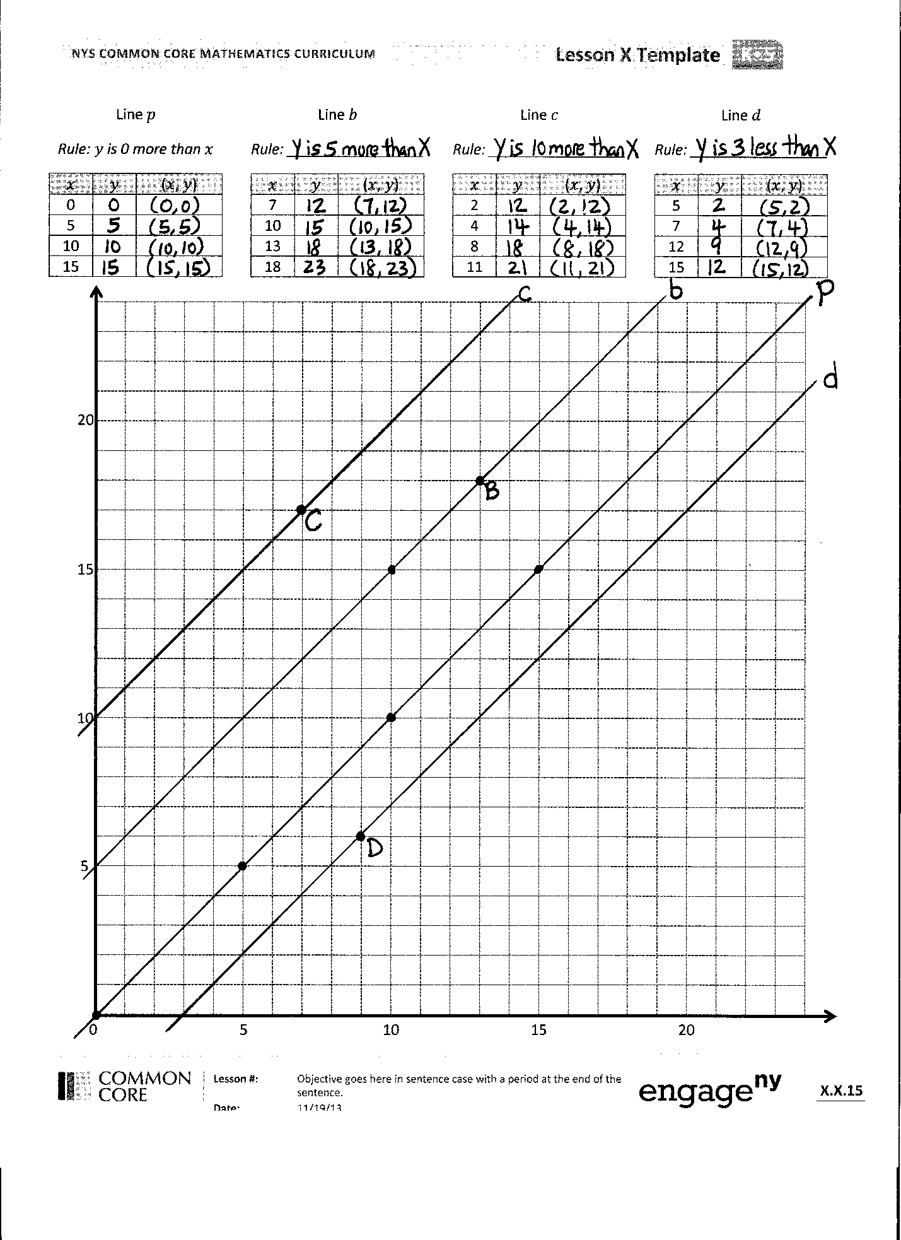
Problem 1: Compare the lines and patterns generated by addition and subtraction rules.
T: (Distribute 1 coordinate plane template to each student. Display coordinate plane on board.) Say the rule for line $p$.
S: $y$is the same as $x$. $x$ is equal to $y$.
T: What point on this line has an$x$- coordinate of 3?
S: (Show (3, 3).)
T: Complete the chart for line $p$.
S: (Complete chart.)
T: Can you find another way to name the rule for line $p$? Turn and talk.
S: We could call it $y$is equal to $x.$ The rule could also be $y$ is $x$ times 1.
T: Plot each coordinate pair on the plane and then use your straight edge to construct line $p$.
S: (As students work, construct line $p$ on board.)
T: What do you notice about line $p$, whose rule is $y$ is equal to $x$? Turn and talk.
S: It cuts the plane into 2 pieces. It passes right through the origin.
`
NOTES ON
MULTIPLE MEANS OF ACTION AND EXPRESSION
One way to help students with visual acuity differences to accurately locate points and give the correct coordinate pair is to provide a transparent, colored, cellophane sheet for aligning with the grid lines on the plane. Students can place the right corner of the sheet with the point. The edges of the sheet will then align with the $x$- and $y$-coordinates on the axes.
T: On your plane, plot $B$ at the following location. (Show $B$ (13, 18) on board and plot B.)
S: (Plot $B$.)
T: On the coordinate plane, use your straight edge and set square to construct line $b$ so that it’s parallel to line $p$ and contains point $B$. Check your work with a neighbor when you’re finished.
S: (Work and check. Construct line $b$ on board.)
T: Look at line $b$. (Point to location (10, 15) on board.) When $x$ is 10, what is the $y$-coordinate?
S: 15.
T: Show the coordinate pair.
S: (Show (10, 15).)
T: Record the missing $y$-coordinates in the chart for line $b$. Share your work with a neighbor when you’re finished.
S: (Record and share.)
T: What pattern do you notice in the coordinate pairs for line $b$? Turn and talk.
S: Every $y$-coordinate is 5 more than the $x$-coordinate. If I add 5 to every $x$- value, I get the $y$-value.
MP.7
T: Work with a neighbor to identify the rule for line $b$. Show me the rule on your personal board.
S: (Show rule $y$is 5 more than $x.$ $x$ plus 5 is $y$.)
T: Since every $y$-coordinate is 5 more than the $x$-coordinate, the rule for line $b$ is, $y$ is 5 more than $x$. Record the rule on your chart.
Repeat the process for lines $c$, and $d$ as possible.
T: Look again at the coordinate plane. Do any of our lines intersect?
S: No.
T: What can you say then about lines $p, c, b,$and $d$?
S: Lines $p, c, b,$ and $d$ are parallel lines.
T: Compare lines $b$and $c$to line $p$. What do you notice? Turn and talk.
S: They’re all parallel. Lines $c$ and $b$both have $y$-coordinates that are greater than the ones for the same $x$-coordinates on line $p$. The $y$’s on$b$ are all 5 more, and the ones on $c$ are all 10 more than the ones on $p$.
T: What do the rules for lines $c$and $b$ have in common?
S: They’re both addition rules. They both require us to add to the $x$-coordinate, but line $c$ is adding more to the $x$-coordinate.
T: What about line $d$? What operation is used in the rule for line $d$?
S: Subtraction.
T: And where does line $d$ lie on the plane, in relation to the other lines? Turn and talk.
S: The points on this line will be closer to the $x$-axis than on the other lines. The line will be drawn below the other lines on the plane.
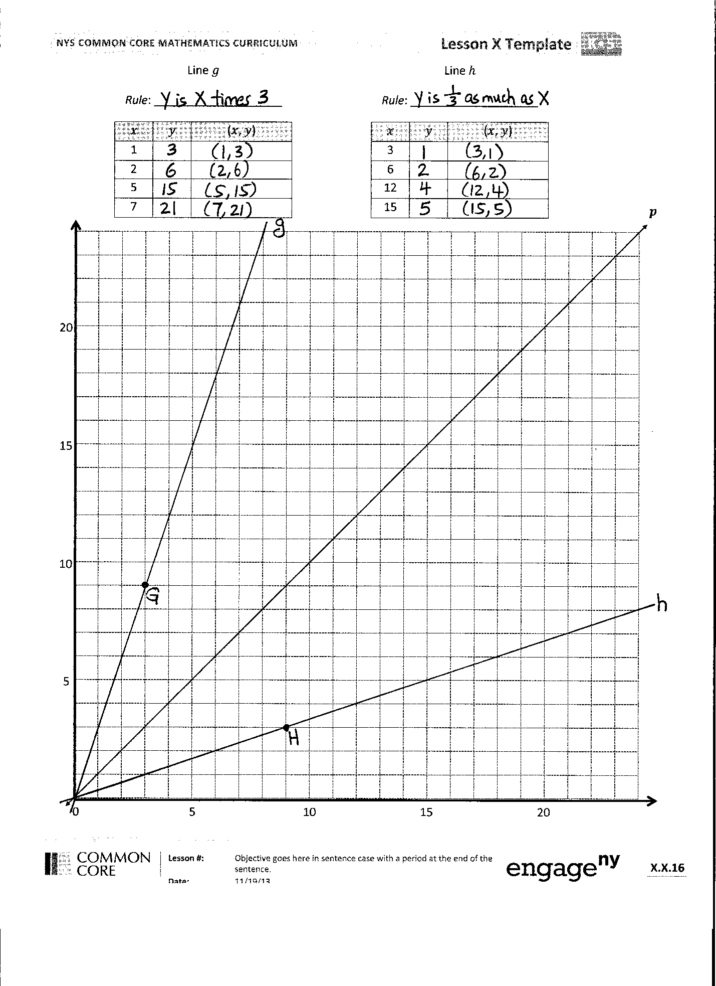
Problem 2: Compare the lines and patterns generated by multiplication rules.
T: (Display a second coordinate plane on board.) What do you notice about line $p$? Turn and talk.
S: It’s the same as line $p$ on the other plane. It’s the line for rule $y$is equal to $x.$
T: This is the same line we drew on the other plane. It represents the rule, $y$ is equal to $x,$ or we can also think of it as $y$is $x$times 1. On your plane, plot point $G$ at the following location. (Show $G$ (3, 9) on board and plot point $G$.)
S: (Plot point $G$.)
T: Use your straight edge to draw line $g$ so that it passes through the origin and contains point $G$. (Model on board.)
S: (Students construct line $g$.)
T: Look at line $g$. What point on the line has an $x$-coordinate of 1?
S: (1,3).
T: Record that in the chart for line $g;$ then, work with a neighbor to fill in the rest of the missing $y$-coordinates.
S: (Record and share.)
T: What pattern do you see in the coordinate pairs for line $g$? Turn and talk.
S: The $y$-coordinate is always more than the $x$-coordinate. If I multiply the $x$-values by 3, I get the $y$-coordinates. I think the rule is multiply $x$ by 3.
T: I hear that you noticed that the $y$-coordinate is always 3 times as much as the $x$-coordinate. Show me the rule for line $g$.
S: $y$ is 3 times as much as $x.$ $y$ is $x$ times 3. Multiply $x$ by 3.
T: Record the rule on the chart for line $g$.
S: (Record.)
T: Compare line $g$to line $p$. Which is steeper? Turn and talk.
S: Line $g$is steeper than line $p$.
T: Are lines $g$ and $p$ parallel?
S: No, they intersect.
T: Where do they intersect?
S: They both pass through the origin.
Repeat the process with line $h$, noticing the division or multiplication by a fraction rule.
T: Compare line $h$to lines $p$ and $g.$Which is the steepest? Turn and talk.
S: Line $h$ goes up more gradually than the others. Line $h$is less steep than the others. Line $g$ is still the steepest, and line $h$ is the least steep.
T: Look back at the rules that describe these lines. Why do you think line $g$is the steepest and line $h$ is less steep than the others? Turn and talk.
S: They’re both described by multiplication rules. However, line $g^{'}s$rule multiplies by a larger number than the rule for line $h$. It reminds me of the scaling work we did. The rule for line $g$ multiplies by a number greater than 1, so the line is really steep; line $h$ multiplies by a number less than 1, so the line goes up more gradually.
T: (On board, display image of line $i$, whose rule is, $y$is $x$times 2.) Line $i$ represents the rule, $y$is $x$ times 2. Why does it make sense that line $i$ would be steeper than line $p,$but not as steep as line $g$? Turn and talk.
S: Multiplying by 2 is more than multiplying by 1 and less than multiplying by 3. It’s almost like measuring angles on a protractor. 60 degrees is in between 45 degrees and 80 degrees, so the line for multiplying by 2 should be in between the lines for multiplying by 1 and 3.
T: Show your neighbor where the line for rule, $y$is $x$ times 4 would be.
S: (Share with a neighbor.)
T: Would the line for rule, $y$ is $x$times $\frac{1}{10}$ be more steep or less steep than line $h$? Turn and talk.
S: It would be less steep because you’re multiplying by a smaller number than $\frac{1}{3}$. Line $h$ would be steeper. The line for multiplying by $\frac{1}{10}$ would go through the origin and point (10, 1), which would be way less steep than line $h$.
T: That’s right! The line for rule, $y$is $x$times $\frac{1}{10}$ would be less steep than line $h.$(Drag your finger along plane showing its approximate location.)
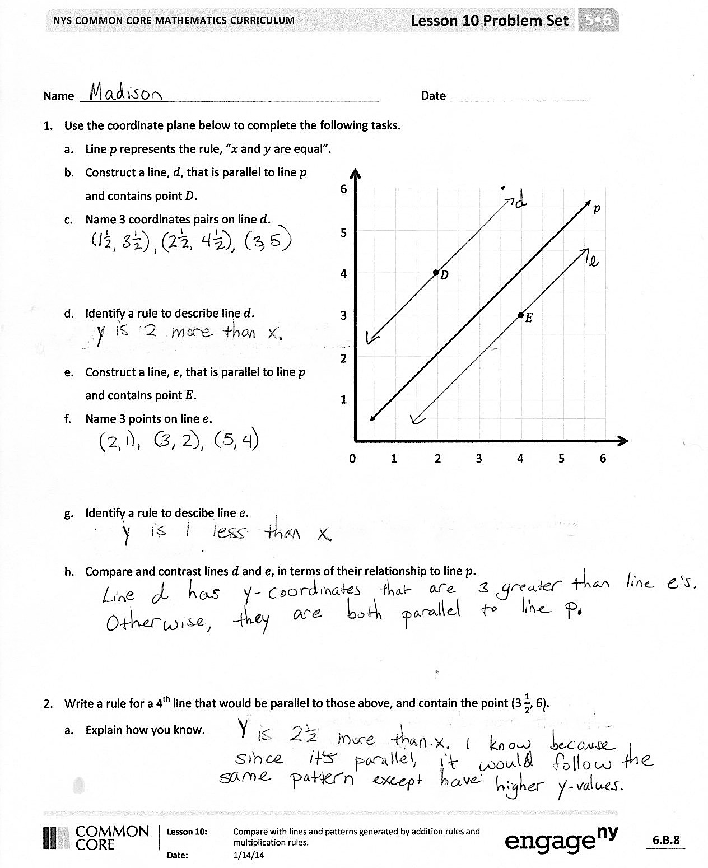
Problem Set (10 minutes)
Students should do their personal best to complete the Problem Set within the allotted 10 minutes. For some classes, it may be appropriate to modify the assignment by specifying which problems they work on first. Some problems do not specify a method for solving. Students solve these problems using the RDW approach used for Application Problems.
Student Debrief (10 minutes)
Lesson Objective: Compare the lines and patterns generated by addition rules and multiplication rules.
The Student Debrief is intended to invite reflection and active processing of the total lesson experience.
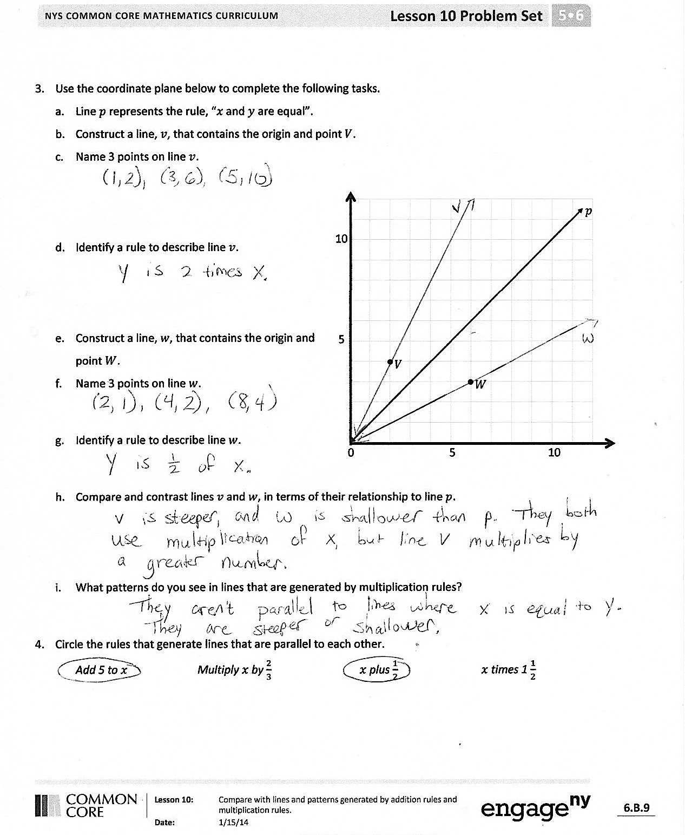
Invite students to review their solutions for the Problem Set. They should check work by comparing answers with a partner before going over answers as a class. Look for misconceptions or misunderstandings that can be addressed in the Debrief. Guide students in a conversation to debrief the Problem Set and process the lesson.
You may choose to use any combination of the questions below to lead the discussion.
- In Problem 1, explain how you could create a rule that describes a line that is parallel to line $d$ and whose points are even further from the $x$-axis.
- In Problem 2, explain how you could create a rule that describes a line that is less steep than line $w$.
- What point lies on any line that can be described by a multiplication rule?
- Explain to your partner how lines generated by addition and subtraction rules are different from those generated by multiplication rules.
Exit Ticket (3 minutes)
After the Student Debrief, instruct students to complete the Exit Ticket. A review of their work will help you assess the students’ understanding of the concepts that were presented in the lesson today and plan more effectively for future lessons. You may read the questions aloud to the students.
Name Date
- Use the coordinate plane below to complete the following tasks.
  - Line $p$ represents the rule, $x$and $y$ are equal.
  - Construct a line, $d$, that is parallel to line $p$ and contains point $D$.

$$p$$
0 1 2 3 4 5 6
1
2
3
4
5
6
•$D$
•$E$
  - Name 3 coordinates pairs on line $d$.

  - Identify a rule to describe line $d$.

  - Construct a line, $e$, that is parallel to line $p$ and contains point $E$.
  - Name 3 points on line $e$.

  - Identify a rule to describe line $e$.

  - Compare and contrast lines $d$ and $e$ in terms of their relationship to line $p$.

- Write a rule for a fourth line that would be parallel to those above and would contain the point ($\text{3}\frac{1}{2}$, 6).
  - Explain how you know.

- Use the coordinate plane below to complete the following tasks.
  - Line $p$ represents the rule $x$and $y$ are equal.
  - Construct a line, $v$, that contains the origin and point $V$.
  - Name 3 points on line $v$.

•$V$
•$W$
0 5 10
5
10
$$p$$

  - Identify a rule to describe line $v$.

  - Construct a line, $w$, that contains the origin and point $W$.
  - Name 3 points on line $w$.

  - Identify a rule to describe line $w$.

  - Compare and contrast lines $v$ and $w$ in terms of their relationship to line $p$.

  - What patterns do you see in lines that are generated by multiplication rules?

- Circle the rules that generate lines that are parallel to each other.
Add 5 to $x$ Multiply $x$ by $\frac{2}{3}$ $x$ plus $\frac{1}{2}$ $x$ times $1\frac{1}{2}$

Name Date
- Use the coordinate plane below to complete the following tasks.
  - Line $p$ represents the rule $x$and $y$ are equal.
  - Construct a line, $a$, that is parallel to line $p$ and contains point $A$.
  - Name 3 points on line $a$.
•$Α$

$$p$$
0 1 2 3 4 5 6
1
2
3
4
5
6

  - Identify a rule to describe line $a$.

Name Date
- Use the coordinate plane to complete the following tasks.
•$D$
•$E$

$$p$$
0 1 2 3 4 5 6
1
2
3
4
5
6
  - Line $p$ represents the rule $x$and $y$ are equal.
  - Construct a line, $d$, that is parallel to line $p$ and contains point $D$.
  - Name 3 coordinates pairs on line $d$.

  - Identify a rule to describe line $d$.

  - Construct a line, $e$, that is parallel to line $p$ and contains point $E$.
  - Name 3 points on line $e$.

  - Identify a rule to describe line $e$.

  - Compare and contrast lines $d$ and $e$ in terms of their relationship to line $p$.

- Write a rule for a fourth line that would be parallel to those above and that would contain the point
($\text{5}\frac{1}{2}$, 2). Explain how you know.

- Use the coordinate plane below to complete the following tasks.
  - Line $p$ represents the rule $x$and $y$ are equal.
  - Construct a line, $v$, that contains the origin and point $V$.
  - Name 3 points on line $v$.
$$p$$

•$V$
•$W$
0 5 10
5
10

  - Identify a rule to describe line $v$.

  - Construct a line, $w$, that contains the origin and point $W$.
  - Name 3 points on line $w$.

  - Identify a rule to describe line $w$.

  - Compare and contrast lines $v$ and $w$ in terms of their relationship to line $p$.

  - What patterns do you see in lines that are generated by multiplication rules?

Line $p$
Rule: $y$is 0 more than $x$
$$x$$ | $$y$$ | ($x$, $y$)
0
5
10
15

Line $b$
Rule: _________________
$$x$$ | $$y$$ | ($x$, $y$)
7
10
13
18

Line $c$
Rule: _________________
$$x$$ | $$y$$ | ($x$, $y$)
2
4
8
11

Line $d$
Rule: _________________
$$x$$ | $$y$$ | ($x$, $y$)
5
7
12
15

0 5 10 15 20

5
10
15
20

Line $g$
Rule: ____________________
$$x$$ | $$y$$ | ($x$, $y$)
1
2
5
7

Line $h$
Rule: ____________________
$$x$$ | $$y$$ | ($x$, $y$)
3
6
12
15

0 5 10 15 20
5
10
15
20
$$p$$

