Lesson 9
Objective: Generate two number patterns from given rules, plot the points, and analyze the patterns.

Suggested Lesson Structure
 Fluency Practice (12 minutes)
 Application Problem (5 minutes)
 Concept Development (33 minutes)
 Student Debrief (10 minutes)
Total Time (60 minutes)
Fluency Practice (12 minutes)
- Round to the Nearest One 5.NBT.4 (4 minutes)
- Add and Subtract Decimals 5.NBT.7 (5 minutes)
- Plot Points on a Coordinate Grid 5.G.1 (3 minutes)
Round to the Nearest One (4 minutes)
Materials: (S) Personal white boards
Note: This fluency activity reviews G5–Module 1 concepts.
T: (Write 4 ones 1 tenth.) Write 4 ones and 1 tenth as a decimal.
S: (Write 4.1.)
T: (Write 4.1 ≈ __.) Round 4 and 1 tenth to the nearest whole number.
S: (Write 4.1 ≈ 4.)
Continue the process for 4.9, 14.9, 3.4, 23.4, 2.5, 32.5, 5.17, 8.76, and 17.51.
Add and Subtract Decimals (5 minutes)
Materials: (S) Personal white boards
Note: This fluency activity reviews G5–Module 1 concepts.
T: (Write 5 + 1.) Say the answer.
S: 6.
T: 5 tenths + 1 tenth?
S: 6 tenths.
T: 5 hundredths + 1 hundredth?
S: 6 hundredths.
T: 5 thousandths + 1 thousandth?
S: 6 thousandths.
Continue the process with 5 – 1, 5 tenths – 1 tenth, 5 hundredths – 1 hundredth, and 5 thousandths – 1 thousandth.
T: (Write 4 + 1.) Write the number sentence.
S: (Write 4 + 1 = 5.)
T: (Write 4.8 + 1.) Write the number sentence.
S: (Write 4.8 + 1 = 5.8.)
Continue the process with 4.8 – 1, 4.83 + 1, 4.83 – 1, 0.6 + 0.2, 0.6 – 0.2, 0.63 + 0.2, 0.63 – 0.2, 0.638 + 0.2, 0.638 – 0.2, 1.746 + 0.02, 1.746 – 0.02, 3.456 + 0.003, and 3.456 – 0.003.
Plot Points on a Coordinate Grid (3 minutes)
Materials: (S) Personal white board with coordinate grid insert
Note: This fluency activity reviews G5–M6–Lesson 8.
T: Label the $x$- and $y$-axes.
S: (Label $x$- and $y$-axes.)
T: Label the origin.
S: (Write 0 at the origin.)
T: Along both axes, label every other grid line, counting by two’s to 12.
S: (Label 2, 4, 6, 8, 10, and 12 along each axis.)
T: (Write (0, 2).) Plot the point on your coordinate grid.
S: (Plot point at (0, 2).)
Continue the process for the following possible sequence: (1, 4), (2, 6), (3, 8), and (4, 10).
T: Draw a line to connect these points.
S: (Draw line.)
T: Plot the points that fall on this line when $x$ is 5 and when $x$ is 6.
S: (Write (5, 12) and (6, 14).
T: Erase your board. (Write (0, 0).) Plot the point on your coordinate grid.
S: (Plot point at the origin.)
Continue the process for (1, 1) and (2, 2).
T: Draw a line to connect these points.
T: Write 2 coordinate pairs for points that fall on this line whose $x$-coordinates are larger than 12.
S: (Write 2 coordinates with the same digit for $x$ and $y$ that is larger than 12.)
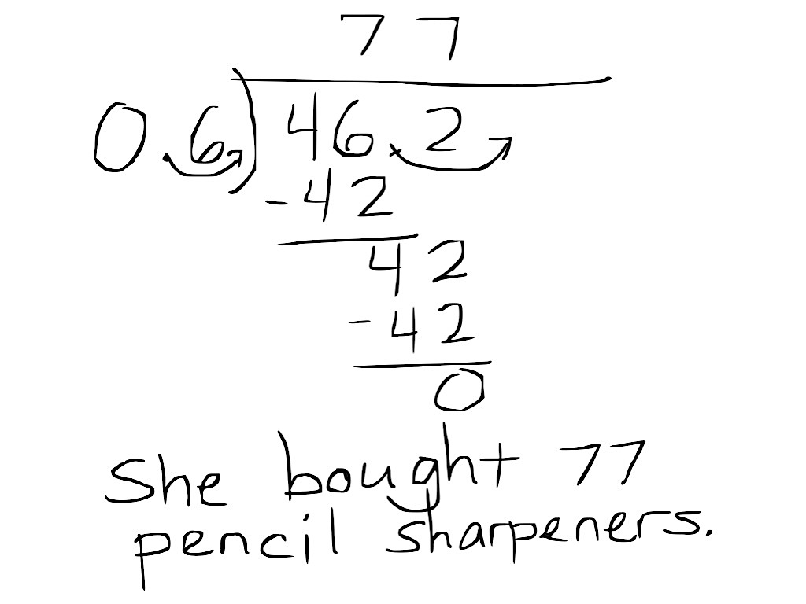
Application Problem (5 minutes)
Maggie spent $46.20 to buy pencil sharpeners for her gift shop. If each pencil sharpener cost 60 cents, how many pencil sharpeners did she buy? Solve by using the standard algorithm.
Note: This Application Problem looks back to G5–Module 4 to review division of decimal numbers.
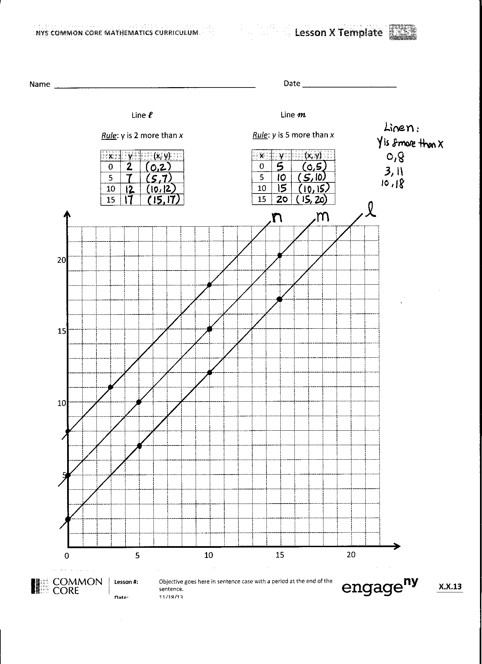
Concept Development (33 minutes)
Materials: (S) Coordinate plane template, straightedge
Problem 1: Graph two lines described by addition rules on the same coordinate plane, and compare/contrast them.
T: (Display chart for line $l$ on board. Distribute 1 coordinate plane template for each student.) Say the rule that describes line $l$.
S: $y$ is 2 more than $x$.
T: When $x$ is 1, what is the $y$-coordinate if I apply the rule?
S: (Show (1 3).)
T: (Record on board.) Tell your partner how you generated this ordered pair.
S: The rule says, “$y$ is 2 more than $x,$” so if $x$ is 1, $y$must be 3 because 3 is 2 more than 1. I just added 2 to 1 and got 3 as the $y$-coordinate.

NOTES ON
MULTIPLE MEANS OF REPRESENTATION:
Use color to enhance learners’ perception of the grid, pairs, and lines. You may want to present lines $l, m,$and $n$ in three different colors. It may be helpful to pick a consistent color for the numbers on the $x$- and $y$-axes and coordinate pairs. If students with visual impairments and others find plotting points challenging, you may want to magnify the grid, or use the Graphic Aid for Mathematics.

T: Complete the chart for the remaining values of $x$.
S: (Generate coordinate pairs.)
T: Plot each point on the plane, then use your straightedge to draw line $l$.
S: (Plot and construct.)
T: Show your work to a neighbor and check to make sure line $l$ is drawn correctly.
S: (Share and check work. While students share, teacher constructs line $l$ on board.)
Repeat the sequence for $m$.
T: Look at lines $l$ and $m$. Do they intersect?
S: No.
T: What is the name we give to lines that do not intersect?
S: Parallel.
T: Compare and contrast lines $l$ and $m$. What do you notice about each line?
S: They look very similar. They’re parallel, so they look like they go up at the same angle. They look like copies of the same line, except line $m$ is farther up than line $l$.
T: I heard you say that line $m$ is “farther up” than line $l$. Farther up from what? Turn and talk.
S: It looks like we can take line $l$and shift it up a bit to get the other one. Each point is a little higher than the points on line $l$. The rule for line $m$ is to add 5 to each $x$-coordinate; so, it makes sense that the line will be higher up than line $l$, because line $l$’s rule is to only add 2. All the $y$-coordinates on line $m$ are 3 units above all the $y$-coordinates on line $l$ with the same $x$-coordinates.
T: Compare the rules for lines $l$ and $m$. What do you notice?
S: Both rules are adding to the $x$-coordinate. One rule had us add 2 to the $x$-coordinate, and the other had us add 5 to the $x$-coordinate. We are adding 3 more to the $x$-coordinates in $m$ than we are to $l$. That’s why all the $y'$s are 3 more than the $y$’s on $l$!
T: (Post on the board the rule for line $n$, $y$ is 8 more than $x.$) Compare the rule for line $n$ to the other rules we’ve seen today. Turn and talk.
S: It’s another addition rule. We’re still adding, but this time we have to add 8 to the $x$-coordinate. The rule for this line adds 6 more to $x$ than line $l$ and 3 more to $x$ than line $m$.
T: Make a prediction. What will it look like if we draw line $n$ on this plane? Turn and talk.
S: It might make another parallel line. I bet line $n$ will be above the other two on the plane.
T: Work with a partner to generate 3 points for line $n$; then, draw it on the plane.
S: (Work and draw line $n$.)
T: Were your predictions correct? Turn and talk.
S: (While students share, teacher draws line $n$ on board.) Yes, line $n$ is parallel to the other two lines. I was right; line $n$ is above the other two lines.
T: As you can see, line $n$, whose rule is $y$is 8 more than $x$ creates another parallel line. Tell and show your neighbor what the line for rule $y$ is 10 more than $x$ would look like.
S: (Share.)
T: The line for rule $y$ is 10 more than $x$ would again be parallel, and its $y$-coordinates would be greater than those for the same $x$-coordinates in the other lines. (Drag your finger across the plane to show the approximate location of this line.)
Problem 2: Graph 2 lines described by multiplication rules on the same coordinate plane, and compare and contrast them.
T: (Display chart for line $p$on board.) Say the rule for line $p$.
S: $y$ is $x$ times 2.
T: When $x$ is 2, what is the $y$-coordinate if I apply the rule?
S: (Show (2, 4).)
T: (Record on board.) Tell your partner how you generated this ordered pair.
S: The rule says, “$y$ is $x$ times 2”; so, if $x$ is 2, $y$must be 4, because 2 times 2 is 4. I just multiplied 2 times 2 and got 4 as the $y$-coordinate.
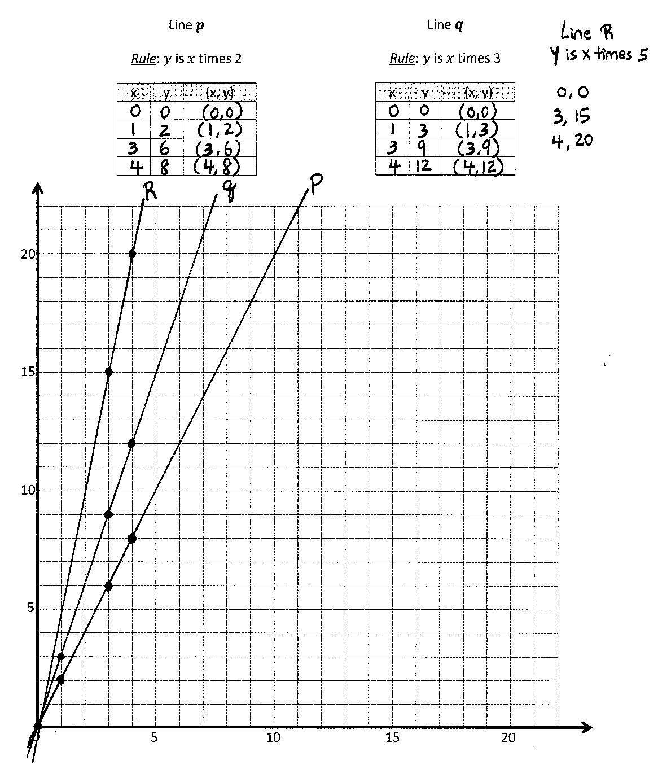
T: Great! Complete the chart for $x$-values of 0, 1, 3, and 4.
S: (Generate coordinate pairs.)
T: Plot each coordinate pair on the plane, then use your straightedge to draw line $p$.
S: (Plot and draw.)
T: Show your work to a neighbor, and check to make sure line $p$ is drawn correctly.
S: (Share and check work. While students share, teacher draws line $p$ on board.)
Follow a similar sequence for line $q$.
T: Compare and contrast the rules for lines $p$ and $q$. Turn and talk.
S: They are both multiplication rules. They’re a little different cause $p$ is multiplied by 2 and $q$ is multiplied by 3.
T: Do lines $p$ and $q$ intersect?

NOTES ON
MULTIPLE MEANS OF REPRESENTATION:
Clarify math language for English language learners so that they may confidently explore and discuss lines on the coordinate plane. Define steep and steepness. Offer explanations in students’ first language, if possible. Link the vocabulary to their experiences, such as walking a steep hill or paying a steep price.
S: Yes.
T: At what location do they intersect?
S: At (0, 0). At the origin.
T: Compare lines $p$ and $q$ in terms of their steepness. What do you notice? Turn and talk.
S: They both seem to start at the origin, but then line $q$ starts going up really quickly. It’s steeper than line $p$. Line $p$ goes up more gradually than line $q$. Line $p$ is less steep.
T: You noticed that line $q$ is steeper than line $p$. Look again at the rules for these lines and at the coordinate pairs that you generated for each line. Can you explain why line $q$ is steeper than line $p$? Turn and talk.
S: We used all the same values for the $x$-coordinates, but we multiplied them by different numbers to get the $y$-coordinate. I think line $q$ is steeper because we tripled the $x$-coordinate, rather than doubling it as we did in line $p$. So, the $y$-coordinate gets higher faster when you triple it.
T: (Post the rule for line $r$, $y$ is $x$ times 5 on the board.) Compare the rule for line $r$ to the rules for lines $p$ and $q$. Turn and talk.
S: It’s another multiplication rule. We’re still multiplying, but this time we have to quintuple the $x$-coordinate.
MP.7
MP.7
T: Make a prediction. What will it look like if we drew line $r$ on this plane? Turn and talk.
S: I think it’s going to start at the origin again. I bet line $r$ will be even steeper than the other two.
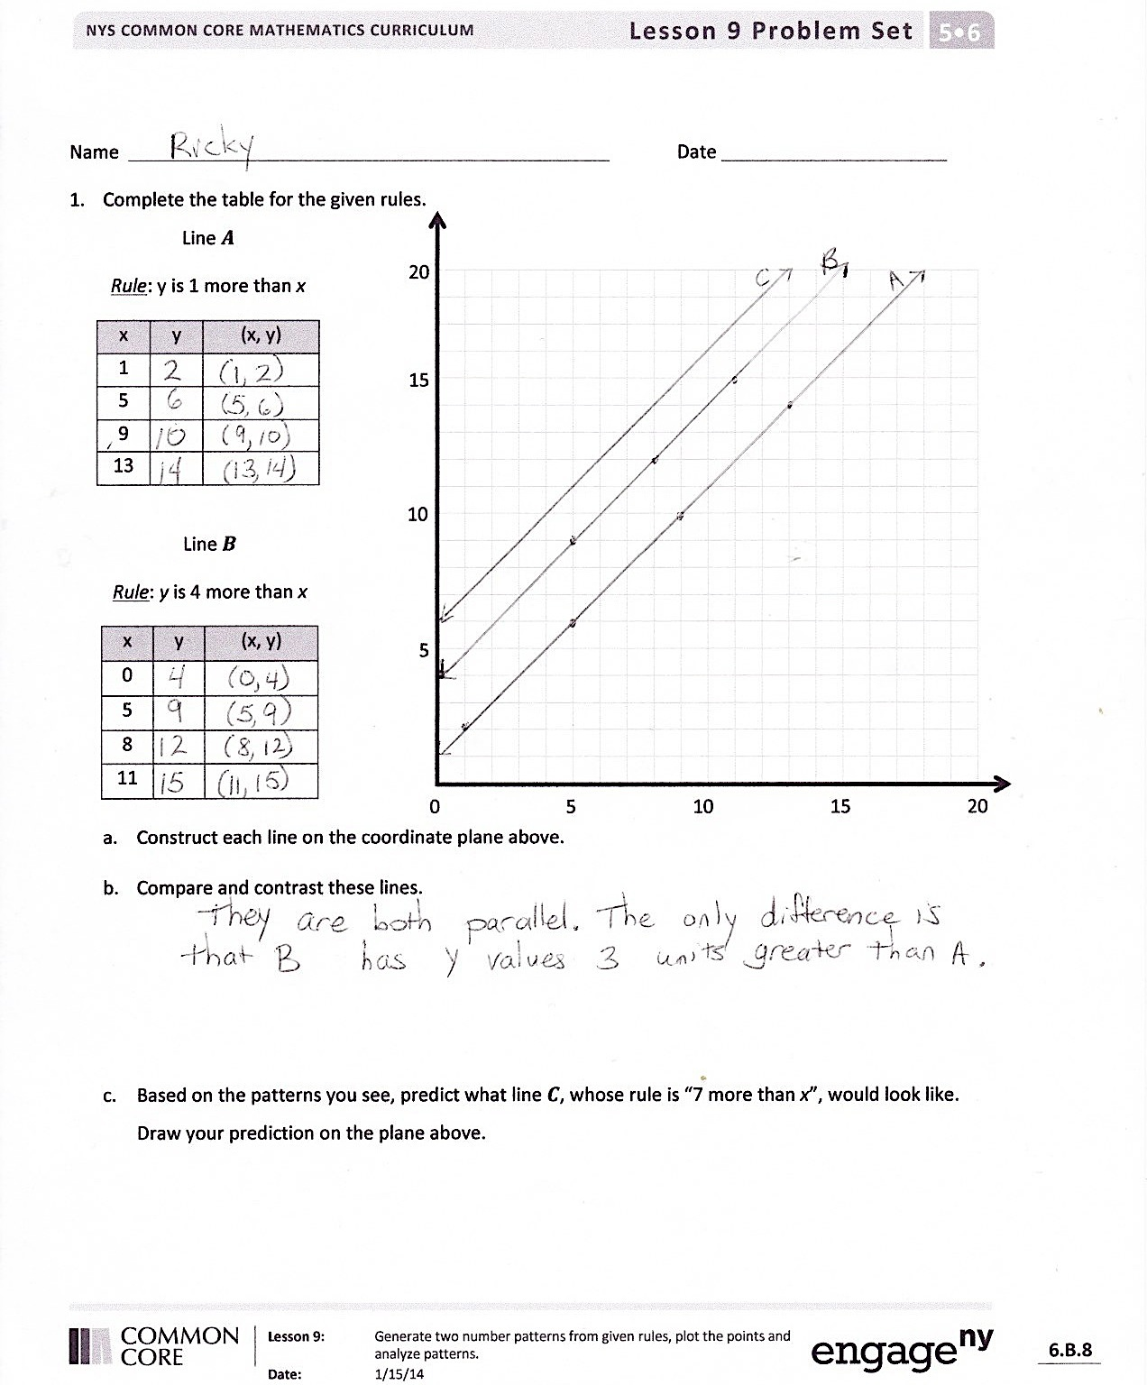
T: Work with a partner to generate 3 points for line $r$; then, construct it on the plane.
S: (Work and construct line $r$.)
T: Were your predictions correct? Turn and talk.
S: (While students share, teacher constructs line $r$ on board.) Yeah, line $r$ also contains point (0, 0). I was right; line $r$ is even steeper than lines $p$ and $q$.
MP.7
T: As you can see, line $r$, whose rule is $y$is $x$ times 5, passes through the origin and is even steeper than the other lines we’ve drawn. Tell and show your neighbor what the line for rule $y$ is $x$ times 6 would look like.
S: (Share.)
T: What sort of multiplication rule could we use to produce a line that was not as steep as line $p$? Turn and talk.
S: We would need to multiply the $x$-coordinates by something less than 2.
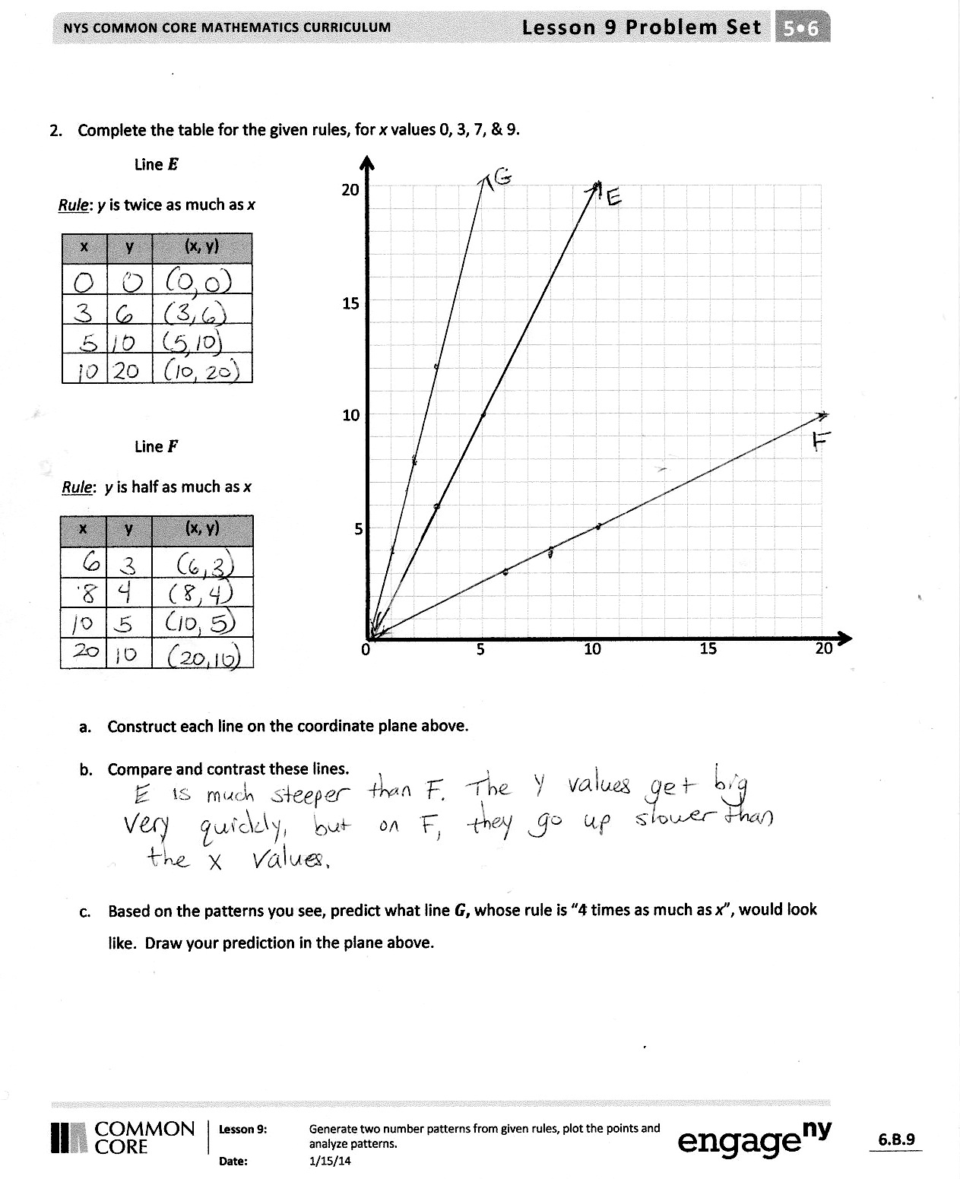
Problem Set (10 minutes)
Students should do their personal best to complete the Problem Set within the allotted 10 minutes. For some classes, it may be appropriate to modify the assignment by specifying which problems they work on first. Some problems do not specify a method for solving. Students solve these problems using the RDW approach used for Application Problems.
Student Debrief (10 minutes)
Lesson Objective: Generate two number patterns from given rules, plot the points, and analyze the patterns.
The Student Debrief is intended to invite reflection and active processing of the total lesson experience.
Invite students to review their solutions for the Problem Set. They should check work by comparing answers with a partner before going over answers as a class. Look for misconceptions or misunderstandings that can be addressed in the Debrief. Guide students in a conversation to debrief the Problem Set and process the lesson.
You may choose to use any combination of the questions below to lead the discussion.
- What pattern did you notice between lines $a$and $b$?
- If you could have chosen any values for $x$ when generating points for line $f$, what would you have chosen? Why? What if the rule were, $y$ is one-third as much as $x$?
- Explain to your partner how you made your predictions for Problems 1(c) and 2(c).
- Based on the patterns you saw in Problem 1, predict what the line for the rule, $y$ is 2 less than $x$ would look like. Use your finger to show your neighbor where you think the line would be.
- Compare the lines generated by addition and multiplication, for example $x$ + 2 and 2$x.$ What effect does adding 2 to $x$have as compared to multiplying $x$by 2?
Exit Ticket (3 minutes)
After the Student Debrief, instruct students to complete the Exit Ticket. A review of their work will help you assess the students’ understanding of the concepts that were presented in the lesson today and plan more effectively for future lessons. You may read the questions aloud to the students.

Name Date
- Complete the table for the given rules.

0 5 10 15 20
5
10
15
20
Line $a$
Rule: $y$ is 1 more than $x$
$$x$$ | $$y$$ | ($x$, $y$)
1
5
9
13

Line $b$
Rule: $y$ is 4 more than $x$
$$z$$ | $$y$$ | ($x$, $y$)
0
5
8
11

  - Construct each line on the coordinate plane above.

  - Compare and contrast these lines.

  - Based on the patterns you see, predict what line $c$, whose rule is 7 more than $x,$ would look like. Draw your prediction on the plane above.

- Complete the table for the given rules for $x$ values 0, 3, 7, and 9.
Line $e$
Rule: $y$ is twice as much as$x$
$$x$$ | $$y$$ | ($x$, $y$)

0 5 10 15 20
5
10
15
20

Line $f$
Rule: $y$ is half as much as $x$
$$x$$ | $$y$$ | ($x$, $y$)

  - Construct each line on the coordinate plane above.

  - Compare and contrast these lines.

  - Based on the patterns you see, predict what line $g$, whose rule is 4 times as much as $x,$ would look like. Draw your prediction in the plane above.

Name Date
Complete the tables for the given rules. Then, construct lines $l$ and $m$ on the coordinate plane.

Line $l$
Rule: $y$ is 5 more than $x$
$$x$$ | $$y$$ | ($x$, $y$)
0
1
2
4

0 5 10 15 20
5
10
15
20

Line $m$
Rule: $y$ is 5 times as much as $x$
$$x$$ | $$y$$ | ($x$, $y$)
0
1
2
4

Name Date
- Complete the table for the given rules.
Line $a$
Rule: $y$ is 1 less than $x$
$$x$$ | $$y$$ | ($x$, $y$)
1
4
9
16

0 5 10 15 20
5
10
15
20

Line $b$
Rule: $y$ is 5 less than $x$
$$x$$ | $$y$$ | ($x$, $y$)
5
8
14
20

  - Construct each line on the coordinate plane.

  - Compare and contrast these lines.

  - Based on the patterns you see, predict what line $c$, whose rule is 7 less than $x,$ would look like. Draw your prediction on the plane above.

- Complete the table for the given rules for $x$ values 0, 3, 4, and 6.
Line $e$
Rule: $y$ is 3 times as much as $x$
$$x$$ | $$y$$ | ($x$, $y$)

0 5 10 15 20
5
10
15
20

Line $f$
Rule: $y$ is a third as much as $x$
$$x$$ | $$y$$ | ($x$, $y$)

  - Construct each line on the coordinate plane.

  - Compare and contrast these lines.

  - Based on the patterns you see, predict what line $g$, whose rule is 4 times as much as $x,$ and line $h$, whose rule is one-fourth as much as $x,$ would look like. Draw your prediction in the plane above.

Name Date
Line $l$
Rule: $y$ is 2 more than $x$
$$x$$ | $$y$$ | ($x$, $y$)
1
5
10
15

Line $m$
Rule: $y$ is 5 more than $x$
$$x$$ | $$y$$ | ($x$, $y$)
0
5
10
15

0 5 10 15 20
5
10
15
20
Line $p$
Rule: $y$ is $x$ times 2
$$x$$ | $$y$$ | ($x$, $y$)

Line $q$
Rule: $y$ is $x$ times 3
$$x$$ | $$y$$ | ($x$, $y$)

0 5 10 15 20
5
10
15
20

