Lesson 8
Objective: Generate a number pattern from a given rule, and plot the points.

Suggested Lesson Structure
 Fluency Practice (12 minutes)
 Application Problem (5 minutes)
 Concept Development (33 minutes)
 Student Debrief (10 minutes)
Total Time (60 minutes)
Fluency Practice (12 minutes)
- Sprint: Multiply Decimals by 10, 100, and 1,000 5.NBT.2 (9 minutes)
- Plot Points on a Coordinate Grid 5.G.1 (3 minutes)
Sprint: Multiply Decimals by 10, 100, and 1,000 (9 minutes)
Materials: (S) Multiply Decimals by 10, 100, and 1,000 Sprint
Note: This fluency activity reviews G5–Module 1 concepts.
Plot Points on a Coordinate Grid (3 minutes)
Materials: (S) Personal white boards with coordinate grid insert
Note: This fluency activity reviews G5–M6–Lesson 7.
T: Label the $x$- and $y$-axes.
S: (Label the axes.)
T: Label the origin.
S: (Write 0 at the origin.)
T: Along both axes, label each interval, counting by ones to 5.
S: (Label 1, 2, 3, 4, and 5 along each axes.)
T: (Write (0, 1).) Plot the point on your coordinate grid.
S: (Plot point at (0,1).)
Continue the process for the following possible sequence: (1, 2), (2, 3), and (3, 4).
T: Write 2 pairs of whole number coordinates on the line passing through the points you plotted.
S: (Possibly write (4, 5) and (5, 6).)
T: Erase your boards and label your axes and the origin.
S: (Label $x$-axis, $y$ -axis, and origin.)
T: Label each interval along both axes, counting by halves to 4.
S: (Label $\frac{1}{2}$, 1, $\text{1}\frac{1}{2}$, 2, $\text{2}\frac{1}{2}$, 3, $\text{3}\frac{1}{2}$, and 4 along each axis.)
T: (Write (1, $\frac{1}{2}$).) Plot the point on your coordinate grid.
S: (Plot point at (1, $\frac{1}{2}$).)
Continue the process for (2, 1), (3, $\text{1}\frac{1}{2}$), and (4, 2).
T: Write another coordinate pair that is on the same line as the points you just plotted.
Application Problem (5 minutes)
The coordinate pairs listed locate points on two different lines. Write a rule that describes the relationship between the $x$- and $y$-coordinates for each line.
Line $l$: (3$\frac{1}{2}$, 7), (1$\frac{2}{3}$, 3$\frac{1}{3}),$ (5, 10)

Line $m$: ( $\frac{6}{3}, 1),$ (3$\frac{1}{2}$, 1$\frac{3}{4}$ ), (13, $6\frac{1}{2}$)

Note: These problems review G5–M6–Lesson 7’s objectives.
Concept Development (33 minutes)
Materials: (S) Personal white board, coordinate plane template, straightedge
Problem 1: Create coordinate pairs from rules.
- $y$ is equal to $x$
- $y$ is 1 more than $x$
- $y$ is 5 times $x$
- $y$ is 1 more than 3 times $x$
- $y$ is 1 less than 2 times $x$
T: I will give you a rule that describes a relationship between the $x$- and $y$-coordinates for some points on a line. You will write a coordinate pair that has the same relationship and that follows the same rule on your board. (Write $y$ is equal to $x$ on the board.) Write and show a coordinate pair for $y$ is equal to $x$.
S: (0, 0). (2, 2). (47, 47). ($\frac{7}{8}, \frac{7}{8}$). (0.21, 0.21).
T: This next rule describes a different relationship between the coordinates of a set of points. (Write $y$is 1 more than $x$ on the board.)
T: How can you find the $y$-coordinate of a point on this line if you know the $x$-coordinate of the point is 0? Turn and talk.
S: The rule says that all the $y$’s are 1 more than all the $x$’s. So, if $x$ is 0, then we have to add 1 to that to get $x$. If $x$ = 0, then $y$ is 1. (0, 1) is the point’s coordinate pair.

NOTES ON
MULTIPLE MEANS OF REPRESENTATION:
Support English language learners and others as they articulate coordinate pairs based on rules such as $y$ is 1 more than $x$. In addition to providing extra response time, you may want to rephrase questions in multiple ways, either simplifying or elaborating.
Students working below grade level may benefit from scaffolds such as sentence frames to find $y$ using the rule $y$ is 5 times $x$. You might present $x$ = __ , so $y$ = 5 times ___ = 5 $\text{×} ___$.

T: Write and show other coordinates for this rule.
S: (2, 3). (3, 4). (10$\frac{1}{2}$, 11$\frac{1}{2}$). (0.1, 1.1).
T: (Write $y$ is 5 times $x$ on the board.)
T: What would be another way to state this rule? Turn and talk.
S: Multiply $x$ by 5 to get $y$. $x$ times 5 is $y$.
T: Give the coordinate pair for this rule, if $x$ is 1.
S: (Show (1, 5).)
T: Give the coordinate pair for this rule, if $x$ is 0.
MP.2
S: (0, 0).
T: Give another coordinate pair for a point on this line.
S: (2, 10). ( $\text{9}\frac{1}{5}$, 46). (0.3, 1.5).
T: Explain to your partner how you thought about your coordinate pair.

NOTES ON
MULTIPLE MEANS OF REPRESENTATION:
Simplify and clarify the phrase range of values for English language learners and others. While it may not be necessary to present the multiple meanings for each word, you may want to define the term as used here, or express your request in another manner, such as, “What are the greatest and smallest values on the $x$ - and $y$-axes?”

S: I just multiplied $x$ by 5. I picked the number 2 to be my $x$, multiplied it by 5, and got 10 for $y$. My coordinate pair is (2, 10).
Continue the sequence with (d) $y$ is 1 more than 3 times $x$ and (e) $y$ is 1 less than 2 times $x$.
Problem 2: Create coordinate pairs from rules and plot the points.
Line $a$: $y$ is 2 more than $x$.
Line $b$: $y$ is 2 times $x$.
Line $c$: $y$ is 1 more than $x$doubled.
T: (Hand out coordinate plane template to students. Display the coordinate plane on the board. Write Line $a: y$ is 2 more than $x$ on the board.) Say the rule for line $a$.
S: $y$ is 2 more than $x$.
T: Record the rule in the chart for line $a$.
S: (Record rule.)
T: What range of values do our axes show?
S: Both the $x$- and $y$-axis show even numbers from 0 to 14.
T: What will you need to think about as you pick your values for $x$? Talk to your partner, and then generate your coordinate pairs.
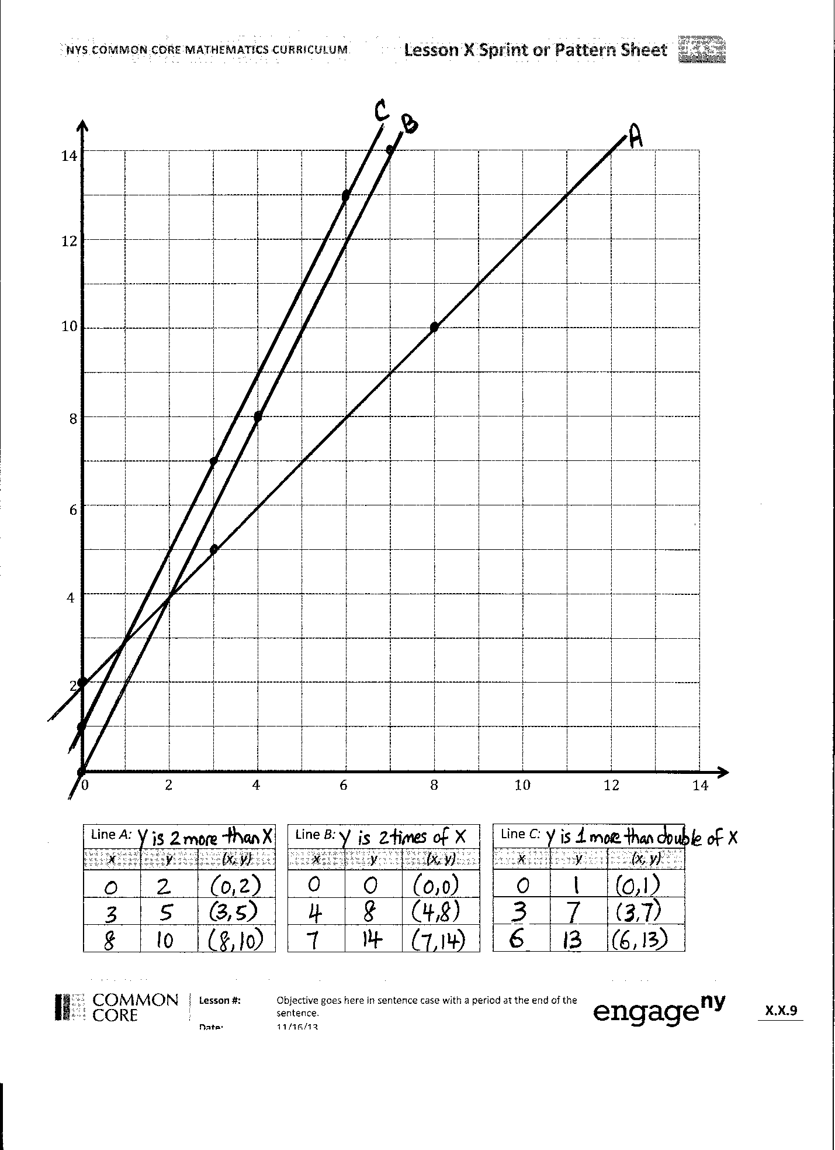
S: We have to make sure we don’t pick $x$’s that are bigger than 14. Since all our $y$’s will be 2 more than our $x$’s, we can’t have an $x$ that is bigger than 12 if we want to be able to put it on this part of the plane. I’m going to pick whole number $x$’s so that adding 2 and putting the points on the gridlines will be easy.
$$a$$
$$b$$
$$c$$
S: (Create points and share with partner.)
T: Plot the 3 points on your grid paper.
S: (Plot points.)
T: Use a straightedge to draw line $a$. (Draw line $a$)
S: (Draw line $a$.)
Repeat a similar sequence for lines $b$and $c$.
T: Show your lines to your neighbor.
S: (Share.)
T: Raise your hand if your neighbor generated the exact same points as you.
S: (Most, if not all, should keep hands down.)
T: Raise your hand if your neighbor’s lines were the same as yours.
S: (All should raise their hands.)
T: How is it possible that we all have the same lines on our plane, and, yet, we all plotted different points? Turn and talk.
S: The lines are all the same because we used the same rules to give the points. There are a whole bunch of points on each line; we just picked a few of them to name. We’re doing the same operation to the $x$’s every time. So, no matter what numbers we put in, when we draw the line, they will have all the same lines drawn, which have all the same points.
T: Which lines appear to be parallel?
S: Lines $b$and $c$.
T: Do any of the lines intersect?
S: Yes. Line $a$ intersects line $b$. Line $a$ intersects both lines $b$ and $c$.
T: Line $a$ intersects line $b$. What is the coordinate pair for the point at which these lines intersect?
S: (2, 4).
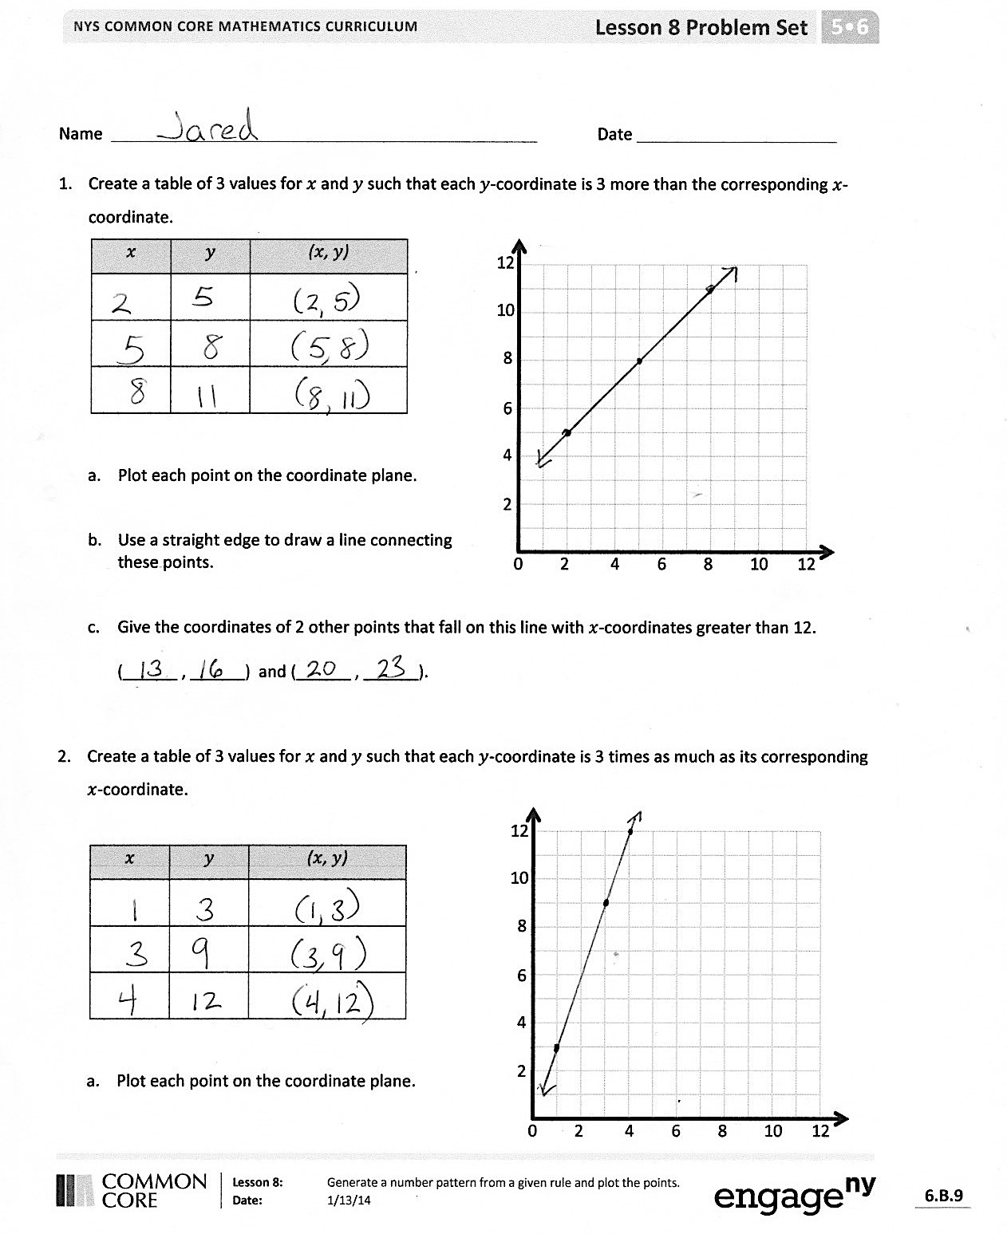
T: Give the coordinate pair where $a$ and $c$ intersect.
S: (1, 3).
T: How can one coordinate pair follow more than one rule? Turn and talk.
S: In the point (2, 4), the $y$-coordinate is both 2 times greater than $x,$ and it’s 2 more than $x$, so it satisifies both rules. With coordinates (1, 3), the $y$-coordinate is 2 more than $x,$ so it’s part of the rule $y$ is 2 more than $x$; it’s also 1 more than $x$ doubled, so it’s on that line, too! There are lots of ways to get from 1 to 3. I can add two, or I could double 1 and then add 2. Or, I could add 5 and subtract 3.
Problem Set (10 minutes)
Students should do their personal best to complete the Problem Set within the allotted 10 minutes. For some classes, it may be appropriate to modify the assignment by specifying which problems they work on first. This Problem Set has 3 pages. Copy the last page just for early finishers if you so choose.
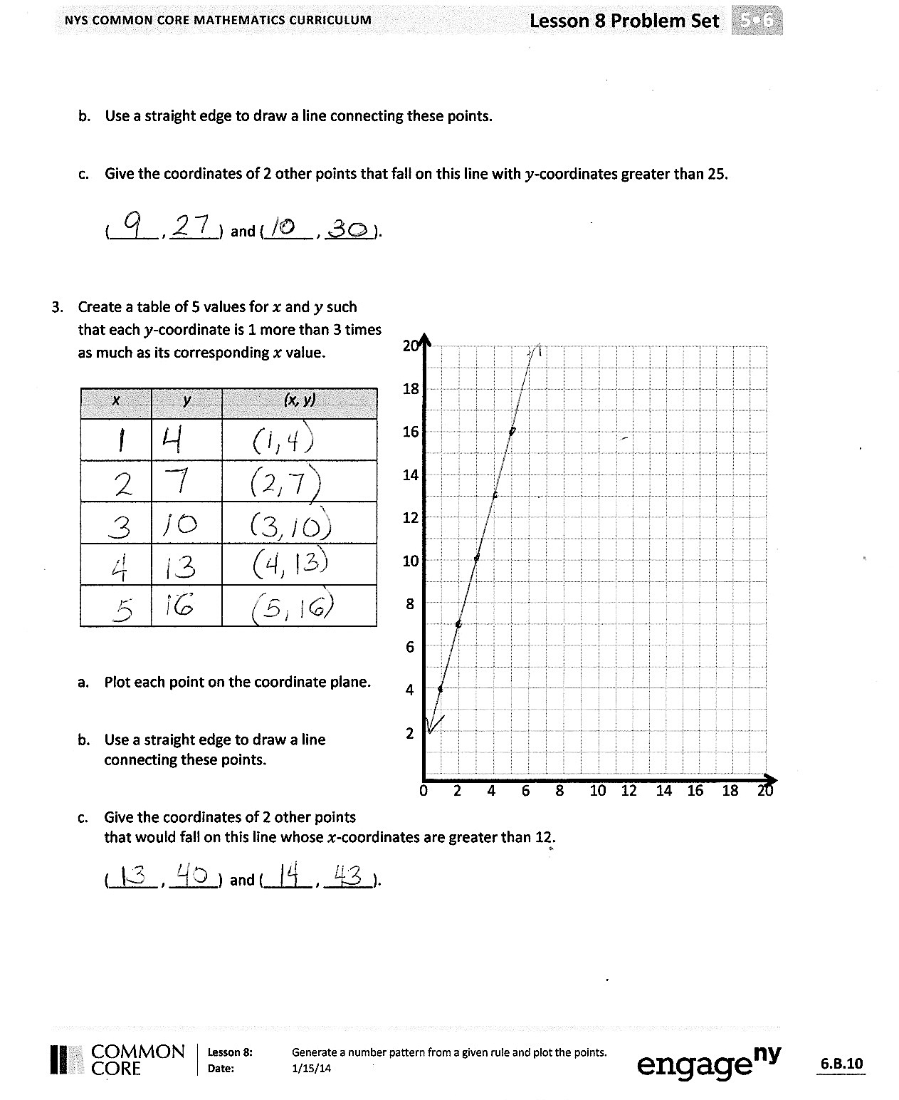
Student Debrief (10 minutes)
Lesson Objective: Generate a number pattern from a given rule, and plot the points.
The Student Debrief is intended to invite reflection and active processing of the total lesson experience.
Invite students to review their solutions for the Problem Set. They should check work by comparing answers with a partner before going over answers as a class. Look for misconceptions or misunderstandings that can be addressed in the Debrief. Guide students in a conversation to debrief the Problem Set and process the lesson.
You may choose to use any combination of the questions below to lead the discussion.
- How did you create the points for Problem 1? Explain to a partner.
- Share how you solved Problem 1(c) with a partner.
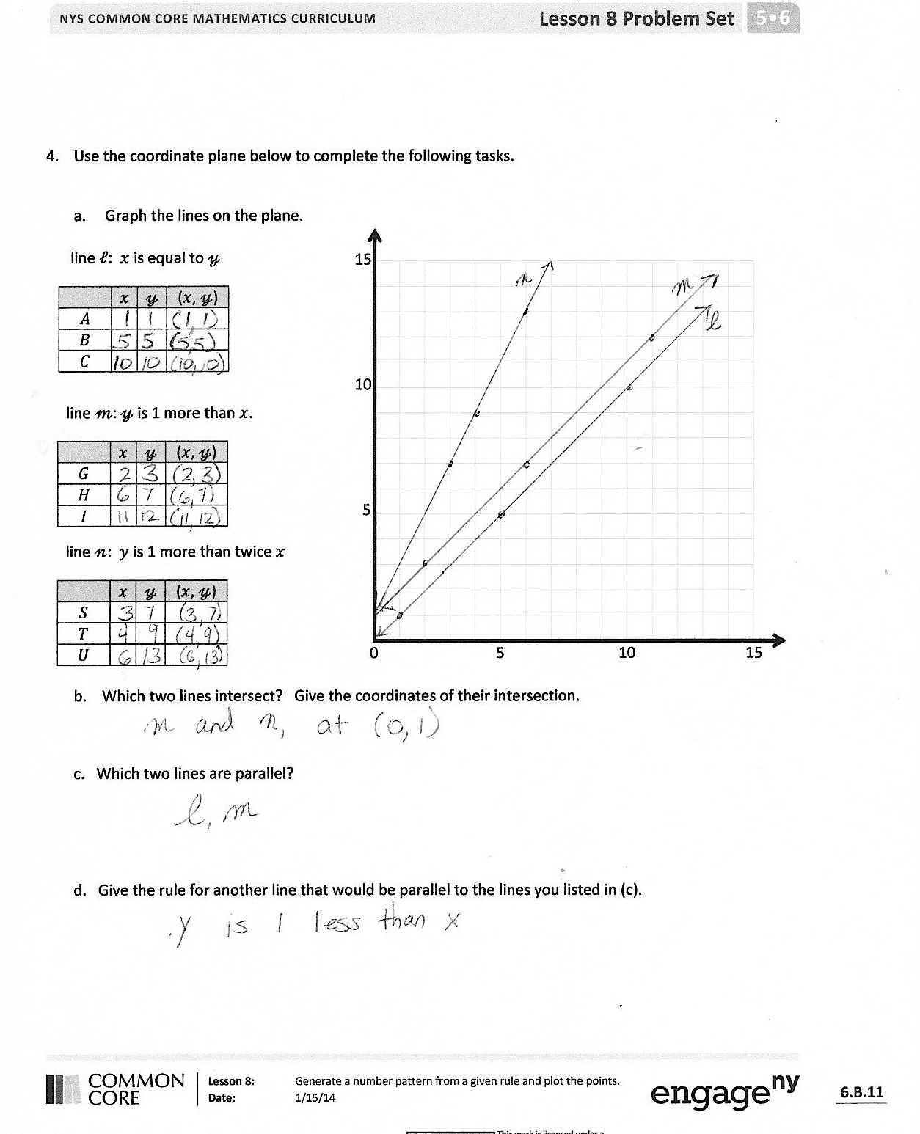
- How did you create the points for Problem 2? Explain to a partner.
- Share how you solved Problem 2(c) with a partner.
- How did you create the points for Problem 3? Explain to a partner.
- Share how you solved Problem 3(c) with a partner.
- Compare the three lines you drew for Problem 4. Do they look the same or different? Explain your thinking to a partner.
- (Note: Problem 4(d) should be viewed as a challenge and previews the work in G5–M6–Lesson 9.) In Problem 4(c), what did you notice about the two rules that created parallel lines? Share your solution to Problem 4(d) with a partner, and explain your thinking.
Exit Ticket (3 minutes)
After the Student Debrief, instruct students to complete the Exit Ticket. A review of their work will help you assess the students’ understanding of the concepts that were presented in the lesson today and plan more effectively for future lessons. You may read the questions aloud to the students.

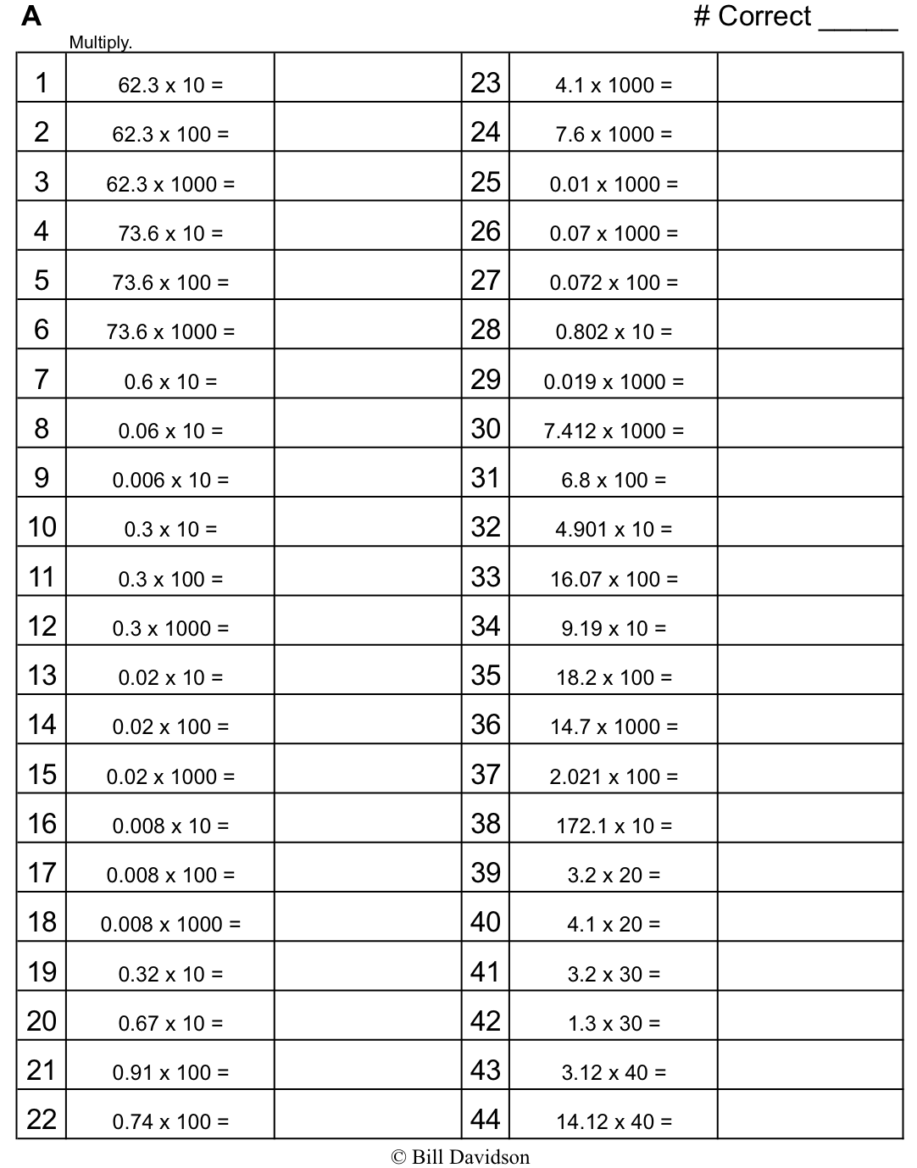
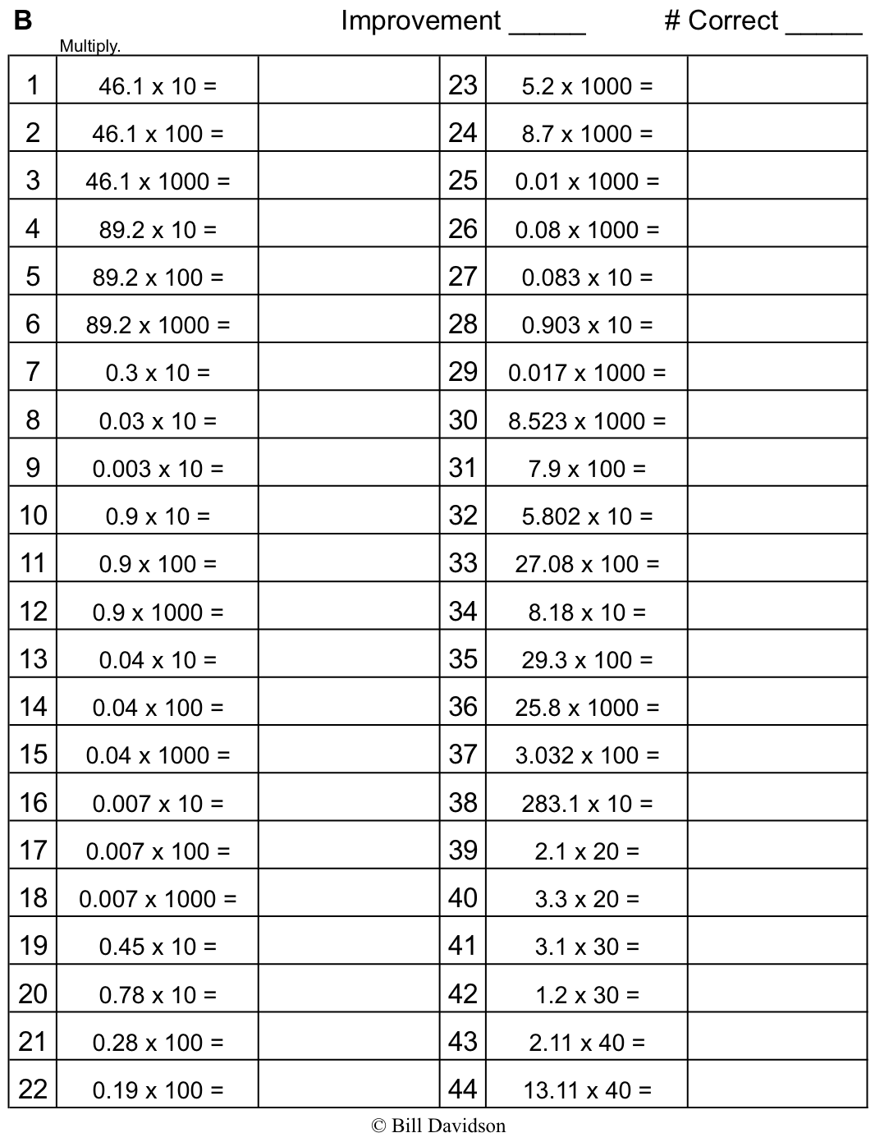

Name Date
- Create a table of 3 values for $x$ and $y$ such that each $y$-coordinate is 3 more than the corresponding $x$-coordinate.

0 2 4 6 8 10 12
2
4
6
8
10
12
$$x$$ | $$y$$ | ($x$, $y$)

  - Plot each point on the coordinate plane.

  - Use a straightedge to draw a line connecting these points.

  - Give the coordinates of 2 other points that fall on this line with $x$-coordinates greater than 12.

(______ , ______) and (______ , ______).

- Create a table of 3 values for $x$ and $y$ such that each $y$-coordinate is 3 times as much as its corresponding $x$-coordinate.

0 2 4 6 8 10 12
2
4
6
8
10
12

$$x$$ | $$y$$ | ($x$, $y$)

  - Plot each point on the coordinate plane.

  - Use a straightedge to draw a line connecting these points.

  - Give the coordinates of 2 other points that fall on this line with $y$-coordinates greater than 25.

(______ , ______) and (______ , ______).

- Create a table of 5 values for $x$ and $y$ such that each $y$-coordinate is 1 more than 3 times as much as its corresponding $x$ value.

20
18
16
14
12
10
8
6
4
2
0 2 4 6 8 10 12 14 16 18 20

x | $$y$$ | (x, $y$)

  - Plot each point on the coordinate plane.

  - Use a straightedge to draw a line connecting these points.

  - Give the coordinates of 2 other points that would fall on this line whose $x$-coordinates are greater than 12.

(______ , ______) and (______ , ______).

- Use the coordinate plane below to complete the following tasks.

0 5 10 15
5
10
15
- Graph the lines on the plane.
line $l$: $x$ is equal to $y$
 | $$x$$ | $$y$$ | ($x$, $y$)
$$A$$
$$B$$
$$C$$

line $m$: $y$ is 1 more than $x$
 | $$x$$ | $$y$$ | ($x$, $y$)
$$G$$
$$H$$
$$I$$

line $n$: $y$ is 1 more than twice $x$
 | $$x$$ | $$y$$ | ($x$, $y$)
$$S$$
$$T$$
$$U$$

b. Which two lines intersect? Give the coordinates of their intersection.

c. Which two lines are parallel?

d. Give the rule for another line that would be parallel to the lines you listed in (c).

Name Date

- Complete this table with values for $x$and $y$ such that each $y$-coordinate is 5 more than 2 times as much as its corresponding $x$-coordinate.

0 2 4 6 8 10 12
2
4
6
8
10
12
$$x$$ | $$y$$ | ($x$, $y$)
0
2
3.5
  - Plot each point on the coordinate plane.

  - Use a straightedge to draw a line connecting these points.
  - Name 2 other points that fall on this line with $y$-coordinates greater than 25.

Name Date

- Complete this table such that each $y$-coordinate is 4 more than the corresponding $x$-coordinate.

0 2 4 6 8 10 12
2
4
6
8
10
12
$$x$$ | $$y$$ | ($x$, $y$)
  - Plot each point on the coordinate plane.
  - Use a straightedge to construct a line connecting these points.
  - Give the coordinates of 2 other points that fall on this line with $x$-coordinates greater than 18.
(______ , ______) and (______ , ______).

- Complete this table such that each $y$-coordinate is 2 times as much as its corresponding $x$-coordinate.

0 2 4 6 8 10 12
2
4
6
8
10
12
$$x$$ | $$y$$ | ($x$, $y$)
  - Plot each point on the coordinate plane.

  - Use a straightedge to draw a line connecting these points.
  - Give the coordinates of 2 other points that fall on this line with $y$-coordinates greater than 25.
(______ , ______) and (______ , ______).

- Use the coordinate plane below to complete the following tasks.

0 5 10 15
5
10
15
  - Graph these lines on the plane.
line $l$: $x$ is equal to $y$
 | $$x$$ | $$y$$ | ($x$, $y$)
$$A$$
$$B$$
$$C$$

line $m$: $y$ is 1 less than $x$
 | $$x$$ | $$y$$ | ($x$, $y$)
$$G$$
$$H$$
$$I$$

line $n$: $y$ is 1 less than twice $x$
 | $$x$$ | $$y$$ | ($x$, $y$)
$$S$$
$$T$$
$$U$$

- `

- Do any of these lines intersect? If yes, identify which ones, and give the coordinates of their intersection.

c. Are any of these lines parallel? If yes, identify which ones.

d. Give the rule for another line that would be parallel to the lines you listed in (c).

0 2 4 6 8 10 12 14
4
8
12
2
6
10
14
Line $a$:
$$x$$ | $$y$$ | $$(x, y)$$

Line $b$:
$$x$$ | $$y$$ | $$(x, y)$$

Line $c$:
$$x$$ | $$y$$ | $(x$, $y$)

