Lesson 7
Objective: Plot points, using them to draw lines in the plane, and describe patterns within the coordinate pairs.

Suggested Lesson Structure
 Fluency Practice (11 minutes)
 Application Problem (7 minutes)
 Concept Development (32 minutes)
 Student Debrief (10 minutes)
Total Time (60 minutes)
Fluency Practice (11 minutes)
- Multiply and Divide by 10, 100, and 1,000 5.NBT.2 (5 minutes)
- Name Coordinates 5.G.1 (6 minutes)

Multiply and Divide Decimals by 10, 100, and 1,000 (5 minutes)
Materials: (T) Place value chart (S) Personal white boards
Note: This fluency activity reviews G5–Module 1 topics. The suggested place value chart allows students to see the symmetry of the decimal system around one.
T: (Project place value chart from the one thousands place to the one thousandths place. Draw 4 disks in the tens column, 3 disks in the ones column, and 5 disks in the tenths column.) Say the value as a decimal.
S: Forty-three and five tenths.
T: Write the number on your personal boards. (Pause.) Multiply it by 10.
S: (Write 43.5 on their place value charts, cross out each digit, and shift the number one place value to the left to show 435.)
T: Show 43.5 divided by 10.
S: (Write 43.5 on their place value charts, cross out each digit, and shift the number one place value to the right to show 4.35.)
Repeat the process and sequence for 43.5 $\text{×}$ 100, 43.5 ÷ 100, 948 ÷ 1,000, and 0.529 $\text{×}$ 1,000.

Name Coordinates (6 minutes)
Materials: (T) Coordinate grid template (S) Personal white boards
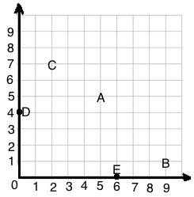
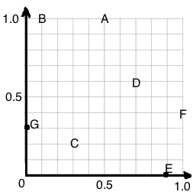
Note: This fluency activity reviews G5–M6–Lesson 6.
T: (Project coordinate grid.) Write the coordinate positioned at A.
S: (Write (5, 5).)
Continue the process for letters B–E.
T: (Project coordinate grid.) Write the coordinate that is positioned at A.
S: (Write (0.5, 1.0).)
Continue the process for the remaining letters.
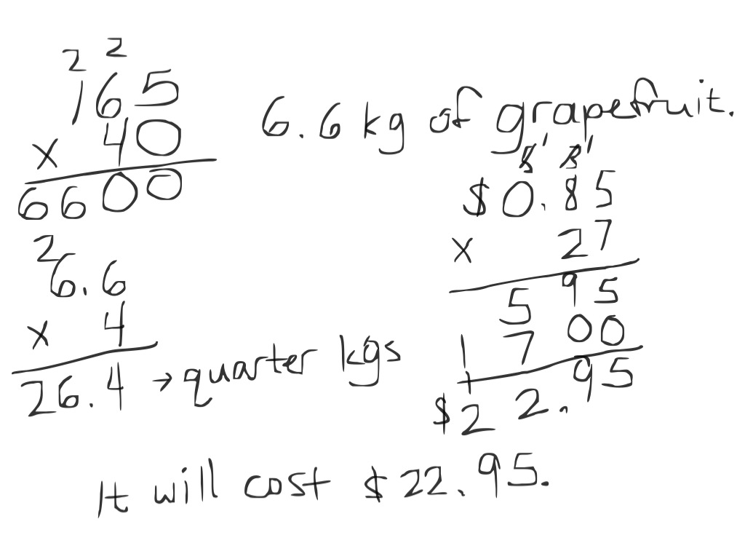
Application Problem (7 minutes)
An orchard charges $0.85 to ship a quarter kilogram of grapefruit. Each grapefruit weighs approximately 165 grams. How much will it cost to ship 40 grapefruits?
Note: This problem reviews fraction and decimal concepts from earlier in the year, in a multi-step, real world context.
Concept Development (32 minutes)
Materials: (S) Coordinate plane template, straightedge
Point | $$x$$ | $$y$$ | ($x$, $y$)
$$A$$ | 0 | 0 | (0, 0)
$$B$$ | 1 | 1 | (1, 1)
$$C$$ | 2 | 2 | (2, 2)
$$D$$ | 3 | 3 | (3, 3)

Problem 1: Describe patterns in coordinate pairs and name the rule.
T: (Distribute 1 copy of coordinate plane template to each student. Display image of the chart, showing coordinate pairs $A$ through $D$.) Work with a partner to plot points A through D on the first plane, and draw $\overset{⃡}{AD}$.
S: (Draw the line.)
T: Look at the coordinates of the points contained in $\overset{⃡}{AD}$. What pattern do you notice about the $x$- and $y$-coordinates? Turn and talk.
MP.6
S: When $x$ is 0, so is $y$. When $x$ is 1, so is $y,$ all the way up to 3. The $x$-coordinate equals the $y$-coordinate.
T: So, you’re saying that the $x$-coordinate and the $y$-coordinate are always equal to one another. Will the point with coordinates (4, 4) also fall on $\overset{⃡}{AD}$?
S: Yes!
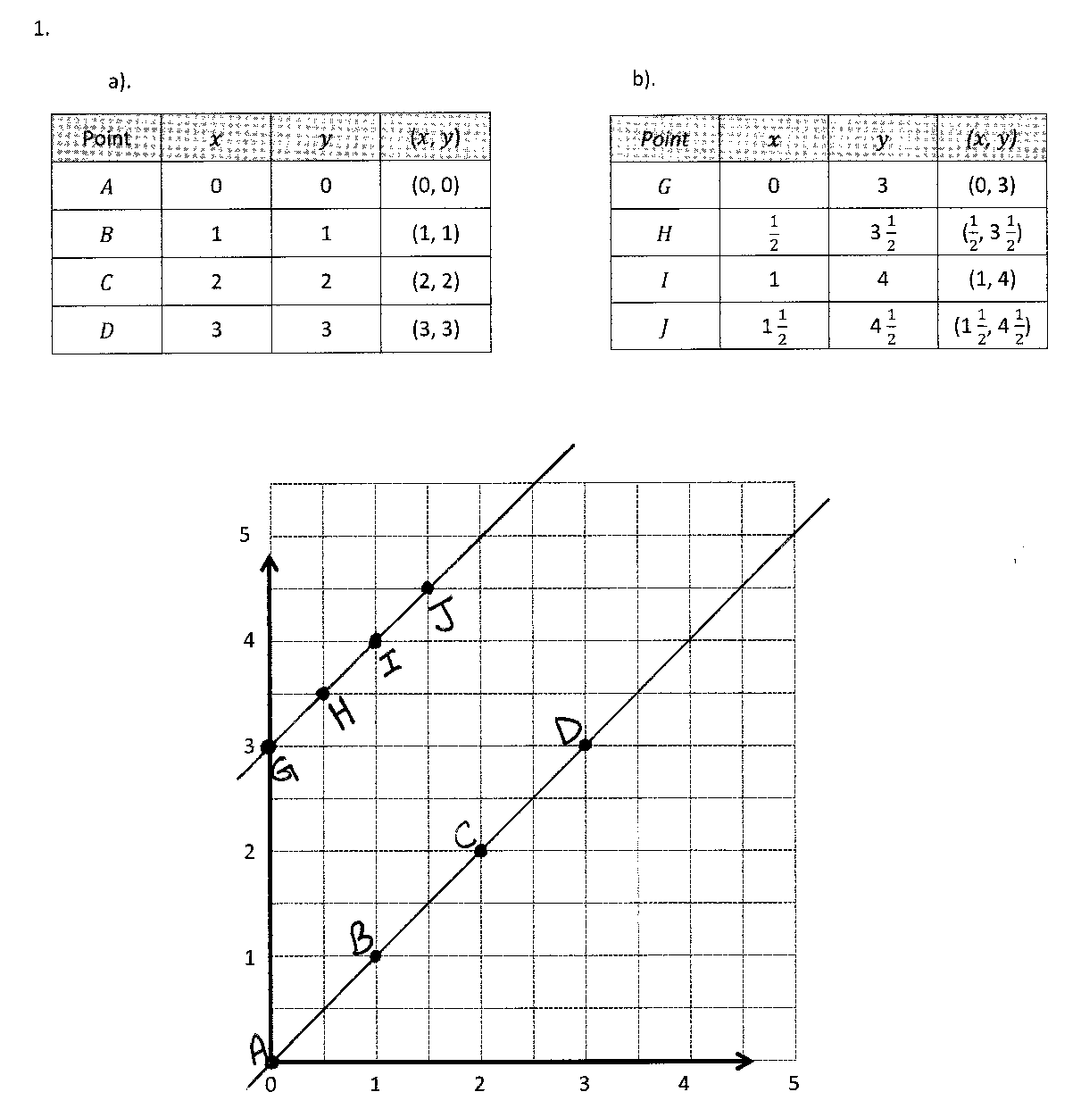
T: As long as the $x$- and $y$-coordinates are the same, the point will be on $\overset{⃡}{AD}$. We can say that the relationship between these coordinates can be described by the rule $x$ and $y$ are equal. (Write on board: Rule: $x$ and $y$ are equal.) Or, we can also say the rule, $y$ is equal to $x$. (Write, Rule: $y$ is equal to $x$.)
MP.6
T: Will $\overset{⃡}{AD}$contain the point with coordinates (10, 10)? Turn and talk.
S: I can’t see it on this plane because the numbers stop at 5. However, if it kept going, we could see it. Yes, as long as the $x$- and $y$-coordinates of the point are equal, the point will be on the line.
T: Show me a point on $\overset{⃡}{AD}$ whose coordinates are mixed numbers.
S: (Show a coordinate pair where $x$ and $y$ are equal mixed numbers.)
T: Can $\overset{⃡}{AD}$contain a point where the $x$-coordinate is a mixed number and the $y$-coordinate is not? Turn and talk.

NOTES ON
MULTIPLE MEANS OF ENGAGEMENT:
It may be difficult for some students to read the information displayed in the charts showing the coordinate pairs. The information in the charts can be managed in ways to help students:
- Shade alternate rows of information so that students can easily track information within the chart.
- Display the information one line at a time in order to help students see relevant information as needed.

S: Don’t they have to be the same? $x$ and $y$ need to be equal. If the $x$-coordinate is a mixed number, the $y$-coordinate will be the same mixed number, or it could be expressed in another equivalent form such as 3 halves and $\text{1}\frac{1}{2}$.
T: Give the coordinate pair of a point that would not fall on $\overset{⃡}{AD}$.
S: (Show a coordinate pair where $x$ and $y$ are not equal.)
T: (Display image of chart, showing coordinate pairs for points $G$ through $J$.) What pattern do you notice in these coordinate pairs? Turn and talk.
S: $x$ and $y$ aren’t equal this time. The $y$ is always more than the $x$-coordinate. The$x$-coordinates are increasing by $\frac{1}{2}$ every time and so are the $y$-coordinates. It goes from 0 to 3 and $\frac{1}{2}$ to $\text{3}\frac{1}{2}$, and 1 to 4. So, the $y$-coordinate is always 3 more than the $x$-coordinate.
Point | ($x$, $y$)
$$G$$ | (0, 3)
$$H$$ | ($\frac{1}{2}$, $3\frac{1}{2}$)
$$I$$ | (1, 4)
$$J$$ | ( $1\frac{1}{2}$, $4\frac{1}{2}$)

T: Plot the points from the chart on the coordinate plane. Then, connect them in the order they were plotted.
S: (Plot and draw $\overset{⃡}{GJ}$.)
T: What do you notice?
S: They are all on the same line.
T: These points are collinear, so the relationship between each $x$ and its corresponding $y$ will be the same. Use this relationship to locate more points on this line. When $x$ is 2, what is $y$? (Show (2, ?) on board.) Turn and talk.
S: $y$ would be 5, because $y$ is always 3 more than the $x$-coordinate for points on this line. If I add 3 plus 2, then $y$ is 5. The coordinates would be (2, 5).
T: Work with a partner to write a rule in words that tells the relationship between the $x$- and $y$-coordinates for the points on this line. Be sure to include both$x$ and $y$ when you write the rule.
S: $y$ is 3 more than $x$. Add 3 to the $x$-coordinate to get $y$.
T: (Display charts (a) through (d) on board.) Each of these charts shows points on each of four different lines. Take a minute to notice the pattern within the coordinate pairs for each line. Share your thoughts with a partner.
S: (Study and share.)
a.
Point | ($x$, $y$)
$$L$$ | (0, 3)
$$M$$ | (2, 3)
$$N$$ | (4, 3)

b.
Point | ($x$, $y$)
$$O$$ | (0, 0)
$$P$$ | (1, 2)
$$Q$$ | (2, 4)

c.
Point | ($x$, $y$)
$$R$$ | (1, $\frac{1}{2}$)
$$S$$ | (2, $1\frac{1}{2}$)
$$T$$ | (3, $2\frac{1}{2}$)

d.
Point | ($x$, $y$)
$$U$$ | (1, 3)
$$V$$ | (2, 6)
$$W$$ | (3, 9)

T: Which chart shows coordinate pairs for the rule $y$ is always 3?
S: Chart (a).
T: (Write $y$ is always 3 beneath Chart (a).) Which chart shows every $y$-coordinate is less than every $x$-coordinate?
S: Chart (c).
T: How much less than $x$ is each $y$-coordinate?
S: $\frac{1}{2}$ less.
T: Work with a partner to write a rule for finding points on the line shown in chart (c).
S: $y$ is $\frac{1}{2}$ less than $x$. Subtract $\frac{1}{2}$ from $x$ to get $y$.
T: (Write $y$ is $\frac{1}{2}$ less than $x$ beneath chart (c).) Which chart shows coordinate pairs on a line that follows the rule, $y$ is $x$ times 2?
S: Chart (b). (Write students responses beneath chart (b).)
T: How else might we state this rule for this line? Turn and talk.
S: $y$ is double $x.$ $y$ is twice as much as $x.$ $x$ is half of $y$.
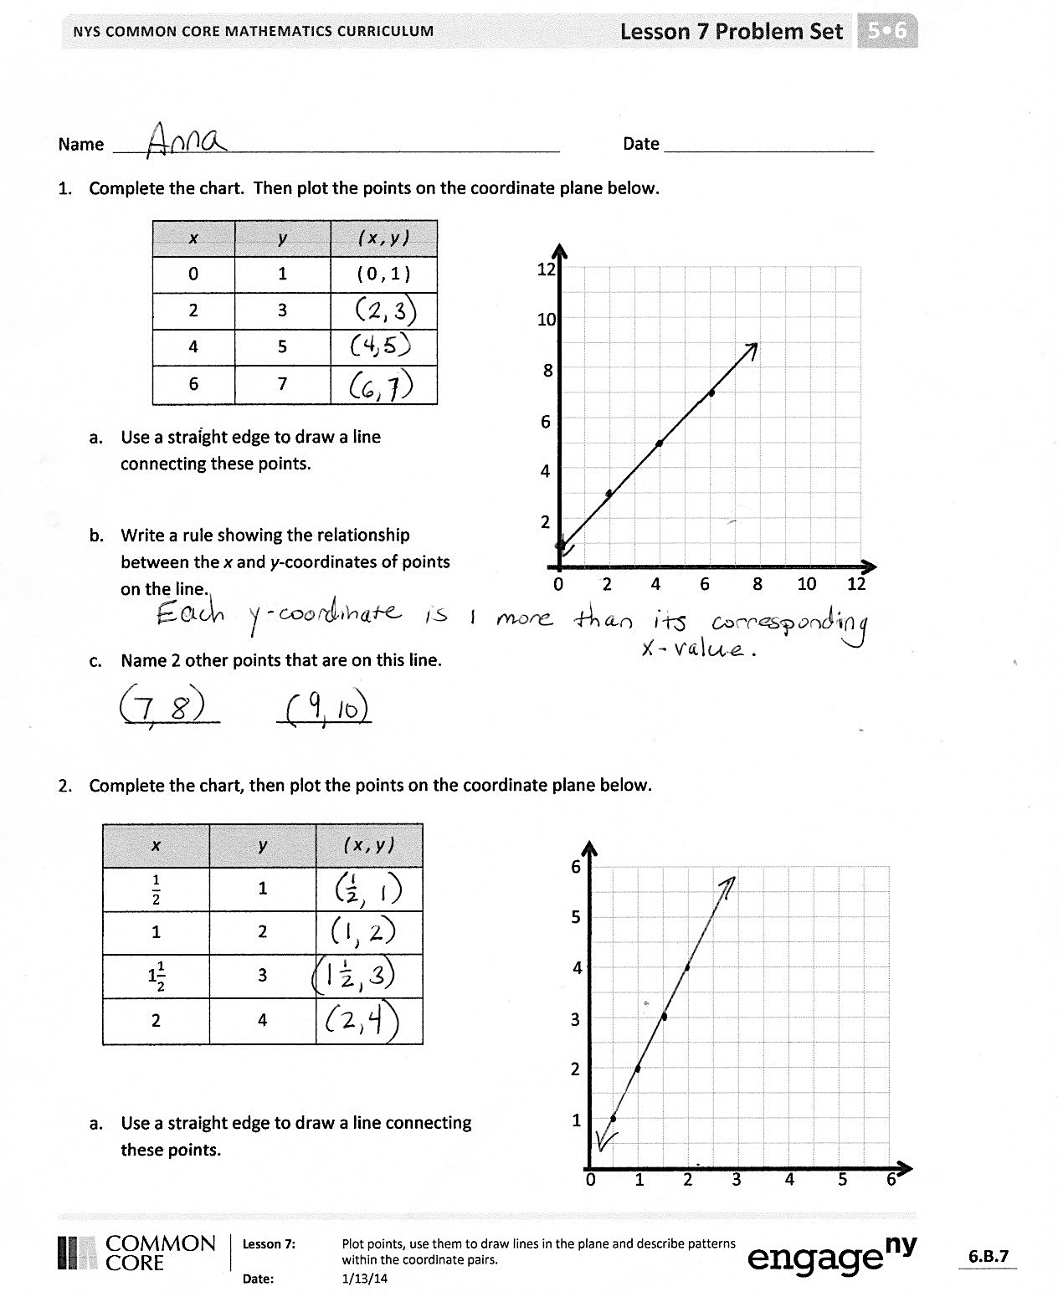
T: Write a rule for the coordinate pairs in chart (d).
S: $y$ is $x$ times 3. $y$ is 3 times more than $x$. Triple $x$ to get $y$. (Write student responses beneath chart (d).)
T: On the second plane, work with a neighbor to plot the three points from each chart, and the draw a line to connect the three points. (Circulate as students plot and construct lines.)
T: I’m going to show you some coordinate pairs. I’d like you to tell me which line the point would fall on. Be prepared to explain how you know. (Show coordinate pair (5, 10).)
S: $x$ times 2. Because 5 times 2 is ten, and this follows the pattern in chart (b). It’s the same as the pattern in chart (b). If you double $x,$ which is 5, you get 10, which is $y$. The $y$-coordinate is twice as much as the $x$-coordinate in this pair. That’s the same relationship as the other points on the line shown by chart (b).
T: (Show coordinate pair (5, $\text{4}\frac{1}{2}$).)
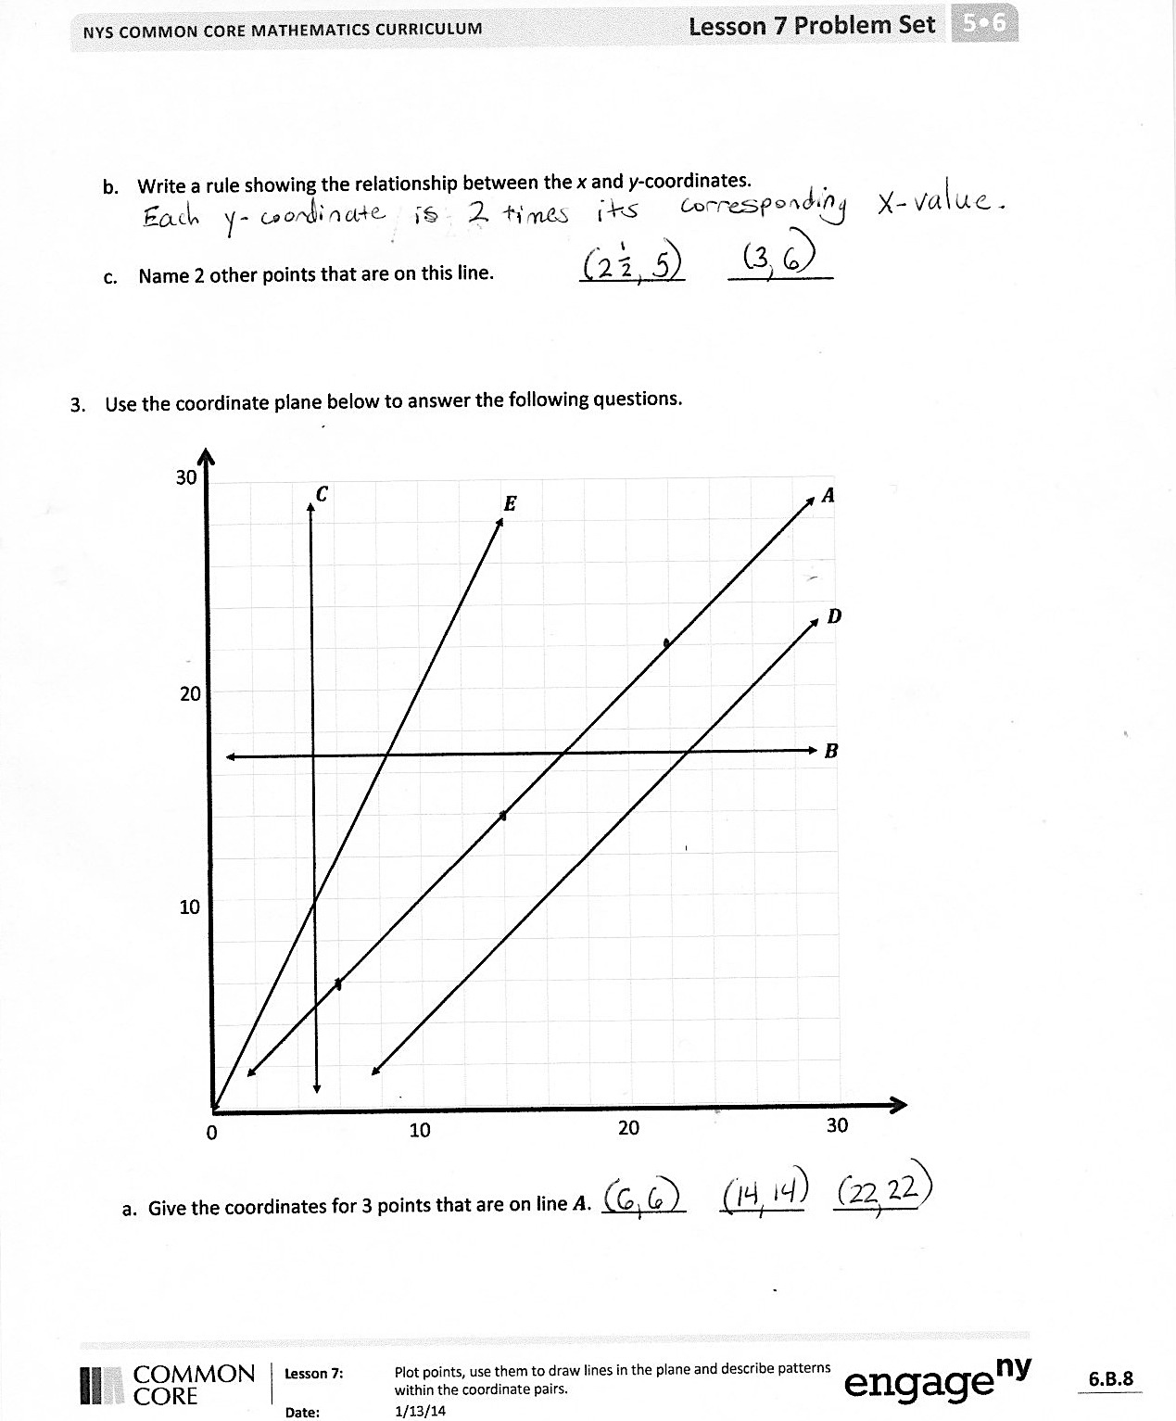
S: $y$ is $\frac{1}{2}$ less than $x$.
T: Tell a neighbor how you know.
S: 5 minus $\frac{1}{2}$ is $\text{4}\frac{1}{2}$. The $y$-coordinate is $\frac{1}{2}$ less than the $x$-coordinate.
T: (Show the coordinate pair ($\frac{1}{2}$, $\text{1}\frac{1}{2}$).)
S: $x$ times 3.
T: Tell a neighbor how you know.
S: 3 times $\frac{1}{2}$ is 3 halves, which is $\text{1}\frac{1}{2}$. The $y$-coordinate is 3 times as much as the $x$-coordinate.
T: (Show the coordinate pair, ($\text{1}\frac{1}{2}$, 3).)
S: $x$ times 2. $y$ is always 3.
T: Some of you said the rule for the coordinate pair is, $x$ times 2, and some of you said the rule is $y$ is always 3. Which relationship is correct? How do you know? Turn and talk.
S: Both rules are correct because this point is on both lines. The same point can be part of more than one line at a time.
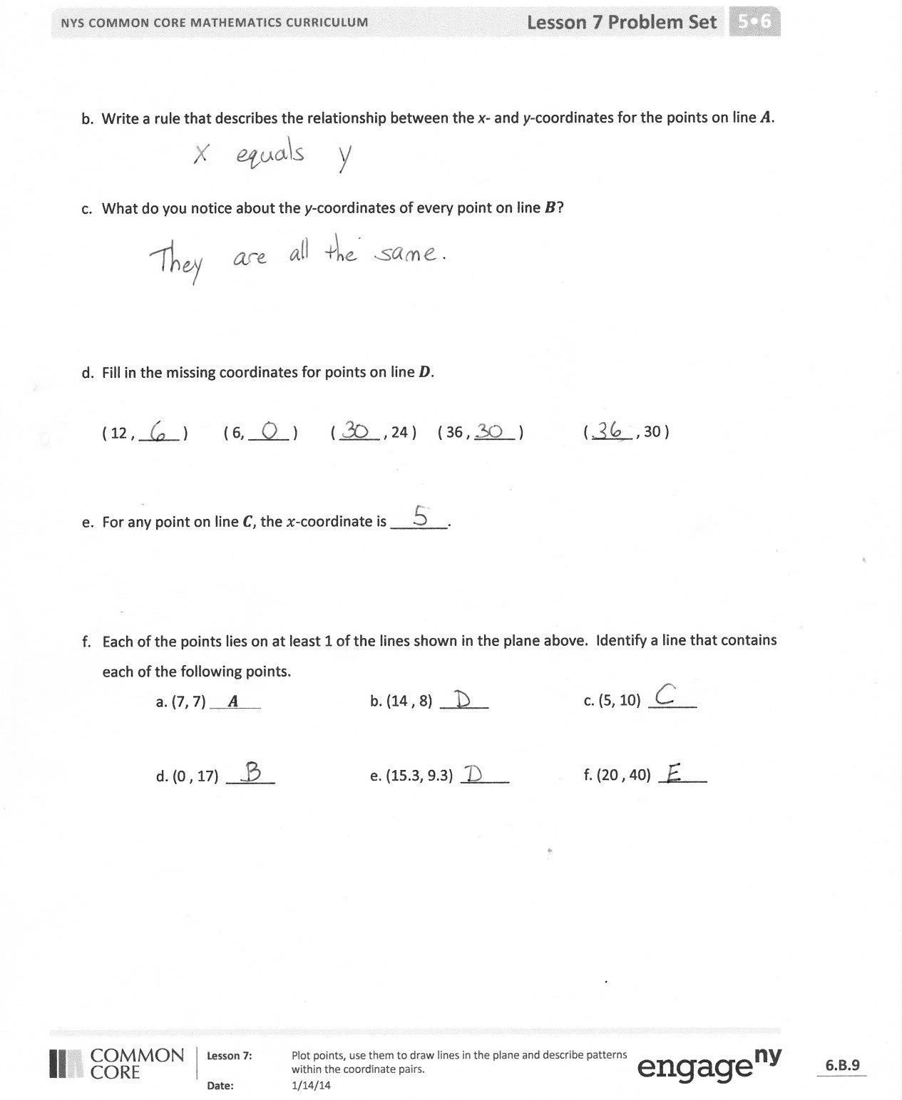
T: Looking at these lines, how can you tell that this coordinate pair would appear in both charts?
S: The two lines cross each other at that point. The lines intersect at ( $\text{1}\frac{1}{2}$, 3).
T: What about this coordinate pair? (Show (0, 0).)
S: $x$ times 2, and $x$ times 3.
T: Again, the point (0, 0) lies on both lines. Does that seem consistent with what we see when we look at the lines themselves? Explain.
S: Yes. You can see both lines going through the same point. The origin lies on both lines.
Problem Set (10 minutes)
Students should do their personal best to complete the Problem Set within the allotted 10 minutes. For some classes, it may be appropriate to modify the assignment by specifying which problems they work on first. Some problems do not specify a method for solving. Students solve these problems using the RDW approach used for Application Problems.

NOTES ON
MULTIPLE MEANS OF ENGAGEMENT:
One goal of the Student Debrief is to give all students time to articulate their thinking and make connections to prior knowledge. Whole group conversations may not always be the best way to give all students a chance to express themselves.
- Establish small groups with norms or protocols that give each member an opportunity to speak in turn.
- Ask students to talk to various classmates until they find a peer with a like viewpoint, opinion, or answer. This strategy requires students to express their ideas multiple times, perhaps improving as they go along.
- Pair students with peers with unlike opinions or answers. Require these pairs to talk to each other to find common understandings or errors in their ideas.

Student Debrief (10 minutes)
Lesson Objective: Plot points, using them to draw lines in the plane, and describe patterns within the coordinate pairs.
The Student Debrief is intended to invite reflection and active processing of the total lesson experience.
Invite students to review their solutions for the Problem Set. They should check work by comparing answers with a partner before going over answers as a class. Look for misconceptions or misunderstandings that can be addressed in the Debrief. Guide students in a conversation to debrief the Problem Set and process the lesson.
You may choose to use any combination of the questions below to lead the discussion.
- When you see a set of coordinate pairs, what is your strategy for identifying their pattern? What do you look for first? Then what?

- Compare your answers to Problems 1(c) and 2(c) with a neighbor. Are they the same or different? How many different sets of coordinate pairs are there for each rule?
- Look back at the coordinate pair (5, 10) in Problem 3 (f); how many lines shown on the plane contain this point? Compare and contrast the lines that contain this point.
Exit Ticket (3 minutes)
After the Student Debrief, instruct students to complete the Exit Ticket. A review of their work will help you assess the students’ understanding of the concepts that were presented in the lesson today and plan more effectively for future lessons. You may read the questions aloud to the students.
Name Date
- Complete the chart. Then, plot the points on the coordinate plane below.

0 2 4 6 8 10 12
2
4
6
8
10
12
$$x$$ | $$y$$ | ( $x$ , $y$ )
0 | 1 | ( 0 , 1 )
2 | 3
4 | 5
6 | 7

  - Use a straightedge to draw a line connecting these points.

  - Write a rule showing the relationship between the $x$- and $y$-coordinates of points on the line.

  - Name 2 other points that are on this line.

__________ __________

- Complete the chart. Then, plot the points on the coordinate plane below.

0 1 2 3 4 5 6
2
3
4
5
6
1
$$x$$ | $$y$$ | ( $x$ , $y$ )
$$\frac{1}{2}$$ | 1
1 | 2
1$\frac{1}{2}$ | 3
2 | 4

  - Use a straightedge to draw a line connecting these points.
  - Write a rule showing the relationship between the $x$- and $y$-coordinates.

  - Name 2 other points that are on this line. __________ __________

0 10 20 30

10
20
30
$$a$$
$$b$$
$$c$$
$$d$$
$$e$$
- Use the coordinate plane below to answer the following questions.
  - Give the coordinates for 3 points that are on line $a$. ________ ________ ________

  - Write a rule that describes the relationship between the $x$- and $y$-coordinates for the points on line$a$.
  - What do you notice about the $y$-coordinates of every point on line $b$?

  - Fill in the missing coordinates for points on line$d.$

( 12, _____ ) ( 6, _____ ) ( _____, 24 ) ( 36 , _____ ) ( _____, 30 )

  - For any point on line$c$, the $x$-coordinate is _______.

  - Each of the points lies on at least 1 of the lines shown in the plane above. Identify a line that contains each of the following points.
- (7, 7) $a$ b. (14 , 8) ______ c. (5, 10) ______
- (0 , 17) ______ e. (15.3, 9.3) ______ f. (20 , 40) ______

Name Date
Complete the chart. Then, plot the points on the coordinate plane.

0 2 4 6 8 10 12
2
4
6
8
10
12
$$x$$ | $$y$$ | ( $x$ , $y$ )
0 | 4
2 | 6
3 | 7
7 | 11

- Use a straightedge to draw a line connecting these points.
- Write a rule to show the relationship between the $x$- and $y$- coordinates for points on the line.

- Name two other points that are also on this line.

Name Date
$$x$$ | $$y$$ | ( $x$ , $y$ )
2 | 0
3$\frac{1}{2}$ | 1$\frac{1}{2}$
4$\frac{1}{2}$ | 2$\frac{1}{2}$
6 | 4
- Complete the chart. Then, plot the points on the coordinate plane.

0 1 2 3 4 5 6
2
3
4
5
6
1

- Use a straightedge to draw a line connecting these points.
- Write a rule showing the relationship between the $x$- and $y$- coordinates of points on this line.
- Name two other points that are also on this line. _____________ _____________

- Complete the chart. Then, plot the points on the coordinate plane.
2

0 1 2 3
3
1
$$x$$ | $$y$$ | ( $x$ , $y$ )
0 | 0
$$\frac{1}{4}$$ | $$\frac{3}{4}$$
$$\frac{1}{2}$$ | $$1\frac{1}{2}$$
1 | 3

- Use a straightedge to draw a line connecting these points.
- Write a rule showing the relationship between the $x$- and $y$- coordinates for points on the line.
- Name two other points that are also on this line. _____________ _____________
- Use the coordinate plane to answer the following questions.
2

0 2 4 6 8 10 12 14 16 18 20 22 24
4
6
8
10
12
14
16
18
20
22
$$l$$
$$m$$
$$q$$
$$n$$

  - For any point on line$m$, the $x$-coordinate is _______.
- Give the coordinates for 3 points that are on line $n$.

- Write a rule that describes the relationship between the $x$- and $y$-coordinates on line $n$.

- Give the coordinates for 3 points that are on line $q$.

- Write a rule that describes the relationship between the $x$- and $y$-coordinates on line $q$.

- For each point, identify a line on which each of these points lie.
(10,3.2) ______ (12.4, 18.4) ______ (6.45, 12) ______ (14, 7) ______

Name Date
1.
- b.
Point | $$x$$ | $$y$$ | ($x$, $y$)
$$A$$ | 0 | 0 | (0, 0)
$$B$$ | 1 | 1 | (1, 1)
$$C$$ | 2 | 2 | (2, 2)
$$D$$ | 3 | 3 | (3, 3)

Point | $$x$$ | $$y$$ | ($x$, $y$)
$$G$$ | 0 | 3 | (0, 3)
$$H$$ | $$\frac{1}{2}$$ | $3\frac{1}{2}$ | ($\frac{1}{2}$, $3\frac{1}{2}$)
$$I$$ | 1 | 4 | (1, 4)
$$J$$ | $1\frac{1}{2}$ | $4\frac{1}{2}$ | ( $1\frac{1}{2}$, $4\frac{1}{2}$)

0 1 2 3 4 5

4

3

2

1

1
5

2.
a.
Point | ($x$, $y$)
$$L$$ | (0, 3)
$$M$$ | (2, 3)
$$N$$ | (4, 3)

b.
Point | ($x$, $y$)
$$O$$ | (0, 0)
$$P$$ | (1, 2)
$$Q$$ | (2, 4)

c.
Point | ($x$, $y$)
$$R$$ | (1, $\frac{1}{2}$)
$$S$$ | (2, $1\frac{1}{2}$)
$$T$$ | (2, $2\frac{1}{2}$)

d.
Point | ($x$, $y$)
$$U$$ | (1, 3)
$$V$$ | (2, 6)
$$W$$ | (3, 9)

0 1 2 3 4 5

1
2
3

3

3
4
5
6
7
8
9

