Lesson 6
Objective: Investigate patterns in vertical and horizontal lines, and interpret points on the plane as distances from the axes.

Suggested Lesson Structure
 Fluency Practice (12 minutes)
 Application Problem (7 minutes)
 Concept Development (31 minutes)
 Student Debrief (10 minutes)
Total Time (60 minutes)
Fluency Practice (12 minutes)
- Multiply and Divide by 10, 100, and 1,000 5.NBT.2 (4 minutes)
- Count by Decimals 5.NBT.1 (4 minutes)
- Find the Missing Number on a Number Line 5.G.1 (4 minutes)
Multiply and Divide by 10, 100, and 1,000 (4 minutes)
Materials: (T) Place value chart (S) Personal white boards
Note: This fluency activity reviews G5–Module 1 topics.
T: (Project place value chart from millions to thousandths.) What is 0.003 × 10?
S: 0.03
Repeat the process for this possible sequence: 0.005 $\text{×}$ 100, 0.005 $\text{×}$ 1000, 1.005 $\text{×}$ 1,000, 1.035 $\text{×}$ 100, 1.235 $\text{×}$ 100, 1.235 $\text{×}$ 10, 1.235 $\text{×}$ 1,000.
Repeat the process for dividing by 10, 100 and 1,000 for this possible sequence: 2 ÷ 10, 2.1 ÷ 10, 2.1 ÷ 100,
21 ÷ 1,000, 547 ÷ 1,000.
Count by Decimals (4 minutes)
Materials: (S) Personal white boards
Note: This fluency activity prepares students for G5–M6–Lesson 6.
T: Count by twos to twenty, starting at zero.
S: 0, 2, 4, 6, 8, 10, 12, 14, 16, 18, 20.
T: Count by 2 tenths to 20 tenths, starting at zero.
S: 0 tenths, 2 tenths, 4 tenths, 6 tenths, 8 tenths, 10 tenths, 12 tenths, 14 tenths, 16 tenths, 18 tenths, 20 tenths.
T: (Write 10 tenths = 1 __.) Write the number sentence.
S: (Write 10 tenths = 1 one.)
T: (Write 20 tenths = __ ones.)
S: (Write 20 tenths = 2 ones.)
T: Starting at zero, count by 2 tenths again. This time, when you come to a whole number, say the whole number.
S: 0 tenths, 2 tenths, 4 tenths, 6 tenths, 8 tenths, 1, 12 tenths, 14 tenths, 16 tenths, 18 tenths, 2.
T: (Write $\text{0.2} \text{=} \frac{}{}$.)
S: (Write $\text{0.2} \text{=}\frac{2}{10}$.)
T: Count from zero tenths to 2 again. When I raise my hand, stop.
S: 0 tenths, 2 tenths, 4 tenths, 6 tenths.
T: (Raise hand.) Write 6 tenths as a decimal.
S: (Write 0.6.)
T: Continue.
S: 8 tenths, 1, 12 tenths, 14 tenths, 16 tenths.
Continue up to and down from 2 ones, stopping to have students write various numbers in decimal form.
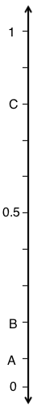
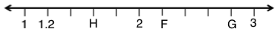
Find the Missing Number on a Number Line (4 minutes)
Materials: (S) Personal white boards
Note: This fluency activity reviews G5–M6–Lesson 1. For the last number line, challenge students by having them write simplified fractions.
T: (Project number line partitioned into 10 intervals. Label 0 and 1 as the endpoints. Point to $A$.) What is the value of $A$?
S: 1 tenth.
T: What’s the value of $B$?
S: 2 tenths.
T: Write the value of $C$.
S: (Write 0.8.)
Continue the process for the other number lines.
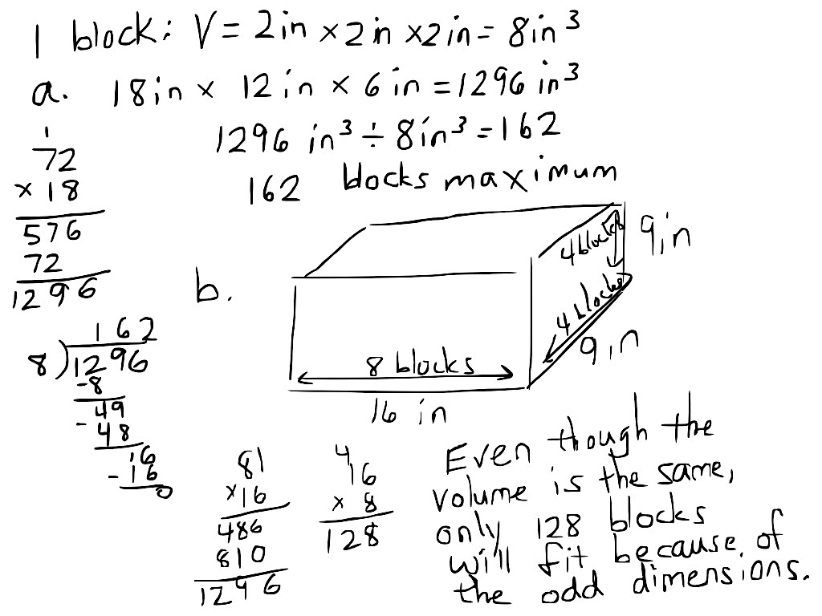
Application Problem (7 minutes)
Adam built a toy box for his children’s wooden blocks.
- If the inside dimensions of the box are 18 inches by 12 inches by 6 inches, what is the maximum number of 2-inch wooden blocks that will fit in the toy box?
- What if Adam had built the box 16 inches by 9 inches by 9 inches? What is the maximum number of 2-inch wooden blocks that would fit in this size box?
Note: Today’s Application Problem reviews the volume work done in G5–Module 5. Part (b) extends the problem so that students must take into account the individual dimensions of the blocks.
Concept Development (31 minutes)
Materials: (S) Coordinate plane template, 1 red and 1 blue pencil or crayon, straightedge
Problem 1: Refer to locations as distances from the axes.
T: (Distribute one coordinate plane template to each student, and display an image of it on the board.) Plot a point, $A$, at ($\text{2}\frac{1}{2}$, $\text{1}\frac{1}{4}$).
S: (Plot.)
T: Explain to your partner what these coordinates tell us.
S: They tell how far over on $x$ you have to travel from zero, and then how far up parallel to $y$ you have to go to find the point. The first one tells how far over, and the second one tells how far up.
T: I’d like to describe the shortest distance to $A$ from the $x$-axis. (Point to the perpendicular distance from $x$ to the point.) How might I do that? Turn and talk.
S: You just go straight up from the $x$-axis and count the units. It’s $\text{1}\frac{1}{4}$ straight up from the line. The $y$-coordinate tells how far from the $x$-axis you have to go up. It’s like the horizontal lines we did yesterday. $Y$ tells how far from the $x$ line. Go the same distance as the $y$-coordinate in a perpendicular line from the $x$-axis.
T: I’d like to describe the shortest distance to $A$ from the $y$-axis. How far is $A$from the $y$-axis along a line perpendicular to $y$? (Point to the distance on the plane.) Turn and talk.
S: It’s the same thing. Just go straight over from the $y$-axis. It is $\text{2}\frac{1}{2}$ from $y$ in a straight line that’s parallel to $x$. The $x$-coordinate tells the distance from $y$. It is $\text{2}\frac{1}{2}$ in a perpendicular line from $y$.
T: Let’s record. What is the shortest distance to $A$ from the $x$-axis?
S: $\text{1}\frac{1}{4}$ units.
T: (Write on the board: The shortest distance to $A$ is $\text{1}\frac{1}{4}$ units from the $x$-axis.)
T: What is the shortest distance to $A$ from the $y$-axis?
S: $\text{2}\frac{1}{2}$ units.
T: (Write on the board: The shortest distance to $A$ from the $y$-axis is $\text{2}\frac{1}{2}$ units.)
T: What do you notice about these distances from each of the axes? Turn and talk.
S: They are the same numbers as in the coordinates, but the order is switched. The $x$-coordinate tells the shortest distance to the point from the $y$-axis, and the $y$-coordinate tells the shortest distance to the point from the $x$-axis.
Problem 2: Construct horizontal and vertical lines on the coordinate plane.
T: Construct a line, $l$, so that it contains $A$ and is perpendicular to the $x$-axis. (Draw line.)
S: (Draw line.)
T: Work with a neighbor to give the coordinates for another point on line $l$ that is $\text{1}\frac{1}{2}$ units farther from the $x$-axis than $A$. Label it $B$.
S: (Work and share.)
$$l$$
$$n$$
$$m$$
T: Name the coordinates of $B$.
S: ($\text{2}\frac{1}{2}$, $\text{2}\frac{3}{4}$).
T: (Plot $B$ on the board.) Give the coordinates for the point on $l$ that is halfway between $A$ and $B$. How did you find it? Turn and talk.
S: I used my fingers to go up 1 fourth from $A$ and down 1 fourth from $B$ until I found the middle. The middle was at ($\text{2}\frac{1}{2}$, 2). I counted up from $A$, and there were 6 fourths until I got to $B$. Half of 6 fourths is 3 fourths. So, the location of the point would have to have a $y$-coordinate that is $\frac{3}{4}$ more than $A$, which would be $\text{2}$. The length of $AB$ is $\text{1}\frac{1}{2}$. I could find half of $\text{1}\frac{1}{2}$, which is $\frac{3}{4}$, and that would help me locate the point. Since the point is on line $l$, we know the $x$-coordinate is going to be $\text{2}\frac{1}{2}$. Halfway between the $y$-coordinates is 2. So, the location is ($\text{2}\frac{1}{2}$, 2).
T: Name the coordinates of the point that is halfway between $A$ and $B$.
S: ($\text{2}\frac{1}{2}$, 2).
T: Plot this point, name it $C$, and record its location in the chart.
S: (Plot and record.)
T: Now, work with a partner to draw a line, $m$, that is perpendicular to line $l$ and $\frac{1}{2}$ unit from the $x$-axis.
S: (Draw line.)
T: Plot a point, $D$, where lines $l$ and $m$ intersect.
S: (Plot $D$.)
T: Record the coordinates of $D$ in the chart.
S: (Record the coordinates.)
T: How far is $D$ from the $y$-axis?
S: $\text{2}\frac{1}{2}$ units.
T: How far is $D$ from the $x$-axis?
S: One half unit.
T: What are the coordinates of $D$.
S: ($\text{2}\frac{1}{2}$, $\frac{1}{2}$). (Plot $D$ on the board.)
T: Plot a point, $E$, on line $m$, that is $\frac{3}{4}$ unit from the $y$-axis. Then, record the coordinates of $E$ in the chart.
S: (Plot $E$ and record.)
T: Name the coordinates of $E$.
S: ($\frac{3}{4}$, $\frac{1}{2}$). (Plot $E$ on the board.)
T: Plot a point $F$, on line $m$, that is $\frac{3}{4}$ unit farther from the $y$-axis than $E$. Then, record the coordinates of $F$ in the chart.
S: (Plot $F$ and record.)
T: Name the coordinates of $F$.
S: ($\text{1}\frac{1}{2}$, $\frac{1}{2}$). (Plot $F$ on the board.)
T: Use your straightedge to construct a line, $n$, that is parallel to line $l$ and contains point $F$.
S: (Construct $n$.)
T: Name the $x$-coordinate for every point on line $n$.
S: $\text{1}\frac{1}{2}$. (Draw line $n$ on board.)
Problem 3: Identify regions of the plane created by intersecting lines.
T: I’m going to move my finger along the plane. Say, “Stop,” when I get to a location that is $\text{1}\frac{1}{2}$ units from the $y$-axis. (Slowly drag finger horizontally across plane along any line perpendicular to the $y$-axis.)
S: (Say, “Stop,” when teacher’s finger gets to $x$-coordinates of $\text{1}\frac{1}{2}$.)
$$l$$
$$n$$
T: (Run your finger vertically along line $n$.) Is every $x$-coordinate to the left of this line greater than or less than a distance of $\text{1}\frac{1}{2}$?
S: Less than $\text{1}\frac{1}{2}$.
T: And every $x$-coordinate to the right of this line is…?
S: Greater than $\text{1}\frac{1}{2}$.
T: Let’s use our red pencil (or crayon) to shade the part of the plane that we can see that is more than $\text{1}\frac{1}{2}$ units from they $y$-axis. (Model on board.)
$$m$$
S: (Shade plane.)
T: Show your neighbor the portion of the plane that is less than $\text{2}\frac{1}{2}$ units from the $y$-axis.
S: (Indicate plane to the left of line $l$.)
T: Shade this region of the plane using your blue pencil (or crayon).
S: (Shade plane.)
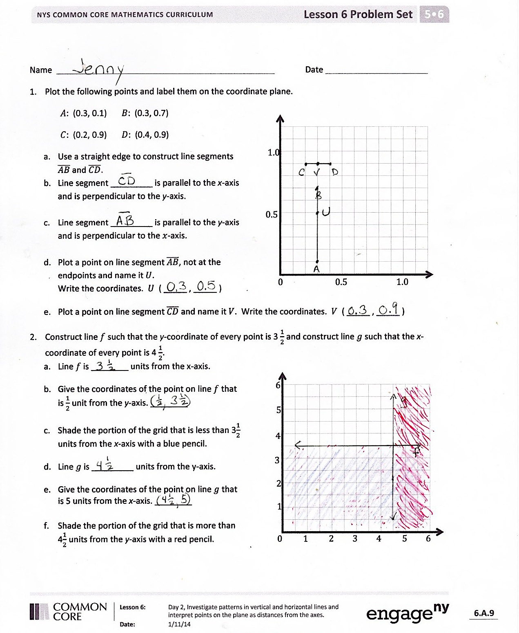
T: Work with a partner to name a point that would lie in the region that is double shaded.
S: (Work and share with partner.)
T: Show your neighbor the part of the plane that is double shaded and contains points which are farther from the $x$-axis than those on line $m$.
S: (Share with partner.)
T: On your boards, write the coordinates of a point that is in the double shaded part and is also closer to the $x$-axis than line $m$.
S: (Give an $x$-coordinate between $\text{1}\frac{1}{2}$ and $\text{2}\frac{1}{2}$ and a $y$-coordinate between 0 and $\frac{1}{2}$.)
Problem Set (10 minutes)
Students should do their personal best to complete the Problem Set within the allotted 10 minutes. For some classes, it may be appropriate to modify the assignment by specifying which problems they work on first. Some problems do not specify a method for solving. Students solve these problems using the RDW approach used for Application Problems.
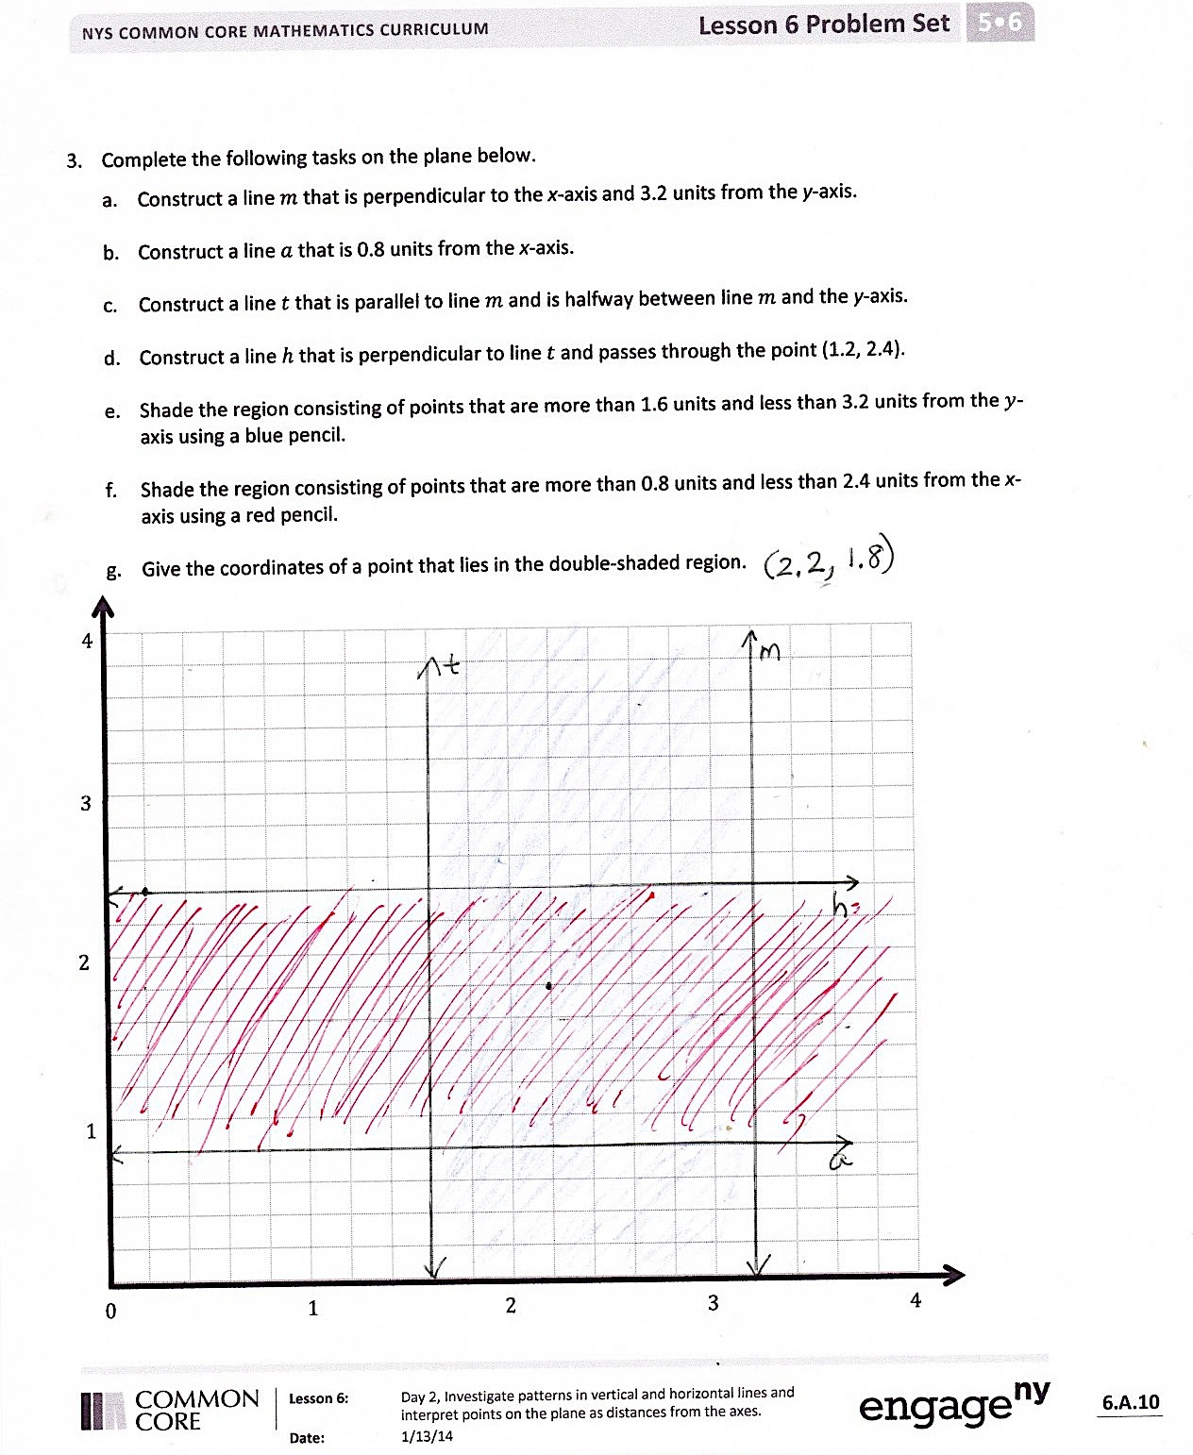
Student Debrief (10 minutes)
Lesson Objective: Investigate patterns in vertical and horizontal lines, and interpret points on the plane as distances from the axes.
The Student Debrief is intended to invite reflection and active processing of the total lesson experience.
Invite students to review their solutions for the Problem Set. They should check work by comparing answers with a partner before going over answers as a class. Look for misconceptions or misunderstandings that can be addressed in the Debrief. Guide students in a conversation to debrief the Problem Set and process the lesson.
You may choose to use any combination of the questions below to lead the discussion.
- In Problem 3, name the coordinates shared by lines $t$ and $h,$ $m$ and $h$, $m$ and $a$, $t$ and $a$.
- Do lines $m$ and $t$ have any points in common? Just by looking at the distances of these lines from the $y$-axis, could you answer this question? Why or why not? How do you know by looking at the graphs of the lines?
- In Problem 3, what is the area of the shape enclosed by lines $m$, $a, t$, and $h$?
- What patterns do you notice in the coordinates for vertical lines? What patterns do you notice in the coordinates for horizontal lines?
- Which coordinate tells the distance of a point from the $x$-axis? Which coordinate tells the distance of a point from the $y$-axis?
Exit Ticket (3 minutes)
After the Student Debrief, instruct students to complete the Exit Ticket. A review of their work will help you assess the students’ understanding of the concepts that were presented in the lesson today and plan more effectively for future lessons. You may read the questions aloud to the students.

Name Date
- Plot the following points, and label them on the coordinate plane.

0 0.5 1.0
0.5
1.0
$A$: (0.3, 0.1) $B$: (0.3, 0.7)
$C$: (0.2, 0.9) $D$: (0.4, 0.9)
- Use a straightedge to construct line segments $\overline{AB}$and $\overline{CD}$.

- Line segment _________ is parallel to the $x$-axis and is perpendicular to the $y$-axis.

- Line segment _________ is parallel to the $y$-axis and is perpendicular to the $x$-axis.

- Plot a point on line segment$\overline{AB}$ that is not at the endpoints, and name it$U$.
Write the coordinates. $U$ ( _____ , _____ )
- Plot a point on line segment$\overline{CD}$ and name it$V$. Write the coordinates. $V$ ( _____ , _____ )
- Construct line $f$ such that the $y$-coordinate of every point is $3\frac{1}{2},$ and construct line $g$ such that the $x$-coordinate of every point is $4\frac{1}{2}$.
- Line $f$ is ________ units from the $x$-axis.

2
4
0 1 2 3 4 5 6
1
3
5
6

- Give the coordinates of the point on line $f$ that is $\frac{1}{2}$unit from the $y$-axis. ________

- With a blue pencil, shade the portion of the grid that is less than $3\frac{1}{2}$ units from the $x$-axis.

- Line $g$ is _________ units from the $y$-axis.

- Give the coordinates of the point on line $g$ that is 5 units from the $x$-axis. ________

- With a red pencil, shade the portion of the grid that is more than $4\frac{1}{2}$ units from the $y$-axis.

- Complete the following tasks on the plane below.
- Construct a line $m$ that is perpendicular to the $x$-axis and 3.2 units from the $y$-axis.
- Construct a line $a$ that is 0.8 units from the $x$-axis.
- Construct a line $t$ that is parallel to line $m$ and is halfway between line $m$ and the $y$-axis.
- Construct a line $h$ that is perpendicular to line $t$ and passes through the point (1.2, 2.4).
- Using a blue pencil, shade the region that contains points that are more than 1.6 units and less than 3.2 units from the $y$-axis.

- Using a red pencil, shade the region that contains points that are more than 0.8 units and less than 2.4 units from the $x$-axis.

- Give the coordinates of a point that lies in the double-shaded region.
4
0 1 2 3 4

3

2

1

Name Date
- Plot the point $H$ ($2\frac{1}{2}$, $1\frac{1}{2}$).
- Line $l$ passes through point $H$ and is parallel to the $y$-axis. Construct line $l$.
- Construct line $m$ such that the $y$-coordinate of every point is $\frac{3}{4}$.
- Line $m$ is ________ units from the $x$-axis.
- Give the coordinates of the point on line $m$ that is $\frac{1}{2}$unit from the $y$-axis.

- With a blue pencil, shade the portion of the plane that is less than $\frac{3}{4}$ units from the $x$-axis.
- With a red pencil, shade the portion of the plane that is less than $2\frac{1}{2}$ units from the $y$-axis.
- Plot a point that lies in the double-shaded region. Give the coordinates of the point.

2

0 1 2 3
3
1

Name Date
- Plot and label the following points on the coordinate plane.
$C$: (0.4, 0.4) $A$: (1.1, 0.4) $S$: (0.9, 0.5) $T$: (0.9, 1.1)
  - Use a straightedge to construct line segments $\overline{CA}$and $\overline{ST}$.

0 0.5 1.0
0.5
1.0
  - Name the line segment that is perpendicular to the $x$-axis and parallel to the $y$-axis.
  - Name the line segment that is parallel to the $x$-axis and perpendicular to the $y$-axis.
  - Plot a point on $\overline{CA}$ and name it$E$. Plot a point on line segment$\overline{ST}$ and name it$R$.
  - Write the coordinates of points $E$ and$R$.
$E$ ( ____ , ____ ) $R$ ( ____ , ____ )

- Construct line $m$ such that the $y$-coordinate of every point is $1\frac{1}{2},$ and construct line $n$ such that the $x$-coordinate of every point is $5\frac{1}{2}$.

- Line $m$ is ________ units from the $x$-axis.

2
4
0 1 2 3 4 5 6
1
3
5
6
- Give the coordinates of the point on line $m$ that is $2$units from the $y$-axis. ________

- With a blue pencil, shade the portion of the grid that is less than $1\frac{1}{2}$ units from the x-axis.
- Line $n$ is _________ units from the $y$-axis.
- Give the coordinates of the point on line $n$ that is $3\frac{1}{2}$ units from the $x$-axis. ________
- With a red pencil, shade the portion of the grid that is less than $5\frac{1}{2}$ units from the $y$-axis.

- Construct and label lines $e$, $r,$ $s,$ $o$ on the plane below.
- Line $e$ is 3.75 units above the $x$-axis.
- Line $r$ is 2.5 units from the $y$-axis.
- Line $s$ is parallel to line $e$ but 0.75 farther from the $x$-axis.
- Line $o$ is to perpendicular to lines $s$ and $e$ and passes through the point ($3\frac{1}{4}$, $3\frac{1}{4}$).
- Complete the following tasks on the plane.
- Using a blue pencil, shade the region that contains points that are more than $2\frac{1}{2}$ units and less than $3\frac{1}{4}$ units from the $y$-axis.
- Using a red pencil, shade the region that contains points that are more than $3\frac{3}{4}$ units and less than $4\frac{1}{2}$ units from the $x$-axis.
- Plot a point that lies in the double shaded region, and label its coordinates.
0 1 2 3 4 5
1
3
2
4

Point | $$x$$ | $$y$$ | ($x$, $y$)
$$A$$
$$B$$
$$C$$

Point | $$x$$ | $$y$$ | ($x$, $y$)
$$D$$
$$E$$
$$F$$

0 1 2 3
1
2
3

