Lesson 5
Objective: Investigate patterns in vertical and horizontal lines, and interpret points on the plane as distances from the axes.

Suggested Lesson Structure
 Application Problem (7 minutes)
 Fluency Practice (12 minutes)
 Concept Development (31 minutes)
 Student Debrief (10 minutes)
Total Time (60 minutes)
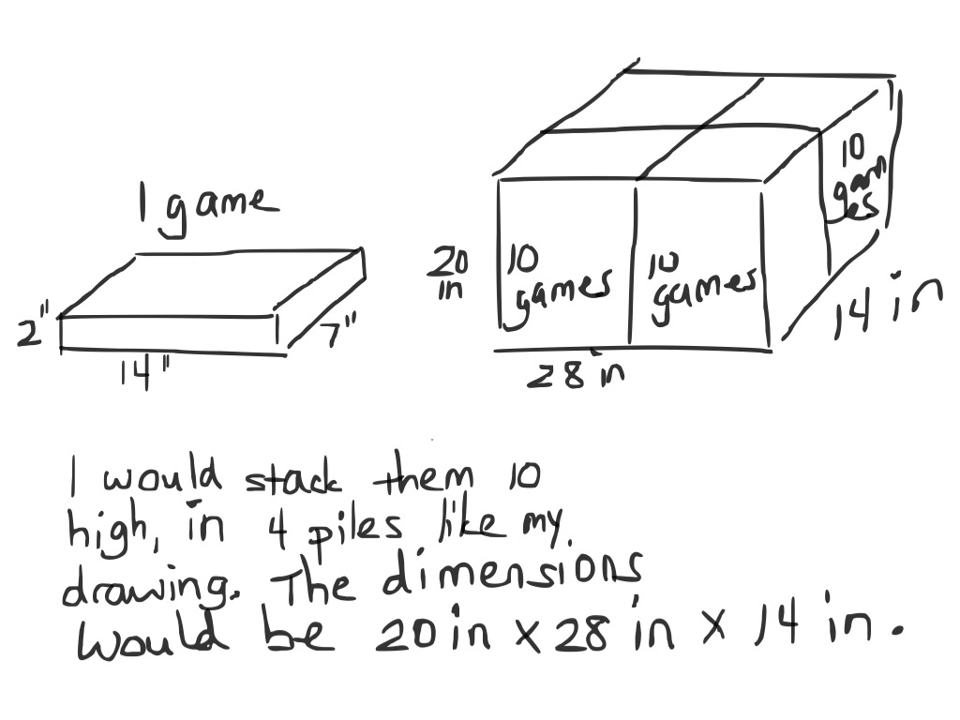
Application Problem (7 minutes)
A company has developed a new game. Cartons are needed to ship 40 games at a time. Each game is 2 inches high by 7 inches wide by 14 inches long.
How would you recommend packing the board games in the carton? What are the dimensions of a carton that could ship 40 board games with no extra room in the box?
Note: Today’s Application Problem reviews the volume work done in G5–Module 5. It precedes the fluency work so that the decimal practice in today’s Fluency Practice flows directly into the Concept Development where it is applied.
Fluency Practice (12 minutes)
- Multiply 5.NBT.5 (4 minutes)
- Count by Decimals 5.NBT.1 (4 minutes)
- Decimals on Number Lines 5.G.1 (4 minutes)
Multiply (4 minutes)
Materials: (S) Personal white boards
Note: This fluency activity reviews year-long fluency standards.
T: (Write 4 tens 5 ones × 3 tens 1 one = __ × __.) Write the multiplication expression in standard form.
S: (Write 45 × 31.)
T: Solve 45 × 31 using the standard algorithm or the area model.
S: (Solve 45 × 31. The product is 1,395.)
Continue the process for 345 × 31, 47 × 23, 247 × 23, and 753 × 35.
Count by Decimals (4 minutes)
Materials: (S) Personal white boards
Note: This fluency activity prepares students for G5–M6–Lesson 6.
T: Count with me by ones to ten, starting at zero.
S: 0, 1, 2, 3, 4, 5, 6, 7, 8, 9, 10.
T: Count by tenths to 10 tenths, starting at zero.
S: 0 tenths, 1 tenth, 2 tenths, 3 tenths, 4 tenths, 5 tenths, 6 tenths, 7 tenths, 8 tenths, 9 tenths, 10 tenths.
T: (Write 10 tenths = 1 __.) Write the number sentence.
S: (Write 10 tenths = 1 one.)
T: Starting at zero, count by tenths again. This time, when you come to a whole number, say the whole number.
S: 0 tenths, 1 tenth, 2 tenths, 3 tenths, 4 tenths, 5 tenths, 6 tenths, 7 tenths, 8 tenths, 9 tenths, 1.
T: Write the fraction equivalent to zero point one.
S: (Write $\frac{}{10}$.)
T: Count from 0 tenths to 1 again. When I raise my hand, stop.
S: 0 tenths, 1 tenth, 2 tenths, 3 tenths.
T: (Raise hand.) Write 3 tenths as a decimal.
S: (Write 0.3.)
Continue the process counting up to 1 one and down from 1 one to zero, stopping students at various points to write numbers in decimal form.
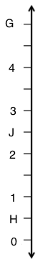
Decimals on Number Lines (4 minutes)
4
Materials: (S) Personal white boards
Note: This fluency activity reviews G5–M6–Lesson 1.
T: (Project a number line partitioned into 10 intervals. Label 4 and 5 as the endpoints. Point to $A$.) What is the value of $A$ as a decimal?
S: 4.9.
T: What’s the value of $B$?
S: 4.1.
T: Write the value of C.
S: (Write 4.7.)
Continue the process for the other number lines.
$$w$$
$$p$$
$$q$$
Concept Development (31 minutes)
Materials: (S) Straightedge, coordinate plane template
Problem 1: Identify the pattern in coordinate pairs that results in horizontal lines.
T: (Distribute a copy of the coordinate plane template to each student, and project a copy on the board.) On coordinate plane (a), plot a point $H$, that is 3 units from the $x$-axis and 4 units from the $y$-axis.
S: (Plot $H$.)
T: Say the coordinates of this point.
S: (4, 3). (Plot $H$ on the board.)
T: Write the coordinates of $H$ in the chart.
S: (Fill in the chart.)
T: Plot a second point, $I$, at (10, 3), and write its coordinates in the chart.

NOTES ON
MULTIPLE MEANS OF ENGAGEMENT:
Many of the math lessons in A Story of Units, although scaffolded, are meant to be challenging. Therefore, some students may need support in developing perseverance. There are several websites endorsed by the Universal Design for Learning Center dedicated to this end:
- Coping Skills for Kids: Brain Works Project. This website addresses the varying ways one can cope and learn to cope.
- Lesson Planet: 386 Coping Skills Strategies Lesson Plans Reviewed by Teachers. These lesson plans are rated by teachers and sorted by grade level.

S: (Plot $I,$ and fill in the chart.)
T: Plot a third point, $J$, at (8, 3), and put the coordinates in the chart.
S: (Plot $J$.)
T: What do you notice about these three points and their coordinates? Turn and talk.
S: They have different $x$-coordinates, but the $y$-coordinates are all threes. All of the points are the same distance away from the $x$-axis.
T: Use a straightedge to draw a line that goes through $H$, $I,$ and $J$. Label the line $w$.
S: (Construct line.)
T: What do you notice about line $w$?
S: It’s a perfectly straight line. It goes from left to right across the page. It’s a horizontal line. It’s almost like another $x$-axis, except it’s been shifted up.
T: Does line $w$ ever intersect with the $x$-axis?
S: No.
T: Tell a neighbor the term for lines that never intersect?
S: Parallel.
T: Right! Finish my sentence. Line $w$ is parallel to the…?
S: $x$-axis.
T: Does line $w$ ever intersect with the $y$-axis?
S: Yes.
T: Give the coordinates of the intersection.
S: (0, 3).
T: What kind of angle is formed at the intersection of line $w$ and the $y$-axis? Turn and talk.
S: I can see two 90-degree angles being made when they intersect. When the $x$- and $y$-axis meet, it makes a right angle, and since $w$ is parallel to the $x$-axis, it must also make a right angle.
T: What is the name for intersecting lines that form right angles?
S: Perpendicular.
T: Yes! Finish this sentence. Line $w$ is perpendicular to the…?
S: $y$-axis.
T: Plot points $K$ and $L$ so that they are on line $w$; then, record their coordinates in the chart.
S: (Plot and record.)
T: Looking at the coordinates of this line again, what can you conclude about the coordinates of points on the same horizontal line? Turn and talk.
S: The $y$-coordinate doesn’t change for any points on the line. No matter what the $x$-coordinate is, the $y$-coordinate stays the same.
T: Tell your neighbor the coordinates of two other points that would fall on line $w,$ but whose $x$-coordinates are greater than 12. Would these points be visible on the part of the plane we see here? Why or why not?
S: (Share.) You couldn’t see them on this part. We would have to extend both axes a little farther to see points with $x$-coordinates greater than 12.
MP.2
T: Would the point with coordinates ($\text{15}\frac{1}{2}$, 3) fall on line $w$? Tell a neighbor how you know.
S: Yes, it would, because it has 3 as a $y$-coordinate. It doesn’t matter what the $x$-coordinate is. If the $y$-coordinate is 3, then the point will be on line $w$.
T: Would the point with coordinates (3, 5) fall on line $w$? Tell your partner how you know.
S: (Share.)
T: Work with a neighbor to create a line that would also be parallel to the $x$-axis. If we wanted this line to be a greater distance from the $x$-axis than $w$, what will we need to think about?
S: We will have to pick a $y$-value that is greater than 3. We can use the same $x$-values, but our $y$-values will have to be greater than $w$’s.
T: What about a line whose distance from the $x$-axis is less than $w$’s?
S: The $y$-coordinate for all our points will have to be less than 3. We can use anything for $x$, but $y$ will have to be between 0 and 3 for every point we plot.
T: One partner should construct his line so that it is closer to the $x$-axis, while the other should draw her line so that it is farther than $w$ from the $x$-axis. Partner 1 should label the line $p,$ and Partner 2 should label the line $q$. Record the coordinates of three points that your line contains, and compare your work with your partner. (Circulate to check student work.)
S: (Work and share.)
T: Look at the two lines you created. What is their distance from the $x$-axis? Distance from $w$? Distance from each other?
S: (Discuss. Answers will vary.)
Problem 2: Identify the pattern in coordinate pairs that results in vertical lines.
T: Look at the coordinate pairs found in the chart next to coordinate plane (b). What do you notice about these coordinate pairs? Turn and talk.
S: This time, the $y$-coordinate is always changing, but the $x$-coordinate stays the same. $x$is always $\text{2}\frac{1}{2}$.
$$m$$
$$n$$
T: Imagine that we have plotted the points found in this chart and connected them to make a line. Make a prediction about what that line would look like. Turn and talk.
S: Well, since the $x$-coordinate is always $\text{2}\frac{1}{2}$, I think the line will go straight up and down. I think it will be a vertical line that goes through $\text{2}\frac{1}{2}$ all the way.
T: Work with a partner to plot points $D$, $E$, and $F$. Then, construct a line $m$, that goes through these points.
S: (Plot and draw.)
T: Line $m$ is parallel to which axis?
S: The $y$-axis.
T: Line $m$ is perpendicular to which axis?
S: The $x$-axis.
T: What is the distance of point $D$ from the $y$-axis? Point $E$? Point $F$? What do you notice about these points’ distances from $y$? Turn and talk.
S: The distance from $y$ is the same number that we use for the $x$-coordinates. The distances are all equal to each other and are the same as the $x$-coordinates.

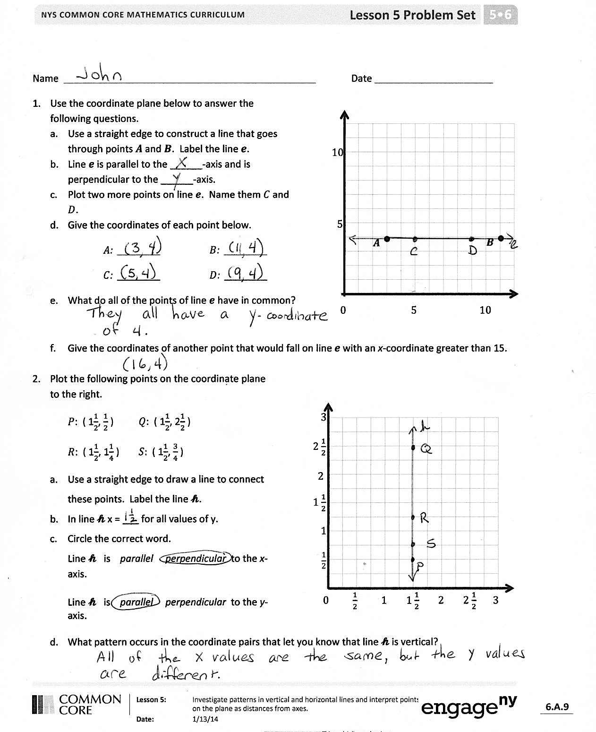
T: Create another vertical line,$n,$ that is also perpendicular to the $x$-axis, but whose distance is more or less than $\text{2}\frac{1}{2}$. Record the coordinates of three points that line $n$ contains. Share your work with a neighbor when you’re finished. Then, copy your partner’s line onto your plane. (Circulate to check student work.)
S: (Work and share.)
T: What is the distance of every point on your line from the $y$-axis? What is the distance from your line to your partner’s that you copied?
Problem Set (10 minutes)
Students should do their personal best to complete the Problem Set within the allotted 10 minutes. For some classes, it may be appropriate to modify the assignment by specifying which problems they work on first. Some problems do not specify a method for solving. Students solve these problems using the RDW approach used for Application Problems.
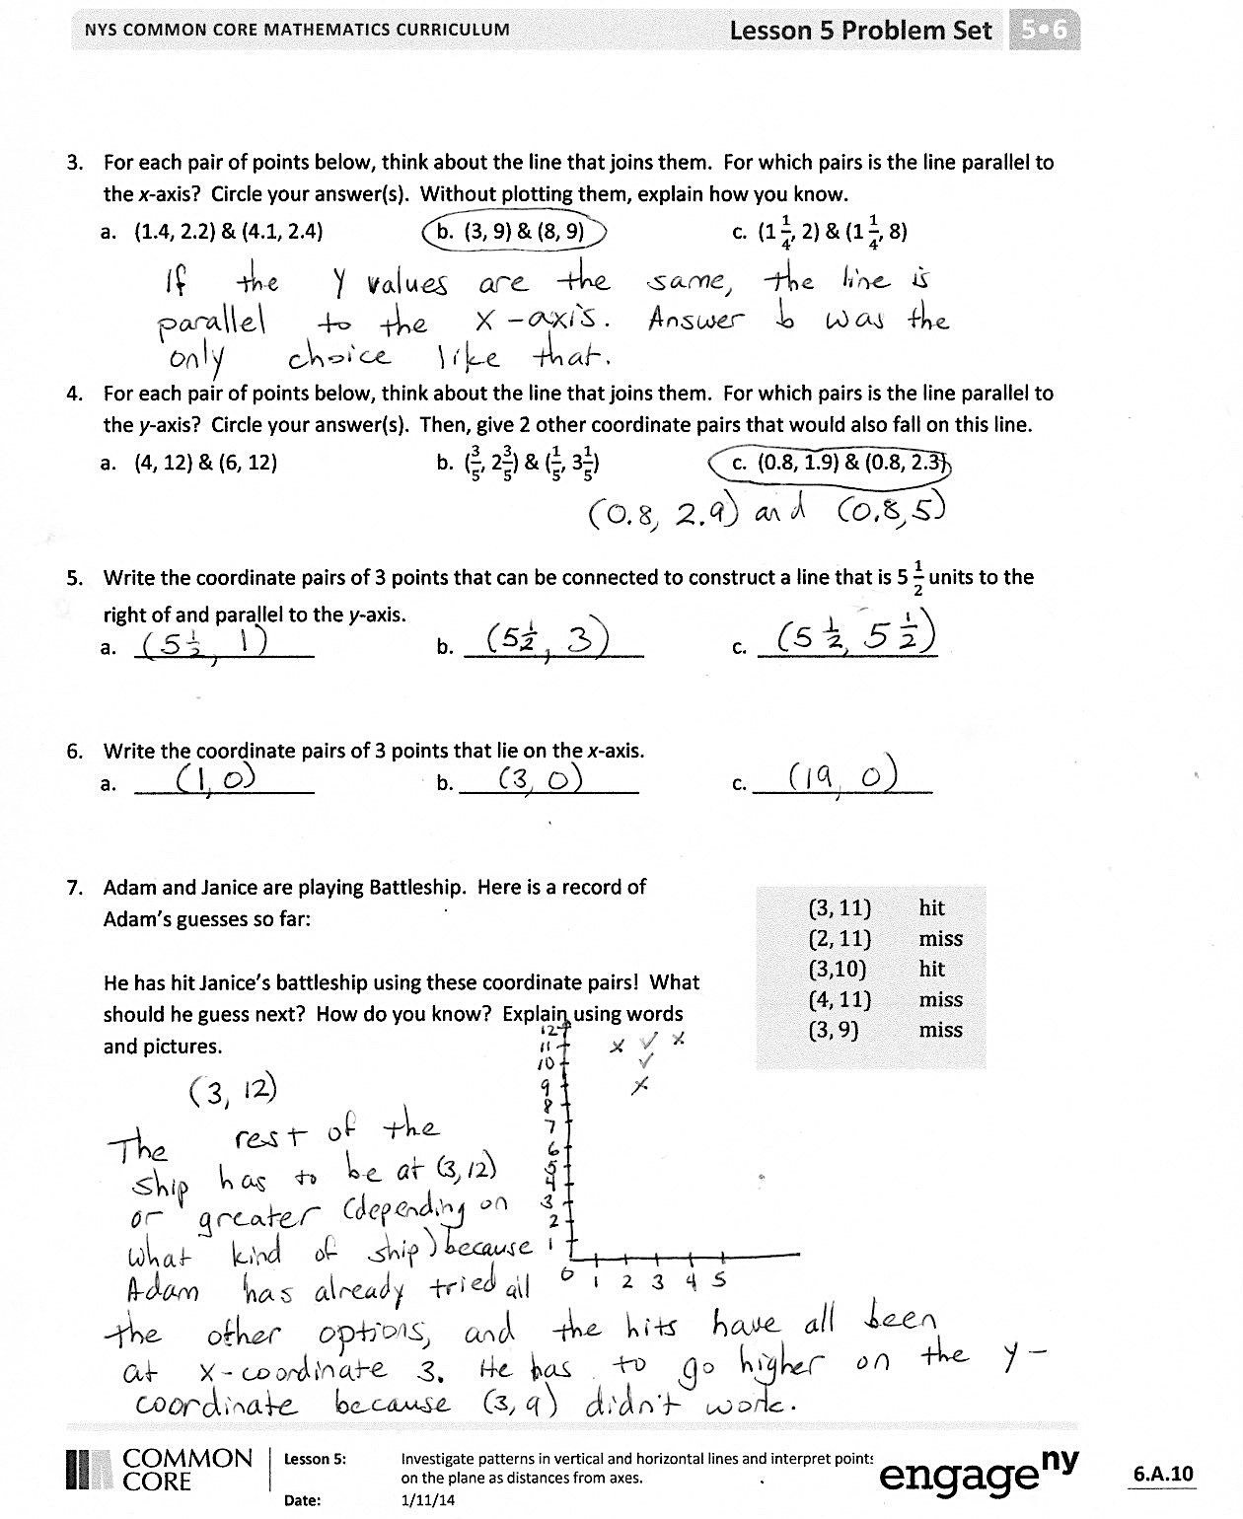
Student Debrief (10 minutes)
Lesson Objective: Investigate patterns in vertical and horizontal lines, and interpret points on the plane as distances from the axes.
The Student Debrief is intended to invite reflection and active processing of the total lesson experience.
Invite students to review their solutions for the Problem Set. They should check work by comparing answers with a partner before going over answers as a class. Look for misconceptions or misunderstandings that can be addressed in the Debrief. Guide students in a conversation to debrief the Problem Set and process the lesson.
You may choose to use any combination of the questions below to lead the discussion.
- In Problem 1, what’s the relationship of line $e$ to the $x$-axis and $y$-axis? Explain to a partner.
- Explain to a partner how you solved Problem 1(f).
- In Problem 2, what’s the relationship of line $h$to the $x$-axis and $y$-axis? Explain to a partner.

NOTES ON
MULTIPLE MEANS OF ENGAGEMENT:
Some students, when asked to work cooperatively with a partner, may need more direction. It may be necessary to develop roles and guidelines for each person in the group. In addition, a collaboratively produced set of expectations or class norms for all group work should be part of the class culture for small group success.

- Share your answer to Problem 2(d) with a partner.
- In Problem 3, how did you know that the points were on a line that was not parallel to $x$? For the lines that were parallel to $x$, what was the distance of every point on those lines from the $x$-axis?
- In Problem 4, how did you know that the points were on a line that was not parallel to the $y$-axis?
- Share your idea for solving Problem 7 with a partner. What kinds of lines do you need to think about to be a winner at Battleship?
Exit Ticket (3 minutes)
After the Student Debrief, instruct students to complete the Exit Ticket. A review of their work will help you assess the students’ understanding of the concepts that were presented in the lesson today and plan more effectively for future lessons. You may read the questions aloud to the students.
Name Date

0 5 10
5
10
$A$•
$B$ •
- Use the coordinate plane below to answer the following questions.
- Use a straightedge to construct a line that goes through points $A$ and $B$. Label the line $e$.
- Line $e$ is parallel to the ______-axis and is perpendicular to the ______-axis.
- Plot two more points on line $e$. Name them $C$and $D$.
- Give the coordinates of each point below.
$A$: ________ $B$: ________
$C$: ________ $D$: ________
- What do all of the points of line $e$ have in common?

- Give the coordinates of another point that would fall on line $e$ with an $x$-coordinate greater than 15.

- Plot the following points on the coordinate plane to the right.
2

0 $\frac{1}{2}$ 1 1 $\frac{1}{2}$ 2 2 $\frac{1}{2}$ 3
1
$$\frac{1}{2}$$
1 $\frac{1}{2}$
2 $\frac{1}{2}$
3
$P$: ( $1\frac{1}{2}$, $\frac{1}{2}$ ) $Q$: ( $1\frac{1}{2}$, $2\frac{1}{2}$ )
$R$: ( $1\frac{1}{2}$, $1\frac{1}{4}$ ) $S:$ ( $1\frac{1}{2}$, $\frac{3}{4}$ )
- Use a straightedge to draw a line to connect these points. Label the line $h$.
- In line $h,$ $x$ = ___ for all values of $y$.
- Circle the correct word.
Line $h$ is parallel perpendicular to the $x$-axis.

Line $h$ is parallel perpendicular to the $y$-axis.

- What pattern occurs in the coordinate pairs that let you know that line $h$ is vertical?

- For each pair of points below, think about the line that joins them. For which pairs is the line parallel to the $x$-axis? Circle your answer(s). Without plotting them, explain how you know.
  - (1.4, 2.2) and (4.1, 2.4) b. (3, 9) and (8, 9) c. ( $1\frac{1}{4}$, 2) and ( $1\frac{1}{4}$, 8)

- For each pair of points below, think about the line that joins them. For which pairs is the line parallel to the $y$-axis? Circle your answer(s). Then, give 2 other coordinate pairs that would also fall on this line.
  - (4, 12) and (6, 12) b. ($\frac{3}{5}$, $2\frac{3}{5}$) and ($\frac{1}{5}$, $3\frac{1}{5}$) c. (0.8, 1.9) and (0.8, 2.3)

- Write the coordinate pairs of 3 points that can be connected to construct a line that is $5\frac{1}{2}$ units to the right of and parallel to the $y$-axis.
  - ________________ b. ________________ c. ________________

- Write the coordinate pairs of 3 points that lie on the $x$-axis.
  - ________________ b. ________________ c. ________________

- Adam and Janice are playing Battleship. Presented in the table is a record of Adam’s guesses so far.
(3, 11) hit
(2, 11) miss
(3, 10) hit
(4, 11) miss
(3, 9) miss

He has hit Janice’s battleship using these coordinate pairs. What should he guess next? How do you know? Explain, using words and pictures.

Name Date
- Use a straightedge to construct a line that goes through points $A$ and $B$. Label the line $l$.

0 5 10
5
10
$A$•
$B$ •
- Which axis is parallel to line $l$?
Which axis is perpendicular to line $l$?

- Plot two more points on line $l$. Name them $C$and $D$.

- Give the coordinates of each point below.
$A$: ___________ $B$: ___________
$C$: ___________ $D$: ___________

- Give the coordinates of another point that falls on line $l$ with a $y$-coordinate greater than 20.

Name Date
- Use the coordinate plane to answer the questions.

0 5 10
5
10
$A$•
$B$ •
  - Use a straightedge to construct a line that goes through points $A$ and $B$. Label the line $g$.
  - Line $g$ is parallel to the ______-axis and is perpendicular to the ______-axis.
  - Draw two more points on line $g$. Name them $C$and $D$.
  - Give the coordinates of each point below.
$A$: ________ $B$: ________
$C$: ________ $D$: ________
  - What do all of the points on line $g$ have in common?

  - Give the coordinates of another point that falls on line $g$ with an $x$-coordinate greater than 25.

- Plot the following points on the coordinate plane to the right.
2

0 $\frac{1}{2}$ 1 1 $\frac{1}{2}$ 2 2 $\frac{1}{2}$ 3
1
$$\frac{1}{2}$$
1 $\frac{1}{2}$
2 $\frac{1}{2}$
3
$H$: ( $\frac{3}{4}$, $3$) $I$: ($\frac{3}{4}$, $2\frac{1}{4}$ )
$J$: ($\frac{3}{4}$, $\frac{1}{2}$ ) $K$: ($\frac{3}{4}$, $1\frac{3}{4}$ )
- Use a straightedge to draw a line to connect these points. Label the line $f$.
- In line $f$, $x$ = ______ for all values of $y$.
- Circle the correct word:
Line $f$ is parallel perpendicular to the $x$-axis.

Line $f$ is parallel perpendicular to the
$y$-axis.
- What pattern occurs in the coordinate pairs that make line $f$ vertical?
- For each pair of points below, think about the line that joins them. For which pairs is the line parallel to the $x$-axis? Circle your answer(s). Without plotting them, explain how you know.
  - (3.2, 7) and (5, 7) b. (8, 8.4) and (8, 8.8) c. ( $6\frac{1}{2}$, 12) and (6.2, 11)

- For each pair of points below, think about the line that joins them. For which pairs is the line parallel to the y-axis? Circle your answer(s). Then, give 2 other coordinate pairs that would also fall on this line.
  - (3.2, 8.5) and (3.22, 24) b. ($13\frac{1}{3}$, $4\frac{2}{3}$) and ($13\frac{1}{3}$, 7) c. (2.9, 5.4) and (7.2, 5.4)

- Write the coordinate pairs of 3 points that can be connected to construct a line that is $5\frac{1}{2}$ units to the right of and parallel to the $y$-axis.
  - ________________ b. ________________ c. ________________

- Write the coordinate pairs of 3 points that lie on the $y$-axis.
  - ________________ b. ________________ c. ________________

- Leslie and Peggy are playing Battleship on axes labeled in halves. Presented in the table is a record of Peggy’s guesses so far. What should she guess next? How do you know? Explain using words and pictures.
(5, 5) miss
(4, 5) hit
($3\frac{1}{2}$, 5) miss
($4\frac{1}{2}$, 5) miss

a)

0 5 10
5
10
Point | $$x$$ | $$y$$ | ($x$, $y$)
$$H$$
$$I$$
$$J$$
$$K$$
$$L$$

b)

1
2
3
4
5
0 1 2 3 4 5

Point | $$x$$ | $$y$$ | ($x$, $y$)
$$D$$ | $$2\frac{1}{2}$$ | 0 | ($2\frac{1}{2}$, 0)
$$E$$ | $$2\frac{1}{2}$$ | 2 | ($2\frac{1}{2}$, 2)
$$F$$ | $$2\frac{1}{2}$$ | 4 | ($2\frac{1}{2}$, 4)

