Lesson 4
Objective: Name points using coordinate pairs, and use the coordinate pairs to plot points.

Suggested Lesson Structure
 Fluency Practice (11 minutes)
 Application Problem (5 minutes)
 Concept Development (34 minutes)
 Student Debrief (10 minutes)
Total Time (60 minutes)
Fluency Practice (11 minutes)
- Multiply 5.NBT.5 (4 minutes)
- Name the Parts of the Coordinate Grid 5.G.1 (1 minutes)
- Name Coordinates on a Coordinate Grid 5.G.1 (6 minutes)
Multiply (4 minutes)
Materials: (S) Personal white boards
Note: This fluency activity reviews year-long fluency standards.
T: Solve 34 $\text{×}$ 21 using the standard algorithm.
S: (Solve 34 $\text{×}$ 21 using the standard algorithm. The product is 714.)
Continue the process for 234 $\text{×}$ 21, 46 $\text{×}$ 32, 146 $\text{×}$ 32, and 537 $\text{×}$ 35.
Name the Parts on the Coordinate Grid (1 minute)
Note: This fluency activity reviews G5–M6–Lesson 2.
T: (Project a coordinate grid. Point to the horizontal axis.) Name the axis.
S: $x$-axis.
T: (Point at the vertical axis.) Name the axis.
S: $y$-axis.
T: The $x$-axis and $y$-axis intersect at a 90$°$ angle. What kinds of line intersect at this angle?
S: Perpendicular.
T: (Point to the origin.) Name the coordinate.
S: Zero, zero.
T: What’s the term for the coordinate zero, zero?
S: Origin.
Name Coordinates on a Coordinate Grid (6 minutes)
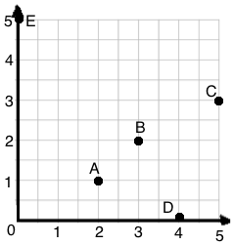
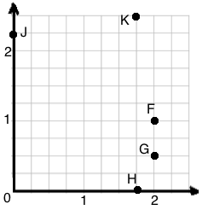
Materials: (S) Personal white boards
Note: This fluency activity reviews G5–M6–Lesson 2.
T: (Project coordinate grid.) Write the coordinate pair for A.
S: (Write (2, 1).)
Continue the process for letters B–E.
T: (Project coordinate grid.) Write the coordinate pair for F.
S: (Write (2, 1).)
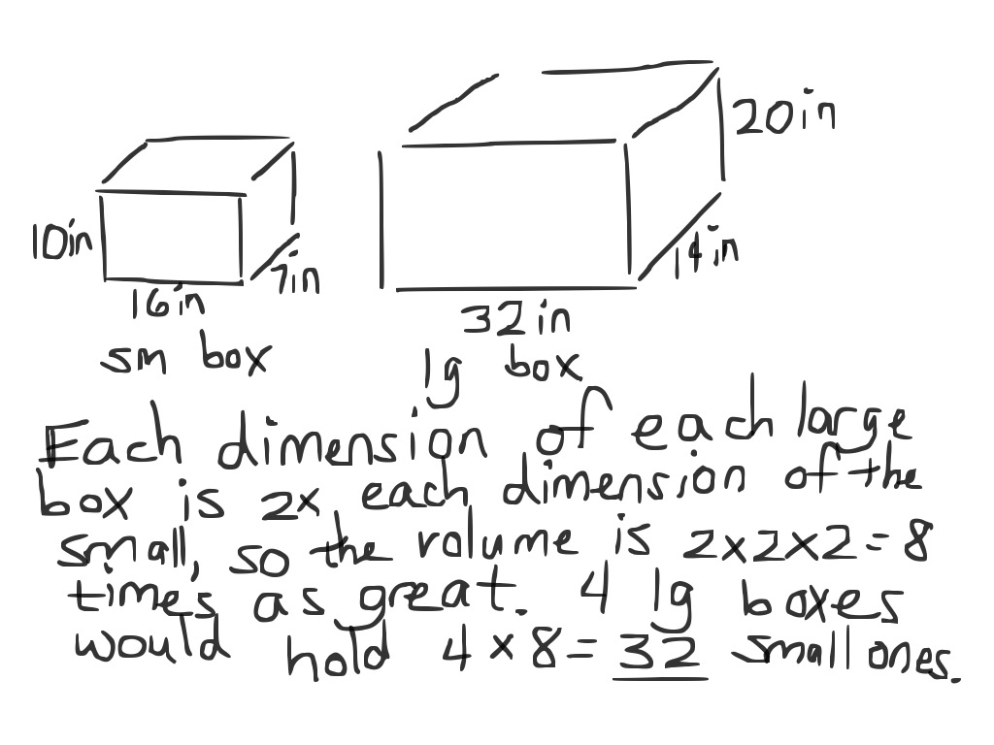
Continue the process for the remaining letters.
Application Problem (5 minutes)
Violet and Magnolia are shopping for boxes to organize the materials for their design company. Magnolia wants to get small boxes, which measure 16 in $\text{×}$ 10 in $\text{×}$ 7 in. Violet wants to get large boxes, which measure 32 in $\text{×}$ 20 in $\text{×}$ 14 in. How many small boxes will equal the volume of four large boxes?
Note: Today’s Application Problem reviews the volume work done in G5–Module 5.

NOTES ON
MULTIPLE MEANS OF ENGAGEMENT:
One possible extension of today’s Concept Development would be to have students write a handbook for winning at Battleship. To write such a guide, students must articulate strategic thinking, which gives them an opportunity to use critical thinking and communication skills.

Concept Development (34 minutes)
Materials: (S) Battleship Rules, Problem Set with Enemy Ships and My Ships grids (1 per student/per game), red pencil or crayon (1 per student), black pencil or crayon (1 per student), folder (1 per pair of students)
Note: Today, students will be playing a version of the board
game, Battleship. Depending on the level of experience your
students have with this game, the following suggested discussion might be modified.
T: Raise your hand if you’ve heard of, or have ever played, Battleship.
T: (Distribute a copy of the Problem Set to each student.) Take four minutes to read and talk about Battleship Rules with a partner.
S: (Read and share.)
T: Find your My Ships coordinate plane and hold it up.
S: (Hold up paper.)
T: Once we get started, one of the first things you’ll do with your opponent is label the axes using halves, thirds, fourths, or fifths. (Display image on board.) This is an example of a coordinate plane that has already been prepared for play. What fractional unit is designated by the grid lengths? Turn and talk.
S: Thirds!
T: The next step is the fun part. You get to secretly select locations for your fleet on the coordinate plane. How many ships does each player get?
S: 5.
T: Exactly, and some ships are small, such as the patrol boat, while others are large, such as the aircraft carrier. Let’s look at an example of how a fleet might be set up on the coordinate plane. (Display image on board.)
T: Then, once both of you have your ships secretly placed on your My Ships plane, you’ll take turns guessing attack shots, attempting to hit your enemy’s boats. Work with a neighbor to show a coordinate pair that would “hit” the submarine on this plane.
S: (Share and show.)
T: Jasmine, I saw you named the location ($\text{2}\frac{2}{3}$, $\frac{1}{3}$). What would her opponent have to say if Jasmine guessed these coordinates?
S: Hit!
T: That’s right! Then, Jasmine would record those coordinates on her paper, and mark a red check on her Enemy Ships plane. What would the opponent have to do?
S: Mark a red check on the hit coordinate of the submarine.
T: You got it! Then, it’s Jasmine’s opponent’s turn to make an attack shot. When does the game end? How do you win?
S: The game ends when one person sinks all of the opponent’s ships!
T: Or, when time is up, the winner is the player who has sunk the most ships. Let’s play!

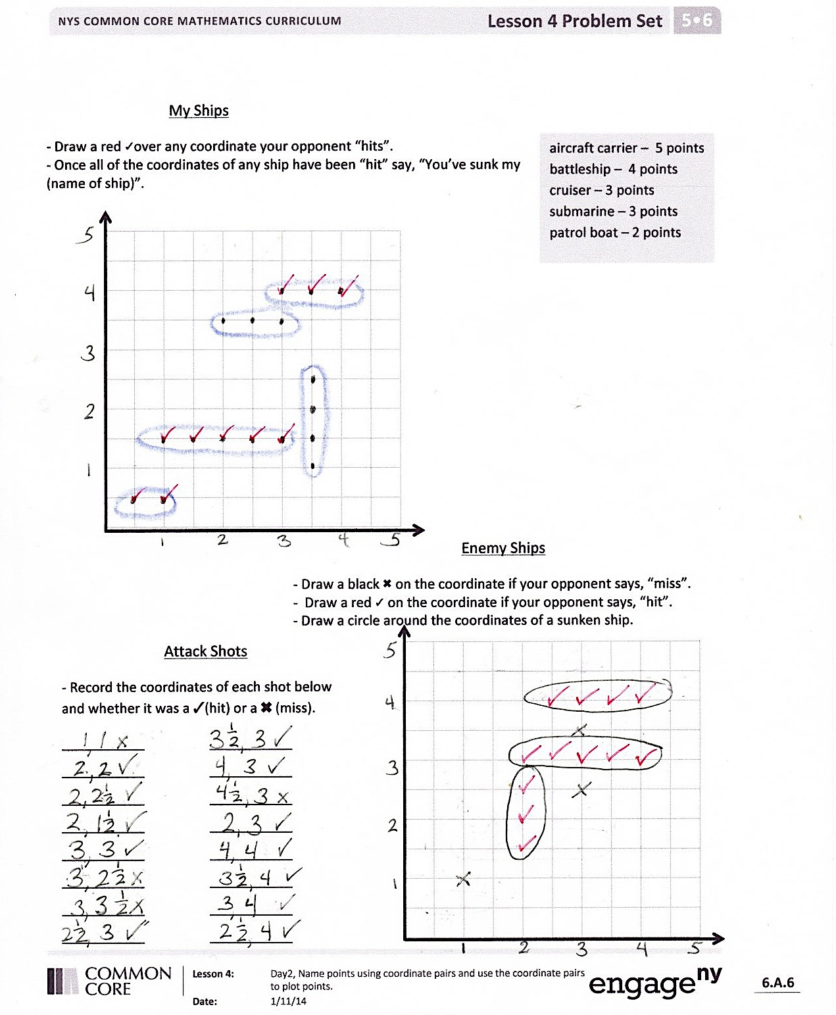
Game Play (20 minutes)
Students should select or be assigned an opponent and begin play. Early finishers may choose to play a rematch or be assigned another opponent. Please note that a new copy of the Problem Set is needed for each game. However, the grid sheets can be inserted into page protectors for multiple uses.
MP.2
Student Debrief (10 minutes)
Lesson Objective: Name points using coordinate pairs, and use the coordinate pairs to plot points.
Note: Today’s Debrief may take place at the end of the math session, or may prove more purposeful after about 10 minutes of play. Students could count ships to declare a winner and then engage in a short discussion about their game strategy before beginning a second game with a new opponent.
You may choose to use any combination of the questions below to lead the discussion.
- What was your strategy in choosing where to set up your fleet? Did it work? What would you do differently next time? (These strategies can be recorded and displayed for future use.)

NOTES ON
MULTIPLE MEANS OF ACTION AND EXPRESSION:
One goal of playing Battleship is to use strategic thinking, rather than using trial and error, or simply guessing. Teachers can help students develop strategic planning and thinking by employing these suggestions:
- Require students to play with a partner. Partners can collaborate on strategy while playing.
- Encourage each student to verbalize why a move is made before it is made. These think- alouds may not result in a competitive game, but it can help students learn to play in a more strategic way.

- How did you decide where to make your attack shots?
- When you did hit an opponent’s ship, how did you plan your next shot?
- What did your opponent do that seemed to work well for him or her?
- What could be done to the coordinate plane to make the game easier or more challenging?
- How did today’s game strengthen your understanding of the coordinate plane?
- Do you think coordinate pairs are actually used in war? Why or why not?

Exit Ticket (3 minutes)
After the Student Debrief, instruct students to complete the Exit Ticket. A review of their work will help you assess the students’ understanding of the concepts that were presented in the lesson today and plan more effectively for future lessons. You may read the questions aloud to the students.
Battleship Rules
Goal: To sink all of your opponent’s ships by correctly guessing their coordinates.

Materials
- Each player gets 1 grid sheet(per game)
- Red crayon/marker for hits
- Black crayon/marker for misses
- Folder to place between players

Ships
- Each player must mark 5 ships on the grid.
- Aircraft Carrier – Plot 5 points
- Battleship – Plot 4 points
- Cruiser – Plot 3 points
- Submarine – Plot 3 points
- Patrol Boat – Plot 2 points

Setup
- With your opponent, choose a unit length and fractional unit for the coordinate plane.
- Label chosen units on both grid sheets.
- Secretly select locations for each of the 5 ships on your My Ships grid.
- All ships must be placed horizontally or vertically on the coordinate plane.
- Ships can touch each other, but may not occupy the same coordinate.

Play
- Players take turns firing one shot to attack enemy ships.
- On your turn, call out the coordinates of your attacking shot. Record the coordinates of each attack shot.
- Your opponent checks his My Ships grid. If that coordinate is unoccupied, he says, “Miss.” If you named a coordinate occupied by a ship, he says, “Hit.”
- Mark each attempted shot on your Enemy Ships grid. Mark a black ✖ on the coordinate if your opponent says, “Miss.” Mark a red ✓ on the coordinate if your opponent says, “Hit.”
- On your opponent’s turn, if he hits one of your ships, mark a red ✓on that coordinate of your My Ships grid. When one of your ships has every coordinate marked with a ✓, say, “You’ve sunk my [name of ship].”
Victory
  - The first player to sink all (or the most) opposing ships wins.

My Ships
aircraft carrier – 5 points
battleship – 4 points
cruiser – 3 points
submarine – 3 points
patrol boat – 2 points
- Draw a red ✓over any coordinate your opponent hits.
- Once all of the coordinates of any ship have been hit, say, “You’ve sunk my [name of ship].”

Enemy Ships
          - Draw a black ✖ on the coordinate if your opponent says, “Miss.”
          - Draw a red ✓ on the coordinate if your opponent says, “Hit.”
          - Draw a circle around the coordinates of a sunken ship.
Attack Shots
- Record the coordinates of each shot below and whether it was a ✓ (hit) or a ✖ (miss).
___________ ___________ ___________ ___________ ___________ ___________
___________ ___________ ___________ ___________ ___________ ___________
___________ ___________ ___________ ___________ ___________ ___________
___________ ___________ ___________ ___________ ___________ ___________
___________ ___________ ___________

Name Date
Fatima and Rihana are playing Battleship. They labeled their axes using just whole numbers.
- Fatima’s first guess is (2, 2). Rihana says, “Hit!” Give the coordinates of four points that Fatima might guess next.

- Rihana says, “Hit!” for the points directly above and below (2, 2). What are the coordinates that Fatima guessed?

Name Date
Your homework is to play at least one game of Battleship with a friend or family member. You can use the directions from class to teach your opponent. You and your opponent should record your guesses, hits, and misses on the sheet as you did in class.
When you have finished your game, answer these questions.
- When you guess a point that is a hit, how do you decide which points to guess next?
- How could you change the coordinate plane to make the game easier or more challenging?
- Which strategies worked best for you when playing this game?

