Lesson 3
Objective: Name points using coordinate pairs, and use the coordinate pairs to plot points.

Suggested Lesson Structure
 Fluency Practice (12 minutes)
 Application Problem (6 minutes)
 Concept Development (32 minutes)
 Student Debrief (10 minutes)
Total Time (60 minutes)
Fluency Practice (12 minutes)
- Name the Parts of the Coordinate Grid 5.G.1 (1 minutes)
- Find the Missing Number on a Number Line 5.G.1 (5 minutes)
- Name Coordinates on a Coordinate Grid 5.G.1 (6 minutes)
Name the Parts on the Coordinate Grid (1 minute)
Materials: Coordinate plane template from G5–M6–Lesson 2.
Note: This fluency activity reviews G5–M6–Lesson 2.
T: (Project the coordinate plane template. Point at the horizontal axis.) Name the axis.
S: $x$-axis.
T: (Point at the vertical axis.) Name the axis.
S: $y$-axis.
T: The $x$-axis and $y$-axis intersect at what angle measure?
S: 90 degrees.
T: Lines that intersect at right angles are called?
S: Perpendicular lines.
T: (Point at the origin.) Name the coordinate.
S: Zero, zero.
T: What else can we call this point?
S: Origin.

Find the Missing Number on a Number Line (5 minutes)
Materials: (S) Personal white boards
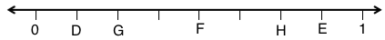
Note: This fluency activity reviews G5–M6–Lesson 1.
T: (Project a number line partitioned into 10 intervals. Label 0 and 50 as the endpoints. Point to $A$.) What is the value of $A$?
S: 10.
T: What’s the value of B?
S: 45.
T: Write the value of C.
S: (Write 30.)
Continue the process for the other number lines.
Name Coordinates on a Coordinate Grid (6 minutes)
Materials: (S) Personal white boards
Note: This fluency activity reviews G5–M6–Lesson 2.
T: (Project coordinate planes shown below.) Write the coordinate pair for A.
S: (Write (1, 1).)
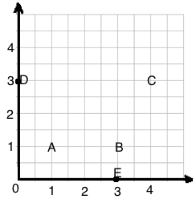
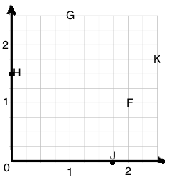

Continue the process for letters B–E.
T: (Project a coordinate grid.) Write the coordinate pair for F.
S: (Write (2, 1).)
Continue the process for the remaining letters.
Application Problem (6 minutes)
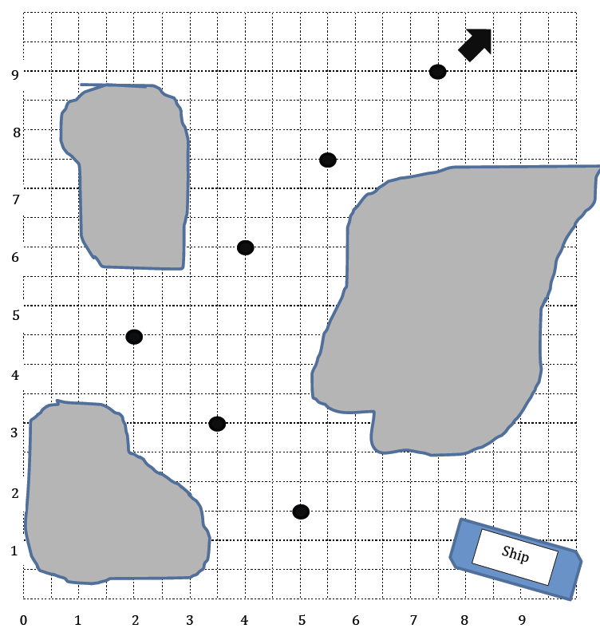
The captain of a ship has a chart to help him navigate through the islands. He must follow points that show the deepest part of the channel. List the coordinates the captain needs to follow in the order he will encounter them.
1
2
3
4
5
6
7
8
9
10
1. (____, ____) 2. (____, ____)
3. 4.
5. 6.
Note: Today’s Application Problem not only asks students to identify the coordinates of points, but also provides them with an example of how a basic coordinate plane is used in the real world.
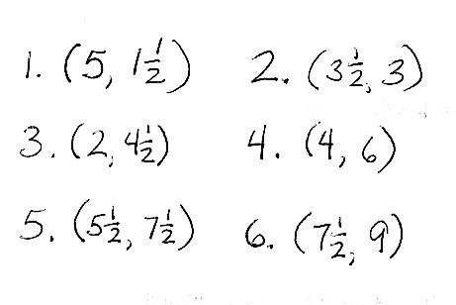

Concept Development (32 minutes)
Materials: (S) Ruler, coordinate plane template
Problem 1: Construct a coordinate plane.
T: (Distribute 1 copy of the coordinate plane template to each student.) Use your ruler to draw an $x$-axis so that it goes through points $A$ and $B$, and label it $x$-axis. (Model on the board.)
MP.6
S: (Draw and label the axis.)
T: Use your ruler to draw the $y$-axis so that it goes through points $C$ and $D$, and label it $y$-axis.
S: (Draw and label the axis.)
T: Label 0 at the origin.
S: (Label the origin.)
MP.6
T: On the $x$-axis, we’re going to label the whole numbers only. The length of one square on the grid represents 1 fourth. How many whole numbers can we label? Turn and talk.
S: I counted 20 grid lengths, or 20 fourths, which is 5. We can label the whole numbers 0 through 5. Each grid length is 1 fourth, so every 4 grid lengths is a whole number. Point $A$ is at 4 fourths, or 1, and there is room for 4 more groups of 4 fourths.
T: Count by fourths with me as we label the whole number grid lines. One fourth…. (Move along the $x$-axis as you count, and label every whole number grid line.)
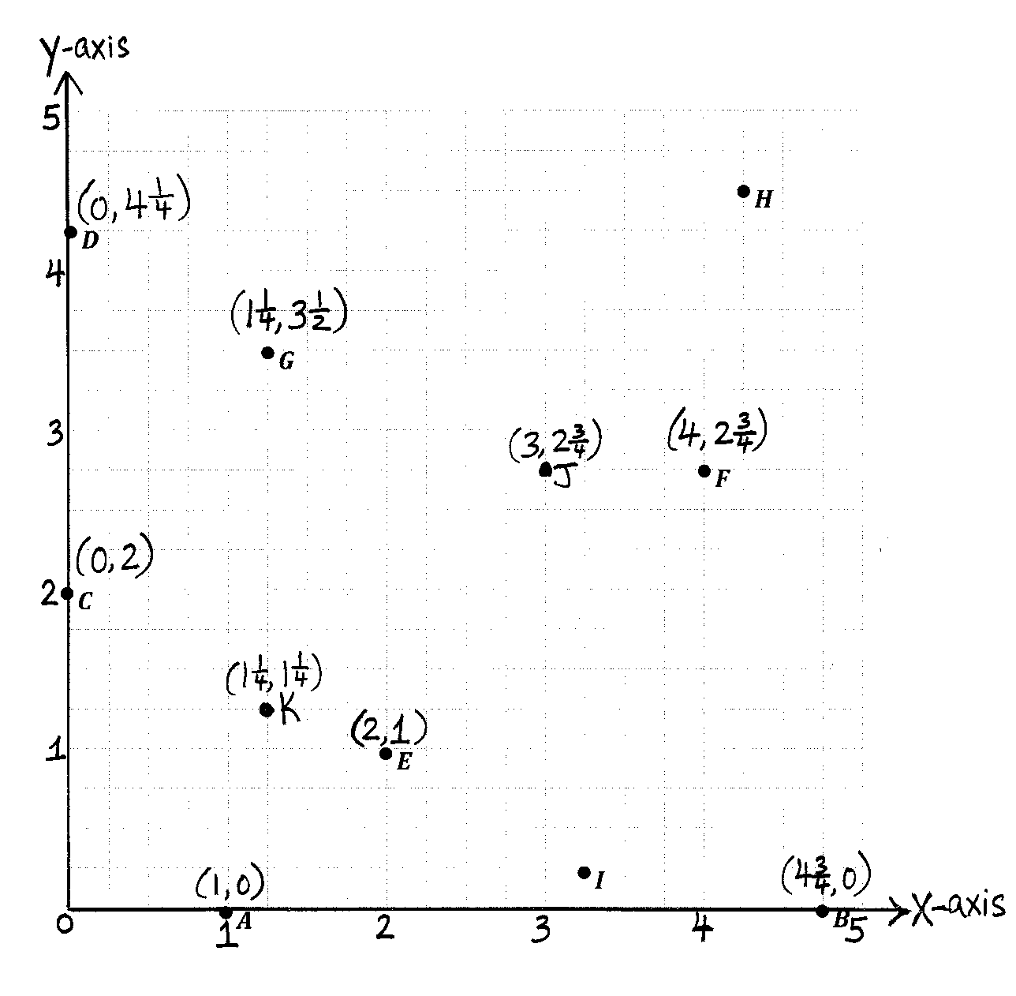
S: 2 fourths, 3 fourths, 1 (label 1), 1 and 1 fourth, 1 and 2 fourths, 1 and 3 fourths, 2 (label 2).
T: You do the same on your $x$-axis.
S: (Label the whole number grid lines.)
T: What is the $x$-coordinate of $A$?
S: 1.
T: $B$?
S: 4 and 3 fourths.
T: Label the $y$-axis in the same way.
S: (Label the whole number grid lines.)
T: What is the $y$-coordinate of $C$?
S: 2.
T: $D$?
S: $\text{4}\frac{1}{4}$.
Problem 2: Use coordinate pairs to name and plot points.
T: Put your finger on $E$. How do we find the $x$-coordinate of $E$? Turn and talk.
S: I can just follow the grid line down from $E$ to the $x$-axis, and it falls at a distance of 2 from the origin. So, the $x$-coordinate is 2. $E$ is directly above 2 on the $x$-axis, so its $x$-coordinate is 2. Start at the origin, and move on $x$-axis to the $x$-coordinate of $E.$
T: What is the $x$-coordinate of $E$?
S: 2.
T: Show me that $x$-coordinate as part of a coordinate pair.
S: (Show (2, ___).)
T: Find the $y$-coordinate of $E.$ (Pause.) Show me the coordinate pair for $E$.
S: (Show (2, 1).)
T: Write that coordinate pair above point $E$ on your plane. Work with a partner to name the coordinate pair for $F$.
S: (Share and show $F,$ (4, $2\frac{3}{4}$).)
Repeat for points $G$, $B$, and $C$, respectively ($\text{1}\frac{1}{4}$, $\text{3}\frac{1}{2}$), ($\text{4}\frac{3}{4}$, 0), (0, 2).
T: Name the point located at (1, 0).
S: $A$.
T: Name the point located at (0, $\text{4}\frac{1}{4}$).
S: $D$.
T: I want to name the point whose distance from the $y$-axis is $\text{4}\frac{1}{4}$. How is this question different from the other questions I’ve asked you about points in this plane? Turn and talk.
S: You are asking us about the distance from the whole line, not the distance from the origin on $x$. We are looking at the distance away from the $y$-axis, rather than going a distance down the $x$-axis.
T: Work with a neighbor to name the point whose distance from the $y$-axis is $\text{4}\frac{1}{4}$.
S: $H$.

NOTES ON
MULTIPLE MEANS OF REPRESENTATION:
G5–Module 6, “Problem Solving with the Coordinate Plane,” has many new vocabulary words. Here are a few strategies to help students make these new words their own:
- Have students tap and whisper a new word three times.
- Allow students to explore online vocabulary builders such as, Word2Word, an online collection of dictionaries of multiple languages.
- Have students continue to add to their collection of math words on 3" × 5" cards held together by a metal ring.
- Have students continue building their illustrated glossary.
(The last two options assume students have been using these tools all year, which may not be the case.)

T: Which point lies at a distance of $\frac{1}{4}$ from the $x$-axis?
S: $I$.
T: Plot a point $J$at (3, 2 $\frac{3}{4}$). Have a neighbor check your work.
S: (Work and share.)
T: Turn and tell a partner how to find the distance between $J$ and $F$.
S: Since they both have a $y$-coordinate of $\text{2}\frac{3}{4}$, I can just count the number of 1 fourth lengths on the $x$-axis from $J$ to $F$. It’s just like finding the distance between 3 and 4 on a ruler. It’s just 1 unit away.
T: What is the distance between $J$ and $F$? (Gesture between the points.)
S: One unit.
T: Yes. Now, plot a point $K$ so that the $x$- and $y$-coordinates are both $\text{1}\frac{1}{4}$, then find the distance between $K$ and $G$.
S: (Work.)
T: Say the distance between $K$ and $G$.
S: $\text{2}\frac{1}{4}$ units.

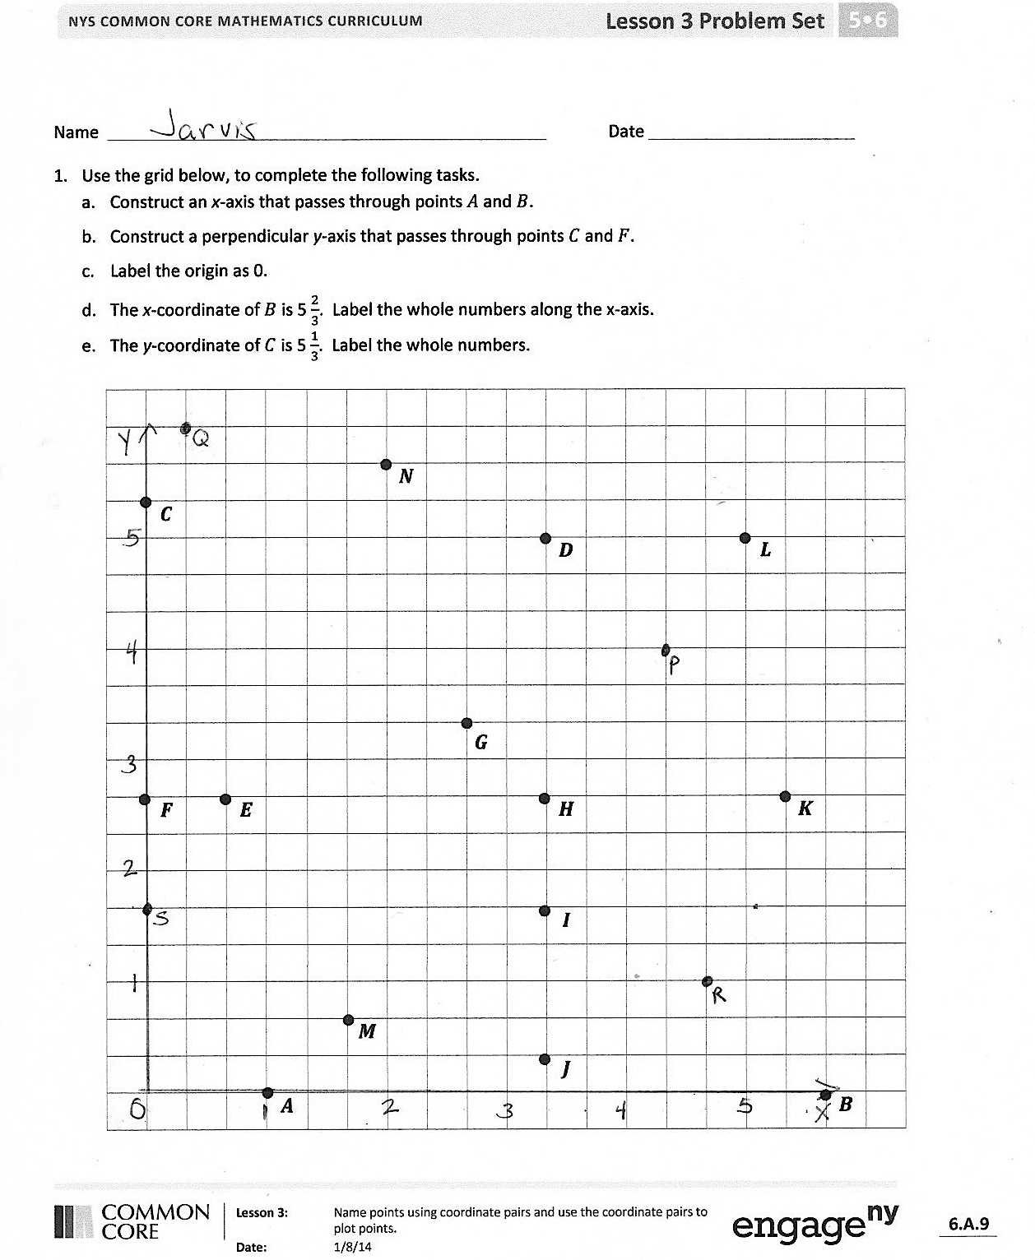
Problem Set (10 minutes)
Students should do their personal best to complete the Problem Set within the allotted 10 minutes. For some classes, it may be appropriate to modify the assignment by specifying which problems they work on first. Some problems do not specify a method for solving. Students solve these problems using the RDW approach used for Application Problems.
Student Debrief (10 minutes)
Lesson Objective: Name points using coordinate pairs and use the coordinate pairs to plot points.
The Student Debrief is intended to invite reflection and active processing of the total lesson experience.
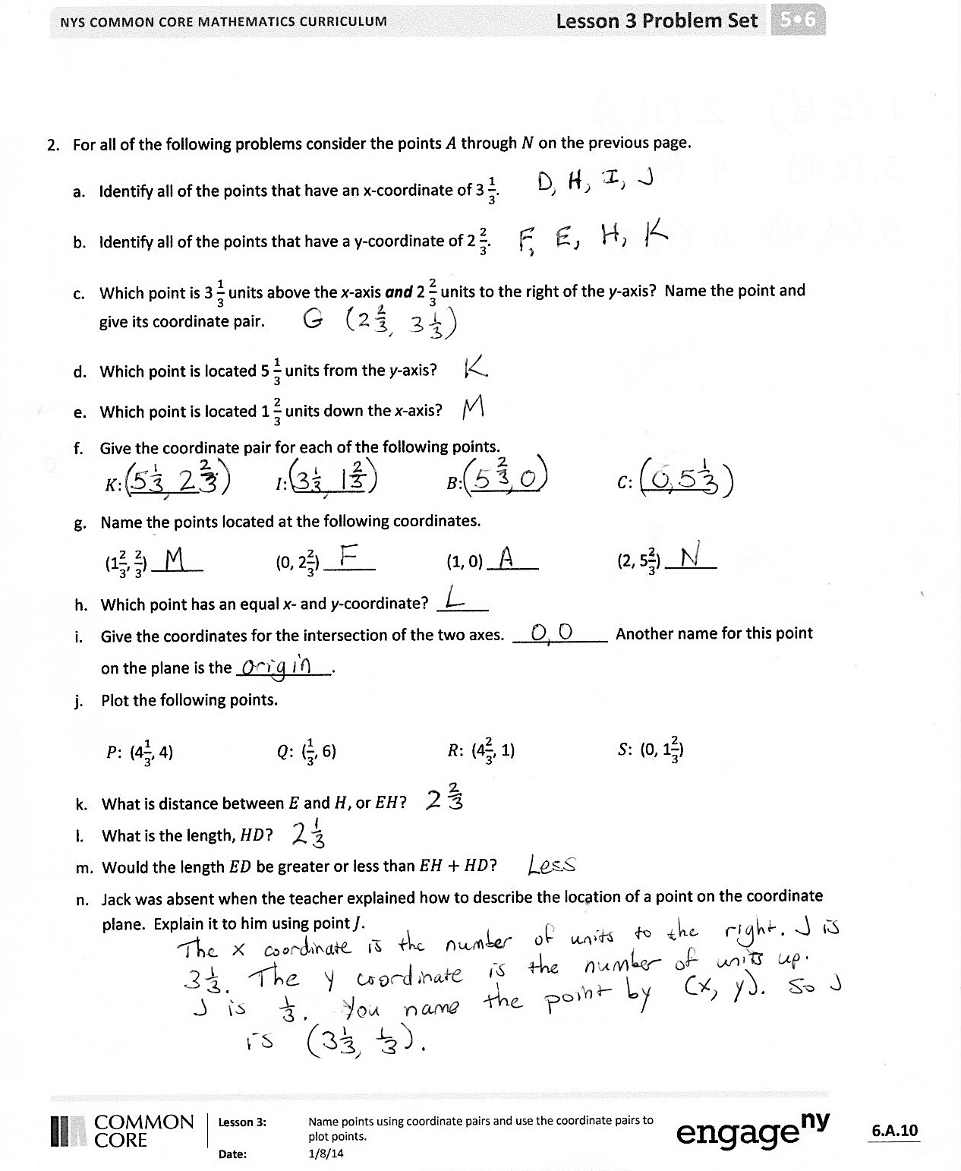
Invite students to review their solutions for the Problem Set. They should check work by comparing answers with a partner before going over answers as a class. Look for misconceptions or misunderstandings that can be addressed in the Debrief. Guide students in a conversation to debrief the Problem Set and process the lesson.
You may choose to use any combination of the questions below to lead the discussion.
- Explain your thought process as you decided how to label the whole numbers along the $x$- and $y$-axes.
- Share your answer to Problem 2(j) with your neighbor.
- Explain how locating a point at (1, 4) is different from locating a point at (4, 1).
- In the Application Problem, the captain of the ship used coordinate pairs. Why was it important for him know the difference between (5, $\text{1}\frac{1}{2}$) and ($\text{1}\frac{1}{2}, \text{5}$)?
- Problem 1(m) asks you to compare lengths. What strategies did you use to answer this question?
- Again thinking about Problem 1(m), will a square’s diagonal be longer or shorter than the sum of two side lengths? Is one side of a triangle longer or shorter than the sum of the other two sides? How do you know?
Exit Ticket (3 minutes)
After the Student Debrief, instruct students to complete the Exit Ticket. A review of their work will help you assess the students’ understanding of the concepts that were presented in the lesson today and plan more effectively for future lessons. You may read the questions aloud to the students.

Name Date
- Use the grid below, to complete the following tasks.
  - Construct an $x$-axis that passes through points $A$ and $B$.
  - Construct a perpendicular $y$-axis that passes through points $C$ and $F$.
  - Label the origin as 0.
  - The $x$-coordinate of $B$ is $5\frac{2}{3}$. Label the whole numbers along the $x$-axis.
  - The $y$-coordinate of $C$ is $5\frac{1}{3}$. Label the whole numbers.
 |  |  |  |  |  | •
• |  |  |  |  |  |  | $$N$$
 | $$C$$ |  |  |  |  |  |  |  |  | • |  |  |  |  | •
 |  |  |  |  |  |  |  |  |  |  | $$D$$ |  |  |  |  | $$L$$
•

$$G$$
• |  | • |  |  |  |  |  |  |  | • |  |  |  |  |  | •
 | $$F$$ |  | $$E$$ |  |  |  |  |  |  |  | $$H$$ |  |  |  |  |  | $$K$$
 |  |  |  |  |  |  |  |  |  | •
 |  |  |  |  |  |  |  |  |  |  | $$I$$
 |  |  |  |  | •
 |  |  |  |  |  | $$M$$ |  |  |  | •
 |  |  | • |  |  |  |  |  |  |  | $$J$$ |  |  |  |  |  | •
 |  |  |  | $$A$$ |  |  |  |  |  |  |  |  |  |  |  |  |  | $$B$$
- For all of the following problems, consider the points $A$ through $N$ on the previous page.

- Identify all of the points that have an $x$-coordinate of $3\frac{1}{3}$.

- Identify all of the points that have a $y$-coordinate of $2\frac{2}{3}$.

- Which point is $3\frac{1}{3}$ units above the $x$-axis and $2\frac{2}{3}$ units to the right of the $y$-axis? Name the point and give its coordinate pair.

- Which point is located $5\frac{1}{3}$ units from the $y$-axis?
- Which point is located $1\frac{2}{3}$ units along the $x$-axis?
- Give the coordinate pair for each of the following points.
$K:$ ________ $I$: ________ $B$: ________ $C$: ________
- Name the points located at the following coordinates.
($1\frac{2}{3}$, $\frac{2}{3}$) ______ (0, 2$\frac{2}{3}$) ______ (1, 0) ______ (2, $5\frac{2}{3}$) ______
- Which point has an equal $x$- and $y$-coordinate? ______
- Give the coordinates for the intersection of the two axes. ___________ Another name for this point on the plane is the ___________.
- Plot the following points.
$P$: ($4\frac{1}{3}$, 4) $Q$: ($\frac{1}{3}$, 6) $R:$ ($4\frac{2}{3}$, 1) $S$: (0, $1\frac{2}{3}$)
- What is distance between $E$and $H$, or $EH$?
- What is the length $HD$?
- Would the length $ED$ be greater or less than $EH+HD$?
- Jack was absent when the teacher explained how to describe the location of a point on the coordinate plane. Explain it to him using point $J$.

Name Date
- Use a ruler on the grid below to construct the axes for a coordinate plane. The $x$-axis should intersect points $L$ and $M$. Construct the $y$-axis so that it contains points $K$ and $L$. Label each axis.

$$K$$

$$L$$
$$M$$
$$A$$

- Place a hash mark on each grid line on the $x$- and $y$-axis.

- Label each hash mark so that $A$ is located at (1, 1).

- Plot the following points:
Point | $x$-coordinate | $y$-coordinate
$$B$$ | $$\frac{1}{4}$$ | 0
$$C$$ | $$1\frac{1}{4}$$ | $$\frac{3}{4}$$

Name Date
- Use the grid below to complete the following tasks.
  - Construct a $y$-axis that passes through points $Y$and $Z.$
  - Construct a perpendicular $x$-axis that passes through points $Z$ and $X$.
  - Label the origin as 0.
  - The $y$-coordinate of $W$ is $2\frac{3}{5}$. Label the whole numbers along the $y$-axis.
  - The $x$-coordinate of $V$ is $2\frac{2}{5}$. Label the whole numbers.
 |  |  |  |  |  | •
• |  |  |  |  |  |  | $$K$$
 | $$Y$$ |  |  |  |  |  |  |  |  |  | • |  |  |  | •
 |  |  |  |  |  |  |  |  |  |  | $$L$$ |  |  |  |  | $$N$$
• |  |  |  |  |  |  |  |  |  |  |  |  |  | $$T$$
 | $$W$$
$$P$$
•

 |  | • |  |  |  |  |  |  |  |  | • |  |  |  |  | •
 |  |  | $$R$$ |  |  |  |  |  |  |  | $$M$$ |  |  |  |  |  | $$Q$$
 |  |  |  |  |  |  |  |  |  |  | •
 |  |  |  |  |  |  |  |  |  |  | $$O$$
 |  |  | $$U$$
 |  |  |  |  | •
 |  |  |  |  |  | $$S$$
• |  |  |  |  |  |  |  |  |  |  |  | • | $$V$$ |  |  |  | •
$$Z$$ |  |  |  |  |  |  |  |  |  |  |  |  |  |  |  |  |  | $$X$$

- For all of the following problems, consider the points $K$ through $X$ on the previous page.
- Identify all of the points that have a $y$-coordinate of $1\frac{3}{5}$.

- Identify all of the points that have an $x$-coordinate of $2\frac{1}{5}$.

- Which point is $1\frac{3}{5}$ units above the $x$-axis and $3\frac{1}{5}$ units to the right of the $y$-axis? Name the point and give its coordinate pair.

- Which point is located $1\frac{1}{5}$ units from the $y$-axis?
- Which point is located $\frac{2}{5}$ units along the $x$-axis?
- Give the coordinate pair for each of the following points.
$T:$ ________ $U$: ________ $S$: ________ $K$: ________
- Name the points located at the following coordinates.
($\frac{2}{5}$, $\frac{3}{5}$) ____ ($3\frac{2}{5}$, 0) ____ ($2\frac{1}{5}$, 3) ____ ($0$, $2\frac{3}{5}$) ____
- Plot a point whose $x$- and $y$-coordinates are equal. Label your point $E.$
- What is the name for the point on the plane where the two axes intersect? ___________ Give the coordinates for this point. ___________
- Plot the following points.
$A$: ($1\frac{1}{5}$, 1) $B$: ($\frac{1}{5}$, 3) $C:$ ($2\frac{4}{5}$, $2\frac{2}{5}$) $D$: ($1\frac{1}{5}$, 0)
- What is the distance between $L$ and $N$, or $LN$?
- What is the distance $MQ$?
- Would $RM$ be greater, less than, or equal to $LN+MQ$?
- Leslie was explaining how to plot points on the coordinate plane to a new student, but she left off some important information. Correct her explanation so that it is complete.
“All you have to do is read the coordinates; for example, if it says (4, 7), count four, then seven, and put a point where the two grid lines intersect.”

•$A$
•$B$
•$C$
•$D$
•$E$
•$F$
•$G$
•$H$
•$I$

