Lesson 2
Objective: Construct a coordinate system on a plane.

Suggested Lesson Structure
 Fluency Practice (10 minutes)
 Application Problem (7 minutes)
 Concept Development (33 minutes)
 Student Debrief (10 minutes)
Total Time (60 minutes)
Fluency Practice (10 minutes)
- Count by Equivalent Fractions 4.NF.1 (6 minutes)
- Find the Missing Number on a Number Line 5.G.1 (4 minutes)
Count by Equivalent Fractions (6 minutes)
Note: This fluency activity reviews G5–M6–Lesson 1 and prepares students for today’s lesson.
T: Count from 0 to 10 by ones.
$\frac{0}{4}$ $\frac{1}{4}$ $\frac{2}{4}$ $\frac{3}{4}$ $\frac{4}{4}$ $\frac{5}{4}$ $\frac{6}{4}$ $\frac{7}{4}$ $\frac{8}{4}$ $\frac{9}{4}$ $\frac{10}{4}$
0 $\frac{1}{4}$ $\frac{2}{4}$ $\frac{3}{4}$ 1 $\frac{5}{4}$ $\frac{6}{4}$ $\frac{7}{4}$ 2 $\frac{9}{4}$ $\frac{10}{4}$

S: 0, 1, 2, 3, 4, 5, 6, 7, 8, 9, 10.
T: Count by 1 fourth to 10 fourths. Start at zero fourths. (Write as students count.)
S: $\frac{0}{4}, \frac{1}{4}$, $\frac{2}{4}$, $\frac{3}{4}$, $\frac{4}{4}$, $\frac{5}{4}$, $\frac{6}{4}$, $\frac{7}{4}$, $\frac{8}{4}$,$\frac{9}{4}$, $\frac{10}{4}$.
T: 4 fourths is the same as 1 of what unit?
S: 1 one.
T: (Beneath $\frac{4}{4}$, write 1.) 2 ones is the same as how many fourths?
S: 8 fourths.
T: (Beneath $\frac{8}{4}$, write 2.) Let’s count to 10 fourths again, but this time say the whole numbers when you come to a whole number. Start at 0.
S: 0, $\frac{1}{4}$, $\frac{2}{4}$, $\frac{3}{4}$, 1, $\frac{5}{4}$, $\frac{6}{4}$, $\frac{7}{4}$, 2,$\frac{9}{4}$, $\frac{10}{4}$.
Repeat the process, counting by thirds to 10 thirds.
Find the Missing Number on a Number Line (4 minutes)
Materials: (S) Personal white boards
Note: This fluency activity reviews G5–M6–Lesson 1. For the last number line, challenge students by having them write simplified fractions.
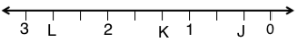
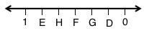
T: (Project a number line partitioned into 10 intervals. Label 60 and 0 as the endpoints. Point at $A$.) What is the value of $A$?
60
1E
H
F
G
D
0
S: 6
T: What’s the value of $B$?
S: 42.
T: Write the value of $C$.
S: (Write 24.)
Continue the process for the other number lines.
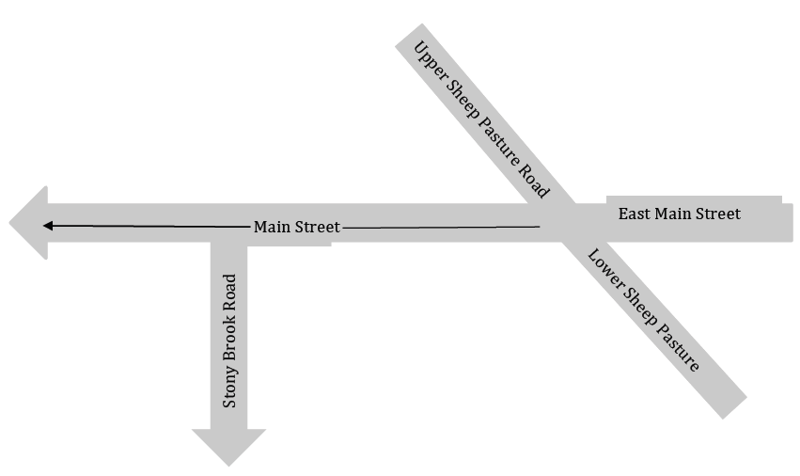
Application Problem (7 minutes)
The picture shows an intersection in Stony Brook Village.
- The town wants to construct two new roads, Elm Street and King Street. Elm Street will intersect Lower Sheep Pasture Road, run parallel to Main Street, and be perpendicular to Stony Brook Road. Sketch Elm Street.
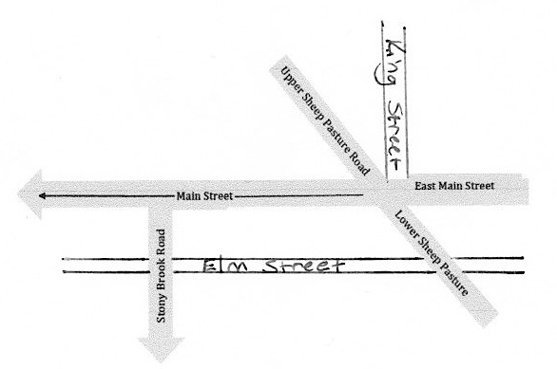
- King Street will be perpendicular to Main Street and begin at the intersection of Upper Sheep Pasture Road and East Main Street. Sketch King Street.
Note: The Application Problem prepares students for today’s discussions regarding parallel and perpendicular lines. To expedite the sketches, you might suggest to students that they abbreviate the street names as SBR, MS, and USPR.

Concept Development (33 minutes)
Materials: (S) Set square, equal unit strip created during G5–M6–Lesson 1, unlined paper, coordinate plane template (multiple sheets per student)
Note: In this lesson, the axes are drawn with arrows that show the increasing direction of the numbers only. Students should be reminded that although the arrows are not visible on both ends of the axes, they still represent lines that continue in both directions infinitely.
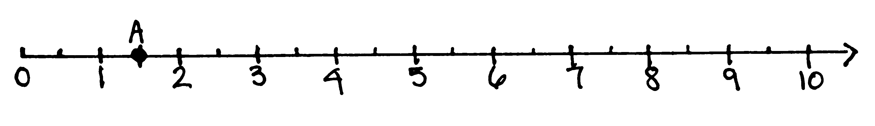
Problem 1: Construct a second number line, perpendicular to the $x$-axis, to give the coordinates of points that do not fall directly on the $x$- or $y$-axis.
Directions for Drawing the Number Line.
- Draw a horizontal number line using your straightedge along the bottom of the paper.
- Label the origin on the left at the first hash mark.
- Draw 20 more equally spaced hash marks using one of your fractional units from yesterday’s strip.
- Mark every other hash mark with the whole numbers from 1 to 10.
T: Turn your paper on its side.
S: (Turn the paper to a landscape orientation.)
T: (Post or read the step-by-step directions pictured to the right.)
S: (Draw the number line.)
T: (Draw number line on board.) Our unit for this number line is ones. Label this line as $x$. (Model for students.)
S: (Label the line.)
T: (Point to 2.) What is the coordinate for the point at this location on $x$?
S: 2.
T: (Point to 6.) What is the coordinate for this point?
S: 6.
T: What does this point’s coordinate tell us?
S: It tells us the point is 6 units from zero. The distance from zero to that point is 6.
T: Remember that our unit is 1 whole. What is the coordinate of the point that is $\frac{1}{2}$ unit farther from zero than 3? When you’ve found it, put your finger on the point, and show your partner.
S: (Point to $\text{3}\frac{1}{2}$.) That hash mark is halfway between 3 and 4, so we can call it $\text{3}\frac{1}{2}$. The point’s coordinate is $\text{3}\frac{1}{2}$.
T: (Point to $\text{1}\frac{1}{2}$.) What is the coordinate for this point?
S: $\text{1}\frac{1}{2}$.
T: Plot a point at $\text{1}\frac{1}{2}$ and name it $A$.
S: (Plot $A$.)
T: We have a great strategy for describing the locations of points, such as point A, that fall directly on a number line.
T: How can we describe the location of a point that does not lie directly on line $x$? (Point to a location approximately 2 units above 1 on the $x$-axis.) Turn and talk.
S: We could just say go about an inch above 1 on $x$. We could measure how far up we need to go above the 1 with a ruler.
T: I hear you saying that if we could somehow measure the distance above $x$, we could describe the point’s location. True! Let’s construct a second number line perpendicular to $x$ to do just that.
T: (Draw a line intersecting $x$ at the origin at a right angle)
T: Construct this second number line. Place your set square on $x,$ and draw a perpendicular line that goes through the origin like mine does. (Model on board.)
S: (Draw a perpendicular line.)
T: Let’s mark the same unit length on this number line as on $x$. Use your unit strip to do so. Draw 20 more hash marks using the same fractional units as on line $x$. Label the whole numbers just like before.
S: (Draw hash marks and label.)
T: Now we have two perpendicular number lines that intersect at the origin. This arrangement allows us to describe the location of any point that falls in this plane. (Point.)
T: We call the horizontal number line the $x$-axis. Let’s label it by writing $x$-axis down by the arrow on the right. (Demonstrate.)
S: (Label the horizontal line.)
T: The vertical number line is called the $y$-axis. Label the $y$-axis up by the arrow toward the top. (Demonstrate.)
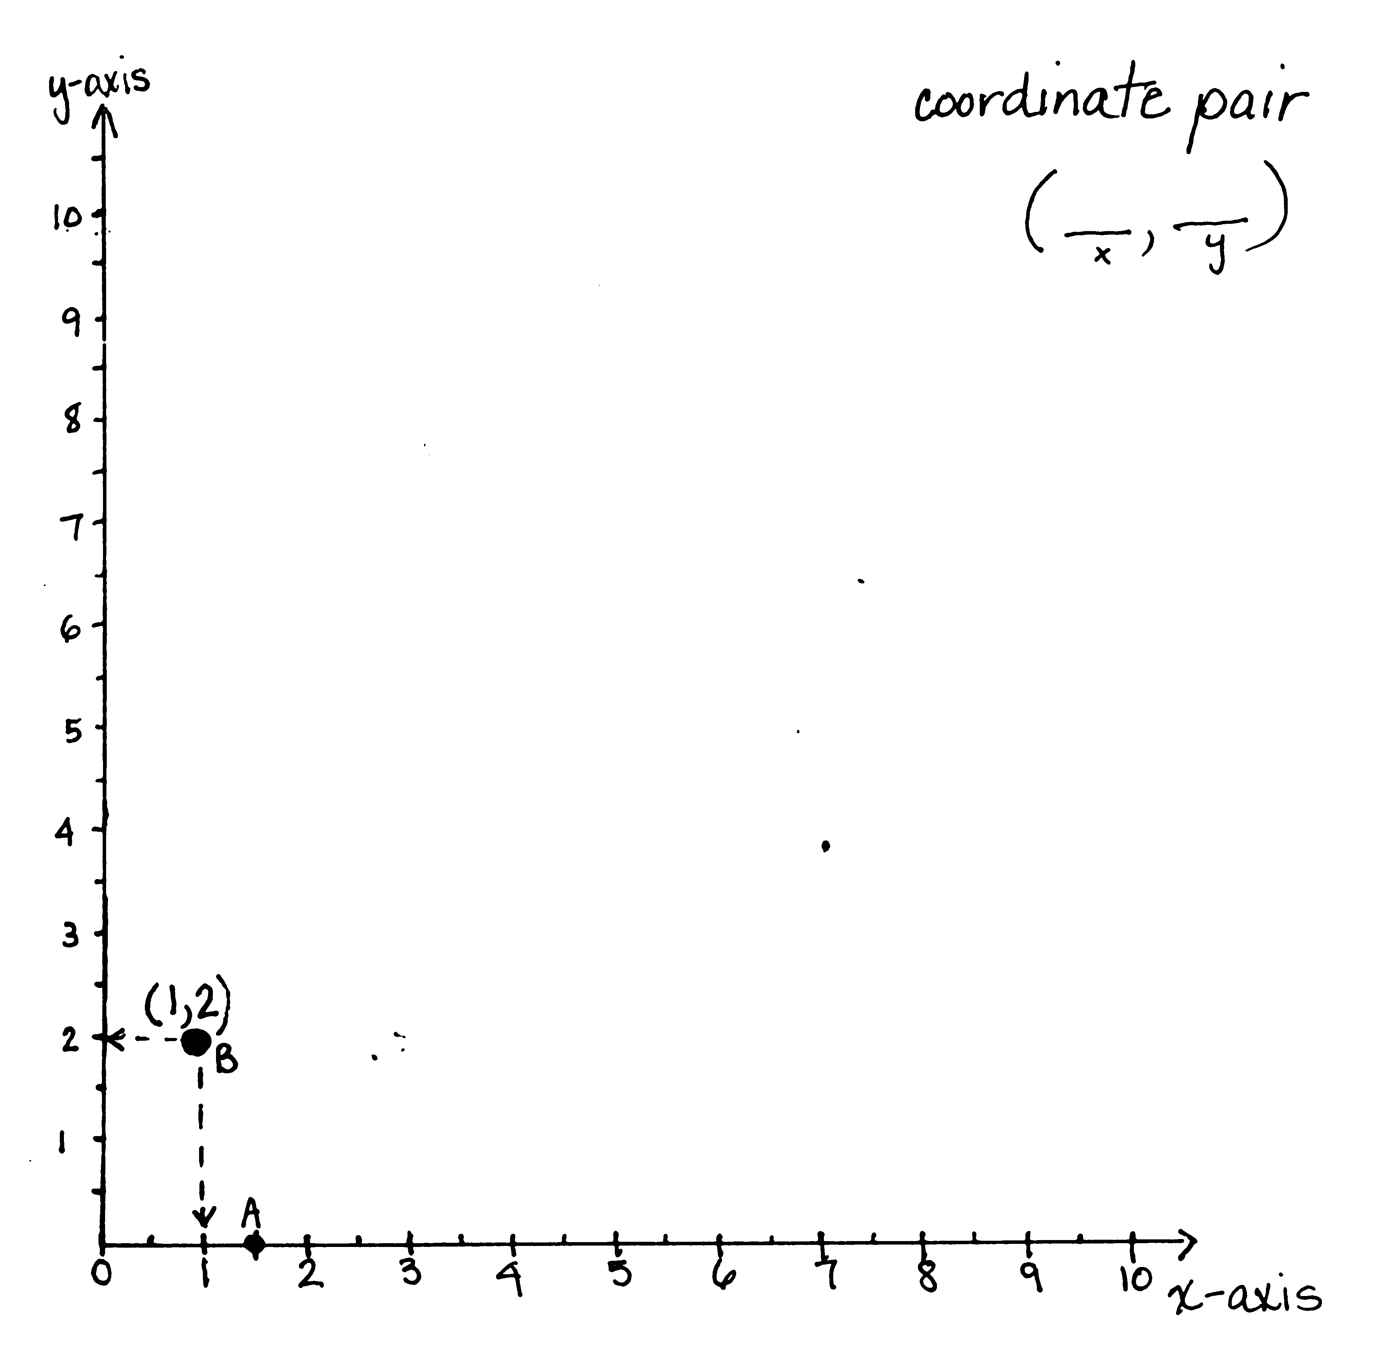
S: (Label the vertical line.)
T: Let’s look again at the location of the point that stumped us earlier. (Plot a point at (1, 2) and label it $B$.) How can having both number lines help us describe the location of point $B$? Turn and talk.
S: It’s about an inch up and to the right of the origin at about a 60 degree angle. We could say it is above the 1 on the $x$-axis and to the right of 2 on the $y$-axis.
T: When describing the location of point, we want to be precise. I’m going to draw a dotted-perpendicular line from $B$ to both the $x$- and $y$-axes. (Model on board.)
T: At what coordinate does the line I drew intersect the $x$-axis?
S: At 1.
T: Yes, it intersects the $x$-axis at a distance of 1 from the origin. (Move a finger to the right 1 unit on the $x$-axis.) We say that this point has an $x$-coordinate of 1. At what coordinate on the $y$-axis does the dotted-line intersect?
S: 2.
T: It intersects the $y$-axis at a distance of 2 from the origin. (Move a finger up from the $x$-coordinate 2 units.) Point $B$ has a $y$-coordinate of 2.
T: We can describe the location of this point by giving directions. Starting at the origin, move 1 unit to the right along the $x$-axis. Then, move 2 units up, parallel to the $y$-axis. These two numbers, taken together, are called a coordinate pair. (Write coordinate pair on the board.) Repeat this term.
S: Coordinate pair.
T: Why does this term make sense? Turn and talk.
S: Pair means two. We need two coordinates to tell where the point is. It just says what it is. We have two coordinates. Coordinate pair means two coordinates!
T: We have a convention when we write coordinate pairs. We always write the $x$-coordinate first (write a blank with an x under it), followed by a comma, and then the $y$-coordinate second (write a blank with a y under it). We show that these two distances describe the same point by putting parentheses around the pair. (Place parentheses around the blanks.)
T: Let’s write the coordinate pair for this point. Remind me, what was the $x$-coordinate of the point?
S: 1.
T: (Fill in the first blank on the board with a 1.)
T: What was the $y$-coordinate?
S: 2.
T: (Fill in the second blank on the board with a 2.)
T: The coordinate pair for this point is (1, 2). Put your finger on the origin. (Model.)
S: (Point to the origin.)
T: Our $x$-coordinate is 1, so travel 1 unit on the $x$-axis. (Model.)
S: (Drag finger.)
T: Our $y$-coordinate is 2, so now we travel 2 units up, parallel to the $y$-axis. (Model.)
S: (Drag finger.)
T: Say the coordinate pair that names the location of your finger.
S: (1, 2).
T: What do these coordinates tell us? Turn and talk.
S: They tell us the location of our finger. We have to go over 1 unit and go up from there 2 units. The first one means that we started at the origin and traveled 1 unit along the $x$-axis; then, we traveled up 2 units parallel to the $y$-axis. We travel along the $x$-axis 1 unit. Then, we travel parallel to the $y$-axis 2 units up to find the point.
T: Write the coordinate pair on your boards.
S: (Write and show.)
T: (Write (4, 8) on the board.) Start at the origin. Which coordinate tells us how far to travel on the $x$-axis?
S: The first one. 4.
T: Now we’ll travel parallel to the $y$-axis. What distance do we travel parallel to the $y$-axis?
S: Eight units.
T: Plot the point.
Repeat the process with (5, 3), (7, 7), and (9, 0).
Problem 2: Name the coordinate pairs of shapes on the coordinate plane.
T: (Display the coordinate plane and give a coordinate plane template to each student.) This coordinate plane is printed on grid paper. Label the $x$- and $y$-axes. Also, notice that the axes on this plane only show the direction that the numbers increase. Leaving off the arrows on the other end of the line just helps the plane be a bit neater, but remember that the axes continue in both directions forever.
S: (Label the axes.)
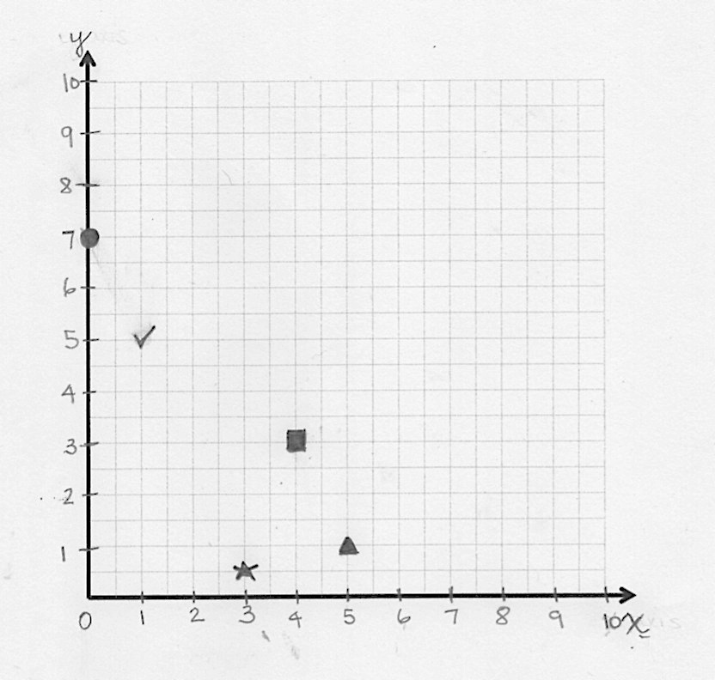
T: Label the point where the axes intersect as zero. Remind me what we call this point.
S: The origin.
T: Starting at the origin, on every other blue grid line, draw 10 hash marks on both axes. Label them using whole numbers up to 10. (Model on board.) Our unit for these axes will be ones.
MP.7
S: (Label the hash marks.)
T: (Draw a square at (4, 3) on the plane.) How can we name the location of this square? Turn and talk.
S: It’s 3 up and 4 over. It’s over 4 and up 3. It’s above the 4 on the $x$-axis and across from 3 on the $y$-axis. It’s 4 units above the $x$-axis and 3 units to the right of the $y$-axis. It’s at (4, 3).
T: Use the grid lines to help you. What is the $x$-coordinate of the square?
S: 4.

NOTES ON
MULTIPLE MEANS OF ENGAGEMENT:
Some students can lose motivation because they do not recognize the progress they are making. Teachers can explicitly help students recognize their accomplishments by constructing systems that help students see their progress. A chart that monitors progress is one way students can visibly see and track accomplishments.

T: (Write (4, ___ ) on the board.) Tell a neighbor how you know.
S: I just counted over from the $y$-axis, and there were 8 spaces; since we labeled every other grid line, that makes 4 for an $x$-coordinate. I can see that the little blue line that comes down from the square intersects the $x$-axis at 4.
T: What is the $y$-coordinate of the square?
S: 3.
T: (Write (4, 3) on board.) Tell a neighbor how you know.
S: (Share answer with neighbor.)
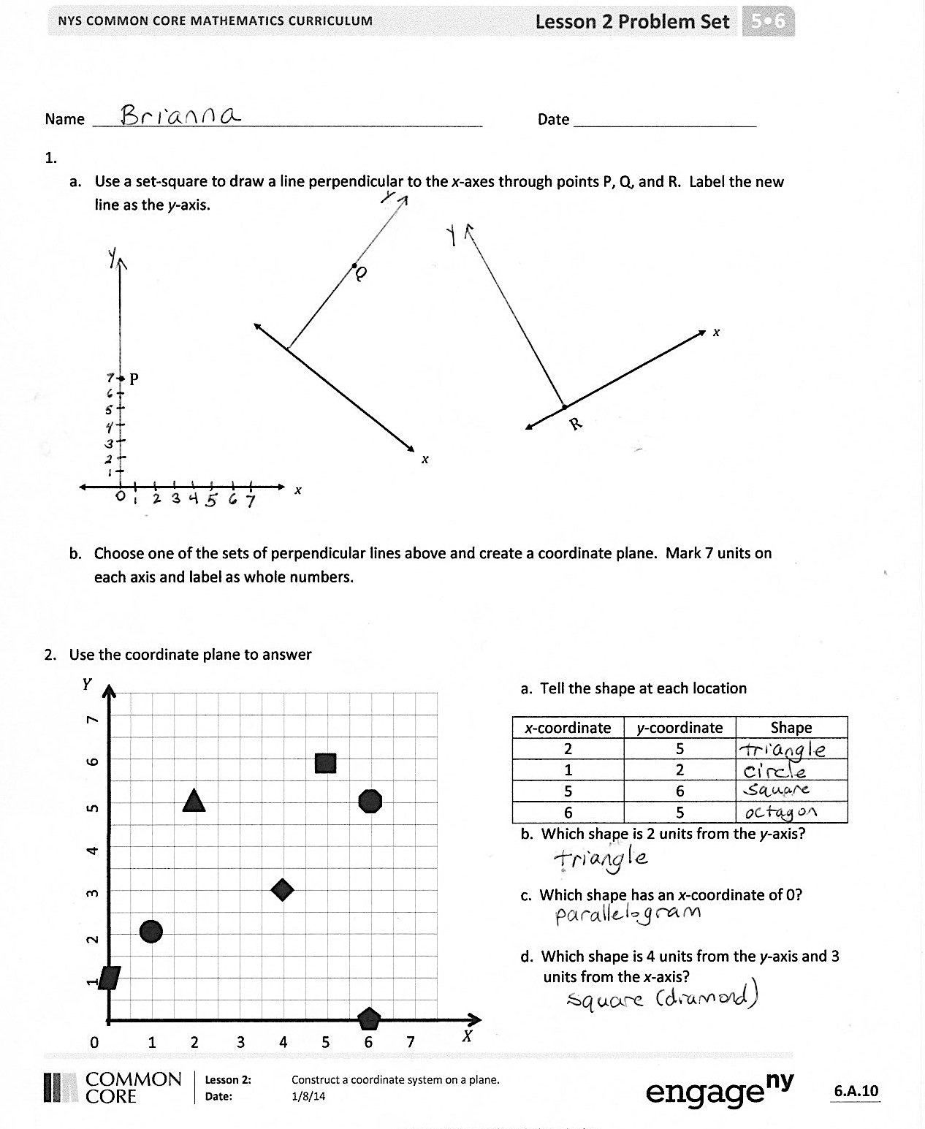
T: Say the coordinate pair for the square.
S: Four, three.
T: Draw a square on your coordinate plane at (4, 3). Compare your work with your partner’s.
Follow a similar sequence with the suggested shapes and locations.
Triangle: (5, 1) Check Mark: (1, 5)
Circle: (0, 7) Star: (3, $\frac{1}{2}$)
Note: Be sure to watch for students who may reverse the coordinates when graphing—especially the locations of the triangle and check mark.
Problem Set (10 minutes)
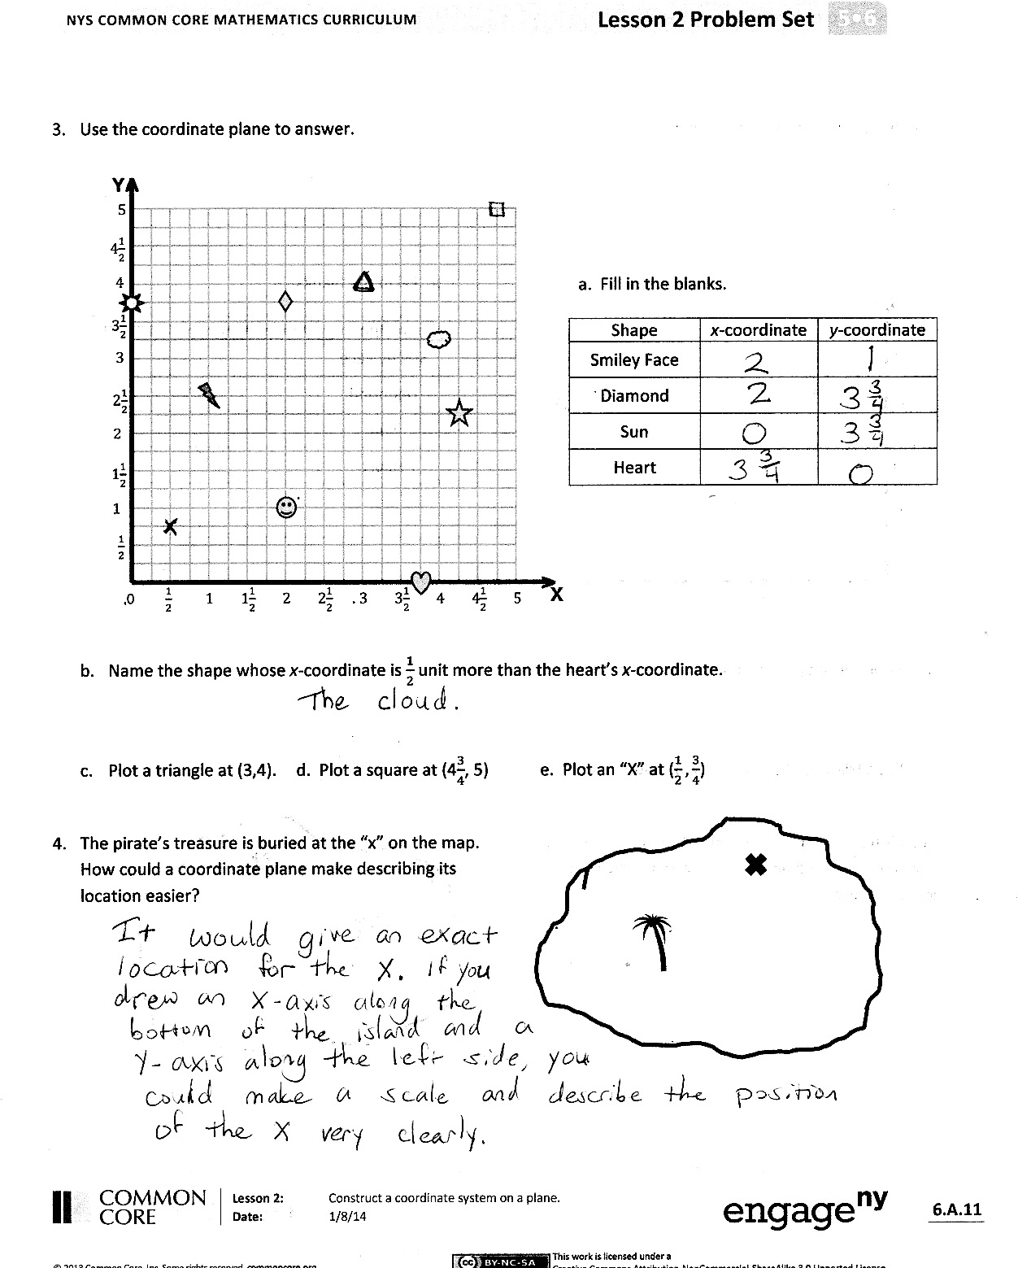
Students should do their personal best to complete the Problem Set within the allotted 10 minutes. For some classes, it may be appropriate to modify the assignment by specifying which problems they work on first. Some problems do not specify a method for solving. Students solve these problems using the RDW approach used for Application Problems.
Student Debrief (10 minutes)
Lesson Objective: Construct a coordinate system on a plane.
The Student Debrief is intended to invite reflection and active processing of the total lesson experience.
Invite students to review their solutions for the Problem Set. They should check work by comparing answers with a partner before going over answers as a class. Look for misconceptions or misunderstandings that can be addressed in the Debrief. Guide students in a conversation to debrief the Problem Set and process the lesson.
You may choose to use any combination of the questions below to lead the discussion.
- Share your thinking about Problem 4. What did we learn today that could help the pirate locate his treasure more easily?
- When answering questions about the coordinate plane in Problem 3, how did you identify the $y$-coordinate of the Diamond and the Sun?

NOTES ON
MULTIPLE MEANS OF ENGAGEMENT:
Offering learners choices can develop self-determination, instill pride, and increase the level in which they feel connected to their learning. One way to offer choice is to let students decide the sequence of some components of their learning. Menus from which students may choose tasks are one way to offer such academic choice.

- What new math vocabulary did we learn today? (Coordinate pair, axis.) Tell a neighbor what you know about these new terms.
- Why is a vertical line at the origin the best place for the $y$-axis?
- Why would it be important for us to all follow the same order when we write down the $x$- and $y$-coordinates? Talk to your partner.
- Grid paper is sometimes used when working on the coordinate plane. Tell a neighbor how this grid paper is helpful in working on the coordinate plane.
- If I tell you that point $A$lies at a distance of 3 units from the $x$-axis, which coordinate do you know?
Exit Ticket (3 minutes)
After the Student Debrief, instruct students to complete the Exit Ticket. A review of their work will help you assess the students’ understanding of the concepts that were presented in the lesson today and plan more effectively for future lessons. You may read the questions aloud to the students.

Name Date

- Use a set square to draw a line perpendicular to the $x$-axes through points $P$, $Q$, and $R$. Label the new line as the $y$-axis.

x
•Q
•
x
$$R$$
• $P$
x

- Choose one of the sets of perpendicular lines above and create a coordinate plane. Mark 7 units on each axis and label as whole numbers.

- Use the coordinate plane to answer.
a. Tell the shape at each location.
$x$-coordinate | $y$-coordinate | Shape
2 | 5
1 | 2
5 | 6
6 | 5
b. Which shape is 2 units from the $y$-axis?

c. Which shape has an $x$-coordinate of 0?

d. Which shape is 4 units from the $y$-axis and 3
units from the $x$-axis?

Y
X
0 1 2 3 4 5 6 7
1 2 3 4 5 6 7

- Use the coordinate plane to answer.

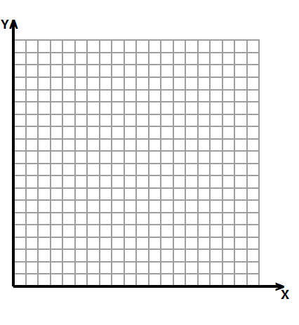
a. Fill in the blanks.

Shape | $x$-coordinate | $y$-coordinate
Smiley Face
Diamond
Sun
Heart

0 $\frac{1}{2}$ 1 1$\frac{1}{2}$ 2 2$\frac{1}{2}$ 3 3$\frac{1}{2}$ 4 4$\frac{1}{2}$ 5
$\frac{1}{2}$
1
1$\frac{1}{2}$
2
2$\frac{1}{2}$
3
3$\frac{1}{2}$
4$\frac{1}{2}$
4
5

- Name the shape whose $x$-coordinate is $\frac{1}{2}$ unit more than the heart’s$x$-coordinate.

- Plot a triangle at (3, 4). d. Plot a square at ($\text{4}\frac{3}{4}$, 5). e. Plot an X at ($\frac{1}{2}, \frac{3}{4}$).

- The pirate’s treasure is buried at the X on the map. How could a coordinate plane make describing its location easier?
X
0 6 12 18 24 30

Name Date
- Name the coordinates of the shapes below.
$$x$$
$$y$$

0 1 2 3 4 5
1
2
3
4
5
Shape | $x$-coordinate | $y$-coordinate
Sun
Arrow
Heart

- Plot a square at (3, 3 $\frac{1}{2}$).

- Plot a triangle at (4 $\frac{1}{2}$, 1).

Name Date

- Use a set-square to draw a line perpendicular to the $x$-axis through point $P$. Label the new line as the $y$-axis.
x
• P
•
P
x

- Choose one of the sets of perpendicular lines above and create a coordinate plane. Mark 5 units on each axis, and label them as whole numbers.

- Use the coordinate plane to answer.

X
Y
0 1 2 3 4 5 6
1
2
3
4
5
6
- Name the shape at each location.
$x$-coordinate | $y$-coordinate | Shape
2 | 4
5 | 4
1 | 5
5 | 1

- Which shape is 2 units from the $x$-axis?

- Which shape has the same $x$- and $y$-coordinate?

- Use the coordinate plane to answer.
- Name the coordinates of each shape.
X
Y
0 1 2 3 4 5 6
1
2
3
4
5
6

Shape | $x$-coordinate | $y$-coordinate
Moon
Sun
Heart
Cloud
Smiley Face

- Which 2 shapes have the same $y$-coordinate?

- Plot an X at (2, 3).
- Plot a square at (3, $\text{2}\frac{1}{2}$).
- Plot a triangle at (6, $\text{3}\frac{1}{2}$).

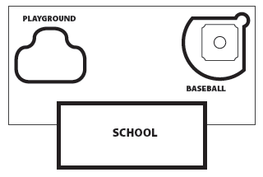
- Mr. Palmer plans to bury a time capsule 10 yards behind the school. What else should he do to make naming the location of the time capsule more accurate?

