Lesson 1
Objective: Construct a coordinate system on a line.

Suggested Lesson Structure
 Fluency Practice (12 minutes)
 Application Problem (6 minutes)
 Concept Development (32 minutes)
 Student Debrief (10 minutes)
Total Time (60 minutes)
Fluency Practice (12 minutes)

NOTES ON
MULTIPLE MEANS OF REPRESENTATION:
The Count by Equivalent Fractions fluency activity supports language acquisition for English language learners as it offers valuable practice speaking fraction names, such as fourths. Model and assist students’ enunciation of the ending digraph /th/. Couple the counting with prepared visuals to increase comprehension.

- Count by Equivalent Fractions 4.NF.1 (6 minutes)
- Find the Missing Number on a Number Line 5.G.1 (4 minutes)
- Physiometry 4.G.2 (2 minutes)
Count by Equivalent Fractions (6 minutes)
Materials: (S) Personal white boards
Note: This fluency activity prepares students for G5–M6–Lesson 1.
T: Count by 1 half to 10 halves. Start at zero halves. (Write as students count.)
$\frac{0}{2}$ $\frac{1}{2}$ $\frac{2}{2}$ $\frac{3}{2}$ $\frac{4}{2}$ $\frac{5}{2}$ $\frac{6}{2}$ $\frac{7}{2}$ $\frac{8}{2}$ $\frac{9}{2}$ $\frac{10}{2}$
0, $\frac{1}{2}$ 1 $\frac{3}{2}$ 2 $\frac{5}{2}$ 3 $\frac{7}{2}$ 4 $\frac{9}{2}$ 5

S: $\frac{0}{2}, \frac{1}{2}, \frac{2}{2}, \frac{3}{2},\frac{4}{2},\frac{5}{2,},\frac{6}{2},\frac{7}{2},\frac{8}{2},\frac{9}{2},\frac{10}{2}$.
T: 2 halves is the same as 1 of what unit?
S: 1 one.
T: (Beneath $\frac{2}{2}$, write 1.) 2 ones is the same as how many halves?
S: 4 halves.
T: (Beneath $\frac{4}{2}$, write 2.) 3 ones is the same as how many halves?
Repeat the process through $\frac{10}{2}$ or 5.
T: (Beneath $\frac{10}{2}$, write 5.) Let’s count to 10 halves again, but this time when you come to a fraction that is equal to a whole number, say the whole number.
S: 0, $\frac{1}{2}$, 1, $\frac{2}{2}$, 2, $\frac{5}{2}$, 3, $\frac{7}{2}$, 4, $\frac{9}{2}$, 5.
Repeat the process, counting by fourths to $\frac{10}{4}$.
Find the Missing Number on a Number Line (4 minutes)
Materials: (S) Personal white boards
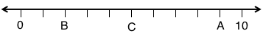
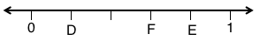
Note: This fluency activity prepares students for G5–M6–Lesson 1.
T: (Project a number line partitioned into 10 unit intervals. Label 0 and 10 as the endpoints. Point to the A.) What’s the value of $A$?
S: 9.
T: (Point to $B$.) What’s the value of $B$?
S: 2.
T: Write the value of $C$.
S: (Write 5.)
Continue the process for the other number lines.
Physiometry (2 minutes)
Note: This fluency activity prepares students for G5–M6–Lesson 2.
T: (Stretch one arm up, directly toward the ceiling. Stretch the other arm out, directly toward a wall and parallel to the floor.) What type of angle do you think I am making?
S: Right angle.
T: What is the relationship of the lines formed by my arms?
S: Perpendicular.
T: (Point to a wall on the side of the room.) Point to the walls that run perpendicular to the wall I’m pointing to.
S: (Point to the front and back walls.)
T: (Point to the back wall.)
S: (Point to the side walls.)
Continue the exercise, pointing to remaining walls and asking students to respond.
T: (Point to the back wall.) Point to the wall that runs parallel to the wall I’m pointing to.
S: (Point to the front wall.)
Continue the exercise, pointing to remaining walls and asking students to respond.
Application Problem (6 minutes)
A landscaper is planting some marigolds in a row. The row is 2 yards long. The flowers must be spaced $\frac{1}{3}$ yard apart so that they will have proper room to grow. The landscaper plants the first flower at 0. Place points on the number line to show where the landscaper should place the other plants. How many marigolds will fit on this row?
Note: In today’s Application Problem, students must make sense of the fractional units marked on a number line. This prepares students for today’s work with creating number lines in various orientations and with various fractional units. Be aware that the problem cannot be solved correctly by simply dividing 2 yards by one-third since a marigold is being planted at the zero hash mark.

NOTES ON
MULTIPLE MEANS OF ENGAGEMENT:
The use of parallel lines to create equidistant intervals is outlined in G3–M5–Lesson 30. Please see that lesson for more detail.

0 1yd 2yd

Concept Development (32 minutes)
Materials: (T) Teacher created number lines in various orientations and scales (see Problem 3 in the Concept Development) (S) Straightedge or ruler,
2 pieces of unlined paper, 1 piece of lined paper,
2 1" $\text{×}$ 4¼" tag board strips
Problem 1: Create a number line by choosing a unit length, an origin, and a direction of increase.
T: (Distribute tag board strips, unlined paper, lined paper, and straightedges.) Tell me all you know about number lines. (Record what students say.)
S: Number lines start with zero. They count from zero. Numbers increase from left to right as far as you want. Really, they don’t ever stop; we just stop writing down the numbers. We can count by ones, twos, or even by fractions. When you draw a number line, you have to be sure that the tick marks are the same distance apart.
T: The things you’ve said are true. We can think of 0 as the starting point for a number line, even when we don’t actually show it. They do count by anything, and the distance between the marks must be the same. (Display the collection of lines at the right or a similar collection.) These are all number lines, too. What do you notice that is different? Turn and talk.
S: Some go up and down, not side-to-side. Some vertical lines have zero at the top, and the numbers increase from the top to the bottom. Some are at an angle. Some increase from right to left.
T: Use your straightedge to draw a long line on your plain paper. You may draw your line at any angle.
S: (Draw lines.)
T: Let’s draw an arrow on both ends to show that the line goes on forever in both directions.
S: (Draw arrows on the lines.)
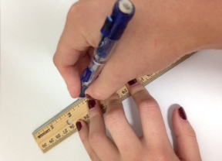
T: We can turn the line that we’ve drawn into a number line. (If possible, list three steps on the board, as shown below.) First, choose a unit length. Use the tag board to pick a unit length. Cut one of your tag board strips so that it is at least 1 inch long. How can we be sure our cut is straight?
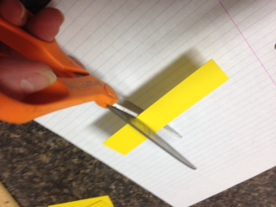
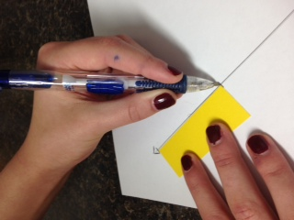
S: Fold it so that the edges meet and cut on the fold. (Cut tag board strip.)
T: Compare your unit length to your partner’s. Are they the same or different?
S: (Compare unit lengths. There should be a variety.)
T: Use this unit length to mark off equal distances on our lines with hash marks. Start at either end, and mark as many equal units as you can. (Demonstrate, if necessary.)
T: Now that our number lines show equal units, read our second step.
S: (Read.) Choose a direction of increase of the numbers and label zero.
MP.6
T: Label a hash mark as zero on one end of your line so that your numbers increase in the direction you chose. Show your partner what you did. (Allow students time to work and discuss with a partner.)
- Choose a unit length by cutting a piece of tag board.
- Choose a direction of increase of the numbers, and label zero.
- Label the units starting with the origin.

T: The point on the number line labeled zero is called the origin.
T: The third step, now that we’ve labeled our origin, is to label the rest of your units using whole numbers. While we could label them with any numbers, we will use whole numbers for this line.

NOTES ON
MULTIPLE MEANS OF REPRESENTATION:
Students with fine motor deficits may find number line creation difficult. Allow students to partner such that one draws the lines and partitions, and the other labels the tick marks.

S: (Label units.)
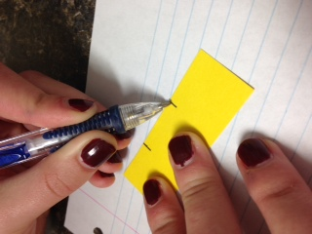
Problem 2: On the number line created above, partition unit lengths into fractional units, and label those fractions.
T: Now that we’ve marked the whole units on our number lines, let’s partition these wholes into fractional units. We can use lined paper to mark off any fractional unit precisely without the use of a ruler. Place your lined paper on your desk so that the red margin is horizontal.
S: (Place paper so that red margin is horizontal.)
T: Angle your tag board unit so that the left top corner touches one line, and the right top corner touches another line. Mark the intersection of your unit with the lines on the paper.
S: (Mark intersection.)
T: What fractional unit did you mark? How do you know?
S: I marked thirds. I see 3 equal parts. I marked fourths. I made my paper touch a line, and then I counted 4 lines over and marked where they touched. This made 4 equal parts.
T: Use the vertical lines to mark a different fractional unit on the other long edge of your tag board. Then, flip your unit over and mark two more fractional units on those edges as well.
S: (Mark additional units.)
T: Why does this method work?
S: Because the lines on the paper are parallel and the same distance apart, it doesn’t matter how you lay your paper strip across them; the distance between each mark is still the same. Because the lines are equal distances, we can choose how many marks we want and angle the paper across that many lines. If we want halves, we touch a line and count two spaces to figure out the line to touch with the other end of the unit. If we want thirds, we touch a line and count three spaces to figure out the line to touch with the other corner.
T: Now choose one of the fractional units you’ve marked on your tag board, and use it to partition your number line. Label the fractional units.
S: (Label the units.)
T: Try to find someone in our class whose number line is exactly the same as yours. What do you notice?
S: I couldn’t find anybody’s that was exactly like mine. Some counted in the same direction, but the units were different size. Number lines can increase in any direction. Units can be whatever size you choose, and the line can be at any angle. We can choose to show any fraction of our unit on the number line.
Problem 3: Identify the coordinate of a given shape placed on a number line.
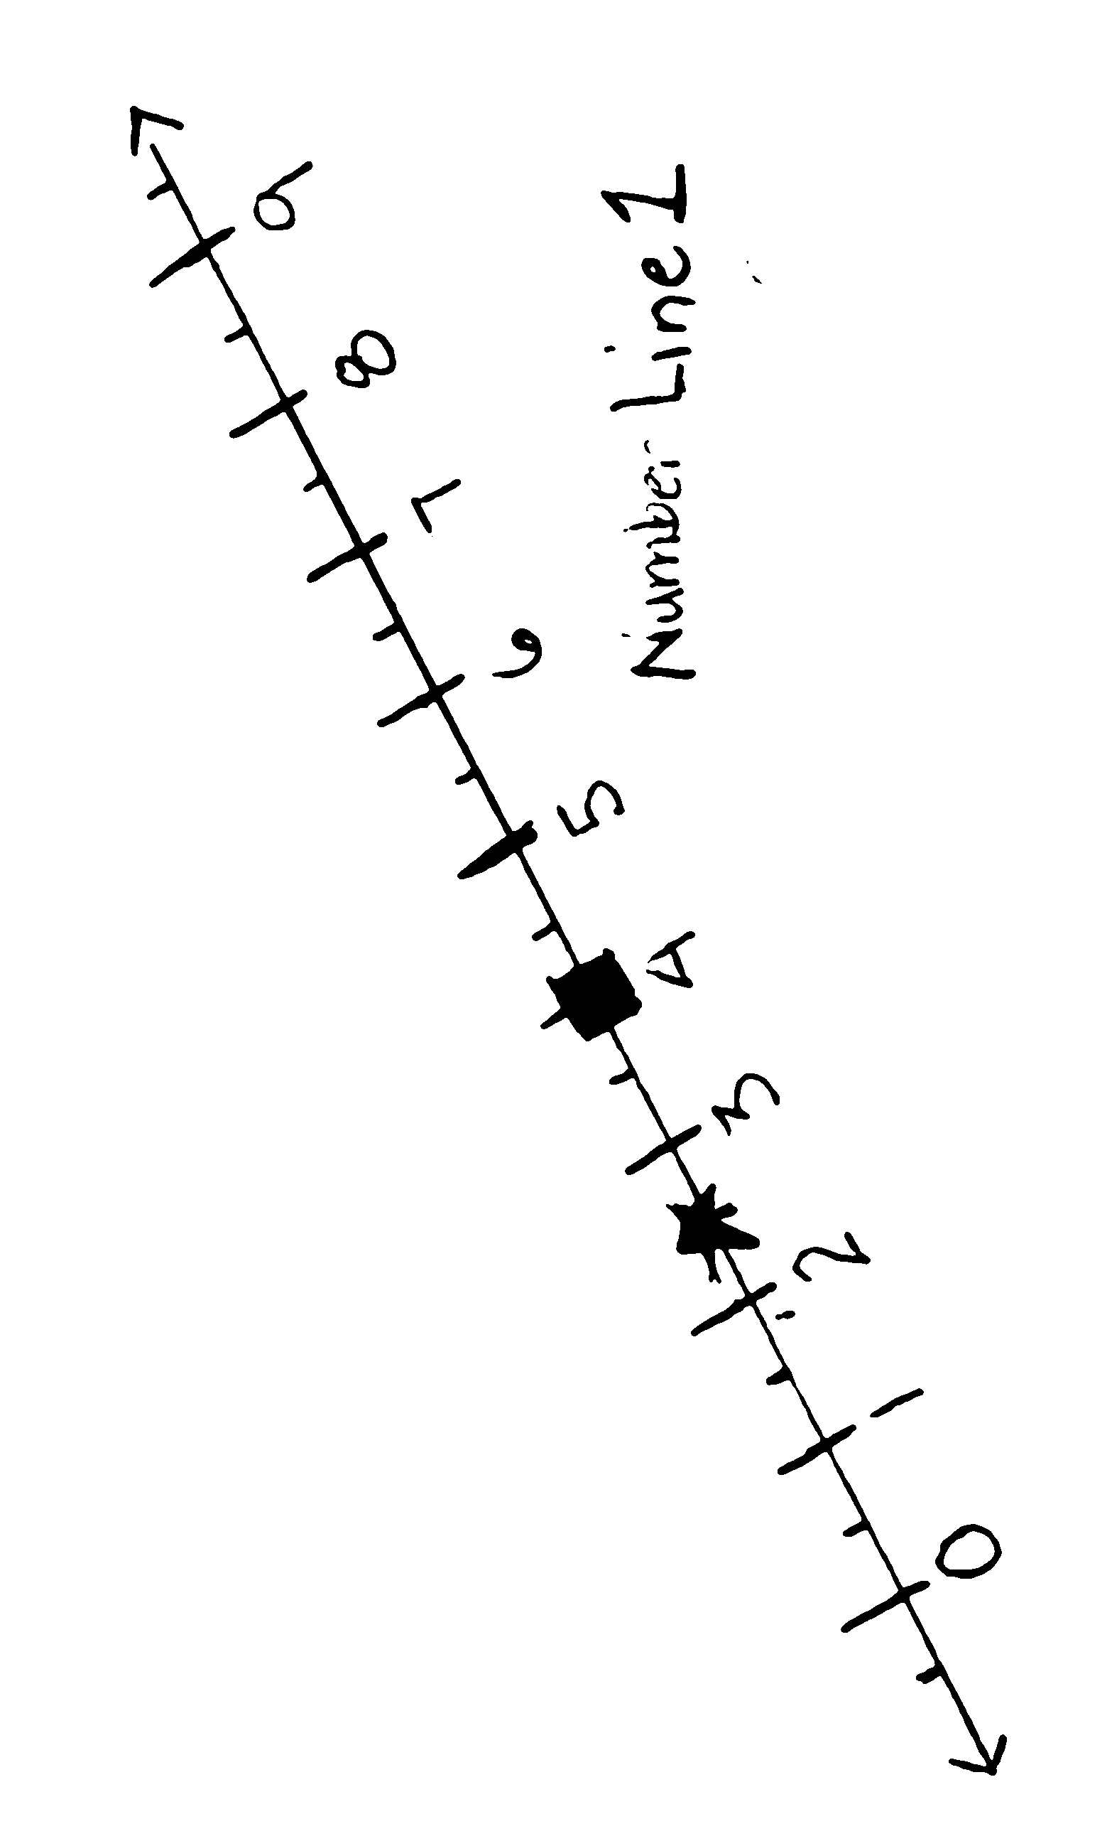
T: (Display Number Line 1.) Here is a number line that I created. I want to describe the location of one of the shapes on this number line without pointing to it. What can I say? Turn and talk.
S: You could tell how far it is from another shape. You could tell how far the shape was from one end of the line. You could tell how far it is from zero.
T: Because every number line has an origin, we can use it as a reference point to tell the location of other points on and off the line. We can describe the location of a shape on this line by telling its coordinate. (Write coordinate on the board.) Say coordinate.
S: (Repeat coordinate.)
T: The coordinate tells the distance from zero to the shape. On Number Line 1, the square’s coordinate is 4. (Point.) That’s another way to say that the distance from zero to the shape is 4 units. (Show the distance by running a finger along the line from 0 to 4.) What is the star’s coordinate?
S: $\text{2}\frac{1}{2}$.
T: Remind your partner what the coordinate tells.
S: (Share with partner.)
T: (Display Number Lines 2 and 3.) A point has been plotted on each of these number lines. What is the coordinate of point $A$ on Number Line 2? The coordinate of point $B$on Number Line 3? Tell your partner.

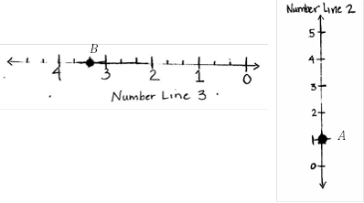

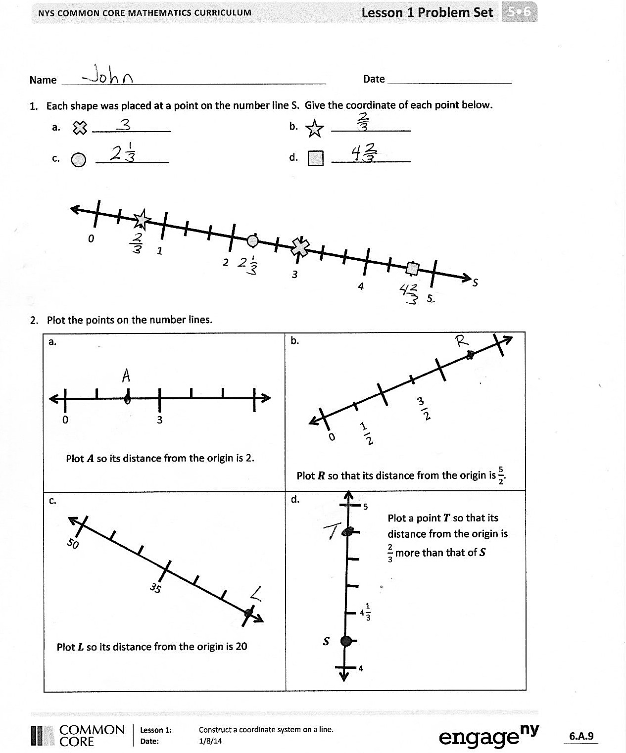
S: Point $A$ is 1 unit from the origin. The coordinate of point $B$ is $\text{3}\frac{1}{3}$.
T: Plot 2 points on your number line and label them $C and D.$ Have your partner give the coordinate of the points.
S: (Plot and label points; partner gives coordinates.)
Problem Set (10 minutes)
Students should do their personal best to complete the Problem Set within the allotted 10 minutes. Some problems do not specify a method for solving. This is an intentional reduction of scaffolding that invokes MP.5, Use Appropriate Tools Strategically. Students should solve these problems using the RDW approach used for Application Problems.
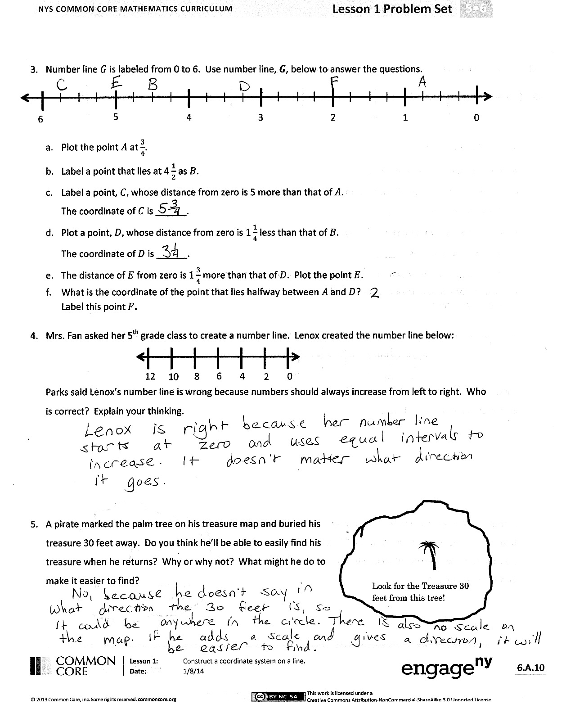
For some classes, it may be appropriate to modify the assignment by specifying which problems students should work on first. With this option, let the careful sequencing of the Problem Set guide your selections so that problems continue to be scaffolded. Balance word problems with other problem types to ensure a range of practice. Assign incomplete problems for homework or at another time during the day
Student Debrief (10 minutes)
Lesson Objective: Construct a coordinate system on a line.
The Student Debrief is intended to invite reflection and active processing of the total lesson experience.
Invite students to review their solutions for the Problem Set. They should check work by comparing answers with a partner before going over answers as a class. Look for misconceptions or misunderstandings that can be addressed in the Debrief. Guide students in a conversation to debrief the Problem Set and process the lesson.
You may choose to use any combination of the questions below to lead the discussion.
- Share your answer for Problem 4 with a partner. (Discuss with students that the cultural convention for single number lines is that the numbers increase from left to right, but in reality it doesn’t matter. This will help prepare students to encounter concepts of absolute value in later grades.)
- What advice did you have for the pirate in Problem 5? Share and explain your thinking to a partner.
- What did you learn about the number line that you did not know before?
- G5–Module 6 is rich in new vocabulary. A word wall for this new vocabulary (e.g., origin, coordinate, plot) may be a helpful scaffold for all students. The word wall might even take on the appearance of a coordinate plane in future lessons with words plotted at different coordinates each day. Students could be asked to explain the word plotted at (2, 4), for example.
Exit Ticket (3 minutes)
After the Student Debrief, instruct students to complete the Exit Ticket. A review of their work will help you assess the students’ understanding of the concepts that were presented in the lesson today and plan more effectively for future lessons. You may read the questions aloud to the students.

Name Date
- Each shape was placed at a point on the number line S. Give the coordinate of each point below.
  - ______________ b. ______________
c. _____________ d. ______________

0 1 2 3 4 5
S

- Plot the points on the number lines.
a.  0  3  Plot $A$ so its distance from the origin is 2.  Plot $R$ so that its distance from the origin is$\frac{5}{2}$. | b.  0  $$\frac{3}{2}$$  $$\frac{1}{2}$$
c.  Plot $L$ so its distance from the origin is 20  50  35 | d.  $$4\frac{1}{3}$$  4  5  $$S$$  Plot a point $T$ so that its distance from the origin is $\frac{2}{3}$ more than that of $S$
- Number line $G$ is labeled from 0 to 6. Use number line $G$ below, to answer the questions.
4
3
6
5
1
2
0
$$G$$

- Plot point $A$ at $\frac{3}{4}$.
- Label a point that lies at $4\frac{1}{2}$ as $B$.
- Label a point, $C,$ whose distance from zero is 5 more than that of $A$.
The coordinate of $C$ is ______.
- Plot a point, $D,$ whose distance from zero is $1\frac{1}{4}$ less than that of $B.$
The coordinate of $D$ is ______.
- The distance of $E$ from zero is $1\frac{3}{4}$ more than that of $D$. Plot point $E$.
- What is the coordinate of the point that lies halfway between $A$ and $D$?
Label this point $F$.
- Mrs. Fan asked her fifth-grade class to create a number line. Lenox created the number line below:
12
6
4
10
8
2
0

Parks said Lenox’s number line is wrong because numbers should always increase from left to right. Who is correct? Explain your thinking.

Look for the treasure 30 feet from this tree!
- A pirate marked the palm tree on his treasure map and buried his treasure 30 feet away. Do you think he’ll be able to easily find his treasure when he returns? Why or why not? What might he do to make it easier to find?

Name Date
- Use number line $l$ to answer the questions.
$$D$$

1 $\frac{3}{5}$
2
$$l$$
N

  - Plot point $C$ so its distance from the origin is 1.
  - Plot point $E$ $\frac{4}{5}$ closer to the origin than $C$. What is its coordinate? ____________
  - Plot a point at the midpoint of $C$ and $E.$ Label it $H$.

Name Date
- Answer the following questions using number line $Q,$ below.
- What is the coordinate, or the distance from the origin, of the ? ______________
- What is the coordinate of ? ______________
- What is the coordinate of ? _____________
- What is the coordinate at the midpoint of and ? ______________
0 3 6 9 12 15
$$Q$$

- Use the number lines to answer the questions.

Plot $M$ so its distance is $\frac{11}{4}$ from the origin.
What is the distance from $P$ to $M$?
0
$$P$$
3
12
0

Plot $T$ so its distance from the origin is 10.

Plot $U$ so that its distance from the origin is $\frac{3}{6}$ closer than that of $W$.

$$9\frac{2}{6}$$
10
9
$$W$$
Plot a point that is 0.15 closer to the origin than $Z$.

1.05

0.75
$$Z$$

- Number line $K$ shows 12 units. Use number line $K$, below, to answer the questions.
$$F$$
8
6
12
10
2
4
0
$$K$$

- Plot a point at 1. Label it $A$.
- Label a point that lies at $\text{3}\frac{1}{2}$ as $B$.
- Label a point, $C$, whose distance from zero is 8 units farther than that of $B$.
The coordinate of $C$ is ________.
- Plot a point, $D,$ whose distance from zero is $\frac{6}{2}$ closer to zero than $B$.
The coordinate of $D$ is ________.
- What is the coordinate of the point that lies $\frac{17}{2}$ farther from the origin than $D$?
Label this point $E$.
- What is the coordinate of the point that lies halfway between $F$ and D?
Label this point $G$.

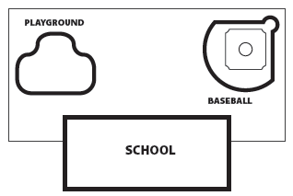
- Mr. Baker’s fifth-grade class buried a time capsule in the field behind the school. They drew a map and marked the location of the capsule with an X so his class can dig it up in ten years. What could Mr. Baker have done to make the capsule easier to find?

