Topic B

Arrays and Equal Groups
2.OA.4, 2.NBT.2
Focus Standard: | 2.OA.4 | Use addition to find the total number of objects arranged in rectangular arrays with up to 5 rows and up to 5 columns; write an equation to express the total as a sum of equal addends.
Instructional Days: | 5
Coherence -Links from: | G2–M3 | Place Value, Counting, and Comparison of Numbers to 1,000
-Links to: | G2–M8 | Time, Shapes, and Fractions as Equal Parts of Shapes
 | G3–M1 | Properties of Multiplication and Division and Solving Problems with Units of 2–5 and 10
Topic B focuses on spatial relationships and structuring as students organize equal groups (from Topic A) into rectangular arrays. They build small arrays (up to 5 by 5) and use repeated addition of the number in each row or column (i.e., group) to find the total.
In Lesson 5, students compose arrays either one row or one column at a time and count to find the total using the scattered sets from Topic A. For example, they might arrange one row of 3 counters, followed by three more identical rows, to compose a 4 by 3 array of 12 counters. Then, students use the same equal groups to create an array, column by column (shown below). They count to find the total, noticing that each row and each column contain the same number of units. Thus, for 4 rows of 3 or 4 columns of 3, a student might observe, “There are 4 equal groups of 3.” This is foundational to the spatial structuring students need to discern a row or column as a single entity, or unit, when working with tiled arrays without gaps and overlaps in Topic C.

In Lesson 6, students decompose one array by both rows and columns. Thus, an array of 4 rows of 3 teddy bears can be pulled apart to show either 4 rows of 3 or 3 columns of 4. Also, students see that when another row or column is added or removed, so is another group, or unit. As Lesson 6 progresses, students move the objects of the arrays closer together so the gaps are smaller, forcing them to discern the rows and columns without the visual aid of spacing. For example, when decomposing a 4 by 3 array, students see the rows as equal groups of 3. After identifying the number in each row, or group, students realize that they can write a repeated addition sentence to find the total number of objects in the array: 3 + 3 + 3 + 3 = 12. It may be noted that since there are 4 rows, the equation will have 4 addends, or 4 threes. Students add from left to right and write the sum, such that 3 plus 3 equals 6, 6 plus 3 equals 9, and 9 plus 3 equals 12.
In Lesson 7, students move to the pictorial as they use math drawings to represent arrays and relate the drawings to repeated addition. For example, students are asked to draw an array with 4 rows of 3 or 3 rows of 4 on their personal white board, and then use their marker to draw horizontal lines to see the rows within the array (shown below). When counting rows containing 3 or 4 objects, students apply repeated addition strategies once again, adding from left to right to find the sum (e.g., 4 + 4 + 4 = 12, such that 4 plus 4 equals 8 and 8 plus 4 equals 12). Additionally, when representing arrays with rows of 2 or 5, students may add to find the total and naturally point out a connection to skip-counting by twos or fives (2.NBT.2); the focus, however, is on establishing a strong connection between the array and repeated addition.
4
4
4
3
3
3
3
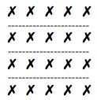
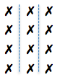
4 + 4 + 4 = 12

3 + 3 + 3 + 3 = 12

In Lesson 8, students work with square tiles to create arrays with gaps, composing the arrays from parts to whole, either one row or one column at a time. Seeing arrays as composed of individual, separated tiles provides the foundation for Topic C, where students work with square tiles without gaps. As usual, students relate the arrays to repeated addition.
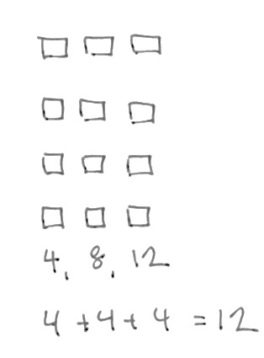
In Lesson 9, students apply the work of Topic B to word problems involving repeated addition (shown below), interpreting array situations as either rows or columns and using the RDW process, e.g., “Mrs. Levy moves desks into 3 columns of 4 desks. How many desks does she move?” In addition to drawing objects, students may also represent the situation with more abstract tape diagrams, just as they did in the final lesson of
Topic A.

A Teaching Sequence Toward Mastery of Arrays and Equal Groups
Objective 1: Compose arrays from rows and columns, and count to find the total using objects.
(Lesson 5)
Objective 2: Decompose arrays into rows and columns, and relate to repeated addition.
(Lesson 6)
Objective 3: Represent arrays and distinguish rows and columns using math drawings.
(Lesson 7)
Objective 4: Create arrays using square tiles with gaps.
(Lesson 8)
Objective 5: Solve word problems involving addition of equal groups in rows and columns.
(Lesson 9)

