Lesson 2

Objective: Use math drawings to represent equal groups, and relate to repeated addition.

Suggested Lesson Structure

 Fluency Practice (12 minutes)

 Concept Development (32 minutes)

 Application Problem (6 minutes)

 Student Debrief (10 minutes)

**Total Time (60 minutes)**

Fluency Practice (12 minutes)

* Grade 2 Core Fluency Practice Sets **2.OA.2** (5 minutes)
* Using the Nearest Ten to Subtract **2.NBT.5** (5 minutes)
* Subtracting Multiples of Hundreds and Tens **2.NBT.7** (2 minutes)

Grade 2 Core Fluency Practice Sets (5 minutes)

Materials: (S) Core Fluency Practice Sets (G2−M6−Lesson 1 Core Fluency Practice Sets)

Note: During Topic A and for the remainder of the year, each day’s Fluency Practice includes an opportunity for review and mastery of the sums and differences with totals through 20 by means of the Core Fluency Practice Sets or Sprints. Practice Sets, along with details about the process, are provided in Lesson 1.

Using the Nearest Ten to Subtract (5 minutes)

Note: Students apply bonds of 10 to subtracting with larger numbers.

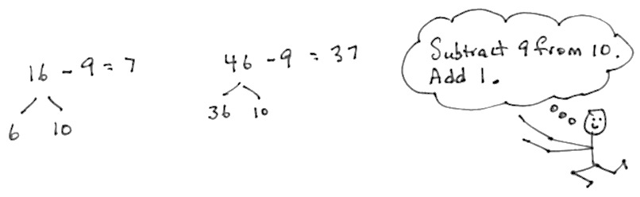

T: (Post 16 – 9 on the board.) Raise your hand   
when you know the answer.

S: 7.

T: (Write the bond of 16 as 6 and 10.) 10 – 9 is…?

S: 1.

T: 1 + 6 is…?

S: 7.

T: 16 – 9 is…?

S: 7.

T: 46 – 9 is…? (Pause.)

S: 37.

T: (Write the bond of 46 as 36 and 10.) 10 – 9 is…?

S: 1.

T: 36 + 1 is…?

S: 37.

T: 46 – 9 is…?

S: 37.

Continue with the following possible sequence: 15 – 9 and 45 – 9, 13 – 8 and 33 – 8, 15 – 7 and 35 – 7, 12 – 9 and 42 – 9, 13 – 7 and 53 – 7, 16 – 9 and 46 – 9, 14 – 8 and 54 – 8, 13 – 5 and 43 – 5, and 16 – 9 and 36 – 9.

Subtracting Multiples of Hundreds and Tens (2 minutes)

Note: Students review subtracting multiples of hundreds and tens to maintain their ability to isolate and manipulate place value units.

T: What is 2 tens less than 130?

S: 110.

T: Give the subtraction number sentence.

S: 130 – 20 = 110.

T: What is 2 hundreds less than 350?

S: 150.

T: Give the subtraction number sentence.

S: 350 – 200 = 150.

Continue with the following possible sequence: 6 tens less than 150, 3 hundreds less than 550,   
and 7 tens less than 250.

Concept Development (32 minutes)

Materials: (T) Counters (S) Personal white board

T: (Display 4 groups with 3 counters in each group.) How can we find the total number of counters?

S: Add them all up.

T: Excellent! Let’s do that. (Draw a line below each group. Point to the counters in the first group.) How many in this group?

S: 3.

T: (Write 3 below the first group, followed by the plus sign.)

T: (Point to the next group, and repeat the process for the remaining groups.)

T: So, what’s our number sentence to find the total?

S: 3 + 3 + 3 + 3 = ____.

T: We just used **repeated addition**! (Point to each 3 from left to right.) 3 + 3 is…?

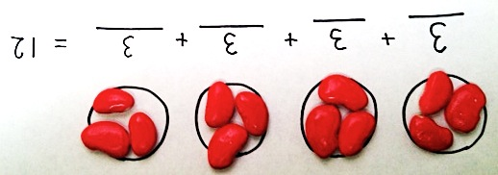S: 6.

T: 6 + 3 is…?

S: 9.

T: 9 + 3 is…?

S: 12.

T: Four groups of 3 equals…? Say the complete sentence.

S: Four groups of 3 equals 12.

T: Talk with your partner about how the number sentence relates to the model.

S: The 3 stands for how many are in each group. 🡪 There are 4 groups of 3, so that’s why we added 3 four times. 🡪 There are 4 threes in the model, and there are 4 threes in the addition sentence.

|  |  |
| --- | --- |
|  | NOTES ON  MULTIPLE MEANS  OF ACTION AND EXPRESSION: |
| Have manipulatives available for students who need to return to the concrete experience to master this concept. Allow them to progress at their own pace through the pictorial and abstract levels of this concept. | |

T: Yes! And, since the groups are equal, instead of counting one by one, we can use repeated addition. We add the same addend over and over.

T: Now, it’s your turn! Since it’s math, not art, we want to be quick and efficient, so you’re going to draw groups of circles. You can pretend they’re stars or donuts, whatever you want, but when we model, we’ll be drawing circles!

**MP.8**

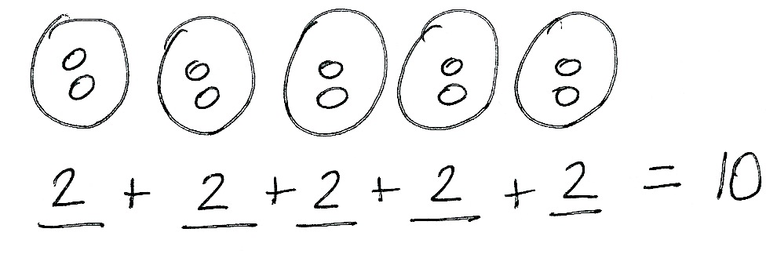T: Draw 5 large circles to represent the groups. (Model as students draw.)

T: Draw 2 circles in each group. (Model as students draw.)

T: Draw a line beneath each group. (Model as students draw.)

T: Tell your partner what number you’re going to write on each line and why.

S: 2, because there are 2 in each group.

T: What number is repeating?

S: 2.

T: Let’s write our repeated addition equation. (Write 2 + 2 + 2 + 2 + 2 = ____ as students do the same.)

T: Let’s read the equation.

S: 2 + 2 + 2 + 2 + 2 = ____.

T: 2 + 2 equals…?

S: 4.

T: 4 + 2 equals…?

S: 6.

T: 6 + 2 equals…?

|  |  |
| --- | --- |
|  | NOTES ON  MULTIPLE MEANS  OF REPRESENTATION: |
| Periodically inform parents of new vocabulary, such as *addend* and *repeated addition*, so parents can help their children with the homework and understand the math vocabulary they are learning. Send home handouts or update the vocabulary on a class website. | |

S: 8.

T: 8 + 2 equals…?

S: 10.

T: (Point to each group of circles.) So, 5 groups of 2 equals 10. Repeat that with me.

S: Five groups of 2 equals 10.

T: Erase your board. This time, let’s draw groups of 5. Draw one group of 5. (Model as students do the same.)

T: Now, add another group of 5.

T: Now, draw 5 more than that.

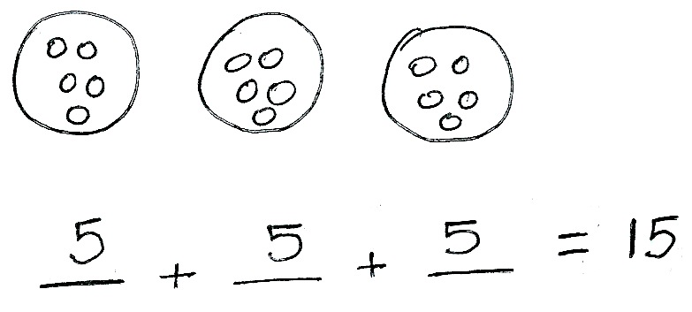T: How many groups do we have?

S: 3 groups.

T: How many in each group?

S: 5 in each group.

T: What is the repeated addition expression?

S: 5 + 5 + 5.

T: Let’s write that as an equation. (Write 5 + 5 + 5 = ___ as students do the same.)

T: 5 + 5 equals…?

S: 10.

T: 10 + 5 equals…?

S: 15.

T: Three groups of 5 equals…? Say the complete sentence.

S: Three groups of 5 equals 15.

T: We can also say 3 fives equal 15. Say that with me.

S: 3 fives equals 15.

T: Now, you’re going to show what you know! Let’s practice our repeated addition on the Problem Set.

Problem Set (10 minutes)

Students should do their personal best to complete the Problem Set within the allotted 10 minutes. Some problems do not specify a method for solving. This is an intentional reduction of scaffolding that invokes MP.5, Use Appropriate Tools Strategically. Students should solve these problems using the RDW approach used for Application Problems.

Application Problem (6 minutes)

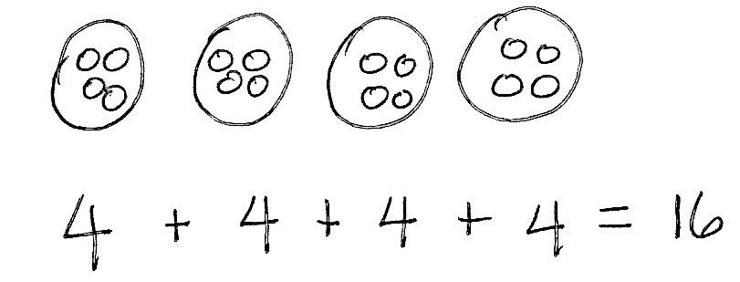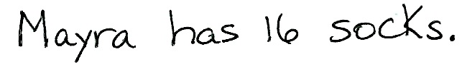

Mayra sorts her socks by color. She has 4 purple socks, 4 yellow socks, 4 pink socks, and 4 orange socks.

1. Draw groups to show how Mayra sorts her socks.
2. Write a repeated addition equation to match.
3. How many socks does Mayra have in all?

Note: This problem is intended to give students independent practice drawing equal groups and writing the corresponding repeated addition equation to solve.

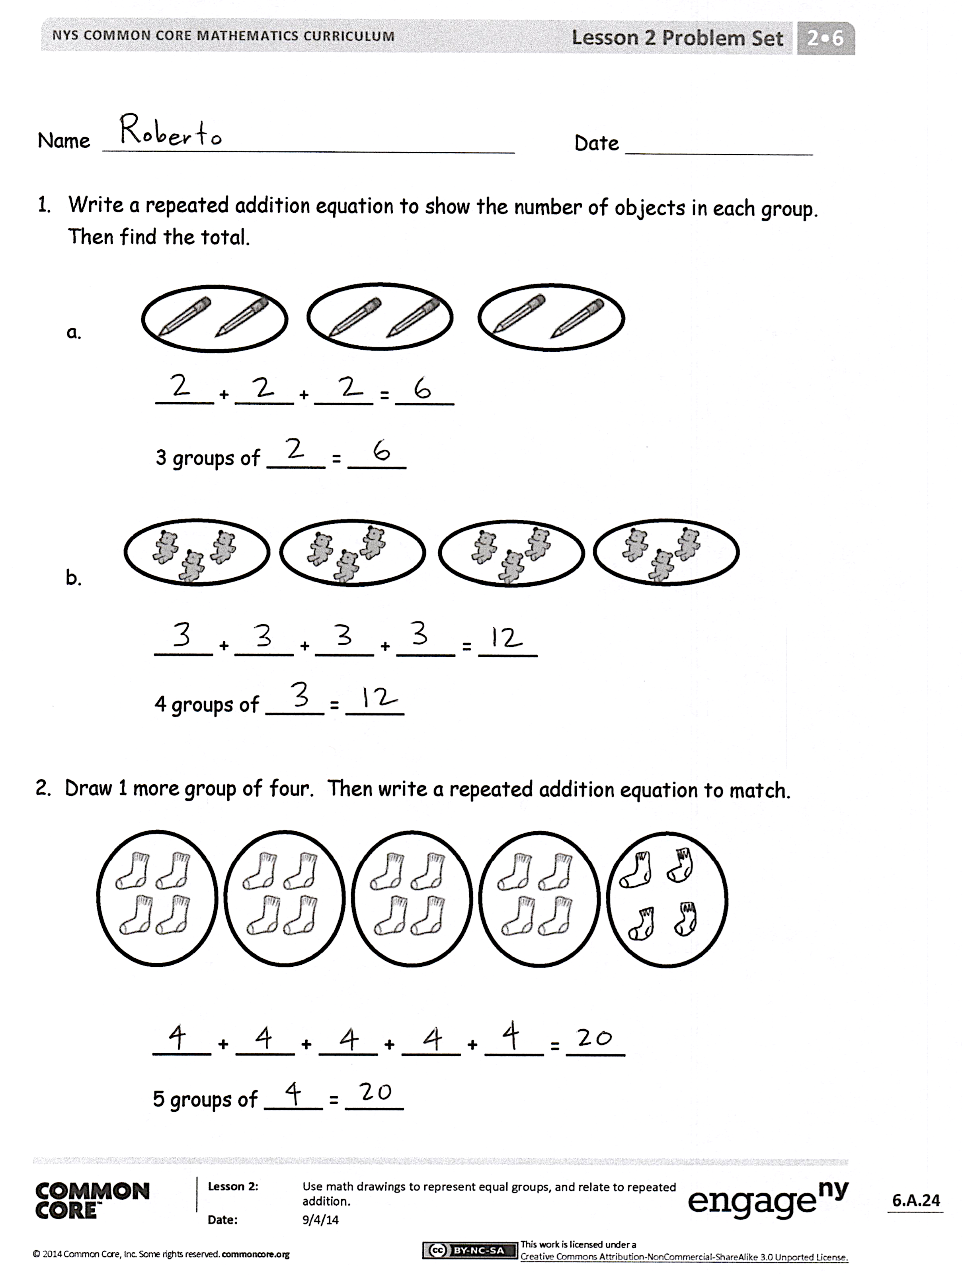Student Debrief (10 minutes)

**Lesson Objective:** Use math drawings to represent equal groups, and relate to repeated addition.

The Student Debrief is intended to invite reflection and active processing of the total lesson experience.

Invite students to review their solutions for the Problem Set. They should check work by comparing answers with a partner before going over answers as a class. Look for misconceptions or misunderstandings that can be addressed in the Debrief. Guide students in a conversation to debrief the Problem Set and process the lesson.

Any combination of the questions below may be used to lead the discussion.

* For Problem 1(a), what **repeated addition** equation matches the picture? How did you find the total?
* For Problem 1(b), what repeated addition equation matches the picture? Why are there 4 addends?
* For Problem 2, how many equal groups are there? What repeated addition equation matches the picture? What does the number 4 represent? How did you find the total?
* For Problem 3, share your drawing and your equation with a partner. There are 4 equal groups. Why didn’t you add 4 + 4 + 4 + 4?
* For Problem 4, share your drawing and your equation with a partner. How many groups of hearts are there altogether? How did you find the total? Compare this problem to Problem 1(a).
* Fill in the blank: “When writing a repeated addition equation, the repeated number shows ______________.”

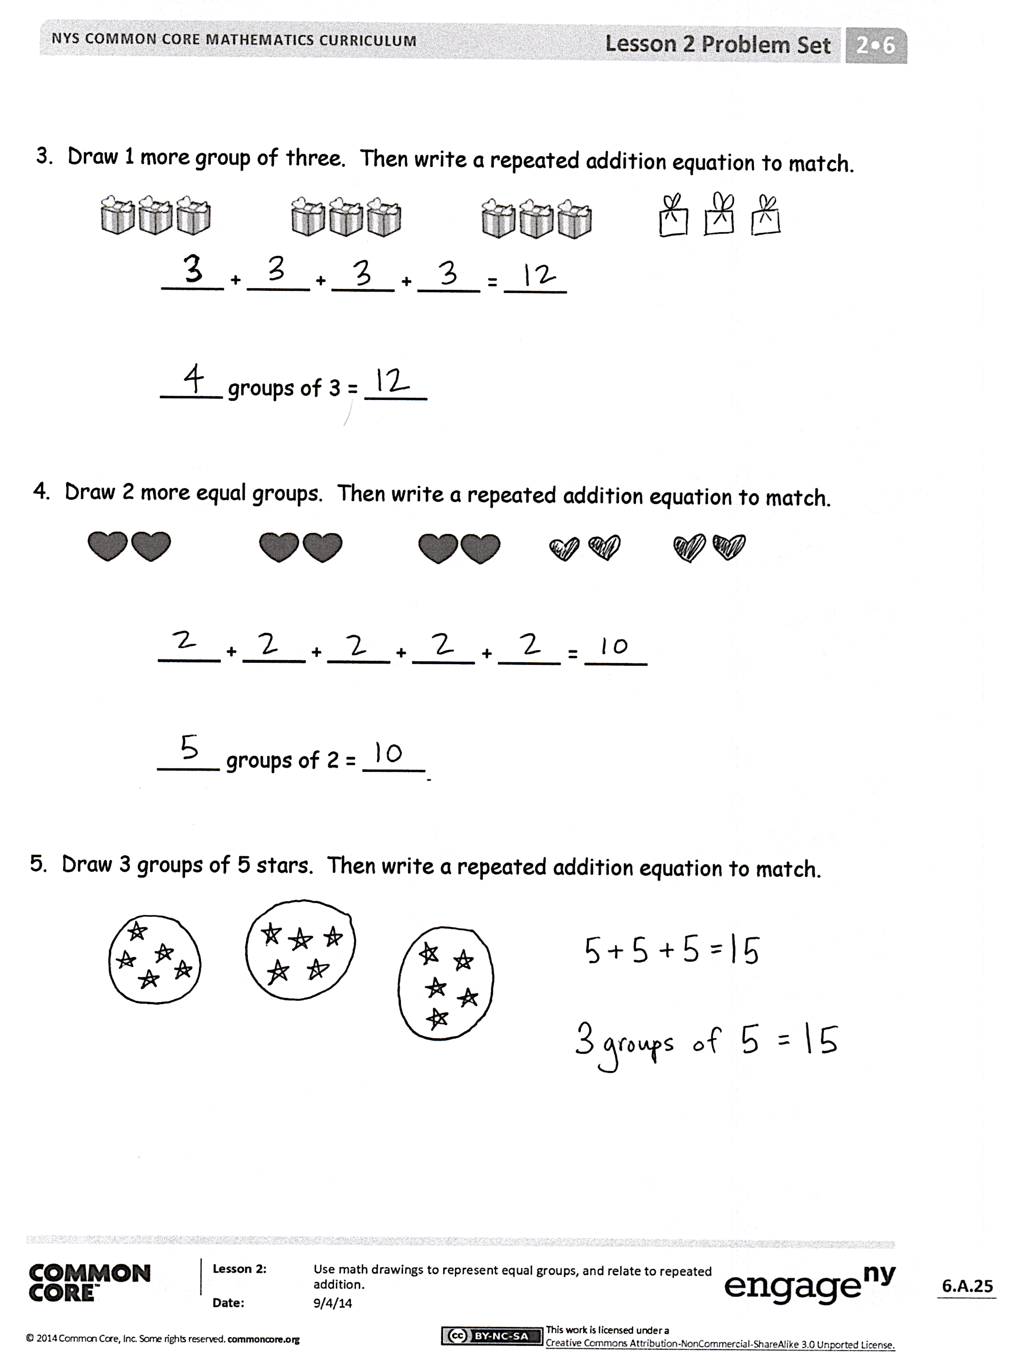Exit Ticket (3 minutes)

After the Student Debrief, instruct students to complete the Exit Ticket. A review of their work will help with assessing students’ understanding of the concepts that were presented in today’s lesson and planning more effectively for future lessons. The questions may be read aloud to the students.

Name Date

1. Write a repeated addition equation to show the number of objects in each group.

Then, find the total.





____ + ____ + ____ = ____

3 groups of ____ = ____



____ + ____ + ____ + ____ = ____

4 groups of ____ = ____

1. Draw 1 more group of four. Then, write a repeated addition equation to match.



____ + ____ + ____ + ____ + ____ = ____

5 groups of ____ = ____

1. Draw 1 more group of three. Then, write a repeated addition equation to match.

  

____ + ____ + ____ + ____ = ____

____ groups of 3 = ____

1. Draw 2 more equal groups. Then, write a repeated addition equation to match.

____ + ____ + ____ + ____ + ____ = ____

____ groups of 2 = ____

1. Draw 3 groups of 5 stars. Then, write a repeated addition equation to match.

Name Date

1. Draw 1 more equal group.

____ + ____ + ____ + ____ = ____

4 groups of ____ = ____

1. Draw 2 groups of 3 stars. Then, write a repeated addition equation to match.

Name Date

1. Write a repeated addition equation to show the number of objects in each group. Then, find the total.





____ + ____ + ____ = ____

3 groups of ____ = ____





____ + ____ + ____ + ____ = ____

4 groups of ____ = ____

1. Draw 1 more equal group.



____ + ____ + ____ + ____ + ____ = ____

5 groups of ____ = ____

1. Draw 1 more group of four. Then, write a repeated addition equation to match.

____ + ____ + ____ + ____ = ____

____ groups of 4 = ____

1. Draw 2 more equal groups. Then, write a repeated addition equation to match.

____ + ____ + ____ + ____ + ____ = ____

____ groups of 4 = ____

1. Draw 4 groups of 3 circles. Then, write a repeated addition equation to match.