Lesson 20
Objective: Choose and explain solution strategies and record with a written addition or subtraction method.

Suggested Lesson Structure
 Fluency Practice (12 minutes)
 Concept Development (38 minutes)
 Student Debrief (10 minutes)
Total Time (60 minutes)
Fluency Practice (12 minutes)
- Grade 2 Core Fluency Practice Sets 2.OA.2 (5 minutes)
- Take from the Ten 2.OA.2 (3 minutes)
- Skip-Counting by Twos 2.OA.3 (4 minutes)
Grade 2 Core Fluency Practice Sets (5 minutes)
Materials: (S) Grade 2 Core Fluency Practice Sets (G2–M5–Lesson 14 Core Fluency Practice Sets)
Note: During Topic C and for the remainder of the year, each day’s fluency includes an opportunity for review and mastery of the sums and differences with totals through 20 by means of the Core Fluency Practice Sets or Sprints. In Lesson 14, Practice Sets are provided, and the process is explained in detail.
Take from the Ten (3 minutes)
Materials: Personal white board
Note: Students practice taking from the ten in order to subtract fluently within 20.
T: I say, 11 – 9. You write, 10 – 9 + 1. Wait for my signal. Ready?
T: 12 – 8. Show me your personal white board on my signal.
S: 10 – 8 + 2.
T: Write your answer.
S: 4.
Continue with the following possible sequence: 14 – 9, 13 – 8, 15 – 9, 11 – 8, 15 – 8, 12 – 9, 16 – 7, 18 – 9,
and 14 – 8.
Skip-Counting by Twos (4 minutes)
Note: Students practice counting by twos in anticipation of learning the foundations of multiplication and division in Module 6.
T: On my signal, count by ones from 0 to 20 in a whisper. Ready? (Tap the desk while the students are counting; knock on the twos. For example, tap, knock, tap, knock, etc.)
T: Did anyone notice what I was doing while you were counting? I was tapping by ones, but I knocked on every other number. Let’s count again, and try knocking and tapping with me.
S: 1 (tap), 2 (knock), 3 (tap), 4 (knock), 5 (tap), 6 (knock), etc.
T: Now, let’s count only when we knock. Ready?
S: (Tap), 2 (knock), (tap), 4 (knock), (tap), 6 (knock), (tap), 8 (knock), etc.
Continue this routine up to 20 and back down again.
Concept Development (38 minutes)
Materials: (S) Personal white board, place value disks (if appropriate for student levels)
This lesson gives students the opportunity to talk about their understanding of addition and subtraction strategies and to choose which strategies to apply to a variety of problems. To allow for this talk, the Application Problem has been omitted from today’s lesson.
Problem 1: 499 + 166
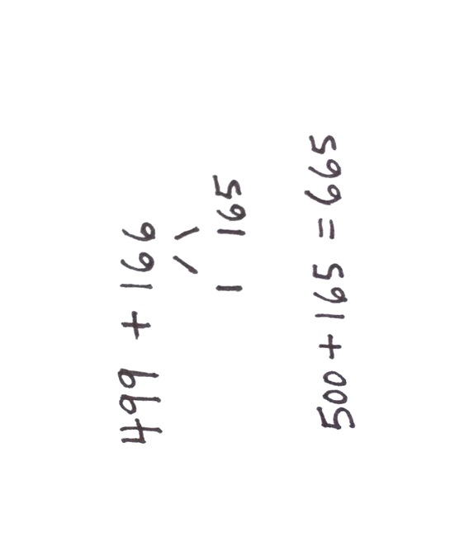
Invite students to solve the problem using a strategy of their choice as they did in Lesson 19. Give them three minutes to solve the problem. Then, instruct them to find a partner who used a different strategy to solve. Invite one set of partners up to the board, and lead them through the following conversation:
T: Partner 1, teach your strategy to Partner 2, and explain why you chose that strategy.
S1: I used a number bond since 499 is so close to 500. I took 1 from 166 and added it to 499 to get 500; then, I added on the rest to get 665.
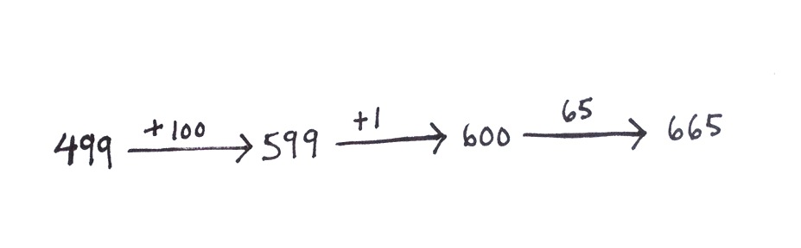
T: Partner 2, teach your strategy to your partner, and explain why you chose that strategy.
S2: I used the arrow way because it’s easy to add on from 499. I added 1 hundred. Then, I added 1 more to make 600, and then 65 more. So, I also got 665.
T: (Point to student drawings on the board.) How were the strategies they used similar? How were they different? Turn and talk with your partner.
S: They both decomposed 166. Partner 1 tried to make friendly numbers, like 500. And Partner 2 broke apart 166 and added on parts. Both partners used a simplifying strategy. Both partners added 1 to make the next hundred. Partner 1 made 500. Partner 2 made 600.
T: Did both strategies work?
S: Yes!
Instruct partners to engage in a conversation similar to the one modeled on the previous page. After partners finish sharing strategies and rationale, give each student a few minutes to solve the problem using her partner’s strategy. Circulate and provide support, while students check each other’s work before returning to their seats for the next problem.
NOTES ON
MULTIPLE MEANS
OF ACTION
AND EXPRESSION:
For more introverted students or those who find spoken communication in groups challenging, allow them to write their explanations or to discuss their solutions with a trusted friend.
T: I noticed that very few of you solved using chips or vertical form. Would that strategy also be efficient?
S: Well, you would have to rename twice. You should always try to solve mentally if you are close to a hundred. I can picture the number bond in my head now, and it’s easy to add on once you make 500.
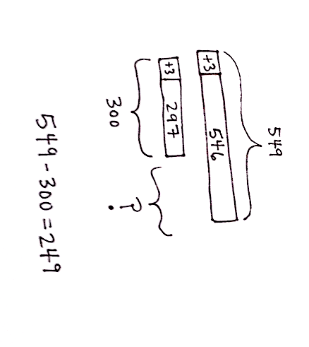
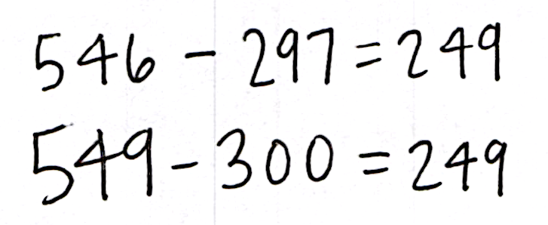
T: I hear some thoughtful responses! Let’s take a look at another problem.
Problem 2: 546 – 297
Give students three minutes to solve using a strategy of their choice. Then, instruct them to find a partner who used a different solution strategy. Prompt them to engage in a conversation similar to the one modeled in Problem 1.
MP.3
T: Class, after you solve and find a partner who used a different strategy, I’d like you to share and explain your strategies. (Circulate and listen.)
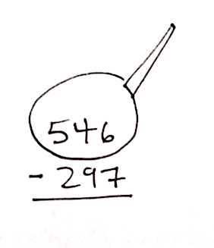
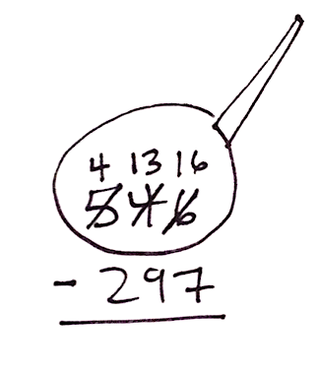
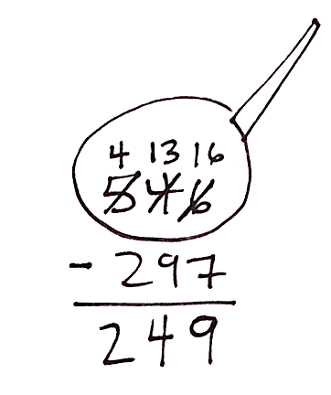
S1: I used compensation and added 3 to both numbers so that I could subtract 300 instead of 297. So, 549 minus 300 equals 249. Easy!
S2: I used vertical form to solve. Because I know the steps, it doesn’t take me long. After drawing my magnifying glass, I decomposed twice because there weren’t enough tens or ones to subtract. I renamed 546 as 4 hundreds, 13 tens, 16 ones. Then, I subtracted hundreds, tens, and ones, and I got 249.
NOTES ON
MULTIPLE MEANS
OF REPRESENTATION:
Post a list of these strategies and examples on the board so students who are still learning the strategies can refer to it.

T: Turn and talk to your partner: How efficient were the strategies you used and why?
S: I like the algorithm because it has steps, and it works every time. Making friendly numbers is a good strategy because you can very easily take away 300 from 549 in your head.
T: How were the strategies you discussed similar, and how were they different? Turn and talk to your partner.
S: We both used subtraction to solve. I used a drawing, and my partner just used vertical form.
I used renaming, but my partner used compensation to make a hundred.
After partners finish sharing strategies and rationale, each student takes a few minutes to solve the problem using his partner’s strategy. While the teacher circulates and provides support, students check each other’s work before returning to their seats for the next problem.
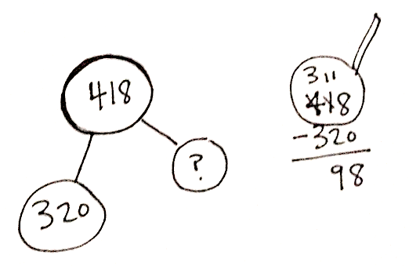
Problem 3: 320 + ______ = 418
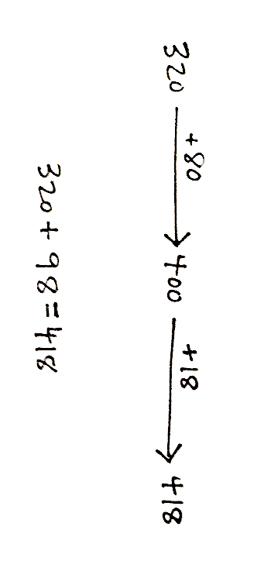
Give students three minutes to solve before finding a partner who used a different solution strategy. Prompt partners to engage in a conversation by following these steps:
1. Share and explain your strategy to your partner.
2. Listen to your partner’s strategy.
3. Practice solving using your partner’s strategy.
4. Decide if your strategies are efficient.
5. Discuss how your strategies are similar and how they are different.
6. Compliment your partner about his work. Be specific!
The following reflects possible student explanations:
- I drew a number bond to show the missing part, and then I used related subtraction to solve.
I thought drawing a number bond was a good idea because it helped me know where to start to find the answer.
- I used the arrow way to count on to 418. I knew by looking at the problem that I had to add on to 320 to get to 418. I started by adding 80 to get to 400. Then, I added a ten and 8 ones. Altogether, I added 98. So, 320 plus 98 equals 418.
The following reflects possible student discussion:
- I think using the number bond was a good idea because it helps me to see the parts and the whole. Another idea would be to draw the number bond, and then count on to solve. If you used the arrow way, you could add on 100, and then just take back 2.
- I solved using addition, but you solved with subtraction. We both knew that 320 was one part, and we were trying to find the missing part. I counted up to get to 418. You started with 418 and subtracted one part.
The sample responses demonstrate the flexibility students are developing in their application of strategies to solve varied problems. Encourage students to consider the strategies they used and how they could adapt them to best meet their own needs.
If students need more practice, continue with one or more problems from the following suggested sequence: 334 + 143, 538 + 180, 450 + ____ = 688, and 746 – _____ = 510. Otherwise, allow them to begin the Problem Set.
Problem Set (10 minutes)
Students should do their personal best to complete the Problem Set within the allotted 10 minutes. For some classes, it may be appropriate to modify the assignment by specifying which problems they work on first. Some problems do not specify a method for solving. Students should solve these problems using the RDW approach used for Application Problems.
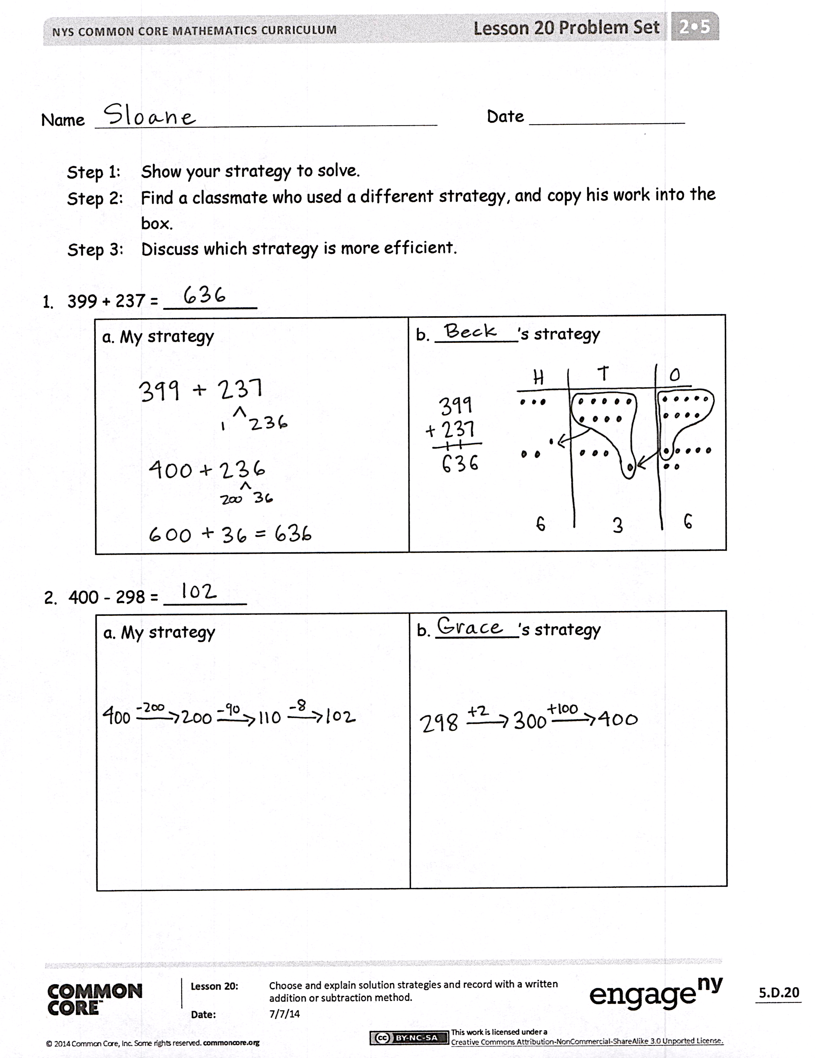
Student Debrief (10 minutes)
Lesson Objective: Choose and explain solution strategies and record with a written addition or subtraction method.
The Student Debrief is intended to invite reflection and active processing of the total lesson experience.
Invite students to review their solutions for the Problem Set. They should check work by comparing answers with a partner before going over answers as a class. Look for misconceptions or misunderstandings that can be addressed in the Debrief. Guide students in a conversation to debrief the Problem Set and process the lesson.
Any combination of the questions below may be used to lead the discussion.
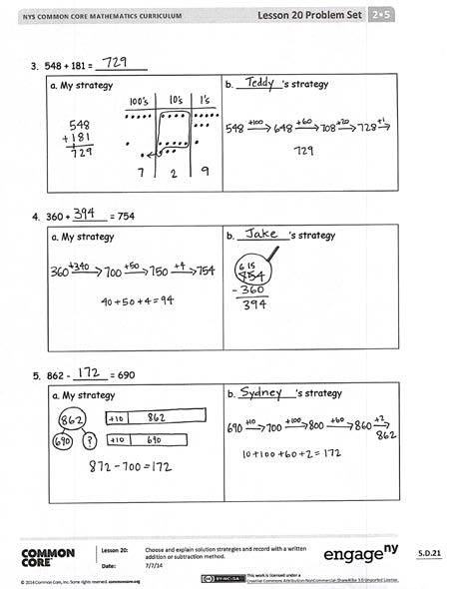
- For Problem 1, which mental or simplifying strategy did you choose? Why? How was this different from your partner’s strategy?
- For Problem 2, did you choose a mental strategy or the algorithm to solve? Why?
- Look at Problem 3. Compare your strategy to your partner’s. Which one was more efficient? Defend your reasoning.
- Turn and talk. For Problem 4, did you solve using addition or subtraction? Why? Explain your reasoning using pictures, numbers, or words.
- What are all the possible ways to solve
Problem 5? Which one do you prefer?
- Which solution strategies are fastest and easiest for you? Why?
Exit Ticket (3 minutes)
After the Student Debrief, instruct students to complete the Exit Ticket. A review of their work will help with assessing students’ understanding of the concepts that were presented in today’s lesson and planning more effectively for future lessons. The questions may be read aloud to the students.
Name Date
Step 1: Show your strategy to solve.
Step 2: Find a classmate who used a different strategy, and copy his work into the
box.
Step 3: Discuss which strategy is more efficient.

- 399 + 237 = _________
a. My strategy | b. ________’s strategy

- 400 − 298 = ________
a. My strategy | b. ________’s strategy

- 548 + 181 = _________
a. My strategy | b. ________’s strategy

- 360 + ______ = 754
a. My strategy | b. _________’s strategy

- 862 − ______ = 690
a. My strategy | b. __________’s strategy

Name Date
Solve each problem using two different strategies.

- 299 + 156 = _________
a. First Strategy | b. Second Strategy

- 547 + ______ = 841
a. First Strategy | b. Second Strategy

Name Date
Solve each problem using two different strategies.

- 456 + 244 = _________
a. First Strategy | b. Second Strategy

- 698 + ______ = 945
a. First Strategy | b. Second Strategy

Circle a strategy to solve and explain why you chose that strategy.

3. 257 + 160 = _____
a. Arrow way or vertical form

b. Solve: | c. Explanation:  _______________________________  _______________________________  _______________________________  _______________________________  _______________________________

4. 754 − 597 = _____
a. Number bond or arrow way

b. Solve: | c. Explanation:  _______________________________  _______________________________  _______________________________  _______________________________  _______________________________

