Lesson 19
Objective: Choose and explain solution strategies and record with a written addition or subtraction method.

Suggested Lesson Structure
 Fluency Practice (12 minutes)
 Concept Development (38 minutes)
 Student Debrief (10 minutes)
Total Time (60 minutes)
Fluency Practice (12 minutes)
- Grade 2 Core Fluency Practice Sets 2.OA.2 (5 minutes)
- Take from the Ten 2.OA.2 (3 minutes)
- Skip-Counting by Twos 2.OA.3 (4 minutes)
Grade 2 Core Fluency Practice Sets (5 minutes)
Materials: (S) Grade 2 Core Fluency Practice Sets (G2–M5–Lesson 14 Core Fluency Practice Sets)
Note: During Topic C and for the remainder of the year, each day’s fluency activity includes an opportunity for review and mastery of the sums and differences with totals through 20 by means of the Core Fluency Practice Sets or Sprints. In Lesson 14, Practice Sets are provided, and the process is explained in detail.
Take from the Ten (3 minutes)
Materials: Personal white board
Note: Students practice taking from the ten to subtract fluently within 20.
T: I say, 11 – 9. You write, 10 – 9 + 1. Wait for my signal. Ready?
T: 12 – 8. Show me your personal white board on my signal.
S: 10 – 8 + 2.
T: Write your answer.
S: 4.
Continue with the following possible sequence: 13 – 9, 14 – 8, 12 – 9, 11 – 8, 15 – 9, 11 – 7, 16 – 8, 17 – 9, and 13 – 7.
Skip-Counting by Twos (4 minutes)
Note: Students practice counting by twos in anticipation of learning the foundations of multiplication and division in Module 6.
T: On my signal, count by ones from 0 to 20 in a whisper. Ready? (Tap the desk while the students are counting; knock on the twos. For example, tap, knock, tap, knock, etc.)
T: Did anyone notice what I was doing while you were counting? I was tapping by ones, but I knocked on every other number. Let’s count again, and try knocking and tapping with me.
S: 1 (tap), 2 (knock), 3 (tap), 4 (knock), 5 (tap), 6 (knock), etc.
T: Now, let’s count only when we knock. Ready?
S: (Tap), 2 (knock), (tap), 4 (knock), (tap), 6 (knock), (tap), 8 (knock), etc.
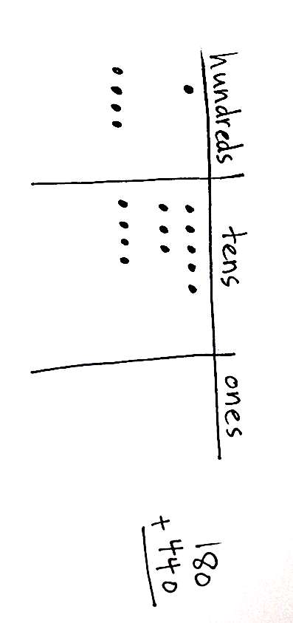
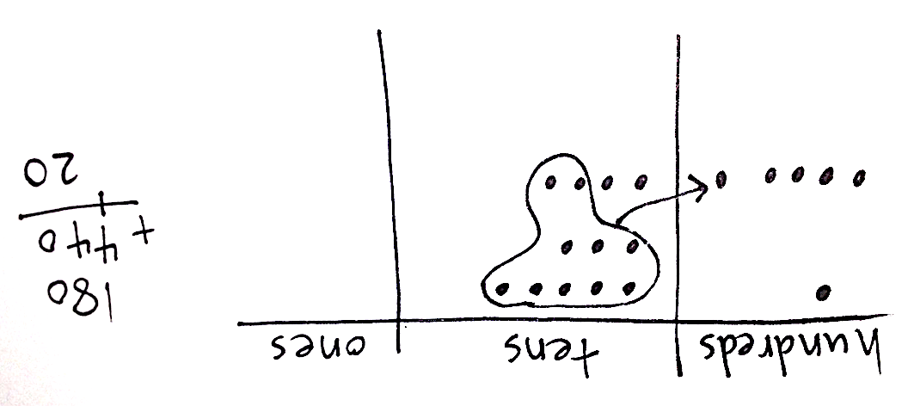
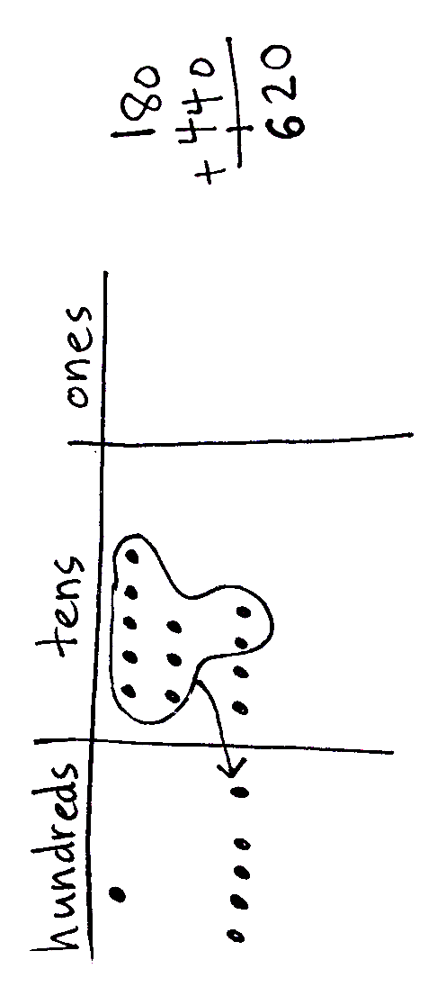
Continue this routine up to 20 and back down again.
Concept Development (38 minutes)
Materials: (S) Personal white board, place value disks (if appropriate for student level)
This lesson gives students the opportunity to choose which strategies to apply to a variety of addition and subtraction problems, and to explain their choices and listen to the reasoning of their peers. To allow for this in-depth conversation, the Application Problem has been omitted from Lessons 19 and 20.
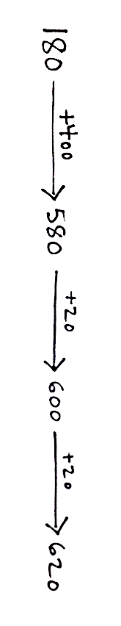
The conversations within this lesson can be structured as a whole group, in teams of four, or in partners, depending on what is best for a given class.
Problem 1: 180 + 440
Give students three minutes to solve the problem using the strategy of their choice. Then, invite students to share their work and reasoning.
T: Turn and talk: Explain your strategy and why you chose it to your small group.
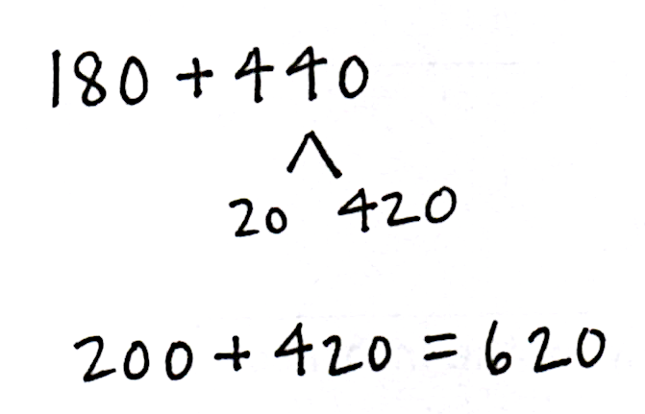
S1: I used a chip model to represent the hundreds and tens for each number, because there were no ones. Then, I added the tens together and the hundreds together. Since there were 12 tens, I renamed 10 tens as 1 hundred, and that leaves 2 tens. 5 hundreds and 1 hundred more makes 6 hundreds. So, my answer is 620.
S2: I used the arrow way. I started with 180, added 400 to get 580, added 20 to make 600, and added 20 more is 620.
S3: I used a number bond to take apart 440. I took 20 from the 440 and added it to 180 to make 200. 200 plus 420 is 620.
T: Turn and talk. How efficient were the strategies we used and why?
S: I think the arrow way was efficient because he did it in his head. I think the number bond was good because adding onto 200 is easy. I think the chip model is inefficient because it took a long time to draw all the chips, and with easy numbers, you can do it faster in your head.
Consider facilitating a discussion about recognizing a problem that is efficiently solved without the algorithm or math drawings. For example, students should recognize that when adding two numbers with only hundreds and tens, mental math or a simplifying strategy is the best option.
Problem 2: 400 – 236
Give students three minutes to solve the problem using the strategy of their choice.
T: Turn and talk to your small group. Explain your strategy and why you chose it.
S1: I used a tape diagram to subtract one from each number, so I could subtract without renaming.
399 – 235 is 164.
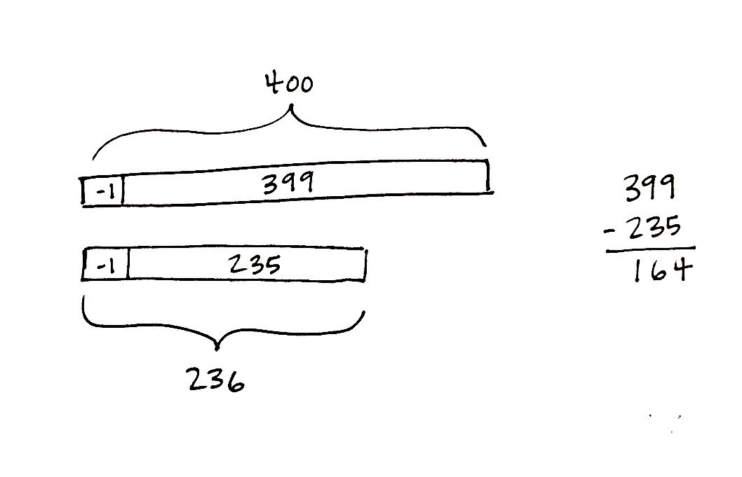
NOTES ON
MULTIPLE MEANS
OF ACTION AND EXPRESSION:
Encourage students who repeatedly choose mental math as the most efficient strategy to describe which simplifying strategy they used mentally. Explain that since they need to show their work on assessments, they will need to practice writing it down.

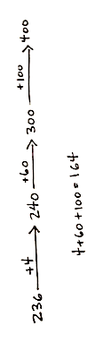
S2: I used the arrow way to count up from 236 to 400. I started at 236 and added 4 to make 240, and then I added 60 more to get to 300. Then, I added 1 hundred to make 400. I added 164 altogether.

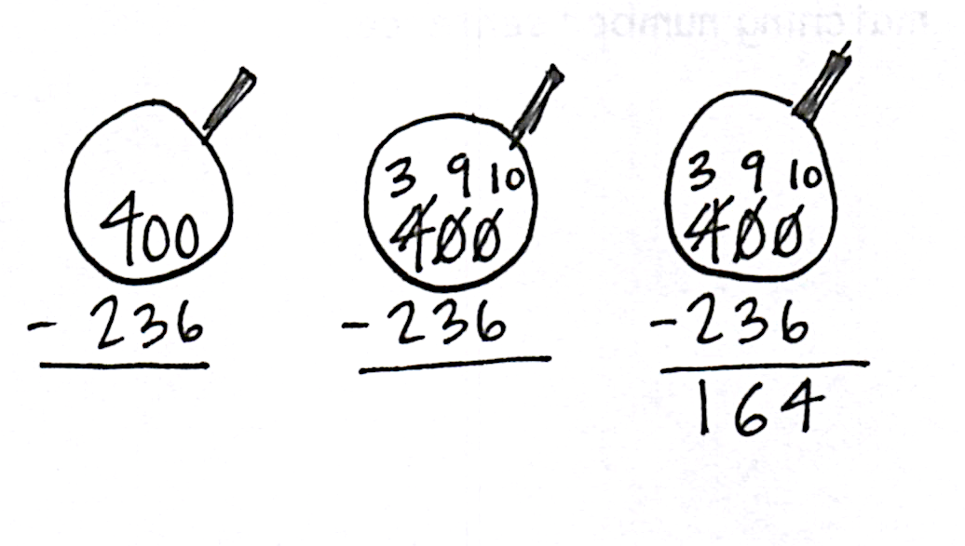

S3: I just used the algorithm because I already know that when I have zeros in the tens and ones places, I can rename the whole easily. I changed 400 to 3 hundreds, 9 tens, and 10 ones. Then, I subtracted. I also got 164.
T: Turn and talk. How was drawing the chip model similar to solving with the algorithm?
S: They are the same except that Student 1 also used a math drawing to decompose 400.
Student 1’s work shows Student 3’s work in a picture. You can see that 400 was broken apart into 3 hundreds, 9 tens, 10 ones to set up for subtraction.
T: Turn and talk. How efficient were the strategies we used and why?
S: I think the arrow way was super-efficient because it was just hop to 240, hop to 300, and hop to 400. The chip model was slow but safe, too, because he was able to check his work easily with the drawing. I think vertical form was less efficient for me because without the drawing I ended up getting the answer wrong, and I had to redo it.
Problem 3: 389 + 411
T: (Allow students three minutes to work the problem.) Turn and talk to your small group. Explain your strategy and why you chose it.
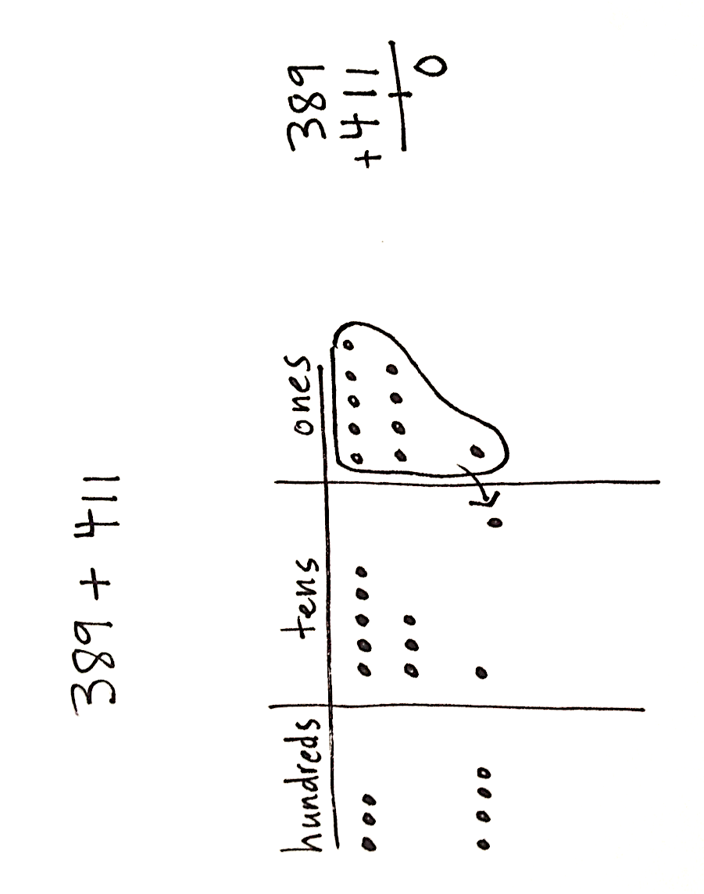
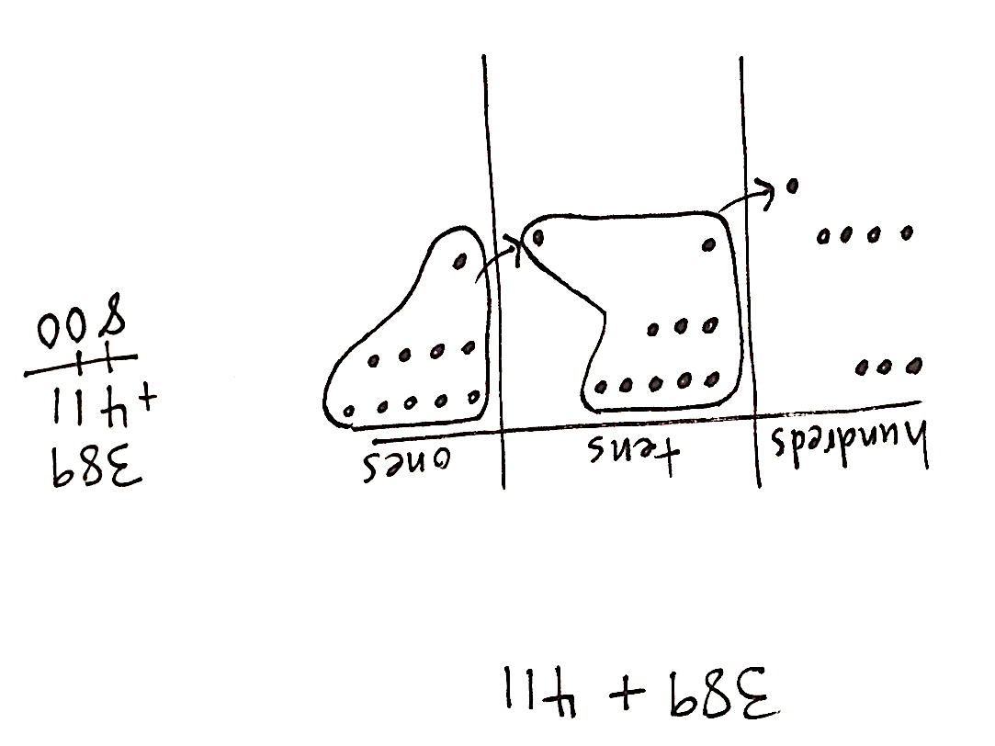
S1: I used a chip model because I saw that I am adding two three-digit numbers. I drew, and then added the ones to make a ten. I added the tens to make a hundred, and then I added the hundreds. I recorded my work using new groups below. My answer is 800.
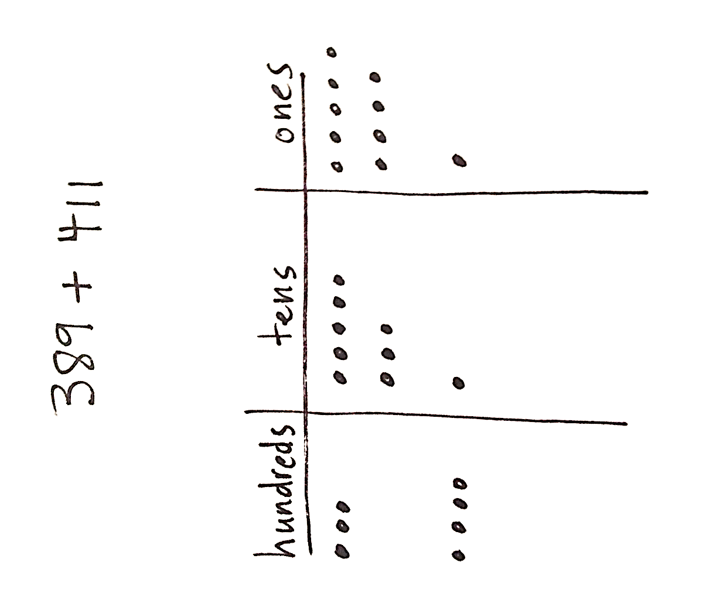

S2: I chose to use the arrow way because I saw that 389 has 9 in the ones place and 411 has 1 in the ones place, so I knew I would be making a ten. I started at 389 and added 1 to get 390. I added 10 to get 400, and then I added 400 more to get 800. It fit like a puzzle.
MP.3
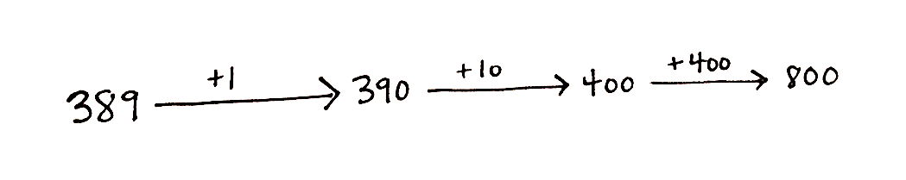

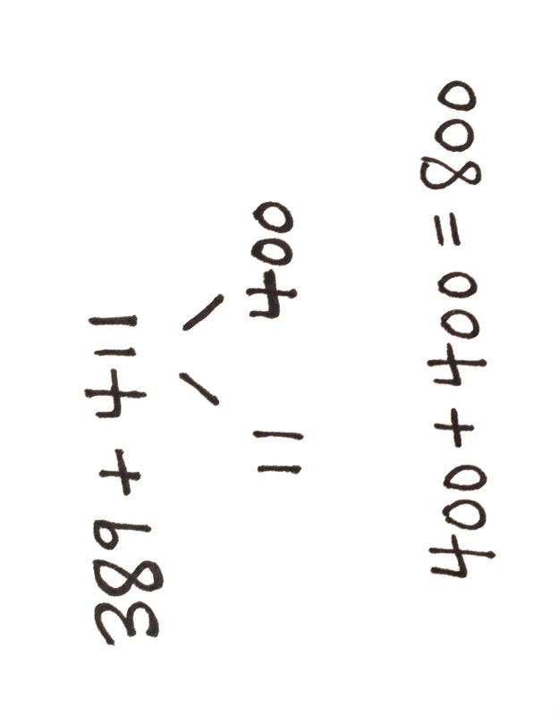

S3: I decided to use a number bond because I noticed that 389 needs 11 to get to 400 and that 411 has 11. So, then I knew a number bond was best. I took 11 from 411 and added it to 389 to get 400, and then I added 400 to get 800.
T: Turn and talk. How efficient were the strategies we used and why?
S: I think the chip model was slow but good for me, because then I didn’t lose track of making 10 and making 100. I think the arrow way was great because it is easy to add on the 411 after you take it apart. I think the number bond was efficient because 11 and 389 makes 400 really easily. Then, you just add on 400 more, and you’re done!
If students are ready to move on to the Problem Set, allow them to begin. If they need more discussion, continue the above sequence with the following problems: 275 + 125, 672 – 458, and 377 + 350.
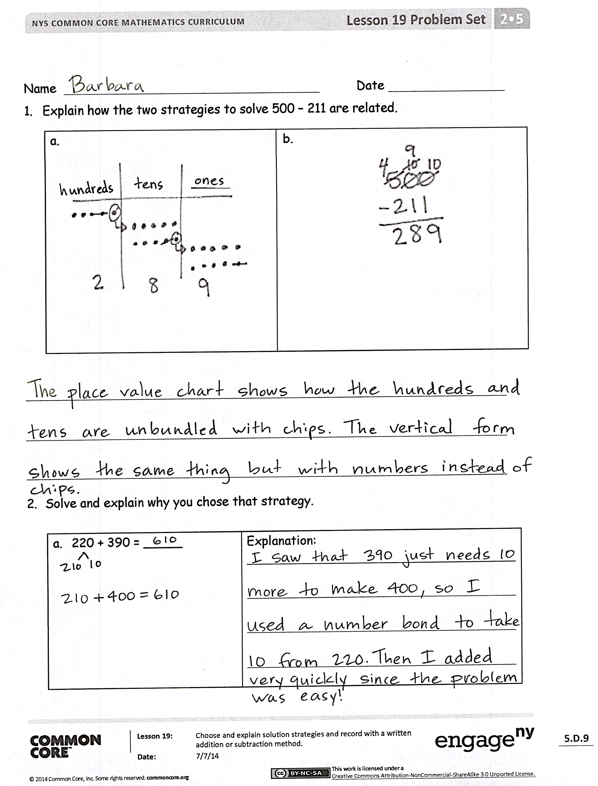
Problem Set (10 minutes)
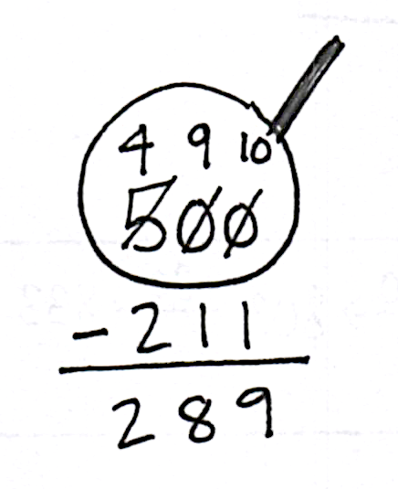
Students should do their personal best to complete the Problem Set within the allotted 10 minutes. For some classes, it may be appropriate to modify the assignment by specifying which problems they work on first. Some problems do not specify a method for solving. Students should solve these problems using the RDW approach used for Application Problems.
Student Debrief (10 minutes)
Lesson Objective: Choose and explain solution strategies and record with a written addition or subtraction method.
The Student Debrief is intended to invite reflection and active processing of the total lesson experience.
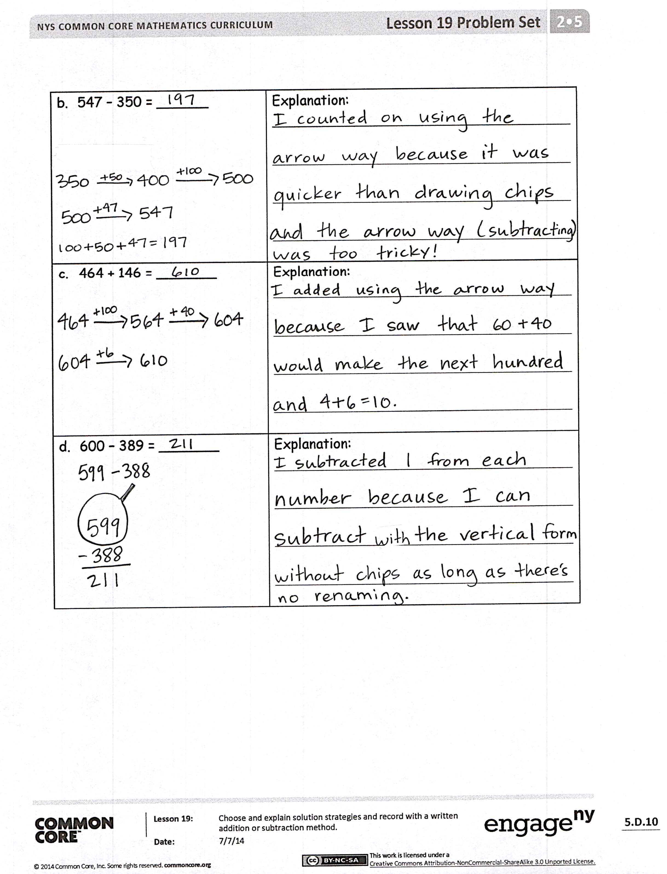
Invite students to review their solutions for the Problem Set. They should check work by comparing answers with a partner before going over answers as a class. Look for misconceptions or misunderstandings that can be addressed in the Debrief. Guide students in a conversation to debrief the Problem Set and process the lesson.
Any combination of the questions below may be used to lead the discussion.
- Share with a partner: For Problems 1(a) and (b), explain and compare the two strategies used to solve 500 – 211.
- For Problem 1, how could you arrive at the same answer using a different solution strategy? Share and compare with a partner.
- For Problem 2(a), how did you solve? Why? In your opinion, which strategy is most efficient?
- For Problem 2(b), did you use addition or subtraction to solve? Explain your thinking. Can you think of an alternate strategy?
- For Problem 2(c), what were you thinking when you selected a solution strategy to solve? How does knowing your partners to 10 help you to solve quickly?
- For Problem 2(d), what is challenging about solving this problem using vertical form? How could you change this into a simpler problem?
Exit Ticket (3 minutes)
After the Student Debrief, instruct students to complete the Exit Ticket. A review of their work will help with assessing students’ understanding of the concepts that were presented in today’s lesson and planning more effectively for future lessons. The questions may be read aloud to the students.

Name Date
- Explain how the two strategies to solve 500 − 211 are related.
a.  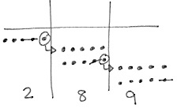 | b.

- Solve and explain why you chose that strategy.
- 220 + 390 = _____ | Explanation:
- 547 − 350 = ______ | Explanation:
- 464 + 146 = _______ | Explanation:
- 600 − 389 = _______ | Explanation:

Name Date
Solve and explain why you chose that strategy.
- 400 + 590 = ______ | Explanation:
- 775 − 497 = _______ | Explanation:

Name Date
- Solve and explain why you chose that strategy.
a. 340 + 250 = _____ | Explanation:
b. 490 + 350 = _____ | Explanation:
c. 519 + 342 = _____ | Explanation:
d. 610 + _____ = 784 | Explanation:
e. 700 − 456 = _____ | Explanation:
f. 904 − 395 = ______ | Explanation:

