Lesson 18
Objective: Apply and explain alternate methods for subtracting from multiples of 100 and from numbers with zero in the tens place.

Suggested Lesson Structure
 Application Problem (8 minutes)
 Fluency Practice (10 minutes)
 Concept Development (32 minutes)
 Student Debrief (10 minutes)
Total Time (60 minutes)
Application Problem (8 minutes)
Joseph collected 49 golf balls from the course. He still had 38 fewer than his friend Ethan.
- How many golf balls did Ethan have?
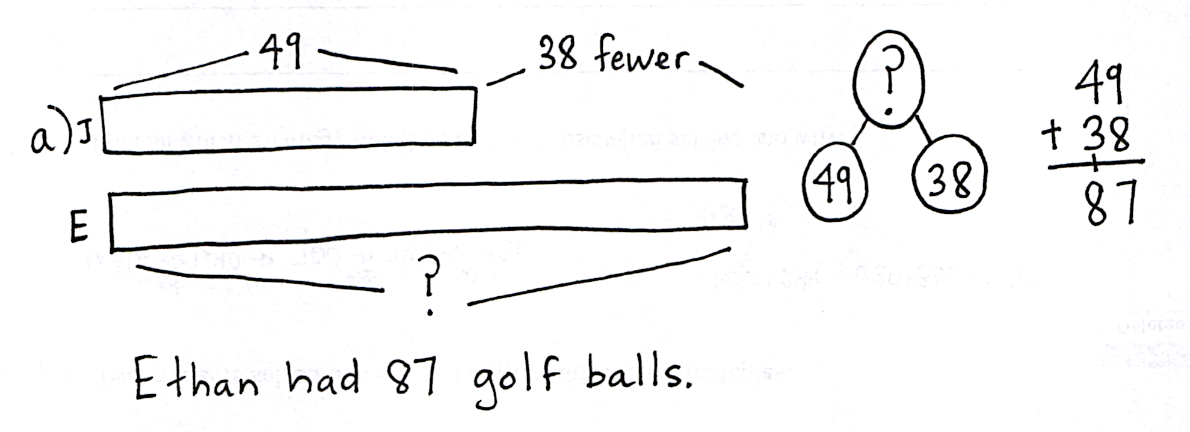
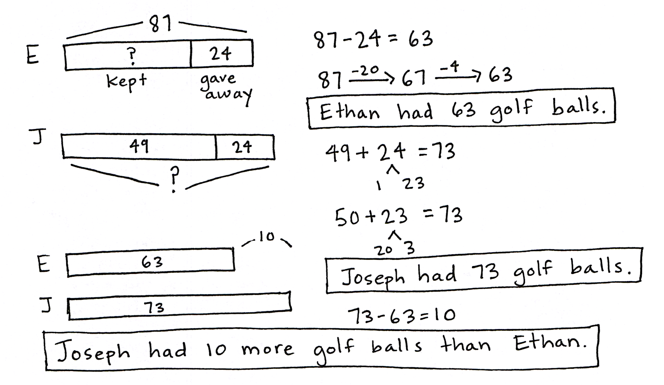
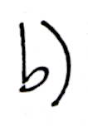
- If Ethan gave Joseph 24 golf balls, who had more golf balls? How many more?
NOTES ON
MULTIPLE MEANS
OF ACTION
AND EXPRESSION:
Initially adjust numbers in the calculation so that students can see that you need to add, rather than subtract, as the word fewer suggests.
Try replacing the two-digit numbers with single-digit numbers to emphasize the relationships. For example, Joseph collected six golf balls from the course. He still had three fewer than his friend. With smaller, more manageable numbers, students can use one-to-one matching to make sense of this comparison problem type.
Use concrete materials to model the second part for students who still struggle to grasp the concept.

Note: In addition to the compare bigger unknown component of Lesson 17’s Application Problem, this problem requires students to shift quantities from one boy to the other (24 from Joseph to Ethan), and then to find the difference. In this case, drawing a tape diagram highlights the shifting quantities and enables the students to visualize the more complex processes. Lead students in the RDW process, or encourage them to work together to solve and check their work.
Fluency Practice (10 minutes)
- Grade 2 Core Fluency Practice Sets 2.OA.2 (5 minutes)
- Get the Ten Out and Subtract 2.NBT.5 (5 minutes)
Grade 2 Core Fluency Practice Sets (5 minutes)
Materials: (S) Grade 2 Core Fluency Practice Sets (G2–M5–Lesson 14 Core Fluency Practice Sets)
Note: During Topic C and for the remainder of the year, each day’s fluency activity includes an opportunity for review and mastery of the sums and differences with totals through 20 by means of the Core Fluency Practice Sets or Sprints. In Lesson 14, Practice Sets are provided, and the process is explained in detail.
Get the Ten Out and Subtract (5 minutes)
Note: Students practice taking out the ten and subtracting to prepare for unbundling a ten in today’s lesson.
T: For every number sentence I give, subtract the ones from ten. When I say 12 – 4, you say 10 – 4 = 6. Ready?
T: 12 – 4.
S: 10 – 4 = 6.
T: 13 – 7.
S: 10 – 7 = 3.
Practice taking the ten out of number sentences fluently before adding the ones back.
T: Now, let’s add back the ones.
T: 12 – 4. Take from ten.
S: 10 – 4 = 6.
T: Now, add back the ones.
S: 6 + 2 = 8.
Continue with the following possible sequence: 13 – 7, 11 – 8, 13 – 9, 15 – 7, and 14 – 8.

Concept Development (32 minutes)
Materials: (S) Personal white board
Problem 1: Use compensation to solve 300 – 159.
T: (Write 300 – 159 on the board.) We know we can use vertical form to subtract from the hundred. Is this something we can do quickly?
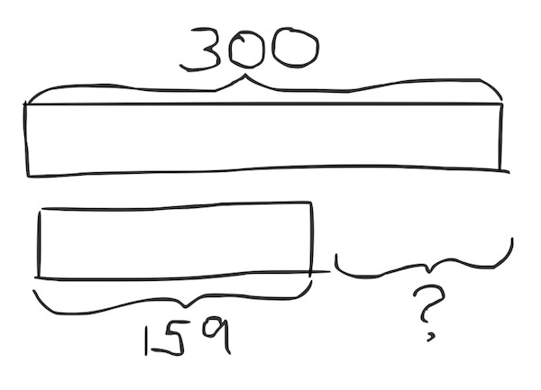
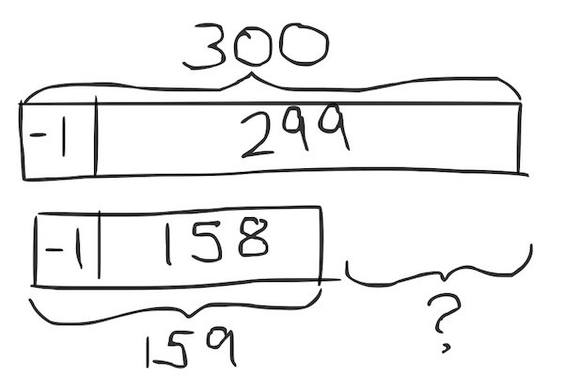
S: No, because we have to decompose numbers. No, we have to unbundle twice to subtract.
T: I’m going to show you a more efficient way to subtract.
T: (Draw the tape diagram at right on the board.) What happens if I take one off each number? What is my new subtraction problem?
S: 299 – 158.
T: (Draw new tape diagram showing the compensation.)
T: Is this any easier to solve? Turn and talk with a partner.
S: Yes! There’s no renaming. Now, we’re ready to subtract in all place values!
T: Solve this problem, and turn your personal white board over when you are finished.
T: What is 299 – 158?
S: 141.
T: Is this similar to a strategy you’ve used before? Talk with a partner.
S: It’s like when we added the same number to both numbers. Yes, like with those other tape diagrams where they both got bigger by the same amount. I think it was called compensation.
Problem 2: Add to solve 400 – 278.
T: (Write 400 – 278 on the board.) Let’s try a different way to subtract from the hundred. Can we use a different operation to solve?
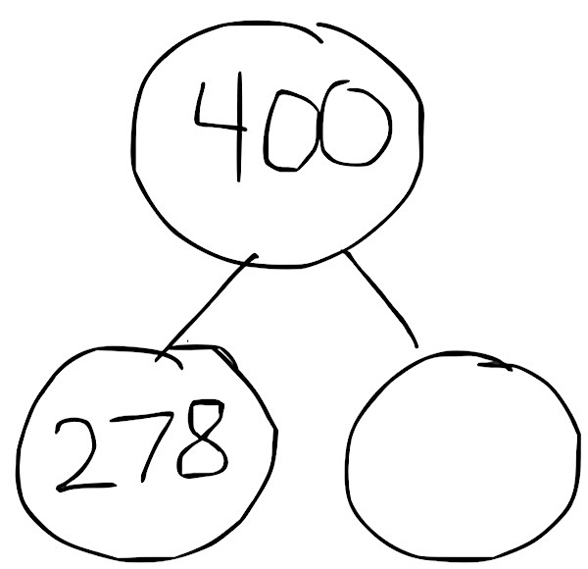
S: Yes, we can start with 278 and count up to 400. We can start with 278, which is one part, and use the arrow way to show the other part.
400 minus 278 is like 278 plus something equals 400.
T: (Draw a number bond with these numbers on the board.)
T: (Write 278 + ____ = 400.) Why can I write the problem like this? Talk with a partner.
S: Because 400 is the whole, and we know one part. Part plus part makes whole. We don’t know one of the parts, so we make it a blank.
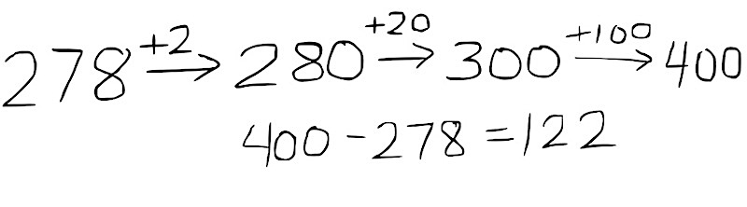
T: Let’s use the arrow way to solve this problem. (Write 278 → on the board.) How many more do we need to make the next ten?
S: 2.
T: (Write 2 above the arrow, then 280.)
T: How many more do we need now to get to the next hundred? (Record student responses.)
S: 20. 2 tens.
T: How many more do we need to get to our whole?
S: 100.
T: We wrote 2, then 20, then 100. Put them all together, and what do we get?
S: 122.
T: So, 400 – 278 is…?
S: 122.
Problem 3: 605 – 498
T: Now, let’s subtract from a number with a zero in the tens place. Which strategies could we use to solve this problem?
S: We could use the arrow way to solve it with addition, because it’s easy to make 500, and then get to 605. We could take 6 off both numbers to make 599 – 492, which means we don’t have to do any renaming. We could just use vertical form.
MP.3
NOTES ON
MULTIPLE MEANS
OF REPRESENTATION:
There is no right answer as to which strategy is the best or most efficient for a given problem type. Different students may find certain strategies easier than others. Allow for creativity in modeling, expressing, and critiquing different solution strategies; however, acknowledge that some students may feel most comfortable and capable using a particular method.

Take the students through the process of solving the problem by relating the chip model to vertical form, renaming 605 as 5 hundreds, 9 tens, 15 ones in one step. When finished, engage students in a discussion about which methods they prefer.
Instruct the students to work in pairs through the following problems, discussing which strategy they think would work best for each problem: 500 – 257, 702 – 195, and 600 – 314. As students demonstrate proficiency renaming in one step, instruct them to work on the Problem Set.
Problem Set (10 minutes)
Students should do their personal best to complete the Problem Set within the allotted 10 minutes. For some classes, it may be appropriate to modify the assignment by specifying which problems they work on first. Some problems do not specify a method for solving. Students should solve these problems using the RDW approach used for Application Problems.
Student Debrief (10 minutes)
Lesson Objective: Apply and explain alternate methods for subtracting from multiples of 100 and from numbers with zero in the tens place.
The Student Debrief is intended to invite reflection and active processing of the total lesson experience.
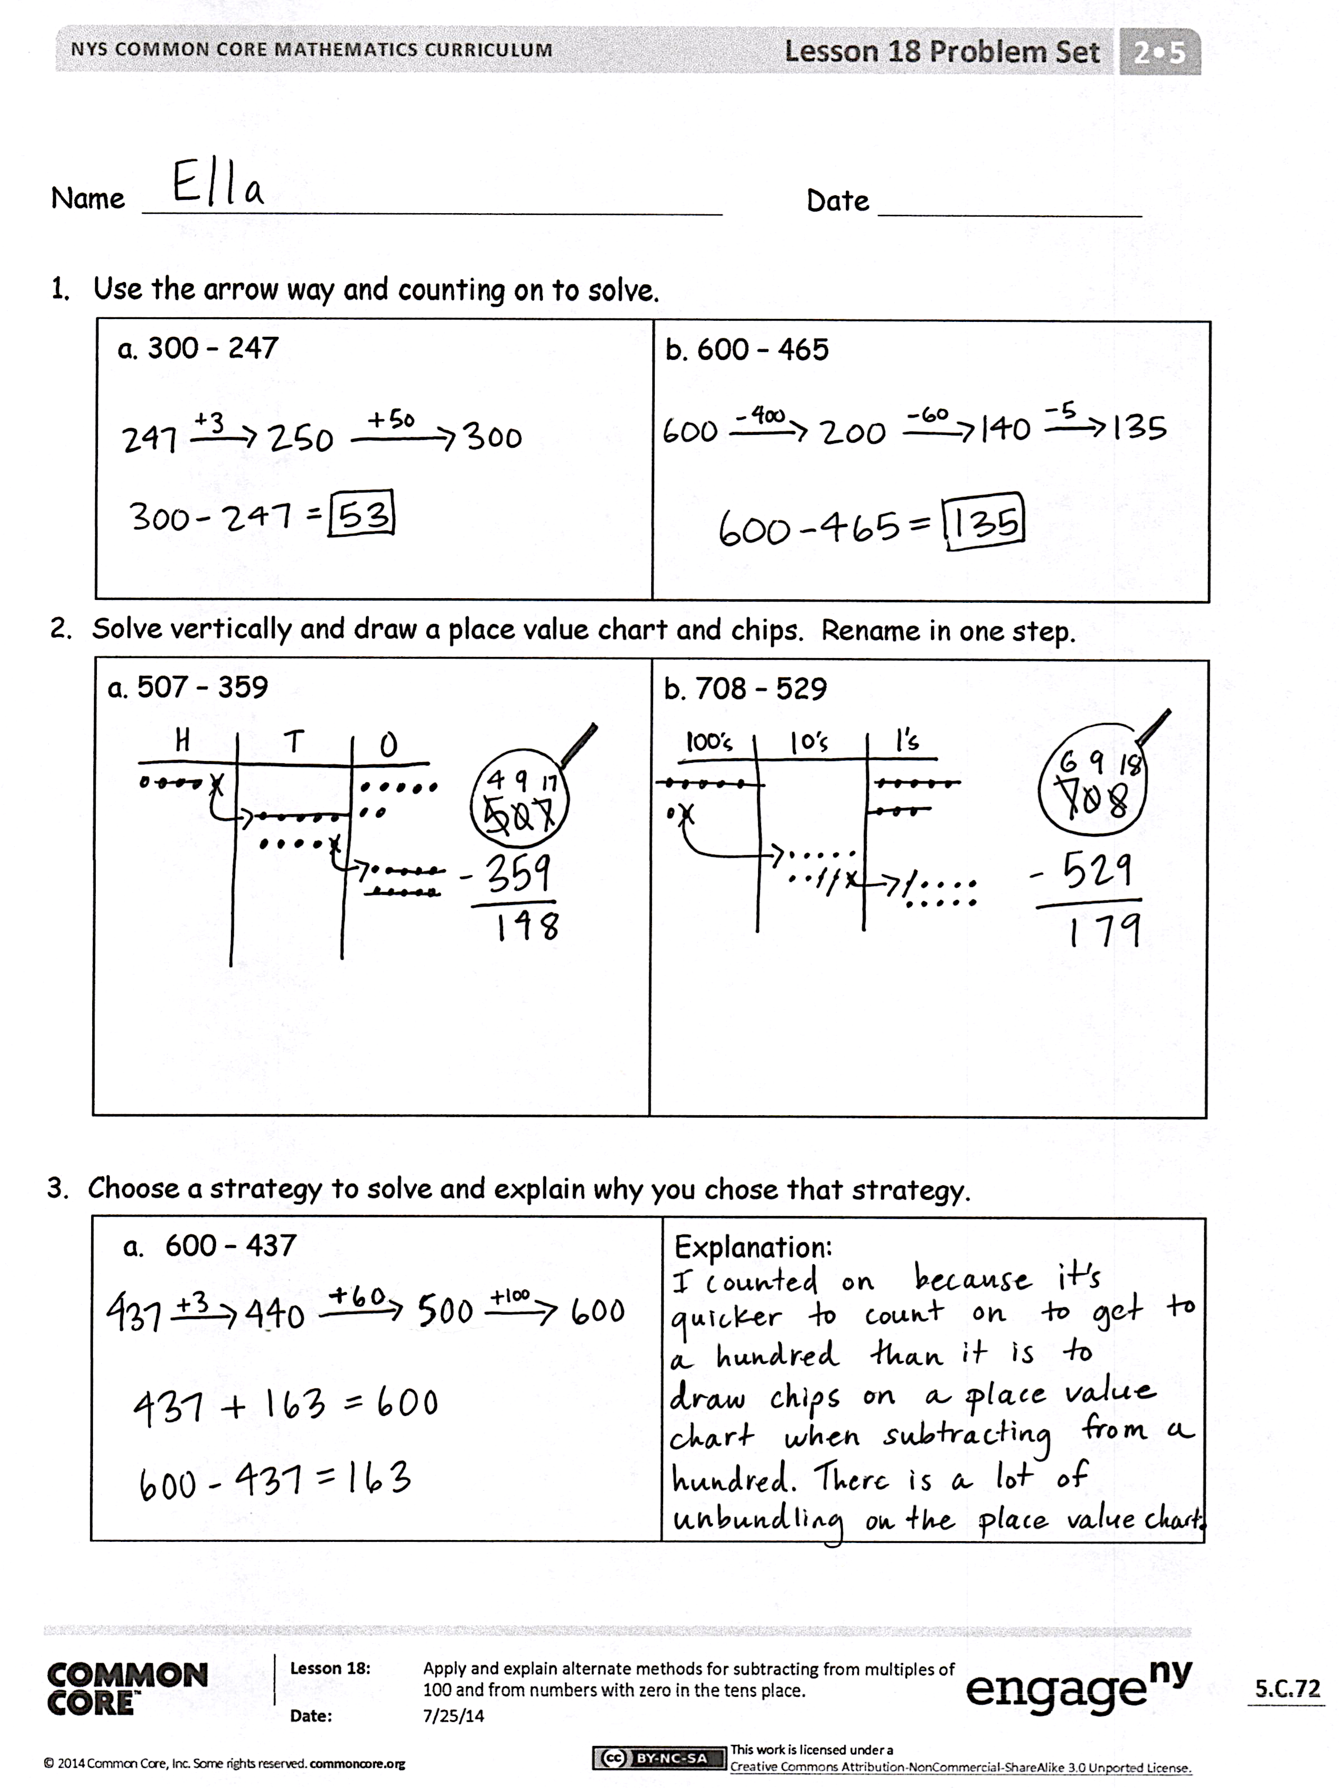
Invite students to review their solutions for the Problem Set. They should check work by comparing answers with a partner before going over answers as a class. Look for misconceptions or misunderstandings that can be addressed in the Debrief. Guide students in a conversation to debrief the Problem Set and process the lesson.
Any combination of the questions below may be used to lead the discussion.
- For Problem 1, how did you use the arrow way to solve? What did you add on first to efficiently solve each problem? Why?
- For Problem 2, explain the meaning of the 9 in the tens place. Where is the other ten?
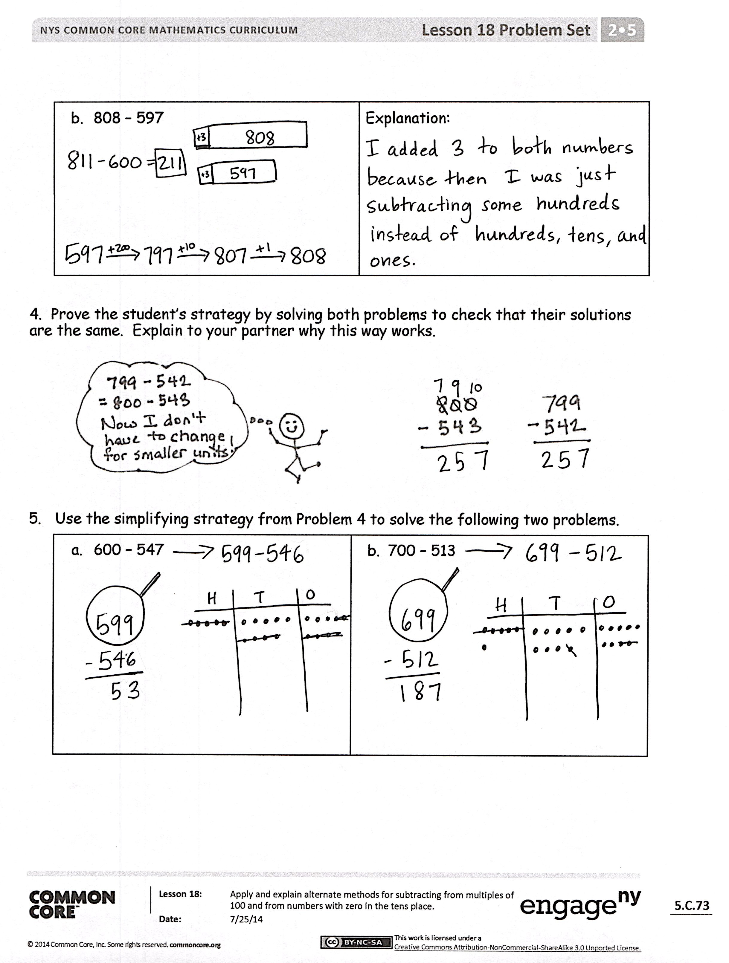
- For Problem 3(a), 600 – 437, explain the strategy you chose to solve? Why was using the arrow way easier than subtracting using the algorithm?
- For Problem 3(b), 808 – 597, how did you rename 808 for subtraction? What does that look like using vertical form? Or, why did you choose to solve mentally?
- For Problem 4, how does the smiling student use compensation to make the subtraction problem much simpler? Why is this strategy a good choice here?
- How did you use compensation to solve Problems 5(a) and (b)? What other simplifying strategies could you have used to solve? Which do you prefer?
Exit Ticket (3 minutes)
After the Student Debrief, instruct students to complete the Exit Ticket. A review of their work will help with assessing students’ understanding of the concepts that were presented in today’s lesson and planning more effectively for future lessons. The questions may be read aloud to the students.

Name Date
- Use the arrow way and counting on to solve.
a. 300 − 247 | b. 600 − 465

- Solve vertically and draw a place value chart and chips. Rename in one step.
a. 507 − 359 | b. 708 − 529

- Choose a strategy to solve and explain why you chose that strategy.
- 600 − 437 | Explanation:
- 808 − 597 | Explanation:

4. Prove the student’s strategy by solving both problems to check that their solutions are the same. Explain to your partner why this way works.
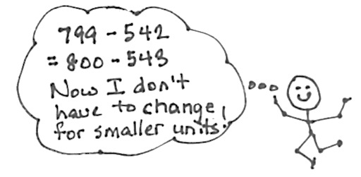

5. Use the simplifying strategy from Problem 4 to solve the following two problems.
- 600 − 547 | - 700 − 513

Name Date
Choose a strategy to solve and explain why you chose that strategy.
- 400 − 265 | Explanation:
- 507 − 198 | Explanation:

Name Date
1. Use the arrow way and counting on to solve.
a. 700 − 462 | b. 900 − 232

- Solve vertically and draw a place value chart and chips. Rename in one step.
a. 907 − 467 | b. 803 − 667

3. Choose a strategy to solve and explain why you chose that strategy.
- 700 − 390 | Explanation:
- 919 – 657 | Explanation:

4. Explain why 300 − 186 is the same as 299 − 185.
Explanation:

5. Solve 500 − 278 using the simplifying strategy from Problem 4.
Solution:

