Lesson 17
Objective: Subtract from multiples of 100 and from numbers with zero in the tens place.

Suggested Lesson Structure
 Application Problem (8 minutes)
 Fluency Practice (12 minutes)
 Concept Development (30 minutes)
 Student Debrief (10 minutes)
Total Time (60 minutes)
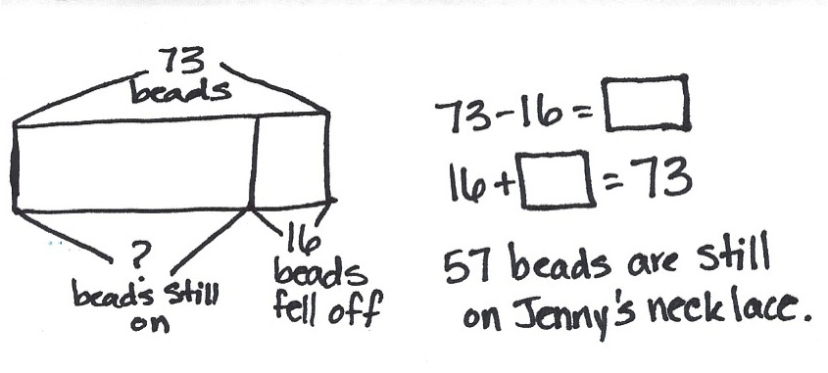
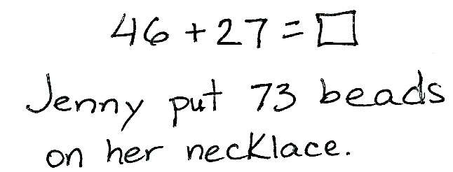
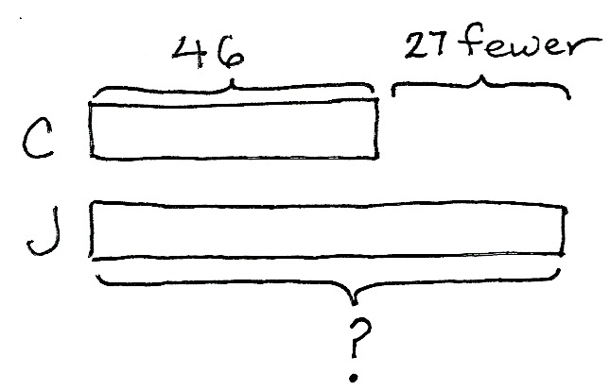
Application Problem (8 minutes)
Colleen put 27 fewer beads on her necklace than Jenny did. Colleen put on 46 beads. How many beads did Jenny put on her necklace?
If 16 beads fell off of Jenny’s necklace, how many beads are still on it?
Note: This compare bigger unknown problem is intended for guided practice. It is one of the four most difficult subtypes of word problems in that the word fewer suggests subtraction, which would be an incorrect operation.
This type of problem highlights the importance of drawing as a way to understand the relationship between numbers in the problem. The question mark indicates the unknown because students recognize that they are looking for the whole or a missing part.
Fluency Practice (12 minutes)
- Sprint: Subtract Crossing the Ten 2.OA.2, 2.NBT.5 (8 minutes)
- Using the Nearest Ten to Subtract 2.NBT.5 (2 minutes)
- Subtract Common Units 2.NBT.5, 2.NBT.7 (2 minutes)
Sprint: Subtract Crossing the Ten (8 minutes)
Materials: (S) Subtract Crossing the Ten Sprint
Note: Students practice subtracting crossing the ten to prepare for the lesson and gain mastery of the sums and differences within 20.
Using the Nearest Ten to Subtract (2 minutes)
Note: Reviewing the Grade 1 skill of counting up and down to 10 to subtract gives students a mental strategy to subtract fluently with larger numbers.
T: (Write 16 – 9 on the board.) Raise your hand when you know the answer to 16 – 9.
16 – 9 = ____
/\
10 6
10 – 9 = 1
1 + 6 = ____
S: 7.
T: (Write in the bond.) 10 – 9 is…?
S: 1.
T: 1 + 6 is...?
S: 7.
Continue with the following possible sequence: 13 – 8, 14 – 9, 15 – 7, 16 – 7, 13 – 9, 12 – 7, 22 – 7, 25 – 7,
25 – 8, 26 – 8, 27 – 8, 27 – 18, 37 – 8, 37 – 18, 35 – 18, 45 – 18, 47 – 19, and 48 – 29.
Subtract Common Units (2 minutes)
Note: Reviewing this mental math fluency activity prepares students for understanding the importance of the subtraction algorithm and place value.
T: (Project 55.) Say the number in unit form.
S: 5 tens 5 ones.
T: (Write 55 – 22 = ____.) Say the subtraction sentence, and answer in unit form.
S: 5 tens 5 ones – 2 tens 2 ones = 3 tens 3 ones.
T: Write the subtraction sentence on your boards.
Continue with the following possible sequence: 66 – 33, 77 – 44, 177 – 44, 88 – 33, and 188 – 33.
Concept Development (30 minutes)
Materials: (S) Personal white board, math journal or paper
Note: This lesson is a continuation of Lesson 16. It extends the student learning from Module 4’s Lessons 27 and 28.
Problem 1: 300 – 195
T: (Write 300 – 195 horizontally.) Talk with your partner: What do you notice about these numbers?
S: 195 is close to 200, so it’s going to be easy to solve mentally. If you add 5 to 195, it will be 200, which makes it easy to subtract from 300. Yeah, making a hundred is just like making a ten.
T: Excellent reasoning! It’s a good math habit to think about the numbers and how they relate to each other before you decide on a strategy.
T: Take a moment to solve this problem using the strategy you like best. Be prepared to explain why it works.
T: Who would like to explain their solution?
S: I thought about this as an addition problem starting with 195. I used arrow notation and wrote
195 + 5 is 200, and 200 + 100 is 300, so 100 + 5 is 105. I broke 300 into 100 and 200, and I subtracted 195 from 200. That left 100 and 5, which is 105. 305 – 200 is 105. I added 5 to 195 and 5 to 300. The difference stays the same, 105.
T: So, we could solve this mentally, use a simplifying strategy, or use vertical form. True?
S: True!
T: Keep that in mind, even as we use models and the algorithm to solve some more problems.
Problem 2: 500 – 213
T: (Write 500 – 213 horizontally.) Let’s set this problem up to solve using the chip model and the algorithm.
NOTES ON
MULTIPLE MEANS
OF ENGAGEMENT:
Although students work extensively with the algorithm in these modules, they will not be assessed on the algorithm until Grade 4. When students build a solid conceptual understanding of subtraction at this level, fluency and accuracy with vertical form should increase greatly.

T: Rewrite the problem with me. (Write the problem vertically as students do the same.)
T: Let’s make a chip model to show the whole. I’ll draw it on the board while you draw yours. Whisper-count as you draw your chips.
S: (Whisper-count and draw.) 100, 200, 300, 400, 500.
T: Now, draw the magnifying glass. (Draw a circle around 500 as students do the same.)
T: Are we ready to subtract?
S: No.
T: Tell your partner what we need to do.
S: There are no tens and no ones, so we have to open up a hundred. We need to rename 1 hundred as 10 tens. Then, cross out 1 ten and rename it as 10 ones. We need to change 1 hundred for 9 tens 10 ones.
T: Let’s do that. Count aloud as you rename 1 hundred as 9 tens 10 ones. (Cross off 1 hundred, draw an arrow to the tens place, and draw 9 tens as students do the same.)
MP.8
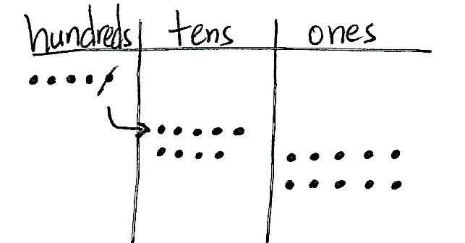
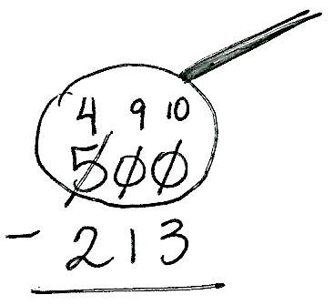
S: (Draw and count.) 10, 20, 30, 40, 50, 60, 70, 80, 90.
T: Count on as you draw the ones. (Draw 10 ones as students do the same.)
S: (Draw and count.) 91, 92, 93, 94, 95, 96, 97, 98, 99, 100.
T: Look at your model. What number is 9 tens?
S: 90.
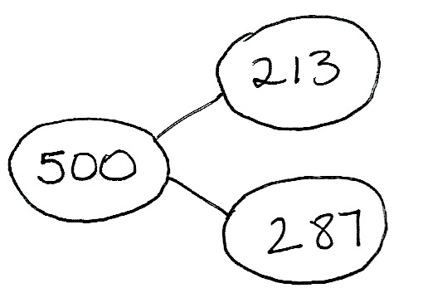
T: And, 10 ones?
S: 10!
T: 90 + 10 =…?
S: 100!
T: So, we can rename 1 hundred as 9 tens 10 ones. True?
S: True!
T: Now, we need to show these changes using the algorithm. As I record the changes on the numbers, check your work with mine. (Cross off 5 and write 4 above the hundreds place. Cross off 0 tens and write 9 above the tens place, then cross off 0 ones and write 10 above the ones place.)
T: Complete the subtraction, and then take turns sharing how your work on the chip model matches the steps in vertical form. (Allow students time to share.)
MP.8
NOTES ON
MULTIPLE MEANS
OF EXPRESSION:
For students who may be impatient to use the algorithm alone, encourage them to use the models to show their thinking. Explain that, while the student may know what she is doing, others who look at her work are helped by seeing the work written out. Models are also helpful for checking work.

T: Read the complete number sentence.
S: 500 – 213 = 287.
T: How can we prove that our answer is correct?
S: Add the parts to see if they equal the whole.
T: Correct! Please check your answer by drawing a chip model to add the two parts. If you are correct, write the number bond for this problem.
Circulate to check for understanding and to support students who struggle. Project student work or call students to the board to show the chip model, vertical form, and number bond. Encourage students to use place value language to explain their work.
Problem 3: 603 – 487
Follow the above procedure to guide students as they write 603 – 487 vertically, model it, and solve. Remind them to be precise in lining up the digits and drawing their chips in neat 5-groups. Encourage students to use place value language to explain each action that they take on their model and how it is represented using vertical form. Instruct students to check their work with addition and explain why this method works.
Repeat the process for 801 – 634 and 900 – 576 or move on to the Problem Set. Continue to support struggling students, but as they demonstrate proficiency, instruct them to work on the Problem Set independently.
Problem Set (10 minutes)
Students should do their personal best to complete the Problem Set within the allotted 10 minutes. For some classes, it may be appropriate to modify the assignment by specifying which problems they work on first. Some problems do not specify a method for solving. Students should solve these problems using the RDW approach used for Application Problems.

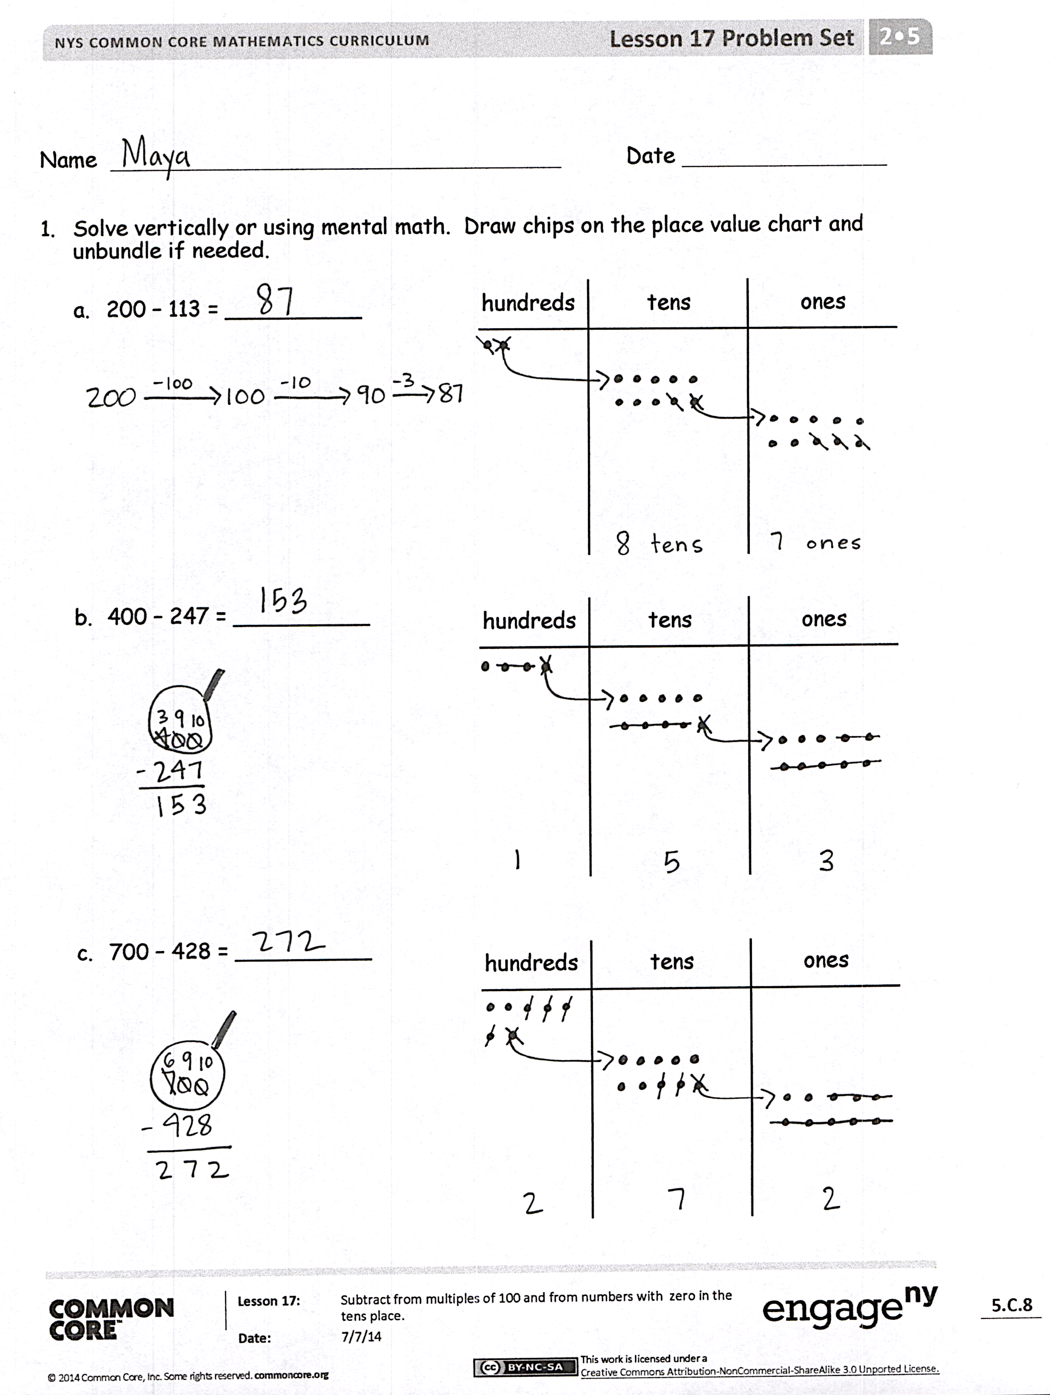
Student Debrief (10 minutes)
Lesson Objective: Subtract from multiples of 100 and from numbers with zero in the tens place.
The Student Debrief is intended to invite reflection and active processing of the total lesson experience.
Invite students to review their solutions for the Problem Set. They should check work by comparing answers with a partner before going over answers as a class. Look for misconceptions or misunderstandings that can be addressed in the Debrief. Guide students in a conversation to debrief the Problem Set and process the lesson.
Any combination of the questions below may be used to lead the discussion.
- For Problem 1, which problems did you choose to solve mentally? Why? What made some easier than others?
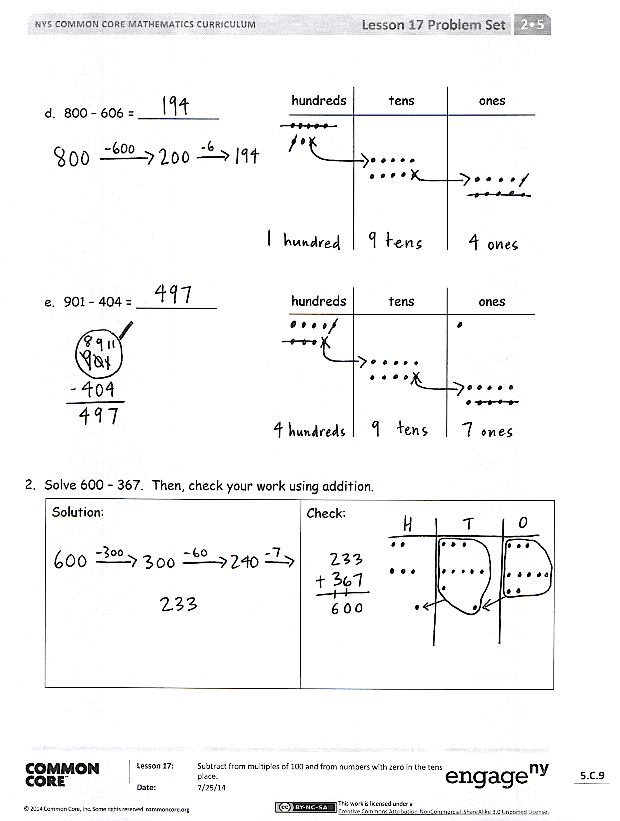
- For Problem 1(b), how did you rename 400 using your chips? Show me what 400 looks like after you have renamed the units.
- Explain to your partner the steps you took to set up Problem 1(c). How was this similar to 1(b)?
- Trey solved Problem 1(d), 800 – 606, by using place value. He started with 800 – 600 = 200. Then, he added 6 more, since one part was 606, so the answer was 206. What was his error?
- For Problem 1(d), explain the meaning of the 9 in the tens place.
Exit Ticket (3 minutes)
After the Student Debrief, instruct students to complete the Exit Ticket. A review of their work will help with assessing students’ understanding of the concepts that were presented in today’s lesson and planning more effectively for future lessons. The questions may be read aloud to the students.

Number Correct: _______
A
Subtract Crossing the Ten
 | 10 – 1 = |  |  |  | 21 – 6 =
 | 10 – 2 = |  |  |  | 91 – 6 =
 | 20 – 2 = |  |  |  | 10 – 7 =
 | 40 – 2 = |  |  |  | 11 – 7 =
 | 10 – 2 = |  |  |  | 31 – 7 =
 | 11 – 2 = |  |  |  | 10 – 8 =
 | 21 – 2 = |  |  |  | 11 – 8 =
 | 51 – 2 = |  |  |  | 41 – 8 =
 | 10 – 3 = |  |  |  | 10 – 9 =
 | 11 – 3 = |  |  |  | 11 – 9 =
 | 21 – 3 = |  |  |  | 51 – 9 =
 | 61 – 3 = |  |  |  | 12 – 3 =
 | 10 – 4 = |  |  |  | 82 – 3 =
 | 11 – 4 = |  |  |  | 13 – 5 =
 | 21 – 4 = |  |  |  | 73 – 5 =
 | 71 – 4 = |  |  |  | 14 – 6 =
 | 10 – 5 = |  |  |  | 84 – 6 =
 | 11 – 5 = |  |  |  | 15 – 8 =
 | 21 – 5 = |  |  |  | 95 – 8 =
 | 81 – 5 = |  |  |  | 16 – 7 =
 | 10 – 6 = |  |  |  | 46 – 7 =
 | 11 – 6 = |  |  |  | 68 – 9 =
B
[KEY]

Number Correct: _______
Improvement: _______
Subtract Crossing the Ten
 | 10 – 2 = |  |  |  | 21 – 6 =
 | 20 – 2 = |  |  |  | 41 – 6 =
 | 30 – 2 = |  |  |  | 10 – 7 =
 | 50 – 2 = |  |  |  | 11 – 7 =
 | 10 – 2 = |  |  |  | 51 – 7 =
 | 11 – 2 = |  |  |  | 10 – 8 =
 | 21 – 2 = |  |  |  | 11 – 8 =
 | 61 – 2 = |  |  |  | 61 – 8 =
 | 10 – 3 = |  |  |  | 10 – 9 =
 | 11 – 3 = |  |  |  | 11 – 9 =
 | 21 – 3 = |  |  |  | 31 – 9 =
 | 71 – 3 = |  |  |  | 12 – 3 =
 | 10 – 4 = |  |  |  | 92 – 3 =
 | 11 – 4 = |  |  |  | 13 – 5 =
 | 21 – 4 = |  |  |  | 43 – 5 =
 | 81 – 4 = |  |  |  | 14 – 6 =
 | 10 – 5 = |  |  |  | 64 – 6 =
 | 11 – 5 = |  |  |  | 15 – 8 =
 | 21 – 5 = |  |  |  | 85 – 8 =
 | 91 – 5 = |  |  |  | 16 – 7 =
 | 10 – 6 = |  |  |  | 76 – 7 =
 | 11 – 6 = |  |  |  | 58 – 9 =

Name Date
- Solve vertically or using mental math. Draw chips on the place value chart and unbundle, if needed.
hundreds tens ones
  - 200 − 113 = __________

hundreds tens ones
  - 400 − 247 = __________

hundreds tens ones
  - 700 − 428 = __________

  - 800 − 606 = __________
hundreds tens ones

hundreds tens ones
  - 901 − 404 = __________

- Solve 600 − 367. Then, check your work using addition.
Solution: | Check:

Name Date
Solve vertically or using mental math. Draw chips on the place value chart and unbundle, if needed.
hundreds tens ones
- 600 − 432 = __________

hundreds tens ones
- 303 − 254 = __________

Name Date
- Solve vertically or using mental math. Draw chips on the place value chart and unbundle, if needed.
hundreds tens ones
  - 200 − 123 = __________

hundreds tens ones
  - 400 − 219 = __________

hundreds tens ones
  - 700 − 542 = __________

  - 800 − 409 = __________
hundreds tens ones

  - 905 − 606 = __________
hundreds tens ones

- Solve 800 − 567. Then, check your work using addition.
Solution: | Check:

