Lesson 16
Objective: Subtract from multiples of 100 and from numbers with zero in the tens place.

Suggested Lesson Structure
 Application Problem (8 minutes)
 Fluency Practice (12 minutes)
 Concept Development (30 minutes)
 Student Debrief (10 minutes)
Total Time (60 minutes)
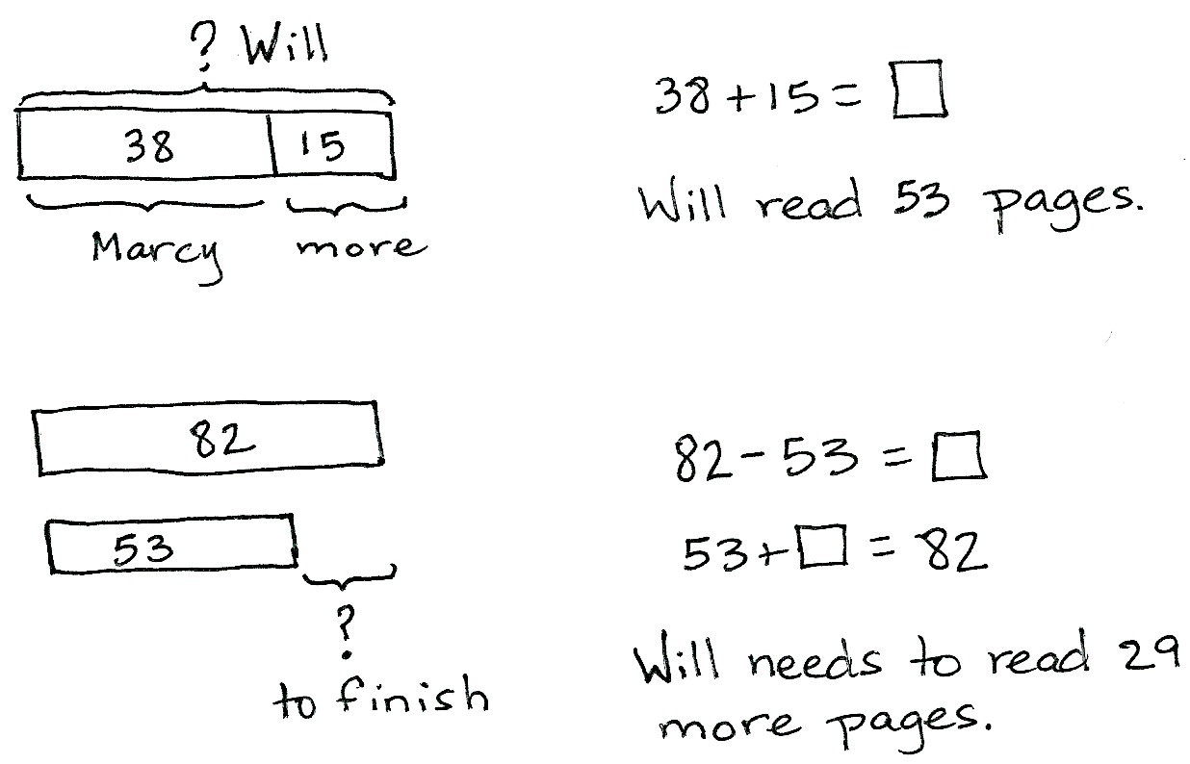
Application Problem (8 minutes)
Will read 15 more pages than Marcy. Marcy read 38 pages. The book is 82 pages long.
- How many pages did Will read?
- How many more pages does Will need to read to finish the book?
Note: This two-step problem is intended for guided practice as students gain familiarity with the compare bigger unknown problem type. Tape diagrams enable students to make sense of the relationships between the numbers and effectively choose an operation to both represent the situation and solve.
Fluency Practice (12 minutes)
- Sprint: Subtraction from Teens 2.OA.2 (8 minutes)
- Coin Drop 2.OA.2 (2 minutes)
- More and Less 2.NBT.5 (2 minutes)
Sprint: Subtraction from Teens (8 minutes)
Materials: (S) Subtraction from Teens Sprint
Note: Students practice subtraction from teens to gain mastery of the sums and differences within 20.
Coin Drop (2 minutes)
Materials: (T) 10 dimes, 10 pennies, can
Note: In this activity, students practice adding and subtracting ones and tens using coins in preparation for Module 7.
T: (Hold up a penny.) Name my coin.
S: A penny.
T: How much is it worth?
S: 1 cent.
T: Listen carefully as I drop coins in my can. Count along in your minds.
Drop in some pennies and ask how much money is in the can. Take out some pennies and show them. Ask how much money is still in the can. Continue adding and subtracting pennies for a minute or so. Then, repeat the activity with dimes, and then with dimes and pennies.
More and Less (2 minutes)
Materials: (T) 10 dimes, 10 pennies
Note: In this activity, students practice adding and subtracting ones and tens using coins.
T: Let’s count by tens. (Move dimes to the side while counting.)
S: 10, 20, 30, 40, 50, 60.
T: How many dimes are shown?
S: 6 dimes.
T: What is the value of 6 dimes?
S: 60 cents.
T: What is 5 cents more? (Move 5 pennies.)
S: 65 cents.
T: Give the number sentence.
S: 60 cents + 5 cents = 65 cents.
T: What is 10 cents less? (Move 1 dime.)
S: 55 cents.
T: Give the number sentence.
S: 65 cents – 10 cents = 55 cents.
Continue to repeat this line of questioning with a similar sequence of numbers.

Concept Development (30 minutes)
Materials: (S) Personal white board, math journal or paper
Note: This Concept Development extends student learning from Module 4’s Lessons 27 and 28.
Problem 1: 402 - 231
T: (Write 402 – 231 horizontally.) Let’s solve this problem using a math drawing and the algorithm.
T: Rewrite the problem with me. (Write the problem vertically as students do the same.)
T: Which number is the whole?
S: 402.
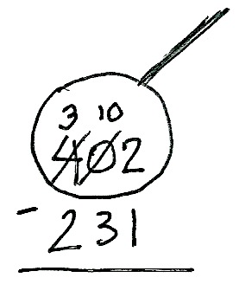
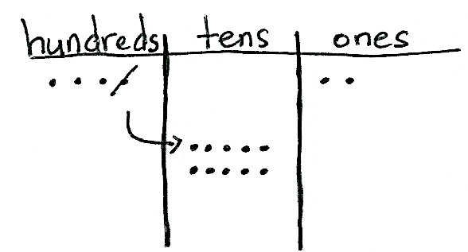
T: Let’s make a chip model to show the whole. I’ll draw it on the board while you draw yours. Whisper-count as you draw your chips.
S: (Whisper-count and draw.) 100, 200, 300, 400, 401, 402.
T: Let’s draw our magnifying glass and get ready to subtract! (Draw a circle around 402 as students do the same.)
T: Look at your chip model. Are we ready to subtract the ones?
S: Yes!
T: Moving on, let’s look at the tens place. I don’t see any tens in the tens place on the model. Point to the digit that represents this in vertical form.
S: (Point to the 0.)
T: The zero holds the tens place open and tells us the number is 402.
T: Without that 0, what number would we read? (Write 42.)
S: 42.
NOTES ON
MULTIPLE MEANS
OF ENGAGEMENT:
It is easy to lose students when subtraction involves zeros in the minuend. Check frequently for understanding by establishing a quiet, non-verbal signal (e.g., thumbs-up) that students can use to indicate whether they are following.

T: (Erase 42.) Yes, so we must be precise when writing and representing numbers.
T: Where can we get some tens so we can subtract 3 tens?
S: The hundreds place. Decompose a hundred.
Rename 1 hundred as 10 tens.
T: Let’s show that on our chip models. Count with me as we rename 1 hundred as 10 tens. (Cross off 1 hundred, draw an arrow to the tens place, and draw 10 dots, or tens.)
S: (Draw and count.) 10, 20, 30, 40, 50, 60, 70, 80, 90, 100.
T: Show that in vertical form. As I do the same, check your work with mine. (Cross off 4 and write 3 above the hundreds place, and then cross off 0 and write 10 above the tens place. Students do the same.)
T: Are we ready to subtract now in the tens place?
S: Yes!
T: Let’s look at the hundreds place. Are we ready to subtract in the hundreds?
S: Yes!
T: Then, we’re ready to subtract! (Allow students time to complete the subtraction.)
T: Talk with your partner. Take turns sharing how you showed the subtraction on your chip model and using the algorithm. (Allow students time to share.)
T: Read the complete number sentence.
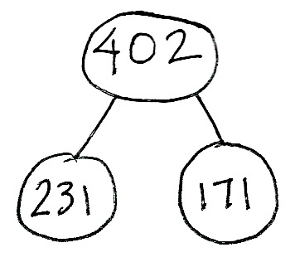
S: 402 – 231 = 171.
T: How can we prove that our answer is correct?
S: Add the parts to see if they equal the whole.
T: Yes! Please check your answer by drawing a chip model to add the two parts. If you are correct, write the number bond for this problem.
Circulate to check for understanding and support students who struggle. Project student work or call students to the board to show the chip model, vertical form, and number bond. Encourage students to use place value language to explain their work.
Problem 2: 800 – 463
NOTES ON
MULTIPLE MEANS
OF REPRESENTATION:
While some students prefer to rename 800 in one step (e.g. 7 hundreds, 9 tens, 10 ones), others may need the intermediate step of renaming a hundred as 10 tens before renaming a ten as 10 ones. Allow students to use place value disks or chips to model the decomposition in two steps.

Follow the above procedure to guide students as they write 800 – 463 vertically and model it.
T: Talk with your partner. What do you notice about the whole, and what will we need to do?
S: This time, there are no tens and no ones. We need to unbundle a hundred to make tens and ones. We need to rename 1 hundred as 9 tens 10 ones.
T: Let’s do that. Count aloud as you rename 1 hundred as 9 tens 10 ones. (Cross off 1 hundred, draw an arrow to the tens place, and draw 9 tens as students do the same.)
MP.8
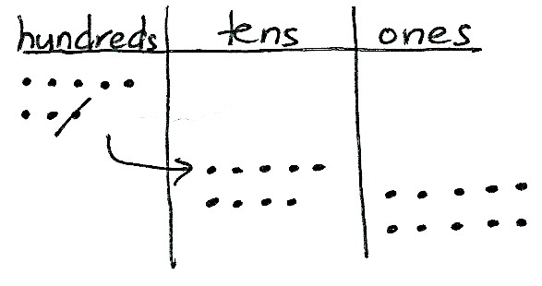
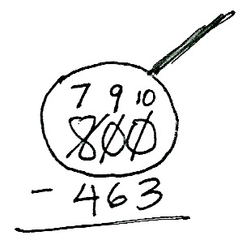
S: 10, 20, 30, 40, 50, 60, 70, 80, 90.
T: Stop! Now, count on as you draw the ones. (Draw 10 ones as students do the same.)
S: 91, 92, 93, 94, 95, 96, 97, 98, 99, 100.
T: So, 1 hundred is the same as 9 tens 10 ones. True?
S: True!
Continue using the procedure from Problem 1 to guide students as they complete the subtraction on both the model and in vertical form, share their work, and verify their solution to Problem 2 using addition.
Repeat the process for 908 – 120, 705 – 36, 600 – 316, and 500 – 327. Continue to support students who struggle, but as they demonstrate proficiency, instruct them to work on the Problem Set independently.
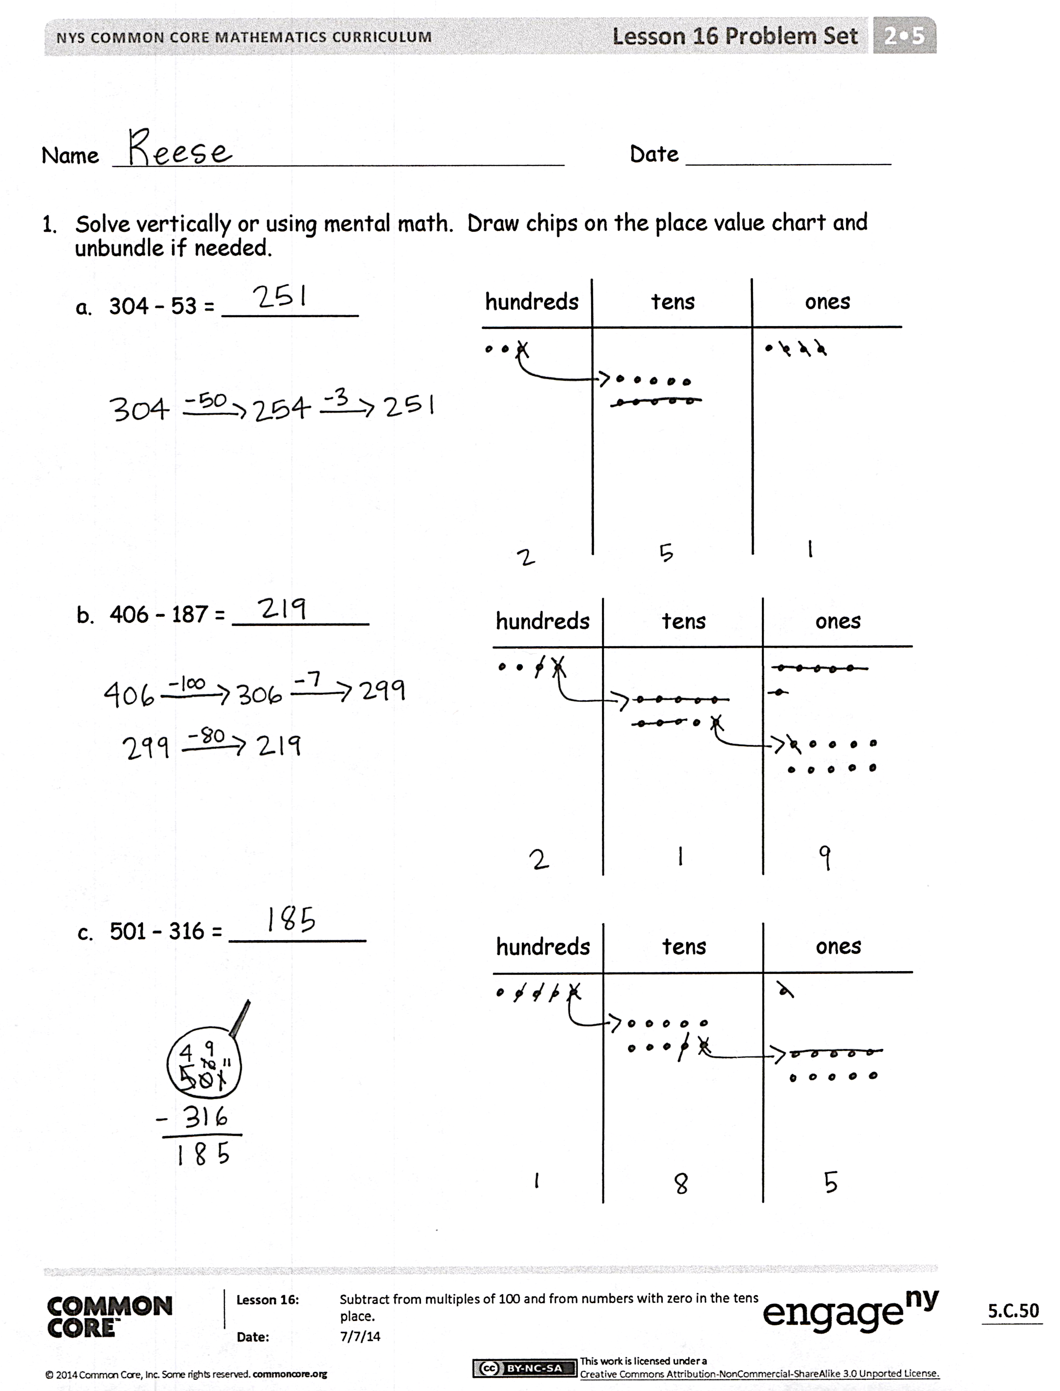
Problem Set (10 minutes)
Students should do their personal best to complete the Problem Set within the allotted 10 minutes. For some classes, it may be appropriate to modify the assignment by specifying which problems they work on first. Some problems do not specify a method for solving. Students should solve these problems using the RDW approach used for Application Problems.
Student Debrief (10 minutes)
Lesson Objective: Subtract from multiples of 100 and from numbers with zero in the tens place.
The Student Debrief is intended to invite reflection and active processing of the total lesson experience.
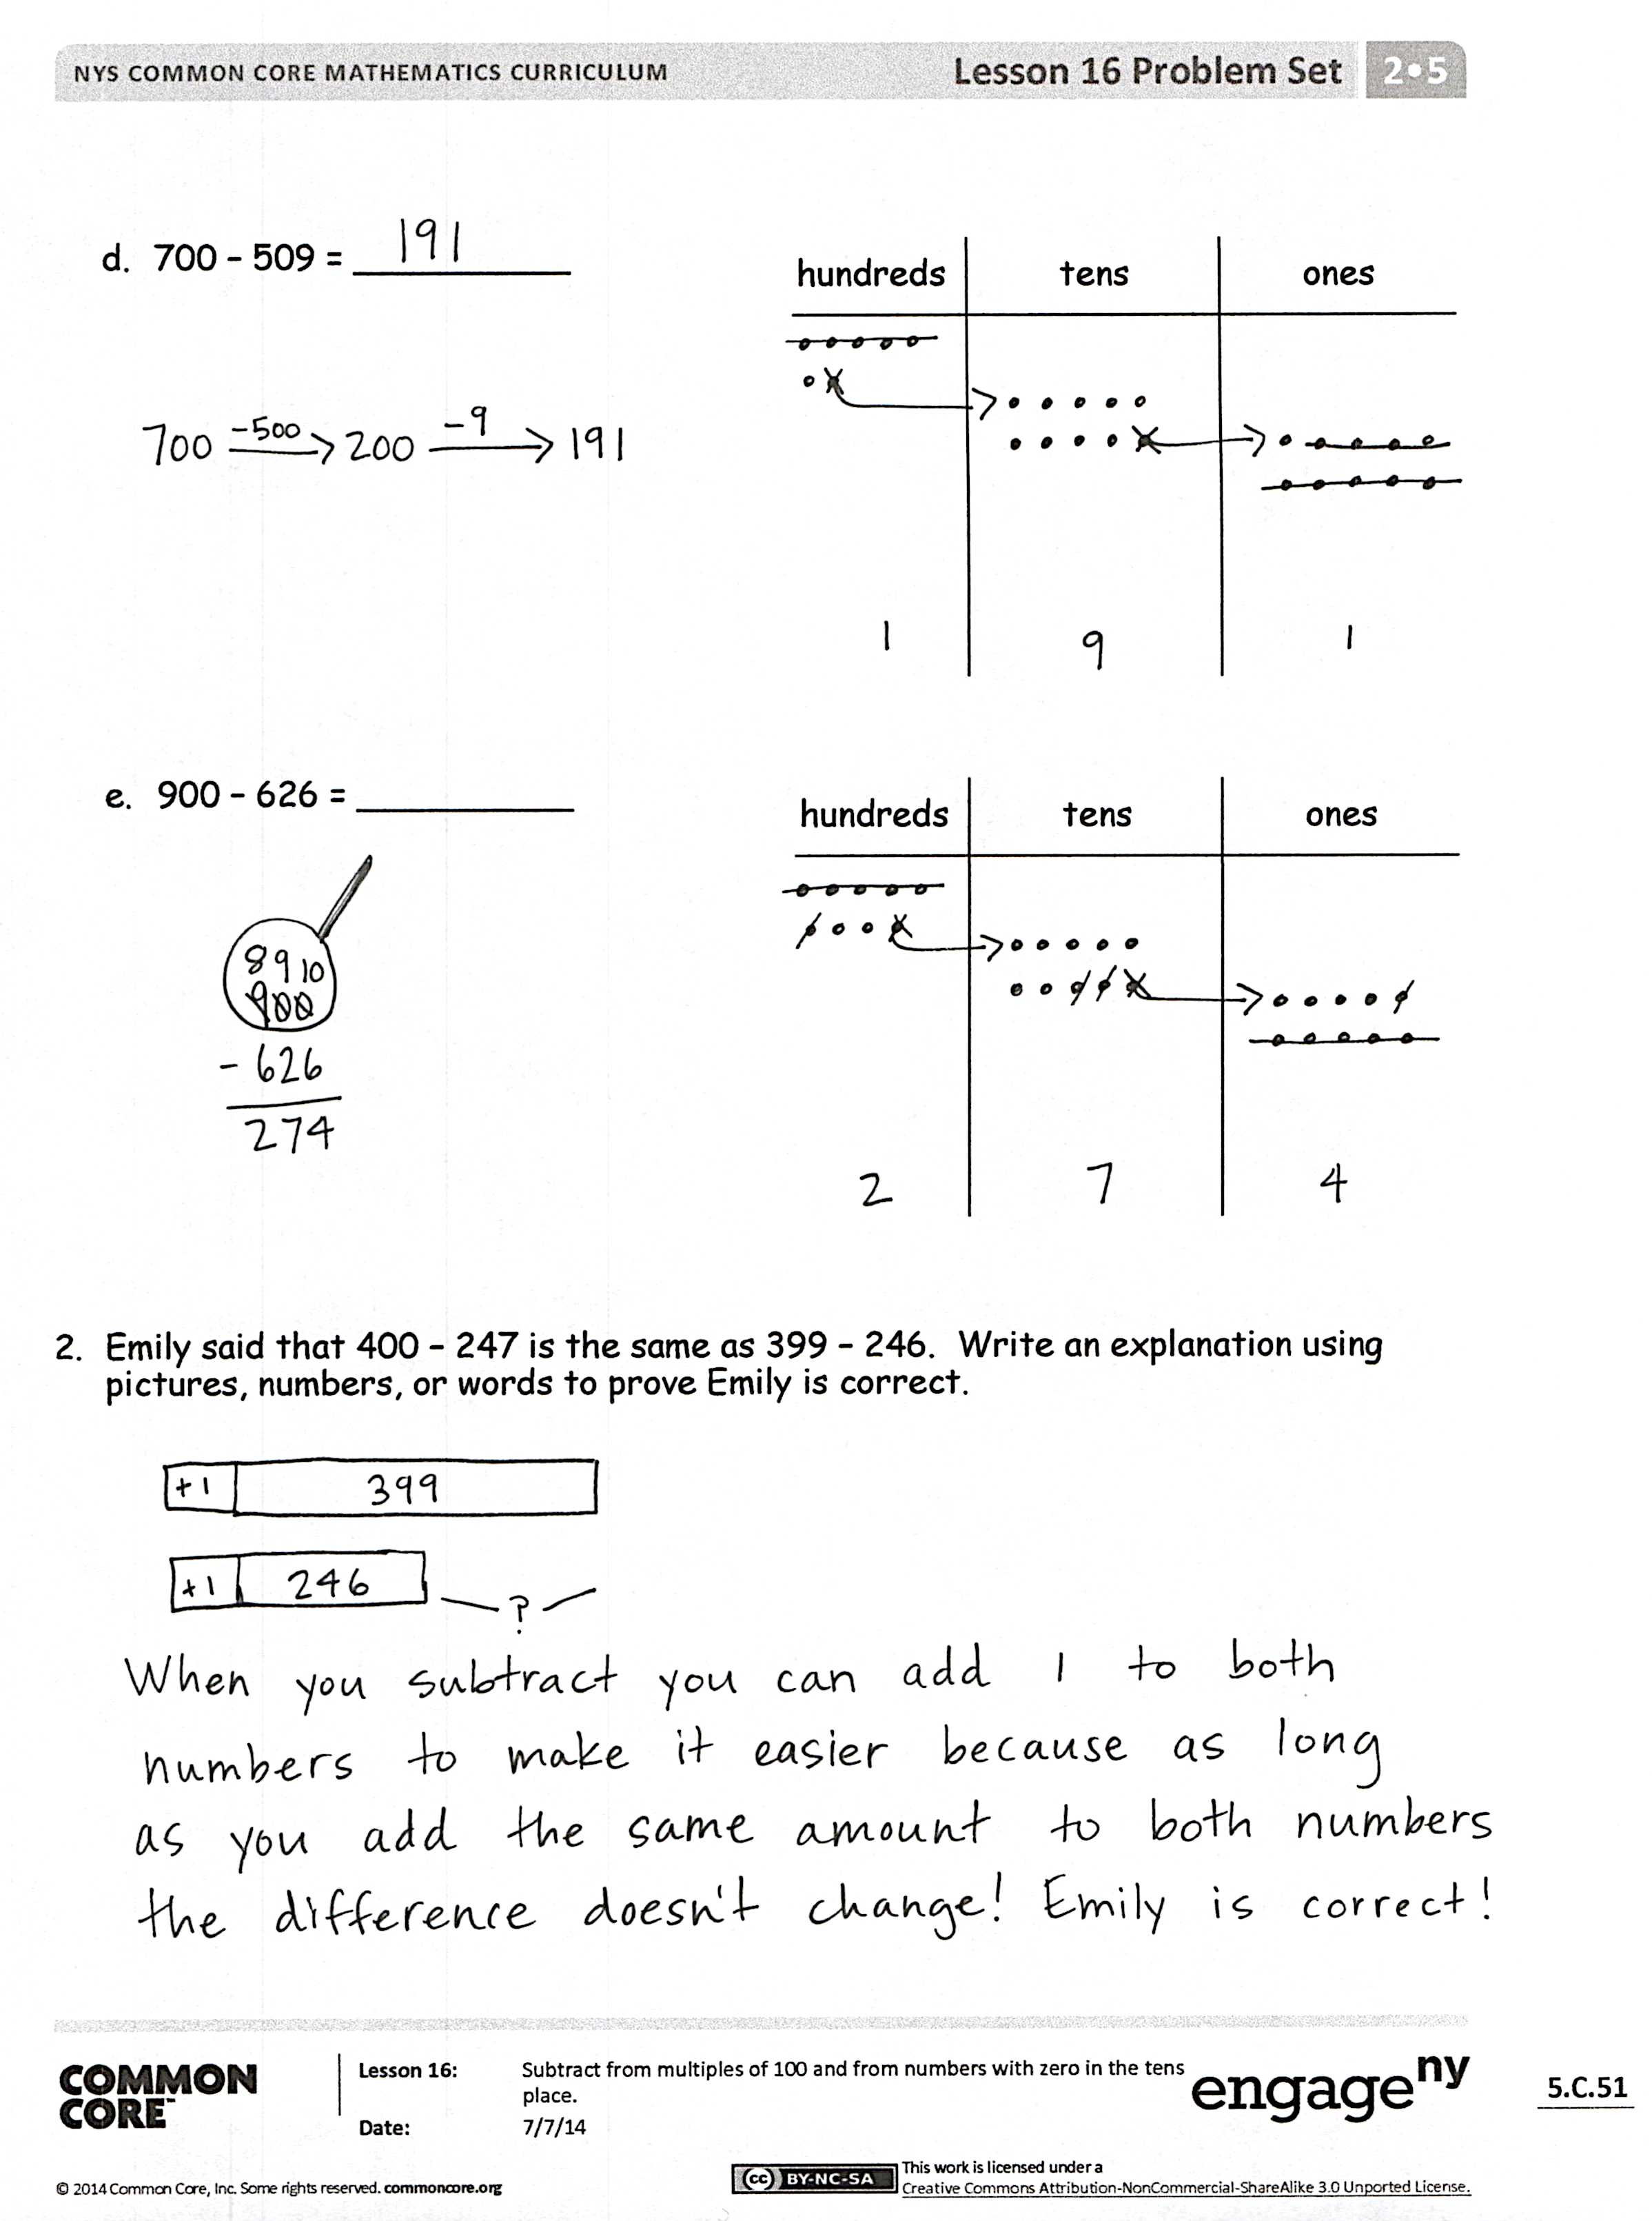
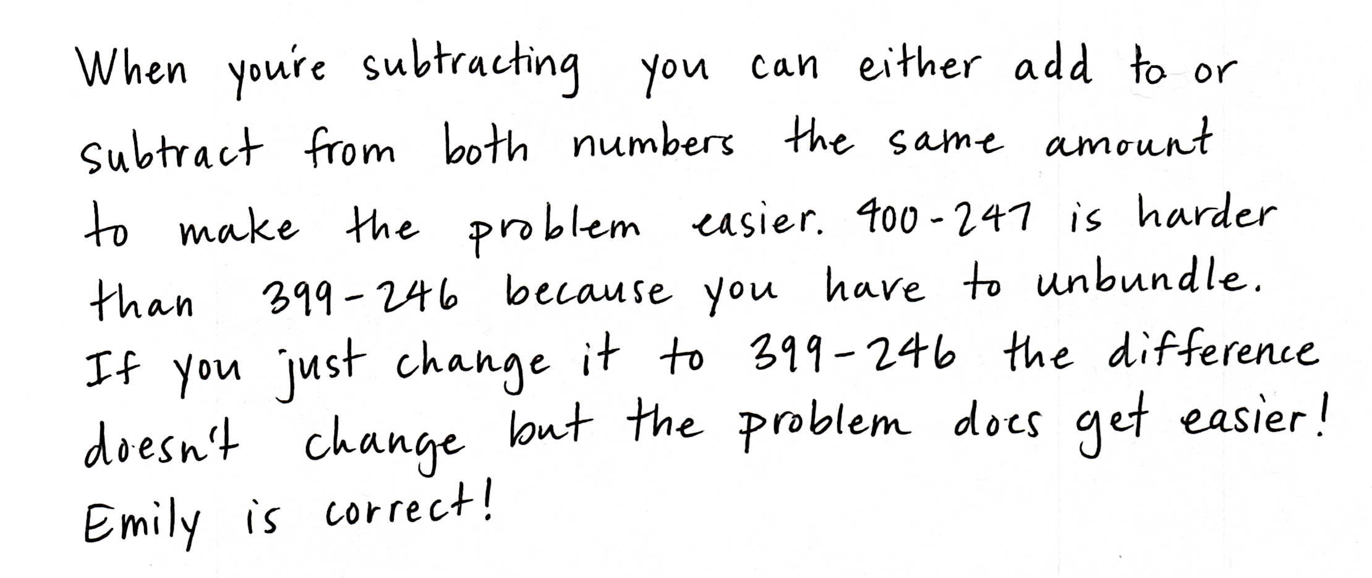
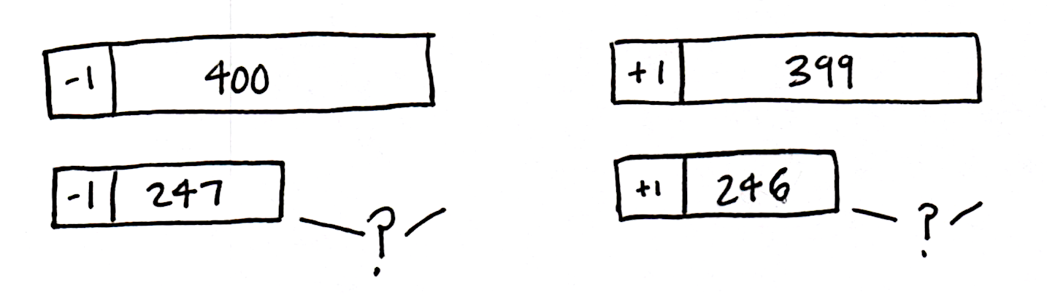
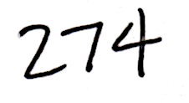
Invite students to review their solutions for the Problem Set. They should check work by comparing answers with a partner before going over answers as a class. Look for misconceptions or misunderstandings that can be addressed in the Debrief. Guide students in a conversation to debrief the Problem Set and process the lesson.
Any combination of the questions below may be used to lead the discussion.
- For Problem 1(a), 304 – 53, explain how you solved this problem. How could you have solved it mentally?
- For Problem 1(b), 406 – 187, what did you draw on your place value chart? How did you unbundle 400? Did you do it in one or two steps?
- For Problem 1(c), 501 – 316, explain to your partner how you changed a larger unit to make more ones when there were no tens?
- For Problem 1(d), what are two different ways you can unbundle 700? How can you do it in one step? How could you have solved this problem mentally?
- Think like a detective: When you are subtracting three-digit numbers, when do you choose to unbundle a hundred? When do you choose to solve mentally? What clues in the numbers help you choose a solution strategy?
Exit Ticket (3 minutes)
After the Student Debrief, instruct students to complete the Exit Ticket. A review of their work will help with assessing students’ understanding of the concepts that were presented in today’s lesson and planning more effectively for future lessons. The questions may be read aloud to the students.

Number Correct: _______
A
Subtraction from Teens
 | 11 – 10 = |  |  |  | 19 – 9 =
 | 12 – 10 = |  |  |  | 15 – 6 =
 | 13 – 10 = |  |  |  | 15 – 7 =
 | 19 – 10 = |  |  |  | 15 – 9 =
 | 11 – 1 = |  |  |  | 20 – 10 =
 | 12 – 2 = |  |  |  | 14 – 5 =
 | 13 – 3 = |  |  |  | 14 – 6 =
 | 17 – 7 = |  |  |  | 14 – 7 =
 | 11 – 2 = |  |  |  | 14 – 9 =
 | 11 – 3 = |  |  |  | 15 – 5 =
 | 11 – 4 = |  |  |  | 17 – 8 =
 | 11 – 8 = |  |  |  | 17 – 9 =
 | 18 – 8 = |  |  |  | 18 – 8 =
 | 13 – 4 = |  |  |  | 16 – 7 =
 | 13 – 5 = |  |  |  | 16 – 8 =
 | 13 – 6 = |  |  |  | 16 – 9 =
 | 13 – 8 = |  |  |  | 17 – 10 =
 | 16 – 6 = |  |  |  | 12 – 8 =
 | 12 – 3 = |  |  |  | 18 – 9 =
 | 12 – 4 = |  |  |  | 11 – 9 =
 | 12 – 5 = |  |  |  | 15 – 8 =
 | 12 – 9 = |  |  |  | 13 – 7 =
B
[KEY]

Number Correct: _______
Improvement: _______
Subtraction from Teens
 | 11 – 1 = |  |  |  | 16 – 6 =
 | 12 – 2 = |  |  |  | 14 – 5 =
 | 13 – 3 = |  |  |  | 14 – 6 =
 | 18 – 8 = |  |  |  | 14 – 7 =
 | 11 – 10 = |  |  |  | 14 – 9 =
 | 12 – 10 = |  |  |  | 20 – 10 =
 | 13 – 10 = |  |  |  | 15 – 6 =
 | 18 – 10 = |  |  |  | 15 – 7 =
 | 11 – 2 = |  |  |  | 15 – 9 =
 | 11 – 3 = |  |  |  | 14 – 4 =
 | 11 – 4 = |  |  |  | 16 – 7 =
 | 11 – 7 = |  |  |  | 16 – 8 =
 | 19 – 9 = |  |  |  | 16 – 9 =
 | 12 – 3 = |  |  |  | 20 – 10 =
 | 12 – 4 = |  |  |  | 17 – 8 =
 | 12 – 5 = |  |  |  | 17 – 9 =
 | 12 – 8 = |  |  |  | 16 – 10 =
 | 17 – 7 = |  |  |  | 18 – 9 =
 | 13 – 4 = |  |  |  | 12 – 9 =
 | 13 – 5 = |  |  |  | 13 – 7 =
 | 13 – 6 = |  |  |  | 11 – 8 =
 | 13 – 9 = |  |  |  | 15 – 8 =

Name Date
- Solve vertically or using mental math. Draw chips on the place value chart and unbundle, if needed.
hundreds tens ones
  - 304 − 53 = __________

hundreds tens ones
  - 406 − 187 = __________
hundreds tens ones
  - 501 − 316 = __________
  - 700 − 509 = __________
hundreds tens ones
  - 900 − 626 = __________
hundreds tens ones

- Emily said that 400 − 247 is the same as 399 − 246. Write an explanation using pictures, numbers, or words to prove Emily is correct.

Name Date
Solve vertically or using mental math. Draw chips on the place value chart and unbundle, if needed.
hundreds tens ones
- 604 − 143 = __________

hundreds tens ones
- 700 − 568 = __________

Name Date
- Solve vertically or using mental math. Draw chips on the place value chart and unbundle, if needed.
hundreds tens ones
  - 206 − 89 = __________

hundreds tens ones
  - 509 − 371 = __________
hundreds tens ones
  - 607 − 288 = __________
  - 800 − 608 = __________
hundreds tens ones
hundreds tens ones
  - 900 − 572 = __________

- Andy said that 599 − 456 is the same as 600 − 457. Write an explanation using pictures, numbers, or words to prove Andy is correct.

