Lesson 15
Objective: Use math drawings to represent subtraction with up to two decompositions, relate drawings to the algorithm, and use addition to explain why the subtraction method works.

Suggested Lesson Structure
 Application Problem (8 minutes)
 Fluency Practice (12 minutes)
 Concept Development (30 minutes)
 Student Debrief (10 minutes)
Total Time (60 minutes)
Application Problem (8 minutes)
Catriona earned 16 more stickers than Peter. She earned 35 stickers. How many stickers did Peter earn?
MaryJo earned 47 stickers. How many more does Peter need to have the same amount as MaryJo?
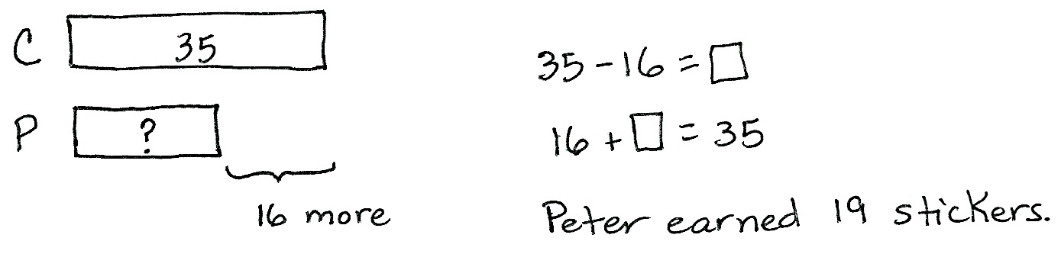
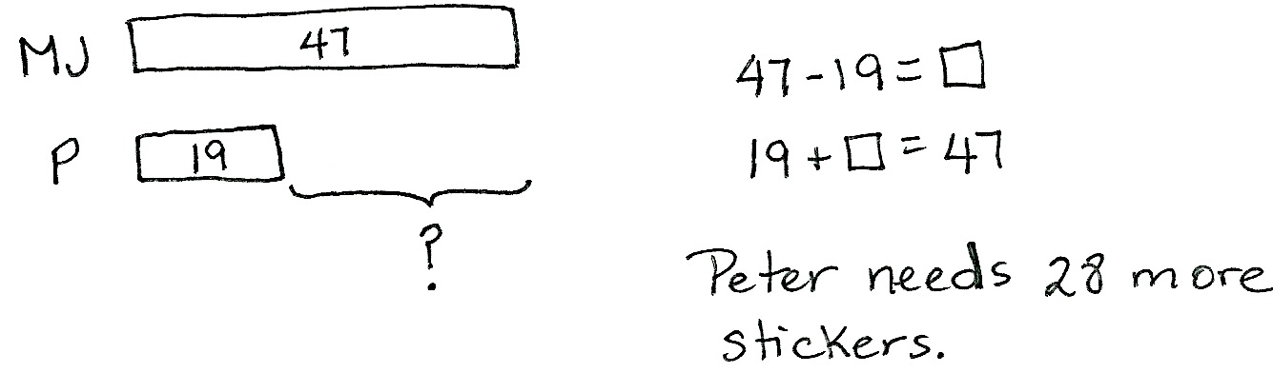
Note: This compare smaller unknown problem is intended for guided practice. It is one of the four difficult subtypes of word problems in that the word more suggests addition, which would be an incorrect operation. This type of problem highlights the importance of drawing as a way to understand relationships in the problem. The question mark indicates the unknown because students recognize that they are looking for a missing part.
Fluency Practice (12 minutes)
- Grade 2 Core Fluency Practice Sets 2.OA.2 (5 minutes)
- Get to 10, 20, or 30 2.OA.2 (4 minutes)
- Count by Ten or One with Dimes and Pennies 2.OA.2 (3 minutes)
Grade 2 Core Fluency Practice Sets (5 minutes)
Materials: (S) Grade 2 Core Fluency Practice Sets (G2–M5–Lesson 14 Core Fluency Practice Sets)
Note: During Topic C and for the remainder of the year, each day’s fluency activity includes an opportunity for review and mastery of the sums and differences with totals through 20 by means of the Core Fluency Practice Sets or Sprints. In Lesson 14, Practice Sets are provided, and the process is explained in detail.
Get to 10, 20, or 30 (4 minutes)
Materials: (S) 3 dimes and 10 pennies
Note: This activity uses dimes and pennies to help students become familiar with coins, while simultaneously providing practice with missing addends to tens.
For the first two minutes:
- Step 1: Lay out 0–10 pennies in 5-group formation and ask students to identify the amount shown (e.g., 9 cents).
- Step 2: Ask for the addition sentence to get to a dime (e.g., 9 cents + 1 cent = 1 dime).
For the next two minutes:
- Repeat Steps 1 and 2, and then add a dime and ask students to identify the amount shown
(e.g., 1 dime 9 cents + 1 cent = 2 dimes).
Count by Ten or One with Dimes and Pennies (3 minutes)
Materials: (T) 10 dimes and 10 pennies
Note: This activity uses dimes and pennies as abstract representations of tens and ones to help students become familiar with coins, while simultaneously providing practice with counting forward and back by tens or ones.
- First minute: Place and take away dimes in a 5-group formation as students count along by ten.
- Second minute: Begin with 2 pennies. Ask how many ones there are. Instruct students to start at 2. Add and subtract 10 while placing and taking away dimes.
- Third minute: Begin with 2 dimes. Ask how many tens there are. Instruct students to begin at 20. Add and subtract 1 while placing and taking away pennies.
Concept Development (30 minutes)
Materials: (S) Personal white board, math journal or paper
Note: While this lesson focuses on relating chip models to the vertical form, guide students toward considering the relationship between the numbers before choosing a strategy to solve.
Problem 1: 430 - 129
T: (Write 430 – 129 horizontally.) Talk with your partner: What do you notice about these numbers?
S: 129 is close to 130, so it’s going to be easy to solve mentally. If you don’t even look at the hundreds, you see 30 minus 29. When I see 129, I think about making the next ten.
T: I like your thinking! So, how would you solve this problem? (Allow students time to solve the problem.)
NOTES ON
MULTIPLE MEANS
OF ENGAGEMENT:
Support oral responses by instructing students to write Problem 1 on their personal white board or paper. Since the hundreds may be distracting, have students underline or draw a box around the 30 in 430 and the 29 in 129. This focuses their attention on the nearest ten, and prompts them to notice the opportunity to use a mental math strategy.

T: Who would like to explain their solution?
S: 400 – 100 is 300, and 30 – 29 is 1, so 301. I used the arrow way and counted on. 129 + 1 is 130, and
130 + 300 is 430, so the answer is 301. I added 1 to both numbers to make it easier, like 431 – 130.
So, 400 – 100 is 300, and 31 – 30 is 1, so 301.
T: I like the way you noticed how close 129 is to 130, and how close 29 is to 30; I like the way you used that to help you solve the problem.
T: So, we could solve this mentally, use a simplifying strategy, or use the algorithm. Is that true?
S: True!
T: It’s important to think about the numbers before you decide which strategy to use.
Solve 560 - 258 as a guided practice or proceed to Problem 2, depending on the needs of your students.
Problem 2: 941 – 587
T: (Write 941 – 587 horizontally.) How about this one? Mental math or the vertical form?
S: The vertical form!
T: Rewrite the problem with me. (Write the problem vertically as students do the same.)
T: Today, let’s make our math drawings using the chip model. I’ll draw a model on the board while you draw your model at your desk. Whisper-count as you draw your chips.
S: (Whisper-count and draw.) 100, 200, 300,…941.
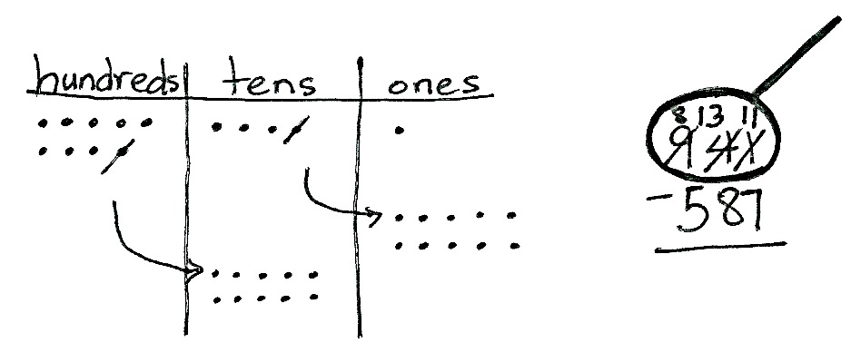
T: Use place value language to tell your partner how your chip model matches vertical form.
S: I can count my chips: 100, 200, 300,…910, 920, …941. I put 9 chips in the hundreds place and that’s 900, 4 chips in the tens place and that’s 40, and 1 chip in the ones place is 1. My model shows 900 + 40 + 1. That’s 941.
T: Let’s draw our magnifying glass and set this problem up to subtract! (Draw a circle around 941 as students do the same.)
T: Look at your model. Are we ready to subtract the ones?
S: No!
T: Ask your partner: Where can we get some more ones?
S: From the tens place. Decompose a ten. Rename 1 ten as 10 ones.
T: Let’s show that on our chip models. (Cross off 1 ten, draw an arrow to the ones place, and draw 10 ones as students do the same.)
T: How many tens are in the tens place now?
S: 3 tens.
T: Show that in vertical form. Check your work with mine. (Cross off 4, and write 3 above the tens place as students do the same.)
T: How many ones do you see on the model?
S: 11 ones!
T: Cross off 1 one, and write 11 ones. (Record the change as students do the same.)
T: Look at the tens place. Are we ready to subtract in the tens?
S: No!
T: Why not?
S: 3 tens is less than 8 tens. 80 is greater than 30.
T: Where can we get some more tens? Unbundle a…?
S: Hundred!
T: Let’s show that on our chip models. (Cross off 1 hundred, draw an arrow to the tens place, and draw 10 tens as students do the same.)
T: We need to record the change. How many hundreds do we see now?
S: 8 hundreds!
T: Cross off 9 hundreds, and write 8 hundreds. (Record as students do the same.)
T: Look at the tens place on the model. How many tens do we see?
S: 13 tens!
T: Let’s record that change as well. (Record as students do the same, changing 3 tens to 13 tens.)
T: Are we completely ready to subtract?
S: Yes! (Allow students time to complete the subtraction.)
T: Talk with your partner. Take turns sharing how you showed the subtraction on your model and using the algorithm. (Allow time for students to share.)
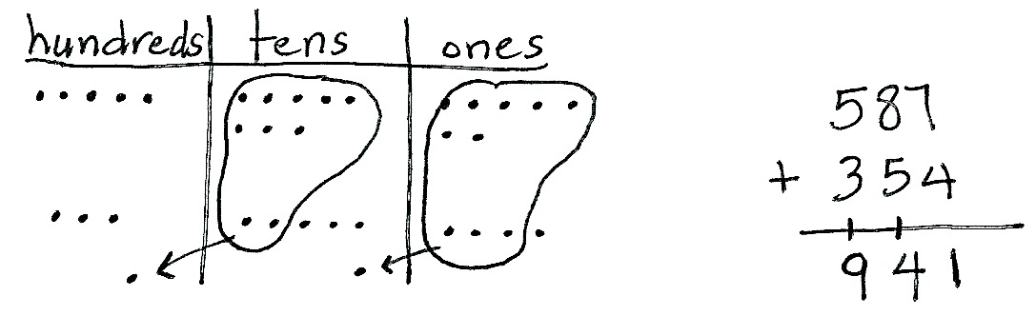
T: I heard some of you notice one of the advantages of getting the problem ready to subtract. You can subtract in any order!
T: Read the complete number sentence.
S: 941 – 587 = 354.
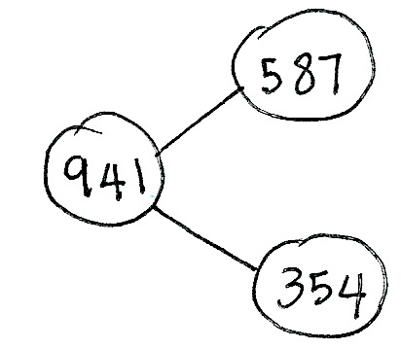
T: How can you prove that this statement is true?
If 941 – 587 = 354, then 354 + 587 = 941. Discuss with your partner.
MP.7
S: You can draw a number bond. You could do the addition and see if it equals the whole. If 354 is the missing part, when you add it to the other part, 587, it will equal the whole, 941.
T: Please check the answer by drawing a chip model to add 354 + 587. Check your model and addition with your partner. If you are correct, write the number bond for this problem.
Circulate to check for understanding and to support students working below grade level. Project student work or call students to the board to show the chip model, vertical form, and number bond. Encourage students to use place value language to explain their work.
Problem 3: 624 – 225
NOTES ON
MULTIPLE MEANS
OF ACTION AND EXPRESSION:
As students work more independently, adjust the numbers in some problems to suit individual learners’ levels:
- For students working below grade level, choose numbers that will only require one decomposition at a time rather than two.
- For students working above grade level, increase the numbers to the thousands to offer a challenge.

Follow the previous procedure to guide students as they write
624 –225 vertically, model it, and solve. Remind them to be precise in lining up the digits and drawing their chips in neat
5-groups. Encourage students to use place value language to explain each action they take on their model and how it is represented using vertical form. Instruct students to check their work with addition and to explain why this method works.
Repeat the process for 756 – 374 and 817 – 758. Continue to support students working below grade level, but as they demonstrate proficiency, instruct them to work on the Problem Set independently.
Problem Set (10 minutes)
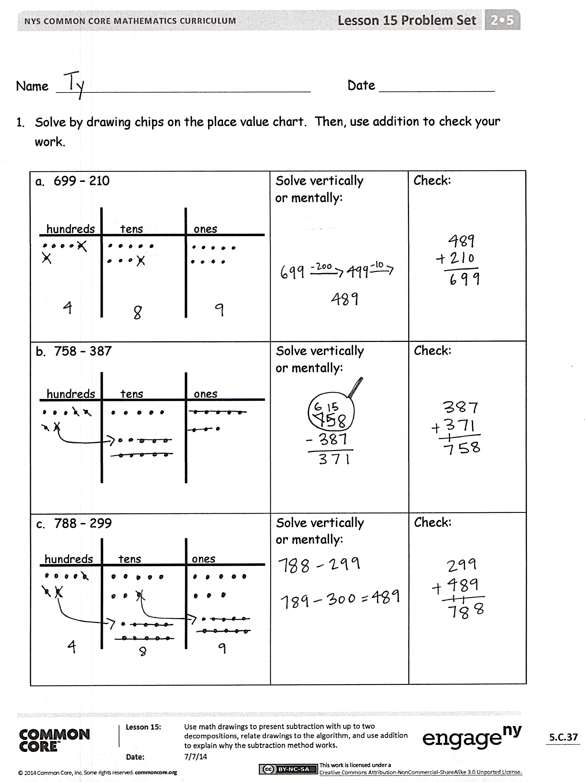
Students should do their personal best to complete the Problem Set within the allotted 10 minutes. For some classes, it may be appropriate to modify the assignment by specifying which problems they work on first. Some problems do not specify a method for solving. Students should solve these problems using the RDW approach used for Application Problems.
Student Debrief (10 minutes)
Lesson Objective: Use math drawings to represent subtraction with up to two decompositions, relate drawings to the algorithm, and use addition to explain why the subtraction method works.
The Student Debrief is intended to invite reflection and active processing of the total lesson experience.
Invite students to review their solutions for the Problem Set. They should check work by comparing answers with a partner before going over answers as a class. Look for misconceptions or misunderstandings that can be addressed in the Debrief. Guide students in a conversation to debrief the Problem Set and process the lesson.
Any combination of the questions below may be used to lead the discussion.
- For Problem 1(a), which strategy did you use to solve? Why? Why didn’t you add one to 699 to make the hundred?
- For Problem 1(b), which strategy did you use to solve? Why? How did you know whether to unbundle a ten or hundred? How did you show the change in vertical form?
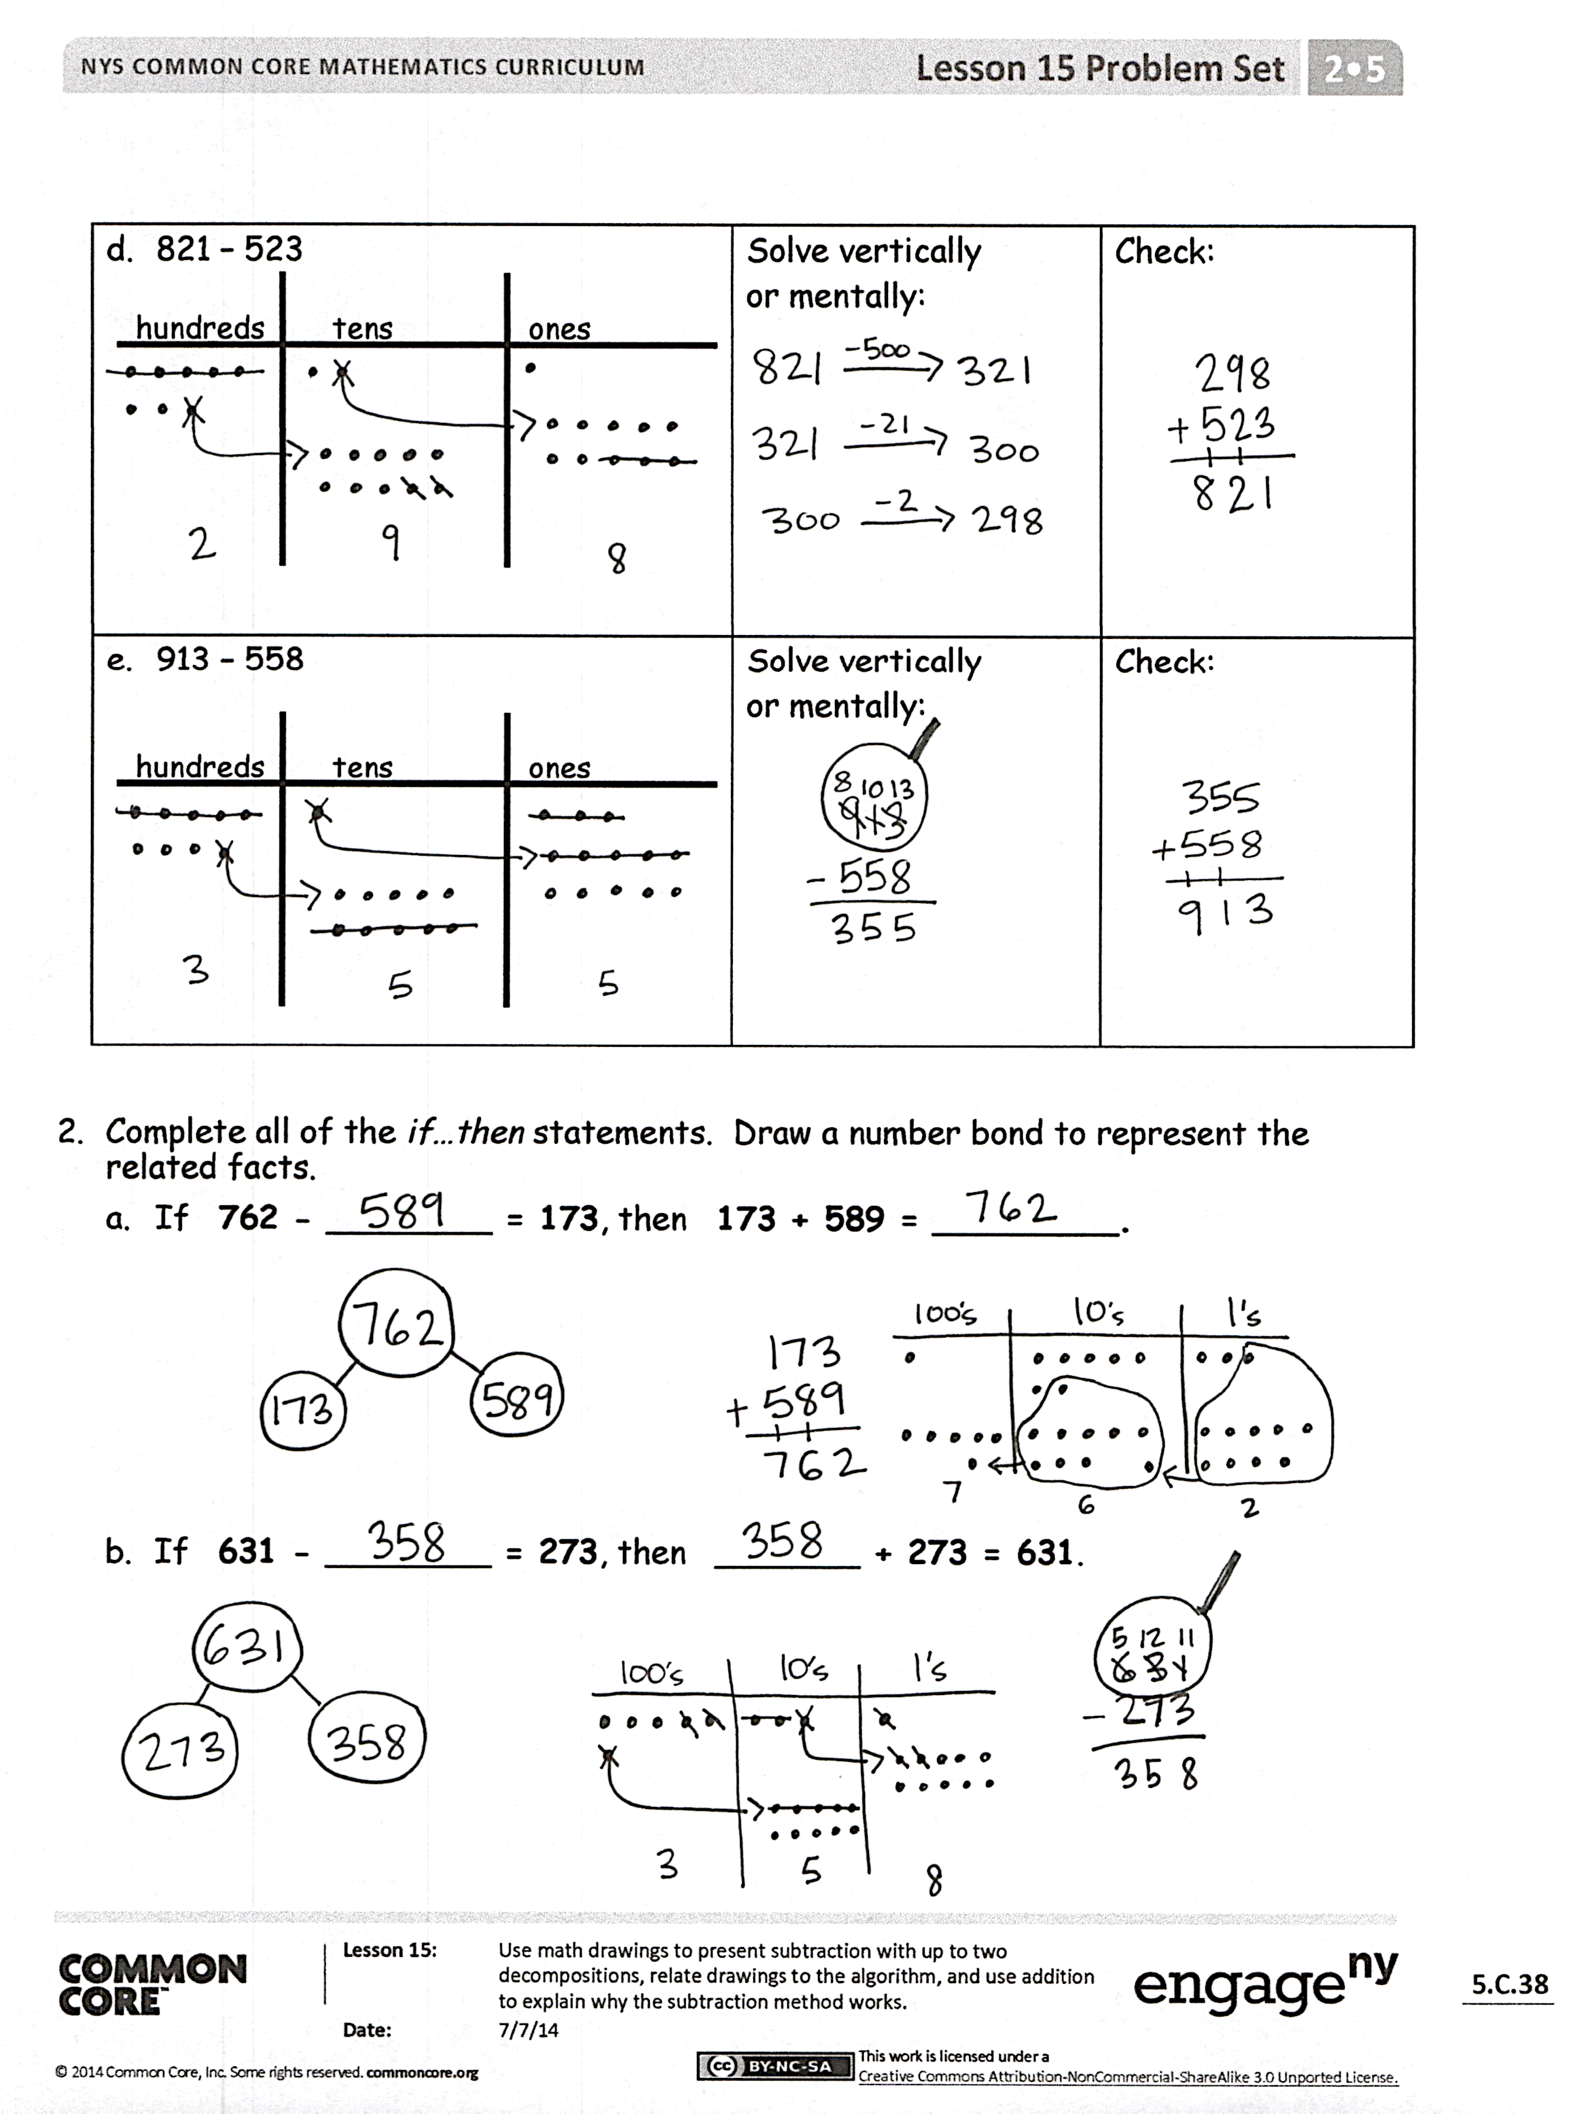
- For Problem 1(c), what is the most efficient way to solve this problem? Why? How was this problem different from Problem 1(a)? How did you check your work?
- For Problem 1(d), what number(s) did you draw on your place value chart? How did you show unbundling with your chips and in vertical form?
- For Problem 1(e), how can you tell right away if you will need to decompose a ten or hundred?
- What important math vocabulary have we used to talk about breaking apart a larger unit into smaller units? (Decompose, rename, unbundle, change.)
Exit Ticket (3 minutes)
After the Student Debrief, instruct students to complete the Exit Ticket. A review of their work will help with assessing students’ understanding of the concepts that were presented in today’s lesson and planning more effectively for future lessons. The questions may be read aloud to the students.

Name Date
- Solve by drawing chips on the place value chart. Then, use addition to check your work.
- 699 − 210  hundreds tens ones | Solve vertically  or mentally: | Check:
- 758 − 387  hundreds tens ones | Solve vertically  or mentally: | Check:
- 788 − 299  hundreds tens ones | Solve vertically  or mentally: | Check:
- 821 − 523  hundreds tens ones | Solve vertically  or mentally: | Check:
- 913 − 558  hundreds tens ones | Solve vertically  or mentally: | Check:

- Complete all of the if…then statements. Draw a number bond to represent the related facts.
  - If 762 − ________ = 173, then 173 + 589 = _________.
  - If 631 − ________ = 273, then _______ + 273 = 631.

Name Date
Solve by drawing chips on the place value chart. Then, use addition to check your work.
- 583 − 327  hundreds tens ones | Solve vertically  or mentally: | Check:
- 721 − 485  hundreds tens ones | Solve vertically  or mentally: | Check:

Name Date
- Solve by drawing chips on the place value chart. Then, use addition to check your work.
- 800 − 675  hundreds tens ones | Solve vertically  or mentally: | Check:
- 742 − 495  hundreds tens ones | Solve vertically  or mentally: | Check:
- 657 − 290  hundreds tens ones | Solve vertically  or mentally: | Check:
- 877 − 398  hundreds tens ones | Solve vertically  or mentally: | Check:
- 941 − 628  hundreds tens ones | Solve vertically  or mentally: | Check:

- Complete all of the if…then statements. Draw a number bond to represent the related facts.
  - If 928 − ________ = 519, then 519 + 409 = _________.
  - If 764 − _______ = 391, then ________ + 391 = 764.

