Lesson 14
Objective: Use math drawings to represent subtraction with up to two decompositions, relate drawings to the algorithm, and use addition to explain why the subtraction method works.

Suggested Lesson Structure
 Application Problem (8 minutes)
 Fluency Practice (12 minutes)
 Concept Development (30 minutes)
 Student Debrief (10 minutes)
Total Time (60 minutes)
Application Problem (8 minutes)
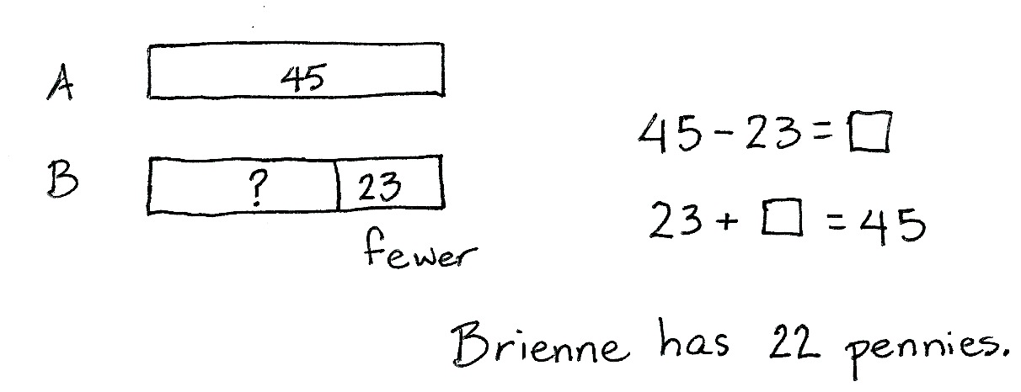
Brienne has 23 fewer pennies than Alonzo. Alonzo has 45 pennies.
- How many pennies does Brienne have?
- How many pennies do Alonzo and Brienne have all together?
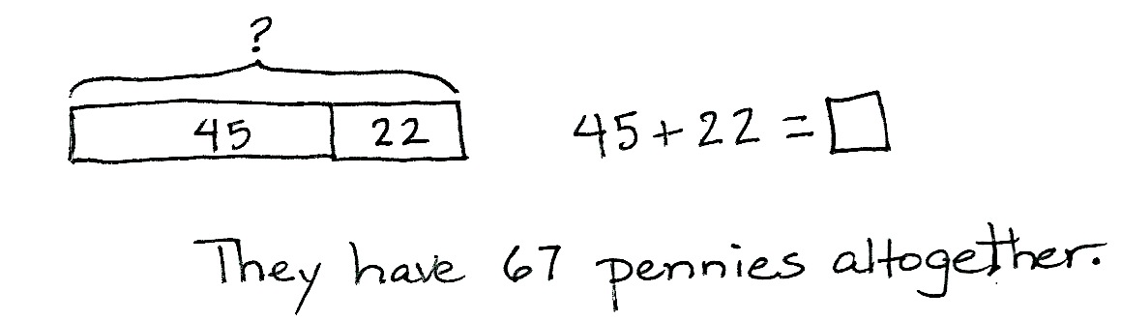
Note: This problem is intended for guided practice to help students gain familiarity with the compare with smaller unknown problem type. The numbers are intentionally small to allow students to focus on the relationship between the numbers. This also serves as a bridge to later work with two-step problems where the second step will not be scaffolded.
Fluency Practice (12 minutes)
- Grade 2 Core Fluency Practice Sets 2.OA.2 (5 minutes)
- Using the Nearest Ten to Subtract 2.NBT.5 (5 minutes)
- Subtract Common Units 2.NBT.5, 2.NBT.7 (2 minutes)
Grade 2 Core Fluency Practice Sets (5 minutes)
Materials: (S) Grade 2 Core Fluency Practice Sets
Note: During Topic C and for the remainder of the year, each day’s fluency activity includes an opportunity for review and mastery of the sums and differences with totals through 20 by means of the Core Fluency Practice Sets or Sprints. Five options are provided in this lesson for the Core Fluency Practice Set, with Set A being the most simple addition fluency exercise of the grade to Set E being the most complex. Start all students on Set A. Keep a record of student progress, so students can progress to more complex sets when they are ready.
Students complete as many problems as they can in 120 seconds. Reaching 100% accuracy and completion is recommended before moving to the next level. Collect any Fluency Practice Sets that have been completed within the 120 seconds, and check the answers. The next time Core Fluency Practice Sets are used, students who have successfully completed their set today can be provided with the next level.
Assign early finishers a counting pattern and start number. Celebrate improvement, as well as advancement. Students should be encouraged to compete with themselves rather than their peers. Discuss possible strategies to solve the problems with students. Notify caring adults of each student’s progress.
Using the Nearest Ten to Subtract (5 minutes)
Note: Students use bonds of 10 when subtracting as a mental strategy to help subtract fluently with larger numbers.
T: (Post 16 – 9 on the board.) Raise your hand when you know 16 – 9.
S: 7.
T: (Write in the bond.) 10 – 9 is…?
S: 1.
T: 1 + 6 is…?
S: 7.
Continue with the following possible sequence: 15 – 9, 13 – 8, 15 – 7, 16 – 7, 12 – 9, 13 – 7, 23 – 7, 25 – 7,
25 – 9, 26 – 9, 27 – 9, 27 – 19, 37 – 9, 37 – 19, 35 – 19, 45 – 19, 47 – 18, and 48 – 29.
Subtract Common Units (2 minutes)
Materials: (S) Personal white board
Note: Reviewing this mental math fluency exercise prepares students for understanding the importance of the subtraction algorithm.
T: (Project 77.) Say the number in unit form.
S: 7 tens 7 ones.
T: (Write 77 – 22 = ____.) Say the subtraction sentence and answer in unit form.
S: 7 tens 7 ones – 2 tens 2 ones = 5 tens 5 ones.
T: Write the subtraction sentence on your board.
Repeat the process and continue with the following possible sequence: 88 – 33, 66 – 44, 266 – 44, 55 – 33, and 555 – 33.
Concept Development (30 minutes)
Materials: (S) Personal white board, math journal or paper
Note: In this lesson, students model subtraction by drawing place value disks. This serves as a bridge between their use of actual place value disks in Lesson 13 and the chip model drawings called for in Lesson 15. Personal white boards can be used in place of paper as students demonstrate precision in their drawings by aligning digits in their proper place and aligning place value disks in 5-groups.
Problem 1: 584 – 147
NOTES ON
MULTIPLE MEANS
OF ACTION AND EXPRESSION:
Some students may answer yes to the question of solving the problem mentally. After all the lessons and practice with simplifying strategies, they may not need to write their work and may even resist having to do so. Encourage these students to follow along with the algorithm practice and use their mental math to check the vertical form, and vice versa.

T: (Write 584 – 147 horizontally.) Would it be easy to solve this problem mentally?
S: No, I can’t keep all those numbers in my head. It would be too confusing to solve mentally. The algorithm would be the easiest way to solve.
T: Ah! Part of your job as students is to know which tools make your work easier. Vertical form is an excellent choice for a problem like this.
T: Rewrite the problem with me. (Write the problem vertically as students do the same.)
T: Now, let’s make a math drawing using place value disks, because that will help us make sense of the numbers. First, tell your partner what you will draw.
S: I’ll draw 500, 80, and 4 with disks. I’ll draw 5 hundreds, 8 tens, and 4 ones.
T: I like the way you used place value language. Let’s draw our models. Whisper-count the total as you draw the place value disks.
S: (Whisper-count and draw.) 100, 200, 300,…584.
T: Do we need to draw 147?
S: No, it’s part of 584. We only draw the whole when we subtract. Then, we take away one part to show the other part.
T: Excellent part–whole thinking!
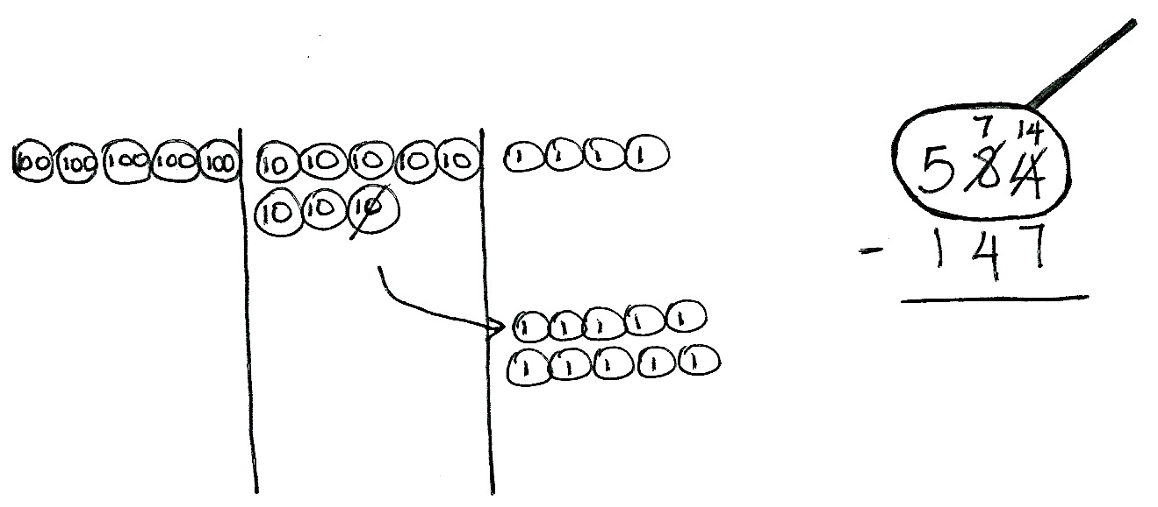
T: Let’s set up the problem to subtract. We need to draw a…?
S: Magnifying glass! (Draw a circle around 584 as students do the same.)
MP.7
T: Let’s ask our questions. Are we ready to subtract in the ones place?
S: No! 4 is less than 7.
T: Where can we get some more ones?
S: From the tens place. Decompose a ten. Rename 8 tens as 7 tens 10 ones.
T: Let’s show that on our model. (Cross off 1 ten, draw an arrow to the ones place, and draw 10 ones as students do the same.)
T: Remember, as we change the model, we change the numbers in vertical form.
T: Looking at our model, how many tens do we have now?
S: 7 tens!
T: So, we cross off the 8 tens and write 7 tens. (Record the change as students do the same.)
T: How many ones do you see now?
S: 14 ones!
T: Let’s cross off the 4 ones and write 14 ones. (Record the change as students do the same.)
T: Look at the tens place. Are we ready to subtract in the tens place?
NOTES ON
MULTIPLE MEANS
OF ENGAGEMENT:
Some students may subtract starting in the hundreds place. Be prepared for that possibility and encourage the students to explain why that works.

S: Yes, because 7 is greater than 4.
MP.7
T: Are we ready to subtract in the hundreds place?
S: Yes!
T: Why?
S: 5 hundreds is greater than 1 hundred!
T: Now, we’re ready to subtract. Talk with your partner. Take turns sharing how you’ll show the subtraction on your model and using the algorithm.
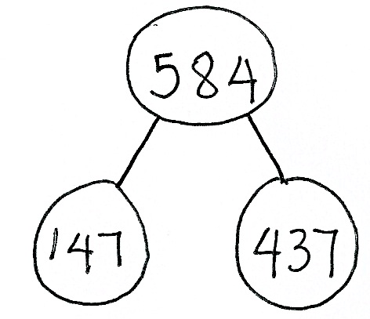
S: I cross off 7 ones and 7 ones are left, so I write 7 below the line in the ones place. I cross off forty and that leaves 30, so I write 3 below the line in the tens place. 5 hundreds minus 1 hundred is
4 hundreds. I cross off 1 hundred and 4 hundreds are left, so I write 4 below the line in the hundreds place.
T: Read the complete number sentence.
S: 584 – 147 equals 437.
T: How can we prove our answer is correct?
S: We can draw a number bond, because part + part = whole.
T: It’s true that part + part = whole, but how can we prove that the part we found is correct?
S: Add the parts to see if they equal the whole. Add 147 + 437 to see if it equals 584.
T: Draw a model to solve 147 + 437. Check your model and vertical form with your partner.
Circulate to assess and support students. Project student work, or call students to the board to show their model, vertical form, or number bond. Encourage students to use place value language to explain their work. Note that students began to work with chip models in Module 4, and those who are confident with this more abstract model and are able to explain it may choose to use it when they work independently.
T: Who can explain why 147 + 437 helps us check 584 – 147?
S: I can show it on my chip model. You see the two parts, 147 and 437, and all together, they show
500 + 80 + 4, which is 584. I can show it on my place value disk drawing. Inside 584, I can show
1 hundred, 4 tens, 7 ones, and also 4 hundreds, 3 tens, and 7 ones. 7 ones + 7 ones equals 14 ones. That’s 4 ones and a new ten. 4 tens + 3 tens + 1 ten is 8 tens. Then, 1 hundred + 4 hundreds is 5 hundreds. That makes 584.
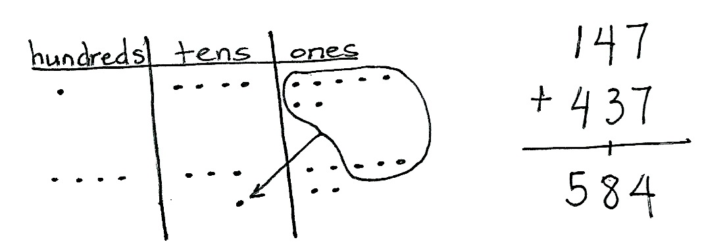
T: Those are very clear explanations using place value language. So, if 584 – 147 = 437, then 437 + 147 = 584. Is this true?
S: True!
Problem 2: 637 – 253
Follow the above procedure to guide students as they write 637 – 253 vertically, model it with disks, and solve. Remind them to be precise in lining up the digits and drawing their place value disks in neat
5-groups. Have them use place value language to explain each action they take on their model and how it is represented using the algorithm. Continue to have them check their work with addition and to explain why this works.
Repeat the process for 725 – 396 and 936 – 468. If students choose to solve 725 – 396 using mental math, be sure to invite them to explain their reasoning, either at this point in the lesson or during the Debrief.
Continue to support struggling students, but as they demonstrate proficiency, instruct them to work on the Problem Set independently.
Problem Set (10 minutes)
Students should do their personal best to complete the Problem Set within the allotted 10 minutes. For some classes, it may be appropriate to modify the assignment by specifying which problems they work on first. Some problems do not specify a method for solving. Students should solve these problems using the RDW approach used for Application Problems.
Student Debrief (10 minutes)
Lesson Objective: Use math drawings to represent subtraction with up to two decompositions, relate drawings to the algorithm, and use addition to explain why the subtraction method works.
The Student Debrief is intended to invite reflection and active processing of the total lesson experience.
Invite students to review their solutions for the Problem Set. They should check work by comparing answers with a partner before going over answers as a class. Look for misconceptions or misunderstandings that can be addressed in the Debrief. Guide students in a conversation to debrief the Problem Set and process the lesson.
Any combination of the questions below may be used to lead the discussion.
- Explain to your partner how you solved Problem 1(a). Did you have to unbundle a ten or hundred? Did you solve this problem mentally or with a simplifying strategy? How did you check your work?
- What significant differences do you notice about the way you changed your place value disks in Problem 1(b) versus 1(c)? How did you show the change using vertical form?
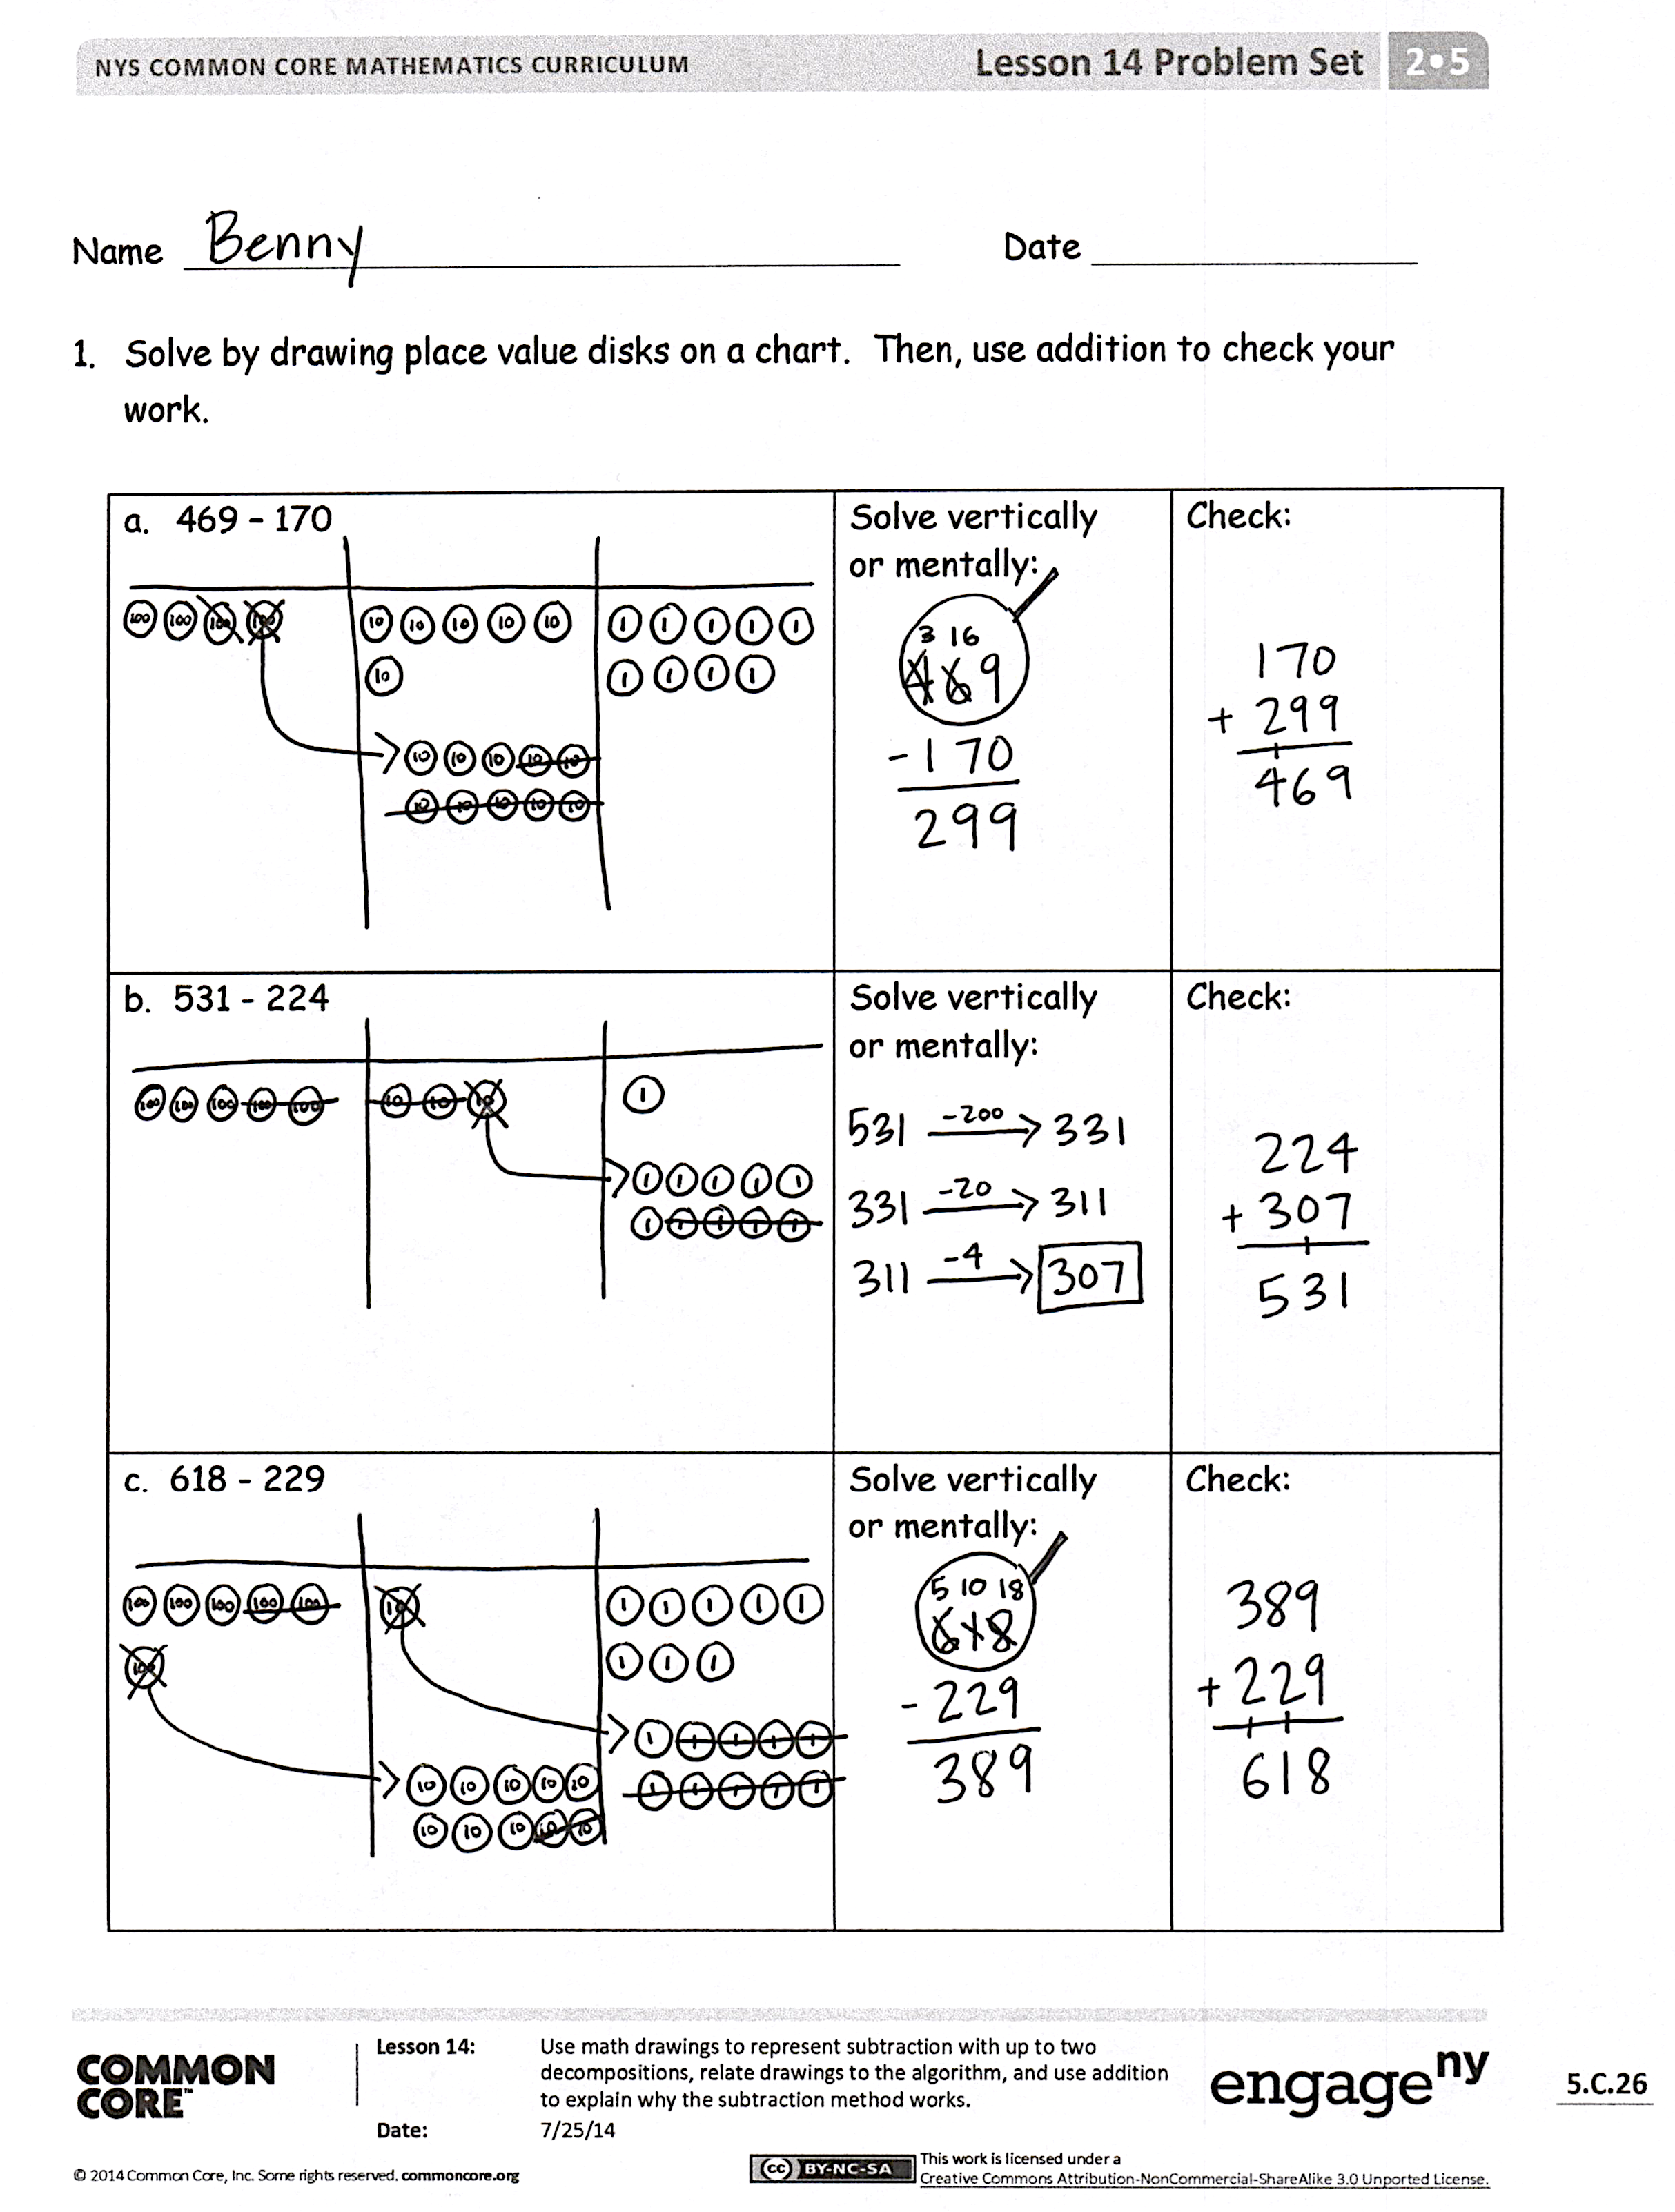
- What significant differences do you notice about the way you changed your place value disks in Problem 1(b) versus 1(c)? How did you show the change using vertical form?
- For Problem 1(d), use place value language to explain to your partner how your model matches the vertical form. Compare how you checked your work.
- One student’s answer for Problem 1(e),
927 – 628, was 209. What mistake did he make in vertical form? How would the chip model have helped him figure out the correct answer?
- For Problem 2, explain to your partner why the statement is true. Using part–whole language, what do you know about the relationship between addition and subtraction?
Exit Ticket (3 minutes)
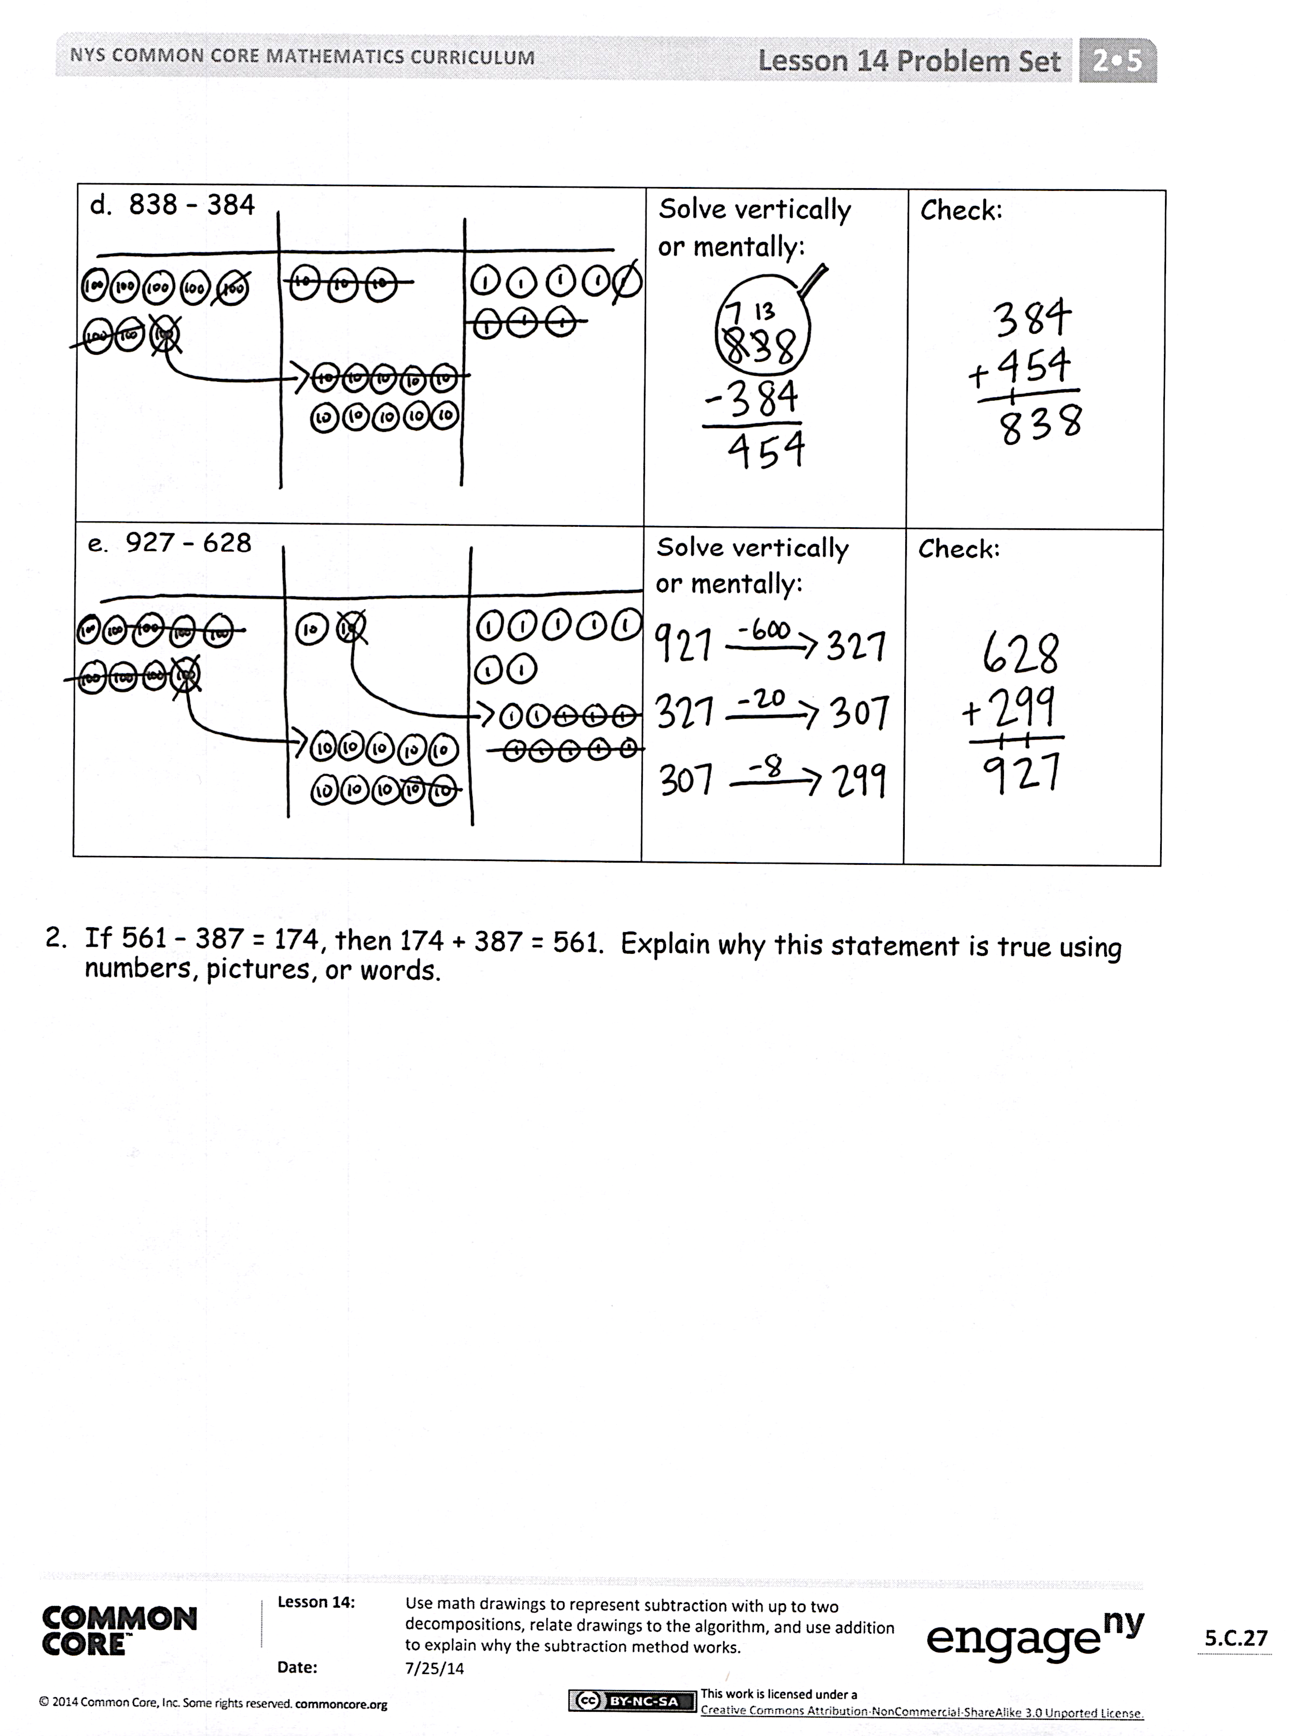
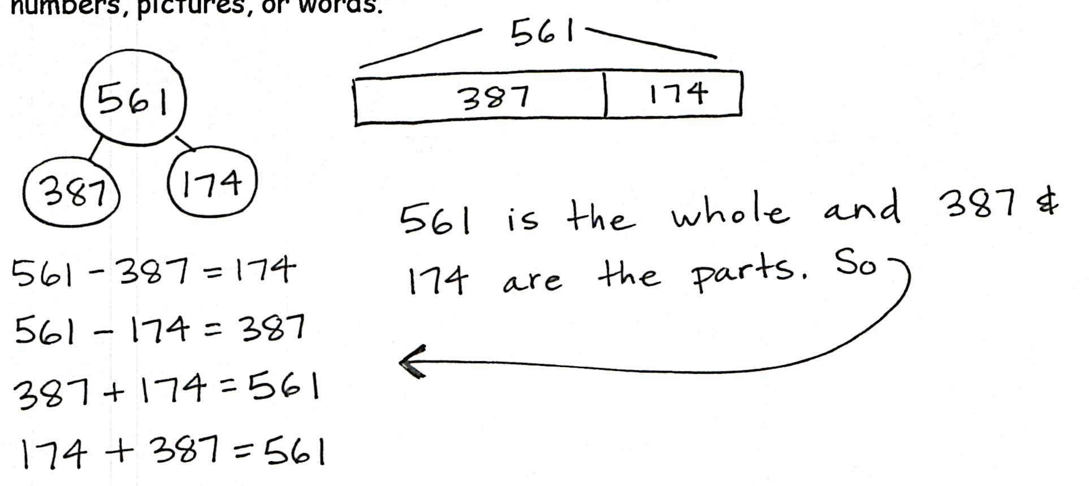
After the Student Debrief, instruct students to complete the Exit Ticket. A review of their work will help with assessing students’ understanding of the concepts that were presented in today’s lesson and planning more effectively for future lessons. The questions may be read aloud to the students.

Name Date

1. | 10 + 2 = | 21. | 2 + 9 =
2. | 10 + 5 = | 22. | 4 + 8 =
3. | 10 + 1 = | 23. | 5 + 9 =
4. | 8 + 10 = | 24. | 6 + 6 =
5. | 7 + 10 = | 25. | 7 + 5 =
6. | 10 + 3 = | 26. | 5 + 8 =
7. | 12 + 2 = | 27. | 8 + 3 =
8. | 14 + 3 = | 28. | 6 + 8 =
9. | 15 + 4 = | 29. | 4 + 6 =
10. | 17 + 2 = | 30. | 7 + 6 =
11. | 13 + 5 = | 31. | 7 + 4 =
12. | 14 + 4 = | 32. | 7 + 9 =
13. | 16 + 3 = | 33. | 7 + 7 =
14. | 11 + 7 = | 34. | 8 + 6 =
15. | 9 + 2 = | 35. | 6 + 9 =
16. | 9 + 9 = | 36. | 8 + 5 =
17. | 6 + 9 = | 37. | 4 + 7 =
18. | 8 + 9 = | 38. | 3 + 9 =
19 | 7 + 8 = | 39. | 8 + 6 =
20. | 8 + 8 = | 40. | 9 + 4 =

Name Date
1. | 10 + 7 = | 21. | 5 + 8 =
2. | 9 + 10 = | 22. | 6 + 7 =
3. | 2 + 10 = | 23. | ____ + 4 = 12
4. | 10 + 5 = | 24. | ____ + 7 = 13
5. | 11 + 3 = | 25. | 6 + ____ = 14
6. | 12 + 4 = | 26. | 7 + ____ = 14
7. | 16 + 3 = | 27. | ____ = 9 + 8
8. | 15 + ____ = 19 | 28. | ____ = 7 + 5
9. | 18 + ____ = 20 | 29. | ____ = 4 + 8
10. | 13 + 5 = | 30. | 3 + 9 =
11. | ____ = 4 + 13 | 31. | 6 + 7 =
12. | ____ = 6 + 12 | 32. | 8 + ____ =13
13. | ____ = 14 + 6 | 33. | ____ = 7 + 9
14. | 9 + 3 = | 34. | 6 + 6 =
15. | 7 + 9 = | 35. | ____ = 7 + 5
16. | ____ + 4 = 11 | 36. | ____ = 4 + 8
17. | ____ + 6 = 13 | 37. | 15 = 7 + ____
18. | ____ + 5 = 12 | 38. | 18 = ____ + 9
19 | 8 + 8 = | 39. | 16 = ____ + 7
20. | 6 + 9 = | 40. | 19 = 9 + ____

Name Date
1. | 15 - 5 = | 21. | 15 - 7 =
2. | 16 - 6 = | 22. | 18 - 9 =
3. | 17 - 10 = | 23. | 16 – 8 =
4. | 12 - 10 = | 24. | 15 – 6 =
5. | 13 - 3 = | 25. | 17 – 8 =
6. | 11 - 10 = | 26. | 14 – 6 =
7. | 19 - 9 = | 27. | 16 – 9 =
8. | 20 – 10 = | 28. | 13 – 8 =
9. | 14 – 4 = | 29. | 12 – 5 =
10. | 18 - 11 = | 30. | 11 - 2 =
11. | 11 – 2 = | 31. | 11 - 3 =
12. | 12 – 3 = | 32. | 13 – 8 =
13. | 14 – 2 = | 33. | 16 – 7 =
14. | 13 – 4 = | 34. | 12 – 7 =
15. | 11 – 3 = | 35. | 16 – 3 =
16. | 12 – 4 = | 36. | 19 – 14 =
17. | 13 - 2 = | 37. | 17 – 4 =
18. | 14 – 5 = | 38. | 18 – 16 =
19 | 11 - 4 = | 39. | 15 – 11 =
20. | 12 - 5 = | 40. | 20 - 16 =

Name Date
1. | 12 - 2 = | 21. | 13 - 6 =
2. | 15 - 10 = | 22. | 15 - 9 =
3. | 17 - 11 = | 23. | 18 - 7 =
4. | 12 - 10 = | 24. | 14 - 8 =
5. | 18 - 12 = | 25. | 17 - 9 =
6. | 16 - 13 = | 26. | 12 – 9 =
7. | 19 - 9 = | 27. | 13 - 8 =
8. | 20 – 10 = | 28. | 15 – 7 =
9. | 14 - 12 = | 29. | 16 - 8 =
10. | 13 - 3 = | 30. | 14 - 7 =
11. | ____ = 11 - 2 | 31. | 13 - 9 =
12. | ____ = 13 - 2 | 32. | 17 - 8 =
13. | ____ = 12 - 3 | 33. | 16 – 7 =
14. | ____ = 11 - 4 | 34. | ____ = 13 - 5
15. | ____ = 13 - 4 | 35. | ____ = 15 - 8
16. | ____ = 14 - 4 | 36. | ____ = 18 - 9
17. | ____ = 11 - 3 | 37. | ____ = 20 - 6
18. | 15 – 6 = | 38. | ____ = 20 - 18
19 | 16 - 8 = | 39. | ____ = 20 - 3
20. | 12 - 5 = | 40. | ____ = 20 - 11

Name Date
1. | 12 + 2 = | 21. | 13 - 7 =
2. | 14 + 5 = | 22. | 11 - 8 =
3. | 18 + 2 = | 23. | 16 – 8 =
4. | 11 + 7 = | 24. | 12 + 6 =
5. | 9 + 6 = | 25. | 13 + 2 =
6. | 7 + 8 = | 26. | 9 + 11 =
7. | 4 + 7 = | 27. | 6 + 8 =
8. | 13 - 6 = | 28. | 7 + 9 =
9. | 12 - 8 = | 29. | 5 + 7 =
10. | 17 - 9 = | 30. | 13 - 7 =
11. | 14 - 6 = | 31. | 15 - 8 =
12. | 16 - 7 = | 32. | 11 – 9 =
13. | 8 + 8 = | 33. | 12 – 3 =
14. | 7 + 6 = | 34. | 14 – 5 =
15. | 4 + 9 = | 35. | 20 - 12 =
16. | 5 + 7 = | 36. | 8 + 5 =
17. | 6 + 5 = | 37. | 7 + 4 =
18. | 13 - 8 = | 38. | 7 + 8 =
19 | 16 - 9 = | 39. | 4 + 9 =
20. | 14 - 8 = | 40. | 9 + 11 =

Name Date
- Solve by drawing place value disks on a chart. Then, use addition to check your work.

- 469 − 170 | Solve vertically  or mentally: | Check:
b. 531 − 224 | Solve vertically  or mentally: | Check:
c. 618 − 229 | Solve vertically  or mentally: | Check:
d. 838 − 384 | Solve vertically  or mentally: | Check:
e. 927 − 628 | Solve vertically  or mentally: | Check:

- If 561 − 387 = 174, then 174 + 387 = 561. Explain why this statement is true using numbers, pictures, or words.

Name Date
Solve by drawing place value disks on a chart. Then, use addition to check your work.

- 375 − 280 | Solve vertically  or mentally: | Check:
- 741 − 448 | Solve vertically  or mentally: | Check:

Name Date
- Solve by drawing place value disks on a chart. Then, use addition to check your work.

- 373 − 180 | Solve vertically  or mentally: | Check:
- 463 − 357 | Solve vertically  or mentally: | Check:
- 723 − 584 | Solve vertically  or mentally: | Check:
- 861 − 673 | Solve vertically or mentally: | Check:
- 898 − 889 | Solve vertically or mentally: | Check:

- If 544 + 366 = 910, then 910 − 544 = 366. Explain why this statement is true using numbers, pictures, or words.

