Lesson 13
Objective: Relate manipulative representations to the subtraction algorithm, and use addition to explain why the subtraction method works.

Suggested Lesson Structure
 Application Problem (8 minutes)
 Fluency Practice (12 minutes)
 Concept Development (30 minutes)
 Student Debrief (10 minutes)
Total Time (60 minutes)
Application Problem (8 minutes)
A fruit seller buys a carton of 90 apples. Finding that 18 of them are rotten, he throws them away.
He sells 22 of the ones that are left on Monday. Now, how many apples does he have left to sell?
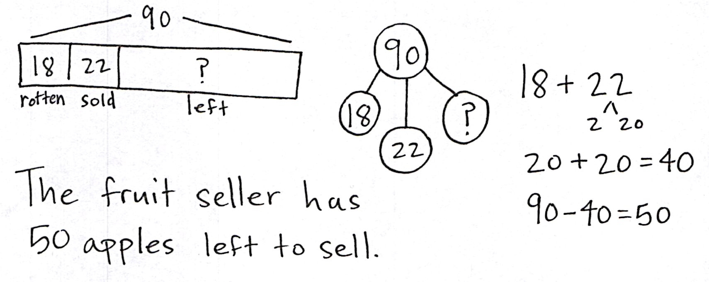

Note: This problem is designed for independent practice. Possibly encourage students to use the RDW process without dictating what to draw. Two-step problems challenge students to think through the first step before moving on to the second. The number sentences can help them to see and articulate the steps as well.
Fluency Practice (12 minutes)
- Making the Next Ten 2.OA.2, 2.NBT.5 (5 minutes)
- Making the Next Hundred 2.NBT.5, 2.NBT.7 (5 minutes)
- Subtracting Multiples of Hundreds and Tens 2.NBT.5, 2.NBT.7 (2 minutes)
Making the Next Ten (5 minutes)
Materials: (S) Personal white board
Note: This fluency activity reviews foundations that lead into today’s lesson.
T: When I say 9 + 4, you write 10 + 3. Ready? 9 + 4.
S: 10 + 3.
T: Give the number sentence with the answer.
S: 10 + 3 = 13.
T: Write the related addition sentence starting with 9 + 4.
S: 9 + 4 = 13.
Continue with the following possible sequence: 19 + 4, 9 + 6, 19 + 6, 8 + 3, 18 + 3, 8 + 5, 18 + 5, 7 + 6, 17 + 6, 7 + 4, 17 + 4, 9 + 5, 19 + 5, 8 + 6, 18 + 6, 8 + 7, and 17 + 8.
Making the Next Hundred (5 minutes)
Note: This fluency exercise reviews foundations that lead into today’s lesson.
T: (Write 170 on the board.) Let’s find the missing part to make the next hundred. What is the next hundred?
S: 200.
T: If I say 170, you say the number needed to make 200. Ready? 170.
S: 30.
T: Give the addition sentence.
S: 170 + 30 = 200.
Continue with the following possible sequence: 190, 160, 260, 270, 370, 380, 580, 620, 720, 740, 940, 194, 196, 216, 214, and 224.
Subtracting Multiples of Hundreds and Tens (2 minutes)
Note: Students review subtracting multiples of tens and hundreds fluently in preparation for today’s lesson.
T: What is 2 tens less than 130?
S: 110.
T: Give the subtraction sentence.
S: 130 – 20 = 110.
T: What is 2 hundreds less than 350?
S: 150.
T: Give the subtraction sentence.
S: 350 – 200 = 150.
Continue with the following possible sequence: 6 tens less than 150, 3 hundreds less than 550, 7 tens less than 250, 6 tens less than 340, and 4 hundreds less than 880.
Concept Development (30 minutes)
Materials: (T) Place value disks (19 ones, 19 tens, 10 hundreds), unlabeled hundreds place value chart (Lesson 1 Template 2) (S) Place value disks (19 ones, 19 tens, and 10 hundreds), unlabeled hundreds place value chart (Lesson 1 Template 2), personal white board
Problem 1: 244 – 121
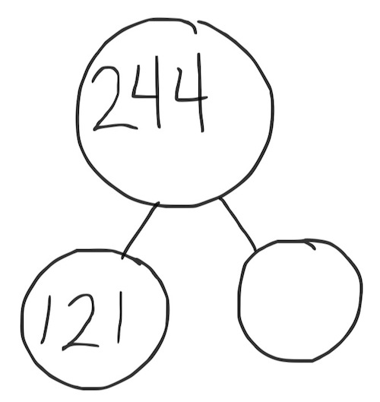
T: (Write 244 – 121 on the board.) Read this problem with me.
T/S: (Read the problem chorally.) 244 minus 121.
T: (Draw a blank number bond on the board.) How would you complete this number bond? Talk to a partner and use part–whole language.
S: I would put 244 in the whole and 121 in one part. I know 244 is the whole, since we are subtracting.
T: Great! What do we need to show on our place value charts? Talk to your neighbor.
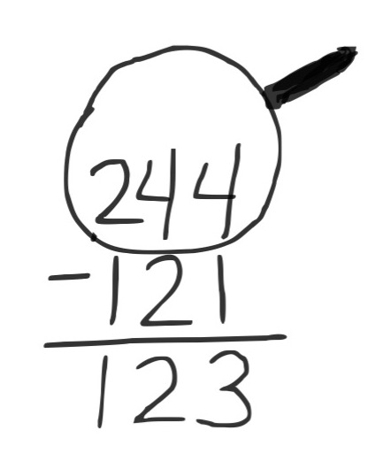
S: We only show the whole when subtracting. We are going to show 244, because it’s the whole. We are going to start with 244, and then take away 121.
T: Count in unit form as I place the disks. 1 hundred, 2 hundreds, 2 hundreds 1 ten, 2 hundreds 2 tens, 2 hundreds 3 tens, …2 hundreds 4 tens 4 ones. (Place 2 hundreds, 4 tens, and 4 ones on the place value chart. Direct students to do the same.)
T: Today, as we solve subtraction problems, we are going to record our work vertically. (Write the problem in the vertical form.)
T: Remember our magnifying glasses! Let’s draw an imaginary magnifying glass around 244, since that is the whole. (Draw the magnifying glass around 244.)
T: Like a detective, look carefully at each place to see if we have enough units to subtract moving from the smallest unit to the largest. (Give students a moment to check.)
T: Are we ready to subtract in the ones, tens, and hundreds?
S: Yes!
T: Go for it!
Have students remove 1 hundred, 2 tens, and 1 one from their place value charts and record the subtraction using the vertical form.
NOTES ON
MULTIPLE MEANS
OF ACTION
AND EXPRESSION:
Students may remark upon the sequence of the digits in 123. Encourage the excitement some may feel about finding the pattern in the numbers.

T: What is 244 – 121?
S: 123.
T: (Write 123 in the missing part in the number bond.)
T: Now, using our number bond, I bet it’s easy for someone to come up with a related addition problem to check our answer. What problem should we write?
S: 123 + 121.
T: Solve this problem on your personal white board, and turn it over when you have the answer.
T: What is the sum?
S: 244.
T: It worked!
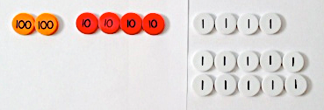
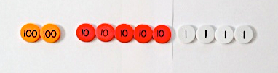
Problem 2: 244 – 125
T: Let’s try another problem together. This time, I want you to record your work as I do mine. (Write 244 – 125 on the board in vertical form. Students do the same.)
T: What should we do first?
S: Find out if we need to unbundle. Look at the numbers to see if we can solve mentally.
T: True! For this problem, let’s solve using the algorithm. Show me the whole using your place value disks.
S: (Represent 244 using place value disks on their place value charts.)
T: (Draw the magnifying glass with enough space to write renaming, and instruct students to do the same.)
T: Okay, I’m looking closely. Where do we start?
S: Start in the ones column. Check to see if you can subtract the ones.
T: Can we subtract 5 ones from 4 ones?
S: No!
T: What should we do?
MP.6
S: Decompose a ten. Rename a ten as ten ones.
Add 10 ones to 4 ones, so we have 14 ones.
T: Okay, go ahead and show that change using your place value disks. (Change a ten for 10 ones. Arrange them in 5-groups on the place value chart.)
NOTES ON
MULTIPLE MEANS
OF REPRESENTATION:
Some students may benefit from recording a new group of 10 differently. For example, while most will likely cross out the 4 in the ones place and write a 14 above it, others may internalize the change by crossing out the 4 and writing 10 + 4 above it, then subtracting 10 – 5 and adding 4 to make 9 ones.

T: Whatever we do to the place value disks, we must also do in the vertical form. How should we record unbundling a ten?
S: Cross out 4 tens, and write 3 tens above it. Cross out the 4 in the ones place, and write 14 above it.
Change 4 tens to 3 tens and 4 ones to 14 ones.
T: Now, how many tens and ones do we have on our charts?
S: 3 tens 14 ones.
T: Look at each column closely. Tell me, are we ready to subtract?
S: Yes!
T: Then, let’s subtract!
T: What is the answer to 244 – 125?
MP.6
S: 119.
T: Check your answer with addition. Write a complete number bond. Does it work? (Pause to give students time to work.)
S: Yes!
Problem 3: 312 – 186
T: Let’s model another problem together. (Write 312 – 186 on the board in the vertical form. Allow students time to model and record the problem.) I’m going to follow what you do.
T: What is different about this problem?
S: We are taking away hundreds, too. We are subtracting three digits. You need to unbundle tens and hundreds in this problem.
T: Let’s see if we need to unbundle. Do we have enough ones?
S: No!
T: Do we have enough tens?
S: No!
T: Let’s unbundle to get ready to subtract. What should we do?
S: Change a ten for 10 ones. Rename a ten as 10 ones. Decompose a ten to make more ones.
T: (Change a ten for 10 ones.) Are we ready to subtract in the ones place?
T: How many ones do we have now?
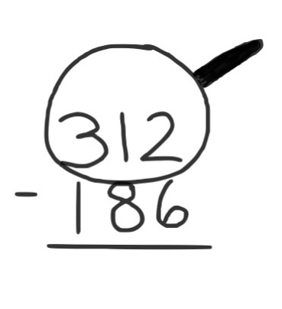
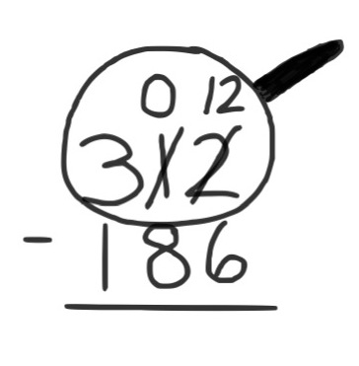
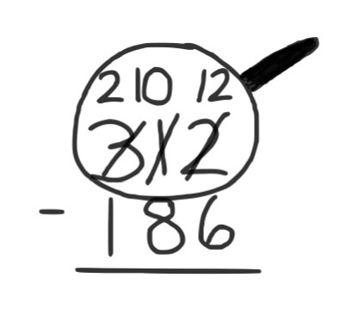
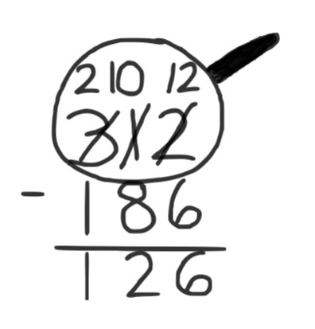
S: 12.
T: How many tens are in the tens place?
S: None! Zero!
T: Let’s record this in the vertical form (shown at the right).
T: Are we ready to subtract in the tens place?
S: No!
T: What should we do now?
S: Unbundle a hundred! Rename a hundred as 10 tens. Break open a hundred to make 10 tens.
T: (Change a hundred for 10 tens.) How many tens do we have now?
S: 10.
T: How many hundreds?
S: 2.
T: Let’s write this in the vertical form (shown above).
T: Are we ready to subtract 186 from 312?
S: Yes!
Allow time for students to complete the subtraction independently, write a complete number bond, and check their work with addition.
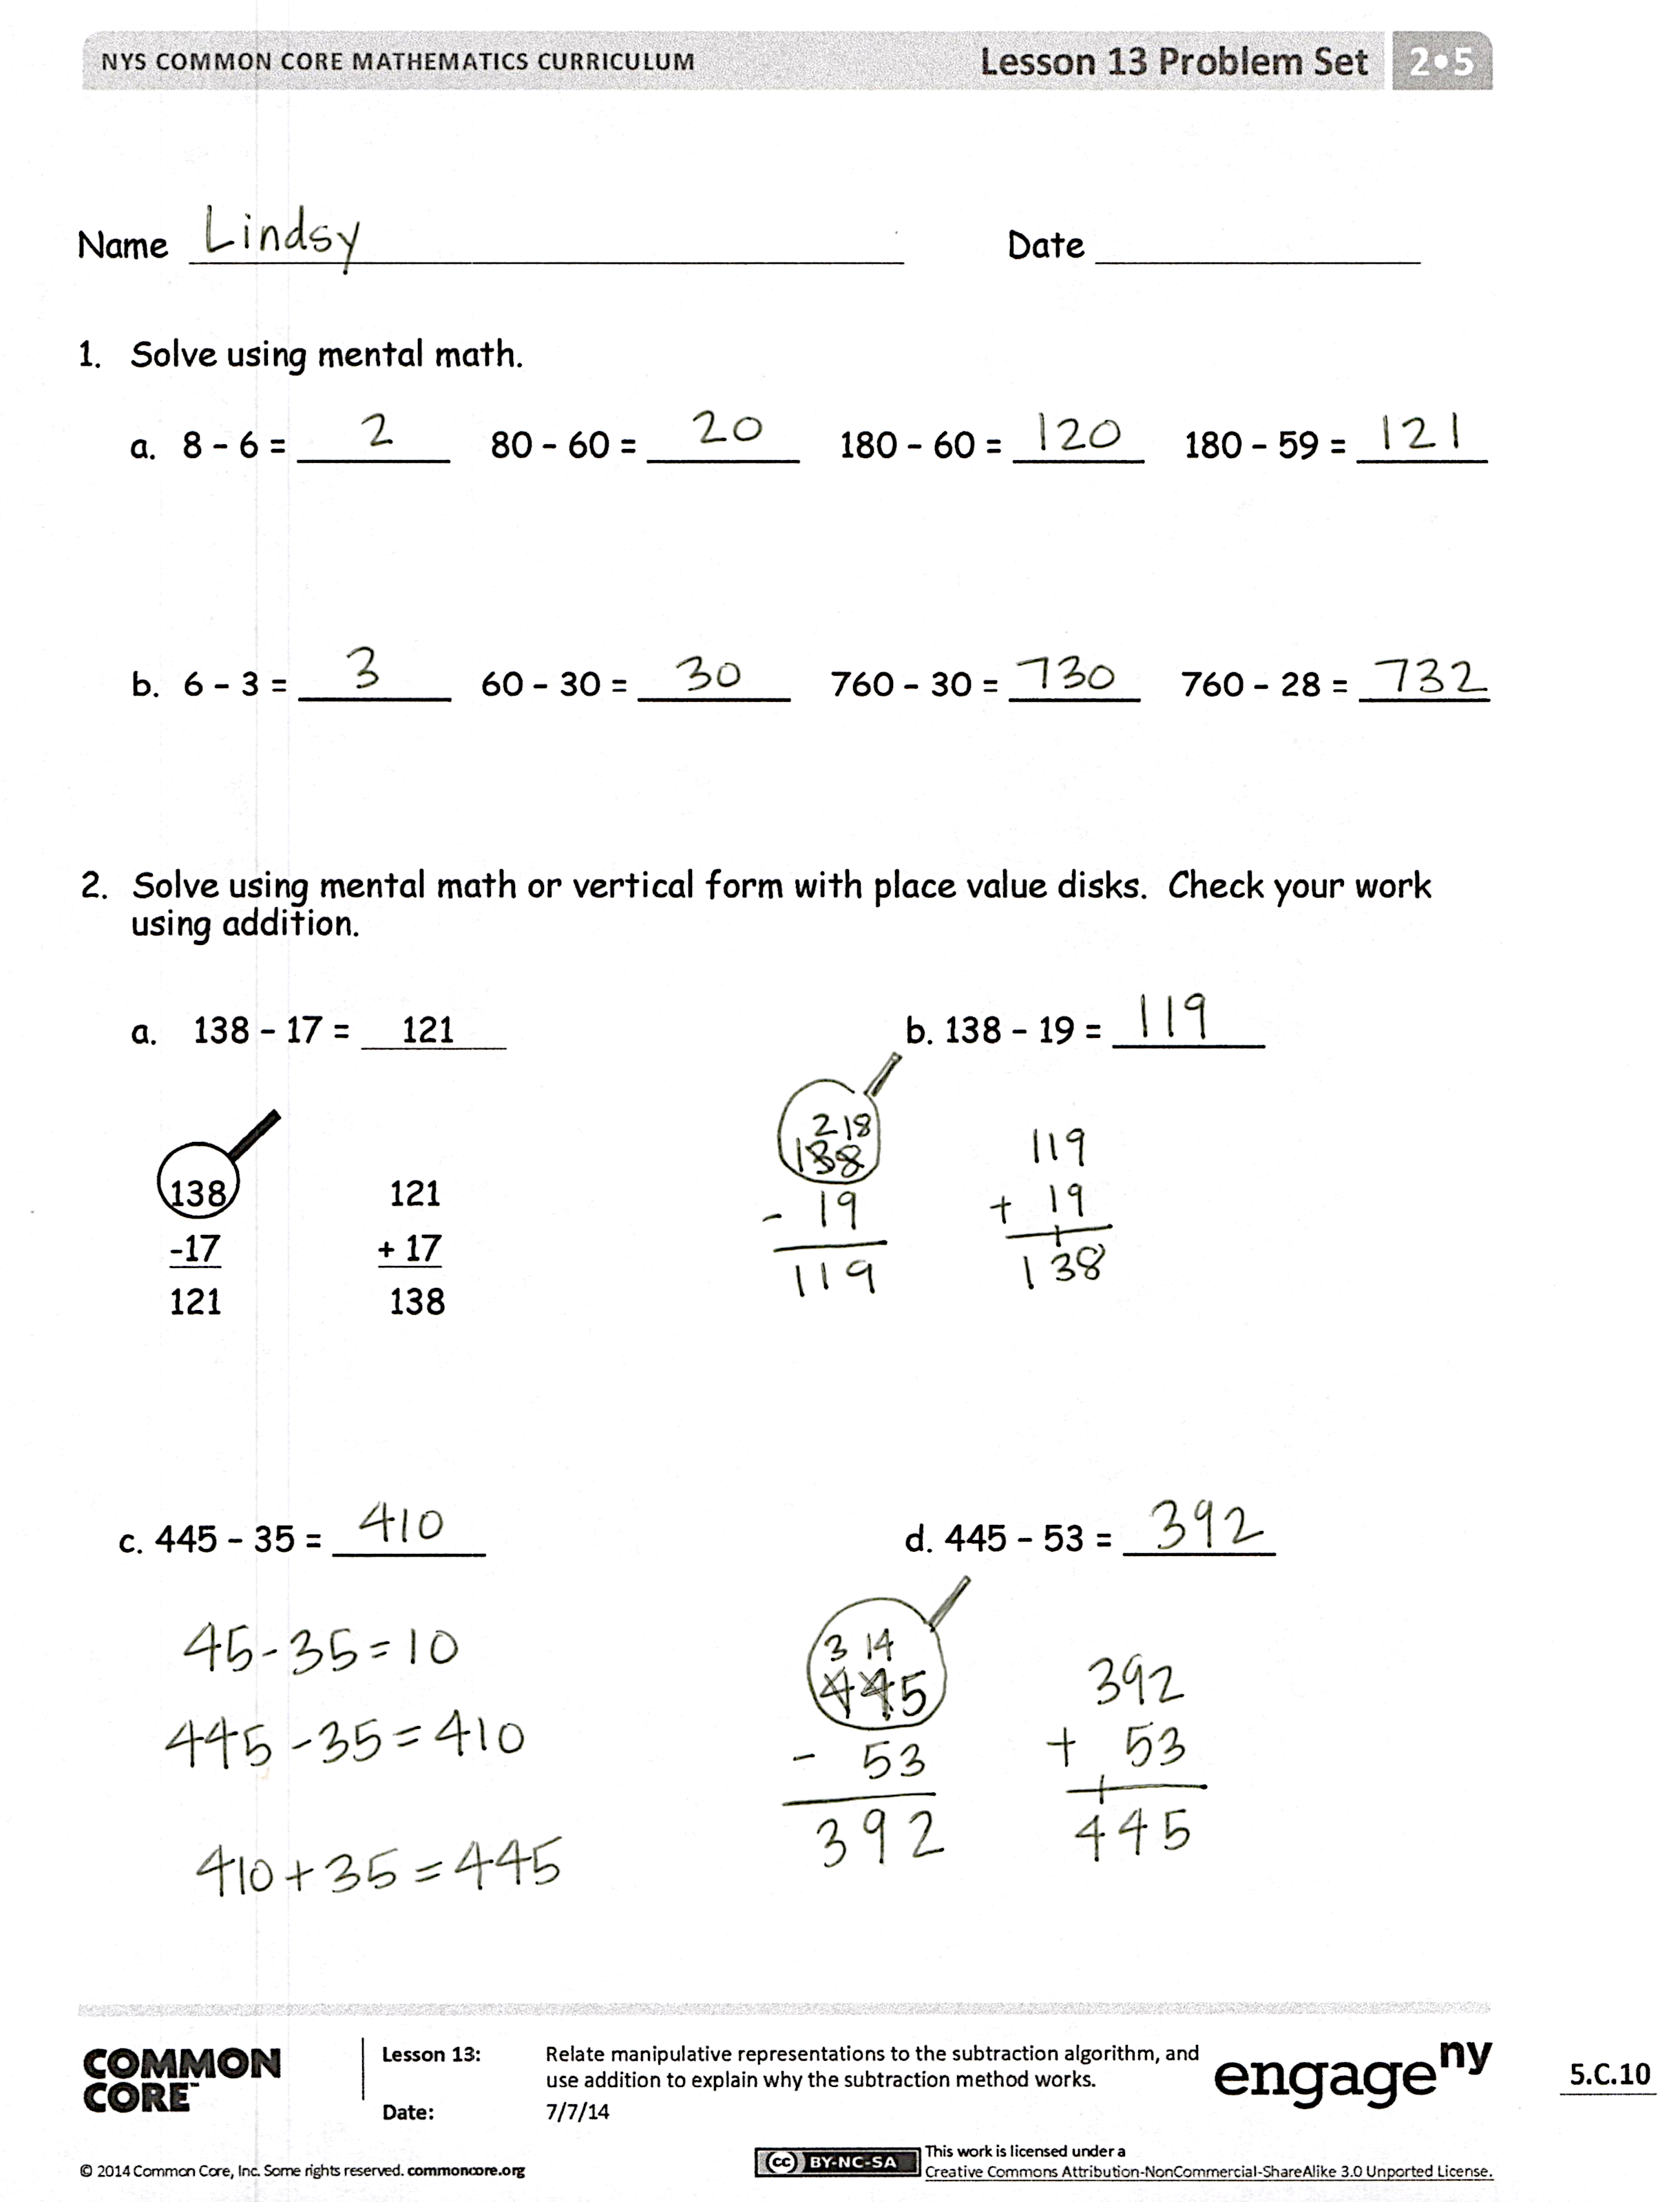
Problem Set (10 minutes)
Students should do their personal best to complete the Problem Set within the allotted 10 minutes. For some classes, it may be appropriate to modify the assignment by specifying which problems they work on first. Some problems do not specify a method for solving. Students should solve these problems using the RDW approach used for Application Problems.
Student Debrief (10 minutes)
Lesson Objective: Relate manipulative representations to the subtraction algorithm, and use addition to explain why the subtraction method works.
The Student Debrief is intended to invite reflection and active processing of the total lesson experience.
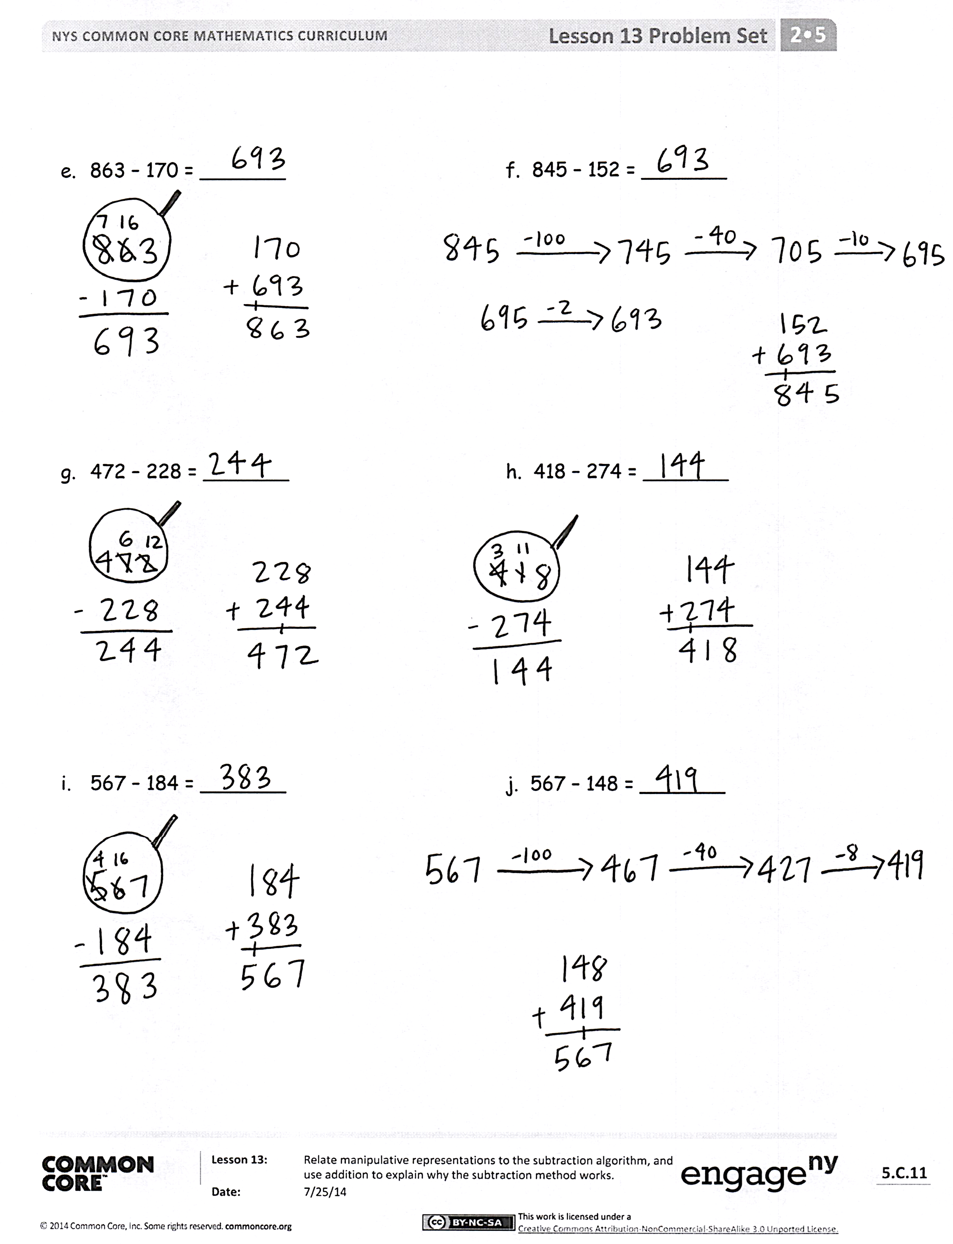
Invite students to review their solutions for the Problem Set. They should check work by comparing answers with a partner before going over answers as a class. Look for misconceptions or misunderstandings that can be addressed in the Debrief. Guide students in a conversation to debrief the Problem Set and process the lesson.
Any combination of the questions below may be used to lead the discussion.
- What pattern did you notice in Problems 1(a) and (b)?
- For Problems 2(a) to (d), which problems were you able to solve mentally? Why?
- For Problems 2(e) and (f), how is it possible that both problems have the same difference?
- Explain to your partner how you used place value disks to solve Problems 2(g) and (h). How did your work with the place value disks match the vertical form?
- In Problems 2(i) and (j), did you change 1 hundred for 10 tens or 1 ten for 10 ones? How did you show the change using the algorithm?
- How did you use addition to prove that you subtracted correctly? Use part–whole language to explain your thinking.
Exit Ticket (3 minutes)
After the Student Debrief, instruct students to complete the Exit Ticket. A review of their work will help with assessing students’ understanding of the concepts that were presented in today’s lesson and planning more effectively for future lessons. The questions may be read aloud to the students.

Name Date
- Solve using mental math.
  - 8 − 6 = _____ 80 − 60 = _____ 180 − 60 = ____ 180 − 59 = ____
  - 6 − 3 = _____ 60 − 30 = _____ 760 − 30 = ____ 760 − 28 = ____

- Solve using mental math or vertical form with place value disks. Check your work using addition.

  - 138 − 17 = 121 b. 138 − 19 = _______

138 121
−17 + 17
121 138

c. 445 − 35 = _______ d. 445 − 53 = _______
- 863 − 170 = _______ f. 845 − 152 = _______

- 472 − 228 = _______ h. 418 − 274 = _______

- 567 − 184 = _______ j. 567 − 148 = _______

Name Date
Solve using mental math or vertical form with place value disks. Check your work using addition.

- 378 − 117 = _______ 2. 378 − 119 = _______

3. 853 − 433 = _______ 4. 853 − 548 = _______

Name Date
- Solve using mental math.
  - 9 − 5 = _____ 90 − 50 = _____ 190 − 50 = ____ 190 − 49 = ____
  - 7 − 4 = _____ 70 − 40 = _____ 370 − 40 = ____ 370 − 39 = ____

- Solve using mental math or vertical form with place value disks. Check your work using addition.

  - 153 − 31 = 122 b. 153 − 38 = _______

153 122
−31 + 31
122 153

c. 362 − 49 = _______ d. 485 − 177 = _______
- 753 − 290 = _______ f. 567 − 290 = _______
- 873 − 428 = _______ h. 817 − 565 = _______
- 973 − 681 = _______ j. 748 − 239 = _______

- Complete the number sentence modeled by place value disks.
