Lesson 12
Objective: Choose and explain solution strategies and record with a written addition method.

Suggested Lesson Structure
 Fluency Practice (12 minutes)
 Concept Development (38 minutes)
 Student Debrief (10 minutes)
Total Time (60 minutes)
Fluency Practice (12 minutes)
- Compensation 2.NBT.7 (4 minutes)
- Sprint: Compensation Addition 2.NBT.7 (8 minutes)
Compensation (4 minutes)
Note: This fluency activity reviews compensation, the mental math strategy. By making a multiple of 10, students solve a much simpler addition problem. Draw a number bond for the first problem on the board to help students visualize the decomposition.
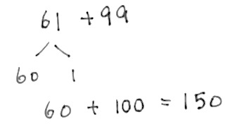
T: (Write 61 + 99 = _____.) Let’s use a mental math strategy to add.
How much more does 99 need to make 100?
S: 1 more.
T: Where can 99 get 1 more?
S: From the 61.
T: Take 1 from 61, and give it to 99. Say the simplified number sentence with the answer.
S: 60 + 100 = 160.
T: 99 + 46. Say the simplified number sentence with the answer.
S: 100 + 45 = 145.
Continue with the following possible sequence: 99 + 38, 98 + 56, 47 + 98, 26 + 98, 54 + 99, 54 + 199, and
73 + 199.
Sprint: Compensation Addition (8 minutes)
Materials: (S) Compensation Addition Sprint
Note: Students review compensation when adding to gain automaticity.
Concept Development (38 minutes)
Materials: (S) Place value disks (9 hundreds, 18 tens, 18 ones), personal white board
Note: The following lesson is designed to help facilitate a discussion about choosing the most efficient problem-solving strategies. Based on student needs and class ability, strategies other than those listed below may be used to solve. To allow for this in-depth discussion, the Application Problem has been omitted from today’s lesson.
Problem 1: 374 + 210
T: Turn and talk: What are some strategies you could use to solve this problem?
S: I can use mental math and place value strategies. I can use the algorithm without place value disks. I can use arrow notation.
Instruct students to choose a written strategy that they prefer and find most efficient. Encourage students to solve independently, and circulate to provide support. Then, invite a few students to share their work and explain how they applied the specific solution strategy. Remind students who used the algorithm to keep explanations brief.
S1: I used mental math and what I know about place value. I started at 374, and then in my head, I counted on 2 more hundreds to make 574. Then, I added a ten, and I had 584.
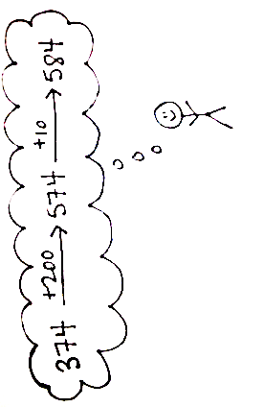
S2: I wrote the problem vertically and added ones, then tens, then hundreds under the line. It was easy to use the algorithm; I didn’t even need to make a new ten or hundred.
S3: I used arrow notation to show the change as I added. I started with 374 and added 200, so I drew an arrow to 574. Then, I added on 10 more and drew an arrow to 584.
T: Turn and talk: Now that you’ve heard different solution strategies, which method do you prefer for this problem and why?
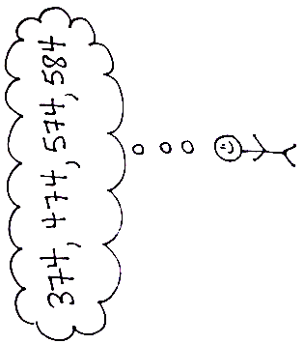
S: I like the arrow way best because 210 only has hundreds and tens, so it is easy to break apart and add on. The chip model and place value disks take longer than using the arrow way. Plus, we don’t have to bundle in this problem. Now that we understand place value, it’s easy to solve mentally.
T: I’m noticing that nobody suggested a number bond for this problem. Why not?
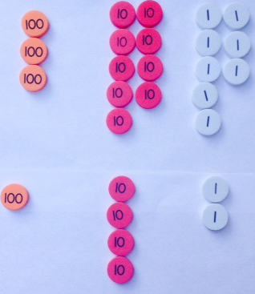
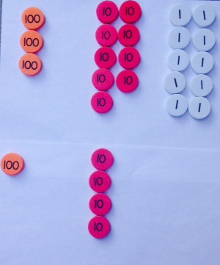
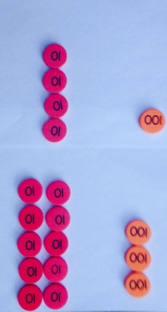
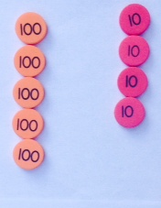
S: None of the numbers are close to making the next hundred. It’s too hard to think of adding on to 374 to make 400. I would have used a number bond if 374 had been 394.
T: I like the way you’re thinking! Let’s take a look at another problem.
Problem 2: 398 + 142
T: Turn and talk: What are some strategies you could use to solve this problem?
MP.3
S: Place value disks and the vertical form. A number bond. Arrow notation.
Again, instruct students to choose a written strategy that they prefer and find most efficient. Encourage them to solve independently, and circulate to provide support. Then, invite a few different students to share their work and explain how they applied the specific solution strategy. Again, remind students who used the written addition to keep explanations brief.
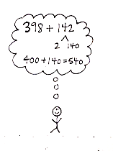
S1: I counted the place value disks to show both parts. I started by adding my ones. When I made a ten, I exchanged 10 ones for 1 ten. Then, I added my tens. When I made a hundred, I exchanged 10 tens for a hundred. Then, I added my hundreds. The answer is 540.
S2: I know that 398 is very close to 400, so I used a number bond. I decomposed 142 into 140 and 2. Then, I bonded the 2 with 398 to make 400, and 400 plus 140 equals 540.
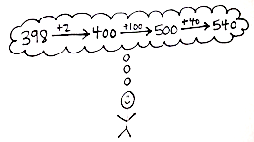
S3: I like arrow notation because you can start with 398 and first add 2, so 400, then add 100, then 40 more, and you have 540.
T: Turn and talk: Which method do you think is best for this problem and why?
S: Making a hundred is the easiest and quickest, especially since you only needed to add on 2. Using the chip model is good, but it was faster to break apart the 142. I prefer the arrow way because once you add 2 to make 400, it’s easy to add a hundred and 4 tens.
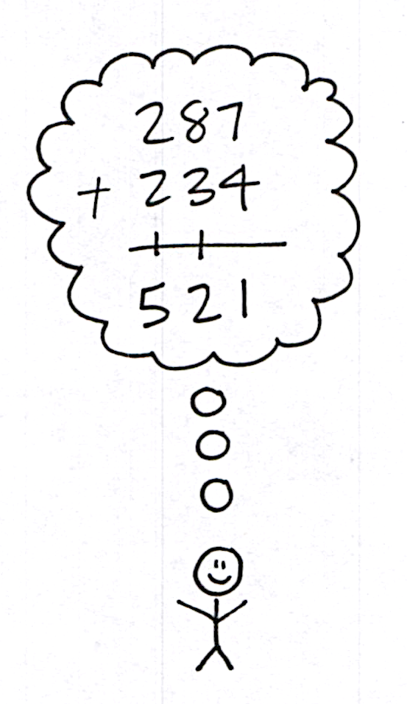
Problem 3: 287 + 234
Note: For this problem, some students may choose to represent the problem using place value disks or drawings, while others may choose to solve using vertical form. Although the most efficient strategy will most likely be using vertical form, the Grade 2 expectation is not that students use the algorithm alone, but that they use it in conjunction with a representation.
T: Turn and talk: What are some strategies you could use to solve this problem?
S: A place value disk drawing. I would write just using the vertical form.
Students follow the same procedure as suggested in Problems 1 and 2. Since this problem does not lend itself to other simplifying strategies, invite one, maybe two, students to share.
S: My model shows that 11 ones becomes 1 ten 1 one. I showed that by writing 1 on the line below the tens place. 11 tens plus 1 ten is 12 tens, so I showed a new hundred, and then I wrote a 1 on the line below the hundreds place and a 2 below the line in the tens place. Then, I just added my hundred. So, the answer is 621.

NOTES ON
MULTIPLE MEANS
OF ENGAGEMENT:
Writing about math can be daunting for some students.
- Provide oral options for informal assessment on the Problem Set rather than writing.
- Before they begin writing, ask students questions to probe.
- Support written responses on the Problem Set by providing a starter such as, “The number bond was the best strategy because…”

T: How was this the most efficient way to solve this problem? Why didn’t you choose a simplifying strategy?
S: Because solving using the arrow way would be too complicated. The make a hundred strategy doesn’t make it easier because the numbers are too far from the closest hundred. Since you have to bundle twice, I like using the chips and the algorithm.
T: Now, you’re going to have the chance to analyze some student work and solve some problems by choosing a written strategy that works best for you.
Problem Set (10 minutes)
Students should do their personal best to complete the Problem Set within the allotted 10 minutes. For some classes, it may be appropriate to modify the assignment by specifying which problems they work on first. Some problems do not specify a method for solving. Students should solve these problems using the RDW approach used for Application Problems.
Student Debrief (10 minutes)

NOTES ON
MULTIPLE MEANS
OF REPRESENTATION:
During the Debrief, invite students to share exemplary explanations with the whole class. Encourage students to model alternative, even creative, solutions. For example, for Problem 1 on the Problem Set (299 + 399), a student might suggest adding hundreds and then subtracting 2: “If you add 1 to 299 and 399, you get 300 + 400 equals 700. Then, you have to subtract 2 from 700, so 698.”

Lesson Objective: Choose and explain solution strategies and record with a written addition method.
The Student Debrief is intended to invite reflection and active processing of the total lesson experience.
Invite students to review their solutions for the Problem Set. They should check work by comparing answers with a partner before going over answers as a class. Look for misconceptions or misunderstandings that can be addressed in the Debrief. Guide students in a conversation to debrief the Problem Set and process the lesson.
Any combination of the questions below may be used to lead the discussion.
- Share with your partner: For Problem 1, which strategy was most efficient for Tracy to use? Why? Do you agree or disagree with your partner?
- Can you explain any alternate problem-solving strategies for Problem 1?
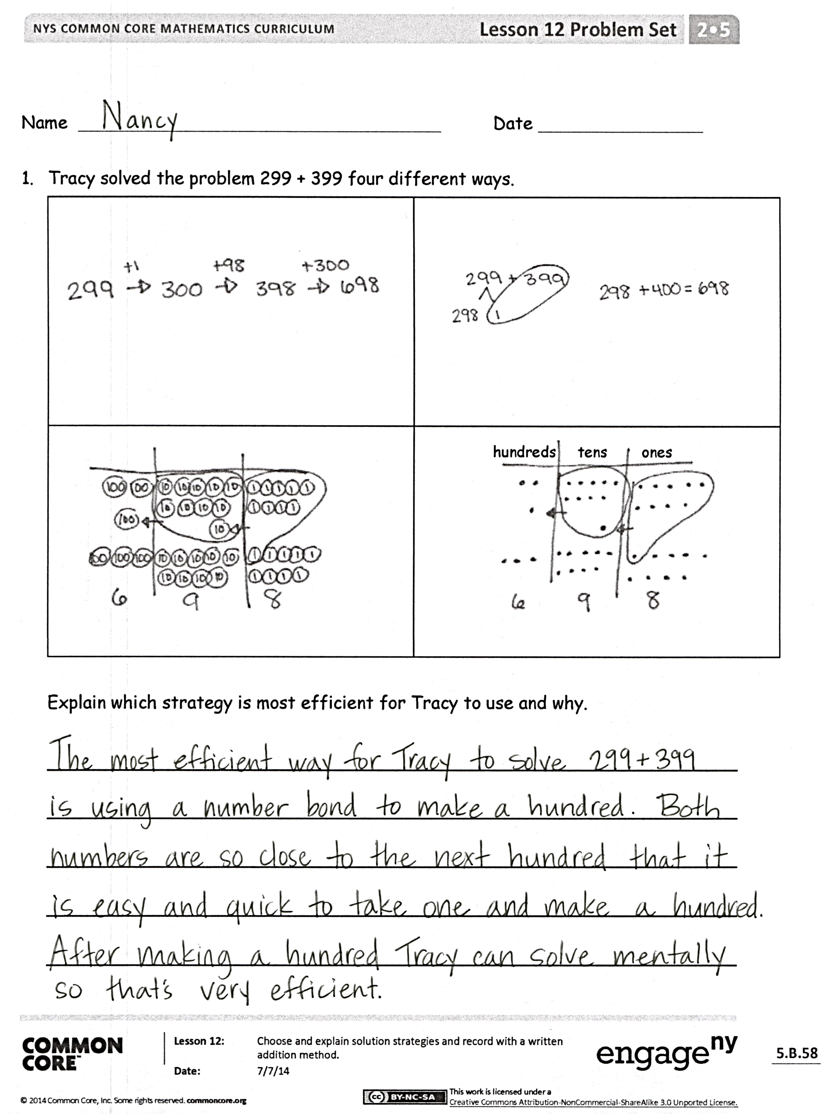
- To solve Problem 2(a), which strategy did you choose? Why?
- To solve Problem 2(b), which strategy did you choose? How did your understanding of place value help you solve this problem quickly?
- How did you solve Problem 2(c)? What made 2(c) more difficult to solve with a simplifying strategy? Could you have done so?
Exit Ticket (3 minutes)
After the Student Debrief, instruct students to complete the Exit Ticket. A review of their work will help with assessing students’ understanding of the concepts that were presented in today’s lesson and planning more effectively for future lessons. The questions may be read aloud to the students.

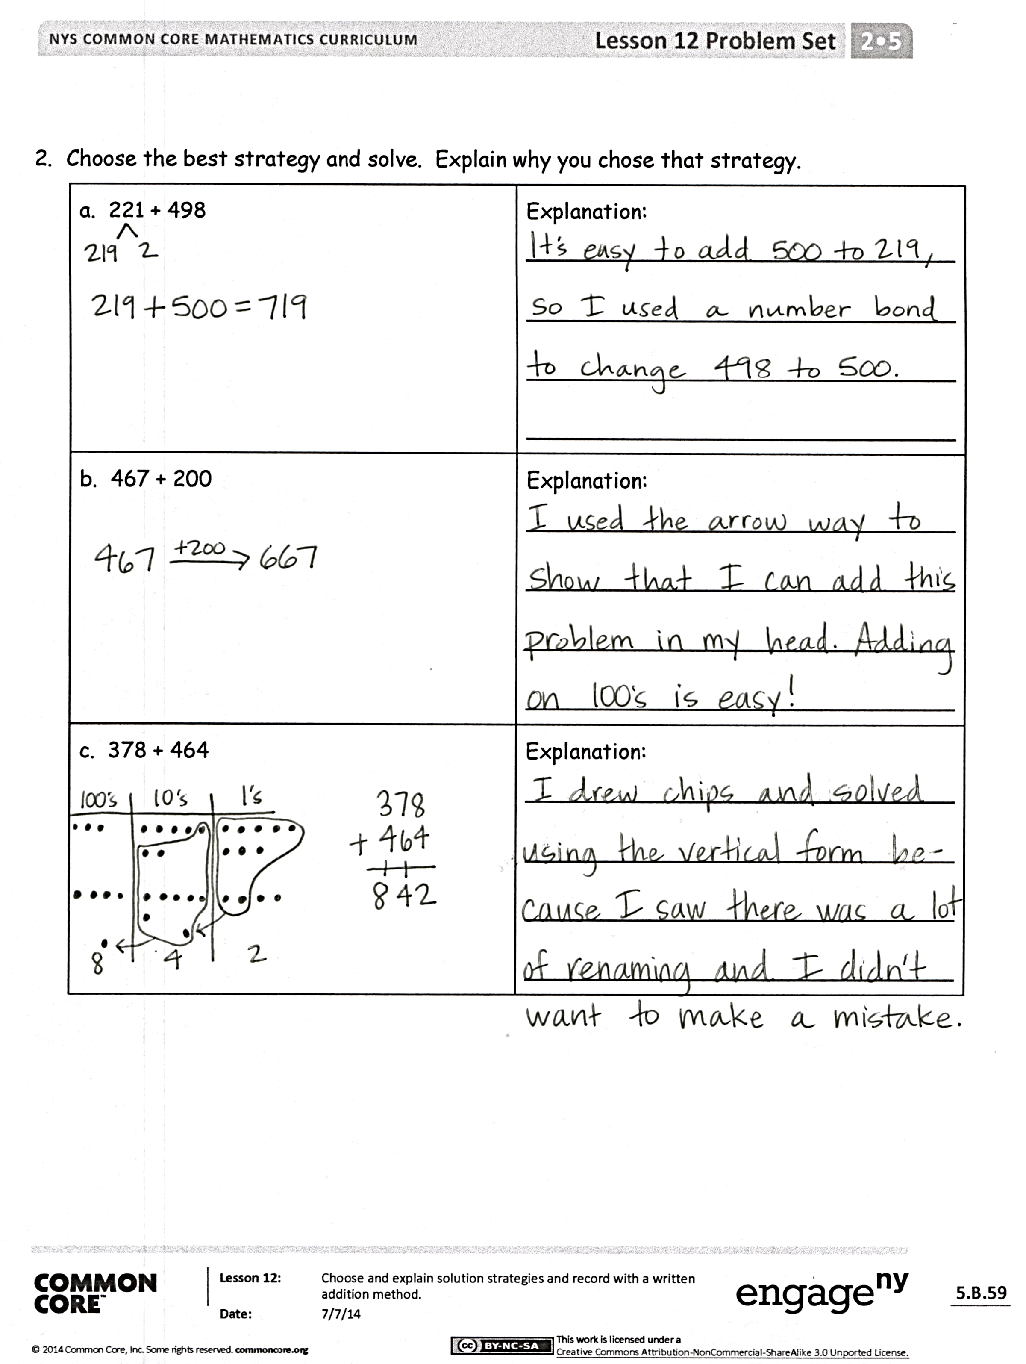

Compensation Addition
A
Number Correct: _______
 | 98 + 3 = |  |  |  | 99 + 12 =
 | 98 + 4 = |  |  |  | 99 + 23 =
 | 98 + 5 = |  |  |  | 99 + 34 =
 | 98 + 8 = |  |  |  | 99 + 45 =
 | 98 + 6 = |  |  |  | 99 + 56 =
 | 98 + 9 = |  |  |  | 99 + 67 =
 | 98 + 7 = |  |  |  | 99 + 78 =
 | 99 + 2 = |  |  |  | 35 + 99 =
 | 99 + 3 = |  |  |  | 45 + 98 =
 | 99 + 4 = |  |  |  | 46 + 99 =
 | 99 + 9 = |  |  |  | 56 + 98 =
 | 99 + 6 = |  |  |  | 67 + 99 =
 | 99 + 8 = |  |  |  | 77 + 98 =
 | 99 + 5 = |  |  |  | 68 + 99 =
 | 99 + 7 = |  |  |  | 78 + 98 =
 | 98 + 13 = |  |  |  | 99 + 95 =
 | 98 + 24 = |  |  |  | 93 + 99 =
 | 98 + 35 = |  |  |  | 99 + 95 =
 | 98 + 46 = |  |  |  | 94 + 99 =
 | 98 + 57 = |  |  |  | 98 + 96 =
 | 98 + 68 = |  |  |  | 94 + 98 =
 | 98 + 79 = |  |  |  | 98 + 88 =

Compensation Addition
B
[KEY]

Number Correct: _______
Improvement: _______
 | 99 + 2 = |  |  |  | 98 + 13 =
 | 99 + 3 = |  |  |  | 98 + 24 =
 | 99 + 4 = |  |  |  | 98 + 35 =
 | 99 + 8 = |  |  |  | 98 + 46 =
 | 99 + 6 = |  |  |  | 98 + 57 =
 | 99 + 9 = |  |  |  | 98 + 68 =
 | 99 + 5 = |  |  |  | 98 + 79 =
 | 99 + 7 = |  |  |  | 25 + 99 =
 | 98 + 3 = |  |  |  | 35 + 98 =
 | 98 + 4 = |  |  |  | 36 + 99 =
 | 98 + 5 = |  |  |  | 46 + 98 =
 | 98 + 9 = |  |  |  | 57 + 99 =
 | 98 + 7 = |  |  |  | 67 + 98 =
 | 98 + 8 = |  |  |  | 78 + 99 =
 | 98 + 6 = |  |  |  | 88 + 98 =
 | 99 + 12 = |  |  |  | 99 + 93 =
 | 99 + 23 = |  |  |  | 95 + 99 =
 | 99 + 34 = |  |  |  | 99 + 97 =
 | 99 + 45 = |  |  |  | 92 + 99 =
 | 99 + 56 = |  |  |  | 98 + 94 =
 | 99 + 67 = |  |  |  | 96 + 98 =
 | 99 + 78 = |  |  |  | 98 + 86 =

Name Date
- Tracy solved the problem 299 + 399 four different ways.
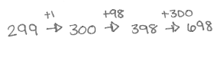 | 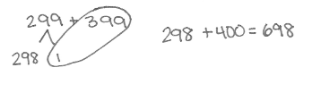
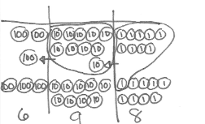 | 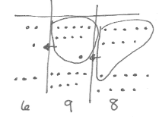  hundreds tens ones

Explain which strategy is most efficient for Tracy to use and why.

_______________________________________________________________
_______________________________________________________________
_______________________________________________________________
_______________________________________________________________
_______________________________________________________________
- Choose the best strategy and solve. Explain why you chose that strategy.
a. 221 + 498 | Explanation:  ________________________________  ________________________________  ________________________________  ________________________________
b. 467 + 200 | Explanation:  ________________________________  ________________________________  ________________________________  ________________________________
c. 378 + 464 | Explanation:  ________________________________  ________________________________  ________________________________  ________________________________

Name Date
Choose the best strategy and solve. Explain why you chose that strategy.
1. 467 + 298 | Explanation:  ________________________________  ________________________________  ________________________________  ________________________________
2. 300 + 524 | Explanation:  ________________________________  ________________________________  ________________________________  ________________________________

Name Date
- Solve 435 + 290 using two different strategies.
a. | b.

Explain which strategy would be easier and why.
_______________________________________________________________
_______________________________________________________________
_______________________________________________________________
_______________________________________________________________

- Choose the best strategy and solve. Explain why you chose that strategy.
a. 299 + 458 | Explanation:  ________________________________  ________________________________  ________________________________  ________________________________
b. 733 + 210 | Explanation:  ________________________________  ________________________________  ________________________________  ________________________________
c. 295 + 466 | Explanation:  ________________________________  ________________________________  ________________________________  ________________________________

