Lesson 11
Objective: Use math drawings to represent additions with up to two compositions and relate drawings to the addition algorithm.

Suggested Lesson Structure
 Application Problem (5 minutes)
 Fluency Practice (10 minutes)
 Concept Development (35 minutes)
 Student Debrief (10 minutes)
Total Time (60 minutes)
Application Problem (5 minutes)

NOTES ON
MULTIPLE MEANS
OF REPRESENTATION:
Since students are not expected to work the algorithm without place value charts and manipulatives in Grade 2, allow students to use place value disks to calculate the solution and explain their thinking. They can even use straws to represent the pencils in the Application Problem.

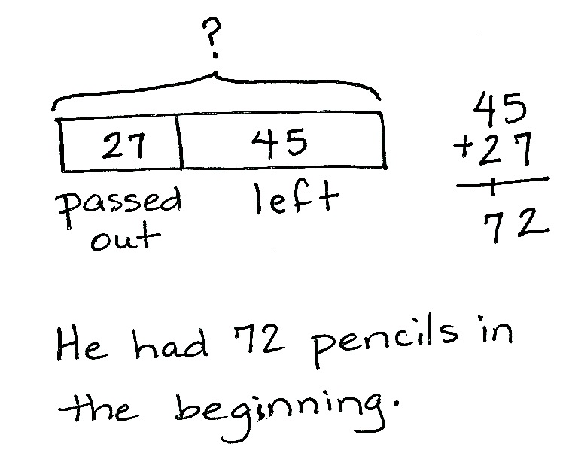
Mr. Arnold has a box of pencils. He passes out 27 pencils and has 45 left. How many pencils did Mr. Arnold have in the beginning?

Note: This is an add to with start unknown problem type that reviews two-digit addition with one composition. Ask students to think about whether they know the parts or the whole and one part. This will guide them toward the recognition that the situation equation ___ – 27 = 45 can be written as a solution equation: 45 + 27 = ___.
Fluency Practice (10 minutes)
- Place Value 2.NBT.1, 2.NBT.3 (3 minutes)
- Say Ten Counting 2.NBT.1 (3 minutes)
- Compensation 2.NBT.5, 2.NBT.7 (4 minutes)
Place Value (3 minutes)
Note: This fluency activity reviews place value concepts from Module 3 to prepare students for today’s lesson.
T: (Write 157 on the board.) Say the number in standard form.
S: 157.
T: Say 157 in unit form.
S: 1 hundred 5 tens 7 ones.
T: Say the unit form with only tens and ones.
S: 15 tens 7 ones.
T: Say the unit form with only hundreds and ones.
S: 1 hundred 57 ones.
T: Say 157 in expanded form.
S: 100 + 50 + 7.
T: How many ones are in 157?
S: 157 ones.
T: How many tens are in 157?
S: 15 tens.
T: What digit is in the ones place?
S: 7.
T: What is the value of the digit in the tens place?
S: 50.
T: What is 1 less than 157?
S: 156.
T: What is 1 more than 157?
S: 158.
Continue with the following possible sequence: 10 less? 10 more? 100 more? and 100 less?
Say Ten Counting (3 minutes)
Note: Students practice making a ten in unit form to prepare for composing a ten on the place value chart in today’s lesson.
T: What is 3 ones + 4 ones?
S: 7 ones.
T: 6 ones + 4 ones?
S: 10 ones.
T: What is another name for 10 ones?
S: 1 ten.
T: When we make a ten, let’s say the number in tens and ones. Ready? 6 ones + 5 ones.
S: 1 ten 1 one.
Continue with the following possible sequence: 7 ones + 4 ones, 6 ones + 7 ones, 8 ones + 4 ones, 9 ones + 3 ones, 4 ones + 4 ones + 4 ones, and 5 ones +3 ones + 4 ones.
Compensation (4 minutes)
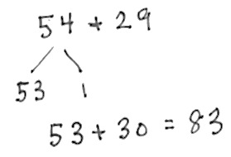
Note: This fluency activity reviews the mental math strategy compensation. By making a multiple of 10, students solve a much simpler addition problem. Draw a number bond for the first problem on the board to help students visualize the decomposition.
T: (Write 54 + 29 = _____.) Let’s use a mental math strategy to add. How much more does 29 need to make the next ten?
S: 1 more.
T: Where can 29 get 1 more?
S: From the 54.
T: Take 1 from 54 and give it to 29. Say the simplified number sentence with the answer.
S: 53 + 30 = 83.
T: 39 + 46. Say the simplified number sentence with the answer.
S: 40 + 45 = 85.
Continue with the following possible sequence: 65 + 39, 79 + 46, 128 + 52, 145 + 38, and 155 + 98.
Concept Development (35 minutes)
Materials: (S) Math journal or paper
Note: Continue checking the accuracy of student drawings. Students must attend to the proper alignment of digits, drawing chips in clear 5-groups, and showing new groups below in the correct place. For this reason, the use of pencil and paper is more suitable than the use of a personal white board and marker.
Problem 1: 342 + 169
T: Write 342 + 169 in vertical form on your paper.
T: Let’s model it by drawing chips on a place value chart. I’ll make a model on the board while you make yours. Whisper-count as you draw your model.
S: (Draw chip model.) 100, 200, 300, 310, 320, 330, 340, 341, 342. (Repeat the process to show 169.)
T: Use place value language to tell your partner how your model matches the vertical form.
S: 3 chips in the hundreds place is 300, 4 chips in the tens place equals 40, and 2 chips in the ones place is 2. The model shows the Say Ten Way: 3 hundreds 4 tens 2. It’s the same for 169, too. The model shows 1 hundred 6 tens 9.
T: I like the connection you made to Say Ten counting. Let’s use that as we add the ones.
2 ones + 9 ones?
S: 11 ones.
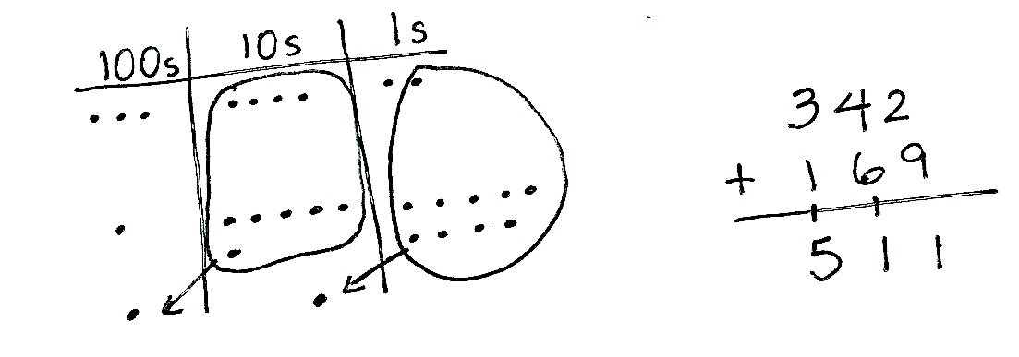
T: What is 11 ones the Say Ten Way?
S: 1 ten 1.
T: Tell your partner what to do first using the model, and then using the algorithm.
S: We made a ten, so we circle it! Bundle 10 ones, and draw an arrow with a new ten in the tens place. Show the new unit on the line below the tens place, and write 1 below the line in the ones place.
T: Yes! You composed a new unit of 10. You renamed 11 ones as 1 ten 1 one. Let’s show that on our models and in vertical form.
S: (Circle 10 ones, draw an arrow to the tens place, and add a chip to show the new unit. Write 1 on the line below the tens place and write 1 below the line in the ones place.)
T: Partners, check each other’s work to make sure it matches my chip model and the vertical form.
T: On the vertical form, you wrote a 1 on the line. Point to what the 1 stands for on your chip model. Who can tell us?
S: (Point to the new ten on the model.) It’s the new ten we drew in the tens place because we bundled 10 ones.
T: Now, we add the tens. What is 4 tens + 6 tens + 1 ten?
S: 11 tens!
MP.6
T: Tell your partner what to do next on the chip model and then in vertical form.
S: Circle 10 tens and draw an arrow and a chip to show the new hundred in the hundreds place.
Write 1 below the line in the tens place because there is 1 ten left over when you compose a hundred. Write 1 on the line below the hundreds place because we have to add a new hundred.
T: Let’s show this on our model and in vertical form.
S: (Show work.)
T: Partners, again, check each other’s work to make sure it matches my chip model and the vertical form.
T: On the vertical form, we have a 1 on the line below the hundreds place. Point to what this 1 stands for on the model. Who can tell us?
S: It’s the new hundred we got when we renamed 10 tens.
T: So, 11 tens became…? The Say Ten Way?
S: 1 hundred 1 ten!
T: Correct! Let’s complete the problem. 3 hundreds + 1 hundred + 1 hundred is...?
S: 5 hundreds!
T: We write the digit 5 below the line in the hundreds place. Let’s read the entire problem.
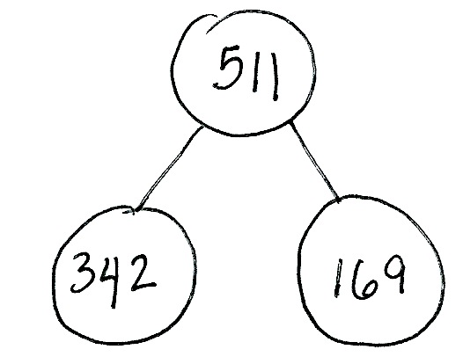
S: 342 + 169 = 511.
T: Talk with your partner: How does each step on the chip model match each step of the algorithm? (Pause as students share.)
T: Now, draw a number bond of this equation on your paper. Check your model with a partner, and explain how the model matches the equation.
T: Who would like to explain the model you drew to the class?
S: We add the parts to find the whole. 342 and 169 are the parts, and 511 is the whole. I decomposed 511 as 342 and 169.
T: Now, you’re going to work through this next problem while I walk around and check to see how it’s going. Show the problem as a number bond as well.
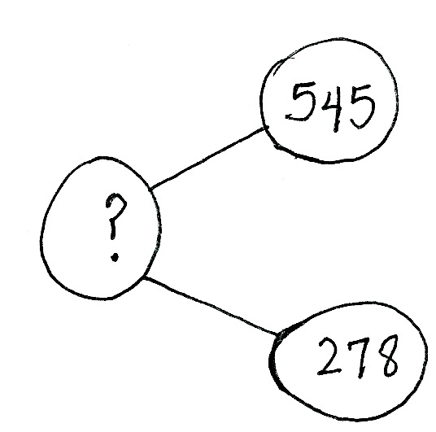
Problem 2: 545 + 278
Follow the procedure used in Problem 1 to guide students as they write 545 + 278 vertically, model it, and solve. Remind them to be precise in lining up the digits and drawing their chips in neat 5-groups. Have them use place value language to explain each action they take on their model and how it is represented in the vertical form.

NOTES ON
MULTIPLE MEANS
OF ACTION AND EXPRESSION:
While it is encouraged that students learn and use new vocabulary during discussion, focus on their mathematical reasoning—their ability to make connections between the chip model and the vertical form, notice patterns when bundling, observe differences between models, and draw conclusions—rather than their accuracy in language.

Repeat the process for 636 + 289 and 784 + 179. Continue to support students working below grade level. As students demonstrate proficiency, instruct them to work on the Problem Set independently.
Problem Set (10 minutes)
Students should do their personal best to complete the Problem Set within the allotted 10 minutes. For some classes, it may be appropriate to modify the assignment by specifying which problems they work on first. Some problems do not specify a method for solving. Students should solve these problems using the RDW approach used for Application Problems.
Student Debrief (10 minutes)
Lesson Objective: Use math drawings to represent additions with up to two compositions and relate drawings to the addition algorithm.
The Student Debrief is intended to invite reflection and active processing of the total lesson experience.
Invite students to review their solutions for the Problem Set. They should check work by comparing answers with a partner before going over answers as a class. Look for misconceptions or misunderstandings that can be addressed in the Debrief. Guide students in a conversation to debrief the Problem Set and process the lesson.
Any combination of the questions below may be used to lead the discussion.
- For Problem 1(a), use place value language to explain to your partner how your model matches the steps of the algorithm.
- Think of the word renaming. A friend says that the Say Ten answer to Problem 1(b), 424 + 288, is 6 hundreds 10 tens 12. How did you use bundling to rename the solution? What is your solution the Say Ten Way?
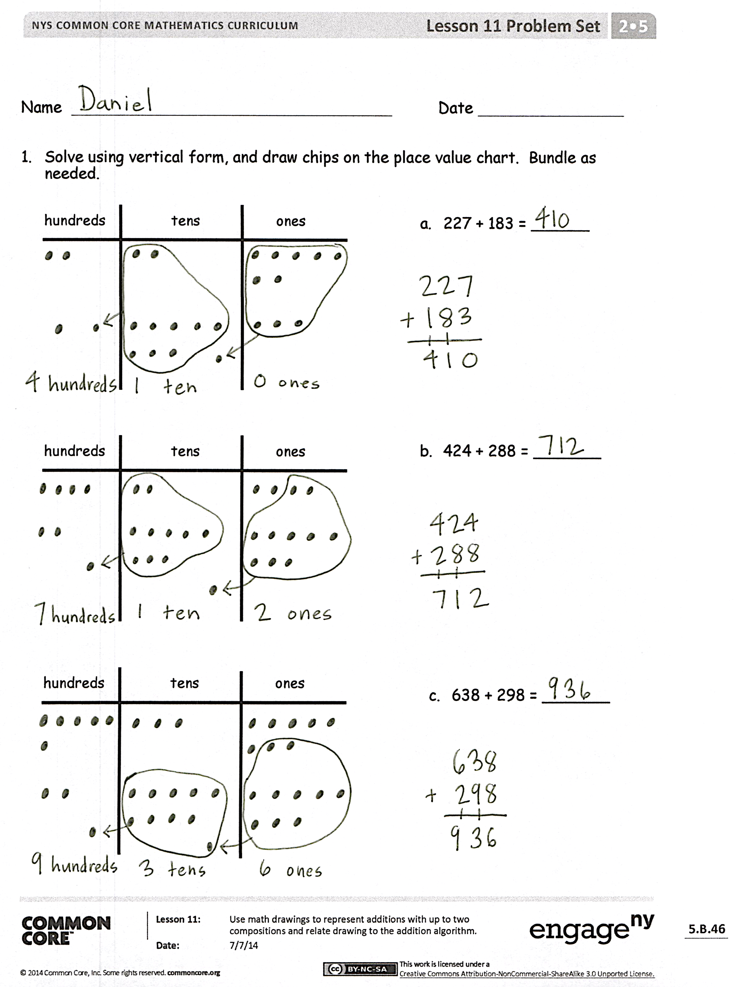
- For Problem 1(c), where did you write the new ten or hundred in the vertical form? How did it match your chip model?
- Explain to your partner how you solved Problems 2(a) and 2(b). What significant differences do you notice about the chip model and the vertical form for these two problems?
- How does having two three-digit addends (as opposed to two-digit) change the way you model and solve the problem?
- What important math vocabulary have we used recently to talk about making a new unit? (Compose, bundle, rename, change.)
Exit Ticket (3 minutes)
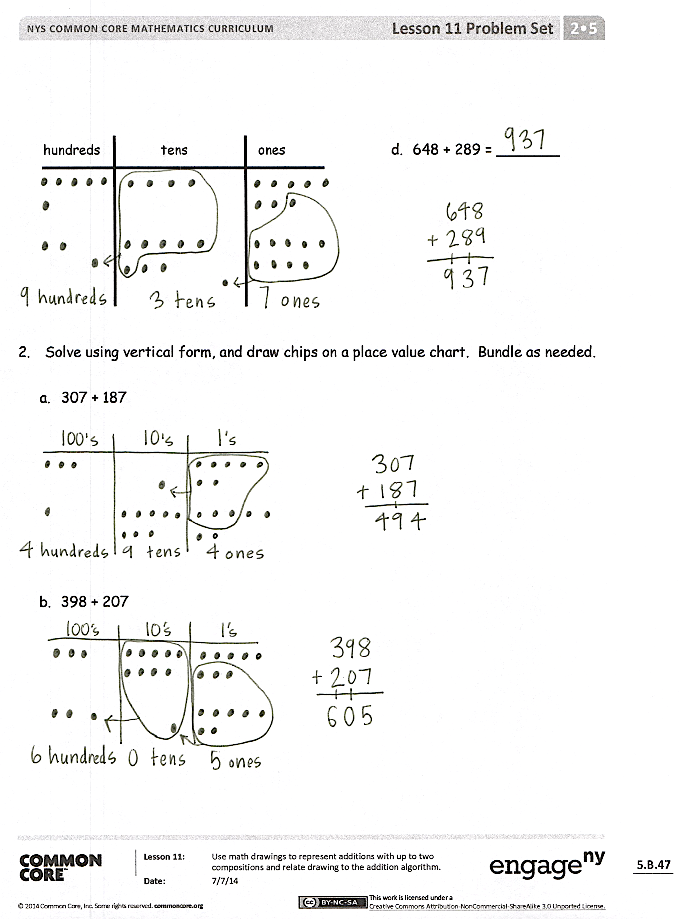
After the Student Debrief, instruct students to complete the Exit Ticket. A review of their work will help with assessing students’ understanding of the concepts that were presented in today’s lesson and planning more effectively for future lessons. The questions may be read aloud to the students.

Name Date
- Solve using vertical form, and draw chips on the place value chart. Bundle as needed.
hundreds tens ones

  - 227 + 183 = ______

hundreds tens ones

  - 424 + 288 = _______

hundreds tens ones

  - 638 + 298 = _______

hundreds tens ones

  - 648 + 289 = _______

- Solve using vertical form, and draw chips on a place value chart. Bundle as needed.

  - 307 + 187

  - 398 + 207

Name Date
Solve using vertical form, and draw chips on a place value chart. Bundle as needed.
- 267 + 356 = _________

- 623 + 279 = _________

Name Date
- Solve using vertical form, and draw chips on the place value chart. Bundle as needed.
  - 167 + 224 = ______
hundreds tens ones

  - 518 + 245 = _______
hundreds tens ones

hundreds tens ones

  - 482 + 369 = _______

  - 638 + 298 = _______
hundreds tens ones

- Solve using vertical form, and draw chips on a place value chart. Bundle as needed.

  - 456 + 378

  - 187 + 567

