Lesson 10
Objective: Use math drawings to represent additions with up to two compositions and relate drawings to the addition algorithm.

Suggested Lesson Structure
 Application Problem (6 minutes)
 Fluency Practice (13 minutes)
 Concept Development (31 minutes)
 Student Debrief (10 minutes)
Total Time (60 minutes)
Application Problem (6 minutes)
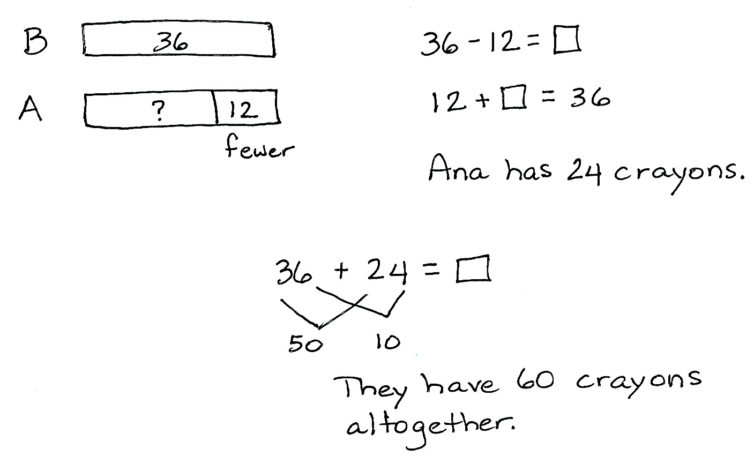
Benjie has 36 crayons. Ana has 12 fewer crayons than Benjie.
- How many crayons does Ana have?
- How many crayons do they have all together?
Note: This problem is intended for guided practice to help students gain familiarity with the compare with smaller unknown problem type. The numbers are intentionally small to allow students to focus on the relationship between the numbers.
Fluency Practice (13 minutes)
- Compensation 2.NBT.5 (4 minutes)
- Sprint: Addition Crossing Tens 2.OA.2, 2.NBT.5 (9 minutes)
Compensation (4 minutes)
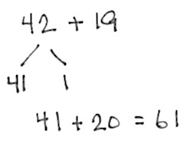
Note: This fluency activity reviews the mental math strategy of compensation. By making a multiple of 10, students solve a much simpler addition problem. Draw a number bond for the first problem on the board to help students visualize the decomposition.
T: (Write 42 + 19 = _____.) Let’s use a simplifying strategy to add. How much more does 19 need to make the next ten?
S: 1 more.
T: Where can 19 get 1 more from?
S: From the 42.
T: Take 1 from 42 and give it to 19. Say the simplified number sentence with the answer.
S: 41 + 20 = 61.
T: 37 + 19. Say the simplified number sentence with the answer.
S: 36 + 20 = 56.
Continue with the following possible sequence: 29 + 23, 38 + 19, 32 + 19, 24 + 17, and 34 + 19.
Sprint: Addition Crossing Tens (9 minutes)
Materials: (S) Addition Crossing Tens Sprint
Note: This Sprint builds fluency with adding when crossing the next ten using mental strategies.
Concept Development (31 minutes)

NOTES ON
MULTIPLE MEANS
OF ACTION AND EXPRESSION:
Since it is important to teach precision when drawing chips and aligning digits, students should use a pencil and paper, which allows for greater accuracy than a white board marker. As they work through each problem step-by-step, students can highlight each column on the place value chart and vertical form. Also, if a student continues to struggle with place value understanding, try highlighting the ones, tens, and hundreds columns in different colors.

Materials: (S) Math journal or paper
As students learn to make math drawings like the chip model to represent the vertical form, it is important to emphasize precision in aligning digits in their proper place, drawing place value disks in clear 5-groups, and showing new groups below in the correct place.
Problem 1: 126 + 160
T: (Write 126 + 160 vertically. Draw two long vertical lines, which serve as the place value chart, next to the vertical form. See image at the right.)
T: Let’s show one part. How many hundreds in 126?
S: 1 hundred.
T: (Draw 1 hundred.) How many tens?
MP.6
S: 2 tens. (Count tens as the teacher draws.)
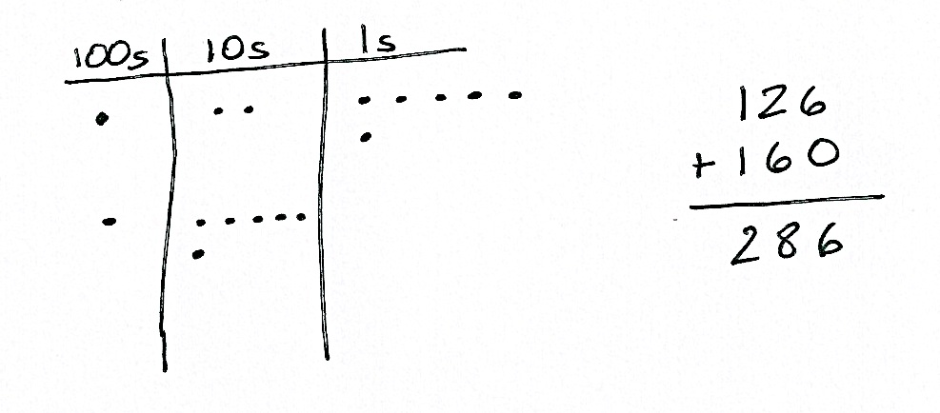
T: How many ones?
S: 6 ones. (Count ones as the teacher draws.)
T: Let’s count the first part to be sure our chip model is correct.
S: 100, 110, 120, 121, 122, 123, 124, 125, 126.
T: Now, let’s show the other part. (Repeat the process to model 160.)
T: Let’s count the second part to check our model.
S: 100, 110, 120, 130, 140, 150, 160.
T: It’s important that our chip model matches the problem we’re solving.
T: Now, let’s solve the problem. 6 ones + 0 ones?
S: 6 ones!
T: Do we make a new ten?
S: No!
T: So, we write the number of ones, 6, below the line in the ones place.
T: 2 tens + 6 tens?
MP.6
S: 8 tens!
T: Do we make a new hundred?
S: No!
T: So, we write the number of tens, 8, below the line in the tens place.
T: 1 hundred + 1 hundred?
S: 2 hundreds!
T: We write the number of hundreds, 2, below the line in the hundreds place. Read the problem with me.
S: 126 + 160 = 286.
T: Did we need to bundle units in this problem? Why or why not? Discuss with your partner.
S: 6 + 0 and 2 + 6 don’t equal 10, and you only bundle when there are partners to ten or more. The ones didn’t make a ten, and the tens didn’t make a hundred. First, I looked in the ones column, and 6 plus 0 doesn’t make a new ten. Then, I looked in the tens column, and 20 plus 60 isn’t enough to make a new hundred.
T: Now, explain to your partner how the chip model matches the vertical form. Explain your thinking using place value language.
Problem 2: 326 + 167
T: Let’s work through another problem together in your math journal. Turn your journal so the lines are already vertical on the page for easy setup. (Repeat the above process to model 326 + 167.)
T: Let’s begin by adding the ones. Look at the vertical form and chip model. Tell your partner what you notice. How are they the same?
S: They both show 6 and 7. They show the same parts. They both show 13 ones, but one is dots and the other is numbers.
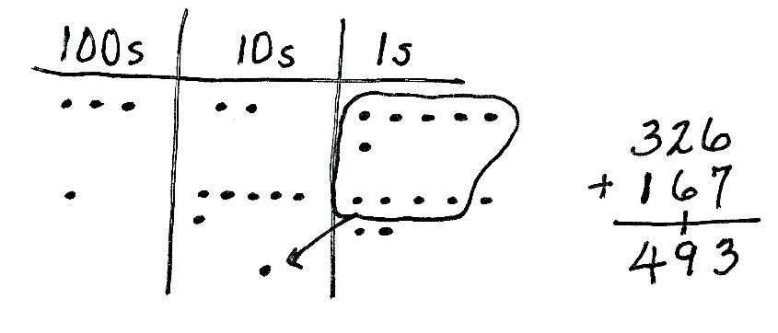
T: Aha! They show the same total, and that total is 13. What do we do now?
S: Bundle 10 ones as 1 ten! Compose a ten! Rename 13 ones as 1 ten 3 ones!
T: Excellent! Remember, what we do on the chip model, we do to the numbers. We composed a ten, so we circle the 10 ones and draw an arrow into the tens place, where we draw the new unit of 10. (See image to the right.)
T: Using vertical form, we show this new unit of 10 by writing a 1 on the line below the tens place. This way, we remember to add it in when we count the tens.
T: We write 3 below the line in the ones place. When we look at the model, we see that there are 3 dots left.
T: Now, let’s add the tens. Remember to add the new unit. (Point to the model.) 2 tens + 6 tens + 1 ten is...?

NOTES ON
MULTIPLE MEANS
OF ENGAGEMENT:
Use a simple rhythm or jingle to help students remember the key concept of composing a new unit. The following are examples:
- “Add your ones up first! Make a bundle if you can!”
- “Add your tens up next! Make a bundle if you can!”

S: 9 tens!
T: Did we make a new hundred?
S: No!
T: So, we write 9 tens below the line in the tens place.
T: And now, let’s add our hundreds. 3 hundreds + 1 hundred is...?
S: 4 hundreds!
T: We record the digit 4 below the line in the hundreds place. Read the entire problem.
S: 326 + 167 = 493.
T: How does each step in the chip model match what we do in the vertical form? Talk with your partner. Explain your thinking using place value language.
T: Now, it’s your turn. Draw a model and use it to solve 462 + 284. I’ll walk around to see how it’s going.
Follow the above procedure to guide students as they write 462 + 284 vertically, model it, and solve. Remind students to be precise in lining up the digits and drawing their chips in neat 5-groups. Have them use place value language to explain each action they take on their model and how it is represented in the written addition.
Repeat the process for 487 + 345 with two renamings. Continue to support students working below grade level, but as students demonstrate proficiency, instruct them to work on the Problem Set independently.
Problem Set (10 minutes)
Students should do their personal best to complete the Problem Set within the allotted 10 minutes. For some classes, it may be appropriate to modify the assignment by specifying which problems they work on first. Some problems do not specify a method for solving. Students should solve these problems using the RDW approach used for Application Problems.
Student Debrief (10 minutes)
Lesson Objective: Use math drawings to represent additions with up to two compositions and relate drawings to the addition algorithm.
The Student Debrief is intended to invite reflection and active processing of the total lesson experience.
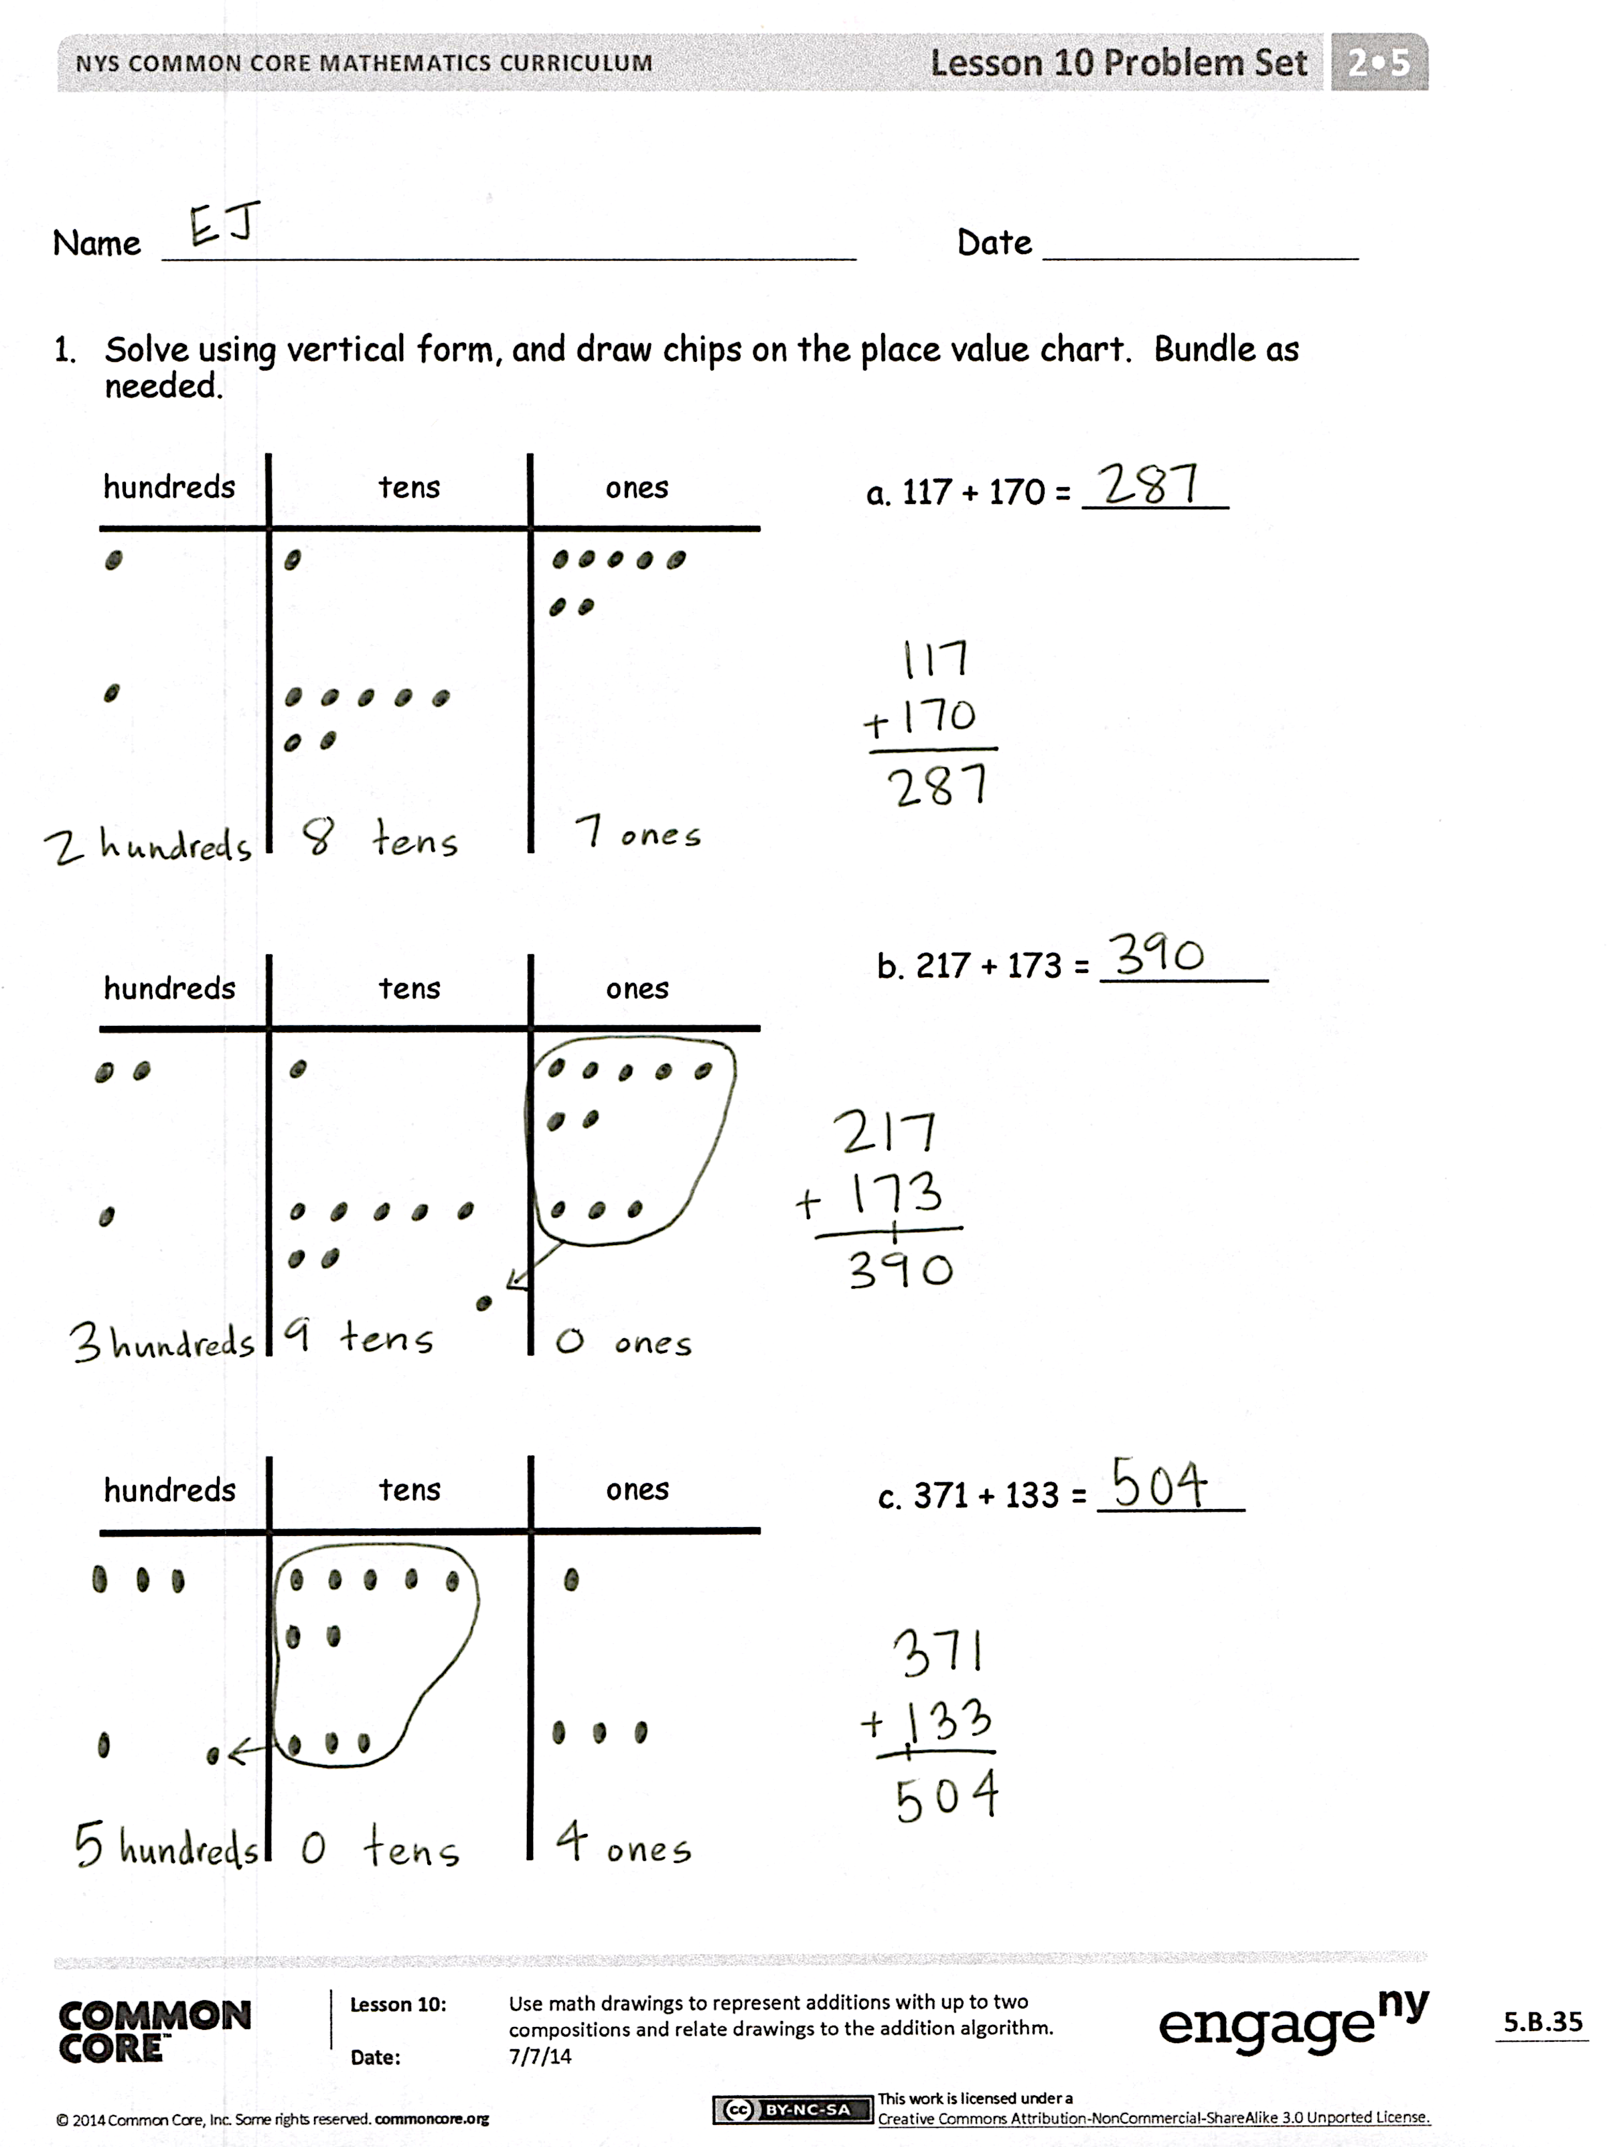
Invite students to review their solutions for the Problem Set. They should check work by comparing answers with a partner before going over answers as a class. Look for misconceptions or misunderstandings that can be addressed in the Debrief. Guide students in a conversation to debrief the Problem Set and process the lesson.
Any combination of the questions below may be used to lead the discussion.
- Explain to your partner how you solved Problem 1(a) using the chip model and the vertical form. How could you solve this problem differently using a simplifying strategy?
- For Problem 1(b), how did you know whether to bundle a new unit of 10 or 100?
- For Problem 1(c), where did you write the new ten or hundred in the vertical form? How did the vertical form match your chip model? How was this different from Problem 1(b)?
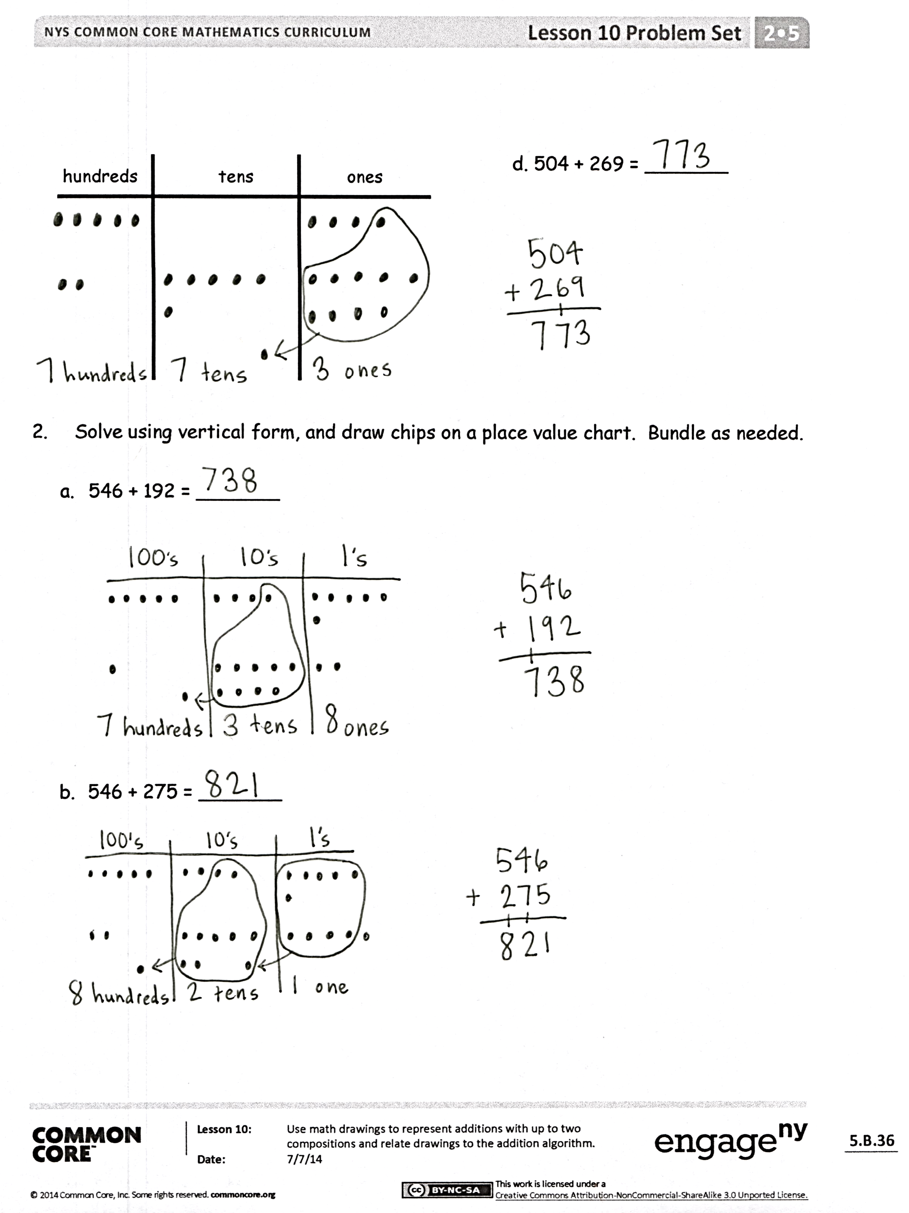
- What was interesting about Problem 1(d)? Could you have solved this problem mentally using your understanding of place value?
- Jade uses place value language to argue that the answer to Problem 2(a), 546 + 192, is 6 hundreds, 13 tens, 8 ones. Sam says that it is 7 hundreds, 3 tens, 8 ones. Who is correct? How do you know?
- How did you solve Problem 2(a)? How did you change your place value disks to show Problem 2(b)? Did you compose a new unit of 10 or 100 in both problems?
Exit Ticket (3 minutes)
After the Student Debrief, instruct students to complete the Exit Ticket. A review of their work will help with assessing students’ understanding of the concepts that were presented in today’s lesson and planning more effectively for future lessons. The questions may be read aloud to the students.

Number Correct: _______
A
Addition Crossing Tens
 | 8 + 2 = |  |  |  | 18 + 6 =
 | 18 + 2 = |  |  |  | 28 + 6 =
 | 38 + 2 = |  |  |  | 16 + 8 =
 | 7 + 3 = |  |  |  | 26 + 8 =
 | 17 + 3 = |  |  |  | 18 + 7 =
 | 37 + 3 = |  |  |  | 18 + 8 =
 | 8 + 3 = |  |  |  | 28 + 7 =
 | 18 + 3 = |  |  |  | 28 + 8 =
 | 28 + 3 = |  |  |  | 15 + 9 =
 | 6 + 5 = |  |  |  | 16 + 9 =
 | 16 + 5 = |  |  |  | 25 + 9 =
 | 26 + 5 = |  |  |  | 26 + 9 =
 | 18 + 4 = |  |  |  | 14 + 7 =
 | 28 + 4 = |  |  |  | 16 + 6 =
 | 16 + 6 = |  |  |  | 15 + 8 =
 | 26 + 6 = |  |  |  | 23 + 8 =
 | 18 + 5 = |  |  |  | 25 + 7 =
 | 28 + 5 = |  |  |  | 15 + 7 =
 | 16 + 7 = |  |  |  | 24 + 7 =
 | 26 + 7 = |  |  |  | 14 + 9 =
 | 19 + 2 = |  |  |  | 19 + 8 =
 | 17 + 4 = |  |  |  | 28 + 9 =
B
[KEY]

Number Correct: _______
Improvement: _______
Addition Crossing Tens
 | 9 + 1 = |  |  |  | 19 + 5 =
 | 19 + 1 = |  |  |  | 29 + 5 =
 | 39 + 1 = |  |  |  | 17 + 7 =
 | 6 + 4 = |  |  |  | 27 + 7 =
 | 16 + 4 = |  |  |  | 19 + 6 =
 | 36 + 4 = |  |  |  | 19 + 7 =
 | 9 + 2 = |  |  |  | 29 + 6 =
 | 19 + 2 = |  |  |  | 29 + 7 =
 | 29 + 2 = |  |  |  | 17 + 8 =
 | 7 + 4 = |  |  |  | 17 + 9 =
 | 17 + 4 = |  |  |  | 27 + 8 =
 | 27 + 4 = |  |  |  | 27 + 9 =
 | 19 + 3 = |  |  |  | 12 + 9 =
 | 29 + 3 = |  |  |  | 14 + 8 =
 | 17 + 5 = |  |  |  | 16 + 7 =
 | 27 + 5 = |  |  |  | 28 + 6 =
 | 19 + 4 = |  |  |  | 26 + 8 =
 | 29 + 4 = |  |  |  | 24 + 8 =
 | 17 + 6 = |  |  |  | 13 + 8 =
 | 27 + 6 = |  |  |  | 24 + 9 =
 | 18 + 3 = |  |  |  | 29 + 8 =
 | 26 + 5 = |  |  |  | 18 + 9 =

Name Date
- Solve using vertical form, and draw chips on the place value chart. Bundle as needed.
hundreds tens ones
  - 117 + 170 = _______

hundreds tens ones

b. 217 + 173 = ________

hundreds tens ones

c. 371 + 133 = _______

hundreds tens ones

d. 504 + 269 = _______

- Solve using vertical form, and draw chips on a place value chart. Bundle as needed.

  - 546 + 192 = _______

  - 546 + 275 = _______

Name Date
Solve using vertical form, and draw chips on a place value chart. Bundle as needed.

- 436 + 509 = ________

- 584 + 361 = ________

Name Date
- Solve using vertical form, and draw chips on the place value chart. Bundle as needed.
hundreds tens ones

a. 124 + 260 = ______

hundreds tens ones

b. 426 + 324 = ______

hundreds tens ones

c. 362 + 243 = ______

hundreds tens ones

d. 606 + 294 = _______

- Solve using vertical form, and draw chips on a place value chart. Bundle as needed.

  - 372 + 118 = _______

  - 248 + 233 = _______

