Lesson 8
Objective: Relate manipulative representations to the addition algorithm.

Suggested Lesson Structure
 Application Problem (5 minutes)
 Fluency Practice (12 minutes)
 Concept Development (33 minutes)
 Student Debrief (10 minutes)
Total Time (60 minutes)
Application Problem (5 minutes)
Susan has 37 pennies.
M.J. has 55 more pennies than Susan.
- How many pennies does M.J. have?
- How many pennies do they have all together?
Note: Some students may read Part (b) and incorrectly add 37 + 55. Once the students have been given the opportunity to solve using any number of written strategies, invite some to share their representations of the problem.
Fluency Practice (12 minutes)
- Add Common Units 2.NBT.7 (3 minutes)
- Sprint: Two-Digit Addition 2.NBT.5 (9 minutes)
Add Common Units (3 minutes)
Materials: (S) Personal white board
Note: Reviewing this mental math fluency activity prepares students for understanding the importance of the written addition method.
T: 2 puppies plus 1 puppy is...?
S: 3 puppies.
T: 3 dogs, 2 puppies, plus 1 puppy is...?
S: 3 dogs 3 puppies.
T: (Project 303.) Say the number in unit form.
S: 3 hundreds 3 ones.
T: (Write 303 + 202 =____.) Say the addition sentence and answer in unit form.
S: 3 hundreds 3 ones + 2 hundreds 2 ones = 5 hundreds 5 ones.
T: Write the addition sentence on your personal white board.
S: (Write 303 + 202 = 505.)
Repeat this process for the following possible sequence: 404 + 203, 660 + 110, 707 + 220, 770 + 202, and
440 + 340.
Sprint: Two-Digit Addition (9 minutes)
Materials: (S) Two-Digit Addition Sprint
Note: Students review two-digit addition in preparation for adding three-digit numbers in today’s lesson.
Concept Development (33 minutes)
Materials: (T) Place value disks, unlabeled hundreds place value chart (Lesson 1 Template 2) (S) Personal white board, unlabeled hundreds place value chart (Lesson 1 Template 2), place value disks (9 hundreds, 18 tens, 18 ones) per pair
T: What is 200 + 300?
S: 500.
T: Explain your strategy for solving to your partner for 15 seconds.
S: I started at 300, and I counted on 2 more hundreds. 2 + 3 = 5, so 2 hundreds + 3 hundreds is 5 hundreds.
T: What is 440 + 200?
S: 640.
T: Explain your strategy for solving to your partner for 15 seconds.
S: I started at 440, and I counted on 2 hundreds, so 440, 540, 640. I know that 400 + 200 is 600, and then I just added on 40.
T: What is 287 + 314?
S: (Solve problem with partner or independently.)
S: 601.
T: Why was this problem more difficult to solve mentally?
S: We weren’t just adding on another hundred. It’s easy to add on hundreds and tens. This time, we had to worry about the ones place, too.
T: What would be a better way to solve this problem to make sure we get the right answer?
S: Use place value disks and a place value chart. Make a math drawing, and show new units on the vertical form.
T: Yes. Let’s try a few more problems that might require using the algorithm. Remember, that’s what we call the steps we take when we solve in vertical form.
Note: In the following modeled activity, it is important to relate each action on the place value chart to the algorithm.
Problem 1: 303 + 37
T: (Write 303 + 37 on the board horizontally.) Read the problem aloud.
S: (Read 303 + 37 chorally.)
T: Talk with your partner. How could you solve this problem using mental math?
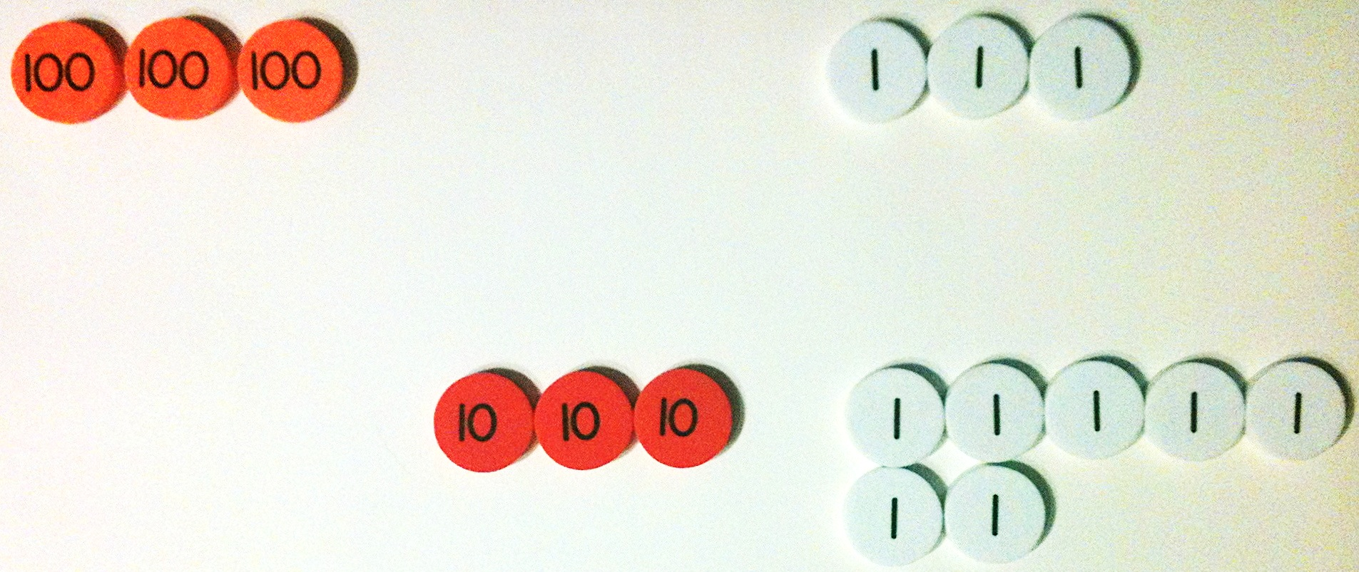
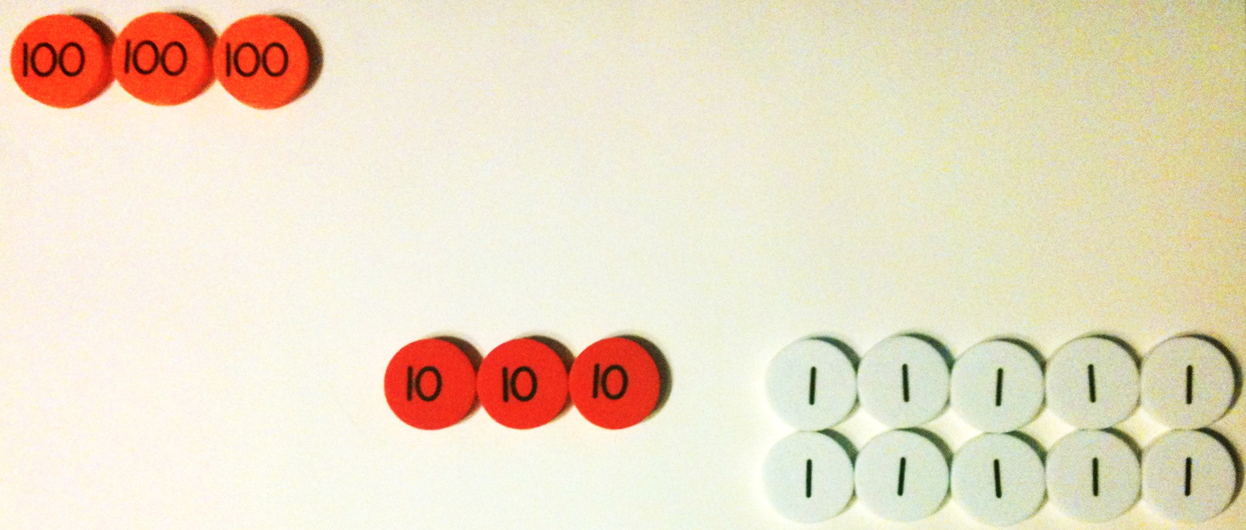
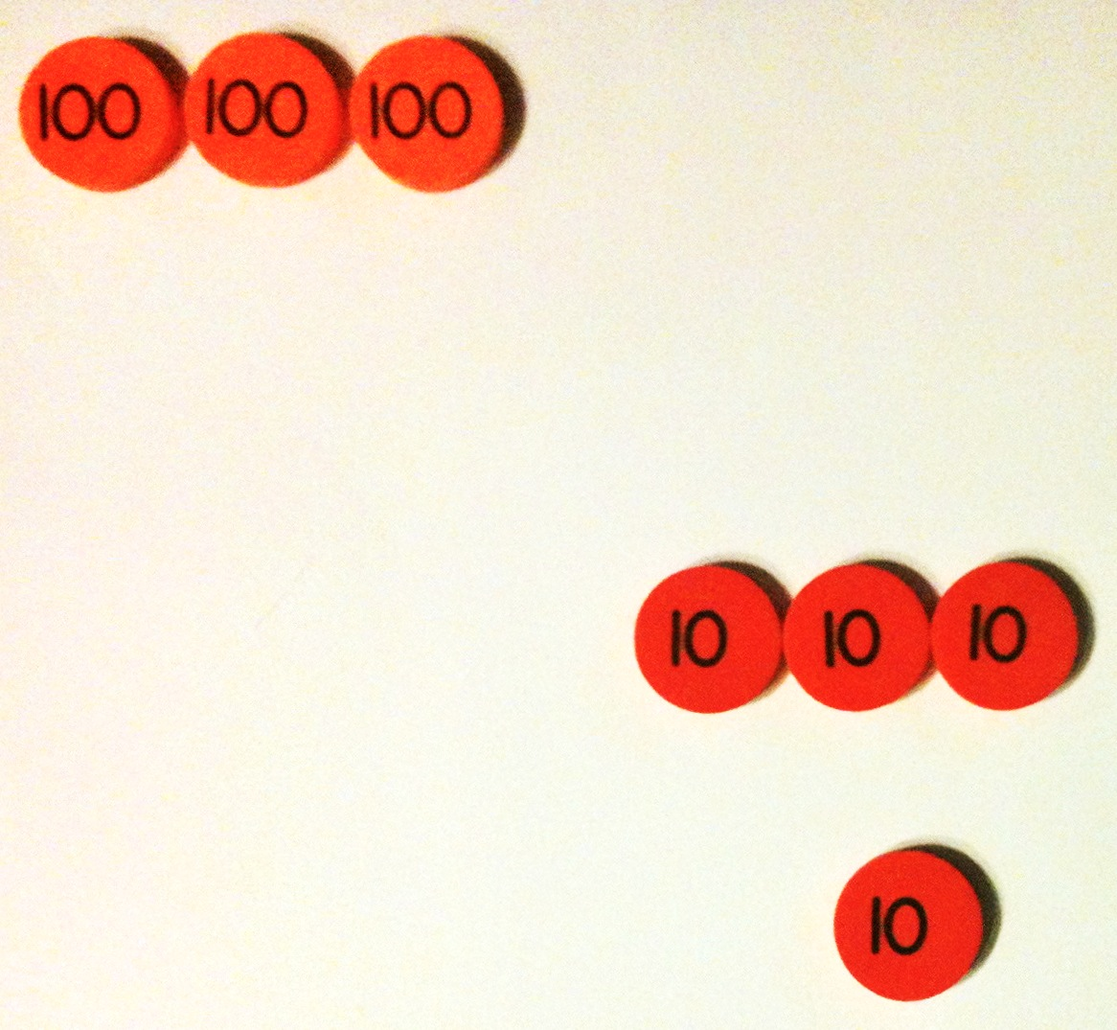
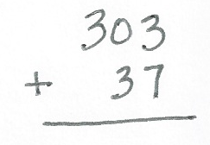
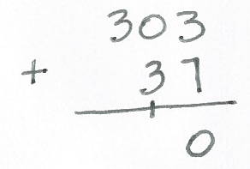
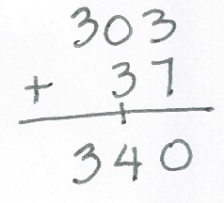
S: 303 + 30 + 7. Add 3 and 7, which makes 10, and then add 300 + 30 + 10. 37 + 3 is 40, plus the 3 hundreds is 340.
T: Can we check our work using vertical form?
S: Yes.
T: Let’s try that.
T: Turn and talk: How do we set up this problem to record it vertically?
S: Write 303 on the top and 37 on the bottom.
Line up the ones and line up the tens.
T: (Rewrite the problem vertically.)
T: Let’s solve using our place value disks and place value charts.
T: How many hundreds do we need for the first addend, the first part?
S: 3 hundreds!
T: How many tens?
S: Zero!
T: How many ones?
S: 3 ones!
T: Count with me to set up the place value chart. (Point to the place value disks on the place value chart.)
S: (Count chorally.) 100, 200, 300, 301, 302, 303.
T: (Repeat the above process for the other part, 37.)
T: Does this model match the vertical form?
S: Yes!
T: Okay, we’re ready to solve! (Point to the ones disks, and then point to the ones in vertical form.)
3 ones + 7 ones is…?
S: 10 ones!
T: What do you see, and what should we do?
S: We made a ten! Change 10 ones for 1 ten. Remove 10 ones, and put a ten disk in the tens place because 10 ones is 1 ten. We should compose a new unit—a ten!
T: That’s right! We rename 10 ones as 1 ten. And where does the new unit of ten belong?
S: In the tens place!
T: Yes! (Model changing 10 ones for 1 ten.)
T: How do we record new groups below using the algorithm? Turn and talk.
S: Write 1 ten below the tens column and 0 ones below the ones column. Write 1 on the line under the 3 in the tens place, and write 0 under the line in the ones place.
T: Why do we write the 1 here? (Point to the line below the tens column.)
S: Because the 1 is actually a ten. We made a ten, so we put it in the tens column.
T: Now, let’s add the tens. (Point to the tens disks.) 0 tens + 3 tens + 1 ten?

NOTES ON
MULTIPLE MEANS
OF ACTION AND EXPRESSION:
For Problem 2, invite students to whisper-count as partners take turns modeling and writing each addend. They may be encouraged to count the regular way (i.e., 10, 20, 30…) or the Say Ten Way (i.e., 2 hundreds 1 ten 1, etc.). Partners also take turns recording their actions using the algorithm. This is an opportunity to support students working below grade level through small group instruction.

S: 4 tens!
T: Did we make a new hundred?
S: No!
T: (Model recording 4 tens in the tens place.)
T: Now, let’s move on to the next larger unit, the hundreds. How many hundreds do we have?
S: 3 hundreds!
T: Turn and talk: Where do we record that on our vertical form?
S: Write 3 in the hundreds place.
T: What is 303 + 37?
S: 340.
T: Explain to your partner how each change that I modeled on my place value chart matches each step that I recorded in the vertical form.
S: 3 ones + 7 ones is 10 ones, so we renamed 10 ones for 1 ten and wrote the 1 on the line as new groups below. There are 4 tens, so we wrote 4 below the line in the tens place.
Distribute place value charts and place value disks. Instruct students to work with a partner on the next problem.
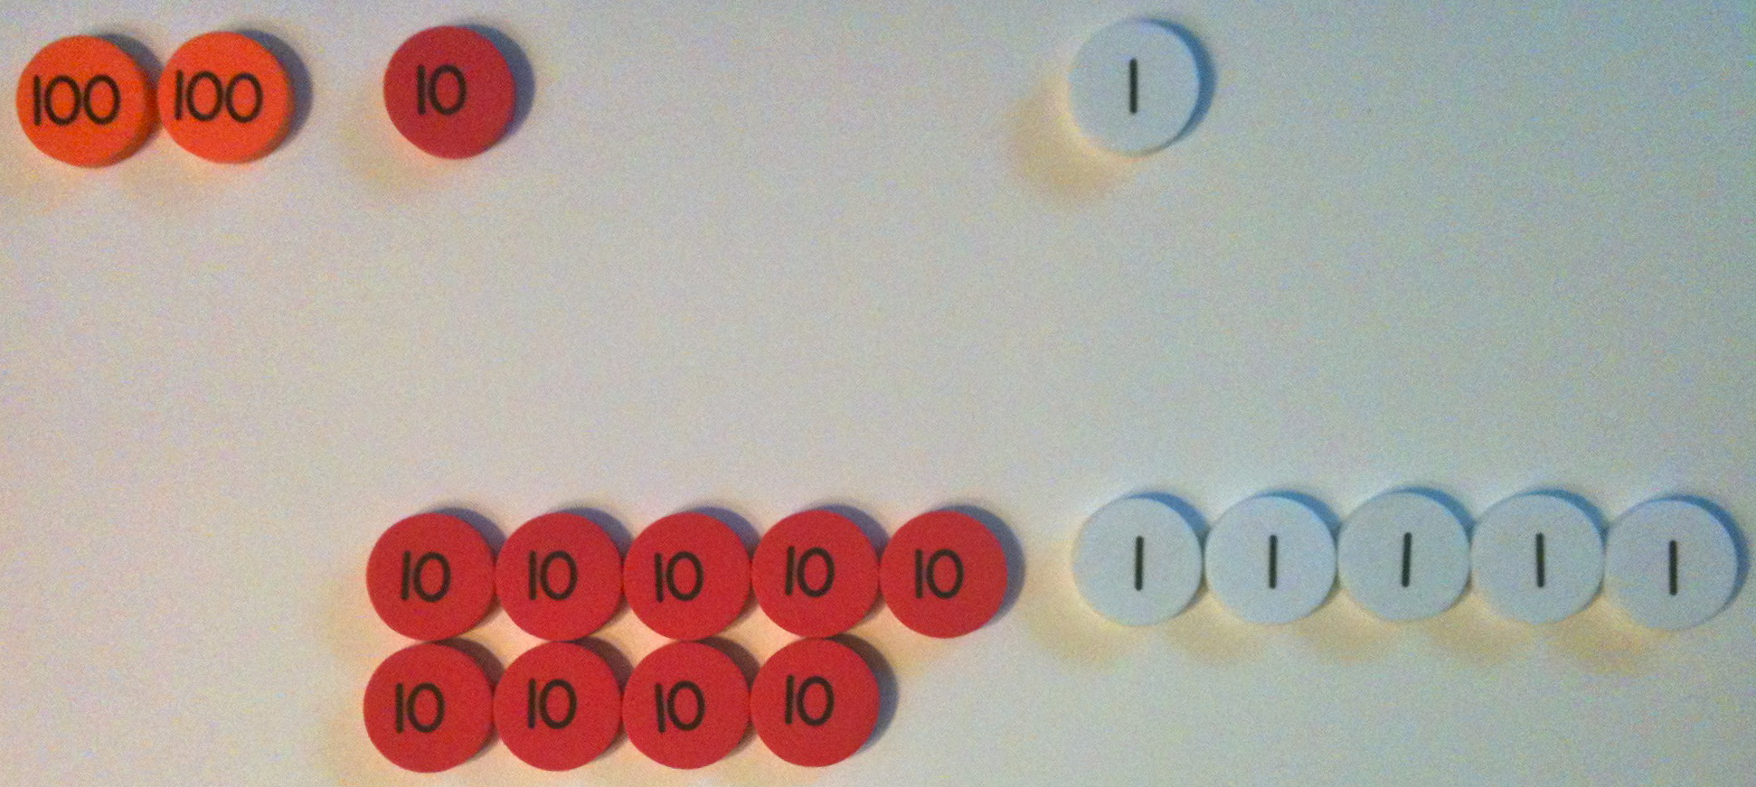
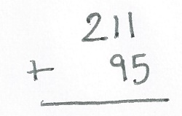
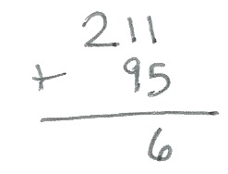
Problem 2: 211 + 95
T: Now, it’s your turn. (Write 211 + 95 on the board vertically.) Write 211 + 95 as I did.
T: Turn and talk: How can we solve this mentally?

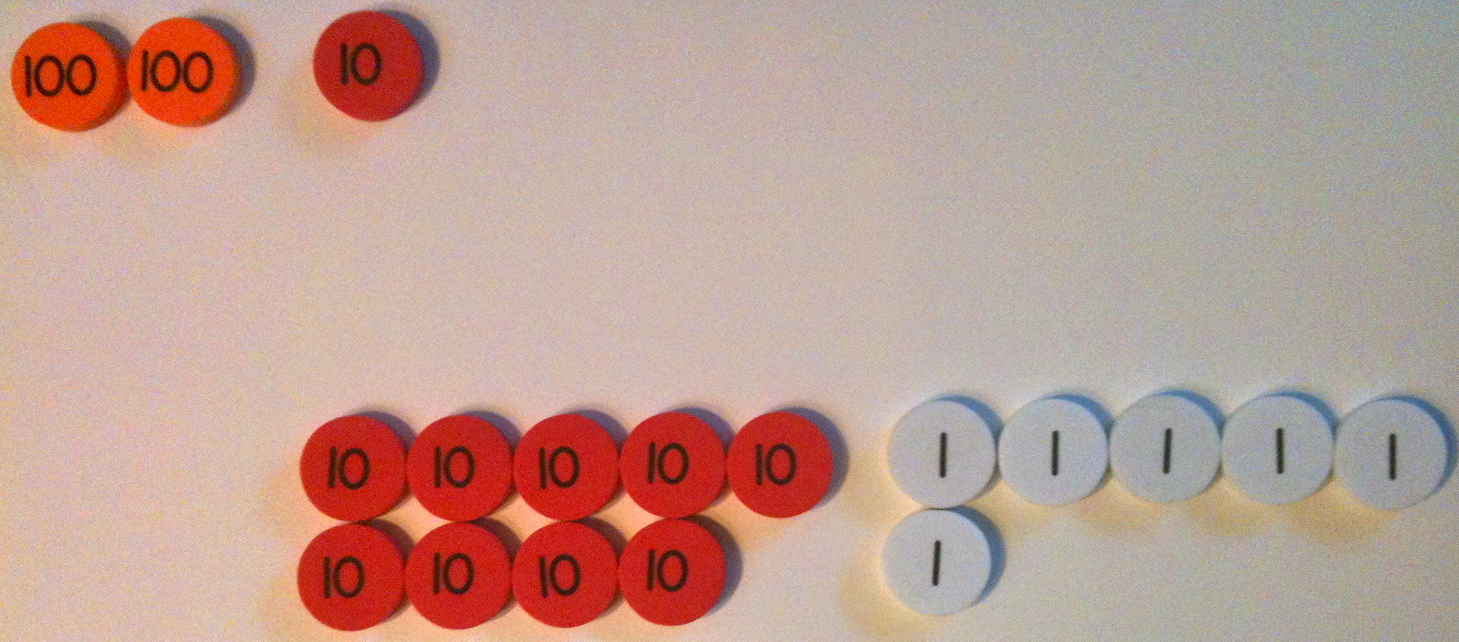
S: I take apart the numbers 200 + 10 + 1 + 90 + 5, and I get 200 + 100 + 6, which is 306. 211 plus 9 tens is 301 plus 5 more is 306.
T: How can we check our mental math to be sure we are correct?
S: Use place value disks. Make a math drawing.
T: Model both addends on your place value chart.
T: We’re ready to solve! Let’s begin with the ones place. (Point to the ones disks.) 1 one plus 5 ones is…?
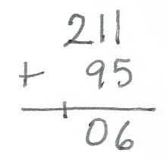
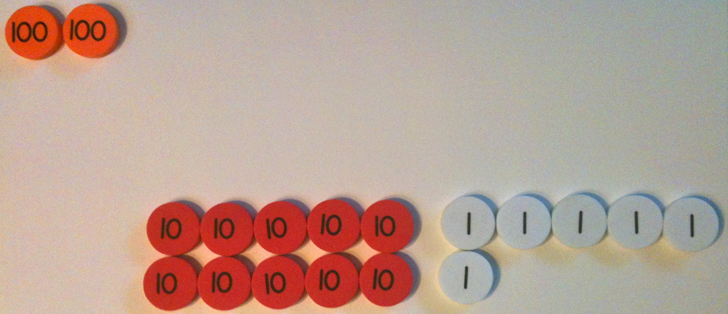
S: 6 ones.
T: Use your place value disks to show what we should do here. (Circulate to check for understanding.)
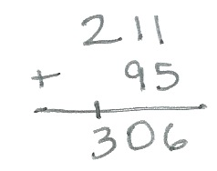
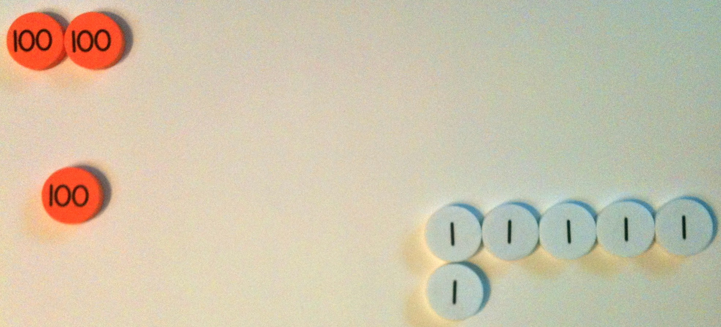
T: Let’s record the total number of ones on our vertical form. (Write 6 in the ones place as students do the same.)
T: Let’s move on to the tens place. (Point to the tens disks.) What are you adding?
S: 1 ten and 9 tens.
T: How many tens do we have all together?
S: 10 tens!
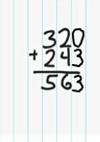
T: What should we do?
MP.8

NOTES ON
MULTIPLE MEANS
OF ENGAGEMENT
Some students struggle with precision and organization. Encourage them to visualize the ten-frame when arranging their disks into 5-groups. Also, help students line up their problems according to place value. Instruct students to use lined paper turned 90 degrees (landscape orientation) and write their numbers between the lines.

S: Bundle 10 tens and make a hundred. Change 10 ten disks for 1 hundred disk. Compose a new unit, a hundred!
S: (Change on place value charts.)
T: Show your work in the vertical form using new groups below. (Circulate as students record 1 on the line in the hundreds place and 0 in the tens place—in that order.)
T: Now, let’s add the hundreds. How many hundreds?
S: 3 hundreds!
T: Yes! You remembered to add the new unit! So, we write 3 below the line in the hundreds place.
T: Explain to your partner how your work with the place value disks and place value chart matches the vertical form.
Continue with the following possible sequence: 324 + 156,
546 + 273, and 435 + 382. As students demonstrate confidence in relating their models to the algorithm, allow them to work independently on the Problem Set.
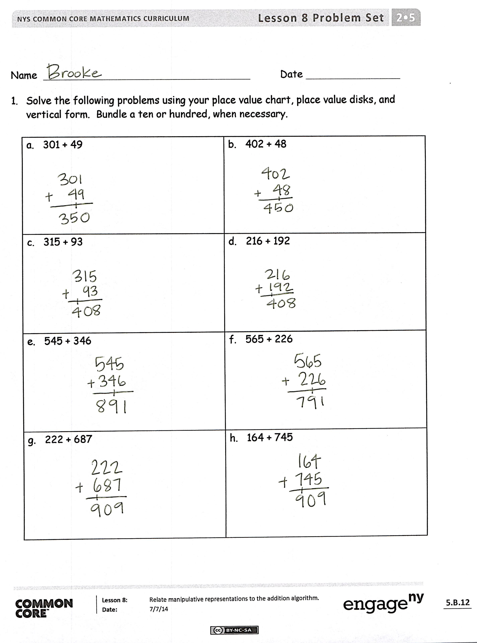
Problem Set (10 minutes)
Students should do their personal best to complete the Problem Set within the allotted 10 minutes. For some classes, it may be appropriate to modify the assignment by specifying which problems they work on first. Some problems do not specify a method for solving. Students should solve these problems using the RDW approach used for Application Problems.
Student Debrief (10 minutes)
Lesson Objective: Relate manipulative representations to the addition algorithm.
The Student Debrief is intended to invite reflection and active processing of the total lesson experience.
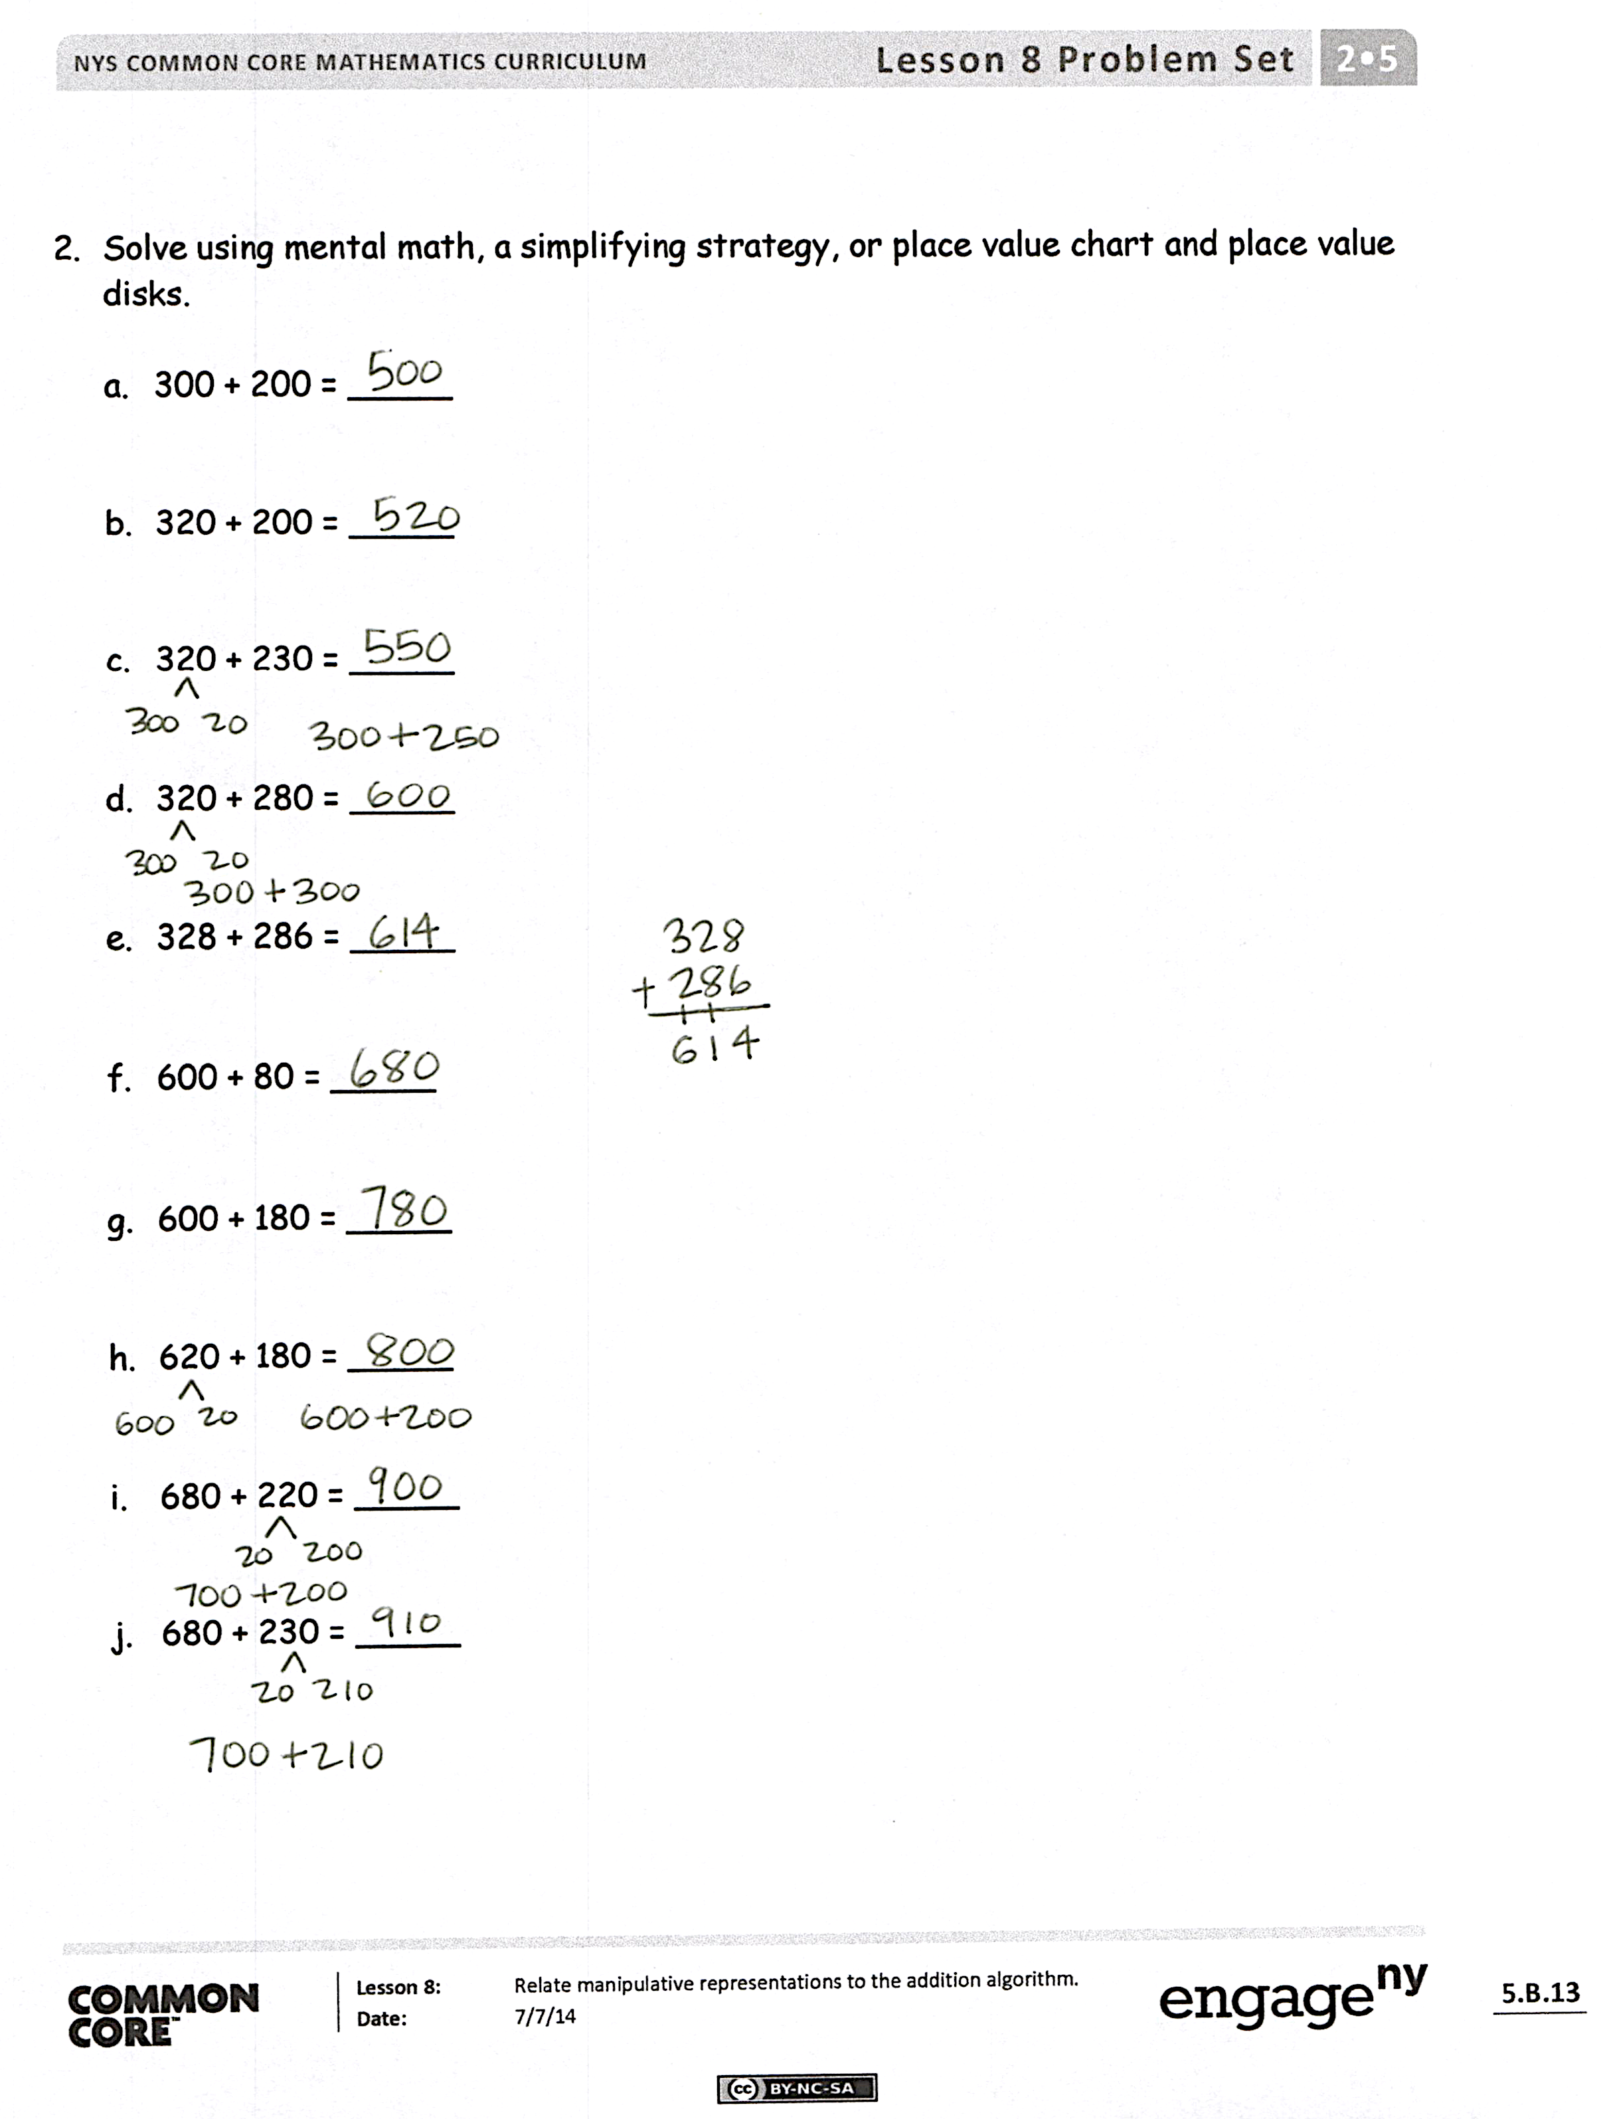
Invite students to review their solutions for the Problem Set. They should check work by comparing answers with a partner before going over answers as a class. Look for misconceptions or misunderstandings that can be addressed in the Debrief. Guide students in a conversation to debrief the Problem Set and process the lesson.
Any combination of the questions below may be used to lead the discussion.
- How did you solve Problems 1(a) and (b),
301 + 49 and 402 + 48? Did you begin by adding the ones only? Why didn’t you need to solve with place value disks? How can you check your mental math? Where did you write the new unit?
- Explain to your partner how you used manipulatives to solve Problems 1(c) and (d). Did you need to bundle a new ten or hundred? How did you know? How did you show it using the algorithm?
- For Problems 1(e) and (f), how did your work with the place value disks match the vertical form? How did you show new groups below? How were these problems different from the ones in Problems 1(c) and (d)?
- What do you notice about the answers for Problems 1(g) and (h)? If the addends in each problem are different, why are the answers the same?
- Did you notice any patterns in Problem 2 that helped you solve efficiently?
- In Problem 2, did you use a place value chart and place value disks every time you composed a new unit of ten or a hundred? How do you know when you should solve using a place value chart and place value disks, a simplifying strategy, or mental math?
Exit Ticket (3 minutes)
After the Student Debrief, instruct students to complete the Exit Ticket. A review of their work will help with assessing students’ understanding of the concepts that were presented in today’s lesson and planning more effectively for future lessons. The questions may be read aloud to the students.

Number Correct: _______
A
Two-digit Addition
 | 38 + 1 = |  |  |  | 85 + 7 =
 | 47 + 2 = |  |  |  | 85 + 9 =
 | 56 + 3 = |  |  |  | 76 + 4 =
 | 65 + 4 = |  |  |  | 76 + 5 =
 | 31 + 8 = |  |  |  | 76 + 6 =
 | 42 + 7 = |  |  |  | 76 + 9 =
 | 53 + 6 = |  |  |  | 64 + 6 =
 | 64 + 5 = |  |  |  | 64 + 7 =
 | 49 + 1 = |  |  |  | 76 + 8 =
 | 49 + 2 = |  |  |  | 43 + 7 =
 | 49 + 3 = |  |  |  | 43 + 8 =
 | 49 + 5 = |  |  |  | 43 + 9 =
 | 58 + 2 = |  |  |  | 52 + 8 =
 | 58 + 3 = |  |  |  | 52 + 9 =
 | 58 + 4 = |  |  |  | 59 + 1 =
 | 58 + 6 = |  |  |  | 59 + 3 =
 | 67 + 3 = |  |  |  | 58 + 2 =
 | 57 + 4 = |  |  |  | 58 + 4 =
 | 57 + 5 = |  |  |  | 77 + 3 =
 | 57 + 7 = |  |  |  | 77 + 5 =
 | 85 + 5 = |  |  |  | 35 + 5 =
 | 85 + 6 = |  |  |  | 35 + 8 =
B
[KEY]

Number Correct: _______
Improvement: _______
Two-digit Addition
 | 28 + 1 = |  |  |  | 75 + 7 =
 | 37 + 2 = |  |  |  | 75 + 9 =
 | 46 + 3 = |  |  |  | 66 + 4 =
 | 55 + 4 = |  |  |  | 66 + 5 =
 | 21 + 8 = |  |  |  | 66 + 6 =
 | 32 + 7 = |  |  |  | 66 + 9 =
 | 43 + 6 = |  |  |  | 54 + 6 =
 | 54 + 5 = |  |  |  | 54 + 7 =
 | 39 + 1 = |  |  |  | 54 + 8 =
 | 39 + 2 = |  |  |  | 33 + 7 =
 | 39 + 3 = |  |  |  | 33 + 8 =
 | 39 + 5 = |  |  |  | 33 + 9 =
 | 48 + 2 = |  |  |  | 42 + 8 =
 | 48 + 3 = |  |  |  | 42 + 9 =
 | 48 + 4 = |  |  |  | 49 + 1 =
 | 48 + 6 = |  |  |  | 49 + 3 =
 | 57 + 3 = |  |  |  | 58 + 2 =
 | 57 + 4 = |  |  |  | 58 + 4 =
 | 57 + 5 = |  |  |  | 67 + 3 =
 | 57 + 7 = |  |  |  | 67 + 5 =
 | 75 + 5 = |  |  |  | 85 + 5 =
 | 75 + 6 = |  |  |  | 85 + 8 =

Name Date
- Solve the following problems using your place value chart, place value disks, and vertical form. Bundle a ten or hundred, when necessary.

a. 301 + 49 | b. 402 + 48
c. 315 + 93 | d. 216 + 192
e. 545 + 346 | f. 565 + 226
g. 222 + 687 | h. 164 + 745

- Solve using mental math, a simplifying strategy, or place value chart and place value disks.

- 300 + 200 = _____
- 320 + 200 = _____
- 320 + 230 = _____
- 320 + 280 = _____
- 328 + 286 = _____
- 600 + 80 = _____
- 600 + 180 = _____
- 620 + 180 = _____
- 680 + 220 = _____
- 680 + 230 = _____

Name Date
Solve the following problems using your place value chart, place value disks, and vertical form. Bundle a ten or hundred, when necessary.
- 378 + 113

- 178 + 141

Name Date
- Solve the following problems using your place value chart, place value disks, and vertical form. Bundle a ten or hundred, when necessary.

a. 505 + 75 | b. 606 + 84
c. 293 + 114 | d. 314 + 495
e. 364 + 326 | f. 346 + 234
g. 384 + 225 | h. 609 + 351

- Solve using mental math, a simplifying strategy, or place value chart and place value disks.
  - 200 + 400 = _____

  - 220 + 400 = _____
  - 220 + 440 = _____
  - 220 + 480 = _____
  - 225 + 485 = _____
  - 500 + 60 = _____
  - 500 + 160 = _____
  - 540 + 160 = _____
  - 560 + 240 = _____
  - 560 + 250 = _____

