Lesson 7
Objective: Share and critique solution strategies for varied addition and subtraction problems within 1,000.

Suggested Lesson Structure
 Application Problem (5 minutes)
 Fluency Practice (10 minutes)
 Concept Development (35 minutes)
 Student Debrief (10 minutes)
Total Time (60 minutes)
Application Problem (5 minutes)
Jeannie got a pedometer to count her steps. The first hour, she walked 43 steps. The next hour, she walked 48 steps.
- How many steps did she walk in the first two hours?
- How many more steps did she walk in the second hour than in the first?
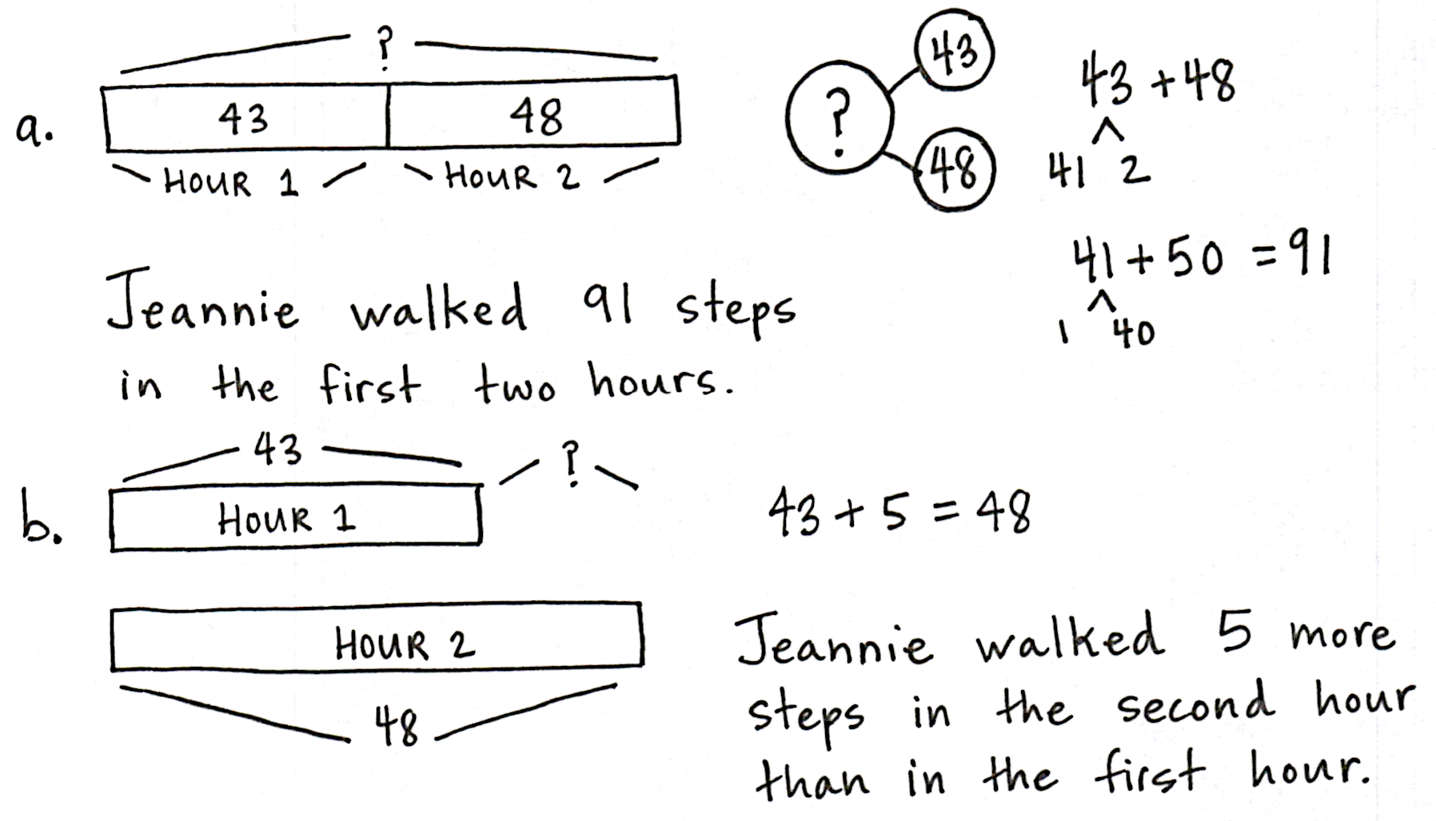

Note: This problem invites students to apply strategies from the previous lessons. They may work alone or with partners. Guide struggling students in drawing tape diagrams to represent the problem, especially for the second step. Encourage the students to explain their thinking about why they used the strategy they chose.

Fluency Practice (10 minutes)
- Making the Next Hundred to Add 2.NBT.5, 2.NBT.7 (5 minutes)
- Compensation with Subtraction 2.NBT.5 (5 minutes)
Making the Next Hundred to Add (5 minutes)
Post on board:
90 + 40 = _____
/\
10 30

90 + 10 = 100
100 + 30 = _____
Note: Students review foundations that lead into today’s lesson.
T: When I say 9 tens + 4 tens, you say 10 tens + 3 tens. Ready? 9 tens + 4 tens.
S: 10 tens + 3 tens.
T: Answer in standard form?
S: 130.
T: 90 + 40.
S: 130.
Continue with the following possible sequence: 19 tens + 4 tens, 29 tens + 4 tens, 29 tens + 14 tens, 9 tens + 6 tens, 19 tens + 6 tens, 19 tens + 16 tens, 29 tens + 16 tens, 8 tens + 3 tens, 18 tens + 3 tens, 18 tens + 13 tens, 28 tens + 13 tens, 8 tens + 5 tens, 18 tens + 15 tens, and 28 tens + 15 tens.
Compensation with Subtraction (5 minutes)
Note: This fluency drill prepares students for today’s lesson by reviewing compensation when subtracting. Students add the same amount to the minuend and subtrahend to make a multiple of 10, thus making the problem easier to solve. Post the tape diagram on the board for visual representation.
T: (Write 34 – 19= _____.) Let’s use a simplifying strategy to subtract. What needs to be added to 19 to make the next ten?
S: 1 more.
+ 1
+ 1
34
19
T: Add 1 to each number, and give me the simplified number sentence.
S: 35 – 20 = 15.
T: So 34 – 19 is...?
S: 15.
T: True or false? (Write 34 – 19 = 35 – 20 on board.)
S: True.
T: What are both expressions equal to?
S: 15.
T: 43 – 28. Give me the simplified number sentence.
S: 45 – 30 = 15.
Continue with the following possible sequence: 52 – 29, 64 – 38, 83 – 27, 74 – 49, 93 – 47, and 95 – 58.
Concept Development (35 minutes)
NOTES ON
MULTIPLE MEANS
OF ENGAGEMENT:
For students working below grade level, assign a buddy who will clarify processes and who can comfortably evaluate student work samples. As some students model their higher-level thinking, they unknowingly encourage their buddies to make connections between problem-solving strategies.

Materials: (T) Student work samples (Template) (S) Personal white board
Problem 1: 697 + 223
T: (Write 697 + 223.) The problem is 697 + 223. Turn and talk to your partner about how you would solve this problem.
T: (Project Student A’s sample.) How did Student A solve this problem? Explain to your partner what this student was thinking. What strategy did Student A use?
S: She used number bonds to make a new hundred.
She made 700 + 220 to get 920. She was thinking that she could easily make a hundred because 697 is only 3 away from 700.
MP.3
T: (Label student work number bond strategy.)
T: Let’s look at a different way to solve this. (Project Student B’s work.)
T: What did Student B choose to do? Turn and talk.
S: He used the arrow way. First, he used arrows to make a new hundred, and then he added the hundreds and tens.
T: (Label student work arrow way.)
T: Which way would you do it? Discuss with your partner.
S: I would use the number bond because it’s so easy to add the hundreds after that. The arrow helps me make sure I don’t miss any parts of the number.
T: Both work. For this one I would use the number bond. It’s fewer steps, and I’m always looking for the shortest route!
Problem 2: 864 – 380
T: (Write 864 – 380.) How would you solve this problem? Solve it on your personal white board, and discuss with a partner.
T: (Circulate and listen while students solve and discuss.)
T: (Project the work samples from Students C and D.) Let’s see how these two students solved the problem. One is correct, and one is incorrect. Which is which, and why? Discuss with a partner.
S: Student C used a number bond, but he did it wrong. He added 20 to 380, but he took 20 away from 864. That means the numbers got closer. The difference changed. Student D kept the difference the same. The second one is right. When you add the same number to both numbers, the difference stays the same. The first one gave us the wrong answer.
T: I even see grown-ups make this mistake! To keep the difference the same, we have to do the same thing to both numbers when we subtract.
Problem 3: 490 + 275
Have students solve this problem, switch boards with their partners, and then follow these steps:
NOTES ON
MULTIPLE MEANS
OF REPRESENTATION:
Teach and post conversation starters to enhance the quality of pair-share conversations:
- I noticed that you…
- Your solution is different from/the same as mine because…
- I agree/disagree because…
- I like the way you…
- This strategy is more efficient because…

- Check to see if you got the same answer.
- Figure out and fix any mistakes.
- Study the strategy your partner used.
- Explain your partner’s strategy. Take turns.
- Compare how your strategies are the same and how they are different.
- Decide which strategy is more efficient.
- Give your partner a compliment about his or her work. Be specific!
If time permits, repeat partner work following the suggested sequence: 380 + 223, 546 – 330, and 811 – 692.
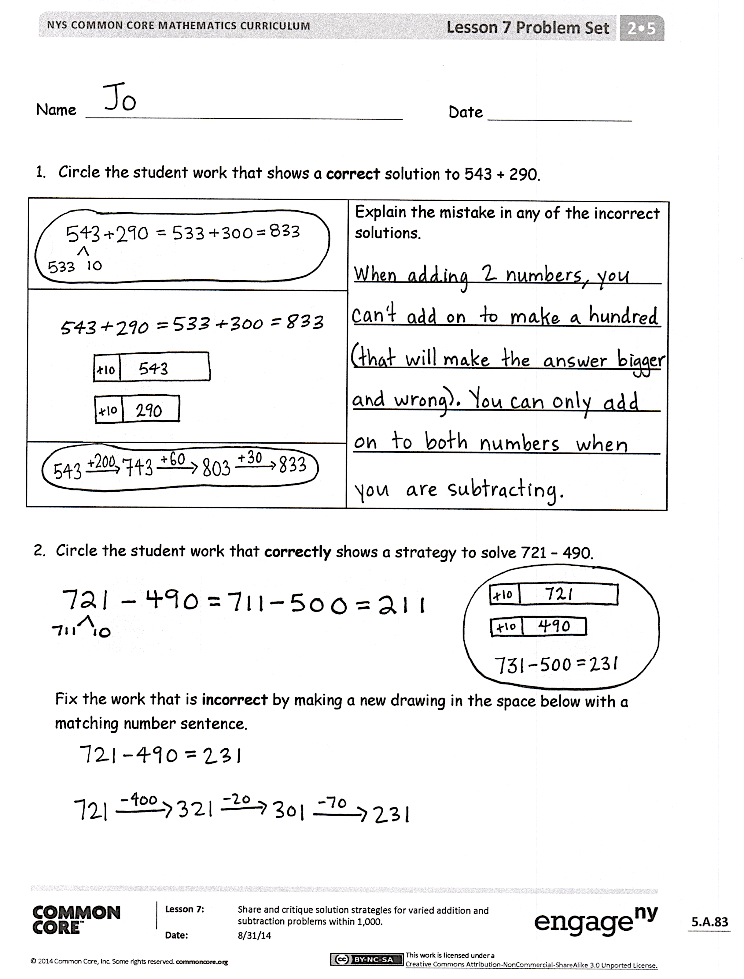
Problem Set (10 minutes)
Students should do their personal best to complete the Problem Set within the allotted 10 minutes. For some classes, it may be appropriate to modify the assignment by specifying which problems they work on first. Some problems do not specify a method for solving. Students should solve these problems using the RDW approach used for Application Problems.
Student Debrief (10 minutes)
Lesson Objective: Share and critique solution strategies for varied addition and subtraction problems within 1,000.
The Student Debrief is intended to invite reflection and active processing of the total lesson experience.
Invite students to review their solutions for the Problem Set. They should check work by comparing answers with a partner before going over answers as a class. Look for misconceptions or misunderstandings that can be addressed in the Debrief. Guide students in a conversation to debrief the Problem Set and process the lesson.
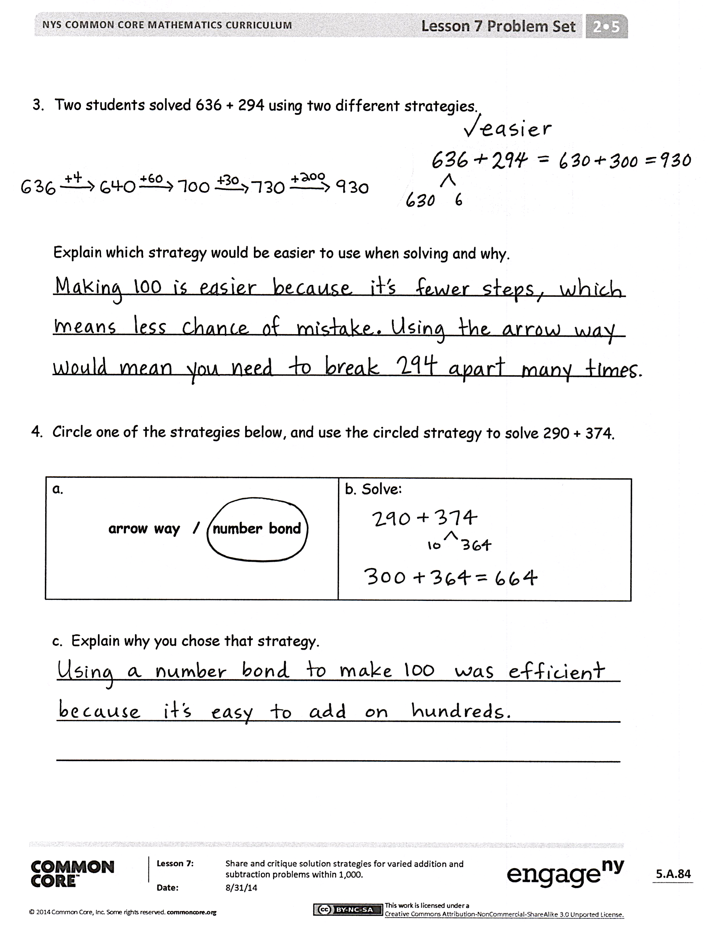
Any combination of the questions below may be used to lead the discussion.
- For Problem 1, explain to your partner the mistake made in the second student work sample. Is compensation for addition the same as for subtraction? Can you add the same amount to both addends without changing the total?
- In Problem 2, which student work sample incorrectly shows a strategy to solve 721 – 490? Share your new drawing and number sentence with a partner. How else could you have solved this problem?
- Which strategy do you prefer for solving Problem 3—the arrow way or a number bond? Why? What made the arrow way more challenging?
- What were you thinking when you selected a solution strategy to solve Problem 4? How was this similar to or different from your partner’s strategy?
- What was the most important thing you learned today?
Exit Ticket (3 minutes)
After the Student Debrief, instruct students to complete the Exit Ticket. A review of their work will help with assessing students’ understanding of the concepts that were presented in today’s lesson and planning more effectively for future lessons. The questions may be read aloud to the students.

Name Date
- Circle the student work that shows a correct solution to 543 + 290.
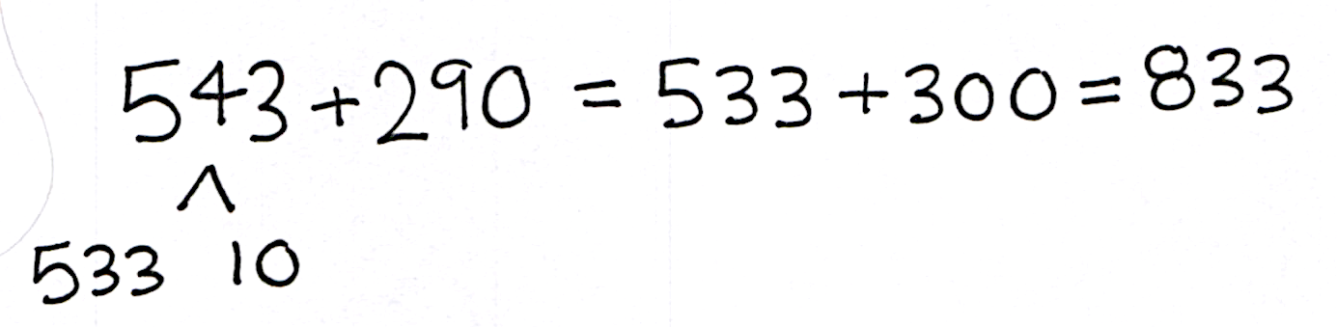 | Explain the mistake in any of the incorrect solutions.  _______________________________  _______________________________  _______________________________  _______________________________  _______________________________
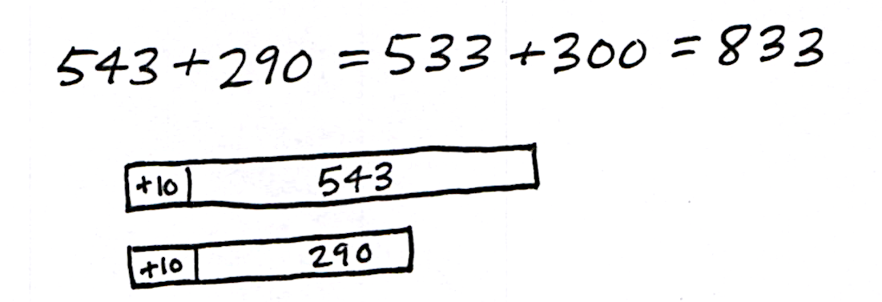
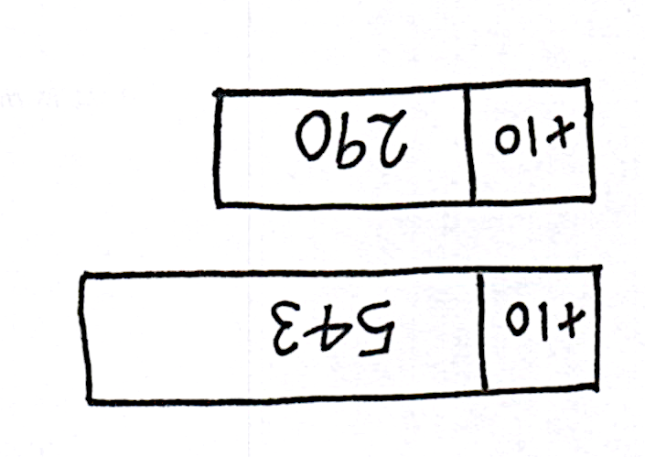
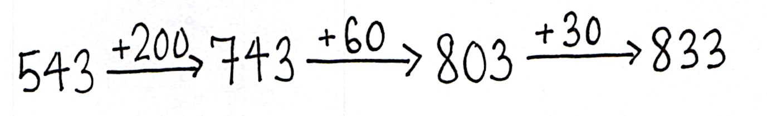

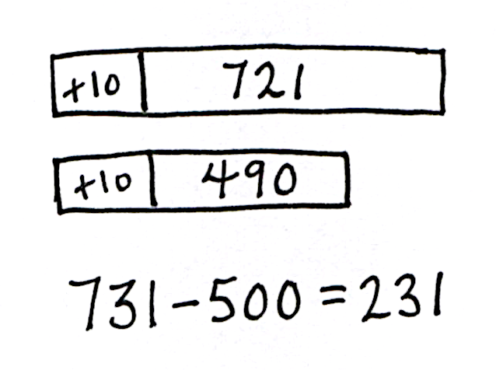
- Circle the student work that correctly shows a strategy to solve 721 – 490.
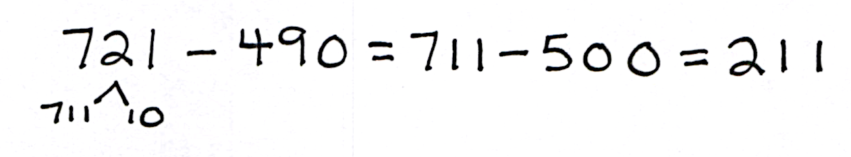

Fix the work that is incorrect by making a new drawing in the space below with a matching number sentence.

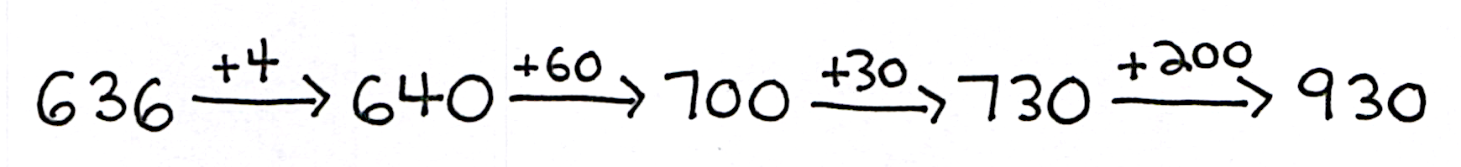
3. Two students solved 636 + 294 using two different strategies.
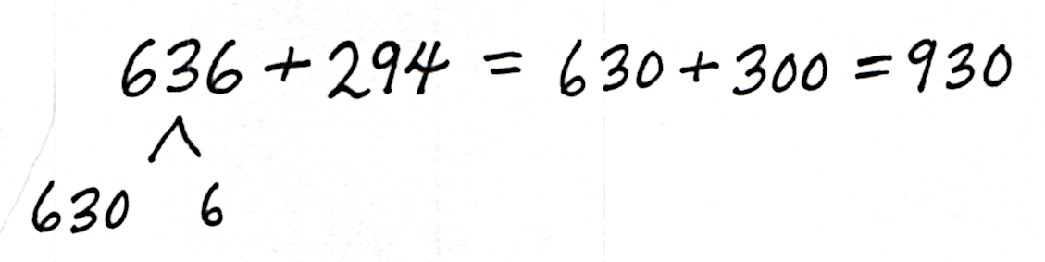

Explain which strategy would be easier to use when solving and why.
_______________________________________________________________
_______________________________________________________________
_______________________________________________________________

4. Circle one of the strategies below, and use the circled strategy to solve 290 + 374.
a.  arrow way / number bond | b. Solve:

c. Explain why you chose that strategy.
______________________________________________________________
______________________________________________________________
______________________________________________________________
Name Date
Circle one of the strategies below, and use the circled strategy to solve 490 + 463.
a.  arrow way / number bond | b. Solve:

- Explain why you chose that strategy.
_______________________________________________________________
_______________________________________________________________
_______________________________________________________________

Name Date
- Solve each problem with a written strategy such as a tape diagram, a number bond, the arrow way, the vertical form, or chips on a place value chart.
a.  370 + 300 = _____ | b.  _____ = 562 – 200 | c.  ______ + 500 = 812
d.  230 - 190 = ______ | e.  ______= 640 – 180 | f.  450 - 290 = ______

- Use the arrow way to complete the number sentences.
a.  420 - 230 = _____ | b.  340 - 160 = _______ | c.  710 – 350 = ________

- Solve 667 + 295 using two different strategies.
a. | b.

- Explain which strategy is easier to use when solving and why.
_______________________________________________________________
_______________________________________________________________
_______________________________________________________________
- Circle one of the strategies below, and use the circled strategy to solve 199 + 478.
a.  arrow way / number bond | b. Solve:

- Explain why you chose that strategy.
______________________________________________________________
______________________________________________________________
______________________________________________________________
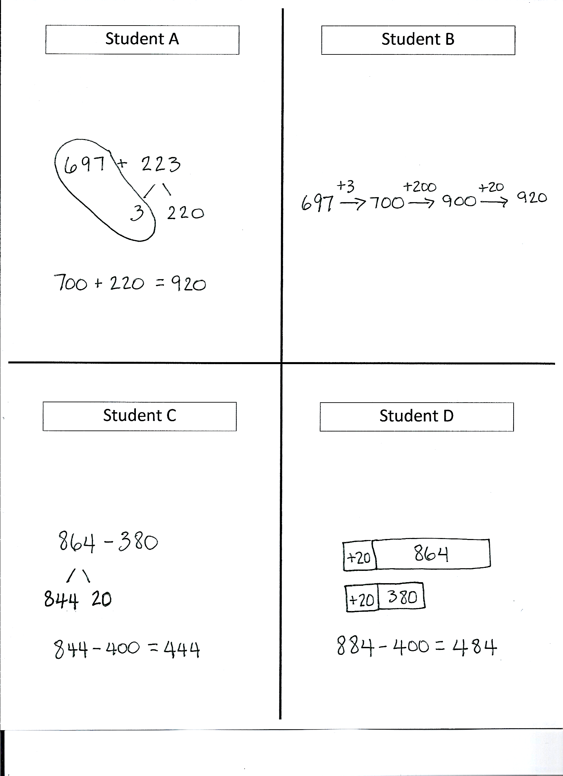

student work samples

